WAQAR ALI
STUDENT 2027054

BA (Hons) Leadership and
Management Skills for the Workplace

Dr Obinna Nkwocha
Module: BMSW5101
Part 2

How Individuals’ beliefs, Attitudes, and
values impact on Workplace behaviour

Section 1:
An analysis of the impact of individual beliefs and values on workplace behaviour
Section 2:
Academic Essay

Section One
In this essay I will be attempting to present an informed analysis of the impact of individual beliefs and values on workplace behaviour. During my process I have attempted to gather information from as many sources as possible to give myself the best chance to attempt to discuss and even evaluate the impact of the statement.
Individual beliefs and values can have huge impact on workplace behaviour as the worker maybe using culture. religion and taught behaviours to influence how they base their behaviour.
What is a belief?
’’ A belief is an internal feeling that something is true, even though that belief may be unproven or irrational. e.g., I believe that walking under a ladder brings bad luck, or I believe that there is life after death.’’ Anderson and Desilva (2009
Across the world belief systems vary in workplaces and sometimes form the structure to the behaviour of entire workplaces. To work effectively in a workplace, it is critical to understand your personal values and beliefs and how they affect your interactions. To remain professional, it is necessary to leave our personal values out of professional relationships to remain business orientated. One of the problems with attitudes is that we very often completely ignore any information which is not in line with them, we often become selective in the way that we perceive and respond to events and issues, and completely lose objectivity in dealing with whatever situation arises. We need to develop an insight about our attitudes in order to lower the risk of decision making at work based on what we know be it unconsciously, using long held pre-existing perceptions about peoples religious or moral beliefs thus allowing us work more professionally and not allowing us to compromise beliefs for professional progression.
Bono and Judge (2003) mentioned ‘’that transformational leaders communicate a vision that highlights the way in which collective goals are in harmony with employee values, causing employees to regard organisational values as their own and submit extra effort toward goals and accomplishments’’
I have tried to articulate my views on the impact of individual beliefs and values on workplace behaviour, I feel that workers can really shape the workplace environment by improving the workplace culture. Everyone is free to have their own principles in life and adhere to them which enables work environments to be vibrant and welcoming places and diversity comes in and allows the use of personal values and attitudes to assist team building and output.
Any other type of behaviour that may bring unique challenges to an organisation can only make it better and aid performance. It is important to separate our personal beliefs and attitudes from our professional lives to avoid poor team unity and lowering moral. Organisations can help build value systems based on personal attitudes within working teams.
influencing individual and organisational behaviour and through understanding its evolution through time and its differences, managers can manage people very effectively, planning performance and motivating them much more effectively.
In conducting workshops on values, with more than 200 organisations, Jaffe and Scott (2001) found that these core values came up routinely: integrity, competence, teamwork, communication, autonomy, creativity, and personal growth. These workshops showed a huge upturn in what is now commonly known as man-management or personal development planning in the workplace.
Workplace behaviour is formed and depends on those contributing to it to make it work, promotion of good communication and trust increases between managers and employees. It is also mentioned that socialising in the workplace increases value and great behavioural challenges and there are differences in cultural, generational values, and understanding these differences can help managers to manage people more effectively.
Any place of work that have been tasked to build relationships between employees can use many forms of team building to achieve the desired outcome which will eventually allow workers to aid customers daily and allow them to take ownership and build trust. Honesty has a massive role in any workplace and by having a solid team environment which will allow everyone to work better. Alternatively, if workers are involved in dishonest practices, then this will be to the detriment of the entire business.

Academic References
Anderson, M. and De Silva, S., 2009. Beliefs, values and attitudes. Me-and-Us.
Bono, J. E., & Judge, T.A. (2003). Self-concordance at work: Toward understanding the motivational effects of transformational leaders. Academy of Management Journal, 46, 554–571.
Jaffe, T.D., & Scott, D.C. (2001). How to link personal values with team values. American Society for Training and Development. Retrieved from http://www.dennisjaffe.com/adminpanel/uploads/documents/1307423812ASTDValuesArticle

PART 2

A brief critical reflection of how your critical thinking skill has developed based on your learning on the module (You must apply a reflective model) (1000 words). 25 Marks

In this module I have really developed my critical thinking skills based on the learning I have done in my current module. The module has really improved my thought process in every way possible. When I started the module, I had a very simplistic thought pattern and never really considered my approach as to what the route to the outcome was or should be. I have been very lucky in this module that my mind has been opened to the many ways of improving my critical thinking skills.
I had a very simplistic approach where solutions were very black or white but during my studies, I realised that this was due to a lack of understanding on my part and how I was able to come to conclusions with whatever subject matter came in front of me.
The following critical thinking model shows a step-by-step process of concluding by using facilities available to individuals.
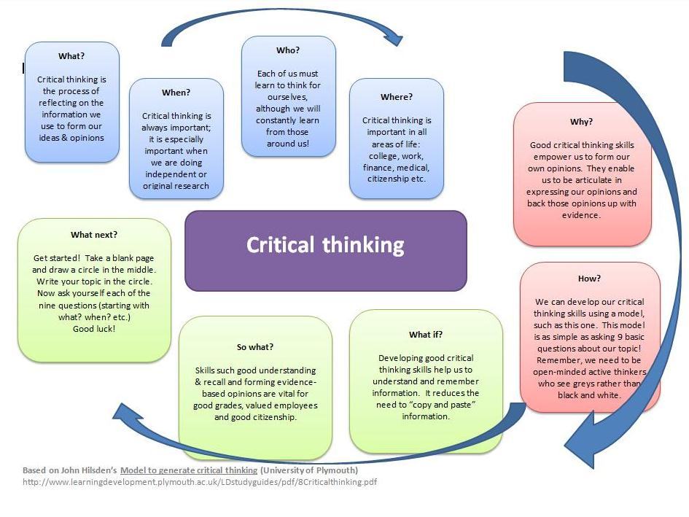

My learning has shown me the value of critical thinking skills in everything I do both day to day and in my professional life. At every age, at every development level critical thinking can be applied in all situations that may arise which also allows a lot of benefits professionally and personally.

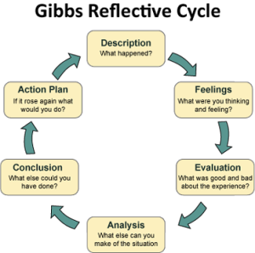

Gibbs reflective cycle is great and shows that when faced with a question or task that seems insurmountable that aiming to simply as best as possible is the way forward. When faced with questions that are not within the norm to in a individual’s routine then the above model can be applied and in my experience within the classroom almost always leads to a general outcome that is unbiased and palatable for all those involved in the communications.
This module has been an absolute revelation for me in so many ways and the area of my life most impacted is my professional life. I work at amazon and regularly am asked to come up with scenario-based models for colleagues to decipher and this learning module has allowed to make up questions with a much wider conceptual meaning and also allowing my peers to learn while they work how to critically assess anything that happens during there work tenures and how to be more successful and productive during their day.
My managers have also seen me applying what I learnt and have allowed me to assume more responsibility in the workplace and this can only be a massive plus on my learning journey.

