

MSc Public Health and Social Care in Practice
LCHS7006 Quality Assurance and Service Improvements

Component 2
Service Improvement Report

Case Study: Shrewsbury and Telford Hospital NHS Trust (UK) - Maternity Scandal

Student name: Disha Nasit
Student ID: 2528386

Word Count: 3280
Table of Contents
1. Introduction 3
1.1 Background 3
1.2 Case Study Overview 3
1.3 Report Aim 4
2. Findings and Analysis 4
2.1 Overview of the Quality Concern 4
2.2 Fishbone Diagram Analysis 6
2.3 Five-Whys Analysis 8
2.4 Donabedian Model Analysis 9
2.5 SWOT Analysis 11
2.6 Benchmarking 11
3. Recommendations 12
3.1 PDSA cycle 12
3.2 Lewin’s 3-stage model 14
4. Conclusion 15
Reference List 16

1. Introduction

1.1 Background
Health and social care services have quality management intrinsic to them and are meant to make the care safe, effective, patient-centred, timely, efficient and equitable. Quality in health care is achieved by means of good governance structures, evidence-based clinical practice, constant monitoring and organisational learning. Donabedian (1988) defined three structure dimensions, process and outcome of healthcare quality and believed that organisational systems and clinical practice are a major component in achieving positive patient outcomes. In a similar fashion, the Department of Health (2000) has stressed the importance of learning from failures and adverse events to avoid harm and enhance the quality of service provided by any healthcare organisation. Thus, the quality of care delivered to service users may be greatly affected by poor governance, leadership, communication and safety systems.

1.2 Case Study Overview
The Shrewsbury and Telford Hospital NHS Trust maternity services in England can be considered one of the largest instances of such failures. As part of an independent review commissioned by Donna Ockenden, common themes of maternity care in the Trust and numerous underlying causes of avoidable damage to mothers and babies were identified (Dobson, 2022). The initial study focused on 23 cases having since grown to a massive scale in general. The study evaluated 1,486 cases of families across 1,592 clinical incidents and is considered as one of the biggest maternity studies in the history of NHS (Ockenden, 2022). The review identified a list of clinical governance, incident reporting, risk management, communication, leadership and organisational learning gaps. Additionally, there was no constant discussion of the issues of patient, family and healthcare professionals, which led to the continuation of unsafe practices in the long term (Bright, 2025).
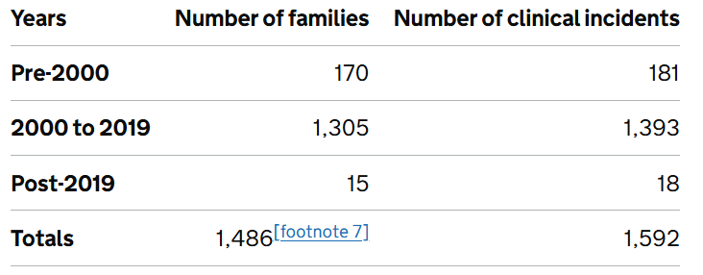
Table 1: Time period of family cases included in this review
(Source: Ockenden, 2022)
This is not merely a case of clinical errors but also the importance of the weaknesses in the system within healthcare organisations which compromise patient safety and quality of the services being offered. The reason is that the systems approach of patient safety, as proposed by Reason (1990) is because the failure to which accidents are very likely to occur is not a failure of the lapse, but of a number of failures within the organisation that cause the most probable accidents. The Ockenden Review results concur with this view and suggest that the health system has significant gaps at many levels, such as the control of leadership, staffing, the system of policy implementation and accountability. The effects of these failures, like serious injuries, fetal death and emotional pain for families could be avoided.

1.3 Report Aim
This report critically examines the quality concerns that were brought up in the Shrewsbury and Telford Hospital NHS Trust, and quality management structure. In particular, the Fishbone Diagram, the analysis of the 5 Whys and the Donabedian Model are used to analyse the root causes of the failures and to determine their impact on the services provided, as well as the SWOT analysis to evaluate them. Based on such analysis, it will be proposed to implement evidence-based recommendations and an implementation plan that will allow achieving sustainable improvement of services and make healthcare organisations safer for patients.

2. Findings and Analysis

2.1 Overview of the Quality Concern
One of the biggest quality failures within the history of the National Health Service (NHS) is the Shrewsbury and Telford Hospital NHS Trust maternity scandal. It has been demonstrated in the Ockenden Review (2022) that the cause of preventable maternal deaths, neonatal deaths, stillbirths, and long-term injuries in mothers and babies was systemic failures in maternity services. The scale and prevalence of the problem were highlighted by the fact that what started as an investigation of 23 maternity cases grew to 1,486 family cases and around 1,592 clinical incidences. The review found that numerous negative consequences might have been avoided in case of the consistent implementation of proper clinical care, escalation procedures, and governance systems (Lethbridge, 2022). These findings indicate that quality assurance systems and patient safety systems within the organisation have failed miserably.
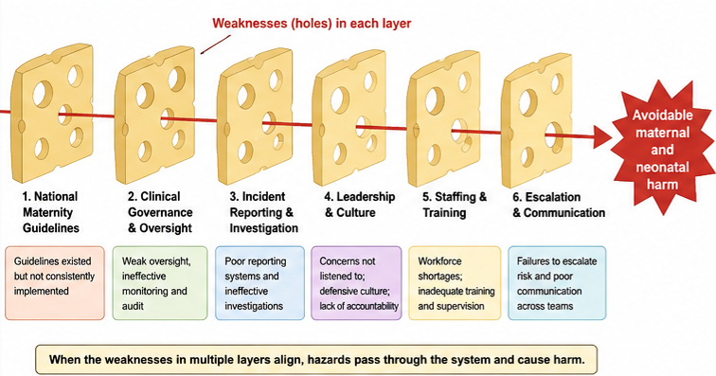
Figure 1: Swiss Cheese model-based analysis
(Source: Ockenden Review, 2022)
Leadership in healthcare is important to facilitate effective leadership and governance, communication and continuous organisational learning. The Department of Health (2000) also advises healthcare organisations to leverage unpleasant experiences to reduce the risks in the future. The Ockenden Review (2022), however, reported that it had failed to make repeated learning opportunities, which would have led to a repeated failure over a long period of time. As a result, the case also offers an excellent chance to discuss the ways in which the quality management framework could be employed to locate the root causes and facilitate the process of service enhancement.
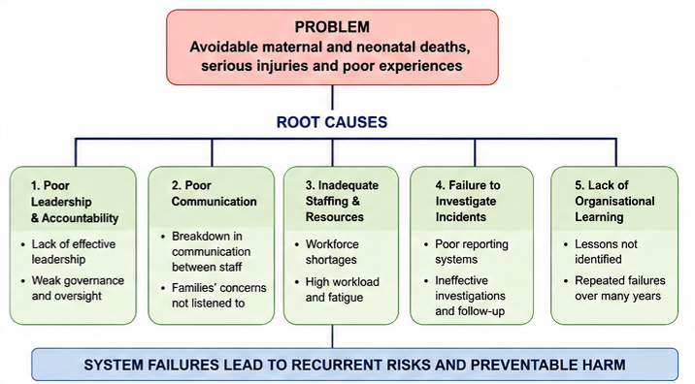
Figure 2: Root cause analysis
(Source: Ockenden Review, 2022)

2.2 Fishbone Diagram Analysis
A tool that is helpful in the identification and classification of the root causes of complex organisational problems is the Fishbone Diagram designed by Ishikawa (1998). The framework does not single out a single cause but rather a myriad of contributing factors that have a cumulative effect on negative outcomes. The factors leading to patient harm in the case of Shrewsbury and Telford can be divided into people, process, management, environment and policy factors.
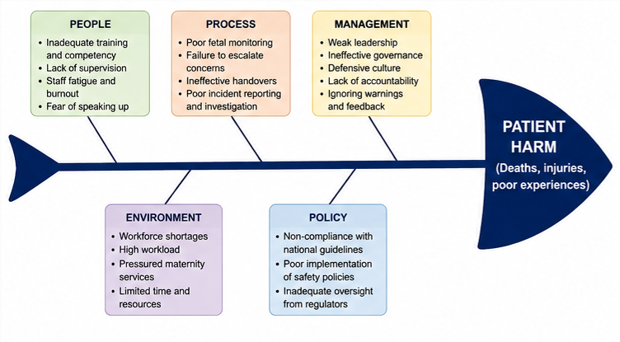
Figure 3: Fishbone analysis
(Source: Lampard, 2023)
The size of people is related to workforce competency, staff behaviour and training. The Ockenden Review has found shortcomings in training staff, and a lack of supervision and communication between healthcare professionals (Lampard, 2023). In addition, not all the staff were confident enough to raise concerns, and the families frequently complained that they were neglected once they started to express their concerns about patient care (Chambers and Taylor, 2021). These were one of the factors that reduced the quality and safety of maternity services.
Process dimension involves clinical practices, reporting systems and channels of communication. There were major areas of weakness that were found in fetal monitoring practices, the clinical decision-making, handovers, and investigation of incidents (Vilanova, 2025). There was a tendency as well not to escalate clinician concerns accordingly, resulting in delays in intervening and missing opportunities to cause harm. Other glitches in the investigation of serious incidents, constraining organisational learning and improvement were also noted in the review.
Of importance were management factors. Weak leadership and bad governance structures, and defensive organisational culture did not facilitate effective oversight and accountability. According to Elkomy et al. (2023), leadership is one of the key elements in the definition of quality of healthcare services, employee engagement, patient safety, and performance. In this case, it was through leadership failures that unsafe practices were spread.
The environmental deficits were staff deficits, rising demand of services, workload and resource constraints. These pressures put further burdens on the maternity services and minimised the ability of employees to deliver safe and quality services. Lastly, policy issues were the absence of the implementation of national maternity safety policies and poor policies. All these related causes can testify to the fact that the quality failure was not a one-time event, but it is a systemic and a systemic problem.

2.3 Five-Whys Analysis
The 5-Whys method is a root cause analysis which attempts to establish the underlying problems of a problem by repeatedly questioning (Barsalou and Starzyńska, 2023). The method enables organisations to transcend the shallow explanations to unearth systemic issues that require solutions as Saapunki (2023) contends.
The main issue detected in Shrewsbury and Telford case was the instances of preventable maternal and neonatal deaths and injuries. The initial question is what the reasons behind these negative consequences were. The solution is in the inabilities to recognise and address clinical risks in a proper way (Roberts, 2023). The second question investigates the reasons why clinical risks were not effectively handled. The audit has revealed that the problems were frequently not reported and the communication between the healthcare providers was also frequently poor.

Figure 4: Five-whys analysis
(Source: Saapunki, 2023)
The third question looks at the causes of unsuccessful escalation processes. The review shows that the governance mechanisms were ineffective and inconsistency existed in the reporting of the incident processes. The fourth question is why the systems of governance were not productive. One of the major factors was the existence of the defensive organisational culture where the concerns were not allowed to be discussed, but constructively (McDonagh Hull et al., 2025). Lastly, the fifth question will look at the reasons why such a culture arose and continued. The fact that there were no organisational learning and accountability and the lack of leadership control and mechanisms of observing the quality of the services was a root cause (McDonagh Hull, 2023).
This discussion shows that the underlying reasons of the maternity scandal were much deeper than individual clinical mistakes. Instead, the failures were the consequences of organisational weaknesses of the governance systems, leadership structures and communication processes, and organisational culture. This implies that there will be no corrective measure that is adequate to guarantee sustainable improvement.

2.4 Donabedian Model Analysis
One of the most well-known models of measurement of healthcare quality is the Donabedian Model. Donabedian (1988) suggested three interrelated dimensions: structure, process, and outcomes, to be used to evaluate healthcare quality. Arguably, the model is particularly useful when analysing the Shrewsbury and Telford case as it demonstrates the impact that the environment within organisation has on clinical practice and, by extension, patient outcomes.
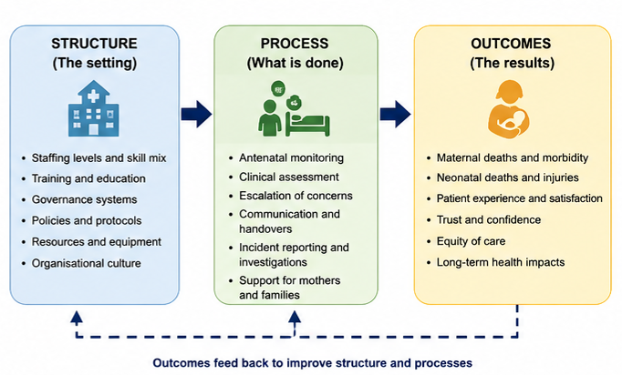
Figure 5: Donabedian model analysis
(Source: Taylor and Goodwin, 2022)
Organisational setting where healthcare is offered is the structure element. Some structural weaknesses might be observed in Shrewsbury and Telford. This was due to lack of staffing, lack of training opportunities, poor governance structures, and poor leadership structures (Taylor and Goodwin, 2022). Workforce demands decreased the capacity of maternity services to deliver to patients in an efficient manner and the governance weaknesses constrained control of clinical performance. Besides, the problems of competency and supervision of the workforce were always detected during the review.
The process part is centered around the care provision approach. There were many process failures identified in the maternity services. These were the inadequate practices in terms of fetal surveillance, inability to adequately assess the risk, inability to escalate concerns, deficiency of power in incident reporting and investigation systems (O'Donovan et al., 2026). These flaws could not provide an opportunity to early identify and manage clinical risks. Additionally, the inability to establish a good rapport with patients and families led to the low patient experience and confidence in the service.
The outcome component shows the results of structural and process related weaknesses. The Ockenden Review recorded preventable maternal deaths, child deaths, still births, injuries that occur during childbirth and long-term emotional trauma by the family (Mattocks, 2026). Such results show severe failures in patient safety and quality of service provision. The scandal not only tarnished the Trust and its financial position but also affected the public trust in maternity services.
The Donabedian framework showed that such negative outcomes were not rare but were a product of weaknesses in the organisational structures and processes of providing care.

2.5 SWOT Analysis
A SWOT analysis is a strategy model that is employed in the analysis of strengths, weaknesses, opportunities and threats of an organisation. Taking into consideration the problem of maternity service improvement, the analysis offers valuable information concerning the points of the further quality management program.
Strengths | Weaknesses
NHS maternity safety frameworks and clinical expertise. | Poor governance, staffing shortages, and weak organisational learning.
Opportunities | Threats
Implementation of Ockenden recommendations and staff training improvements. | Workforce pressures, financial constraints, and loss of public trust.
Table 2: SWOT analysis
(Source: Mattocks, 2026)

2.6 Benchmarking
One of the key strengths is the good quality of the NHS maternity safety policies and national quality standards. The circulation of the Ockenden Review and the subsequent creation on the Maternity and Neonatal Safety Improvement Programme is a solid foundation to build on going forward (Ockenden, 2022). Furthermore, the NHS has extensive clinical expertise and governance frameworks which can enable change.
However, the results also indicate that gaps existed in the past in terms of leadership, governance, investigations of incidents, communication, and workforce management. The latter gaps were directly connected to the quality deficiencies which were easily noticeable at the Trust (Hughes, 2023). Moreover, restoring the trust of patients, families and healthcare professionals is also a major challenge.
There are a number of opportunities that can be used to enhance the quality of service. Improved safer maternity care can be attained in areas such as digital health technologies, enhanced governance systems and increased patient involvement (Mattocks, 2026). The recommendations of the Ockenden Review provide a clear road map on the way to service improvement and organisational learning.
Nevertheless, there are a number of threats that can stifle growth. Persistent lack of workforce, increasing demand on maternity services, financial problems and staff burnout are challenges (Knezevic et al., 2025). The lack of these may hamper the improvement process and contribute to the threat of quality failures in the future. Therefore, a proactive approach is needed, in parallel to the development of governance, professional development and ongoing learning and culture of patient safety in healthcare organisations.

3. Recommendations

3.1 PDSA cycle
The Trust should undertake a specific intervention, as part of the Plan step in the PDSA cycle, which will be a standardised maternity safety and escalation pathway, with a multidisciplinary maternity safety committee. Such intervention should establish explicit boundaries of escalation of clinical deterioration, require incident-reporting, specify leadership role and systematic incorporation of family concerns. These are immediate actions to address the poor governance and regulation as noted by the Ockenden Review. Accountability and reduction of unnecessary harm depend heavily on effective governance systems and frequent quality checks (Cook et al., 2023; Adams et al., 2023). Serious maternity incidents, escalation delays, rate of incident-reporting, time to complete an investigation, compliance with staff training, patient complaints, and patient-satisfaction scores are some of the measures that should be used as a baseline.

Figure 6: PDSA cycle
(Source: Elliott, 2024)
During the Do stage, the intervention should be piloted in one of the maternity units or clinical teams during a certain period and then extended to the entire organisation. The staff needs to be trained to monitor fetuses, multidisciplinary communication, escalation, and digital incident reporting and open disclosure. The workforce assessments should also identify workforce gaps, skills gaps and workload stressors and subsequently recruit, retain and professionally develop workforce (Elliott, 2024). Electronic incident-reporting systems, clinical audits, training records, staff survey, patient questionnaire, complaint data and structured feedback with mothers and families should be used to collect data. This is based on the results that PDSA-based training and reporting interventions can support quantifiable healthcare practice changes (Kay et al., 2023; Lemma et al., 2025).
The Study stage will need to compare the post-intervention results with the baseline indicators. Common adverse events that can be prevented, rates of clinical concern developed during required intervals, reporting rates of inquiries made, competency of the workforce, perceptions of psychological safety and patient experience among the staff should be mentioned as the main metrics. The review of qualitative feedback given by the staff members, patients, and families should be conducted along with the quantitative indicators to determine not only whether improvement has occurred but also the reasons why some aspects worked or not. It is especially crucial since the concerns of families were traditionally not taken into consideration, and the staff lacked a sense of confidence to speak up (Chambers and Taylor, 2021; Bright, 2025).
The Act phase involves the successful elements to be standardised and sized across the maternity services and the ineffective ones to be modified. Indicatively, the continued increase in delays may necessitate a simplified protocol or more simulation training or increased access of senior clinicians. The feedback obtained must be utilized directly to feed into subsequent PDSA cycles therefore creating continuous learning as opposed to the perspective of improvement as being a one-off activity. Safety-culture assessments, patient feedback and clinical audits should be regular to make sure that refinements are sensitive to the emerging risks (Kawalkar et al., 2026; Yu et al., 2026).

3.2 Lewin’s 3-stage model
In order to cope with the broader organisational change, the three-stage model by Lewin is suitable since the improvement that is needed is one that entails permeated cultural, leadership and behavioural issues. During Unfreeze, leaders need to be ready to change, by openly displaying evidence of past failures, patient experience and continued risks, by establishing a leadership team of senior executives, maternity clinicians, midwives, governance experts and patient representatives (Silvola et al., 2024). This might be met with resistance because of a fear of blame, work pressures and distrust of leadership, so; psychological safety and open communication are needed.
The Trust needs to embrace new levels of escalation channels, strengthened incident-reporting procedure, staff training, management accountability and active patient participation throughout Change. Leaders need to provide frequent reports on progress and reward positive safety behaviours and secure time and sufficient resources to train and participate. Refreeze involves entrenching good practices in organisational policies, job descriptions, induction, performance appraisal, governance dashboards and regular audit systems (Foley et al., 2023). This kind of integration will eradicate retrogression into the past unsafe practices and uphold accountability.
Overall, the Trust should make sufficient leadership time, staff training, digital infrastructure and finances to implement these recommendations. Among the short-term outcomes that will be achieved are improved reporting, fast escalation, increased staff confidence, and improved communication with patients. Reduced preventable incidents, enhanced organisational learning, better maternity outcomes and regained public trust should be among long-term outcomes. The constant review by repeated PDSA cycles and strengthened by the Lewin model would make sure that improvement becomes a part of organisational culture and not a short-lived adjustment to failure.

4. Conclusion
Shrewsbury and Telford Hospital NHS Trust maternity scandal are amongst the most well-known examples of healthcare quality failure within the NHS. The results of the Ockenden Review showed that there were widespread systemic vulnerabilities that led to preventable maternal mortality, neonatal mortality, stillbirths, and long-term injuries in hundreds of families. The magnitude of the review that analysed 1,486 family cases and about 1,592 clinical incidents is indicative of the intensity and chronicity of the quality issues that prevailed in the organisation.
Quality management models proved helpful in providing a hint for the underlying causes of such failures. The Fishbone Diagram indicated that the damage was brought about by interrelated factors which were related to people, processes, management, environment and policy. The 5 Whys analysis also revealed that the organisational culture, leadership, accountability, and governance weak sides were the root causes of most of the negative outcomes. The Donabedian Model emphasised structural shortcomings such as shortages in staffing and governance flaws which led to the ineffectiveness of the care processes and eventually to poor patient outcomes. Furthermore, the SWOT analysis indicated the internal weaknesses and external opportunities that will aid in improving the service in the future.
The discussion reveals that to improve the quality of healthcare; it is not sufficient to concentrate on individual errors. Sustainable enhancement is based on the possibility to improve the organisational systems, the culture of learning, development of the working force, effective governance and accountability. The suggestions offered in this report, backed up by the PDSA quality improvement framework, offer a systematised way to implement significant changes and mitigate risks in the future.
Lastly, the lessons of the Ockenden Review touch on the significance of patient/ client’s safety, transparency and continuous quality improvement in the health and social care organisations. Through correcting the cause of failure and instilling the ethos of learning and responsibility, healthcare providers will be able to improve the quality of service, patient outcomes, and rebuild trust in the healthcare services in the population.

Reference List
Adams, M., Hartley, J., Sanford, N., Heazell, A. E., Iedema, R., Bevan, C., ... and Sandall, J. (2023). Strengthening open disclosure after incidents in maternity care: a realist synthesis of international research evidence. BMC Health Services Research, 23(1), 285. https://link.springer.com/content/pdf/10.1186/s12913-023-09033-2.pdf
Barsalou, M., and Starzyńska, B. (2023). Inquiry into the use of five whys in industry. Quality Innovation Prosperity, 27(1), 62-78. https://qip-journal.eu/index.php/QIP/article/download/1771/1362
Bright, M. (2025). Whistleblowing in an empty room. Index on Censorship, 54(1), 52-57.
Chambers, N., and Taylor, J. (2021). Organising care around patients: Stories from the frontline of the NHS. https://uplopen.com/books/2442/files/e727834f-4d92-4ad8-9aa3-b76389586f8b.pdf
Cook, F., Glen, K., and Ngo, A. T. (2023). Service improvement for a dietetic-led radiologically inserted gastrostomy service using the Plan-Do-Study-Act (PDSA) cycle. Clinical Nutrition Open Science, 51, 118-127. https://www.sciencedirect.com/science/article/pii/S266726852300044X
Department of Health (2000). An Organisation with a Memory. London: The Stationery Office.. https://pubmed.ncbi.nlm.nih.gov/12448595/
Dobson, J. (2022). Ignoring women’s experience led to the NHS’s biggest maternity scandal. https://scholar.archive.org/work/buhzqd74pjc6lcm3fdavtbdoeq/access/wayback/https://www.bmj.com/content/bmj/377/bmj.o899.full.pdf
Donabedian, A. (1988). ‘The quality of care: How can it be assessed?’, Journal of the American Medical Association, 260(12), pp. 1743–1748. https://scholar.google.com/scholar?output=instlink&q=info:OpJggMVu6DoJ:scholar.google.com/&hl=en&as_sdt=0,5&scillfp=1167206333893993899&oi=lle
Elkomy, S., Murad, Z., and Veleanu, V. (2023). Does leadership matter for healthcare service quality? Evidence from NHS England. International Public Management Journal, 26(2), 147-174. https://researchportal.port.ac.uk/files/23349200/Does_Leadership_Matter.pdf
Elliott, A. M. (2024). Meeting quality improvement learning outcomes: Applying the Plan-Do-Study-Act cycle. Journal of Nursing Education, 63(11), 788-788. https://journals.healio.com/doi/pdf/10.3928/01484834-20240522-04
Elliott-Mainwaring, H. (2022). A midwife’s exploration into how power & hierarchy influence both staff and patient safety. Journal of Patient Safety and Risk Management, 27(1), 9-14. https://journals.sagepub.com/doi/pdf/10.1177/25160435211027035?fbclid=IwAR21-3M4frgjnjiiesS5EZCfvfnISjdz7M7P8E130r2NLIPcUrqflEellLk&
Foley, C., Allan, J., Lappin, J., Courtney, R., Farnbach, S., Henderson, A., and Shakeshaft, A. (2023, June). Utilising the implementation of integrated care to develop a pragmatic framework for the sustained uptake of service innovations (SUSI). In Healthcare (Vol. 11, No. 12, p. 1786). MDPI. https://www.mdpi.com/2227-9032/11/12/1786
Hughes, H. (2023). Public inquiries, patient safety and the implementation gap. Future Healthcare Journal, 10(1), 7-9. https://www.sciencedirect.com/science/article/pii/S2514664524003758
Ishikawa, K. (1998). What is Total Quality Control? The Japanese Way. Englewood Cliffs: Prentice Hall. https://pqm-online.com/assets/files/lib/books/ishikawa.pdf
Kawalkar, U., Sharma, M., Gaidhane, A., Mankar, A., Chavhan, S., Puri, M., ... and Syed, Z. Q. (2026). Improving private tuberculosis patient notifications in Akot Tuberculosis Unit of Vidarbha region of India: A Plan-Do-Study-Act (PDSA) based approach for enhanced public health reporting. PLOS Global Public Health, 6(5), e0006480. https://journals.plos.org/globalpublichealth/article/file?id=10.1371/journal.pgph.0006480&type=printable
Kay, S., Unroe, K. T., Lieb, K. M., Kaehr, E. W., Blackburn, J., Stump, T. E., ... and Carnahan, J. L. (2023). Improving communication in nursing homes using plan-do-study-act cycles of an SBAR training program. Journal of Applied Gerontology, 42(2), 194-204. https://pmc.ncbi.nlm.nih.gov/articles/PMC9981342/pdf/nihms-1838336.pdf
Knezevic, A., Olcoń, K., Cameron, J., Pai, P., and Allan, J. (2025). From stress to support: an ethnographic journey of a staff-led wellbeing intervention in maternity services. BMC Health Services Research, 25(1), 1057. https://link.springer.com/content/pdf/10.1186/s12913-025-13239-x.pdf
Lampard, C. (2023). What do stories tell us about whistleblowing conflict in the NHS in England and its resolution?. https://qmro.qmul.ac.uk/xmlui/bitstream/handle/123456789/87579/PhD%20THESIS%20-%20CLIVE%20LAMPARD%20-%2016%20May%202023%20PDF.pdf?sequence=2
Lemma, K., Bekele, D., Tolu, L. B., Tadesse, F., Kifle, T., and Sium, A. F. (2025). Birth companionship: The effect of introducing Plan-Do-Study-Act (PDSA) intervention on improving quality of care: An implementation study. Int J Gynaecol Obstet, 168, 842-844. https://www.researchgate.net/profile/Kidist-Lemma-Gizachew/publication/384285910_B_R_I_E_F_C_O_M_M_U_N_I_C_A_T_I_O_N_O_b_s_t_e_t_r_i_c_s_Birth_companionship_The_effect_of_introducing_Plan-Do-Study-Act_PDSA_intervention_on_improving_quality_of_care_An_implementation_study/links/66f2a3ecfc6cc46489723f04/B-R-I-E-F-C-O-M-M-U-N-I-C-A-T-I-O-N-O-b-s-t-e-t-r-i-c-s-Birth-companionship-The-effect-of-introducing-Plan-Do-Study-Act-PDSA-intervention-on-improving-quality-of-care-An-implementation-study.pdf
Lethbridge, J. (2022). What are the barriers to improving public value–the case of maternity services in England?. https://gala.gre.ac.uk/id/eprint/41759/1/Lethbridge%20final%20Barriers%20to%20public%20value%20the%20case%20of%20maternity%20services%20.pdf
Mattocks, K. (2026). Agenda-setting success and the 2024 UK Birth Trauma Inquiry. Policy Studies, 1-20. https://www.tandfonline.com/doi/pdf/10.1080/01442872.2026.2631006
McDonagh Hull, P. (2023). Comparing caesarean birth rates: An institutionalized habit that is hard to break. Journal of Patient Safety and Risk Management, 28(1), 5-8. https://journals.sagepub.com/doi/pdf/10.1177/25160435221150373
McDonagh Hull, P., Boulton, T., and Lashewicz, B. (2025). Recurring red flags: a retrospective study of MBRRACE-UK Perinatal Mortality Surveillance (2015–21) to identify maternity services most consistently reporting higher-than-average deaths. Journal of Public Health, 47(3), 511-520. https://academic.oup.com/jpubhealth/article-pdf/47/3/511/62005646/fdaf019.pdf
NHS England (2023) Maternity and Neonatal Safety Improvement Programme. London: NHS England. https://www.england.nhs.uk/mat-transformation/maternal-and-neonatal-safety-collaborative/
O’Donovan, L., Devaney, S., Mullock, A., and Moore, V. L. (2026). Medical misogyny: understanding epistemic injustice to achieve safer healthcare for women in the UK. Medical Law Review, 34(2), fwag009. https://academic.oup.com/medlaw/article-pdf/34/2/fwag009/68110546/fwag009.pdf
Ockenden, D. (2022) Findings, Conclusions and Essential Actions from the Independent Review of Maternity Services at the Shrewsbury and Telford Hospital NHS Trust. London: Department of Health and Social Care. https://www.gov.uk/government/publications/final-report-of-the-ockenden-review/ockenden-review-summary-of-findings-conclusions-and-essential-actions
Reason, J. (1990). Human error. [Book] Cambridge university press. https://www.academia.edu/download/71746242/HumError.pdf
Roberts, J. T. (2023). Taking embodiment seriously in public policy and practice: adopting a procedural approach to health and welfare. Monash Bioethics Review, 41(Suppl 1), 20-48. https://link.springer.com/content/pdf/10.1007/s40592-023-00183-x.pdf
Saapunki, K. (2023). Root cause analysis and escape defect analysis improvement at continuous delivery by data-driven decision-making. https://www.theseus.fi/bitstream/handle/10024/801915/Saapunki_Katja.pdf
Silvola, S., Restelli, U., Croce, D., and Basu, D. (2024). Change management for services redesign in healthcare: a conceptual framework. Journal of preventive medicine and hygiene, 65(3), E410. https://pmc.ncbi.nlm.nih.gov/articles/PMC11698107/
Taylor, D. J., and Goodwin, D. (2022). Organisational failure: rethinking whistleblowing for tomorrow’s doctors. Journal of medical ethics, 48(10), 672-677. https://jme.bmj.com/content/medethics/48/10/672.full.pdf
Vilanova, G. C. (2025). Incident investigations in maternity services: an ethnographic study in Brazil. https://kclpure.kcl.ac.uk/ws/portalfiles/portal/366780333/2025_Carlomagno_Vilanova_Gabriele_1852561_ethesis.pdf
Yu, X., Wang, X., Yang, Y., Hou, W., and Wang, Z. (2026). Effectiveness of a Plan-Do-Study-Act cycle-based quality control circle in enhancing the research capacity of operating room nurses a pre-post intervention study. BMC nursing. https://link.springer.com/content/pdf/10.1186/s12912-026-04566-3.pdf

