Rebecca Macfarlane

Varteg, Blaenavon: Block D

This report will be analysing data for the remediation site based at Varteg in Blaenavon and exploring whether it is possible to determine any reasons or patterns for the behaviour and development that has taken place. Much of the physical landscape of Wales is in the same condition as Varteg, and so it is imperative to glean as much information as possible to promote and support future reclamation work elsewhere.

Site History
The multiple sites at Varteg date back as far as 1840 (Welsh Coal Mines, nd), with extensive work being carried out up until 1963 when the NCB closed down the main site, though minor works continued on nearby into the early 1990’s. The full extent of the work carried isn’t known as there are abandoned mines that were undocumented and only found when new mining routes came across old routes or chambers (Reed, 2016).
The remediation site appears to be within an area that was heavily used from as early as 1865, referenced below on maps from 1899 as containing an ‘old quarry’ (Industrial Gwent, nd).
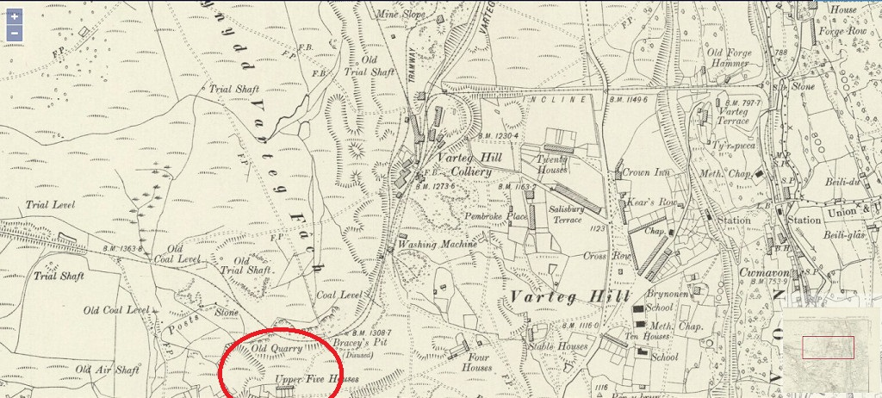
(Industrial Gwent, nd)

Physical Background
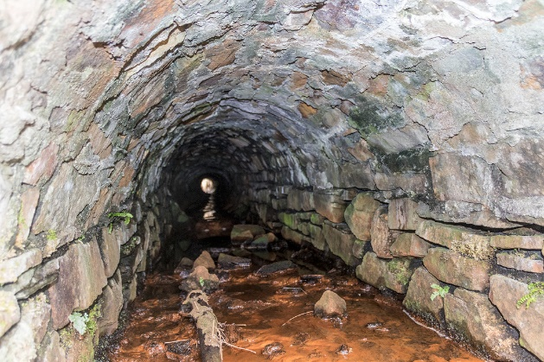
It should be noted that Bracy’s Pit is particularly close to the remediation site and contained many culverts which have now either been destroyed or filled in with no active redirection of the water that they housed. This should be considered when analysing the effect of growth rates, along with the heavy metals that will be present in the soil that is typical of coal spoil.
(Industrial Gwent, nd)
Prior to planting at the site, it should also be noted that the land was ploughed or turned over by the local farmer when it had been determined by the team that they wished for it to remain in situ.
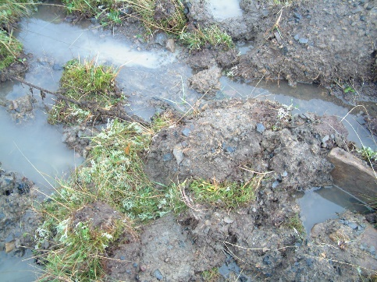
The ground at Varteg is very rocky, with dense and compacted soil that is difficult to plant into. Combined with the site’s exposure and generally poor weather conditions, the water run-off can be extreme with little absorption. With the site also being ploughed, this has in turn led to pockets of water collecting in certain areas, leaving the site somewhat unpredictable in what the constant conditions should be.
(Jenkins, 2019)
Block D differs from the other plots in two minor but notable ways- the planting was carried out by the same two professors without any help from students, and no fertiliser was used directly on any part of it. A major difference in this plot to the others is that the vitality scoring for a large section of it is very high, with a lot of growth from volunteer species as well as accelerated growth in heather and gorse.
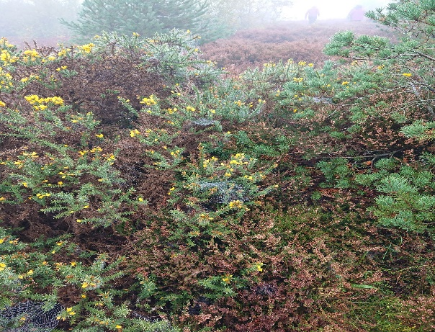 (Author's Own, 2019)

Methodology
This report will analyse the data from previous years of research at the site, along with condition preferences per tree species, weather patterns, and any further relevant information found during a site visit in October 2019. It will take into consideration the overall history of the site when investigating any related patterns or causes for the site to be in its current condition.
Investigating the current conditions whilst keeping in mind the physical history of the site will show a more accurate report on the development of Varteg.

Tree Species
The trees that were mostly used at the site were: alder (alnus glutinosa), sessile oak (quercus petrea), goat willow (salix caprea), downy birch (betula pubescens), and silver birch (betula pendular). In addition to this there were mixed trees such as spruce, whitebeam and spindle, but as the exact species are not known in all cases they will be grouped under ‘mixed’. There will be no in-depth discussion into the mixed group as the numbers are too small to collect cohesive data.
Alder is a popular tree to use on reclamation sites on spoil heaps and is noted to be naturally dominant in bogs or boggy conditions. The nodules that develop on their root system are particularly effective at enhancing soil quality (Johnson & Moore, 2006).
Sessile oak is a hardy species but tends to avoid heavy or alkaline soils. In contrast, it is known for thriving in higher areas than the English oak which prefers lowlands (Johnson & Moore, 2006). It is also one of the slower growing trees on the site.
Goat willow is by nature a species that loves boggy sites or at least a lot of water, and is seldom seen in sites of light soil (Johnson & Moore, 2006). It is known for growing quickly and spreading into all areas with suitable conditions if left unattended.
Downy birch is prevalent on poor and damp soils with minimal chalk (Johnson & Moore, 2006). A hardier strain than silver birch, it is usually overlooked for the latter purely for aesthetic purposes.
Silver birch is mostly dominant in sandy soils (Johnson & Moore, 2006) and planted in abundance. With its partnered downy birch, it is more tolerant of colder temperatures.

Site Conditions
Weather reports that date back to the site’s beginning are more difficult to source and are not readily available for years prior to 2014. However, there are UK climate summaries available that will give a breakdown of mass weather changes year on year that can be used to glean a general idea of any extremes the site would have experienced that could be considered to be outside of the normal range.
Reports show that 2014 was registered as the hottest summer since 1910 (Met Office, 2015), while 2015 was milder with the wettest December on record (Met Office, 2016). Whilst 2016 was another mild year overall it was also sunnier throughout the year but was again one of the wetter winters. There was notably less snow in 2016 than usual, with less than 20cm depth reported across the UK (Met Office, 2017). In contrast, December 2017 saw more snowfall across Wales along with seven named storms affecting the UK and Ireland as a whole with extreme wind conditions (Met Office, 2018). Following from the 2017 snowfall in December, 2018 saw more snowfall again between February and March across the whole of the UK (Met Office, 2019).
In addition to the heavy metals in the soil and the excess water that is not being redirected by the disused/destroyed culverts nearby, the topography of the site leaves it very exposed to the elements. From years of cutting into the ground and building up the spoil heaps, wind is now pushed through a narrow valley and can be strong. In addition to this, the lack of shelter and altitude leaves rain and frost as a constant problem in colder months, along with harsh heat during the summer. There appears to be no middle ground for the site.

Results and Discussion
 | MORTALITY BY YEAR
 | FRONT OF BLOCK D
Row 1 | ³⁰¹ | 2015 | 2009 | ³⁰⁴ | ³⁰⁵
Row 2 | ³⁰⁶ | ³⁰⁷ | ³⁰⁸ | ³⁰⁹ | ³¹⁰
Row 3 | 2013 | 2014 | 2008 | 2012 | 2016
Row 4 | 2009 | 2016 | 2014 | 2014 | 2008
Row 5 | 2012 | 2015 | 2013 | 2010 | 2010
Row 6 | ³²⁶ | 2008 | 2008 | 2009 | 2019
Row 7 | 2012 | 2009 | 2008 | 2008 | 2014
Row 8 | 2014 | 2015 | 2008 | 2017 | 2010
Row 9 | 2012 | 2008 | 2009 | ³⁴⁴ | 2014
Row 10 | ³⁴⁶ | 2014 | ³⁴⁸ | ³⁴⁹ | 2014
Row 11 | ³⁵¹ | 2014 | 2012 | 2010 | 2010
Row 12 | ³⁵⁶ | 2008 | 2014 | ³⁵⁹ | 2015
Row 13 | 2007 | ³⁶² | 2007 | 2010 | ³⁶⁵
Row 14 | ³⁶⁶ | ³⁶⁷ | ³⁶⁸ | 2012 | 2017
Row 15 | ³⁷¹ | ³⁷² | 2009 | 2009 | 2017
Row 16 | ³⁷⁶ | ³⁷⁷ | ³⁷⁸ | ³⁷⁹ | 2010
Row 17 | ³⁸¹ | ³⁸² | ³⁸³ | ³⁸⁴ | 2014
Row 18 | ³⁸⁶ | ³⁸⁷ | ³⁸⁸ | 2008 | ³⁹⁰
Row 19 | ³⁹¹ | ³⁹² | 2014 | ³⁹⁴ | ³⁹⁵
Row 20 | ³⁹⁶ | ³⁹⁷ | ³⁹⁸ | ³⁹⁹ | 2007
 | REAR OF BLOCK D
The mortality rates per year listed on the left and the weather patterns that are listed above show that a lot of the trees that died in 2014 were already exposed on at least one side. This lack of shelter and exposure to the heat of the summer are key contributing factors in what would otherwise appear to be a random mortality pattern.
From the site visit it was clear to see that the rocky and hard ground would be difficult to work with, especially during the initial planting phase. It has also led to build up of boggy pockets of land where the run-off is limited. Many of the trees that had been planted in these pockets had long since died, though lichen and mosses had taken their place and grown in abundance.

(Author's Own, 2019)
When you look at the aerial vitality scoring for the whole site, it is clear to see that the mortality rates are not solely related to the planting techniques used; as the mortality spreads across a large swathe of the midsection for all, it would suggest that the soil in that area is currently too contaminated for the trees to support themselves at this age and size.
(Author's Own, 2019)
There were, however, also signs of positive development in the site at ground-level; there was a large collection of fungi from the boletus family, the majority of which are ectomycorrhizal (developing a mutualistic relationship with tree root systems) (First Nature, nd). This relationship is further developing the site by the fungi aiding in the trees obtaining extra minerals.
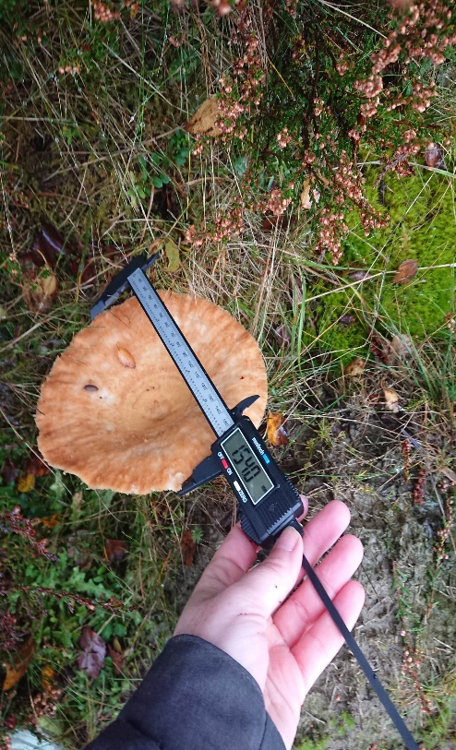 (Author's Own, 2019)
Boletus was also seen to be growing in areas with the tree listed as being either dead or in poor condition in previous years. As the fungi in an ectomycorrhizal relationship cannot survive without the tree, this would imply that the tree is not dead but waiting for better conditions before attempting regrowth. It can be argued that the tree root system the boletus is partnered to is one of the remaining trees, but the pattern of the boletus surrounding what was clearly a previous tree site would suggest otherwise.
The average base diameter growth per species shows that downy birch is thriving. It also shows that whilst alder was initially growing more effectively than oak, it has now died back and massively affected the average. The oak, whilst still with a small average base diameter, has been consistently increasing year on year since a slight dip in year 9. This is to be expected with a slower developer like oak, whereas the goat willow has increased at a more stable rate overall. This, along with the heavy fluctuation in silver birch, would suggest that the conditions, whilst liable to completely change, are still mostly waterlogged.

(Author's Own, 2019)
The presence of thriving gorse and particularly heather in the largest area of dead trees shows that the rotting material has provided a more nourishing environment to grow. Whilst the gorse doesn’t require it, the growth rate of the gorse is estimated to be at the higher end of the national average (Royal Horticultural Society, nd). Heather thrives on acidic soil but can also fare well on alkaline soil as long as there is enough rotting matter to collect nutrients from (Royal Horticultural Society, nd). The prevalence of both is typical for coal spoil sites, but it doesn’t usually grow to the levels that exist in block D. Measuring the larger of the plants and mapping their location may be a valid bit of research moving forward.

Conclusion
The site at Varteg is unique in that it is an open experiment with no clearly defined goals or desired outcomes. The openness of the research makes it difficult to know if or when to intervene at the site and what effect either would have.
The failure of alder to prosper on block D is something that would garner more information- what conditions or contaminants are lethal to them at lower levels than the other species? Further research into this would provide more data on the compacted soil.
It is clear from the vitality scores and average growth rates that block D has been more successful overall. Though while the planting itself was more consistent, the mortality rate is still quite high and follows a pattern when you look at the overall aerial scores from the site. This would suggest that there are veins of soil with higher concentrations of contaminants present which are having an adverse effect on tree growth in that area.
There are positive signs that this is slowly changing over time; the presence of fungi in sites where the mycorrhizal partner appears to be dead show that conditions underground are slowly improving and trees should reappear once those conditions improve further. Due to the slow rate with which fungi can carry out this change it would take a significant amount of time, and so interference or maintenance in these areas would inhibit research and data collection into the effectiveness of natural mycoremediation. It would be advisable to take samples of the existing fungi to test their nutrient levels to analyse for further information.

References
Author's Own. (2019, October). Author Images.
First Nature. (nd). Boletus Edulis. Retrieved from First-Nature: https://www.first-nature.com/fungi/boletus-edulis.php
Industrial Gwent. (nd). Varteg. Retrieved from Industrial Gwent: http://www.industrialgwent.co.uk/a43-varteg/index.htm
Jenkins, R. (2019). Varteg - Blaenavon 2019. Swansea.
Johnson, O., & Moore, D. (2006). Collins Tree Guide. In O. Johnson, & D. Moore, Collins Tree Guide (p. 190). Harper Collins.
Met Office. (2015, September 23). State of UK Climate. Retrieved from Met Office: https://www.metoffice.gov.uk/binaries/content/assets/metofficegovuk/pdf/weather/learn-about/uk-past-events/state-of-uk-climate/state-of-the-uk-climate-2014-v3.pdf
Met Office. (2016, July 25). State of Climate UK. Retrieved from Met Office: https://www.metoffice.gov.uk/binaries/content/assets/metofficegovuk/pdf/weather/learn-about/uk-past-events/state-of-uk-climate/mo-state-of-uk-climate-2015-v3.pdf
Met Office. (2017, July 27). State of UK Climate. Retrieved from Met Office: https://www.metoffice.gov.uk/binaries/content/assets/metofficegovuk/pdf/weather/learn-about/uk-past-events/state-of-uk-climate/mo-state-of-uk-climate-2016-v4.pdf
Met Office. (2018, July 30). State of UK Climate. Retrieved from Royal Meteorological Society: https://rmets.onlinelibrary.wiley.com/doi/10.1002/joc.5798
Met Office. (2019, July 30). State of UK Climate. Retrieved from Royal Meteorological Society: https://rmets.onlinelibrary.wiley.com/doi/full/10.1002/joc.6213
Reed, C. (2016). Tareni Colliery. In C. Reed, Tareni Colliery (p. 166). Swansea: Etifediaeth Cwmtawe - Swansea Valley Heritage.
Royal Horticultural Society. (nd). Hardy Heathers. Retrieved from Royal Horticultural Society: https://www.rhs.org.uk/advice/profile?PID=1003
Royal Horticultural Society. (nd). Ulex Europaeus. Retrieved from Royal Horticultural Society: https://www.rhs.org.uk/plants/18575/Ulex-europaeus/Details
Welsh Coal Mines. (nd). Vipond's. Retrieved from Welsh Coal Mines: http://www.welshcoalmines.co.uk/Gwent/Vipond's.htm

