Section 2: Riding the Storm

This section has three sub-sections. These are:
Sub-section 1: Stormy waters
Sub-section 2: Roles and responsibilities
Sub-section 3: Reflection

Sub-section 1: Stormy waters

Upon completion of this sub section, you will be able to:
- Establish suitable methods to manage and resolve conflict within your team / virtual team.

Introduction
During this session, you will be looking at how conflict and friction can occur between virtual team members and the dangers associated with conflict avoidance.

Characteristics of Storming:
It is during this stage of team development where conflict is more likely to arise between team members. Individuals may start to challenge the team’s mission as their true characters and preferred ways of working surface and clash with other members of the team.

Challenges within the storming stage

Here are some of the challenges that arise in the storming stage of team development:​
- Group show competitive behaviour​
- Members seem to get irritated​
- Communication is one way​
- One or two members attempt to dominate​
- Sub-groups and alliances start to form​.
​
The following also become challenges in the storming stage for virtual teams:​
- Misunderstandings are more likely to arise​​
- Members may find it difficult to motivate themselves without direct interaction​
- Members may experience an increasing feeling of isolation.​​
(Mullins, 2019)​​​

Introductory activities:
Individual Tasks
- Consider some of the challenges that arise in the storming stage of team development. Make notes in the space below.

Picture This:
- How do you visualise ‘storming’? If you were asked to describe 'storming' using an image, what would it be?

During the following sub-sections, you will be focusing on the second dysfunction of Lencioni’s five behaviours: conflict. This will include how conflict avoidance can affect teams in terms of commitment and accountability, how conflict and friction occur in a virtual team and ways to resolve this to enable you to move on to the next stage of virtual team development.​

You will also be looking at the dangers associated with conflict avoidance.

What is conflict?
Conflict is defined by Mullins (2019) as ‘Behaviour intended to obstruct the achievement of some other person’s goals’.

Stages of the Conflict Process
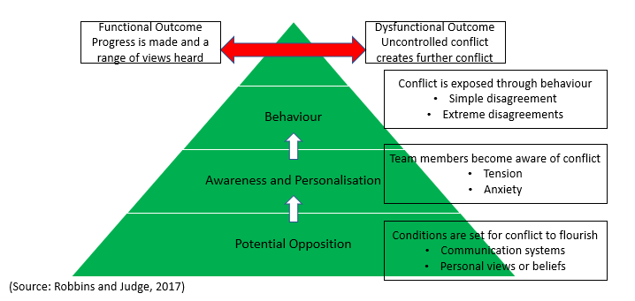

Conflict and virtual team dynamics
If teams cannot control conflict, it leads to further conflict resulting in a dysfunctional outcome. A key point to consider forms part of the first stage of the conflict process: ‘Communication systems’ – and how this can affect virtual team dynamics.​
During the previous section, Life is a Team Sport, you looked at the role of empathy. Empathy plays a critical role in developing successful relationships. ​Empathy allows us to become better listeners and also be more supportive of our team members, which helps to increase productivity within the team.
Take some time to reflect on what you could do to improve how you communicate in a team / virtual team to enable you to work towards a functional outcome. Once you have done this, watch the following videos:
The danger of avoiding conflict (8 mins)​
https://www.youtube.com/watch?v=GqfUW_wEFHM ​
How to manage conflict in virtual teams in 7 easy steps (5 mins)​
https://www.youtube.com/watch?v=a0FjPjdTJI8 ​

Stop and Think!
Remembering and recalling key learning
What are the seven steps of how to manage conflict in virtual teams?

Application
Take some time to reflect on a situation where you have experienced conflict either at work or in your personal life. How did you respond?​ Did your response lead to a dysfunctional or functional outcome?

Developing depth
How can empathy play a part in resolving or preventing conflict in a virtual environment?​

Further Research:
Click on the link below to assess your current people skills levels. https://www.mindtools.com/pages/article/newTMM_36.htm

Let’s Summarise
- In your own words, explain what is meant by ‘conflict’?
- List two challenges that may arise in the storming stage of team development?
- Fill in the missing words:

If teams cannot control conflict, it leads to further conflict resulting in a______.

Sub-section 2: Roles and responsibilities

Upon completion of this sub section, you will be able to:
- Identify roles and responsibilities and how they can help you work more effectively with your team.

​Introduction
If roles and responsibilities are not clear, individuals might begin to feel overwhelmed by their workload or frustrated at the lack of progress made.​
In this sub-section, you will be conducting an individual SWOT analysis before looking at different team roles and how they can help you work more effectively with your team.​
A SWOT analysis is a framework for analysing your strengths and weaknesses as well as the opportunities and threats that you face. This helps you focus on your strengths, minimise your weaknesses, and take the greatest possible advantage of opportunities available to you.​
(Source: Mindtools, 2021)​

Definition:

‘A role is the expected pattern of behaviour associated with members occupying a particular position within the structure of the organisation’ (Mullins, 2019, p 101).

Introductory activity
The previous definition mentions our roles within an organisation. However, we can also consider the roles that we play in our personal lives, which can vary from person-to-person.
Make some notes about the different roles you play in your personal life and analyse your responsibilities within these roles.

Recognising team roles
When working in a team, you will quickly realise that everyone plays a slightly different role. For example, some people are natural leaders, while others may be good at coming up with new ideas. Each role has its strengths and weaknesses, and there are situations where one particular role may be more effective than another. Being able to recognise and understand these different roles will help you to work more effectively with your team members.

Stop and Think
SWOT Analysis

The table below is an example of a personal SWOT analysis template. You can use this as a guide.​

Developing depth - Click on the following link below to learn about: Recognising team roles.​
https://uwtsd.careercentre.me/elearning/scorm-rise.aspx?CourseId=nEZ9vo+Mlt0XWdvgBanHyw== ​

- What do you consider to be your preferred roles? How could playing to your strengths create opportunities for your team?

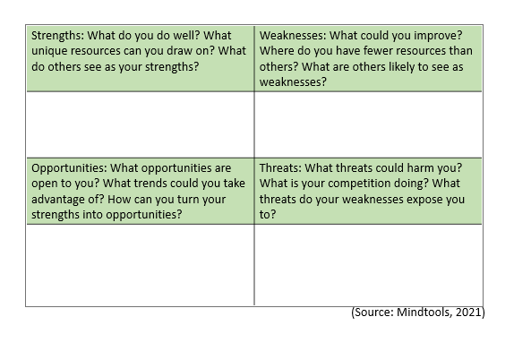

Your Strengths? | Your Weaknesses?
Opportunities? | Threats?

Wider Learning:

Click on the following link to watch a video about the Belbin Team Role theory. https://www.youtube.com/watch?v=XPMN9N6NC7k

- In your own words, explain why it is important to recognise and understand the different roles within a team?

- Reflect on a time where you experienced effective teamworking?

Further Reading
- Lencioni, P. M. (2002) The five dysfunctions of a team: A leadership fable. San Francisco: Josey Bass.
- Mindtools (2021) Personal SWOT Analysis: Making the Most of Your Talents and Opportunities. Available at: https://www.mindtools.com/pages/article/newTMC_05_1.htm#:~:text=A%20SWOT%20matrix%20is%20a,of%20opportunities%20available%20to%20you (Accessed: 5 April 2021).
- Mindtools (2021) Tuckman's Model for Nurturing a Team to High Performance. Available at: https://www.mindtools.com/pages/article/newLDR_86.htm (Accessed: 18 March 2021).
- Mullins, L. J. (2019) Organisational behaviour in the workplace. 12th edn. Harlow: Pearson Education.
- Robbins, S. and Judge, T. (2017) Essentials of Organizational Behaviour. 14th edn. Essex: Pearson Education.

