
reflective report
PROFESSIONAL CAREER DEVELOPMENT


mARINELA COVASNEANU 1920078
University of Wales Trinity Saint David

Table of Contents

1. Introduction 2
2. Findings 2
2.1. Smart goal 2
2.2. SWOT Analysis 3
2.3. Gibbs’s Reflective Cycle (1988) 6
2.4. Learning questionnaires 8
2.5. Personal Development Plan 9
3. Conclusion 10
4. References 11

- Introduction

Going back to school after 22 years is not an easy thing to do. Many things have changed, and I have changed too. During the classes, I have often struggled with all the technology and after each session, I felt like I have learned something new. I also received constant feedback that helped me improve myself and I am grateful for that.
In this report I want to present everything that I have learned and to share my personal experience regarding each lesson. First of all, I will start with my Smart goal, then I will try and analyse myself in different ways using the Swot analysis, the Gibbs’s Reflective Cycle, the Myers Briggs questionnaire and the Honey and Mumford questionnaire. I will finish my reflective report by building a Personal Development Plan and by giving my last thoughts about what all this experience meant to me and how I will include everything that I have learned outside of my courses.

- Findings
  - Smart goal

The first topic that I want to explore in this report is the Smart goal. It is a term I have never encountered before and I struggled to analyse it at first. With time and practice, I get used to it and now I understand better his significance and why is so used.
SMART represent an acronym for Specific, Measurable, Attainable, Realistic and Timed. The goal must be Specific by telling exactly what needs to be accomplished, by who, and what is the reason behind the goal. The goal is Measurable by having a way to track the progress. This is one of the most difficult part of the goal but is necessary for the success. The goal must be Attainable, which means that the goal may require some special skills or resources. The purpose of this part is to make sure that the goal can be achieved taking in consideration the effort needed. For the goal to be Realistic, it must make sense and must be in coordination with the rest of the goal and with the opportunities available. Finally, for the goal to be Timed, it must contain a deadline. This is also very important because without a deadline, the person can lack motivation and will tend to procrastinate more and will not be focused on the goal to be finished.
My goal is to become an Assistant Manager at McDonald’s, by obtaining the Level 4 Certificate, by learning more about back-office and paperwork and by developing the skills that I need: Self-awareness, Digital Skills and Public Speaking, by the end of the spring 2021.
My goal can be seen as SMART because I have all the specifications needed. My goal is Specific because ‘I want to become an assistant manager at McDonald’s’ and it shows that the goal is personal, that has a clear position that I want to achieve and the place of work. My goal is Measurable because for me to achieve it, I must obtain the Level 4 Certificate, I have to learn about what back-office and paperwork means and I have to develop at least three important skills including self-awareness, digital and writing skills. My goal is Attainable because I must develop a few new skills to get the job. My goal is Realistic because I work at McDonald’s from 2015 and I have already advanced from Crew Member to Crew Trainer and then to my current position as a Shift Manager, and I think that I can continue to advance to a higher position of Assistant Manager. My goal is also Timed because I have given myself time to develop and obtain everything I need by the end of the spring of 2021, which means a year starting from now. In this time, I will work towards my Level 4 Certificate and towards the skills and learning that I need.

  - SWOT Analysis

After I have learned how to correctly set up a goal, by making it SMART, it was brought to my attention a new method which can help me improve faster and efficient, the SWOT Analysis. It was the first time that I have encountered this analysis and I did not know what to expect at first. It was a challenge for me because I have never thought of myself from this perspective. It was a bit difficult to put my qualities and my defects on paper, but it was a helpful exercise from which I have learned a lot.
Sarsby (2016) states that the SWOT analysis is used successfully for a few decades in many organisations like: industry, charity, commerce, and education. The acronym SWOT comes from Strengths, Weaknesses, Opportunities and Threats. All of these can be adapted to a personal plan or to an organisational plan, depending on the purpose. The Strengths are always internal, and they are used to support the Opportunities or to overcome the Threats. The Weaknesses are also internal, but they are the opposites of the Strengths, the only difference is that by doing the right actions, the Weaknesses can be transformed into Strengths. The Opportunities and the Threats are based by external factors that can change constantly in favour of the person or organisation or against them (Sarsby, 2016).
My SWOT analysis is adapted to my SMART goal and to my desire to advance in position at work.
My Strengths are:
- Honesty
- Openminded
- Solving problems
- Trustworthy
- Hard working
- Fast learner
- Resilience.
This means that I am an honest person, with an open mind, who takes pleasure in solving problems. I consider myself trustworthy because most of my friend and colleagues are letting me know their private thoughts and opinions. Also, I am a fast learner, but more than that, I am a hard-working person and I think that my career has been 10% luck and 90% hard work. And because I am hard-working, I developed my resilience and I can adapt fast to any change.
My Weaknesses are:
- Digital skills
- Writing skills
- Self-awareness
- Public speaking
- Paperwork.
I admit that even though I live in the Digital Era, I am not too good at it and all I can do is use my smartphone. This is a weakness for me, and I try to learn and to use more the laptop and certain programs like the Microsoft Office. Also, by always doing physic work, my writing skills are a bit forgotten. I struggle to be self-aware because after I have had my kids, they became my main focus. I am not too good at public speaking because I am nervous to not fail, and I do not know how to do the paperwork at my workplace at all yet.
My Opportunities are:
- Growth opportunities at work
- Support from my managers
- Continue with the studying and get Level 5 Certificate
- No real competition.
I am lucky enough to work in a place full of opportunities and with support from the managers of the company. I also started studying for my Level 4 Certificate in Higher Education: Skills for the Workplace and after I will finish it, I plan to continue towards the Level 5. Another opportunity for me at work is that I have no real competition, as most of the staff is only working temporarily there and I already have 5 years of experience.
My Threats are:
- No training available at work
- Self-learning
- My age
- Pressure at work.
I never had the opportunity to study and learn what I am currently doing, and no training is available at work, I always had to learn as I go through something. And the self-learning has never motivated me, I always needed something to push me from behind. Also, the pressure at work to do everything perfect and the night shifts that I usually work is making me really tired. At the same time, I am not anymore at an age where I can manage to be that multitasking, as I also have a family and they are my priority.

  - Gibbs’s Reflective Cycle (1988)

The next challenge that I had to face was the Gibbs’s Reflective Cycle from 1988. As the other theories, at the courses it was my first time hearing about this. In my opinion, this is the easiest and the most specific type of reflection and this is why I chose the Gibbs’s Reflective Cycle over Kolb’s Learning Cycle.

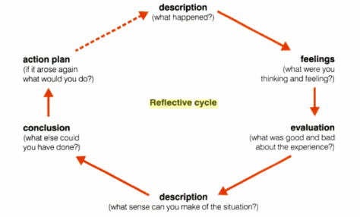
Figure 1. Gibbs’s Reflective Cycle (1988)

The cycle is divided in 6 important steps necessary to an effective reflection. The first step is the Description. Here is where the experience is related as it is, with details that can help further in reflection. The next step is the Feelings, where the reflection becomes more subjective, because the feelings and the thoughts from the experience must be expressed as they were in that particular moment. What comes next is the Evaluation, where the lessons from the experience are related, no matter if they are good or bad. The following part is the Analysis (Description), and here the experience must be break into pieces and each piece must be analysed. Naturally, after the Analysis, comes the Conclusion, where Jasper (2003, p. 80) suggest that the question ‘what else could I have done?’ must be asked and replied to. The final step is the Action Plan, where the conclusions drawn can give a better idea of what to do if the same situation will be faced again in the future.
My example for Gibbs’s Reflective Cycle (1988):
- Description:
A few months ago, I decided to apply for the Level 4 Certificate in Higher Education: Skills for the Workplace. I managed to pass the written interview and the oral interview, and I was accepted.
- Feelings:
Before I have applied, I was really insecure, I did not think that I will pass the interview. I was constantly wondering if I will manage to pass the interview, and I used to think that I was not good enough to study and that it will be difficult to me to go back to school after 22 years. In the day of the interview I was really nervous and scared, but at the same time I was excited for a new experience that will be significantly important for my development.
- Evaluation:
Passing the interview and the test gave me more confidence about my knowledge and my ability of learning new things and accept new challenges. It also made me realise that I can finally take more good care of me and do something that will benefit me in the future and that will help me grow. Also, not reading the questions twice and giving the wrong answer to one of them made me realise how easily I can lose an opportunity if I do not pay enough attention to the details.
- Analysis (Description):
I think that this course can change my life for good. Even if at first, I was insecure, with the passing of the interview I became more and more confident and I started to believe more in myself. I now know for sure that I can improve all my skills and that I can gain new ones, and I more that happy that I did not let the emotions get the best of me, and I began a new journey where I can pay more attention at myself and work more for myself.
- Conclusion:
The only regret that I have is that I did not do that earlier, when I was younger, and I did not have as many obligations as I have now. Time management would have been easier and perhaps I would have already gained the skills that I am missing now.

- Action Plan:
First of all, I look forward to finish this years with good grades, I want to improve my knowledge and gain more confidence. Next, I want to be again in the position where I will have a new interview, because I want to continue my studies and also obtain Level 5. At the next interview I know for sure that I will pay more attention to each question, I will double check my answers and I will be more relaxed and confident in myself.

  - Learning questionnaires

- Myers Briggs Questionnaire:
The Myers Briggs personality profiling test is one of the most popular learning questionnaires in the world, where the results are divided in 4 groups: Extrovert – Introvert, Sensing – Intuitive, Thinking – Feeling, Judging – Perceptive.
My results are:
- Extrovert / Introvert – 2/3: which means that I tend to be more introvert than extrovert.
- Sensing / Intuitive – 3/2: which means that I usually trust more the information that comes from the outside world.
- Thinking / Feeling – 5/0: which means that I act based on logic, not feelings.
- Judging / Perceptive – 2/3: which means that I am more attracted to try new things and explore new possibilities.

- Honey & Mumford Questionnaire:
Another used questionnaire to determine the learning style of a person is the Honey & Mumford. The questionnaire has 80 questions and 4 learning styles: Activist, Reflector, Theorist and Pragmatist.
My results are:
- Activist – 10.
- Reflector – 18.
- Theorist – 15.
- Pragmatist – 17.
This means that I am mostly a Reflector, followed by Pragmatist. This means that I like to hear about new perspectives, but I am sceptic when putting them in practice.

  - Personal Development Plan

The Personal Development Plan is the final step to my reflective report, in which I will conduct an analysis about how I can achieve the employability skills that I am missing at the moment, using the results from the SWOT and from the learning questionnaires. This Personal Development Plan is a useful tool that will help me achieve everything that I need so that I can make my SMART goal a reality.
Development Objective | Specific Actions | Barriers and how they will be removed | Support required | How will I know I achieved the objective
Self-Awareness | I will try to involve myself in everything that I want, and I will have the courage to speak for myself, and even if I will fail, I will learn from it. | I might overthink too much, and this will affect my courage, but I will remind myself that is normal to fail. | I will need support from my teachers, to be patient and from my colleagues and family to not put so much pressure on me. | When I will have no fear of failing anymore.
Digital Skills | I already work on this by doing this report, and by attending the course that can teach us how to use PowerPoint, Word, and Microsoft Teams. | The barriers are every new challenge or project, but with practice and asking for advice to more experienced colleagues and also watching tutorial I can combat them. | Support from teachers, colleagues and from myself, to have patience and to not give up at the first try. | At the end of the year.
Public Speaking | I will take the word more at university and at work. | I will feel nervous and I might not find my words, but practice makes it perfect. | I only need to support myself. | When I will not feel nervous anymore.

This Personal Development Plan will remind me everyday what I have to do, and I will try my best to keep up with it and I will constantly ask for feedback from people.

- Conclusion

After I have finished this reflective report, I understood how much I needed something like that in my life. Being a mom of two kids, I never really had the time to work on myself, I was always working for them, to provide for them. Now that I started this course, I feel like I have wasted a few precious years from my life. This is the reason why, right now, I will do my best to keep up with everything and I will give my best at every activity, because I find it fascinating.
I have found many interesting ideas, and now I feel like my journey has just started. I want to continue studying, I want to develop myself as much as I can, and I will do that for sure.

- References

- Bayne R. (2002) The Myers-Briggs Type Indicator. 2nd Ed. Cheltenham: Nelson Thornes Ltd.
- Business News Daily (2019) SWOT Analysis: What it is and When to use is. Available at: https://www.businessnewsdaily.com/4245-swot-analysis.html (Accessed: 06 June 2020).
- Jasper M. (2003) Beginning reflective practice. Cheltenham: Nelson Thornes Ltd.
- Mind of a Winner (2015) How to Create a Personal Development Plan. Available at: http://www.mindofwinner.com/create-personal-development-plan/ (Accessed: 07 June 2020).
- Oxford Learning College (2016) How to Write a Personal Development Plan. Available at: https://www.oxfordcollege.ac/news/how-to-write-a-personal-development-plan/ (Accessed: 07 June 2020).
- Santangelo J.J. (2013) Setting Goals, Quick & Easy Worksheet, Theory and SMART Goals. 1st Ed. John James Santangelo C. HT.
- Sarsby A. (2016) A guide to SWOT for business studies students. 1st Ed. England: Spectaris Limited.
- The E-Learning Network (2017) Honey and Mumford Learning Styles. Available at: https://www.eln.io/blog/honey-and-mumford-learning-styles (Accessed: 07 June 2020).
- The Myers-Briggs Preference Questionnaire. Available at: https://www.lusd.org/cms/lib6/CA01001399/Centricity/Domain/711/THE%20MYERS-BRIGGS.pdf (Accessed: 07 June 2020).
- University of California (2016) SMART Goals: A How to Guide. Available at: https://www.ucop.edu/local-human-resources/_files/performance-appraisal/How%20to%20write%20SMART%20Goals%20v2.pdf (Accessed: 06 June 2020).

- Appendix

  - The Myers Briggs learning questionnaire:
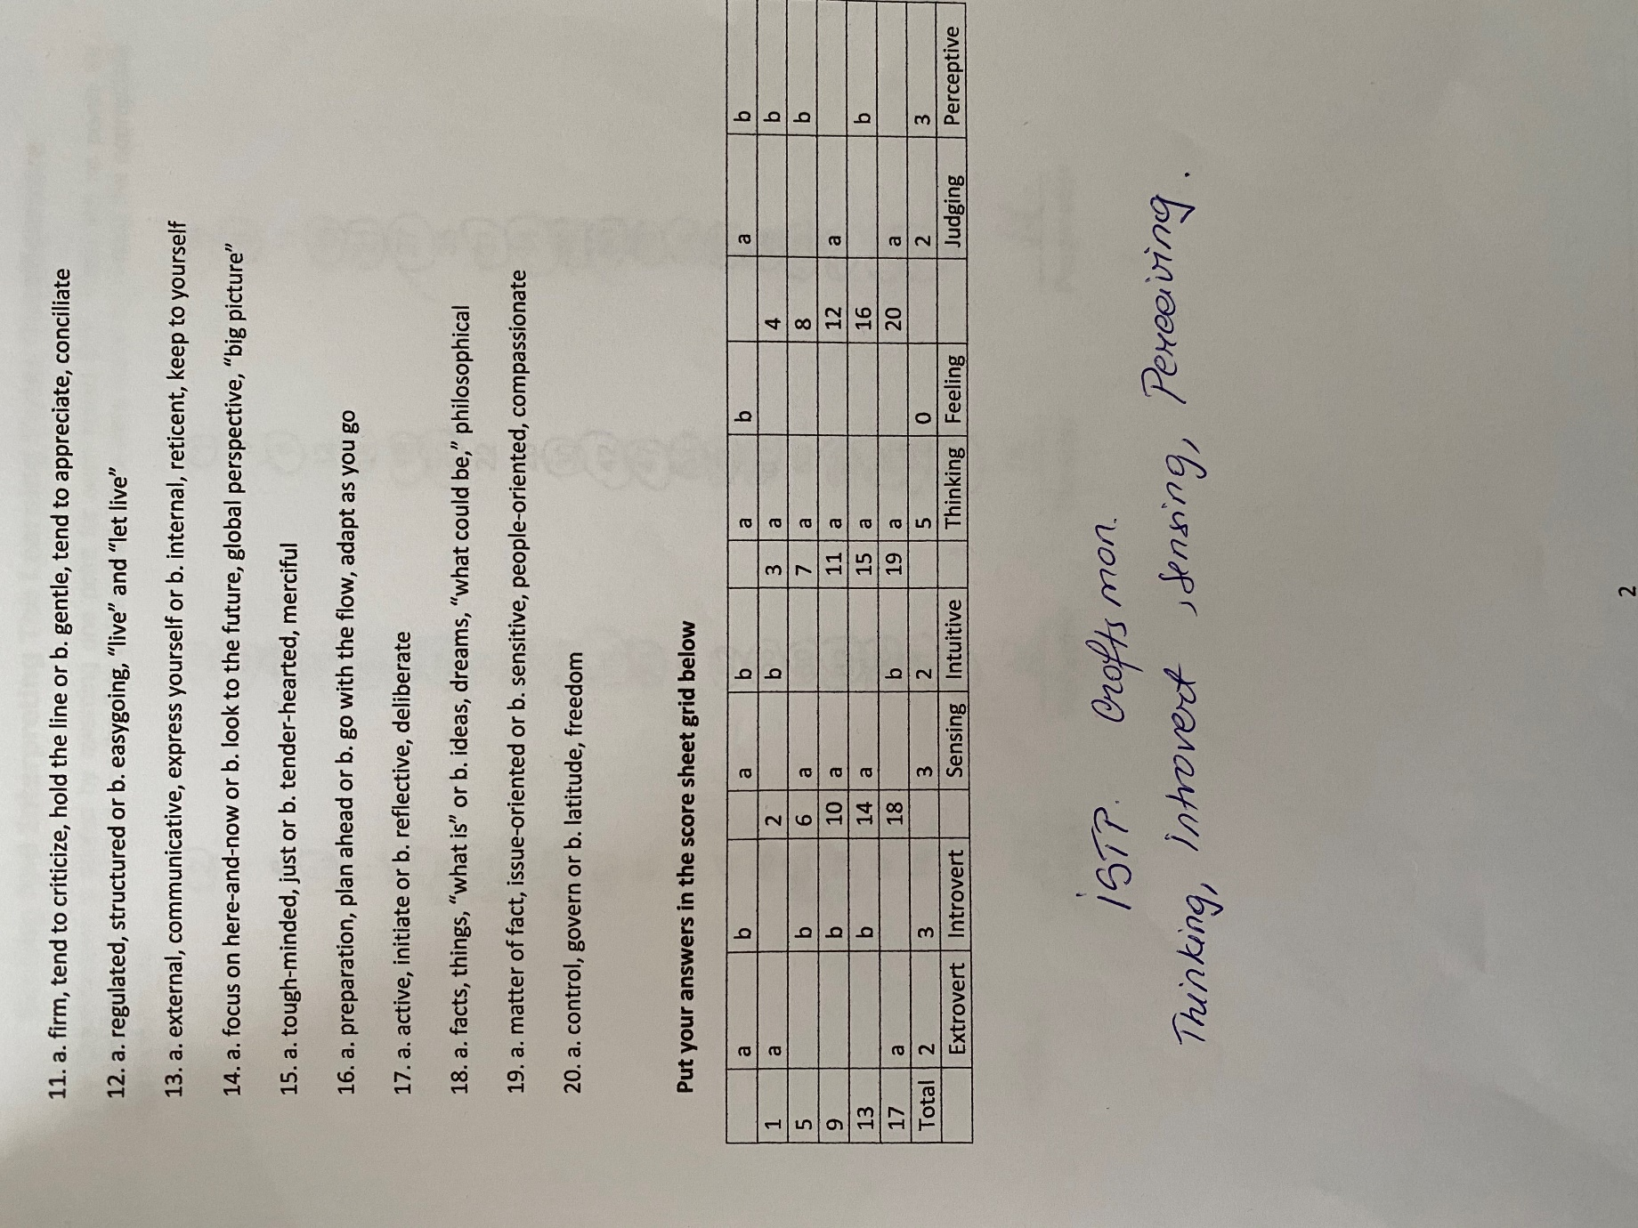
  - The Honey Mumford Learning questionnaire:


