BIM AS A WHOLE LIFE PROCESS AND A BUILDING MANAGEMENT TOOL

BETHAN STROUD
1702210

Tutor: Gavin Traylor
Module: Construction Technology and BIM
Contents
(A)
1.0 - Introduction 3
1.1 - What is BIM? 3
1.2 - BIM Programs 3
1.3 - BIM and it’s Uses 3
2.0 - UWTSD SA1 Campus 3
2.1 - BIM within the Project 4
3.0 - Technical Clash Detection 4
3.1 - Issue Tracker 4
3.2 - Issues Identified 4
4.0 - Improvements 6
(B)
5.0 - Facilities Management 6
5.1 - FM Team Discussion 6
6.0 - BIM Integration Throughout the Construction Project 7
6.1 - Skills Gap and Training 7
6.2 - How This Effects the Building 7
7.0 - Improvements and Recommendations 7
(C)
8.0 - New Technologies 8
8.1 - Benefits of New Technologies 8
8.2 - New Technologies and BIM 9
9.0 - How Can the Building be Improved? 9
9.1 - Limitations 9
10.0 - Conclusion 10
11.0 - References 11

1.0 - Introduction

During this project, building information modelling software was utilised to assess the defects and clashes within the UWTSD SA1 campus’ recent construction. Throughout this project, the uses, benefits and limitations were also researched to gain a further understanding of the universal usage of BIM and what the industry can do to further employ it. It was also important to find out the opinions of the facilitates management team at the university to find out how they think the building would be more effectively managed. The Author also investigated how the building’s management could be improved, as well as how BIM is specifically useful the university. Research in to arising new technologies in the industry was also carried out, finding out how they can assist in managing a building, its construction and BIM improvements. During this project, the Author worked among a team to import the UWTSD SA1 Campus into a BIM software to undertake the actions described, which will be presented and illustrated during this document.

1.1 - What is BIM?

BIM (Building Information Modelling) is the process of using 3D models of buildings, architecture and engineering details for professionals, and client, to visualise, manage, plan and construct. There are many uses of BIM, which can be utilised by a variety of professionals. This includes, engineers, architects, facilities managers and many more. According to AutoDesk, BIM is “a process that begins with the creation of an intelligent 3D model and enables document management, coordination and simulation during the entire lifecycle of a project” (AutoDesk, 2020). The 3D models allow improved visualisation of dimensions, possible errors and build sequencing, which 2D drawings could not provide. This collaborative tool allows increased co-ordination and constancy throughout the entire project, which all professionals can employ.

1.2 - BIM Programs

Within the industry there are many programs and softwares which provide BIM. These softwares include AutoCAD, Sketch-up, Revit and Revizto. During this project, Revizto has been utilised as it is a cloud based program, easily accessible by all members of the team. This is effective for easy accessibility and creating amendments which the whole team can view.

Differing BIM programs include Matterport, which acts like a ‘dollhouse’ to view a 3D model of a building. This is particularly used among real estate, especially due to Corona-Virus as a non-physical viewing.

1.3 - BIM and it’s Uses

BIM is not only utilised for 3D visualisation and collaboration, but can be used for model based cost estimation, clash detection and defects, build sequences, better pre-fabricaiton planning, health and safety, and handover planning. BIM can manage almost every aspect within a project, as well after before and after, resulting in every phase utilising the software. This can allow inefficiencies to be extracted, increasing productivity for all parties. “While BIM is mostly associated with design and preconstruction, it absolutely benefits every phase of the project life-cycle, even well after building is completed. Building Information Modelling allows projects to be built virtually before they are constructed physically, eliminating many of the inefficiencies and problems that arise during the construction process.” (Hall, 2018).

2.0 - UWTSD Campus

University of Wales Trinity Saint David had a new campus built in SA1, Swansea, which completed for use in 2018. The IG building and the Y Fforwm library, were to replace the aged building in Mount Pleasant to provide better facilities and a more environmentally building. This project was apart of the £350 million investment in the Swansea Bay Area. “The scheme provided social benefits throughout the construction process by engagement with local schools, recruitment and up skilling and training to individuals. Business opportunities were achieved with local suppliers and contractors.” (Kier, 2018).
2.1 - BIM within the Project

Although it was not apart of the client brief to include BIM, Kier utilised a modelling software to incorporate this in to the project for the contractors benefit. Using a collaborative software would ensure the large team working on this project, could visually understand the £32 million project. The 3D model would illustrate the “Academic Building (Flexi and Tech) 10,109m2 and the Library Building of 2,705m2.” (Kier, 2018), and detect any clashes or technical issues. The 3D models and BIM could be incorporated within the facilities management team to manage the building after handover. At handover, the Revit drawings and IFC files were collated to provide full 3D model of the buildings, which can be used to measure, draw out issues and understand the mechanical aspects of the buildings.

3.0 - Technical Clash Detection

A major benefit of BIM, is that the software can detect clashes in a project at the early stages. This allows the designers to amend issues before construction, which is easier and cheaper than rectifying the building already built. Clashes can be classed as uncoordinated components, incorrectly spaced and conflicting components. This can occur when collating all drawings from engineering drawings, layouts etc., to form the final model, which would more than likely result in some issues arising when overlapping all drawings. However, this could be avoided by creating a BIM Execution Plan (BEP). This will write out procedures and co-ordinate the team, as well as evaluating design decisions to resolve possible clashes. “Running a clash detection scan or report will typically bring up many duplicate instances of the same issue. If a single run of pipework clashes with five beams, it will show as five clashes though, in reality, resolving one issue (the placement of the pipework) will solve all clashes. Reviewing and cancelling these clashes in the design is a key part of the BIM process. As with any automated process these kinds of scans should not be relied upon in isolation and should form part of wider design co-ordination processes.” (McPartland, 2016).

During this project, the team found that collating the Revit files, including Architect, mechanical and engineering, IFC and furniture, would draw out the issues. If the team was to only look at the drawings individually, it would be difficult to identify clashes. Revizto allowed the team to utilise BIM and create an issue tracker.

3.1 - Issue Tracker

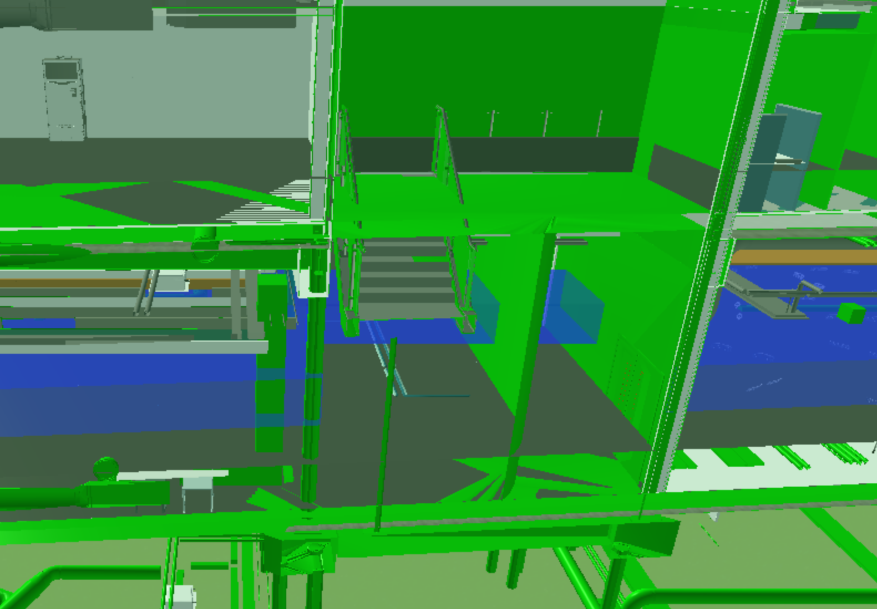
In Revizto, it was possible to create an issue tracker. This would label the clashes which were identified, as well as comment, to identify the specific issue. This would further create a register of these issues, who created it, as well as what the issue is. This collates the information for the team to easily access and extending the collaborative platform for further uses. Each member of the team can access the issue tracker and assess them individually to rectify the clashes.
Revizto Model - Image 1

3.2 - Issues Identified

Within the 3D model of UWTSD SA1 Campus, a few clashes were discovered with the help of BIM and the ability to enter the virtual building. As all the drawings of the building were collated, it was possible to identify items such as overlapping floors or misplaced furniture.

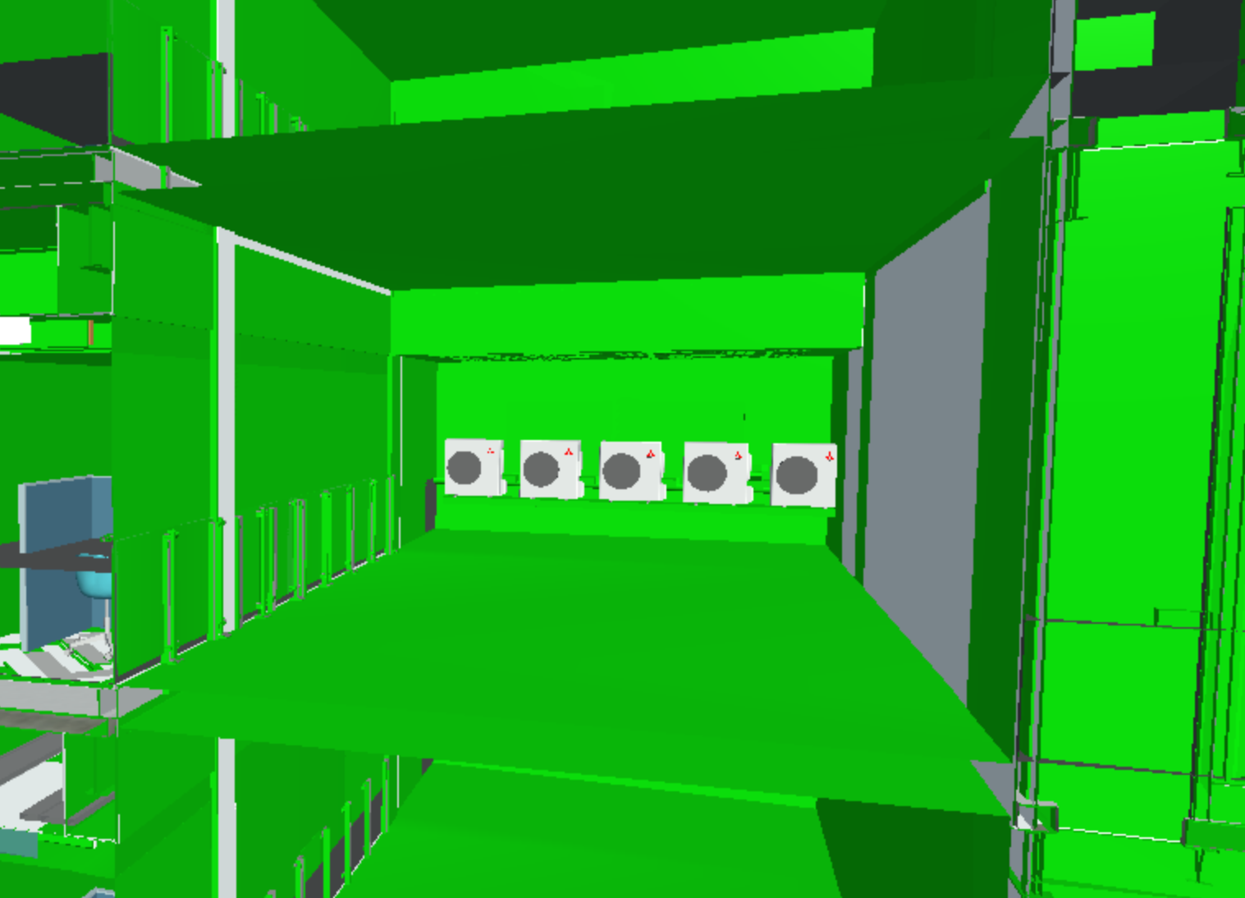
Revizto model - image 1, the team could see a clash where the floor cuts across the stair case within the atrium, as well as an additional wall which is not apart of the construction plans. These clashes cut through the staircase twice, but due to the use of BIM the team can identify these issues and flag it on the issue tracker.
Revizto Model - Image 2
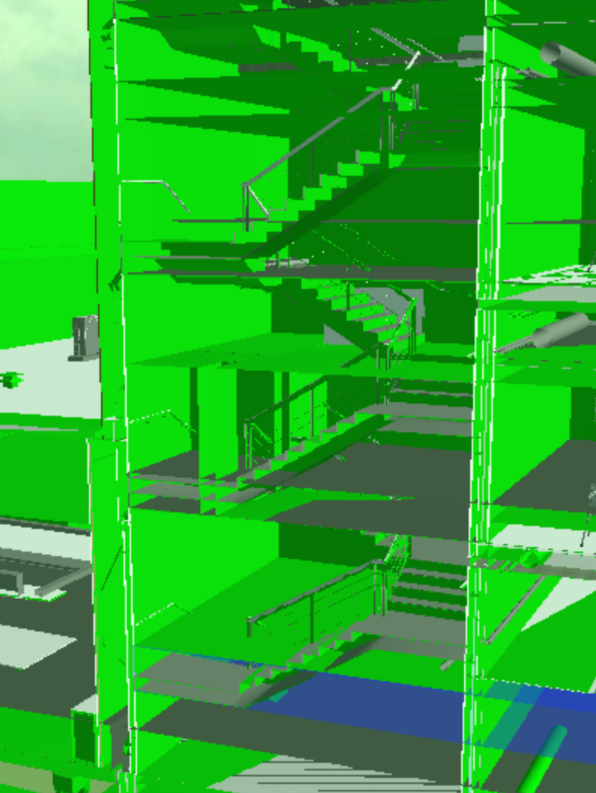
Within image 2, the team can identify mechanical units out of place, along with an additional floor cutting across the void area. The screen shot has been taken within the atrium of the IQ building, showing the units hovering above the reception area within the building.
Revizto Model - Image 3

In image 3 of the Revizto model, the team can identify further flooring and wall issues, showing floors again cutting through staircases. This could be due to the quantity of files imported in to the model, which could cause overlapping, also If dimensions are incorrect it would disrupt the model.

In this instance, the Author believes the IFC files are bringing in additional items, such as creating these floors and walls which do not belong within the building.

4.0 - Improvements

To be able to make improvements within the model of UWTSD SA1 Campus, it would be effective to carry out geometric assessment of the drawing, as well as running a crash detection scran across the model. Softwares such as Revizto can run a scan and pick up clashes within the drawing for the reader to view, however manual checks would need to be carried out. Another way to check measurements would be to manually measure with a laser scanner allowing the team to amend the measurements within the drawings and 3D model of the building. This would improve the accuracy of the measurements and draw out clashes within the building, resulting in reduced errors for the facilities management team.

5.0 - Facilities Management

Facilities management (FM) can include a variety of aspects when running a building. It can include the maintenance of a building, efficiency and operations. Facilities management includes “what are often an organization’s largest and most valuable assets, such as property, buildings, equipment and other environments that house personnel, productivity, inventory and other elements of operation.” (IFMA, 2021). Facilities management also includes the safety of a buildings users, comfort and hospitality. FM can be split in to two sections, hard facilities management and soft facilities management. Hard facilities management would includes assets such as mechanical, plumbing, heating and elevators. Soft facilities management would include aspects such as grounds keeping, catering and security features. Hard facilities management can utilise BIM effectively if used correctly, to manage the mechanical and electrical assets in a building, which would include its repair and finding issues.

5.1 - FM Team discussion

For the team to understand what aspects of BIM are used within the university building, it is important to speak to the facilities management team at the university. When asked if Building Information Modelling should be incorporated among the team during construction stage, they replied “that the maintenance management should have had more input at an early stage. It would have assisted the team in better understanding the benefits of BIM and its uses. The outputs of the system could then have been tailored to suit the requirements of the university. I also believe that BIM training for maintenance staff would have been beneficial” (King, 2021). This would suggest that the facilities management team do not hold the skills or training to utilise BIM to its full potential at the university IQ building since construction has been completed.

When a member of the facilities management team was asked if they have used, or any experience using collaborative software, they answered no. In addition to this, they were asked what opportunities BIM provides in maintaining the campus, to which they responded “I would foresee UWTSD using BIM to develop PPM schedules, monitor product lifecycles and inform the procurement process for the estate department. In further developments, I hope that BIM is used more effectively and made more accessible. This could be achieved by simple training and highlighting the benefits of BIM to the end users.” (King, 2021).

Finally in the discussion, the facilities management team member was asked what challenges arise during the maintenance of the campus, to which they replied “From a user point of view, the training for estates staff on the BMS including troubleshooting could have been improved” (King, 2021).

From these responses, it is clear that there is a large skills gap and lack of training among the facilities management team at the SA1 campus. With the correct training and implementation of BIM, the building could be more effectively managed with the collaborative software.

6.0 - BIM Integration Throughout the Construction Project

It is clear that BIM was highly used throughout the construction project among the contractor and their teams. On handover, there were detailed furniture plans, drawings, IFC files and engineering layouts which were ready to use going forward. The client did not give a BIM brief, and was a contractor led process. The contractor should have advised from the start of the integration of BIM and that the facilities management should be involved with the software, details and training from the start. From the discussions with the facilities management team in the campus, it is clear that there is no training or existing skills in BIM. For the building to run to it’s full effectiveness and efficiency the FM team should be knowledgeable of BIM and make use of the details provided by the contractor. Due to the skills gap and lack of training, it would be difficult to make use of BIM at the university.

6.1 - Skills Gap and Training

It is not news that there is a shortage in BIM skills and training. With the fast paced changes and new technologies within the industry, many will struggle to keep up, or cannot afford to pay for the on-going training and CPD. According to the RICS “The benefits, however, can only be fully experienced when project managers themselves are well-versed on the ins and outs of how BIM works and how it can be used to reach the best result. As an ultimate enabler for effective integration, it is essential for project managers to understand how to harness and operate BIM correctly for their projects.” (RICS, 2019). If BIM is not properly educated to many project managers, how can the end used receive the knowledge of BIM and the final use of the building? This will decrease the true efficiency of the constructed building. The Author questions whose responsibility is it to ensure the facilities management team is educated and knowledgeable with BIM, specifically the most effective way to run the building? The client will not be highly skilled on BIM on most occasions and will not be able to provide training, the contractor will hold the most knowledge of the construction, BIM and how to reach full productivity. “As the construction industry has been through a significant change of the last five years this appears to be congruent with the current loss of skills being experienced.” (Perez, 2017).

6.2 - How This Effects the Building

With the lack of BIM skills and training at UWTSD SA1 Campus facilities management team, it is clear that this will effect the end use of the building and the ability to reach full efficiency and productivity. If the team was correctly skilled to use BIM, all information, possible issues and detailed mapping of the building would be collaborated for the team and easily accessible. This would increase productivity among the team and the building. The building would work to the way it was designed and built to work, possibly saving on maintenance and running costs.

7.0 - Improvements and Recommendations

It would be recommended by the Author that the facilities management team at UWTSD SA1 Campus, should received adequate BIM training to increase their skills and usability of the programs. It would be beneficial for all users involved, including budgeting, personal CPD and productivity of the building. Using and understanding programs such as Revizto, would ensure the team to make use of the files and drawings which Kier provided at handover. It will reduce issues, risks and manage the building effectively like it was designed to do. Admittedly, BIM is still a new and progressing program, however it is universally used and would be unchallenging to obtain constructive training.

8.0 - New Technologies

The construction industry is continually changing and improving technology. BIM is still seen as a new technology, with new softwares, programs and uses. Other new technologies however, include Artificial Intelligence (AI) and Machine Learning (ML). Artificial Intelligence is meant to mimic human behaviour, meaning that the AI will use predictive design and taking more factors in to account what designing a building, reducing human error. This can increase the usage and lifetime of a building. Machine Learning is a type of AI, where a computer can learn from multiple pieces of data. “Using AI driven automation to take over highly repetitive tasks could significantly improve productivity and increase safety, whilst addressing the industry’s shortfall of labour.” (UK Connect, 2020). The information from the AI and ML can also be used within BIM, creating to ability to have a 3D model of what the artificial intelligence has designed.

Drones and robotics are another merging technology within the industry. Already, drones are used to measure and take photographs of sites, but there are other possible uses. “Drones can be used for site safety; they can monitor sites and with the use of cameras be used to identify any danger areas and give a construction manager a quick view of the site without himself being physically present” (UK Connect, 2020). It could also warn off trespassers, alarm and lighting systems for increased security. As construction sites get smarter, the technology which is being used needs to also. This would include the use of robots, which can work more efficiently and reduce errors, while increasing the quality of work.

Another new technology beginning to increase usage is virtual reality (VR) technology. By using virtual reality, it would allow the construction industry to fully visualise a building and its construction, features and finding defects. “Potentials of VR/AR technologies in conjunction with BIM technology are endless. First step would be to create a building model with BIM technology and then to take a sight-seeing and literally walk through and around it” (UK Connect, 2020). This would also be great for the client to see the final design of a building and ability to make changes.

8.1 - Further benefits of New Technologies

Artificial Intelligence and Machine Learning have many benefits, including “Better financial planning and project management – using historical data, AI is able to predict any cost overruns, realistic timelines and can also help staff access information and training material faster to reduce on-boarding times” (UK Connect, 2020). Depending on the payback of the AI and ML, it would create a saving across various projects which it can be utilised. However, with the increased production of AI in the future, it is possible that they may be as common as having a computer. Increased safety is another benefit of artificial intelligence and machine learning, “Construction workers are killed on the job five times more often than other labourers. With the use of AI, sites can be monitored for safety hazards, using photos and recognition technology to tell if a worker is wearing the correct PPE or by using geo-location to identify danger areas and alerting workers.” (UK Connect, 2020).

Other benefits of drone and robot technology would be “to deliver materials to site, reducing the number of vehicles required on site”, as well as “Bricklaying and masonry are tasks in which robots can be used improving the speed and quality of the work” (UK Connect, 2020).

There are many benefits of virtual reality technology within the construction industry, especially the ability to increase collaboration with BIM, which is widely recognised. Another benefit would be “real-time design feedback – visualisation of 3D projects and their surrounding environment provided by AR/VR technology support fast and precise simulation of architectural or structural changes [BR], automatic measurements and enables design improvements.” (UK Connect, 2020). This would be especially helpful for the client and stakeholders to make amendments. “Risk assessments (as a demanding and sensitive activity), reinforced with hazard simulations and clash detections became a routine task encompassed by these innovative technologies” (UK Connect, 2020).

8.2 - New Technologies and BIM

As discussed, there are multiple new technologies which can be highly collaborative with BIM. The Author believes the easiest technologies to integrate would be artificial intelligence and virtual reality. With artificial intelligence, it would be possible to link VR and BIM to an AI’s design. This would provide three stages of eliminating error and checking for deficits or clashes. It would bring BIM to a different level of collaboration and management, additionally management of risk and resources. An example of artificial intelligence within the construction industry would be Mamou-Mani architects, who designed the Polibot in London. “a construction robot which follows blueprint plans. What makes it ‘intelligent’ is its ability to ‘see’ and mistakes, such as placing building blocks out of line, then correct them.” (O’Malley, 2020).

9.0 - How Can the Building be Improved With New Technologies?

Within the UWTSD SA1 Campus, new technologies could have an effective benefit on the running of building. Of course, the first step would be to correctly integrate BIM in to the building and the facilities management team as it is still not used properly, but advancing on this technology would be to collaborate with artificial intelligence. AI would be able to assess the building from the ‘inside’, with the ability to correct the issues by itself, or to notify the facilities management team of the problem. It would be helpful for the artificial intelligence to direct the staff of the management team to the right item or issue at the right time, especially having an untrained team managing the university building. This technology is of course uncommon at this point in time, very expensive and would be almost impossible to get hold of to integrate in to a small university building, however with the correct training in BIM, the management team would be capable of collaborating with ‘smart home’ technology. This would include more responsive sensors, computers and feedback from thee building. An example of this would be a bioclimatic home, but amalgamated in to a larger concept such as the UWTSD SA1 Campus.

9.1 - Limitations

A significant limitation would be the possible job losses if the university employed artificial intelligence technology to manage the facility. With the staff being unskilled and not as productive as artificial intelligence, there would no longer be requirements for a whole team of people, but rather a small amount to take on tasks which the AI or robotics cannot complete. Another limitation for artificial intelligence would be computing time, “Even though technological advancements have been rapidly extending in recent years, there are still some hardware limitations like limited computation resources (for RAM and GPU cycles) that we have to overcome. Here again, established companies have a significant advantage, given the costs that arise from developing such custom and precise hardware” (Shishir, 2020). Of course this would be more difficult, and expensive, for a small university to acquire and run, more so in the early stages of artificial intelligence. Of course, the cost being a major setback in these times due to the lack of production and AI being in the early stages. “Also, given that skilled engineers in these fields are currently a rare commodity, hiring them will definitely dent the pockets of these companies. Here too, putting newer and smaller companies at a disadvantage.” (Shishir, 2020).

At this point in time, a major limitation with integrating smarter home technology would be the lack of skills and knowledge a long the facilities management team. Without the important training and skills progression, the university building will not be able to increase productivity and work to it’s full usage and capacity like it was designed to do. It would be very difficult to introduce newer and more complicated technologies. Another limitation of increased technologies would be security issues, for example “burglars could hack into your smart home system and open the lock in order to get access to your home. Moreover, hackers may also steal your data” (Gebbia, 2020).

10.0 - Conclusion

To conclude the work carried out by the team and research carried out by the Author, it is important to highlight the importance in receiving the appropriate training and knowledge to manage a building, with the ability to utilise BIM to it’s full potential. As previously recommended, it would be useful for the team to complete training to be able to use BIM correctly to make use of the collaborative platform. The facilities management team would be able to utilise items such as the issue tracker and geometrically assessing the 3D model. With the continually progressing industry and new technologies arising each year, such as drones, robotics and artificial intelligence, it is important for the facilities management team at the UWTSD SA1 Campus to keep up to dates with aspects of BIM to easily collaborate with arising technologies which will increase productivity and effectiveness while running a building.
11.0 - References

- Annalise O’Malley, 2020, 7 game-changing innovations in construction technology since 2010, www.planradar.com/gb/innovations-in-construction-technology/ [Last visited 22/02/21].
- AutoDesk, 2020, What is BIM?, www.autodesk.com/solutions/bim/benefits-of-bim [Last visited 20/02/21].
- IFMA, 2021, What is Facility Management?, www.ifma.org/about/what-is-facility-management [Last visited 20/02/21].
- Joe Gebbia, 2020, 30 Key Pros and Cons of Smart Homes, www.environmental-conscience.com/smart-homes-pros-cons/ [Last visited 23/02/21].
- John Hall, 2018, Top 10 Benefits of BIM in Construction, www.bim360resources.autodesk.com/connect-construct/top-10-benefits-of-bim-in-construction [Last visited 20/02/21].
- Kier Construction, 2018, Swansea IQ and Y Fforwm Development (SA1), www.kier.co.uk/our-projects/swansea-iq-and-yfforwm-development-sa1/ [Last visited 20/02/21].
- Perez, 2017, Addressing the #BIM skills gap and education – Whose responsibility is it?, www.addd.io/2016/12/20/addressing-the-bim-skills-gap-and-education-whose-responsibility-is-it/ [Last visited 21/02/21].
- Richard McPartland, 2016, Clash Detection in BIM, www.thenbs.com/knowledge/clash-detection-in-bim [Last visited 20/02/21].
- RICS, 2019, The BIM Skills Shortage, www.rics.org/mena/news-insight/latest-news/news-opinion/the-bim-skills-shortage/ [Last visited 20/02/21].
- Shishir, 2020, 6 Biggest Limitations of Artificial Intelligence Technology, www.hackernoon.com/the-missing-pieces-6-limitations-of-ai-s85r3upr [Last visited 22/02/21].
- UK Connect, 2020, 10 Construction Technology Trends 2020, www.ukconnect.com/construction-technology-trends/ [Last visited 21/02/21].
- Tracey-Anne King, 2021, CONSTRUCTION TECHNOLOGY AND BIM QUESTIONNAIRE.

