
Paulin Bijou Banza
2213374


Module: Usability Engineering
Title: User Requirement and Prototype
28th November 2025

Table of Contents
1. Introduction 2
2. Personas and User Experience Requirements (ILO1, ILO3, ILO4) 2
Persona 1: Sarah Jones – Undergraduate Gamer 2
Persona 2: David Williams – Mature Part-time Student (Age 46, Lampeter Campus) 3
Persona 3: Amina Khan – Disabled Student (Age 23, Carmarthen Campus) 3
Persona 4: Mark Evans – Lecturer in Computing (Age 38, Swansea/Lampeter) 3
Summary of Key User Experience Requirements 4
3. Design Rationale for the Story 4
4. How to Design for Usability? 4
4.1 Visibility and System Status 5
4.2 Reduction of Cognitive Load 5
4.3 Consistency 5
4.4 Accessibility 5
5. UWTSD CLUEDO – Full Story Game 5
5.1Game Mode Selection 6
5.2 Single Player Level List 6
5.3 Multiplayer Lobby 6
5.4 Create or Join Room 6
5.5 Character Select 6
5.6 Settings Menu 7
5.7 Campus Map 7
5.8 Clue Log 7
5.9 Accusation Screen 7
STEP 1: TITLE SCREEN 7
STEP 2 — SELECT GAME MODE 8
STEP 3 — SINGLE PLAYER → LEVEL SELECT 9
STEP 4 CHARACTER SELECT SCREEN 10
STEP 5 CAMPUS MAP SCREEN 11
STEP 6 LOCATION STORY EPISODE 12
STEP 7 CLUE LOG SCREEN 12
STEP 8 STORY PROGRESSES BY LEVEL 13
LEVEL 1 Highlights (Library) 13
LEVEL 2 Highlights (Carmarthen Old Building) 14
LEVEL 3 Highlights (Lampeter Quad) 14
STEP 9 MULTIPLAYER LOBBY FLOW 15
STEP 10 ACCUSATION SCREEN 15
STEP 11 STORY ENDINGS (Multiple Outcomes) 16
6. Feedback From Prototypes 17
7. Appendix A: MoSCoW Prioritisation of Requirements 18
Table for MoSCoW Prioritisation of Gameplay and UX Requirements 19
Must Have – Essential for Core Functionality 19
Should Have – Important but Not Critical for Initial Release 19
Could Have – Enhancements for Future Versions 20
8. Conclusion 20
9. References 21

New In-Game Persona for CLUEDO Gameplay Context

1. Introduction
This report presents the initial design, user research, and prototype development for UWTSD CLUEDO, a mobile adaptation of the classic board game CLUEDO, reimagined for the University of Wales Trinity Saint David (UWTSD). The design of games that emphasise mystery and deduction requires careful attention to cognitive load, visual clarity, and user journey management, in line with established usability frameworks such as Norman’s theory of affordances and feedback [1].
Personas are widely recognised within user-centred design practices as tools that model user motivations, goals, and challenges [2]. In a narrative game, personas also help ensure characters match user expectations, strengthen immersion, and provide context-aware support.
The game’s persona system was directly influenced by feedback from potential users. Students expressed the need for ideal guidance, accessible visuals, and UI feedback loops to help understand objectives. Research indicates that embedding guidance within gameplay, as opposed to instructional overlays, improves learning and reduces cognitive load [3].
The result is a tailored in-game persona that enhances usability, narrative depth, and player immersion. The persona acts as an anchor between story, gameplay, and interface, ensuring that the UWTSD CLUEDO adaptation remains intuitive, engaging, and representative of campus culture.

2. Personas and User Experience Requirements (ILO1, ILO3, ILO4)
The personas developed in this project reflect a user-centred design approach, rooted in established persona methodology [2], [4]. Personas were informed by real feedback collected from UWTSD students and staff. Different user types highlight how players interact with the app depending on their abilities, goals, and level of gaming familiarity.

For example, Persona 2 (mature student) requires reduced visual noise, higher contrast, and slower task flows—reflecting perceptual load principles described by Johnson [5]. Persona 3 (motor impairment) highlights the need for high accessibility and alternative interaction patterns, consistent with WCAG guidance [6] and universal design in higher education [7].

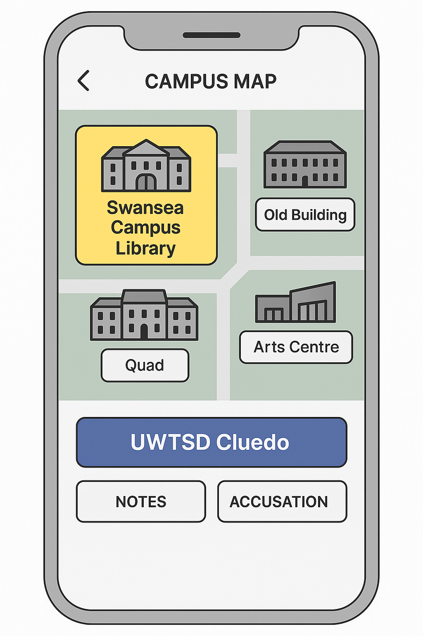
.

Persona 1: Sarah Jones – Undergraduate Gamer
- Age: 20
- Campus: Swansea SA1
- Background: Computer Games Design student
- Scenario: Plays with friends after class; values fun, fast-paced gameplay.
- Main Requirements:
- Quick navigation, responsive UI
- Clear visual icons and minimal text
- Smooth multiplayer functionality
- Light-hearted humour and campus references

Persona 2: David Williams – Mature Part-time Student (Age 46, Lampeter Campus)
- Profile: Studying Theology part-time while working; prefers simple, low-distraction interfaces.
- Scenario: David plays in single-player mode during commutes.
- Experience Requirements:
  - Easy-to-read text and larger buttons.
  - Accessible color contrast for readability.
  - Optional tutorial explaining the game rules clearly.
  - Offline functionality preferred.

Persona 3: Amina Khan – Disabled Student (Age 23, Carmarthen Campus)
- Profile: History student with motor impairment using assistive input devices.
- Scenario: Amina enjoys games with strong narrative and accessible controls.
- Experience Requirements:
  - Full keyboard and switch-access compatibility.
  - Adjustable text size and color contrast.
  - Audio narration and captions for all text.
  - Simple gesture-free interactions.

Persona 4: Mark Evans – Lecturer in Computing (Age 38, Swansea/Lampeter)
- Profile: Uses games for teaching problem-solving and logic.
- Scenario: Uses UWTSD CLUEDO in a class activity to demonstrate reasoning.
- Experience Requirements:
  - “Classroom Mode” for group play.
  - Save and resume sessions.
  - Educational overlay explaining logic deduction.
  - Stable cross-platform access (web + mobile).

Summary of Key User Experience Requirements
- Accessibility (visual, motor, and cognitive).
- Simple navigation and clear iconography.
- Multiplayer and solo options.
- Engaging storyline rooted in UWTSD identity.
- Inclusive humour and representation of all campuses.

3. Design Rationale for the Story
The story structure follows a classic game design ontology where systems, rules, and player actions form an emergent mystery-solving experience [8]. Each level increases complexity, so the player can process clues in manageable increments following Shneiderman’s progressive disclosure principle [9].
Replayability is supported through branching endings and varied clue distribution, consistent with game engagement models emphasised by Juul [10].
Furthermore, embedding narrative and instructional content into the actual game world aligns with Gee’s theory that games are “situated learning environments,” not passive instruction [3].

4. How to Design for Usability?
Usability has been a central design principle of the UWTSD CLUEDO application. The game is intended for a wide range of users, including undergraduate students, mature learners, staff members, and players with accessibility needs. Therefore, the interface prioritises low cognitive load, accessibility, clarity of interaction, and consistent navigation. These principles were implemented at both the gameplay and UI levels to ensure that users can engage with the mystery narrative without frustration.
Usability design was driven by heuristics from Nielsen’s 10 Usability Principles [11] and Norman’s cognitive model of interaction [1].

4.1 Visibility and System Status
Interface screens are clearly titled, and buttons signal purpose, as recommended by Norman [1]. This reduces ambiguity and increases player confidence.

4.2 Reduction of Cognitive Load
Humans hold limited working memory when interpreting visual information [5].
Therefore:
- Only one key task appears per screen
- Clues are externalised into a Clue Log rather than memorised
This matches the guideline “recognition over recall” [11].

4.3 Consistency
Layout, buttons, and iconography repeat across screens. Consistency and standards reduce confusion and improve learnability [11].

4.4 Accessibility
Specific UI elements are adapted using WCAG principles:
- Minimum button size
- Colour contrast ratio
- Multiple modes of presentation (text, icon, dialogue)
This follows universal design guidelines for educational environments [7].

5. UWTSD CLUEDO – Full Story Game
Wireframes are intentionally grayscale to emphasise interface structure instead of artistic colour.
This aligns with Tidwell's recommendation to prototype interaction patterns first and visual design second [12].
Each storyboard screen meets a unique usability goal:
- Title Screen → onboarding
- Mode Select → reduces complexity to two choices
- Map → spatial grounding
- Clue Log → memory offloading
- Accusation Screen → decision point with error prevention
Preventative design helps avoid irreversible user mistakes [11].

5.1Game Mode Selection
- Options: Single Player, Multiplayer
- Icons reinforce understanding
- “Back” button at screen base

5.2 Single Player Level List
- Levels 1–4 presented as selectable cards
- Selected level highlights
- Continue and Back buttons

5.3 Multiplayer Lobby
- Player list with Ready/Not Ready states
- Host-only “Start Game” button
- Chat and Leave Lobby options

5.4 Create or Join Room
- Two clear cards: Create Game / Join Game
- Map selection and player count

5.5 Character Select
- Four selectable roles
- Avatar icons and name labels
- Continue button

5.6 Settings Menu
- Toggles for sound, notifications
- Language dropdown

5.7 Campus Map
- Interactive grid of UWTSD buildings
- Notes and Accusation shortcuts

5.8 Clue Log
- Notebook-style layout
- Scrollable list of clues
- Buttons for Map and Accusation

5.9 Accusation Screen
- Dropdowns for suspect, weapon, location
- Submit and Cancel buttons

STEP 1: TITLE SCREEN
Screen Purpose: Introduces the player to the mystery.
Text/Narrative:
“The Vice-Chancellor has been found dead in mysterious circumstances.
Something is terribly wrong across campus…”
Buttons:
- Start Game
- Settings
- Exit
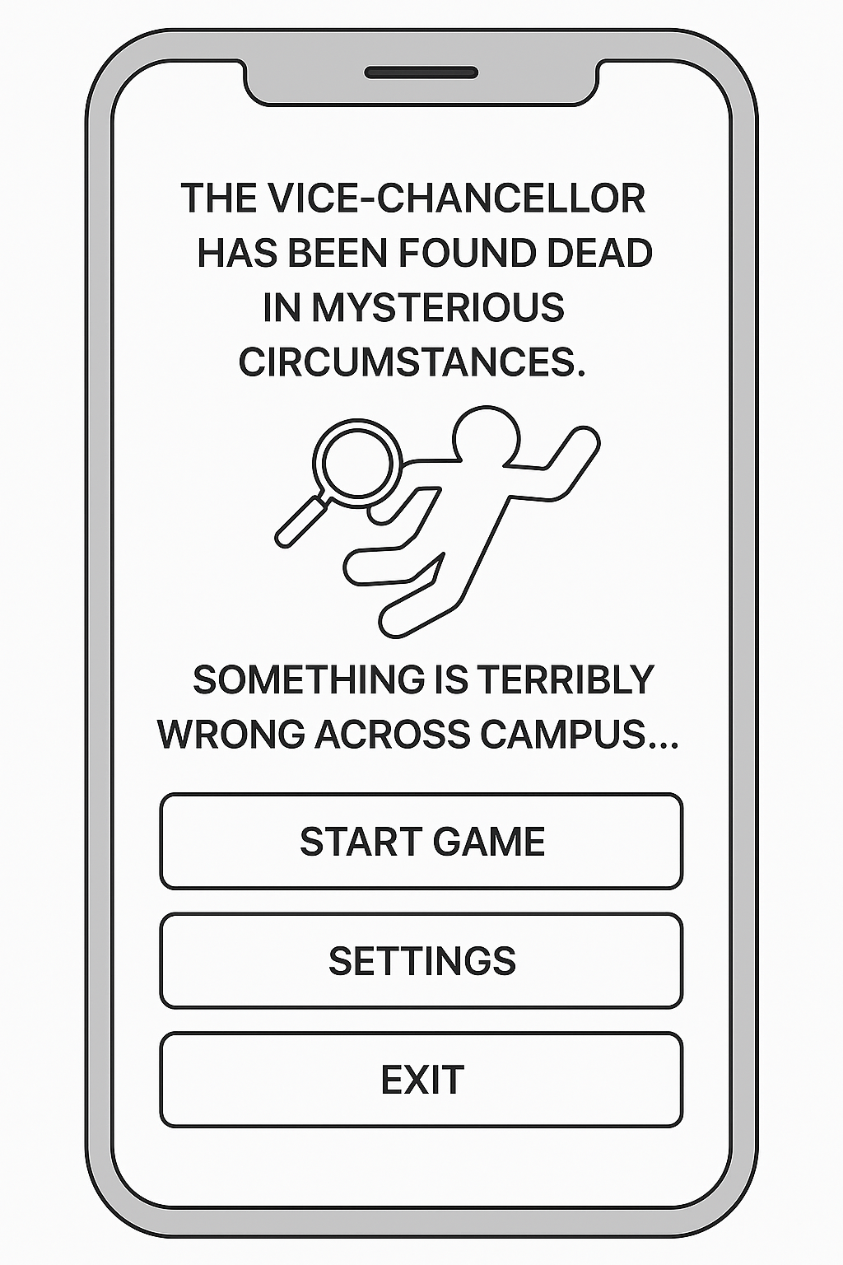

STEP 2 — SELECT GAME MODE

Screen Title: UWTSD CLUEDO
Subtitle: Select Game Mode
Buttons:
- Single Player — Solve the mystery at your own pace
- Multiplayer — Play with 2–8 players online
- Back
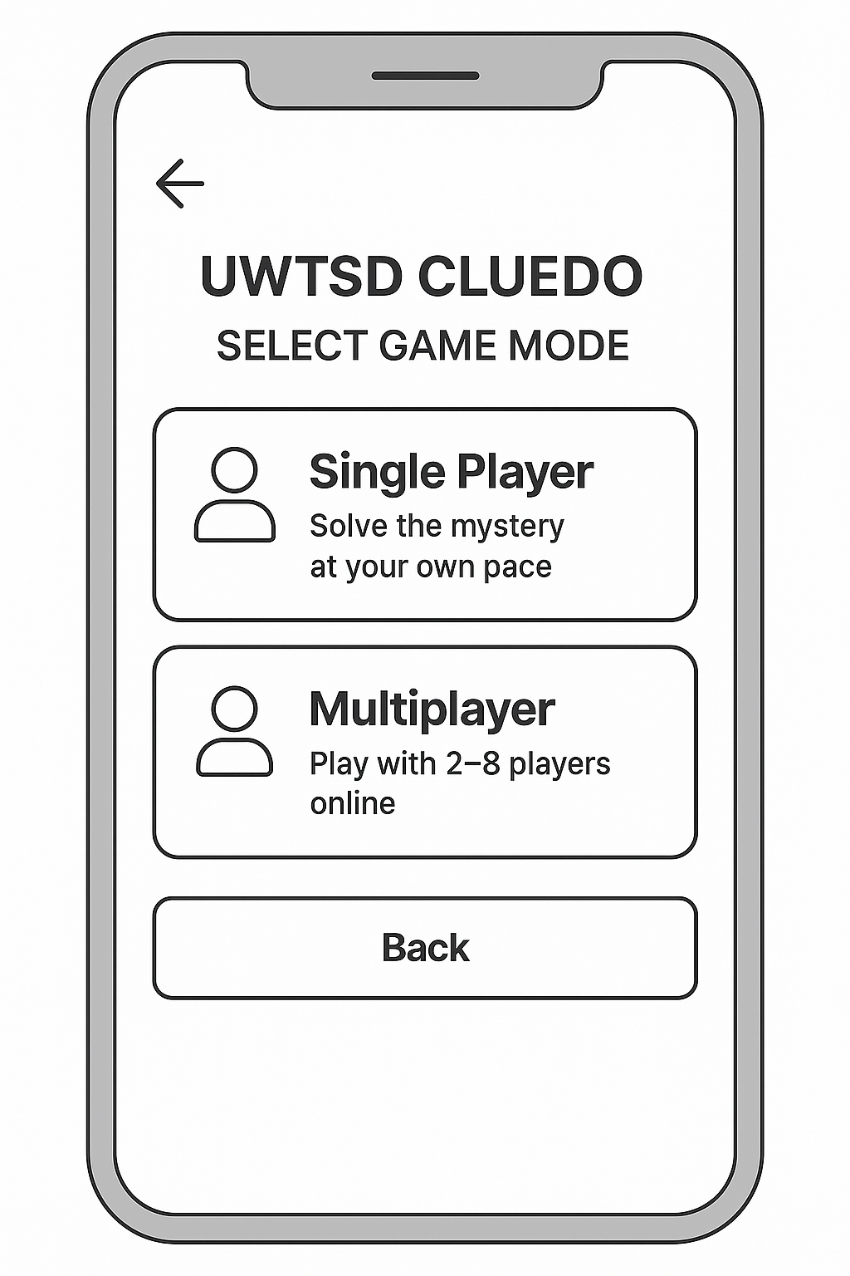

STEP 3 — SINGLE PLAYER → LEVEL SELECT
Story Setup:
The player chooses where the investigation begins.
Levels:
- Swansea Campus — Library
Starting point: discover first clues
- Carmarthen — Old Building
Interview staff, gather motive clues
- Lampeter — Quad
Explore outdoor locations, find hidden evidence
- Final Accusation Chamber
Compile all clues, identify the killer
Button: Continue
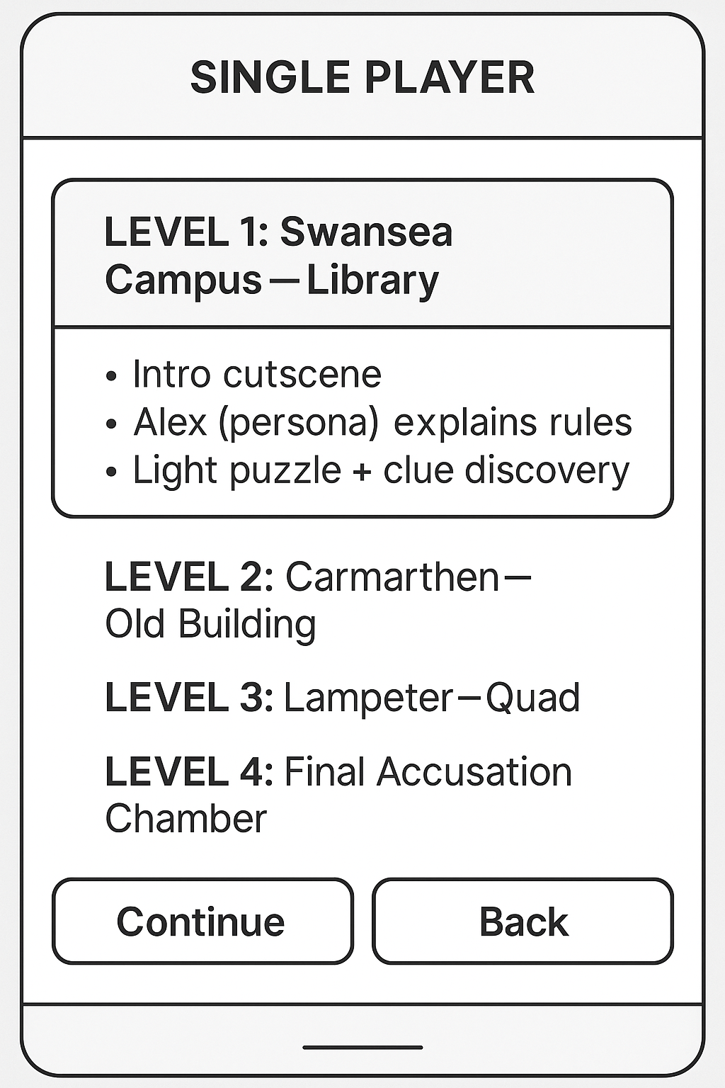

STEP 4 CHARACTER SELECT SCREEN
Narrative:
Before the investigation begins, the player chooses a persona to accompany them.
Characters:
- Alex Morgan — Student ambassador, calm and analytical
- Priya Patel — Journalism student, asks sharp questions
- Dan Wright — Computing student, logical thinker
- Dr. Jones — Lecturer, knows the university well
Button: Continue

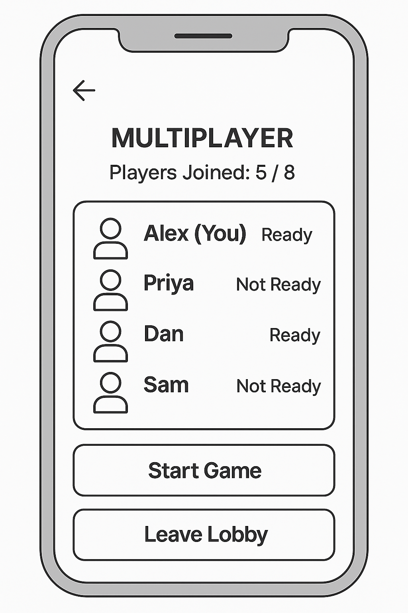

STEP 5 CAMPUS MAP SCREEN
Narrative:
The player can now explore real UWTSD campus locations.
Tap to Enter Locations:
- Swansea Library
- Old Building
- Arts Centre
- Quad
Game Buttons:
- Notes (opens clue log)
- Accusation

STEP 6 LOCATION STORY EPISODE
Each location contains:
- Characters to interview
- Items to inspect
- Clues to collect
Story Example:
You enter the Swansea Campus Library.
Alex (your assistant persona) says:
"Students reported a loud argument here earlier. Let's investigate quietly."
Clues Found:
- Torn timetable
- Vice-Chancellor’s missing planner
- Suspicious message on a sticky note
These clues auto-sync into the Clue Log.

STEP 7 CLUE LOG SCREEN
Each clue appears as a card:
- “Dr. Green’s alibi is unconvincing.”
- “A dressmaker’s dummy was discovered.”
- “A knife is missing from the canteen.”
Buttons:
- Campus Map
- Accusation
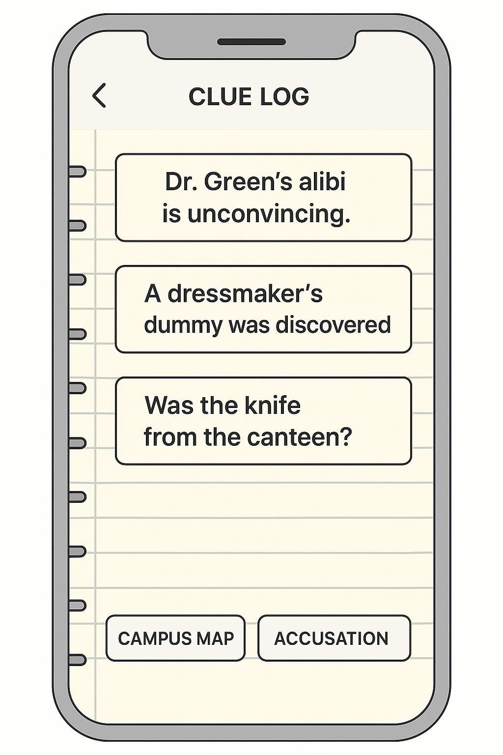

STEP 8 STORY PROGRESSES BY LEVEL

LEVEL 1 Highlights (Library)
- You overhear librarians discussing an argument
- You find a timetable that doesn’t match Dr. Green’s alibi
- Alex notes inconsistencies for you
Swansea Library
Librarian NPC:
- “I heard arguing near the study room — it was heated.”
- “This planner… it belonged to the Vice-Chancellor.”
- “Someone left this note. It looks rushed.”
Alex:
- “This timetable doesn’t match Dr. Green’s alibi. Interesting.”

LEVEL 2 Highlights (Carmarthen Old Building)
- Interview two staff members
- Find evidence of a forced drawer
- Discover motive elements: budget cuts, faculty dispute
Dr. Evans:
- “We… we had disagreements with the Vice-Chancellor. Over budgets.”
- “I didn’t break into that drawer! I found it like that.”
Admin Staff NPC:
- “Someone was in here late last night. Couldn’t see who.”
Alex:
- “This broken drawer worries me. Someone was looking for something.”

LEVEL 3 Highlights (Lampeter Quad)
- Hidden item under the bench
- A false trail planted by someone
- Witness notes strange behaviour the night of the murder
Gardener NPC:
- “I saw someone by that bench last night. Didn’t recognise them.”
- “People drop strange things around here.”
Student NPC:
- “I swear I saw the missing knife earlier near the Arts Centre.”
Alex:
- “All of this is starting to form a pattern…”

STEP 9 MULTIPLAYER LOBBY FLOW
(From your wireframes)
Players join and set their status to “Ready”.
Story Integration:
In multiplayer, you compete to solve the mystery first or collaborate to uncover clues faster.
Buttons:
- Start Game (Host only)
- Chat
- Leave Lobby
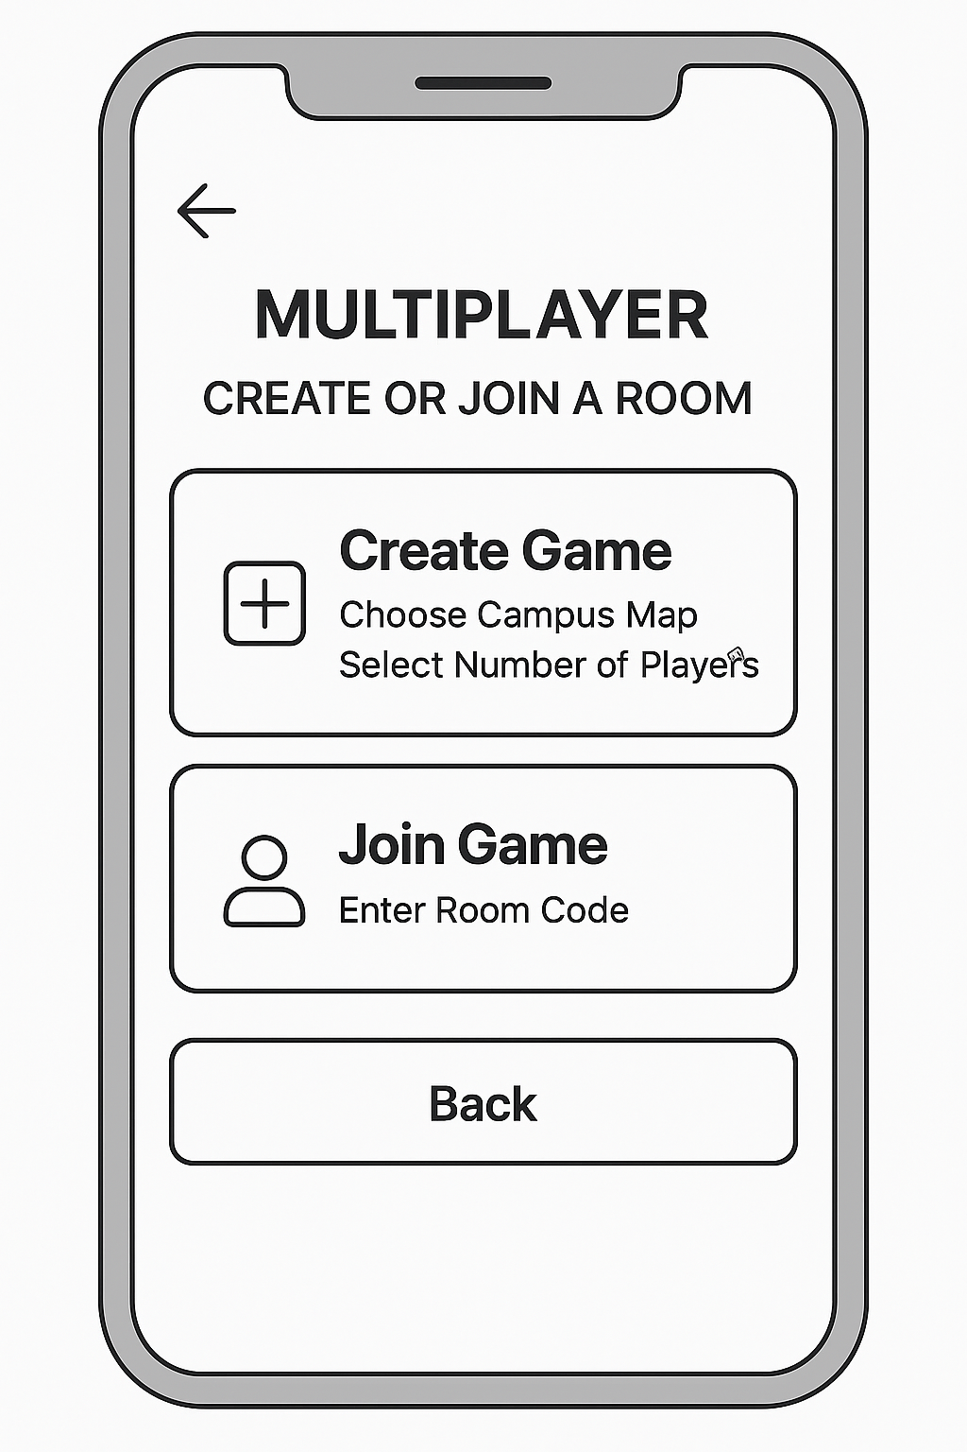

STEP 10 ACCUSATION SCREEN
When enough evidence is collected, the player builds:
- Suspect
- Weapon
- Location
Example Choices:
- Suspect: Prof. Plum
- Weapon: Wrench
- Location: Swansea Campus Library
Buttons:
- Submit
- Cancel
Narrative Purpose: Deduction and final decision-making.
Story:
Alex leads you to a quiet, dimly lit room. All clues are laid out logically in your notebook.
“You’ve gathered everything you need,” Alex says. “Now think carefully — everything depends on this.”
Key Events:
- Player selects: Suspect + Weapon + Location
- Submit accusation
- Receive GOOD or BAD ending depending on correctness

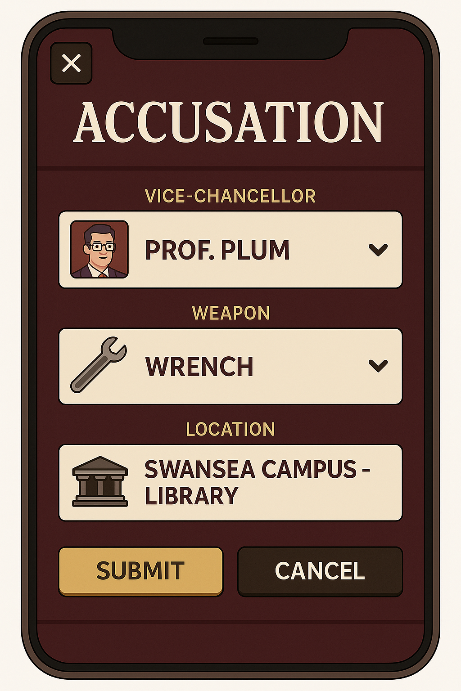

STEP 11 STORY ENDINGS (Multiple Outcomes)
Correct Accusation Ending
Alex says:
"You solved it! All the evidence pointed to Prof. Plum. The Vice-Chancellor’s case is finally closed."
You see a final animation + score.

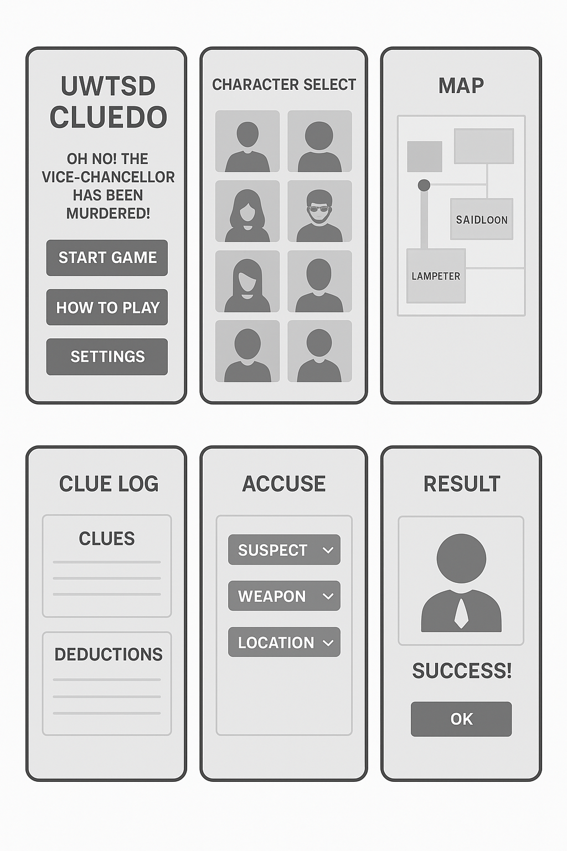

6. Feedback From Prototypes
User feedback influenced several revisions:
- The accusation screen felt “too serious” → redesigned with softer UI elements
- Accessibility toggle buried in settings → moved to upper layers
- Players wanted deception options → multiplayer features extended (future work)
The iterative feedback process follows the design–test–improve cycle recommended in UX research [4], [12].
.

Positive Feedback
- “Feels like a real UWTSD mystery game.”
- Icons and wireframes are easy to understand
- Map screen is “fun and simple.”
- Clue log format is intuitive
Negative Feedback
- Some wanted brighter colours (future work)
- Accessibility toggle is too hidden
- The accusation screen felt “too serious” compared to the rest of the app
- Character selects: “More diverse character options needed”
Emotional Response
- Described as “engaging,” “fun,” and “campus relatable”
- The humour reinforced the student connection
- Mystery narrative increased curiosity
Unexpected Findings
- Two testers wanted the ability to mislead other players in multiplayer
- One mature student asked for a text-only version for low data use
These responses will influence future revisions.

7. Appendix A: MoSCoW Prioritisation of Requirements

To organise and prioritise the functional and user experience requirements for the UWTSD CLUEDO mobile game, the MoSCoW method (Must, Should, Could, Won’t) was applied. This method allows requirements to be categorized based on their importance to the system's success and their alignment with user needs gathered during interviews, focus groups, and questionnaire data.
The following table summarises the prioritised requirements for the initial prototype.

Table for MoSCoW Prioritisation of Gameplay and UX Requirements

Prioritisation is a standard project management approach to avoid scope overload.
Core functions are labelled Must, user comfort functions are Should, and replay incentives are Could.
Choices like “Clue Log” and “Clean Navigation” support primary user goals [4], while advanced cosmetic features are deferred.

Must Have – Essential for Core Functionality
Requirement | Rationale
Accessible text sizes and high-contrast UI | Ensures compliance with WCAG accessibility standards and supports visually impaired users.
Simple and intuitive navigation | Reduces cognitive load and supports users unfamiliar with mobile games.
Single-player mode | Core to narrative progression and primary game loop.
Multiplayer mode (2–8 players) | Maintains the social deduction aspect of the original CLUEDO.
Clue log and deduction system
  Required to track clues logically and facilitate the accusation process.
Campus-based map navigation | Central mechanic linking gameplay to UWTSD’s multi-campus identity.
Functional back-navigation and error prevention | Supports user control and freedom (Nielsen, 1994).
Onboarding/tutorial guided by persona (Alex) | Guides new or casual players and reduces learning barriers.
Compatibility with low-spec mobile devices | Ensures accessibility across the student population.

Should Have – Important but Not Critical for Initial Release
Requirement | Rationale
Humorous narrative dialogue
  Enhances engagement, aligns with student culture, and increases replicability.
Offline access for single-player mode | Supports students with unstable Wi-Fi or who commute between campuses.
Auto-save and quick-save system | Allows play during short intervals (e.g., between lectures).
Character selection screen
  Improves personalisation and supports role-play.
Distinct non-playable characters (NPC personalities) | Enhances narrative depth and emotional engagement.
Vibration or tactile feedback for discovering clues | Supports multimodal feedback and immersion.
Optional hint system | Supports neurodiverse users and those new to deduction-based gameplay.
Background lore and environmental storytelling | Increases depth of narrative world-building.

Could Have – Enhancements for Future Versions
Requirement | Rationale
Campus-themed mini-games | Adds variety and supports puzzle-based engagement.
Leaderboards for multiplayer sessions | Encourages friendly competition between campuses.
Randomised clues for each playthrough | Significantly increases replicability.
Unlockable cosmetic items (avatars, outfits) | Adds motivation through progression.
Seasonal mystery events (e.g., Halloween edition) | Encourages long-term engagement.
Partial voice lines for major characters | Adds personality but is not essential to core gameplay.
Achievement system (e.g., “Master Detective”) | Supports player motivation and long-term goals.
Day/night aesthetic cycle | Improves environmental feel but is non-essential.

8. Conclusion

This report has documented the early design process for UWTSD CLUEDO, including user research, persona development, usability planning, wireframe storyboards, and prototype testing. Findings emphasise the importance of accessibility, clear navigation, and recognisable university environments. The game successfully merges narrative and interaction design, creating an experience that is both playful and meaningful for UWTSD’s diverse student community.
Future improvements include colour enhancement, additional characters, deeper narrative branching, and improved tutorial guidance. Overall, the project demonstrates strong alignment with user-centred design principles and forms a solid foundation for the next stage of development.

9. References
[1] D. A. Norman, The Design of Everyday Things. New York, NY: Basic Books, 2013.
[2] J. Pruitt and T. Adlin, The Persona Lifecycle: Keeping People in Mind Throughout Product Design. San Francisco, CA: Morgan Kaufmann, 2006.
[3] J. P. Gee, What Video Games Have to Teach Us About Learning and Literacy. New York, NY: Palgrave Macmillan, 2007.
[4] A. Cooper, R. Reimann, D. Cronin, and C. Noessel, About Face: The Essentials of Interaction Design, 4th ed. Indianapolis, IN: Wiley, 2014.
[5] J. Johnson, Designing With the Mind in Mind: Simple Guide to Understanding User Interface Design Rules, 3rd ed. Cambridge, MA: Morgan Kaufmann, 2020.
[6] World Wide Web Consortium (W3C), “Web Content Accessibility Guidelines (WCAG) 2.1,” Jun. 2018. [Online]. Available: https://www.w3.org/TR/WCAG21/
[7] S. Burgstahler, Universal Design in Higher Education: From Principles to Practice, 2nd ed. Cambridge, MA: Harvard Education Press, 2015.
[8] K. Salen and E. Zimmerman, Rules of Play: Game Design Fundamentals. Cambridge, MA: MIT Press, 2004.
[9] B. Shneiderman, Designing the User Interface: Strategies for Effective Human-Computer Interaction, 6th ed. Boston, MA: Pearson, 2016.
[10] J. Juul, A Casual Revolution: Reinventing Video Games and Their Players. Cambridge, MA: MIT Press, 2010.
[11] J. Nielsen, “10 usability heuristics for user interface design,” Nielsen Norman Group, 1994. [Online]. Available: https://www.nngroup.com/articles/ten-usability-heuristics/
[12] J. Tidwell, Designing Interfaces: Patterns for Effective Interaction Design, 3rd ed. Sebastopol, CA: O’Reilly Media, 2020.

