Software Development
Lecturer : Renuga Jayakumar

Student: Crucianu Mircea Alexandru
ID: 2025870

Software Development
Part 1 Understanding 3
Part 2 Understanding 4
Part B Implementation 5
Exercise 1: 5
Exercise 2: 6
Exercise 3: 8
Exercise 4: 10
References 11

Part 1 Understanding

Lists are used to store items in a single variable. The other three items that can store data is tuple, set, and dictionary.
Lists are ordered starting with index [0] and the second [1]. Is changeable by adding items at the end of the list and allow duplicate values. (W3Schools, n.d.)
- Pop() : The method return the item present at the given index. This is also removed from the list (if no value is given it will remove the last item)
# Programming languages list
languages = ['Python', 'Java', 'C++', 'French', 'C']

# Remove and return the 4th item
return_value = languages.pop(3)

print('Return Value:', return_value)

# Updated List
print('Updated List:', languages)

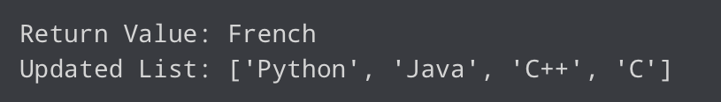

(Programiz, n.d.)

- Sort() : The method will sort the list in ascending order.
- Clear() : or Del list [:] Is removing the items from a list . (Programiz, 2021)
- Copy() : List can be copy to different list=list.copy()
- Reverse : The method will reverse the order of the list.

Part 2 Understanding
User defined function’s is starting with the key “def” followed by the function name. For example, def ex (argument1, argument2). They can take arguments as an input, but they will need at the end a colon.
After defining the def ex (and argument1, and argument2) the following lines will need to be statements.
1 def avg_number(x, y):
2 print("Average of ",x," and ",y, " is ",(x+y)/2)
3 avg_number(3, 4)

Average of 3 and 4 is 3.5

1. Lines 1-2 : Details (definition) of the function.
2. Line 3 : Call the function.
3. Line 1 : Pass parameters : x = 3, y = 4
4. Line 2 : Print the value of two parameters as well as their average value.

Arguments can be also variable name followed by “=”
def marks(english, math = 85, science = 80):
print('Marks in : English is - ', english,', Math - ',math, ', Science - ',science)
marks(71, 77)
marks(65, science = 74)
marks(science = 70, math = 90, english = 75)
Marks in : English is - 71 , Math - 77 , Science - 80
Marks in : English is - 65 , Math - 85 , Science - 74
Marks in : English is - 75 , Math - 90 , Science - 70

Arbitrary argument, we will put the arguments in a tuple “*example”
def sum(*numbers):
s = 0
for n in numbers:
s += n
return s

print(sum(1,2,3,4))
10
In Lambda forms
print((lambda x, y: (x + y)/2)(4, 3))
3.5 (w3resource, 2020)

Part B Implementation

Exercise 1:

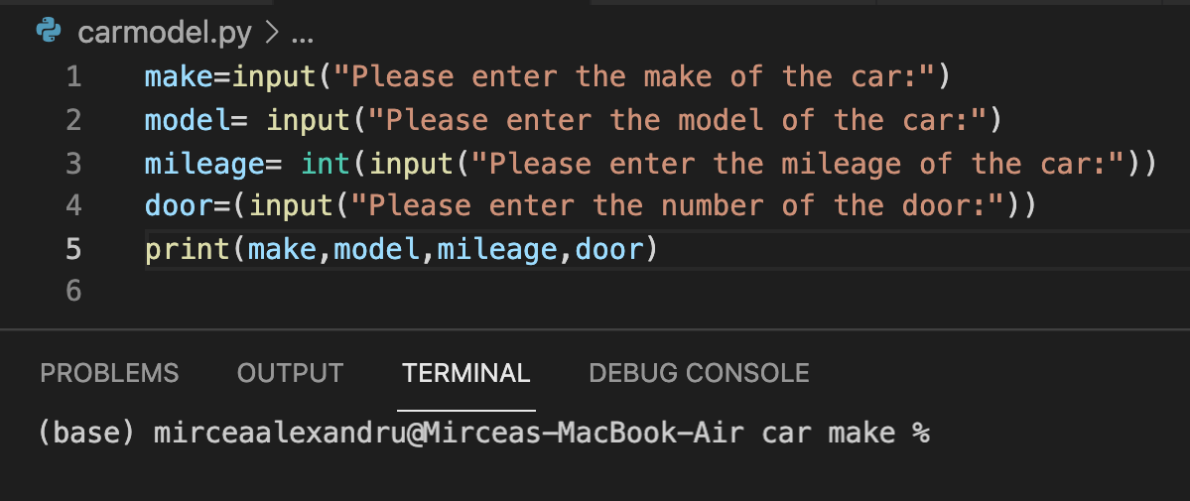

In this exercise we select the variables by type, in the first variable we will leave the type of the input string because the make can also include numbers and for the model also a string. In the third variable we will select the type of the data as a integer (we could use also float but we don’t want any ”,” in the result.
The print function will output the requested make, model, mileage, and number of doors and after will print them all together.

Exercise 2:
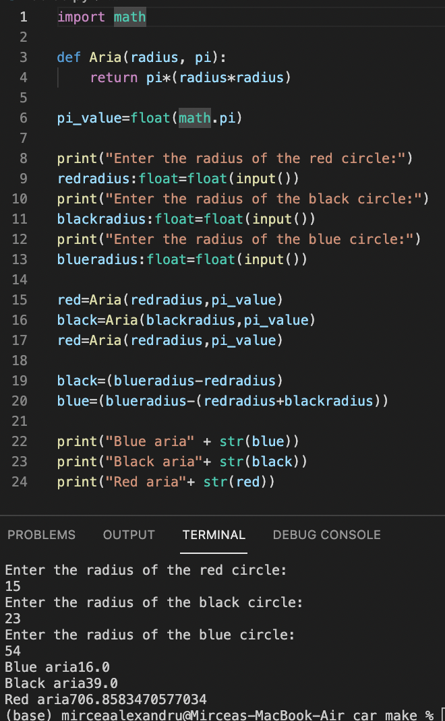
We start with importing from library math. This will allow us to recognize the value of the pi much easy with the math.pi function.
Second line of code will include the Definition of the function “Aria” that can be possible with having two values radius of the circle and the value of pi. As a statement we will say to return the values pi times radius at second power.
We are creating a variable for the math.pi and we are formatting the value for the print function to show us only two decimals after “,”.
At the next code lines, we are inputting the desired radius length for every single color from the circle by creating variables individually. We are formatting the input with the format float function that will allow the result to be with only 2 decimals.
After the input line code, we will create variable that will include the def Aria calling the input and the value of the pi.
For having the desired results, we just need to tell that red radius will be entire, but for black we need to create a new variable called black and from the radius we will need to down the redradius to show us the value. The same we will need to do for the value of the blue, we just need to add red and black and down from the radius of the blue value.

Exercise 3:
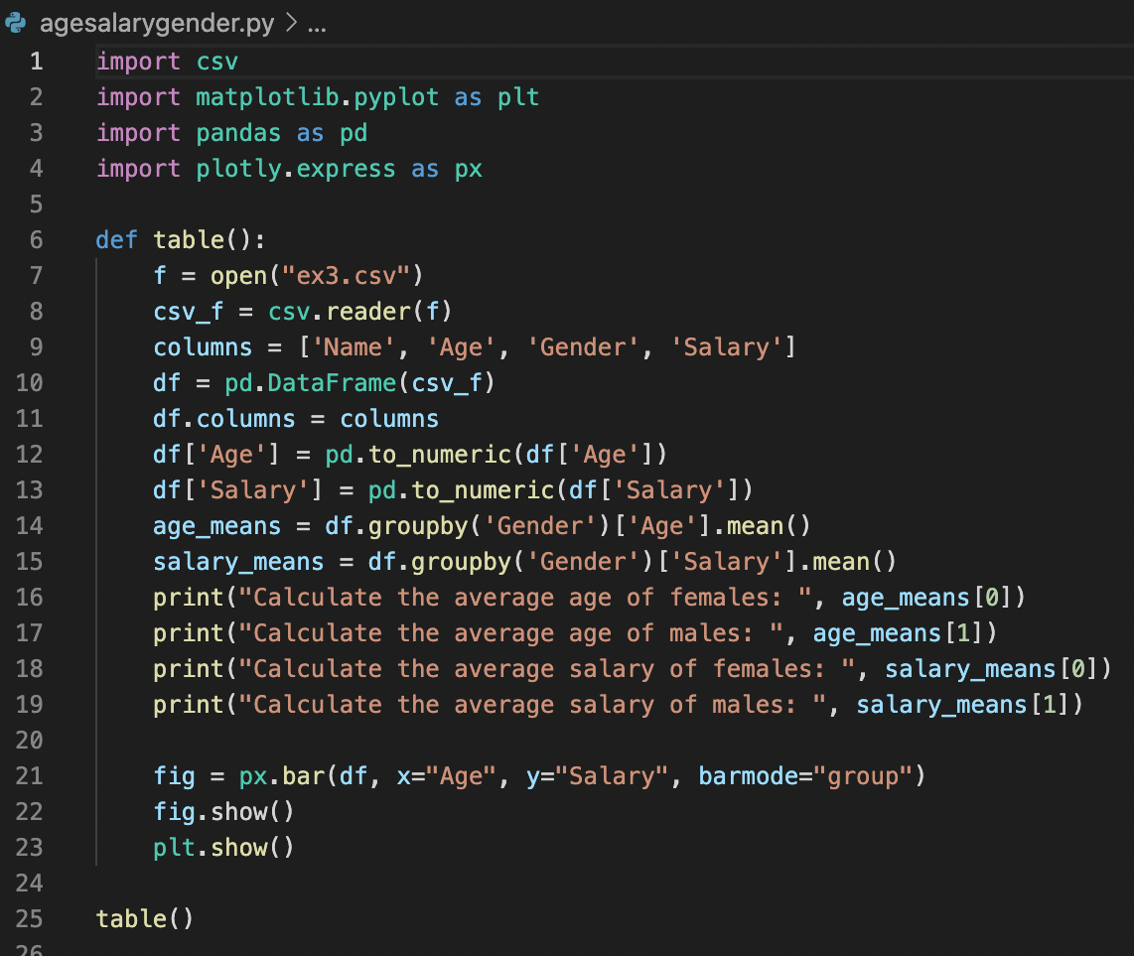
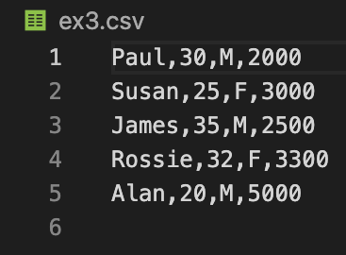

Output

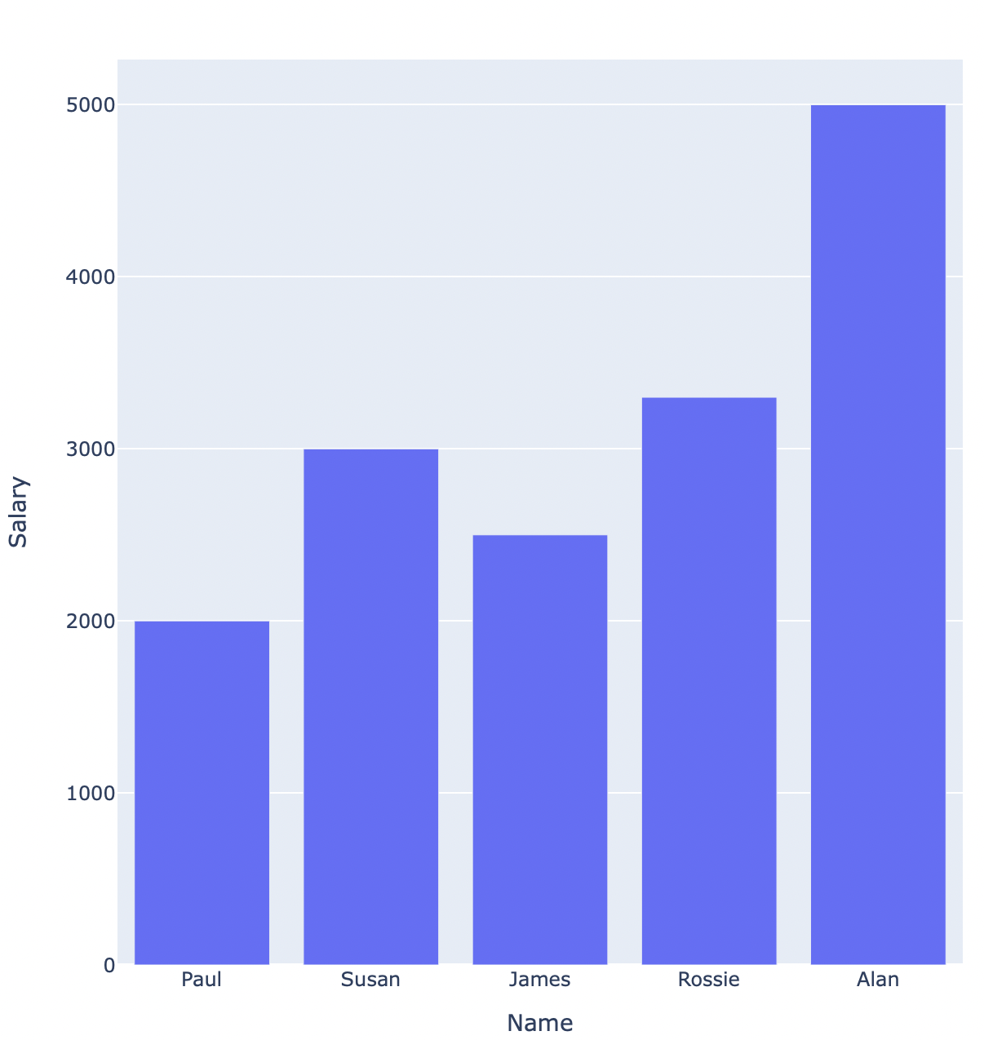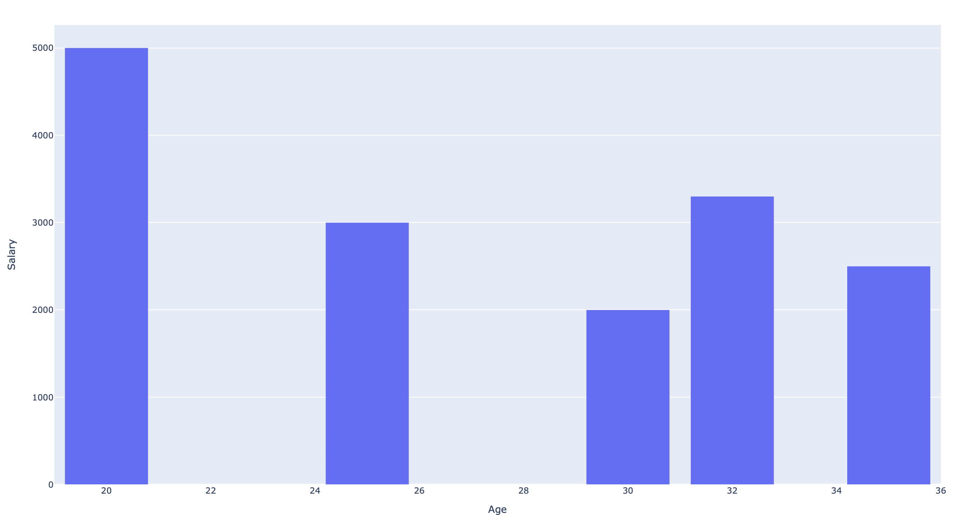

We are starting this exercise by importing from the library the csv file that was created with the columns and rows from the request, pandas to read and to output the data frame, matplot.lib to generate the graph and plotly.express.

Defining the table
Writing the statement that f will read the csv file.
We are after defining the columns and we are sorting the rows by age and salary (base by gender).
We are giving the function for plotly.express to create the data frame. And we are returning the table list. (Plotly, n.d.)

Exercise 4:
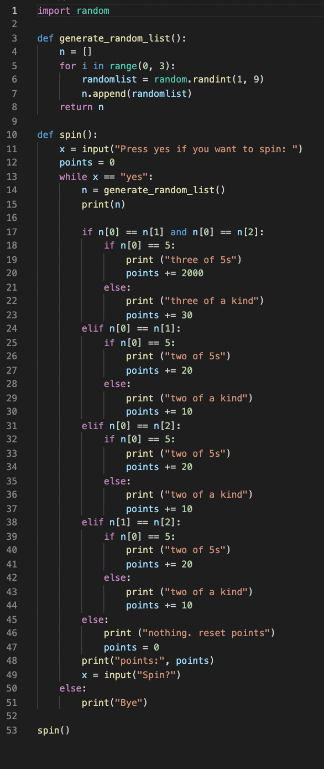
We are starting with importing the random from lib to generate random numbers.
Second line will define the function and we are returning variable n as a list.
We are setting the range of the list with 3 values from the list having an element that can randomly return an integer number selected from 1 to 9.
The next line code will add the element on the list from the back by creating a list.append(element) and we will tell to return n (the list).
After defining the list we need to define the spin() function by having an input statement for an variable that will be on yes to play or else to break (or print “Bye”)
The game is an infinite loop were typing no or other words cand terminate the game. The scoring for landing the desired numbers will add into the points variable.

For not-compress files click here!

For compress files click here!

References
W3Schools, n.d. Python. [Online]
Available at: https://www.w3schools.com/python/python_lists.asp
[Accessed 23 November 2021].
W3Schools, n.d. Python List. [Online]
Available at: https://www.w3schools.com/python/python_lists.asp
[Accessed 23 November 2021].
Programiz, S., n.d. Python List pop(). [Online]
Available at: https://www.programiz.com/python-programming/methods/list/pop
[Accessed 23 November 2021].
Programiz, S., 2021. Example 2: Emptying the List Using del. [Online]
Available at: https://www.programiz.com/python-programming/methods/list/clear
[Accessed 23 november 2021].
w3resource, 2020. Python : user defined functions. [Online]
Available at: https://www.w3resource.com/python/python-user-defined-functions.php
[Accessed 23 November 2021].
Plotly, n.d. Plotly Express in Python. [Online]
Available at: https://plotly.com/python/plotly-express/
[Accessed 30 November 2021].

