
User Requirements and Prototype |   Module: Usability Engineering  Module code: ACCB6017  Lecturer: Dr. Nassir Ibrahim  Student name: Alexei Nica  Student ID number: 2232919  Submission deadline: 31 October 2025

Table of Contents

Introduction 2
A. Four detailed personas & associated scenarios 3
1. Personas 3
2. Associated scenarios 7
B. Usability Issues to be Addressed 8
C. Storyboards 11
D. Feedback Collection Process on Storyboard Design 15
Conclusion and personal reflection 16
References 17
Appendices 19
Appendix A 19
Appendix B. Questionnaires & Evidence of Feedback 24
Appendix C. Low-Fi to Mid-Fi Wireframe Evolution 28
Appendix D. Consent forms 30

Introduction
The board game Cluedo is a classic of deductive reasoning, requiring Personas to navigate a board, collect clues, and solve a murder mystery. This report outlines the initial user research and interface design for a digital adaptation of this game, reimagined for the University of Wales Trinity Saint David (UWTSD). The core challenge of this project is to translate the complex, multifaceted mechanics of a board game into an accessible, engaging, and intuitive mobile interface. Cluedo was chosen because its core mechanics, deductive reasoning, memory, and spatial navigation provide a rich foundation for applying usability principles like task analysis and designing for cognitive load, making it an ideal case study for an interactive environment [1].
The design process is grounded in the principles of Usability Engineering. A user-centred design approach is adopted, beginning with the creation of four detailed personas representing a diverse range of potential users, focusing on varied ages, technological proficiency, and accessibility needs. The use of personas is a well-established practice in HCI for bridging the gap between user data and design solutions, making them ideal for this game design project [2]. The specific research method used to define these personas, observing potential users interact with a selection of existing mobile board games.
This report details the subsequent stages of the design process. It presents the user experience requirements for the UWTSD Cluedo game, categorised using the MoSCoW prioritisation technique. It then identifies key usability issues that must be addressed, drawing on established heuristics from Nielsen and Shneiderman to propose solutions. These solutions are realised in a set of initial wireframe storyboards, designed specifically for a mobile phone screen while considering scalability to other devices. Finally, a process for collecting feedback on these prototypes is described, ensuring the design is validated against the needs of the target users before further development. The final prototype aims to demonstrate how digital interfaces can preserve the logic and engagement of board games while enhancing accessibility for all users [3].

Four detailed personas & associated scenarios

Personas
To build the UWTSD Cluedo design around real user needs, four distinct personas were developed. These personas move beyond the stereotype of the typical student and represent a spectrum of potential Personas. Their goals and pain points, derived from targeted user research sessions including focus groups, interviews, and surveys, directly inform the user experience requirements and subsequent wireframe designs, ensuring the game is both inclusive and engaging [4].

Persona 1
Demographic: 22 years old, male, full-time student from Birmingham campus
One-line description: Persona1 is a second-year Business Management student and a social, competitive gamer.
Goals
- Win fast using a smart strategy.
- Have fun with friends while playing.
- Learn the game by playing, not reading.

Pain
- Hates long, unskippable tutorials.
- Can't stand slow or complicated menus.
- Leaves if the game feels random or unfair.

Media & device preferences
- Plays on his iPhone all the time.
- Uses Discord to plan games with friends.
- Watches gaming clips on YouTube.
- Likes games with quick matches.

Role & responsibilities
- Full-time Business student.
- Organises game nights for friends.
- Works a weekend job.
Tasks
- Coordinates games with 3-7 friends.
- Uses chat for strategy and fun.
- Checks simple stats after the game.

Persona 2
Demographic: 37 years old, female, international student from Moldova.
One-line description: A busy student and mom who plays mystery games to relax and think.
Goals
- Relax with a game that challenges her mind.
- Improve her logic and problem-solving skills.
- Play in short sessions that can be paused.

Pain
- Annoyed by the complex English she can't understand.
- Has very little and unpredictable free time.
- Feels bad if the game feels like a waste of time.

Media & device preferences
- Uses her Android phone for privacy.
- Prefers clear pictures over lots of text.
- Plays only in the evenings when home is quiet.
- Sometimes uses a translator app.

Role & responsibilities
- Final-year Computing student.
- Mother and wife, manages the home.
- Works part-time as a research assistant.

Tasks
- Play for 15-20 minutes in the evening.
- Solve mystery puzzles.
- Pause the game instantly when needed.
- Follow visual clues to understand the game.
Persona 3
Demographic: 19 years old, male, Art Foundation student, has a minor hand tremor.
One-line description: A creative student who needs an interface that is easy to tap and doesn't rush him.

Goals
- To play games without frustration from mis-taps.
- To enjoy social games with friends at his own pace.
- To feel in control of his actions in the game.

Pain
- Gets frustrated when he taps the wrong button by accident.
- Anxious under time pressure in games.
- Feels excluded by interfaces with small, crowded buttons.

Media & device preferences
- Uses a tablet with a stylus for better control.
- Prefers games with simple, clear layouts.
- Uses voice chat with friends instead of typing.

Role & responsibilities
- Full-time art student.
- Part-time volunteer at a community art centre.

Tasks
- Play turn-based games with friends.
- Use large, easy-to-tap buttons to navigate.
- Take his time to make decisions without being rushed.

Persona 4
Demographic: 20 years old, female, final-year Software Engineering student, tech enthusiast.
One-line description: A detail-oriented developer who appreciates clever UX and efficient design but is often short on time.

Goals
- To quickly understand the game's underlying logic and systems.
- To have a seamless, bug-free experience with smooth animations.
- To see innovative UX patterns she can learn from.

Pain
- Immediately notices lag, visual glitches, or poor performance.
- Hates inconsistent design and illogical user flows.
- Gets bored by clunky mechanics that waste time.

Media & device preferences
- Tests apps on both her high-end iPhone and a cheaper Android phone.
- Appreciates dark mode and customisable settings.
- Prefers efficiency and shortcuts over flashy, slow animations.

Role & responsibilities
- Final-year Software Engineering student.
- Part-time junior UX tester for a local startup.
- President of the University Coding Society.

Tasks
- Analyse the game's interface and interaction design.
- Play in short bursts between coding sessions.
- Identify any bugs or usability inconsistencies.

Associated scenarios

The four personas were developed through a two-stage research process designed to gather both broad preferences and specific, observed behaviours from real potential users.

Stage 1: Participant Selection & Initial Profiling

To recruit a diverse range of participants, the study employed various recruitment methods. A focus group of gamers helped identify a participant who became the basis for Persona1. A separate general questionnaire, distributed via email, helps identify participants who would later shape Persona2 and Persona4.
Additionally, a one-on-one interview was conducted with Persona3, providing a deep and personal context about her life as an international student and parent. This mix of methods ensured the personas represented varied needs from the start [5].

Stage 2: Defining Persona Characteristics through Hands-On Feedback

With the participants selected, the goal was to understand their real-world interactions and the frustrations they experienced. They were asked to play three different board games: Monopoly Online, Dice Puzzle, and Forest Dump for 15 minutes each. The subsequent, specific questionnaires weren't about game ideas, but about their personal pain points and what they felt worked well in each interface. By listening to a diverse group of Personas, it could cross-check their feedback, which gave confidence that the final personas truly reflected real user behaviours [6].

Stage 3. Key Findings and Synthesis of Results

The data collected from the research sessions were synthesised to define the core attributes of each persona, as summarised in Table 1. This approach builds on recent usability studies suggesting that meaningful personas come from carefully analysing and translating real user feedback into clear design goals [7].

Persona | Primary Research Method | Key Finding for Design
Persona1 | Focus Group & Observation | Need for fast-paced, competitive gameplay with minimal downtime.
Persona3 | Interview | Critical need for pause functionality and intuitive, visual navigation.
Persona2 | Questionnaire | Essential requirement for large touch targets and a turn-based, stress-free pace.
Persona4 | Observation | Strong emphasis on technical polish, performance, and interface consistency.
Table 1. Key Findings and Synthesis of Results

Appendix B includes the full questionnaires and survey summaries used in the research. By developing personas from real user feedback, this process follows contemporary user-centred design practices that emphasise adaptability and structured iteration in educational contexts [8].

Usability Issues to be Addressed

Designing the UWTSD Cluedo mobile game has been guided by a commitment to usability engineering, ensuring the interface is intuitive, efficient, and satisfying for a diverse user base. This approach is consistent with findings from recent research on digital board games, where interactive, context-sensitive systems were shown to enhance Persona engagement and reduce frustration during onboarding [9]. Building on these findings, the design process focuses on identifying and mitigating key usability issues through evidence-based decisions, informed by established principles and contemporary research [10].
A core usability challenge involves minimising cognitive load during onboarding, particularly for users like Persona1, who prefers to "learn by playing," and Persona3, who may struggle with text-heavy instructions. To address this, the storyboards employ a progressive disclosure approach, introducing game mechanics contextually as Personas encounter them. This aligns with the usability heuristic of “recognition rather than recall”, reducing the memory burden on new users [11].
Another critical issue is ensuring physical accessibility, a primary concern for Persona2, who has a minor hand tremor. The storyboards specify large, well-spaced touch targets that meet or exceed the 44x44 pixel minimum recommended by the Web Content Accessibility Guidelines (WCAG). This design directly tackles the common mobile usability failure of small, difficult-to-press buttons. Furthermore, a high-contrast mode is integrated to support users with visual impairments, adhering to the principle of “perceivability” [12].
For users like Persona3, who have limited and unpredictable time, the inability to pause a game is a significant usability barrier. The storyboards feature a persistent and easily accessible pause button, embodying the principle of user control and freedom [13]. This allows users to interrupt their session without penalty, enhancing their sense of control over the experience.
Providing clear and immediate system feedback is essential for building trust and efficiency, crucial for personas like Persona4 and Persona1. Every user action in the storyboards, from rolling dice to submitting a clue, triggers a visible response. This practice implements the heuristic of “visibility of system status”, which has been reaffirmed as a key factor in improving usability and Persona awareness in recent evaluations of mobile game interfaces [14].
Finally, to prevent confusion and reduce learning time, the interface maintains strict consistency in the placement and styling of key elements, such as the clue notebook and accusation button. This consistency supports the formation of accurate mental models, a concept central to user-centred design [15]. Also, it aligns with recent findings showing that well-structured and visually coherent user interfaces help reduce cognitive load and improve overall usability in mobile applications [16].

The following Table 2 summarises how key usability principles directly informed specific design decisions in the storyboards:

Usability Principle | Design decision in Storyboards | Key Persona2efit / Impact | Primary Persona(s)
Recognition rather than recall | Progressive onboarding with contextual hints and guided discovery | Reduces cognitive load and supports intuitive learning | Persona1, Persona3
User control and freedom | Persistent pause and resume options in single-Persona mode | Empowers users to manage time flexibly without losing progress | Persona3
Perceivability & Accessibility | Large, well-spaced buttons and adjustable contrast mode | Enhances accessibility and usability for motor or visual impairments | Persona2
Visibility of system status | Immediate visual feedback for every user action | Builds trust and reinforces clarity during gameplay | Persona4,  Persona1
Consistency and standards | Uniform layout, iconography, and terminology across all screens | Improves predictability and shortens the learning curve | Persona4
Table 2. Design decision for a storyboard

Storyboards

The storyboard stage of the UWTSD Cluedo project was very important because it transformed ideas from user research into real screens and interactions. The goal in this phase was not to design a beautiful interface, but to make sure the game was clear, simple to use, and easy to navigate. Since this is a mobile game, every screen had to fit small screens, with simple layouts and big touch buttons. The storyboard showed how Personas move through the game, what they see, and how they interact step-by-step [17].
It started with low-fidelity wireframes. These were hand-drawn screens, very basic, without colours or details. The purpose of these sketches was to show the structure of the game and the main ideas, not the final design. At this point, it was focused on clarity and on covering the whole game flow: main menu, choose game mode, map gameplay, settings, and game over screen. These screens matched the project requirements to show major functionality and navigation.
After testing and feedback, it was improved and created mid-fidelity wireframes. These versions were still not full colour, but they were more organised, balanced, and realistic. The layouts became cleaner, spacing was improved, and icons made the actions clearer [18].
The low-fidelity wireframes were useful for checking the early logic of the app. They allowed quick changes and discussions. The screens were simple: plain shapes, basic text, and arrows showing navigation.
For example, the low-fi main menu had four text buttons only, while the mid-fi version introduced a cleaner vertical layout, better spacing between buttons, and a settings icon in the corner to support personalisation and fast access to the settings menu (See Figure 1).
Another example is the gameplay screen. In the low-fi version, the map and icons were drawn in a basic way, just to show movement between buildings. In the mid-fi version, the positions became more organised, buttons were aligned, and icons for notebook, chat, and move actions were clear and placed logically at the bottom [19]. This helps users like Persona2 (motor challenges) and Persona3 (international student) by providing simple, spaced controls and recognisable icons instead of too much text (See Figure 2).
The settings screen also improved. The low-fi version had the menu as plain text buttons. The mid-fi version introduced arrow icons for each option and a cleaner list layout [20]. This supports Persona4’s needs for consistency and quality, because the interface feels closer to a modern mobile app, with a clear and predictable structure Figure 3.
Finally, the game-over screen changed from a simple text layout to a clearer structure where victory message, statistics, and action buttons (Play Again, Leaderboard, Main Menu) were grouped and separated, so the Persona can easily choose the next step. This supports fast gamers like Persona1 who want to quickly play again, but also Personas who want to check their results calmly (See Figure 4, in Appendix C).

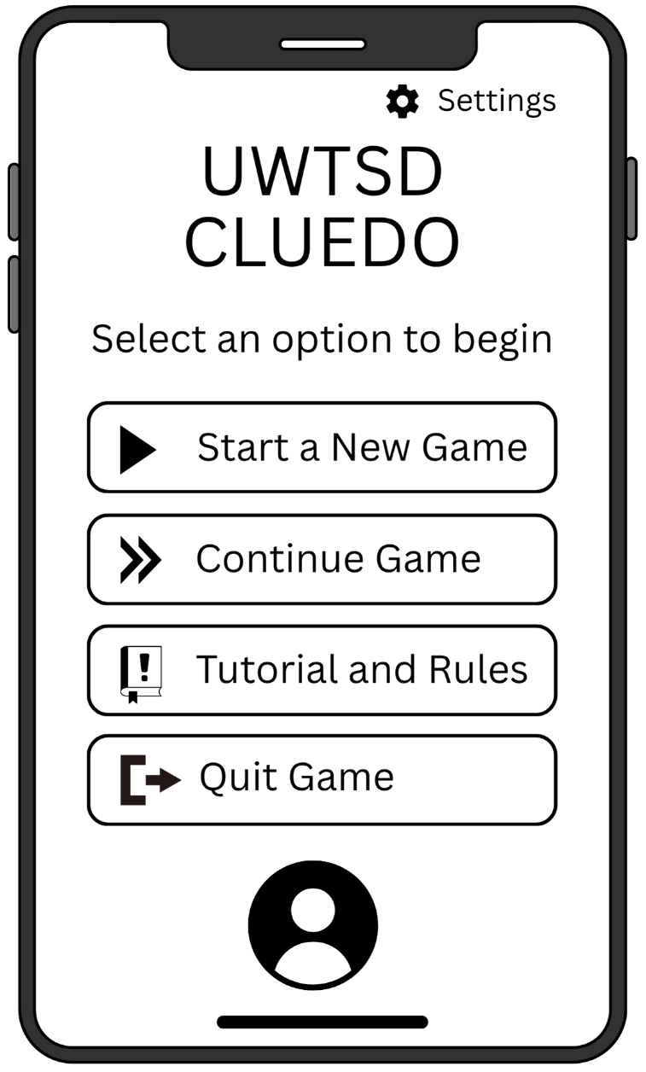
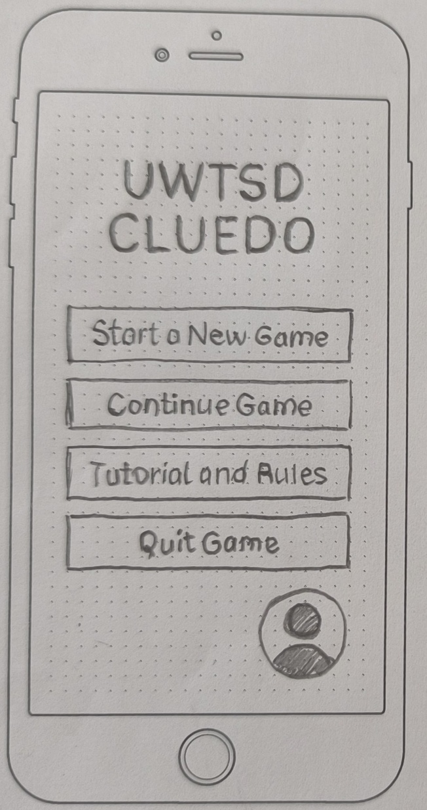
\\\\\\\\\\\\\\\

Figure 1. Low fidelity (left) and improved mid fidelity (right) main menu wireframes

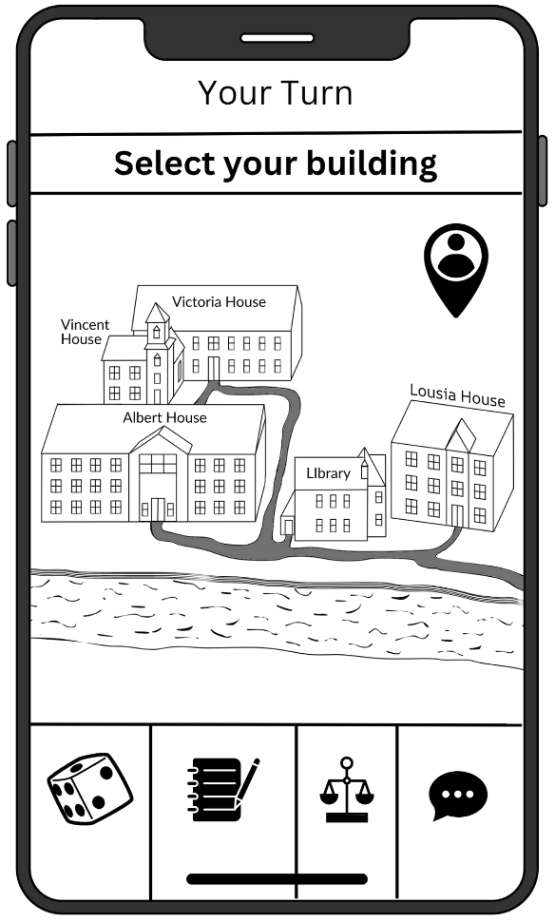
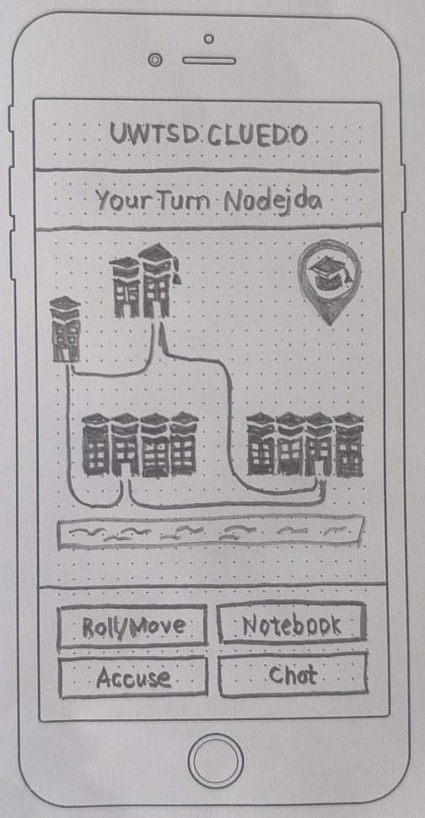

Figure 2. Low fidelity (left) and improved mid fidelity (right) gameplay display wireframe
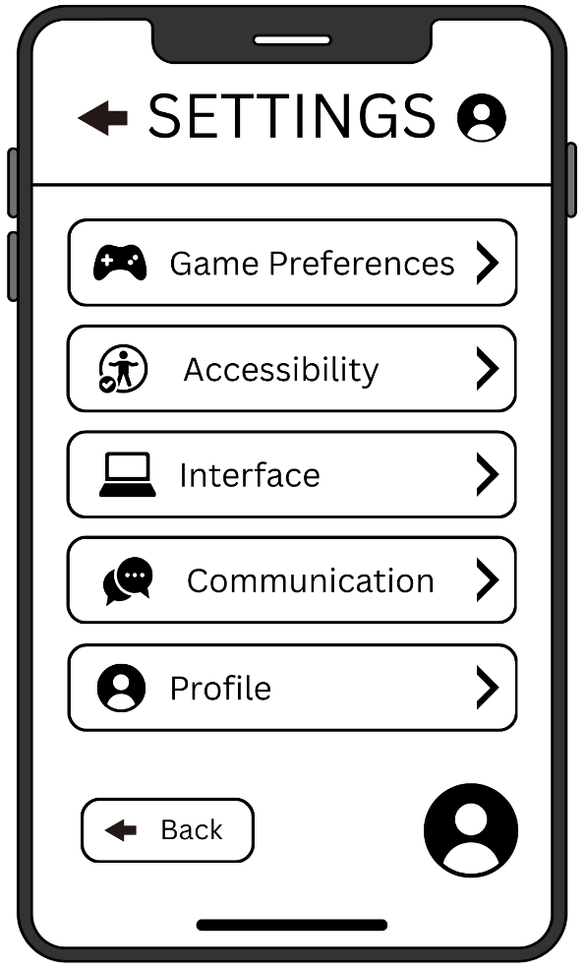
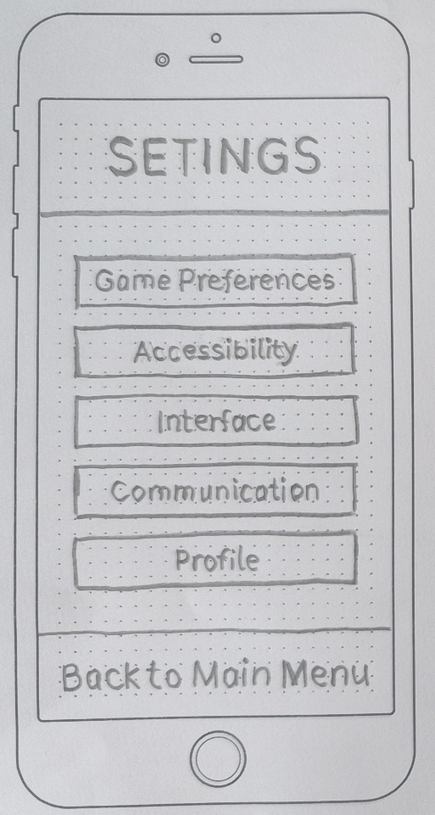

Figure 3. Low fidelity (left) and improved mid fidelity (right) Settings menu wireframe
Connection to Personas
Every improvement from low-fi to mid-fi followed real user needs based on the four personas identified earlier. For example:
- Persona1 wanted fast and simple navigation. The mid-fi screens made buttons larger and reduced the steps to start a new game.
- Persona3 preferred visual guides and simple language. Icons were added, text was reduced, and screens became cleaner.
- Persona2 needed accessibility. Mid-fi screens use bigger buttons, clear spacing, and no rushed interaction.
- Persona4 looks for a logical and modern interface. Mid-fi screens improved alignment, icons, and standard UI patterns.
This shows that the wireframes were not random drawings: they were shaped by real user needs and usability research [21].
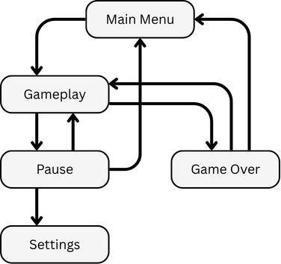
A key part of storyboarding was showing how users move from screen to screen. For example:
Figure 4. The game flowchart.
- Tap “Start New Game” → Go to mode selection
- Tap “Single Persona” → Go to gameplay map
- Tap “Settings” → Open settings list
- End of game → See results and choose next action

In both low-fi and mid-fi versions, arrows and button cues clearly illustrated the direction of user journeys. This supports interaction design theory, especially the principle that users should always know “where they are” and “what they can do next”.
The storyboard process helped transform user needs into real screens and interaction flow. The low-fi wireframes helped explore ideas quickly, while the mid-fi wireframes refined the structure and improved usability [22]. By comparing them and adjusting based on real personas, the final storyboard set demonstrates a clear, consistent, and user-centred design for a mobile version of UWTSD Cluedo. The complete storyboard set is included in the appendix, while the most important screens and improvements were explained in this section to show how design ideas evolved step-by-step.

Feedback Collection Process on Storyboard Design

To validate the initial storyboards, the same four participants who helped define the personas were engaged. Each played three short mobile games—Monopoly GO!, Dice Puzzle, and Forest Dump—for 15 minutes each. The aim was to observe natural reactions to different interface styles, noting frustration (such as small buttons in Forest Dump) and enjoyment (like the fast pace of Monopoly GO!). This practical test set a Persona2chmark for the proposed designs, following user-centred design principles and recent findings that highlight the value of early usability testing [23].
Immediately after, the low-fidelity wireframes were presented. Rather than a generic walkthrough, each participant was assigned tasks tailored to their persona’s core needs. For example, Persona3 was asked to locate and use the pause function, while Persona4 was tasked with navigating to the settings to enable dark mode. This method is consistent with contemporary usability testing practices that emphasise task-based evaluation to capture realistic user behaviours and expectations [24].
The entire feedback process was structured into three distinct stages conducted in a single session: a pre-game questionnaire to confirm preferences, observational gameplay, and a targeted storyboard review. This mixed-method approach enabled the collection of both broad behavioural trends and specific, actionable critiques. Studies suggest that combining observation with direct questioning enhances the accuracy of early-stage design evaluations and reduces redesign costs later in development [25].
Key feedback, particularly regarding button size and menu complexity, was directly incorporated into the final, refined wireframes, illustrating a clear and practical application of the iterative design loop [26]. The complete questionnaires and response summaries for all stages are available in Appendix B in alignment with the documentation standards recommended for usability validation processes.

Conclusion and personal reflection

This project explored how the classic board game Cluedo can be adapted into a mobile experience for UWTSD students. Real user research shaped four diverse personas with different needs and play styles, guiding a clear user-centred design process. Low-fidelity wireframes helped test early ideas quickly, and mid-fidelity versions refined layout, clarity, accessibility, and navigation.
The final prototype keeps the original logic of Cluedo but makes it simple, accessible, and engaging for fast Personas, busy students, international users, and Personas with motor needs. Features such as large buttons, visual icons, progressive learning, and a pause option were directly influenced by user feedback and usability principles.
The project achieved strong foundations, though testing was based on a small sample and early wireframes only. A larger evaluation with interactive prototypes will be needed to confirm usability, enjoyment, and accessibility at scale. Overall, the work demonstrates how structured research and iterative design can transform a complex board game into an intuitive and inclusive digital experience.

References

[1] L. Monteiro-Krebs, et al., "Board games as a research method: a case study on research game design and use in studying algorithmic mediation," Extended Abstracts of the CHI Conference on Human Factors in Computing Systems, 2024.
[2] P. J. White and F. Devitt, "Creating personas from design ethnography and grounded theory," Journal of Usability Studies, 2021.
[3] I. Spyridakis, "User Interface Design: Applying Heuristics for Improved Usability," 2021 ASEE Virtual Annual Conference Content Access, 2021.
[4] J. Salminen, et al., "Use cases for design personas: A systematic review and new frontiers," Proceedings of the 2022 CHI Conference on human factors in computing systems, 2022.
[5] P. J. White and F. Devitt, "Creating personas from design ethnography and grounded theory," Journal of Usability Studies, 2021.
[6] S. Ariyurek, E. Surer and A. Betin-Can, "Playtesting: What is beyond personas," IEEE Transactions on Games, vol. 15, no. 3, pp.348–359, 2022.
[7] K. L. Booker and A. W. MItchell, "From boring to board game: The effect of a serious game on key learning outcomes," Journal of Occupational Therapy Education, vol. 5, no. 4, pp.7, 2021.
[8] I. Visescu, "No title," Complicated, by Design: The Dynamic Use of a User-Centred Design Process, 2025.
[9] M. Allameh, et al., "Jessy: A Conversational Assistant for Tutoring Digital Board Games," 2021. doi: 10.1145/3450337.3483496.
[10] J. Gothelf and J. Seiden,Lean UX, Sebastopol: O'Reilly Media, Incorporated, 2021. [Online]. Available: http://ebookcentral.proquest.com/lib/trinity/detail.action?docID=6685694
[11] J. Nielsen. "10 Usability Heuristics for User Interface Design." Nielsen Norman Group. https://www.nngroup.com/articles/ten-usability-heuristics/
[12] J. E. Reyes Arias, et al., "Accessibility feedback in mobile application reviews: A dataset of reviews and accessibility guidelines," CHI Conference on Human Factors in Computing Systems Extended Abstracts, 2022.
[13] Z. Galavi, S. Norouzi and R. Khajouei, "Heuristics used for evaluating the usability of mobile health applications: a systematic literature review," Digital Health, vol. 10, pp.20552076241253539, 2024.
[14] M. Muhanna, A. Masoud and A. Qusef, "Usability heuristics for evaluating Arabic mobile games," International Journal of Computer Games Technology, vol. 2022, no. 1, pp.5641486, 2022.
[15] H. Tellioglu, "User-centred design as a model-based co-creation process," # PLACEHOLDER_PARENT_METADATA_VALUE#, 2022.
[16] M. A. Faudzi, et al., "User interface design in mobile learning applications: Developing and evaluating a questionnaire for measuring learners' extraneous cognitive load," Heliyon, vol. 10, no. 18, 2024.
[17] S. R. Z. Abidin, S. F. M. Noor and N. S. Ashaari, "Low-fidelity prototype design for serious game for slow-reading students," International Journal of Advanced Computer Science and Applications, vol. 10, no. 3, 2019.
[18] G. Drzyzga and T. Harder, "From low fidelity to high fidelity prototypes: how to integrate two eye tracking studies into an iterative design process for a better user experience," no.Icsoft, pp.485–491, 2024.
[19] T. Hellstén, "Iterative design of mobile game UX: Design defined by a target group," 2019.
[20] A. Andersson, "How to design a user-friendly mobile user interface with the power of visual usability," 2021.
[21] A. D. A. Oliveira and M. M. Eler, "Analyzing Accessibility, Usability, and User Experience in Mobile Apps Through User Reviews: An Extended Systematic Literature Review," Journal on Interactive Systems, vol. 16, no. 1, pp.641–665, 2025.
[22] H. R. Kadaskar, "Enhancing user experience in mobile application design through gestural interaction: a human-computer interaction perspective," International Journal of Scientific Research in Modern Science and Technology, vol. 3, no. 8, pp.1, 2024.
[23] J. Š Novák, et al., "Eye Tracking, Usability, and User Experience: A Systematic Review," Int.J.Hum.-Comput.Interact., vol. 40, no. 17, pp.4484–4500, 2024. doi: 10.1080/10447318.2023.2221600.
[24] J. Natarajan, "From Wireframes to Interfaces: Developing a Practical Framework for UI/UX Design," 2025.
[25] P. Weichbroth, "Usability testing of mobile applications: A methodological framework," Applied Sciences, vol. 14, no. 5, pp.1792, 2024.
[26] M. Abid, et al., "USABILITY EVALUATION EMPOWERED GAMING PLATFORM: AN ANOVA-BASED STATISTICAL ANALYSIS,"

Appendices

Appendix A

MoSCoW Analysis for Personas:
Persona 1: Persona1
Must Have
- Quick, skippable tutorial or learn-as-you-play.
- Fast matchmaking and ability to play with friends (multiPersona).
- Simple, fast navigation with minimal menus.
- Clear, strategic gameplay that feels fair and skill-based.
Should Have
- In-game chat (text/quick phrases) for coordination and banter.
- Post-game statistics and a simple leaderboard.
- "Rematch" or "Play Again" functionality with the same group.
Could Have
- Integration with social platforms for invites.
- Unique Persona avatars or light customisation.
Won't Have
- Long, forced tutorials.
- Complex, multi-layered menus.
- Gameplay reliant heavily on random chance.

Persona 2: Persona3
Must Have
- Ability to pause the game at any point and resume later.
- Strong visual language and icons to reduce reliance on complex text.
- Short, meaningful sessions (progress can be made in 15-20 mins).
- Intuitive, simple interface that doesn't require a manual.
Should Have
- Clear, logical puzzle design.
- An in-game notepad or visual clue tracker (e.g., a mind map).
- Option to replay tutorial hints.
Could Have
- Support for in-app translation of key terms.
- "Daily Puzzle" type of short challenges.
Won't Have
- Complex, verbose English without visual support.
- Long, un-pausable sequences or cutscenes.
- Time pressure in single-Persona modes.

Persona 3: Persona2
Must Have
- Large, well-spaced tap targets (buttons) to prevent mis-taps.
- No time pressure for making moves or selections.
- Turn-based gameplay that allows for a relaxed pace.
- Simple, uncluttered screen layout.
Should Have
- High contrast mode and adjustable text size.
- Option to confirm critical actions (e.g., "Are you sure?" prompts).
- Compatibility with assistive technologies (e.g., good screen reader support).
Could Have
- Fully customizable control schemes (e.g., ability to re-size buttons).
- Voice chat integration as an alternative to text.
Won't Have
- Small, crowded UI elements.
- Quick-time events (QTEs) or forced rapid tapping.
- Gesture-based controls that require precise movements.

Persona 4: Persona4
Must Have
- Polished, bug-free experience with smooth, performant animations.
- Consistent, logical, and efficient user flows.
- Clean, modern UI that follows platform-specific (iOS/Android) design guidelines.
Should Have
- Dark mode theme.
- Innovative or clever UX patterns that feel satisfying to use.
- "Quick Start" option to jump directly into a game.
Could Have
- Advanced settings menu (e.g., to toggle animation quality).
- Insight into game mechanics or "behind the scenes" logic.
Won't Have
- Clunky, slow, or illogical navigation.
- Janky animations or noticeable lag.
- Inconsistent styling and interactions.

Project MoSCoW Requirements
This list merges all "Must Have" and critical "Should Have" requirements from the personas into a unified set of priorities for the UWTSD Cluedo project.
Must Have
Core Gameplay & Usability:
  - Intuitive, simple navigation and UI.
  - Ability to pause and resume game at any time (single-Persona).
  - Turn-based gameplay with no time pressure for moves.
  - Clear, visual language and icons to support understanding.
Accessibility & Inclusion:
  - Large, well-spaced tap targets.
  - High contrast mode and adjustable text size.
  - Polished, performant, and bug-free experience.
- Game Modes:
  - Both single-Persona and multiPersona (with friends) modes.
Onboarding:
  - Quick, optional, or skippable tutorial.
Should Have
Social & MultiPersona:
  - In-game chat (text/quick phrases) for multiPersona.
  - "Invite Friend" functionality.
Features & Customisation:
  - Visual clue tracker (e.g., Mind Map or interactive notebook).
  - Dark Mode theme.
  - Post-game statistics.
  - Option to confirm critical actions.

Could Have
Advanced Features:
  - Voice chat integration.
  - Advanced settings menu (e.g., for performance).
  - Social platform integration.
  - Persona avatars or light customisation.
  - "Daily Challenge" puzzles.
Won't Have
- Long, unskippable tutorials or cutscenes.
- Complex, multi-step menus.
- Time pressure in single-Persona modes.
- Quick-time events (QTEs) or gesture-based controls.
- Gameplay that feels predominantly luck-based.
- Small, crowded UI elements.

Appendix B. Questionnaires & Evidence of Feedback

  - A short closed-question survey was used to screen diverse potential participants based on gaming habits, device type, time availability, and accessibility needs. A visual summary chart of responses supported the selection of four representative personas for deeper qualitative research.
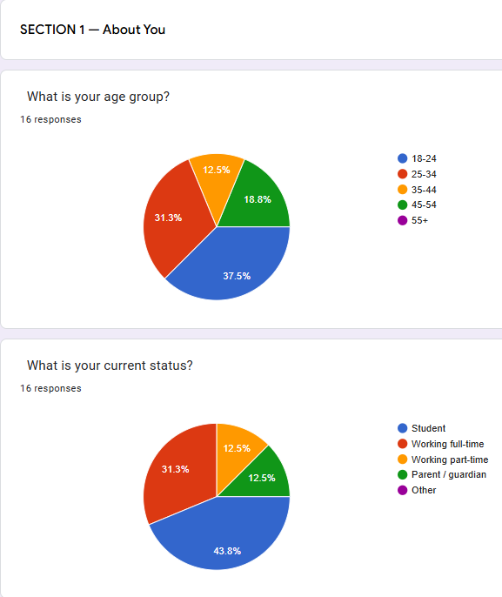
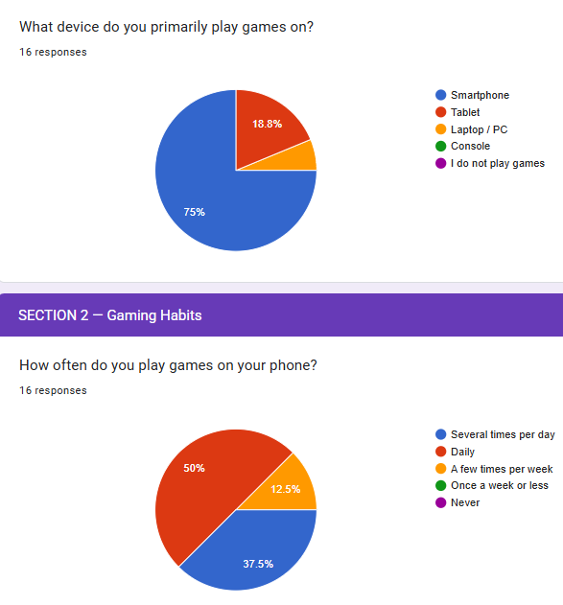
Screenshot 1. Summary of participant responses from the initial questionnaire (First part)

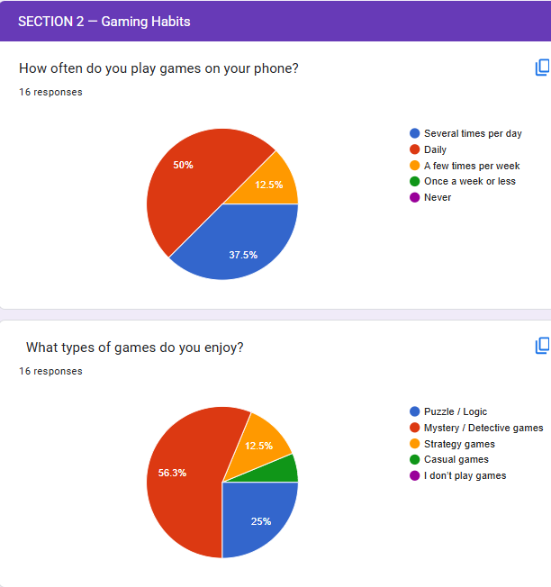
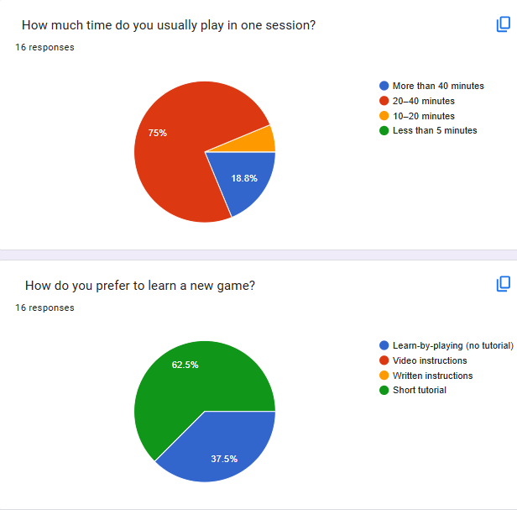
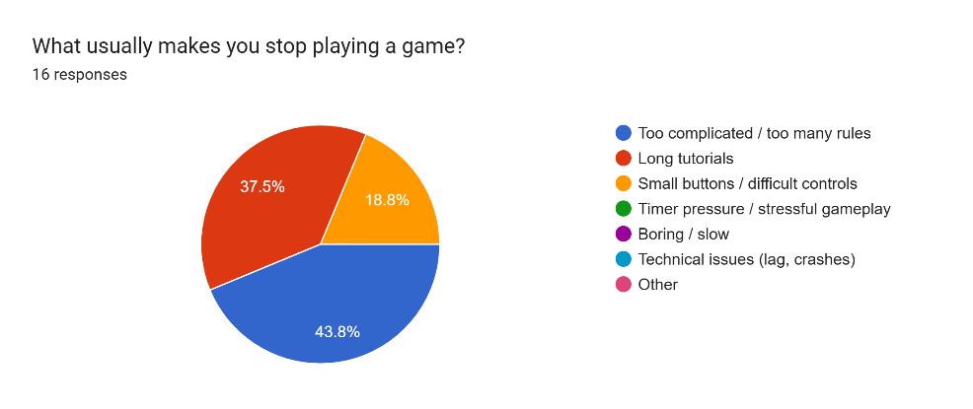
Screenshot 2. Summary of participant responses from the initial questionnaire (Second part)

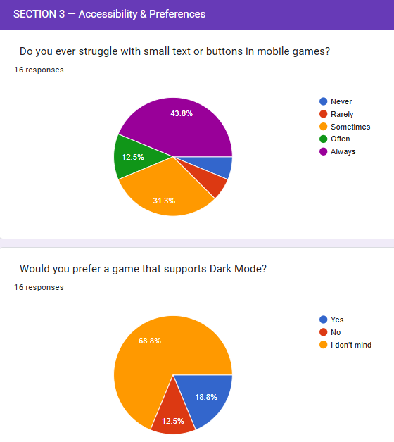
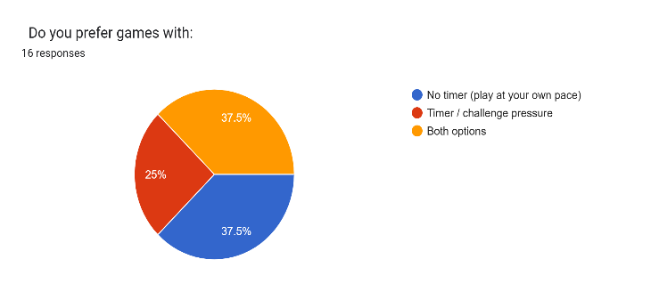
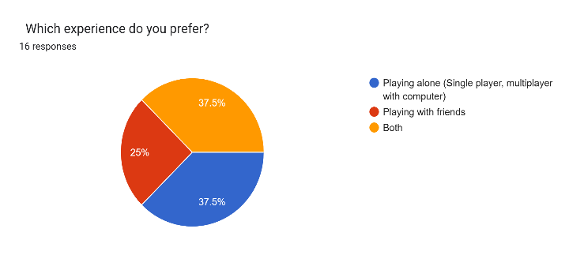
Screenshot 3. Summary of participant responses from the initial questionnaire (Third part)

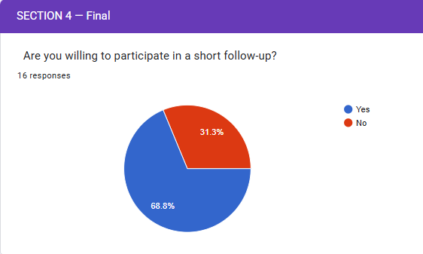

Screenshot 4. Summary of participant responses from the initial questionnaire (Fourth part)

  - The form below was used to collect quick usability feedback after each reference game. Participants completed it once per game, providing ratings and brief comments. The results directly informed the MoSCoW priorities and the low-fidelity storyboard design.

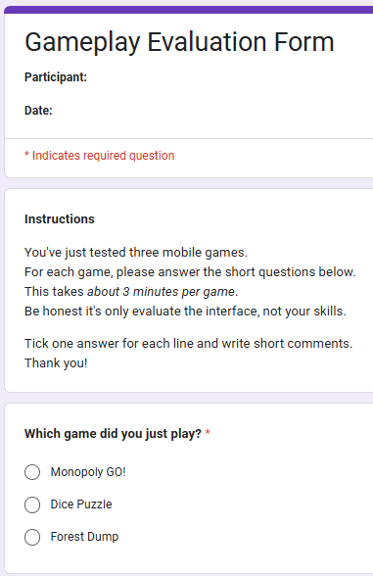
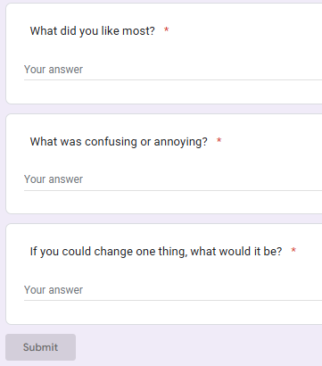
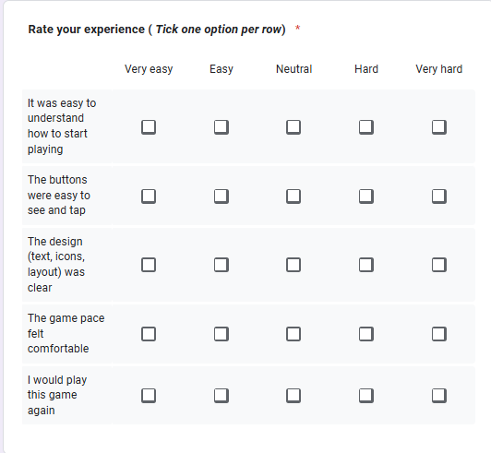
Screenshot 5. Gameplay evaluation questionnaire used after testing reference mobile games.

The table below () summarises the most relevant user observations collected during gameplay testing and shows how each insight directly informed the MoSCoW prioritisation. This mapping demonstrates the link between real user feedback and the design decisions made for the UWTSD Cluedo prototype, ensuring that requirements are created in authentic Persona needs and usability evidence.

Participant | Game Tested | Key Feedback / Quote | Usability Insight | Resulting MoSCoW Requirement
Persona1 | Monopoly GO! | The game is fun, but it takes too long to get started. | Fast onboarding needed | Quick/skippable  tutorial
Persona1 | Dice Puzzle | Simple and quick. I like it when I can play right away. | Learn-by-playing preference | Progressive  disclosure
Persona3 | Forest Dump | I didn’t understand the rules at the start, too much text. | Reduce cognitive load | Strong visual icons, minimal onboarding text
Persona3 | Monopoly GO! | No pause button… I need to stop suddenly sometimes. | Time flexibility needed | Persistent pause & resume
Persona2 | Forest Dump | Buttons too small… I mis-typed twice. | Motor accessibility | Large, spaced tap targets
Persona2 | Dice Puzzle | I liked that I wasn’t rushed. | Stress-free gameplay | No timer pressure in single Persona
Persona4 | Monopoly GO! | UI feels messy sometimes. Some buttons are not in logical places. | Clean, consistent UI required | Consistent layout & performance
Persona4 | Dice Puzzle | Good responsiveness. Smooth transitions. | Expectation for polish. | Smooth animations & performance
Table 3. Playtesting Feedback Mapped to MoSCoW Requirements

Appendix C. Low-Fi to Mid-Fi Wireframe Evolution

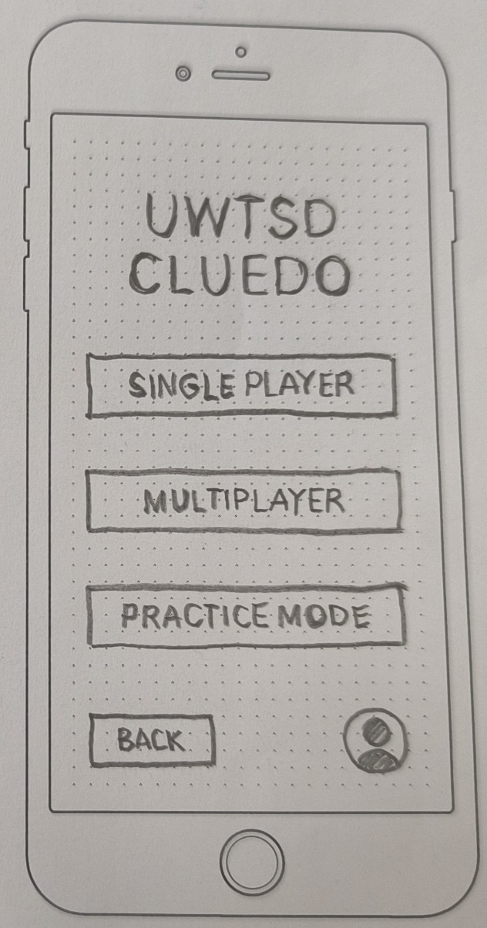
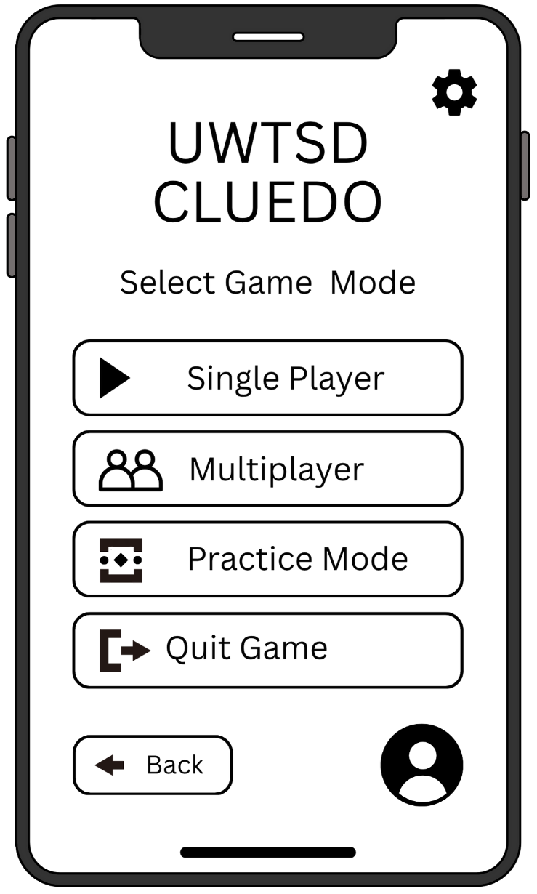
This appendix presents supplementary wireframe iterations that support the design process discussed in the main report. These screens illustrate the evolution from low-fidelity sketches to refined mid-fidelity layouts following user feedback. They are included here to demonstrate the iterative development process and to provide full transparency of the design decisions and improvements made during usability testing.
Figure 5. Low fidelity (left) and improved mid fidelity (right) Persona mode wireframe

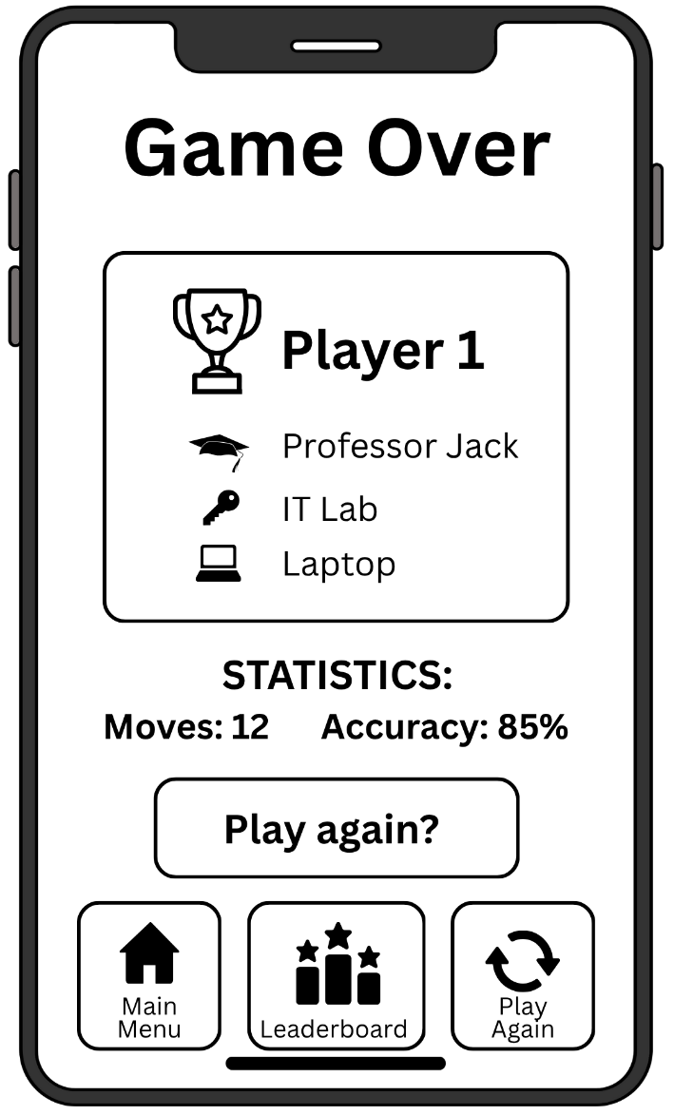
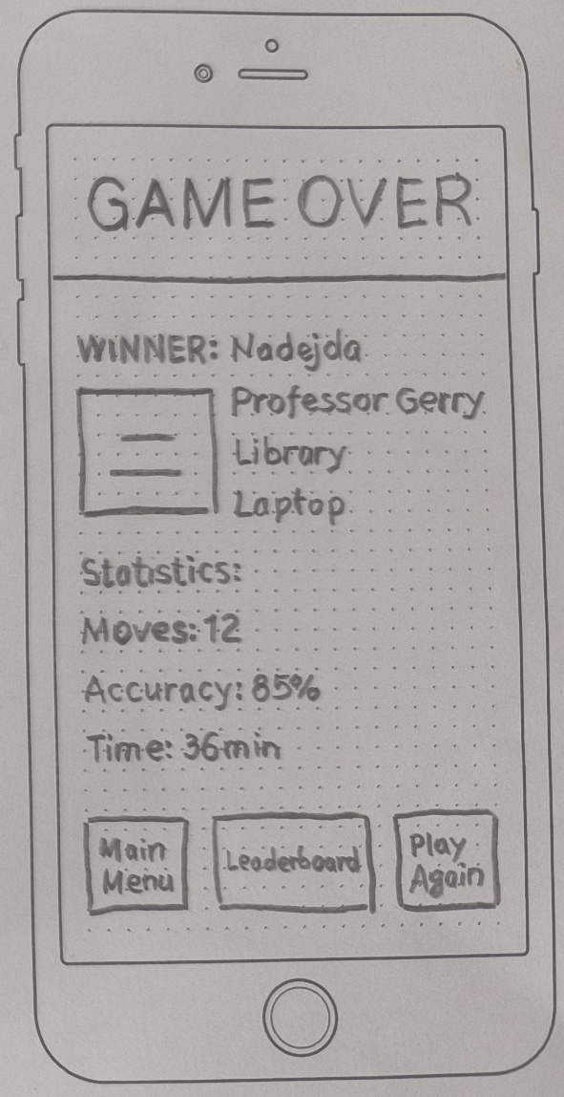

Figure 6. Low fidelity (left) and improved mid fidelity (right) Game over wireframe

Appendix D. Consent forms

Persona 1
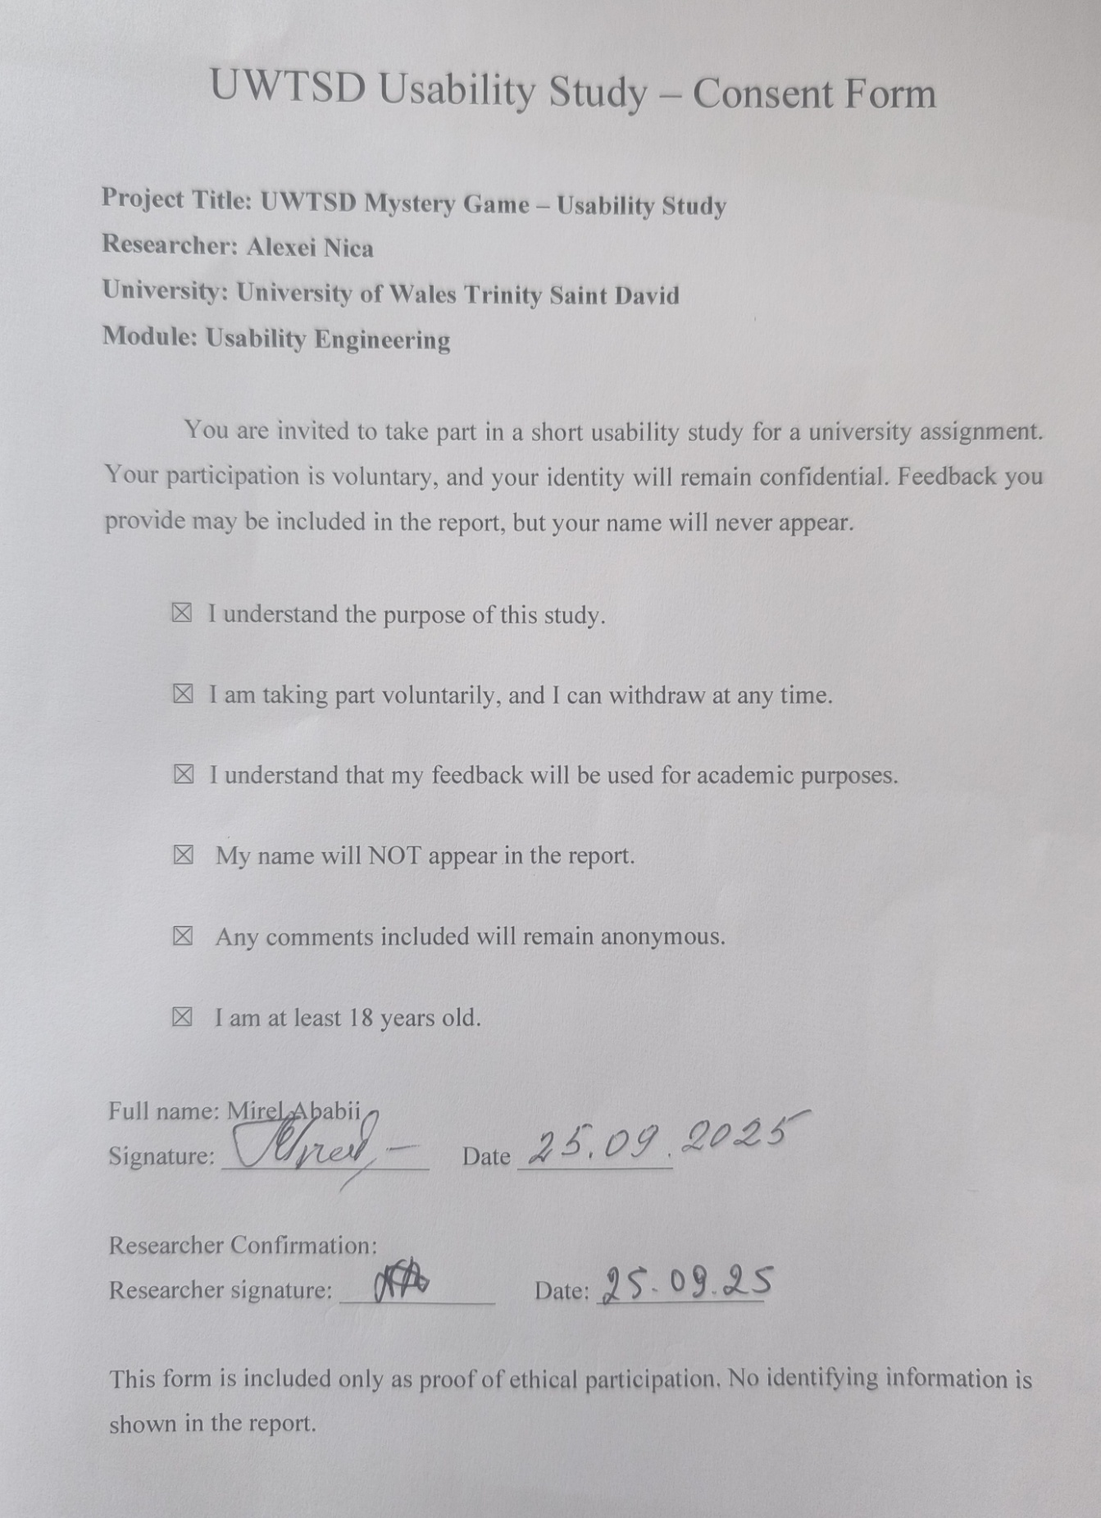

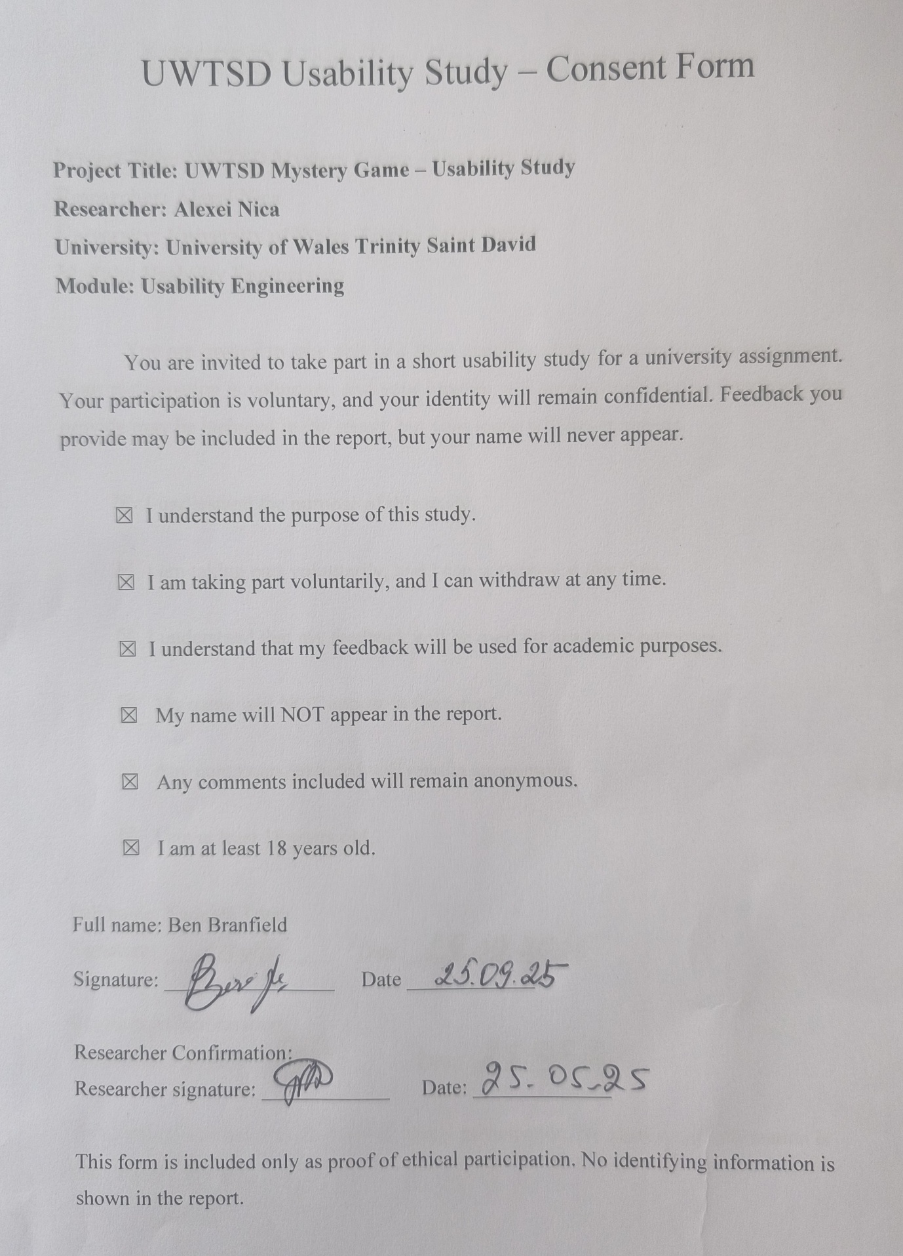
Persona 2

Persona 3
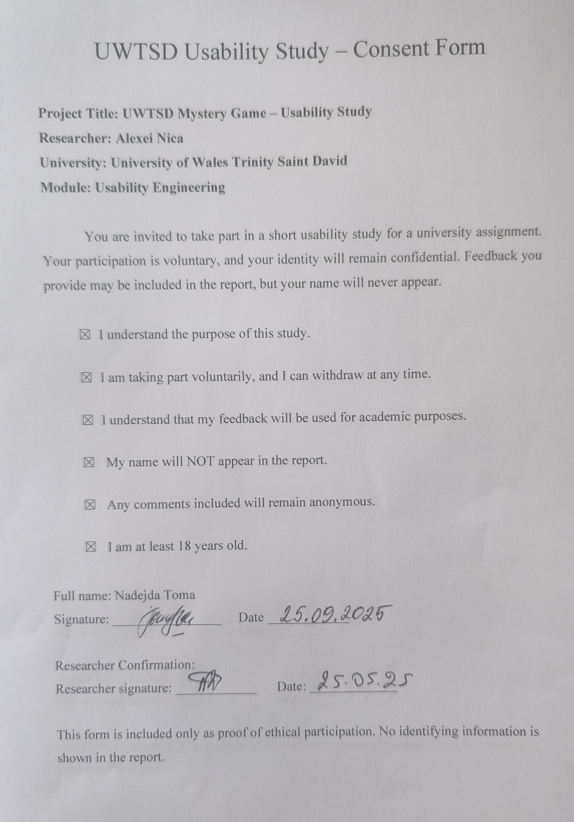

Persona 4


