Geographical Information System & Data Analysis
Evaluating the use of GIS software as a modelling tool for environmental analysis.

By Paige Cole
1804677

Table of Contents
1.0 Task one 4
1.1 Introduction 4
1.2 Case Study: Phytophthora ramorum 5
1.3 Map Construction 5
1.3.1 Data Acquisition 6
1.3.2 Creating the Data Points 7
1.1.3 Design Requirements 7
1.4 Map sets and Discussion 8
1.4.2 Landscape Influences Map 8
1.4.3 Weather Influences Map 10
1.4.4 Human Influences Map 11
1.4.5 Date of Detection 12
1.5 Recommendations for National Resources Wales 13
1.6 Limitations 13
1.7 Conclusion 13
1.8 References 14
1.9 Appendix 17
2.0 Task two 21
2.1 Introduction 21
2.2 Map Construction 21
2.2.1 Data Cleansing 22
2.2.2 Batch Converting 22
2.2.3 Creating the Data Points and Data Acquisition 22
2.2.4 SLQ 23
2.3 Map Sets 24
2.4 Discussion 27
2.5 Conclusion 27
2.6 References 28
2.7 Appendix 29

Table of Figures

Figure 1: Landscape Influences Map. 8
Figure 2: River Afan and South Wales Focus. 8
Figure 3: South Wales Focus. 9
Figure 4: North Wales Focus. 9
Figure 5: Weather Influences Map 10
Figure 6: South Wales Focus. 10
Figure 7: Human Influences Map. 11
Figure 8: South Wales Focus. 11
Figure 9: Infected site by date. 12
Figure 10: South Wales Focus. 12
Figure 1: Survey responses on map of the UK. 24
Figure 2: National Parks and positive insect encounters 25
Figure 3: National Parks and negative insect encounters. 25
Figure 4: Built areas and positive insect encounters. 26
Figure 5: Built areas and negative insect encounters. 26

Tables
Table 1: Layers attained through data acquisition. 6
Table 1: Layers attained through data acquisition. 23
Table 2: Description of the differing categories within SQL select. 23

Task one

1.1 Introduction

Thriving, healthy woodlands provide the environment and society with many benefits. Environmentally, trees provide habitats to many species, act as a carbon sink, and stabilize soils which prevents run off and erosion. They provide shade, absorb sound, provide timbre for products, and offer unique environments for recreational and leisure activities (Natural Resources Wales, n.da). Within Wales, the value of trees is recognized. Governmental bodies such as Natural Resources Wales (NRW) and the Forestry Commission Wales (FCW) work to ensure woodlands within Wales are healthy and protected (Natural Resources Wales, n.db). However, Welsh woodlands face many threats. Phytophthora ramorum is a disease that was first detected on an imported Viburnum plant within the UK in 2002, and first discovered in Wales in 2010 in the Afan Valley (Welsh Government, 2019). The spread of the pathogen has been coined as an epidemic (Cobb et al., 2020), leading to governmental bodies monitoring its progression to protect woodlands (Forest Research, n.d).
The application of Geographical Information Systems (GIS) is becoming a popular and useful tool within the environmental sector. GIS is a computer system that utilizes spatial locations and information layers to gather, present, and analyze data. It serves as a way of identifying and analyzing environmental issues. In by doing so, appropriate management and mitigation techniques can be applied (Chung, 2019). When constructed appropriately, GIS can present large amounts of complex data in relatively simple terms. This makes GIS maps valuable for effectively explaining issues and trends to the public and governing bodies. This can also be valuable in the decision-making process.
Using the data provided, this paper adopts GIS to assess the spread of Phytophthora ramorum in Wales. As a variety of factors impact the spread of Phytophthora ramorum, four maps sets were created. The first map set considers the topography of the landscape. Then, the climate and weather conditions are considered. This is followed by a map set illustrating various social factors of the area. Lastly, a map set showing the date of detection is presented.
The paper starts with a description Phytophthora ramorum and its spread in Wales. This is followed by a description and justification of the construction of the map sets. Then, the maps are presented and their contents is interpreted to inform NRW of the findings, along with suggestions to prevent the spread. The paper makes particular reference to South Wales, and the Afan Valley, where the pathogen was first discovered in 2010. Recommendations to prevent the spread of P. ramorum presented to NRW. Lastly, limitations are described and conclusions are drawn.

1.2 Case Study: Phytophthora ramorum

To understand the spread of Phytophthora ramorum, first the pathogen must be understood. P. ramorum is an algae-like organism that spreads via spores, causing certain tree, shrub, and plant species to die. Infected trees suffer from dieback, which eventually reaches the stem tissue. There are two kinds of spores: zoospores and chlamydospores. Although chlamydospores can travel through harsh conditions, zoospores are the main driver of transfer. Zoospores travel via water and wind, and favor warm, humid air (Welsh Government, 2019). The topography of an area and canopy height can increase disease transfer; with spores being able to travel further above ground level (Condeso & Meentemeyer, 2007). Additionally, another driver of spread is closeness to rivers (UK Centre for Ecology & Hydrology, n.d.) Human activity has also been shown to aid transfer. The plant trade and recreational activities such as hiking and cycling can transport the pathogen to new locations (Frankel et al., 2008).
Affected species include beech (Fagus), sycamore (Acer pseudoplatanus), horse chestnut (Aesculus hippocastanum), cherry (Prunus avium), ash (Fraxinus), birch (Betula), English oak (Quercus robur), sessile oak (Quercus petraea), and many more (Forest Research, n.d). As a popular species within timbre plantations, Larch (Larix) has been particularly impacted by the disease. Larch trees produce a lot of spores and timbre plantations are often monocultures, which furthers the spread of the pathogen (Harris, 2014). The outbreak has led to thousands of larch trees to be felled, with felling operations continuing to date (Forest Research, n.d).

1.3 Map Construction

As mentioned, GIS utilizes geospatial data. By using locations, GIS classifies information into layers. Layers can be employed to reveal a range of trends. Within this project, the provided data was used to show affected sites, and layers were applied to infer modes of transport for the pathogen, P. ramorum.

1.3.1 Data Acquisition

The layers were attained through data acquisition. Data acquisition is a key aspect of GIS, which is often the most time consuming (Bajjali, 2017). The data acquired provided the base map and to illustrate each of the possible influences in the spread of P. ramorum. Geospatial data was acquired through various online platforms. This data is known as the secondary datasets. It is important that the data acquired is current, accurate, and reliable (Mutluoglu & Ceylan, 2009). The website used included UK data service, Lle geo portal, and Digi maps. These websites were chosen because they provide reliable, compatible data. Once downloaded, the files were unzipped and extracted (see appendix 1). Then placed onto the map (see appendix 2).
For the purpose of this research, the potential influences were broken down into three sections: landscape, weather, and human influences. Table one illustrates the data acquired.
Map set | Factors considered | Layers acquired | Description | File type | Additional information | Reference
Base map | Wales | ‘GB Wards, May 2010’ | Map of Wales | Shapefile | N/A | UK Data Service (2010)
Landscape Influences | Water courses | ‘Main Rivers.’ | This layer shows the main rivers of Wales. | Shapefile | N/A | Welsh Government (2021)
Landscape Influences | Woodlands | ‘Ancient Woodland Inventory 2021’ | This layer shows the area of ancient woodland in Wales. | Shapefile | N/A | Welsh Government (2021)
Weather Influences | Wind | ‘Pre-Assessed Areas for Wind Energy.’ | This layer shows the Pre-Assessed Areas for Wind Energy in Wales. | Shapefile | An average wind-speed layer could not be located. This layer was chosen as areas used for wind energy are locations that have high wind speeds. The limitations of this are discussed later. | Welsh Government (2021)
Weather Influences | Rain | N/A | N/A | N/A | No map indicating average rainfall could be located. | N.A
Human Influences | Built areas | ‘Built Areas, Wales’ | The map shows the built areas of Wales, from this human activity is inferred. | Shapefile | N/A | UK Data Service (2011)
Human Influences | National parks | ‘National Parks Wales’ | The map shows the The National Parks of Wales, from this human activity is inferred. | Shapefile | N/A | UK Data Service (2012a)
Table 1: Layers attained through data acquisition.

1.3.2 Creating the Data Points

GIS illustrates locations in three ways; points, lines, and polygons. Point data refers to a single point, i.e. location of a tree. Line data refers to interlinked points, i.e. a location of a river. Polygons refer to a closed shape of linked points, i.e. regional boundaries. As the system works with spatial data, each type of location requires a longitude (x-axis) and latitude (y-axis) reference. Sometimes, this can come in the form of a grid reference.
The data provided represents the primary dataset. The information included confirmed infected sites from 2011 to 2014, with their X and Y coordinates and a grid reference. Additionally, the data described whether the sites are FCW or privately owned.
The first step in placing the data points onto the map was to review the data provided. MapInfo requires each attribute within an excel sheet to be either numbers or letters; otherwise it categorizes it as a “String” type. It is important to check data before applying it to the GIS system to ensure that the data is usable. No changes were made during the data cleanse.

Having ensured the data is suitable, the next step was to upload the data to MapInfo and create data points (see appendix 3). Two sets of data points were created; one showing the data points all together, and one showing the date the infection was recorded. To do this, SQL select was adopted (see appendix 4). This facilitated further analysis of the spread.

1.1.3 Design Requirements

As GIS is a visual medium, it is essential that the map sets are clear and understandable. To ensure this, the scale and color of each data point, polygon, and line were created with this in mind. This process is shown in appendix 5. Additionally, a legend was created for each of the map sets to explain its contents. An example of inappropriate and appropriate map set design is shown in appendix 6.

1.4 Map sets and Discussion

The following sections present the maps and discuss the findings.

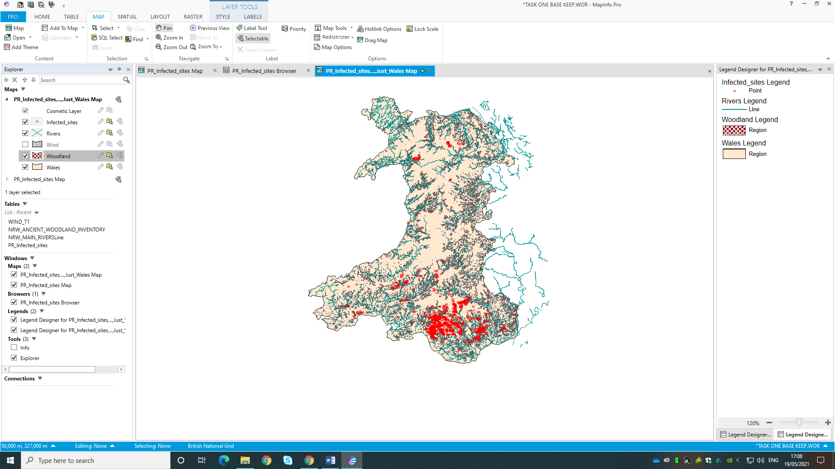
1.4.2 Landscape Influences Map
Afan Valley
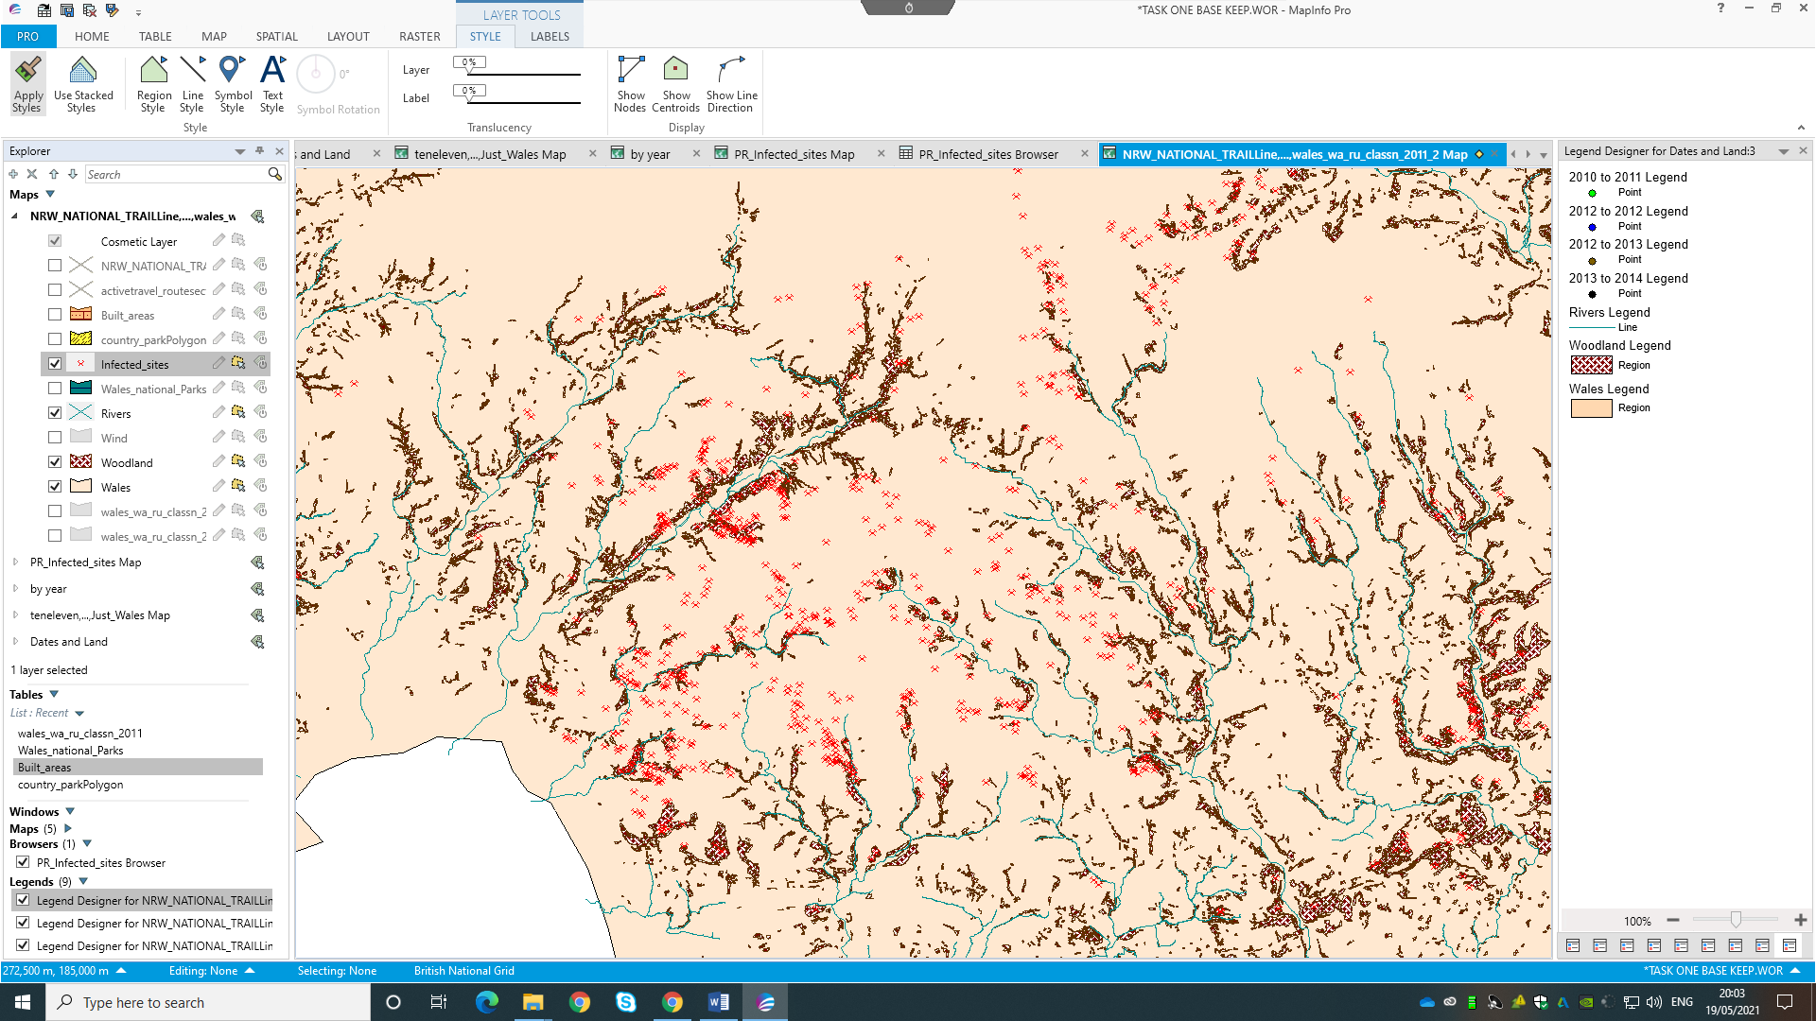
Figure 1: Landscape Influences Map.
Afan Valley
Figure 2: River Afan and South Wales Focus.
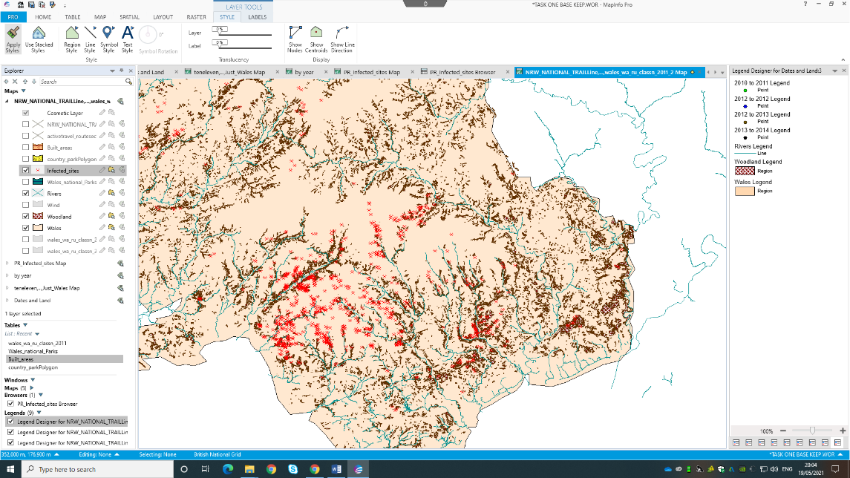
Afan Valley
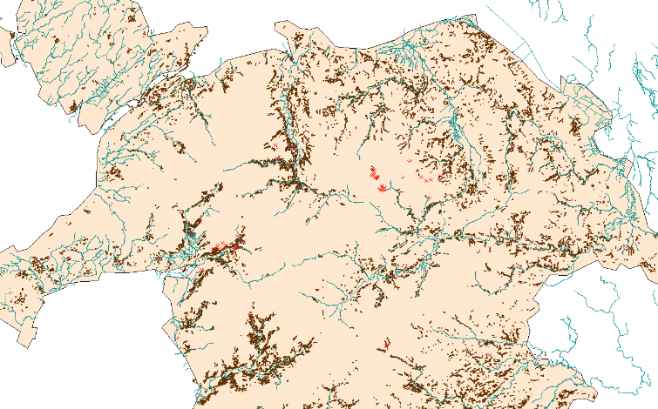
Figure 3: South Wales Focus.
Figure 4: North Wales Focus.
Figure 1 illustrated the landscape influences map with a legend indicating the key. Here, infected points are shown in relation to woodlands and rivers. As mentioned in section 1.3, P. ramorum was first discovered in the Afan Valley in 2010. Figures 2 and 3 show that there is a large number of infected sites in the area. Specifically, each cluster point is located close to the river and in the woodlands. Referring back to the information provided in section 1.3, closeness to rivers can be a key driver of the spread. Furthermore, as the pathogen travels via spores, this describes why the spread is focused on the ancient woodlands as the spores are able to travel due to the closeness of the trees. This also provides an explanation for why P. ramorum has spread into North Wales, which is illustrated in figure 4.

1.4.3 Weather Influences Map

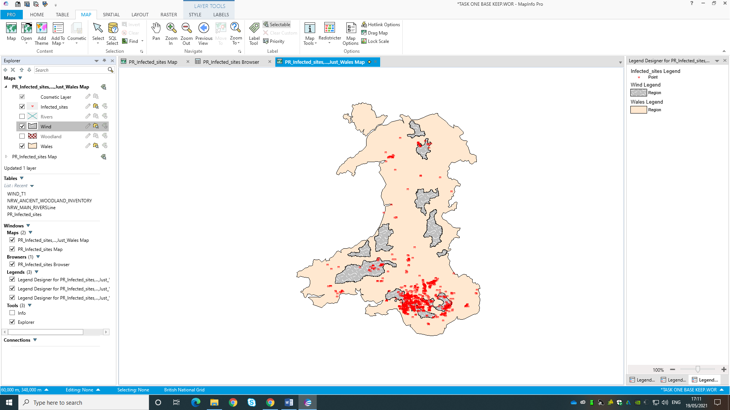

Figure 5: Weather Influences Map

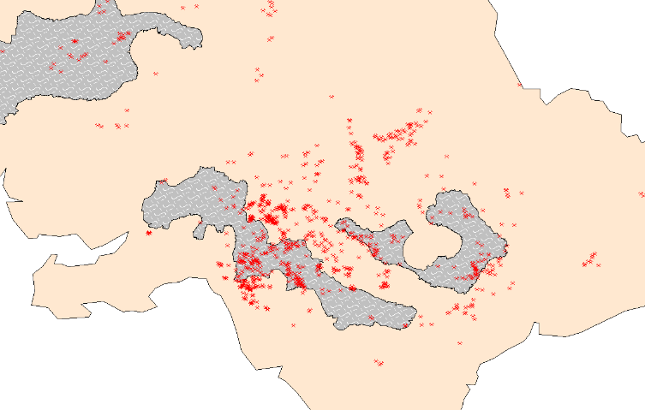
Figure 6: South Wales Focus.
Figure 5 shows the weather influences map. Figure 6 illustrates the cluster surrounding the Afan Valley. Several of the cluster points are located in areas that have high winds. This relates to the research mentioned previously which stated that spores spread via wind. The high wind in the area has provided a good condition for P. ramorum to spread.

1.4.4 Human Influences Map
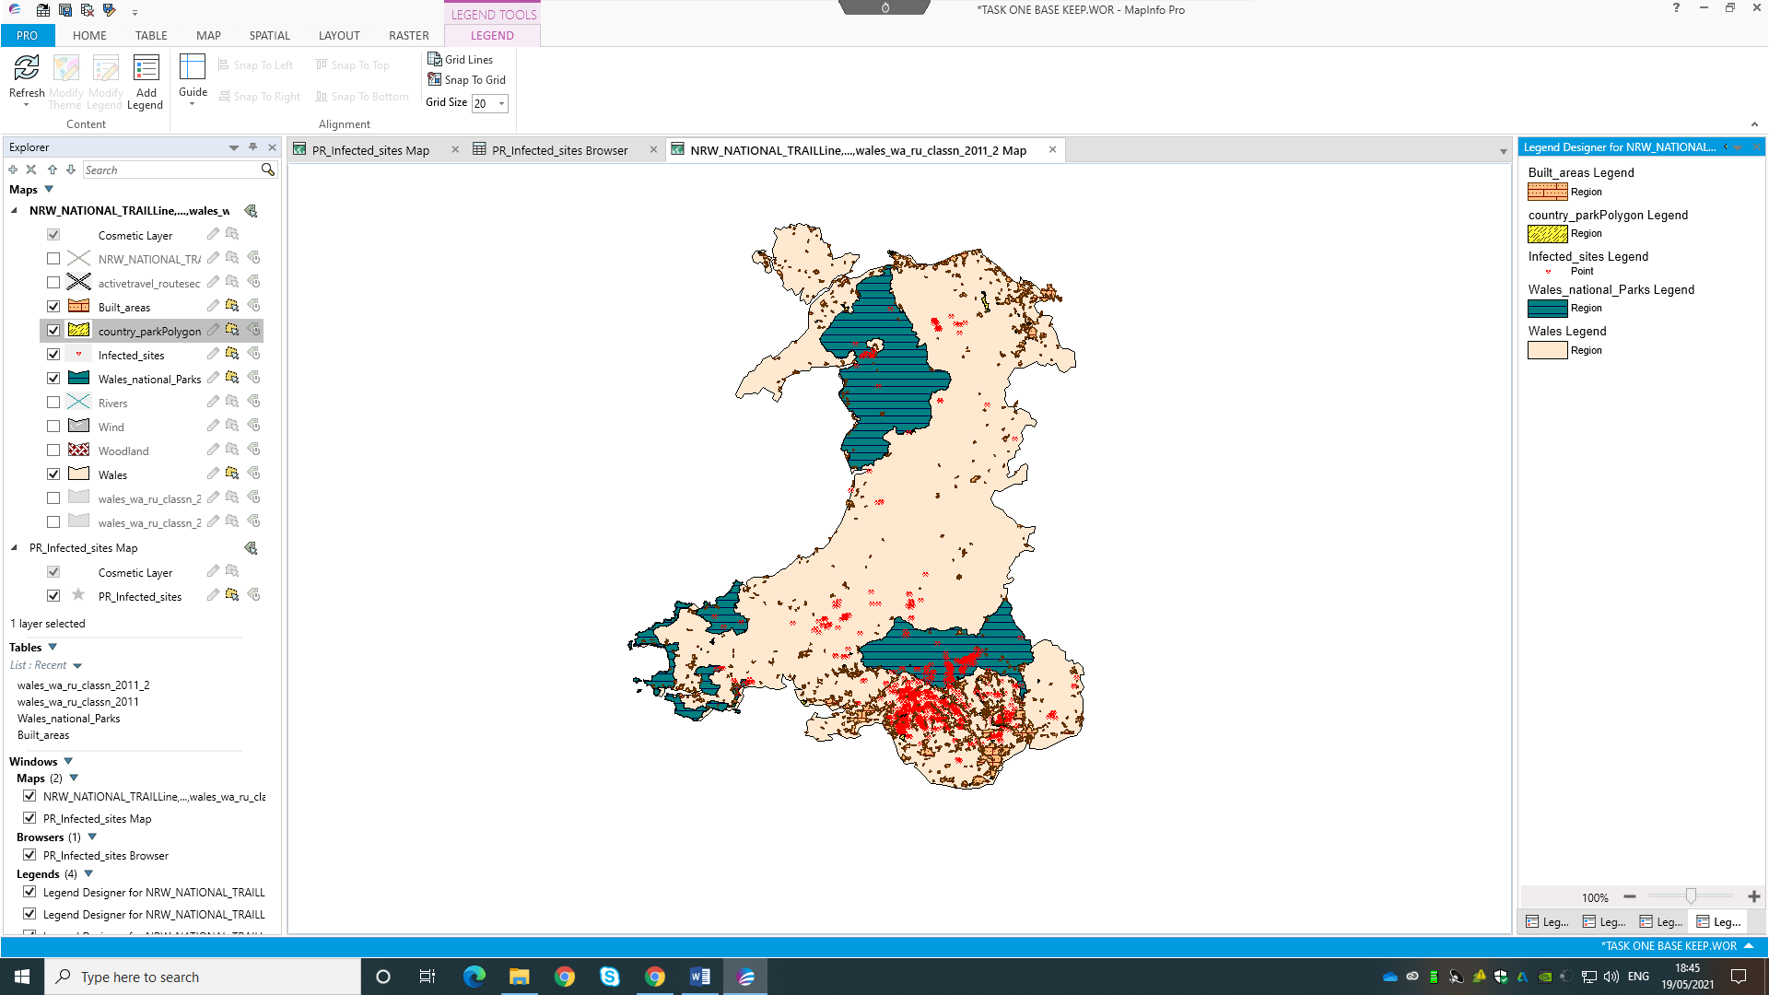
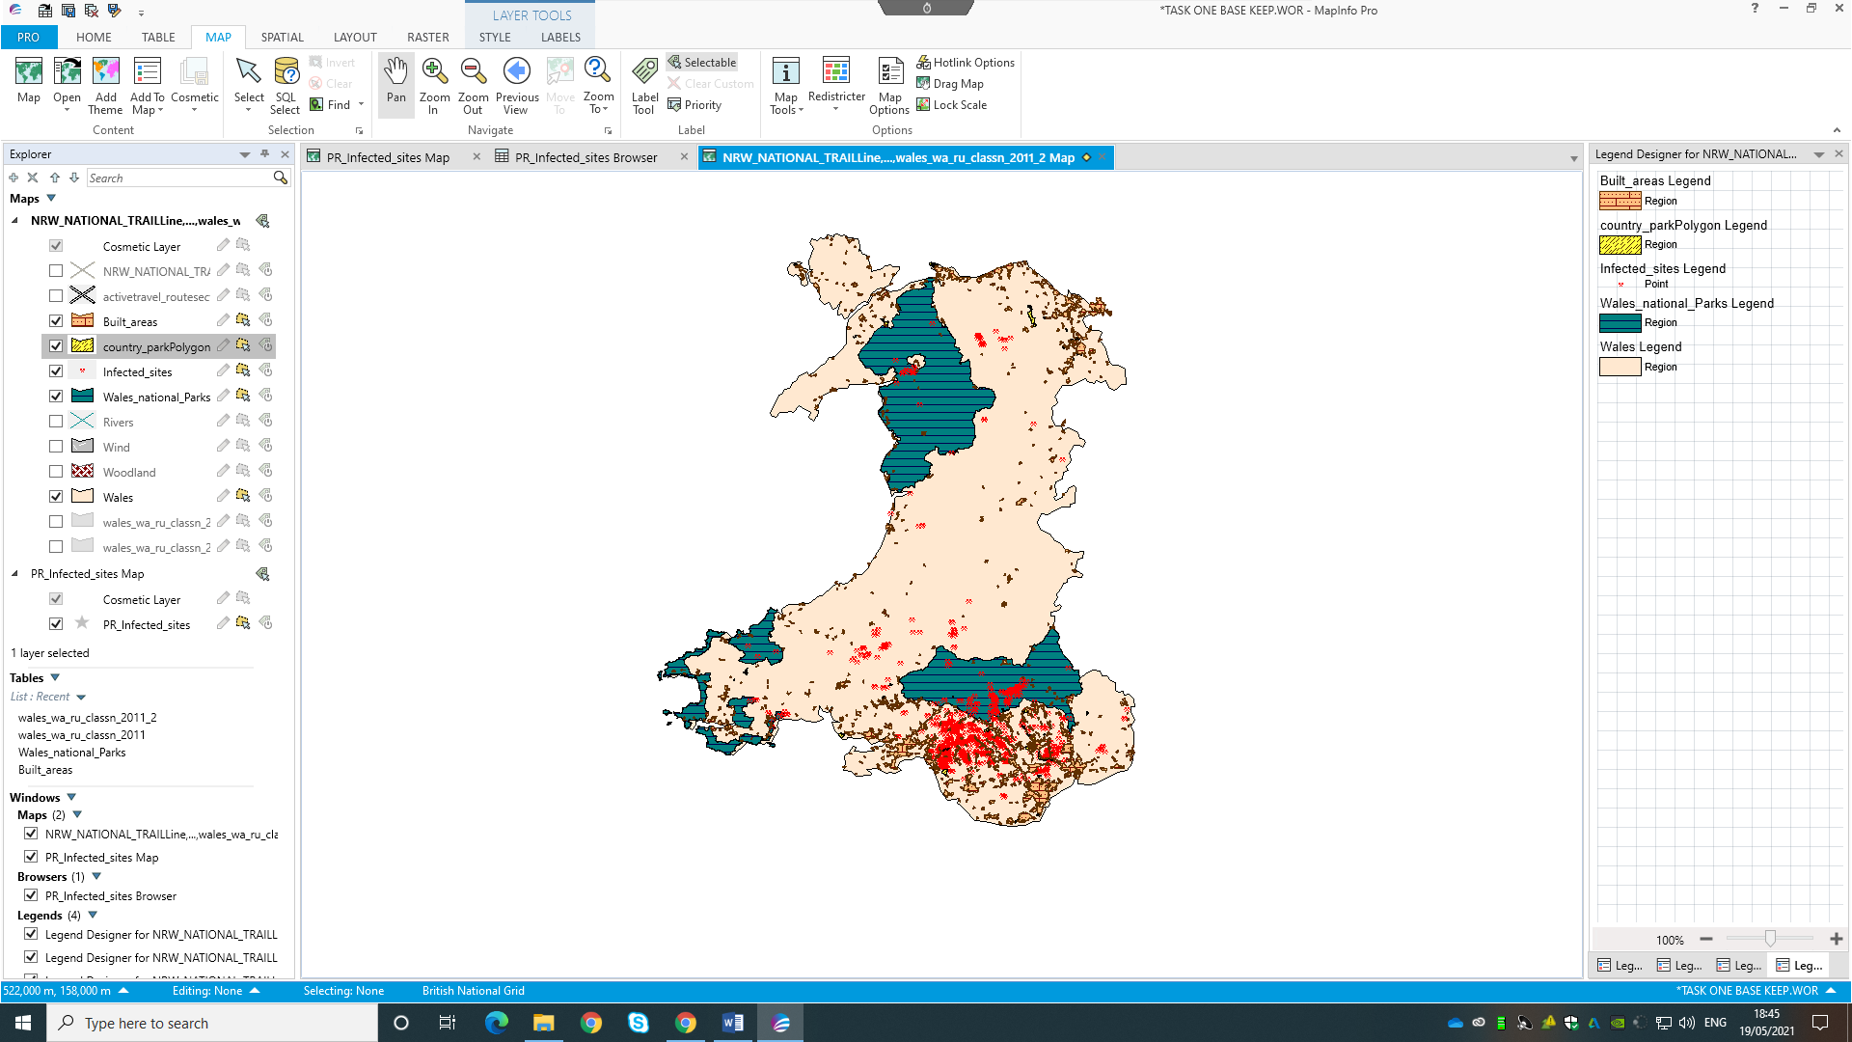

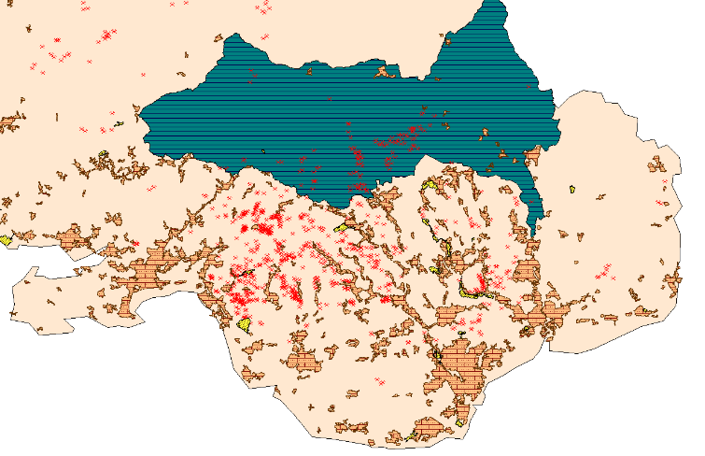
Figure 7: Human Influences Map.

Figure 8: South Wales Focus.
Figure 7 shows the human influences map, and figure 8 shows this map with a South Wales focus. As noted in section 1.3, a key cause of spread can be via human activities. From the built-up areas, we can infer that there is a higher amount of people in the area and thus more chances for P. ramorum to spread on shoes. Linking this to the national parks, we can also infer that the spread reached the area partly due to recreational activities such as walking and hiking taking place in the area.

1.4.5 Date of Detection
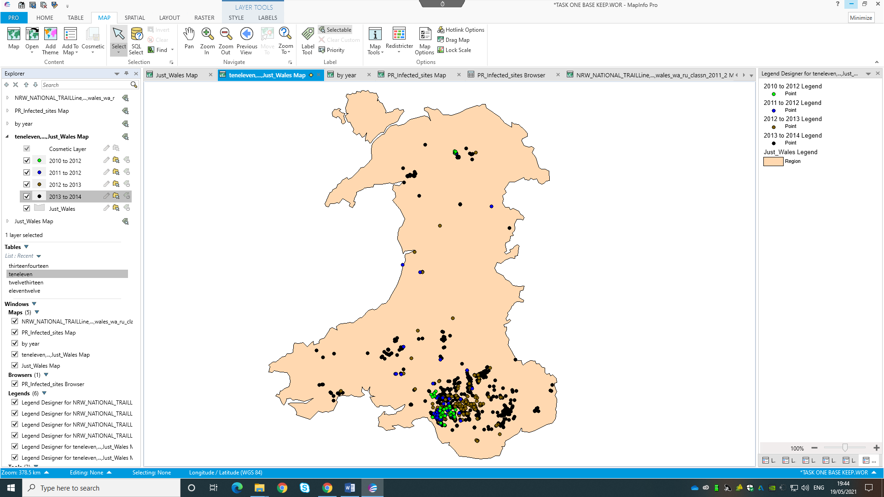

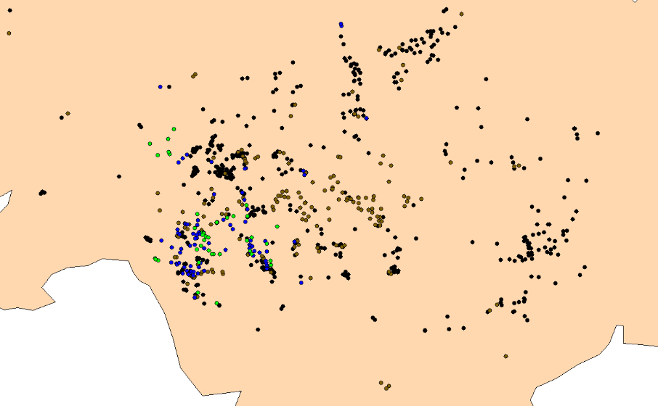
Figure 9: Infected site by date.
Figure 10: South Wales Focus.
Figure 9 shows when the infected sites were recorded. From the map, we can see where the pathogen was first located in 2010 to 2011, and the process of it moving through the Afan Valley (Figure 10). However, a key factor which makes the pathogen challenging to record and regulate is that tress can be infected but without symptoms for years (Welsh Government, 2019). Often in conservation, recording efforts can be spoaradic; meaning that certain locations get assessed before others. Therefore, due to this, no true analysis can be completed or inferred within this section.

1.5 Recommendations for National Resources Wales

There are many drivers of the spread that have been identified within this study. Key drivers include landscapes and weather, which cannot be controlled. Therefore, this paper suggests focusing on factors that can be mitigated. Continuing efforts to inform the public of P. ramorum and what they can do to help, i.e. cleaning shoes when entering woodlands. Additionally, as many plants with P. ramorum may not show symptoms, which makes recording efforts particularly challenging, this paper also recommends furthering and investing in the technology which detects P. ramorum without symptoms. For example, O’Brien et al. (2009) reviewed the use of rapid DNA and antibody tests. Whilst results vary, these technologies are often more effective than relying on site surveys. However, a more cost-efficient way of recording infections is to focus on areas, as opposed to individual trees. Centre for Agriculture and Bioscience (2020) recommend this method, as it considers various plant species that produce spores and therefore can act as drivers of P ramorum.

1.6 Limitations

There are several limitations that must be considered within this research. Firstly, no data could be located for humidity and average rainfall. As these factors are large contributors to the spread of P. ramorum, the analysis is deficient. Similarly, no data could be found which described average wind speed, which is another key contributor to the spread. Therefore, this was substituted for ‘Pre-Assessed Areas for Wind Energy’ (Welsh Government, 2021). Whilst this shows some areas of high wind, it does not indicate all areas of high wind as such locations may be unsuitable for the infrastructure. Additionally, another limitation of this report is the differing dates of the layers acquired, making the information inconsistent. These factors combined represent a key limitation of GIS systems.

Conclusion

Adopting the data provided, this study has illustrated the spread of Phytophthora ramorum within Wales. Data sets were created to illustrate the infected sites, along with numerous factors impacting the spread. The construction of these map sets was described. Overall, the results supported the research reviewed. The infected sites were consistent with the river networks and areas of high wind. Also, connections were made with human activity and the cluster points. Recommendations for NRW included: focusing on controllable elements of the spread (i.e. human activity) and investing in the recording of the spread via DNA and antibody tests, along with assessing sites as a whole. Limitations of the study included the lack of data for average rainfall and wind speed, and the varying date of the data acquired.

1.8 References
Bajjali, W. (2017) ArcGIS for Environmental and Water Issues. Springer International Publishing: Switzerland.
Centre for Agriculture and Bioscience (2020) Phytophthora ramorum (Sudden Oak Death (SOD)). Available at: https://www.cabi.org/isc/datasheet/40991#todetectionAndInspection (Accessed: 19th April 2021).
Chung, S.Y. (2019) GIS and Geostatistical Techniques for Groundwater Science. Elsevier: Netherlands.
Cobb, R.C., Haas, S.R., Kruskamp, N., Dillon, W.W., Swiecki, T.J., Rizzo, D.M., Frankel, S.J., Meentemeyer, R.K. (2020) ‘The Magnitude of Regional-Scale Tree Mortality Caused by the Invasive Pathogen Phytophthora ramorum’ Earth’s Future, 8(7). DOI: 10.1029/2020EF001500
Condeso, T.E., Meentemeyer, R.K. (2007) ‘Effects of landscape heterogeneity on the emerging disease sudden oak death.’ Journal of Ecology, 95, pp.364-375. DOI: 10.1111/j.1365-2745.2006.01206.x
Forest Research (n.d) Ramorum disease (Phytophthora ramorum). Available at: https://www.forestresearch.gov.uk/tools-and-resources/fthr/pest-and-disease-resources/ramorum-disease-phytophthora-ramorum/ (Accessed: 2nd May 2021).
Frankel, S.J., Kliejunas, J.T., Palmieri, K.M. (2008) Proceedings of the sudden oak death third science symposium. Pacific Southwest Research Station: Albany, CA.
Harris, A.R. (2014) The epidemiology of Phytopthora ramorum associated with Larix in the UK. Unpublished PhD thesis. Imperial College London.
Mutluoglu, O., Ceylan, A. (2009) ‘Accuracy and cost comparison of spatial data-acquisition methods for the development of geographical information systems.’ Journal of Geography and Regional Planning. 2(9), pp.235-242.
Natural Resources Wales (n.da) Why we need more trees- the benefits of new woodland creation. Available at: https://naturalresources.wales/guidance-and-advice/business-sectors/forestry/woodland-management/new-woodland-creation/why-we-need-more-trees-the-benefits-of-new-woodland-creation/?lang=en#:~:text=They%20can%20protect%20against%20pollution,are%20important%20reserves%20of%20carbon (Accessed: 2nd May 2021)
Natural Resources Wales (n.db) Acient Woodland Inventory. Available at: https://naturalresources.wales/evidence-and-data/research-and-reports/ancient-woodland-inventory/?lang=en (Accessed: 2nd May 2021)
O’Brien, P.A., Williams, N., Hardy, G.E.S.J. (2009) ‘Detecting Phytophthora.’ Critical Riviews in Microbiology. 35(1), pp.169-181. DOI: 10.1080/10408410902831518
UK Centre for Ecology & Hydrology (n.d.) Risk, climate and host suitability layers for Phytophthora ramorum and Phytopthora kervoviae plant pathogens in Scotland. Available at: https://catalogue.ceh.ac.uk/documents/3a73d5f0-ff33-4bad-9938-0251bc8fd961 (Accessed: 2nd May 2021).
UK Data Service (2010) GB Wards, May 2010. Available at: https://borders.ukdataservice.ac.uk/easy_download_data.html?data=Gb_wa_2010_05 (Accessed: 3rd Map 2021).
UK Data Service (2010) Welsh Wards, May 2010. Available at: https://borders.ukdataservice.ac.uk/easy_download_data.html?data=Wales_wd_2010_05 (Accessed: 4th May 2021).
UK Data Service (2011) Welsh Built-Up Areas 2011. Available at: https://borders.ukdataservice.ac.uk/easy_download_data.html?data=Wales_bua_2011 (Accessed: 17th May 2021).
UK Data Service (2012) Welsh National Parks 2012. Available at: https://borders.ukdataservice.ac.uk/easy_download_data.html?data=Wales_np_2012 (Accessed: 17th May 2021).
Welsh Government (2019) Phytophthora ramorum Strategy for Wales. Available at: https://gov.wales/sites/default/files/publications/2021-01/phytophthora-ramorum-management-strategy.pdf (Accessed: 2nd May 2021).
Welsh Government (2021) Ancient Woodland Inventory 2021. Available at: http://lle.gov.wales/catalogue/item/AncientWoodlandInventory2021/?lang=en (Accessed: 4th April 2021).
Welsh Government (2021) Main Rivers. Available at: http://lle.gov.wales/catalogue/item/MainRivers/?lang=en (Accessed: 4th May 2021).
Welsh Government (2021) Policy 17- Pre-assessed areas for wind energy. Available at: http://lle.gov.wales/catalogue/item/NDFPreAssessedAreasForWindEnergy/?lang=en (Accessed: 4th May 2021).

1.9 Appendix

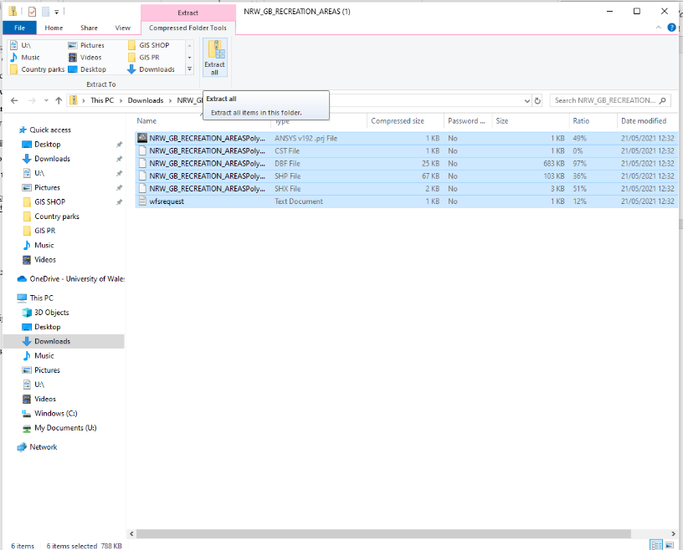
Appendix 1: Unzipping the downloaded data
Figure 1: Unzip in document.
Once the data was downloaded, it was unzipped by selecting: File Explorer > Downloads > Folder > Open > Select All > Extract All.

Appendix 2: Placing the map sets on to the base map
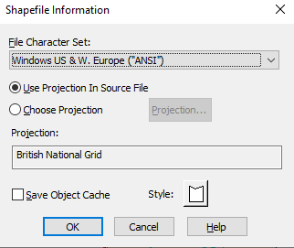

Figure 2: Selecting the Shapefile information

Once acquired, maps were placed on to the system by selecting: HOME > Open> File of type > OK.
This process was completed for each of the layers and map sets.

Appendix 3: Process of placing the data points on to a base map of wales.

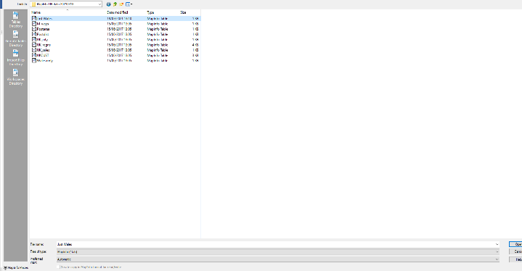

Figure 3: Opening the layer documents.

The base map of Wales was placed on the map by selecting: HOME > Open > MapInfo (*.tab) > Just Wales > Open.

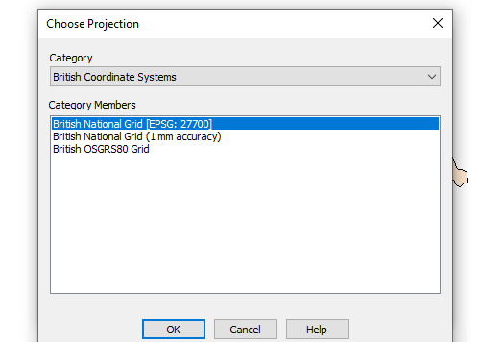
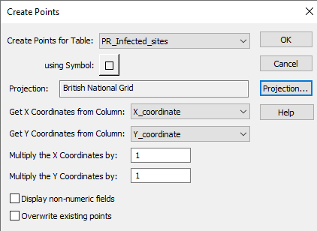

Figure 4: Creating the data points.

The data points were created by selecting: SPATIAL > Create Points > Projection> British National Grid> OK.

Appendix 4: Creating data points by date through SQL select.
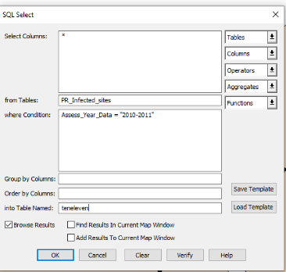

Figure 5: SQL select

To show when the infections were recorded, the points were made by selecting: SPATIAL > SQL Select > Tables > PR_Infected_Sites > Columns > Access_Year_Data > where Condition > Assess_Year_Data = "2010-2011"
This was repeated for each category by altering the condition to each year, i.e. “2011-2012” and so on.
Appendix 5: Symbol override
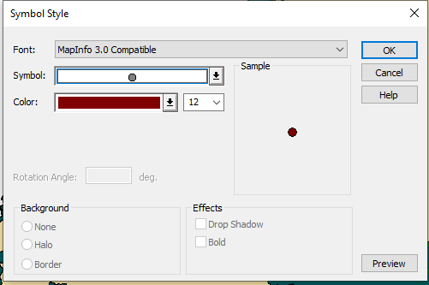
Figure 6: Symbol override
Symbols were changed to show each data point clearly through selecting: Symbol override > Symbol > Select A and Number > Color > Select color > Size > Select size OK.

Appendix 6: Good and bad map set design.

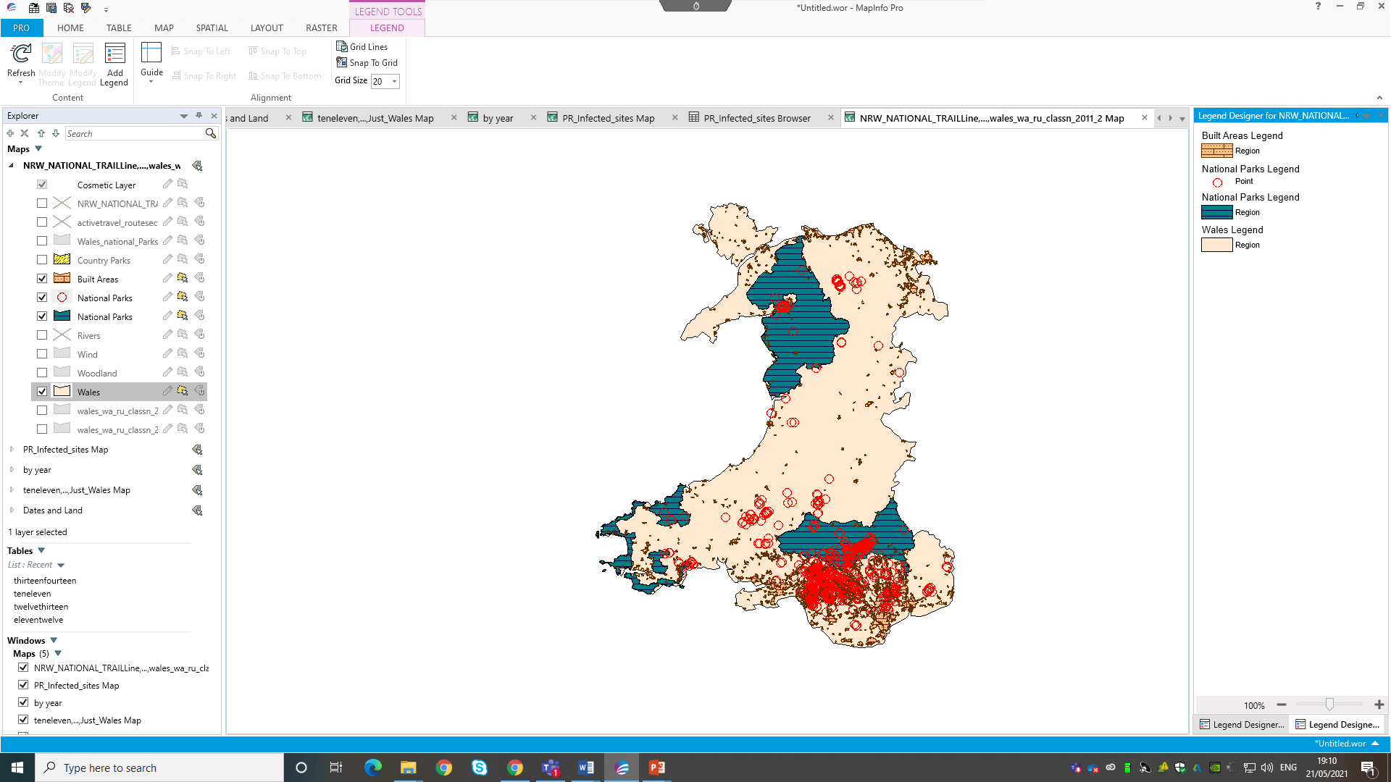
Reasonable scale
Clear legend

Contrasting colours

Figure 7: Good design.
No legend
Unreasonable scale of data points.
Colours of the same shade, making the map less easy to understand

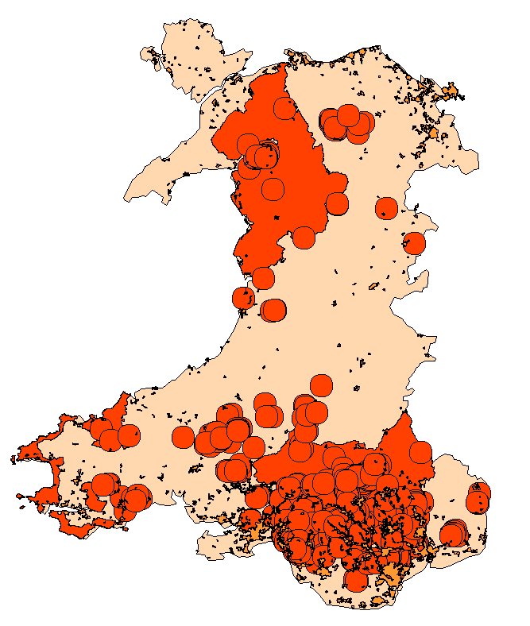
Figure 8: Bad design.

2.0 Task two

2.1 Introduction

As part of an independent project which utilised a questionnaire approach to assess public perceptions of insects, a myriad of factors which contribute to perceptions of insects were uncovered. Within the research, a key element of the report focused on how urbanisation impacts levels of disgust experienced with encountering insects. Fukano & Soga (2021) provided the baseline for this section of the project. Their research suggested that urbanisation leads to more indoor insect encounters and reduces public knowledge of insects. As urbanisation is increasing globally, Fukano & Soga (2021) revealed that these factors play a significant role in negative insect perceptions.
As discussed in section 1.0, a key aspect of GIS is that it can be applied to a range of subjects. In academic report writing, GIS offers an effective tool for displaying key findings in an understandable way. However, the system is not without limitations.
Utilising the questionnaire results from the independent project, this assignment adopts GIS to present the results is a spatial context. Within this section of the report, the skills demonstrated in section one are built upon and applied to the independent dissertation project. Additionally, Geographical Information Systems are critically appraised.
This paper starts an outline of the map construction process in relation to this project. Next, the maps are presented. Then, the merits and demerits of the computer system in an environmental context are discussed. Finally, conclusions are noted.

2.2 Map Construction

The data adopted for this report is from an independent project. The project utilised a questionnaire methodology to asses a range of factors contributing to perceptions of insects. The following sections describe the construction of the maps.

2.2.1 Data Cleansing

The first step of creating the map sets was to cleanse the data. Data cleansing is a key step when placing primary data into GIS. Within this research, the data cleanse included three steps. Firstly, unwanted responses in the results were deleted. This included incomplete responses and responses without post codes. Additionally, As the data used for this research was part of a wider project, the data had to be simplified. This included the removal of questions and responses from topics and areas outside of this study’s focus. Next, the headings of the spreadsheet were changed from the full survey questions and instructions to shorthand descriptions of the context of each column. The survey was checked for typographical errors and overall consistency. These three steps combined increased the data sets accuracy and uniformity, which made the data easier to work with in the MapInfo System. Appendix 1 shows a before and after of the excel sheet, to illustrate the benefits of data cleansing.

2.2.2 Batch Converting

Within the questionnaire, respondents were asked the first three digits of their postcode. This represents the first limitation of this project. Because only the first three digits of the post code were asked, MapInfo represented multiple responses as one data point. The postcodes were converted to X and Y coordinates using an online batch converter website to allow for data points to be created (see appendix 1).

2.2.3 Creating the Data Points and Data Acquisition

Data points were then created using the X and Y coordinates. This is shown in appendix 2.
In order to assess the data in a geospatial context, several layers were acquired. The table below illustrates each layer acquired, along with their description, file type, and reference. Once acquired, the layers were placed onto the map. This is illustrated in appendix 3.

Table 1: Layers attained through data acquisition.
Map set | Factors considered | Data Points and Layers acquired | File type | Reference
Base map | Map of the United Kingdom | Map of UK | Shapefile | UK Data Service (2010)
Insect encounters in relation to UK cities | Urban Locations | Built-up areas | Shapefile | UK Data Service (2011;2011)
Insect encounters in relation to green spaces | Green spaces | National Parks | Shapefile | UK Data Service (2012;2012)

2.2.4 SLQ

As the data used for this research was part of a wider project, the data had to be categorised. Different data points were created using SLQ select. This process is shown in appendix 4. For the project, the data was split into four categories. The table below illustrates the categories chosen.
Legend title | Description
‘Seeing an insect in my home bothers me, strongly.’ | This shows people who responded to the questionnaire that strongly disliked insects in their home
‘Seeing an insect in my home bothers me.’ | This shows people who responded to the questionnaire that disliked insects in their home
‘Seeing an insect in my home doesn’t bother me, strongly.’ | This shows people who responded to the questionnaire that strongly weren’t bothered by insects in their home.
‘Seeing an insect in my home doesn’t bother me.’ | This shows people who responded to the questionnaire that strongly weren’t bothered by insects in their home.
Table 2: Description of the differing categories within SQL select.

2.3 Map Sets
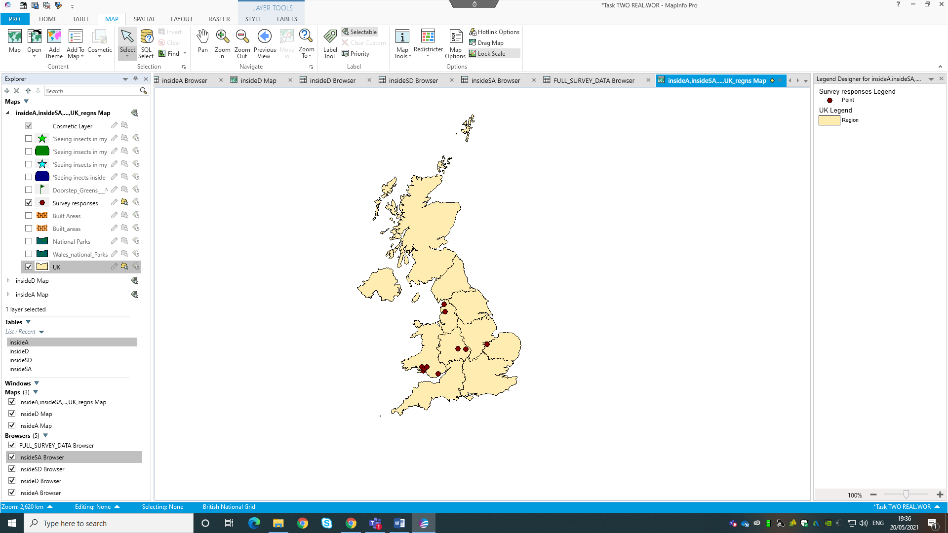

Figure 1: Survey responses on map of the UK.
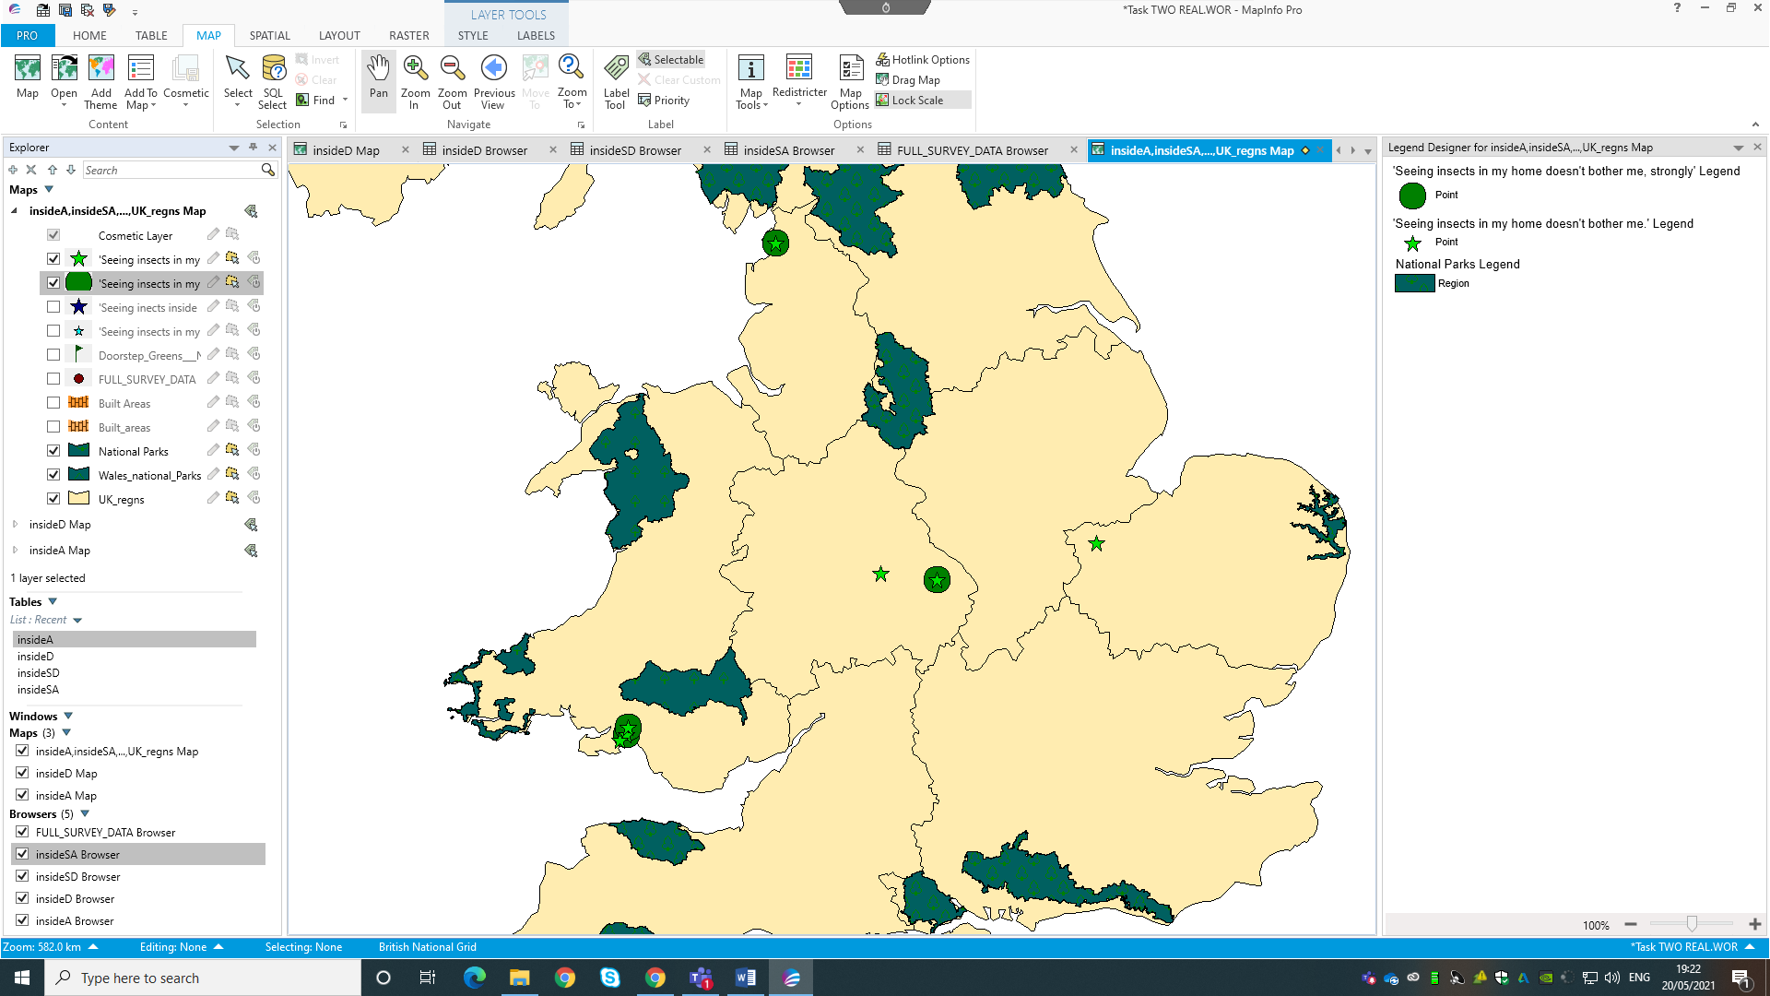

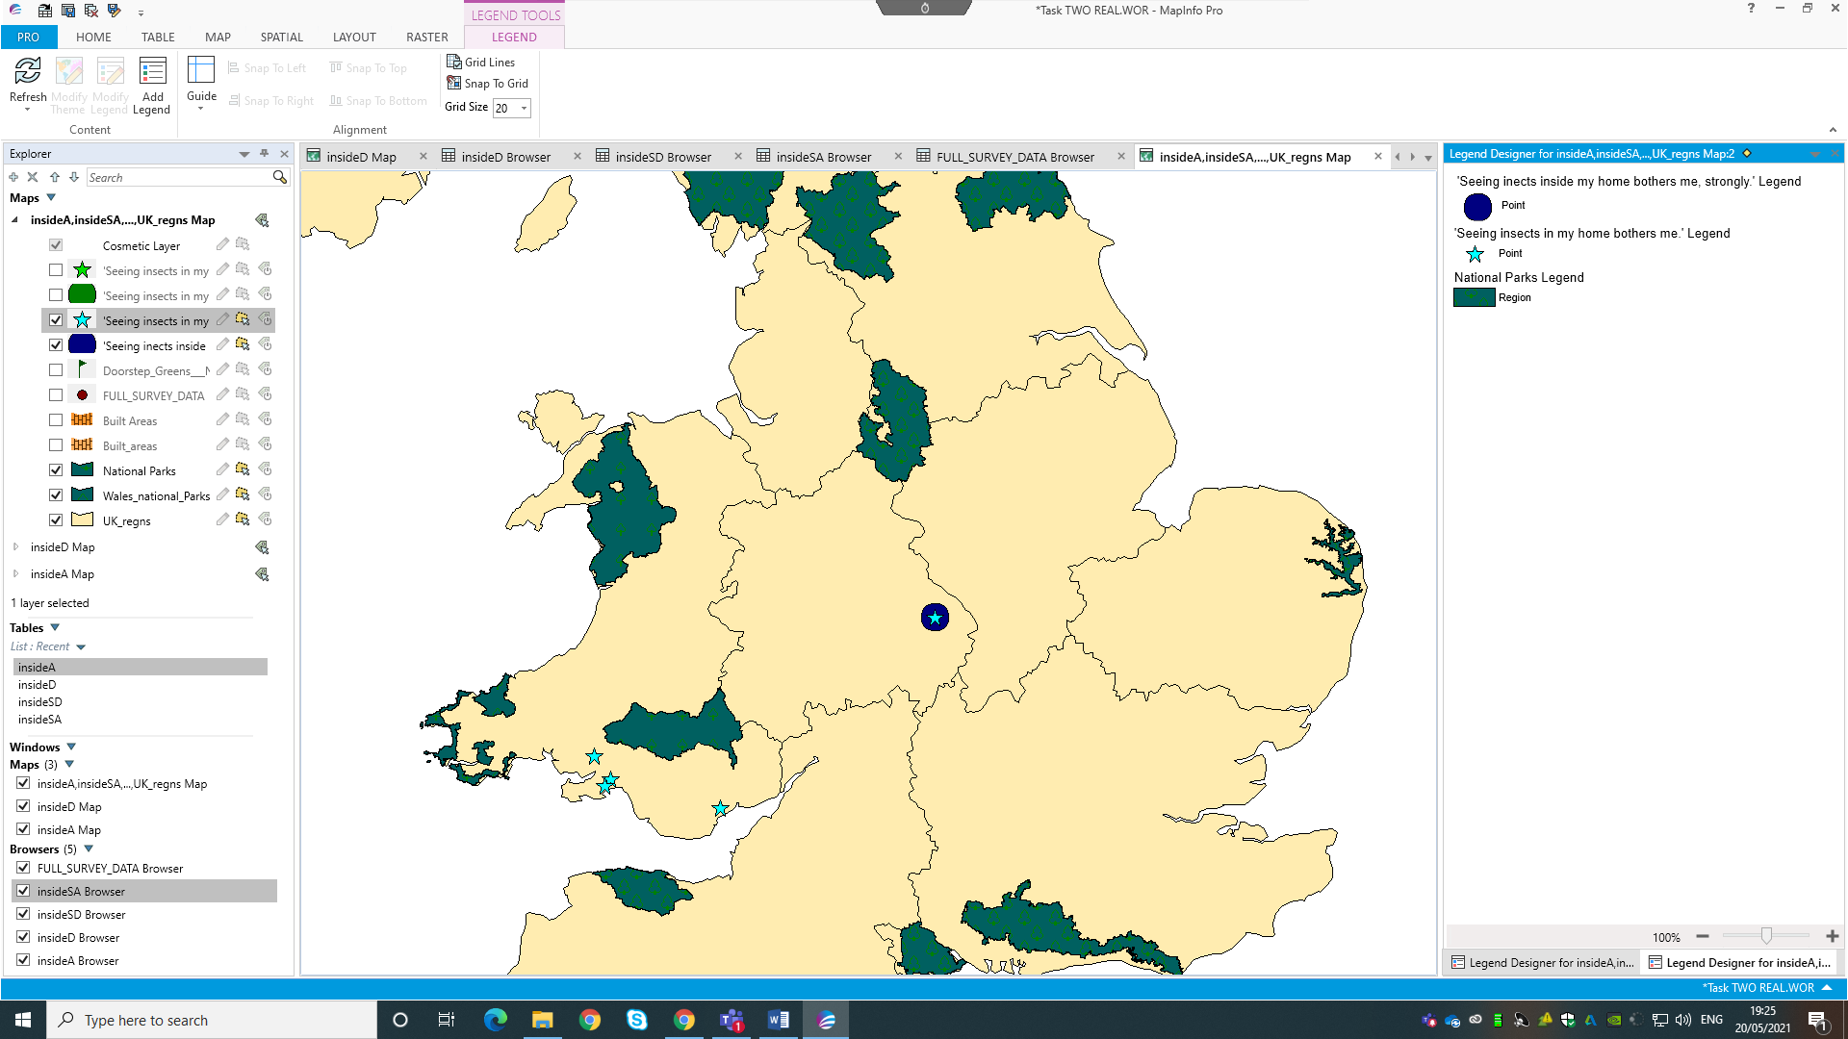
Figure 2: National Parks and positive insect encounters
Figure 3: National Parks and negative insect encounters.
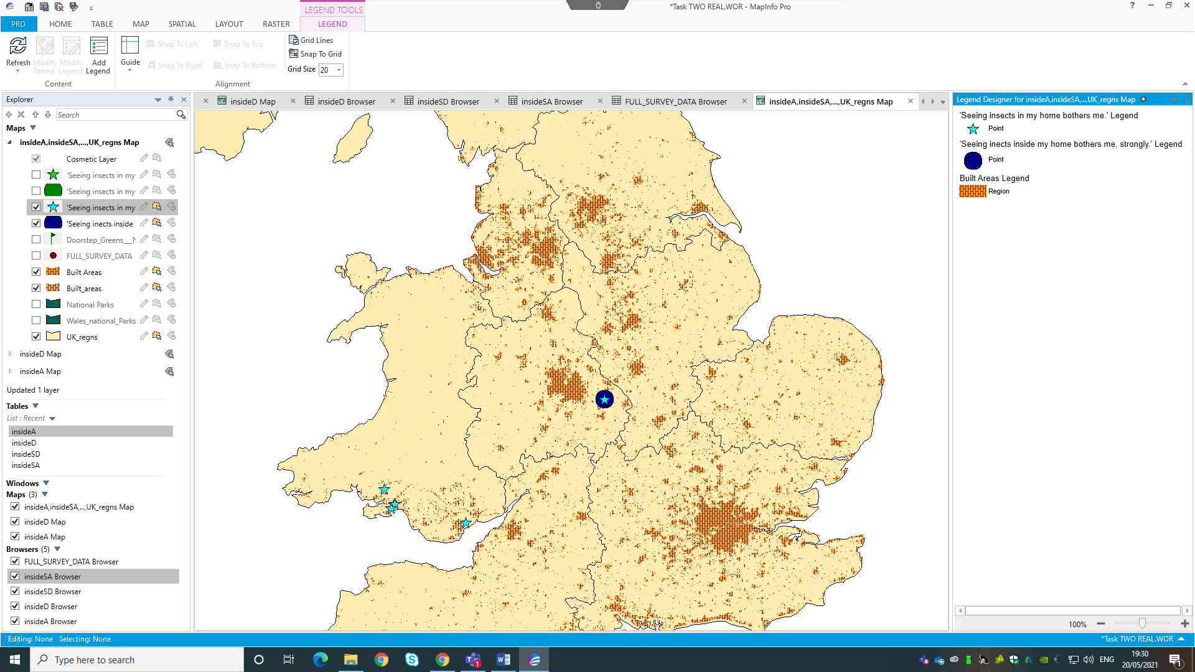
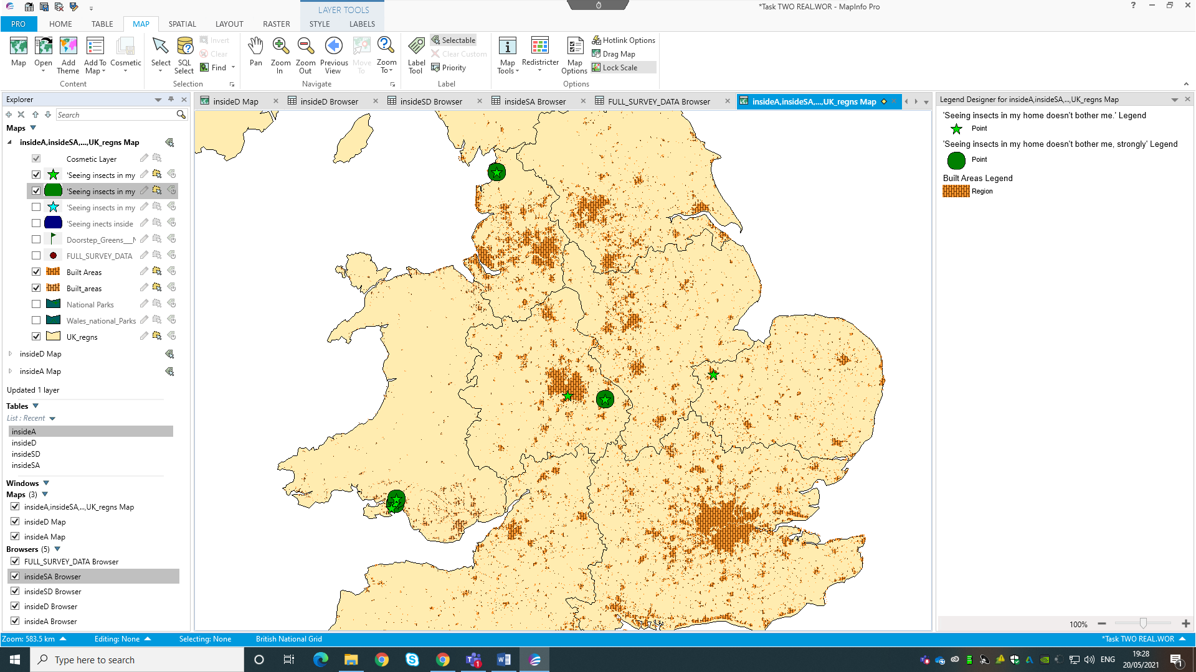
Figure 4: Built areas and positive insect encounters.

Figure 5: Built areas and negative insect encounters.

2.4 Discussion

As seen in figures 1 through 5, Geographical Information Systems provide a good way of placing primary data on to maps. A key advantage of GIS is that the variables (i.e., layers and data points) are adjustable. Therefore, the map sets can be altered until the desired result is reached. Additionally, the system allows for a variety of techniques and layers to be presented simply and simultaneously. This is made more straightforward if the needed information can be acquired through data acquisition. Within this project, through using the system, a map has been created which shows survey responses along with two factors; built areas and national parks. The ability to create map sets has many benefits for researchers and decision makers. For example, within this research, showing participant responses in relation to landscape and urbanisation allows for further analysis of the results. This is particularly useful when working with social science data. Results can be inferred in relation to where the individual lives. Namely, the results of this study show that the majority of the participants live-in built-up areas. Also, many participants live further away from national parks than they do cities.
However, the system is not without limitations. For example, Chung (2019) states that GIS programs are expensive and require training. In application, there can also be geographical errors, leading to misleading results. Problems can also occur when acquiring secondary data. Whilst online data acquisition websites are quick and simple, the dates they were created can vary, leading to potentially misleading results (Bell, 2004). Also, Bell (2004) argues that whilst there are a variety of tools available, inappropriate use of GIS can take away from the value of data manipulation based on professional experience. Bell (2004) says that primary data must be collected appropriately, and the system can be time consuming if primary data is used.

2.5 Conclusion

This paper has created several map sets utilising the data from an independent project, with the aim to build upon research completed by Fukano & Soga (2021) and apply the findings to the independent project. From the study, it has been identified that the majority of the participants live-in built-up areas. Overall, the use of GIS in this paper provided valuable information to the wider project. Advantages and disadvantages of GIS were discussed. Key discussion points included: the advantages of GIS in this study and academia in general, and the limitations of inappropriate data acquisition as highlighted by Chung (2019) and Bell (2004).

2.6 References

Bell, F.G. (2004) Engineering Geology and Construction. Taylor & Francis: London.
Chung, S.Y. (2019) GIS and Geostatistical Techniques for Groundwater Science. Elsevier: Netherlands.
Fukano, Y., Soga, M. (2021) ‘Why do so many modern people hate insects? The urbanization-disgust hypothesis.’ Science of The Total Environment, 777, pp.1-8. DOI: 10.1016/j.scitotenv.2021.146229
UK Data Service (2011) English Built-Up Areas 2011. Available at: https://borders.ukdataservice.ac.uk/easy_download_data.html?data=England_bua_2011 (Accessed: 17th May 2021).
UK Data Service (2011) Welsh Built-Up Areas 2011. Available at: https://borders.ukdataservice.ac.uk/easy_download_data.html?data=Wales_bua_2011 (Accessed: 17th May 2021).
UK Data Service (2012) English National Parks 2012. Available at: https://borders.ukdataservice.ac.uk/easy_download_data.html?data=England_np_2012 (Accessed: 14th May 2021).
UK Data Service (2012) Welsh National Parks 2012. Available at: https://borders.ukdataservice.ac.uk/easy_download_data.html?data=Wales_np_2012 (Accessed: 17th May 2021).

2.7 Appendix

Appendix 1: The process of cleansing the data and batch converting the postcodes.
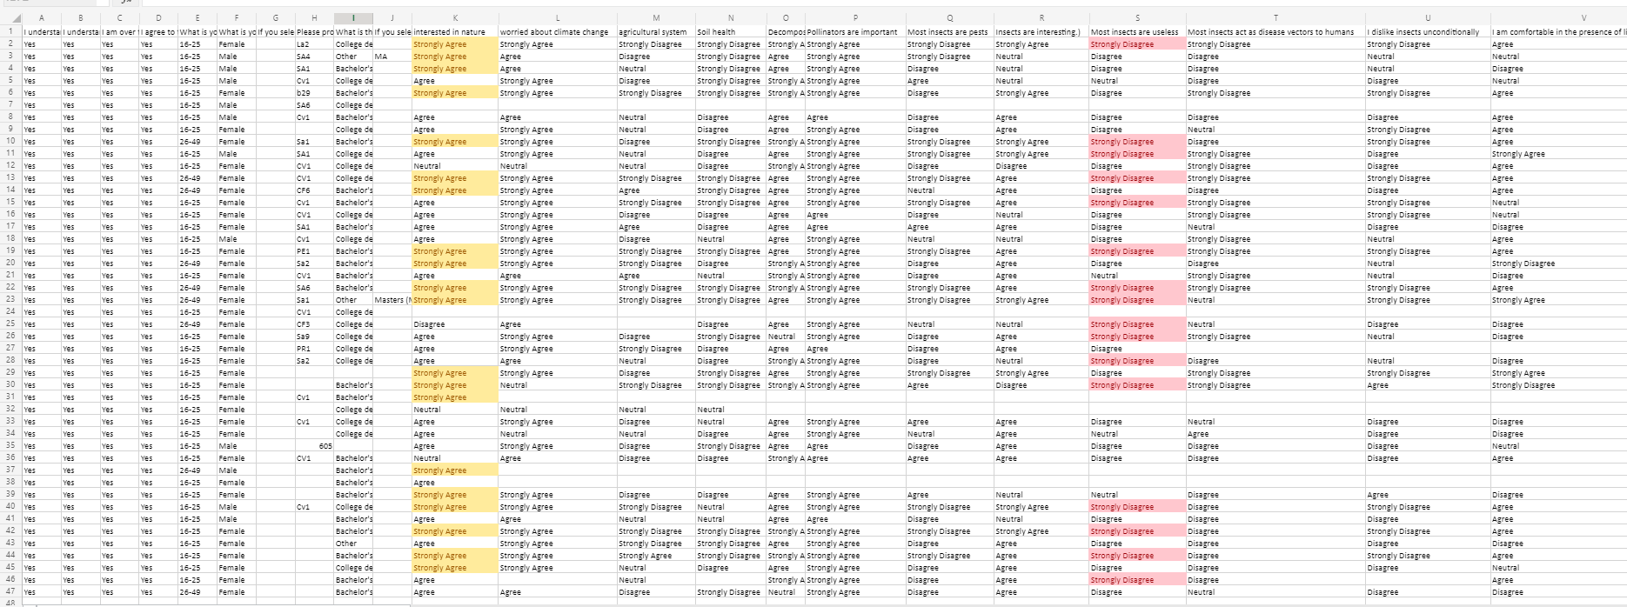
Figure 1: Excel sheet before
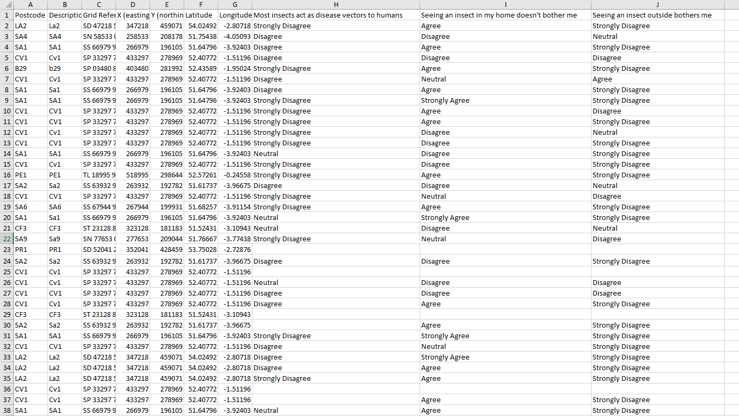
Figure 2: Excel sheet after

Appendix 2: Creating the data points.
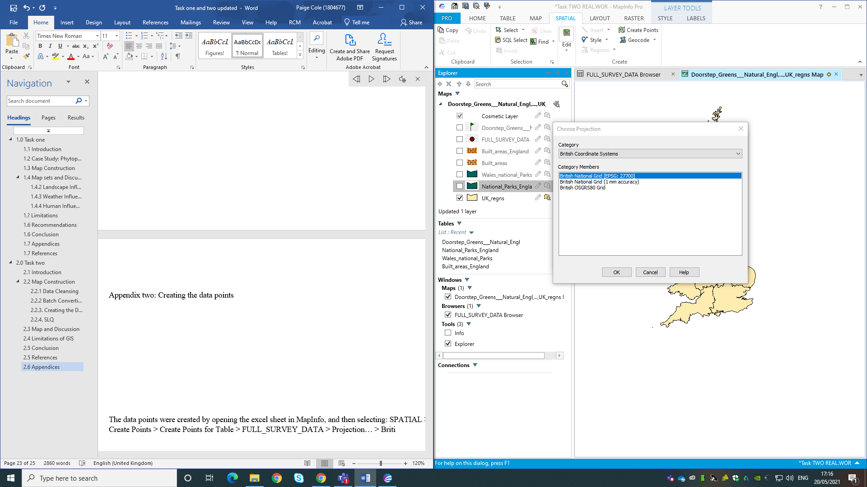
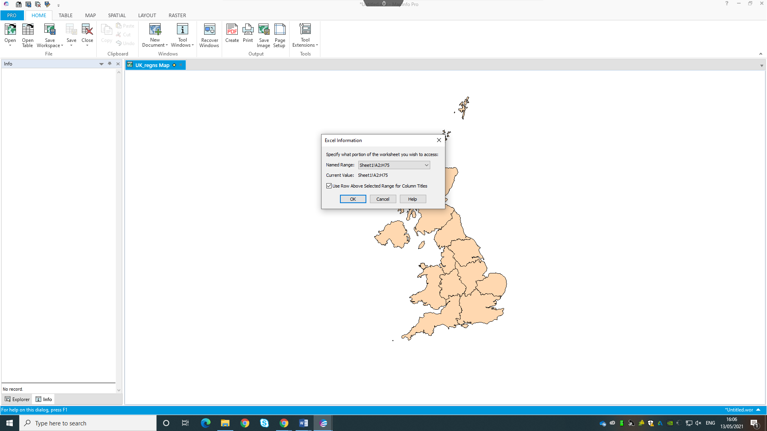
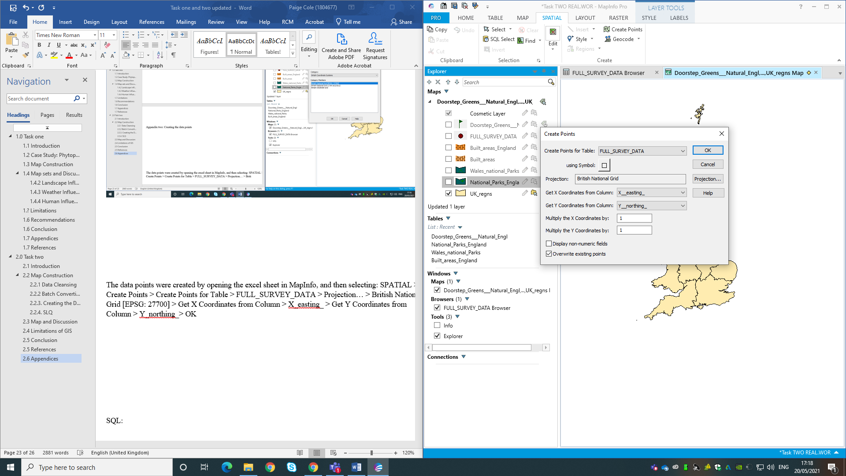
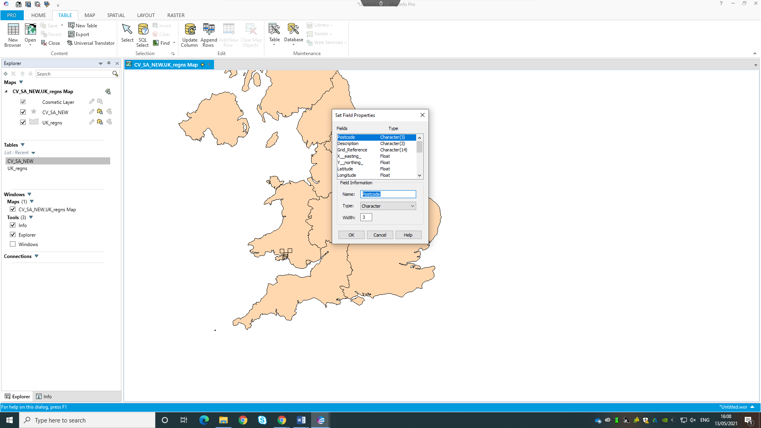

Figure 3: Creating the data points.
The data points were created by opening the excel sheet, and selecting ‘Use Row Above Selected for Column Titles.’ in MapInfo, and then selecting: SPATIAL > Create Points > Create Points for Table > FULL_SURVEY_DATA > Projection… > British National Grid [EPSG: 27700] > Get X Coordinates from Column > X_easting_ > Get Y Coordinates from Column > Y_northing_> OK.
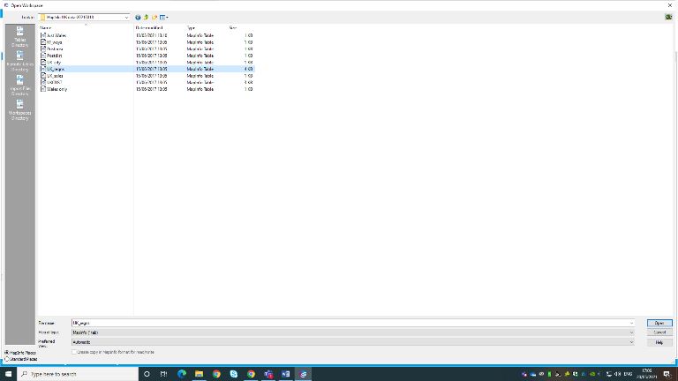
Appendix 3: Placing the base map and layers on the map.
Figure 4: Placing the layers on to the map.
The base map of Wales was placed on the map by selecting: HOME > Open > MapInfo (*.tab) > (Layer needed, i.e. UK_regns) > Open.
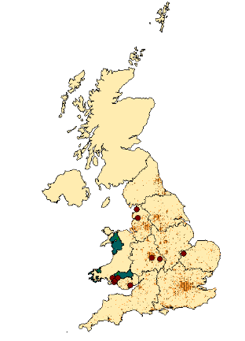
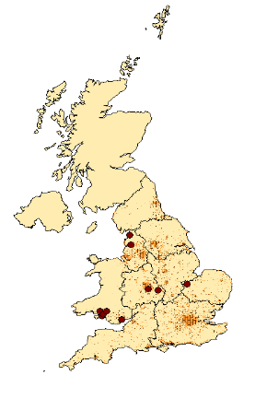
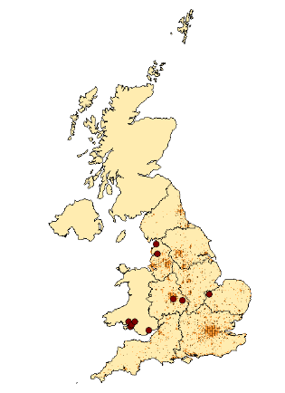
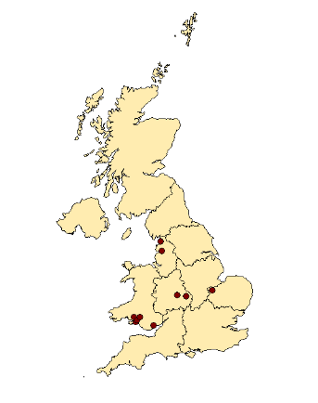
This process is illustrated below.
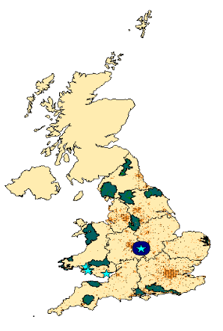
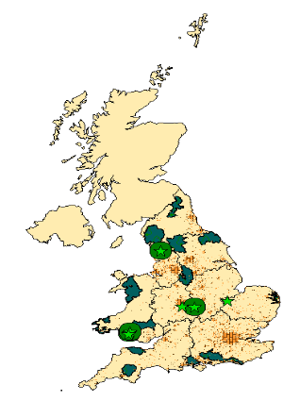
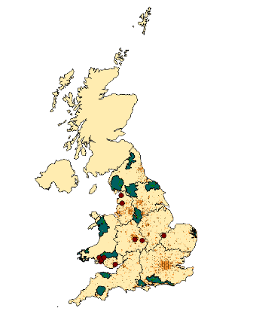

Appendix 4: SQL Select
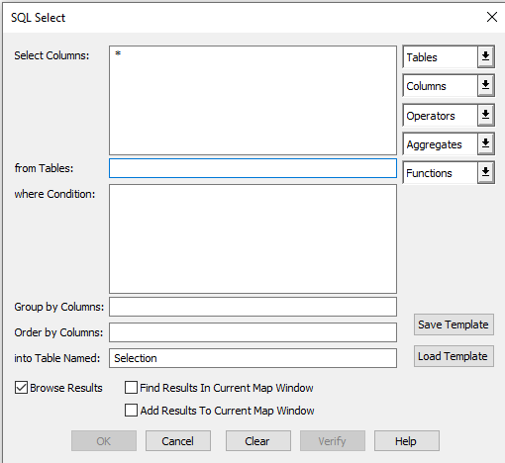
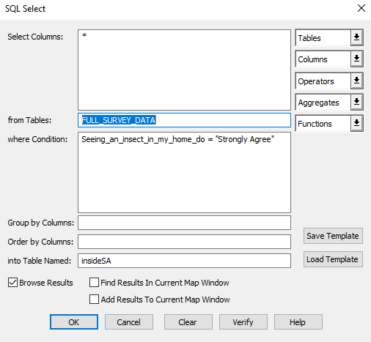
Figure 5:
To show when the infections were recorded, the points were made by selecting: SPATIAL > SQL Select > Tables > SULL_SURVEY_DATA > Columns > Seeing_an_insect_in_my_home_do> where Condition > Seeing_an_insect_in_my_homw_do = “Strongly Agree” > OK.
This was repeated for each category by altering the condition.

