International Meetings Management for the Hotel Industry (BMIH6007)

Event Strategic
Planning and Delivery
Considerations for an
International Meeting.
Student: Orsolya Nagy-Fodor
Student number: 2126671
Tutor: Jemma Smith



Introduction of the event
The world is constantly striving for improvements and sustainability, we try to develop solutions to make our lives and work easier and to protect our environment.
The hotel industry, as one of the largest industries in the world, exerts a lot of pressure on the "health" of the planet during its operation, so it has become of most importance that their system continues to function by using and spreading modern technology.
This event was named Hotel Industry newest technologies and innovations for sustainability practices, which tells about its topic. Its main elements are waste management, optimized "green" operation with a profit orientation, sustainable building operation and education, information about the latest opportunities and innovations. (Techtarget, 2023)
This corporate event about newest technologies and information's how to operate modern sustainable practices within the hotel industry for hotel managers and owners (targeted market) who consider it important to meet the needs of guests looking for sustainability on the market while preserving their uniqueness while applying technical and practical solutions on a daily basis. In choosing the location, the ExCel building in London, whose international approachability can significantly increase the interest of the participants in the event, has fallen on a building that authentically supports the cause. (ExCel London Sustainability, 2024) It will be held on August 31, 2024, which also means that the event will be more accessible once the main holiday season is over.
Although the event is primarily of a professional nature, it is also open to the interested community. The number of tickets sold is 1,000, but the capacity of the building is suitable for many more. The location that uses renewable energy is accessible by car (it has 3,700 parking spaces) and by public transport. The rent is also favourable for this reason. (ExCel London Organiser, 2024)

The Event Cycle
As soon as the need for the event arose, preparations began with planning, budgeting and defining the goals of the event. Strong plan stands for success. Although the event is only a one-day event, the preparation and structure of the tasks must proceed based on a well-developed plan. In this, the Gantt system (Gantt, 2024) provides excellent guidance, which, in addition to being followed, is precisely assigned which activities must be carried out within which deadlines and intervals. As part of organization program location and design plan has to be made and invite all the participant also advert the event in relevant platforms. See in appendix. (Picture 2) (Team Gantt,2024)
On the day of the event, the catering staff and hosts as well as security personnels are responsible for serving and entertaining the participating guests, speakers and exhibiting partners. After the coordination is completed, the finance will speak about how well the event went by numbers, but recent survey assesses the satisfaction of the guests, which provide excellent feedback to measure success of the current project for the sake of future events. (Project Manager, 2023)

Event Concept
After arriving in the morning, the participants of the event can listen to presentations by experts and researchers of the topic. The presentations are interactive, so in addition to the exchange of information, new ideas can be generated through the activities of the participants. As a full-day program, the exhibitors are waiting for hotel owners with product presentations and shopping opportunities. Offering the latest environmental protection solutions systems that are barely or rarely used in practice to those interested. The "wow" factor for the audience is provided by the already electronically sent QR code ticket (My QRCode, 2024) and electronic check-in gates. The performance will be available for participants to review with the help of a drone. At the end of the event, an automatic online survey will be sent to the email address of the participants. Waiting for feedback that can be evaluated. (Cuseum, 2022)
The most important about the event is the engage the exhibitors and the guest to increase their interest about the current and the future events. The reason of the exhibitor/ sponsors interest is they able to meet a bunch of people whose are in their targeted market range. Introduction of their products and services can be beneficial in future and can increase they sales in general. The attendants can benefit of newest ideas and information about sustainable practices, how to engage "green" travellers and maintain or increase revenue led to profit maximalisation. The highest quality products and dynamic performers, highest cuisine experience in excellent and organized event will provide unforgettable memories to the professional industry hospitality leaders. (Social Tables, 2024)

Aim and Objectives of the Meeting / Event
The primary goal of the event is to make profit for the organiser and secondary goal is to increase the efficiency of the industry and bring together the supply and demand of exhibitors and Hotels. Promotion of the products of the exhibitions. If we are talking about measurable goals, the primary goal is to reach the pro, which can be measured by numbers. The event can be considered a success if the attendance is higher than the pre-purchased tickets. Also, in terms of feedback, if at least half of the participants give feedback, as it would testify to the great impression. (EventBrite, 2022)

Event Operations
The most required skills to start an event is time management, flexibility and decision making. At the meantime experience and industry knowledge is could be essential to understand the aims and goals of the event. Event industry is a fast paced and constantly changing environment, new trends and creative ideas comes and goes. Confidence and good listener of people can help to work efficiently. Passion helps to pass your interest and belief of what you as organiser do is made for success. Creativity as skill can help to move on different issues and eyes on details help to prevent unexpected risks. (Falmouth University, 2020)
Correct budgeting can mean a lot if the organiser well informed and a good communicator in world also written otherwise there is a risk of mistaking. Interesting thing but emotional intelligence as skill can be very beneficial as it impacts how we make decisions and work together with other people. (CVENT, 2023)
Main resources are on the event those people whose are performing on stage and hosting the guests during the event day. For them the event requires staff room where they can spend their break time and can prepare their self for performance. Most of the workers, hosts, security, and catering staff will come to the event from an employment agency, who will receive the agenda and to-do list in advance.
The hosting staff receive brief of the event on the day and their task for the day also health and safety instructions. Their position does not require to be professional except security guards they must to have the licence to work in the premises.
The stage and all the audio and visual design provided by the venue. Stage surrounded sitting area chairs and sofas are provided by venue also tables and chairs for hospitality sector for the caterers. This event does not use any flower, or any temporary decoration is the name of sustainability. (Ganttic, n.d.) Electrical cables and plugs also provided by the location. The venue concentrates on simplicity and only put light on technology and the exhibitors’ products. Planning means every step planed and have a need so check list recommended to make sure all things running smooth and efficient.

Event Budget
The main revenue is coming from presold tickets sale (1,000 tickets sold), sponsorships (exhibitors are sponsoring and paying for their spot at venue as they have chance to introduce their business and product to the hotel leaders) catering company also paying for trading on venue and merchandising (sale reward after catering from outsider catering company)
Finance pre calculation based on similar events. The total expected income is 110. 000 Pounds. Against to this expense’s location rent and cleaning after venue (10.000 Pounds) and event staffing as hosts, cleaners, security will cost 4.000 Pounds, the marketing, advertising, and administration takes 6.000 Pounds for budget. The authors and speakers whose are responsible for the live entertainment cost 10.000 Pounds and it is included their daily fee, their flying ticket, accommodation for two nights in the hotel nearby and their food and beverage during their stay. The event budget secured 10.000 Pounds for unexpected loss, damage, or replacement as force majeure. (Event Stop, n.d.) Total expenditure will cost 40.000 Pounds and it shows the event is on profit after all with 90.000 Pounds. See in appendix. (Picture 1)

Industry Trends / Issues / Impacts
Strength of the event this is a modern game changer and demanding topic for industry leader hotels to build more guest, increase their brand reputation and engage existing guest with investments and changes in their business operation. The entry tickets are not overpriced so it can be more attractive to attendance. Professional industry speakers about newest findings and interactive speech can increase of interest and guest engagement on the event. (NBS, n.d.) (I Always Believe In Futures, n.d.) Easy to access to location as London is the capital of the United Kingdom and has many airport for international guest.
Weakness is the event hardly can advertise in social media as the targeted market is hospitality professionals, so it is limiting the advertising platforms. But to change this direct marketing can help to reach the targeted audience. Also, in cost of living crises people and the businesses think twice to spend on investments, however sustainable practices are always cost to invest in even if in long term it means profit. (The Access Group, 2024)
Opportunities for the future to organise this event regularly and make profit on every year. Expand the event to organise in other countries also in Europe. As event organiser it can put on the “map”. Hopefully, in practice, hotel directors or owners can be directed towards the green approach.
Because of market competition other event organisers can copy the method of this event and make profit for their self can be Threats. Industry competition is huge but also market for sustainable practices are. (EMRG Media, 2023)
Political issue can be because of BREXIT (United Kingdom left the European Union) might some of the international traveller need visa to enter to the country or evidence to show such as return ticket on the border. (House of Commons Library, 2023)
The event supports the sellers and buyers’ relationships so economically made to make profit for both participants. Sociologically the event supporting sustainable and healthy industry and lifestyle for hotel guest and environment worldwide. Green travellers and low carbon footprint on earth is trend increasing in last decade. (Statista, 2024)
Technological theme means the venue has own WIFI and lot of tech related gadget and product, for example online check in gate and drone recorded live from auditions. Sponsor exhibitors are supplying AI and technology-based services, supporting hospitality operations. One exhibitor/sponsor provide four robotic humans for the event to increase the "wow" factor. Two will be placed to the entrance to welcome the guests and two at the catering area in the hope it will be great experience for the visitors.
Legal issues are the health and safety consideration, risk assessment and premises licences, insurance need to be sorted by organiser or by venue provider.
Environmentally friendly venue providing the location, but to reach that participants need to travel with can increase carbon footprint (cars, plane, public transport) also catering and exhibition produce lots of waste but in case of right recycling system can reduce the impact on nature. (BBC Bitesize, 2024)

Cultural and Situational Considerations
The event is expected to be a culturally diverse community, as the invited speakers and audience come from all over the world. First, the food is very important, as health and safety, correct labelling, play a prominent role, since it is very easy to cause mass food poisoning at such a large, full-day event, which can cast a very bad light on the event. It can also cause minor health traffic in nearby hospitals. As the most dangerous food allergen caterer has must not offer nuts and foods contain nuts on event.
Fortunately, the weather will not affect the event as it only operates indoors, so it can be held at the original location even under unfavourable conditions. Since the flights of the airlines are often delayed, it can happen that if it turns out that the guests' planes are delayed, but the tickets purchased in advance are not refundable. (Food Standard Scotland, n.d.) In case of public transport strike -what is not regular- in London but can happen international travellers can find difficult of pricier to reach the venue.
The health and safety need to be considered as this event expect hundreds of attendants. Risk assessment is the key to consider potential hazards. As this event has an entertain stage where the speakers are entertaining there is a risk of electric cables are not hidden which can cause accident, before the gates are opening for public need to complete the risk assessment check list and then let the participants in the venue.
Also important to check if the first aid room and all the equipment are ready in case of emergency occurs. The venue has lots of emergency exit and is has to be show by visible sign (require by the law) but it can be blocked by exhibitors or any other reason. So, before the opening also need to be checked by security and so during the event day.
After the event actively has started the planning and paperwork must change for management and monitoring, to make sure all the planned action became smoothly and safely.
Important to inform the staff in case of evacuation from the venue because of bomb or fire or any other reason how to assist and guide hundreds of people to leave the building. Emergency service for example ambulance car next to venue also could be helpful to provide professional help in case of need, but first aid and trained first aider on duty is the minimum essential. (Health and Safety Executive, n.d.)

Conclusion
It is very difficult to come up with something new in the market. A good idea in itself is little to succeed. In reality, a plan is to be prepared, planning, resources and skills. To make such an international event, it requires thoughtfulness from each aspect. Exploring possible visions and emergency situations that may threaten the event, the health of the participants, and the financial and predetermined event goals. If you still succeed as expected. Complete the event and successfully close it with profit satisfaction. It is recommended to be organized regularly or in other countries.
References

- BBC Bitesize (2024) Available at: https://www.bbc.co.uk/bitesize/guides/zcjhfcw/revision/2
Accessed on 27st May 2024

- Cuseum (2022) Available at: https://membership.cuseum.com/digital-membership-cards?utm_term=electronic%20membership%20cards&utm_campaign=CC:+United+Kingdom&utm_source=adwords&utm_medium=ppc&hsa_acc=2822563175&hsa_cam=18517071302&hsa_grp=143005557518&hsa_ad=626280870460&hsa_src=g&hsa_tgt=kwd-305986888240&hsa_kw=electronic%20membership%20cards&hsa_mt=b&hsa_net=adwords&hsa_ver=3&gad_source=1&gclid=Cj0KCQjw3tCyBhDBARIsAEY0XNm_WYJsEkf9OvWJlryaBfZBDac_CpHfwolec4pe3YNtKBOVttPz6cYaApUdEALw_wcB Accessed on 27st May 2024

- CVENT (2023) Available at: https://www.cvent.com/uk/blog/events/12-event-planning-skills-you-need-success Accessed on 27st May 2024

- EMRG Media (2023) Available at: https://www.emrgmedia.com/how-to-beat-the-competition-in-the-industry/ Accessed on 27st May 2024

- EventBrite (2022) Available at: https://www.eventbrite.co.uk/blog/goal-setting-for-event-planners-ds00/ Accessed on 27st May 2024

- Event Stop (n.d.) Available at: https://www.eventstop.co.uk/knowledge_hubs/How-to-budget-for-your-event Accessed on 1st May 2024

- ExCel London Organiser (2024) Available at: https://www.excel.london/organiser/venue-services Accessed on 1st May 2024

- ExCel London Sustainability (2024) Available at: https://www.excel.london/visitor/sustainability-and-legacy Accessed on 1st May 2024

- Falmouth University (2020) Available at: https://flexible.falmouth.ac.uk/resources/top-10-event-management-skills
Accessed on 27st May 2024

- Food Standard Scotland (n.d.) Available at: https://www.foodstandards.gov.scot/consumers/food-safety/at-home/parties-and-events Accessed on 27st May 2024

- Gantt (2024) Available at: https://www.gantt.com/ Accessed on 1st May 2024

- Ganttic (n.d.) Available at: https://www.ganttic.com/blog/resource-planning-for-event-managers Accessed on 27st May 2024

- Health and Safety Executive (n.d.) Available at: https://www.hse.gov.uk/event-safety/managing-an-event.htm Accessed on 27st May 2024

- House of Commons Library (2023) Available at: https://researchbriefings.files.parliament.uk/documents/CBP-9157/CBP-9157.pdf Accessed on 27st May 2024

- I Always Believe In Futures (n.d.) Available at: https://ialwaysbelievedinfutures.com/the-importance-of-speakers-at-your-event/ Accessed on 1st May 2024

- My QRCode (2024) Available at: https://myqrcode.com/?gad_source=1&gclid=Cj0KCQjw3tCyBhDBARIsAEY0XNm1X6ug4tkqfZK4eBiJY2_P08FUm7Q4lKeq6u1zAi_5oQx4bwfOGbEaAoY2EALw_wcB Accessed on 27st May 2024

- NBS (n.d.) Available at: https://nbs.net/top-12-sustainability-issues-in-2020/ Accessed on 1st May 2024

- Project Manager (2023) Available at: https://www.projectmanager.com/training/how-to-plan-an-event Accessed on 1st May 2024

- Social Tables (2024) Available at: https://www.socialtables.com/blog/attendee-engagement/event-engagement/ Accessed on 27st May 2024

- Statista (2024) Available at: https://www.statista.com/statistics/1126996/traveler-attitudes-sustainability/
Accessed on 27st May 2024

- Team Gantt (2024) Available at: https://www.teamgantt.com/event-planning-templates/event-planning-template-checklist Accessed on 1st May 2024

- Techtarget (2023) Available at: https://www.techtarget.com/searchcio/feature/10-key-ESG-and-sustainability-trends-for-business-IT Accessed on 1st May 2024

- The Access Group (2024) Available at: https://www.theaccessgroup.com/en-gb/blog/hos-how-the-cost-of-living-is-impacting-hospitality/ Accessed on 27st May 2024

Appendix

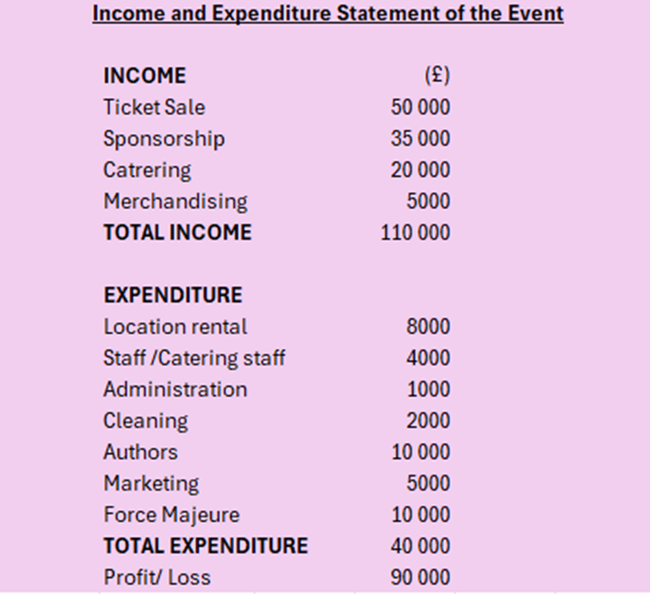
Picture 1. Finance (source: My assignment 1)
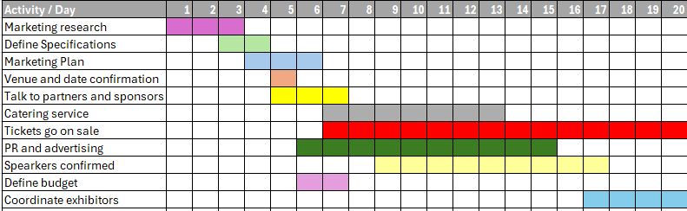
Picture 2. Gantt chart (source: My assignment 1)

