Marketing plan written for:

Marriott Resorts Palm Jumeirah, Dubai

Student Name:

Roberto Alexandru Stere

Student ID number:

2214492

Module name:

Marketing Essentials BMIH4005

Lecturer

Luciana Suardi

Word count: 1319

Introduction:
This essay will present the marketing plan of the Marriott Resort Palm Jumeirah, Dubai. This essay presents the following: situation analysis 5'C's (company, customers, competitors, collaborations and climate), objectives (SMART Target), strategy, tactics (marketing mix 4P’s-product, location, price, promotion) as well as action and control of the marketing plan. The marketing plan is: Cooking with the best: the Emirati cuisine experience of learning from the masters. A monthly evening of cooking, learning and dining experience with a celebrity chef. The resort is located on the beach of the famous Palm Jumeirah and It is the first Marriott Resort in Dubai.

Company:
SWOT-
Strengths  - Wide range of products/service line  - High brand awareness in Dubai  - Surrounded by Natural environment  - Global presence | Weaknesses  - Weak data protection  - Strict code of conduct  - Negative Marketing
Opportunities  - Water Sports (attracts more international visitors)  - Government encourages the development of tourism industry  - Government push for increased use of renewal energy resources  - History and culture in Jumeirah Beach | Threats  - Trade tensions  - Competition(Dubai is the main attraction for luxury hotels wich are in direct competition with Marriott)

Segmentation (customers):
Geographical-
The initial geographical area of likely customers will be from Dubai. The Marriott Resort Palm Jumeirah is located on the beach of the Palm Jumeirah and it’s easy accessible and affordable by common transports. Targeting this population would allow for those customers who wish to return to their homes after the cooking experience, but the linking with the hotel also allows for overnight (or for longer) accommodation to be organized at the time of booking on the experience.
Demographic-
The likely customers would purchase the experience as individuals or in couples or groups and would be in the upper half of the earnings range ( mean disposable income > Dh7,595 (£1,681.13), and would be able to arrange child-minding and be free from the need to look after children during the cooking experience. The pricing of this event would be likely to dissuade those without a moderate to high disposable income.
Behavioural-
The individuals targeted would have an interest in eating out and, in cooking and improving their skills in cooking.
Psychographic-
The targeted individuals would be likely to have a taste for good food and a passion for cooking and be interested in fine cuisine. They would also have some knowledge of celebrity chefs and be interested in meeting such personalities and being instructed by them.
Targeting:
Target audience is likely to be individuals or couples aged 30 till post-retirement, who remain active enough to be able to enjoy the whole cooking and learning experience. Given the nature of the offered experience they are likely to be affluent, with incomes in the upper half of the income range and likely to be able to attend without child-minding responsibilities. Customers with needs due to physical disabilities will be encouraged to inform the Resort of those issues so that a health and safety assessment of the kitchen learning environment could be carried out.

Competitors:
Perceptual positioning maps-
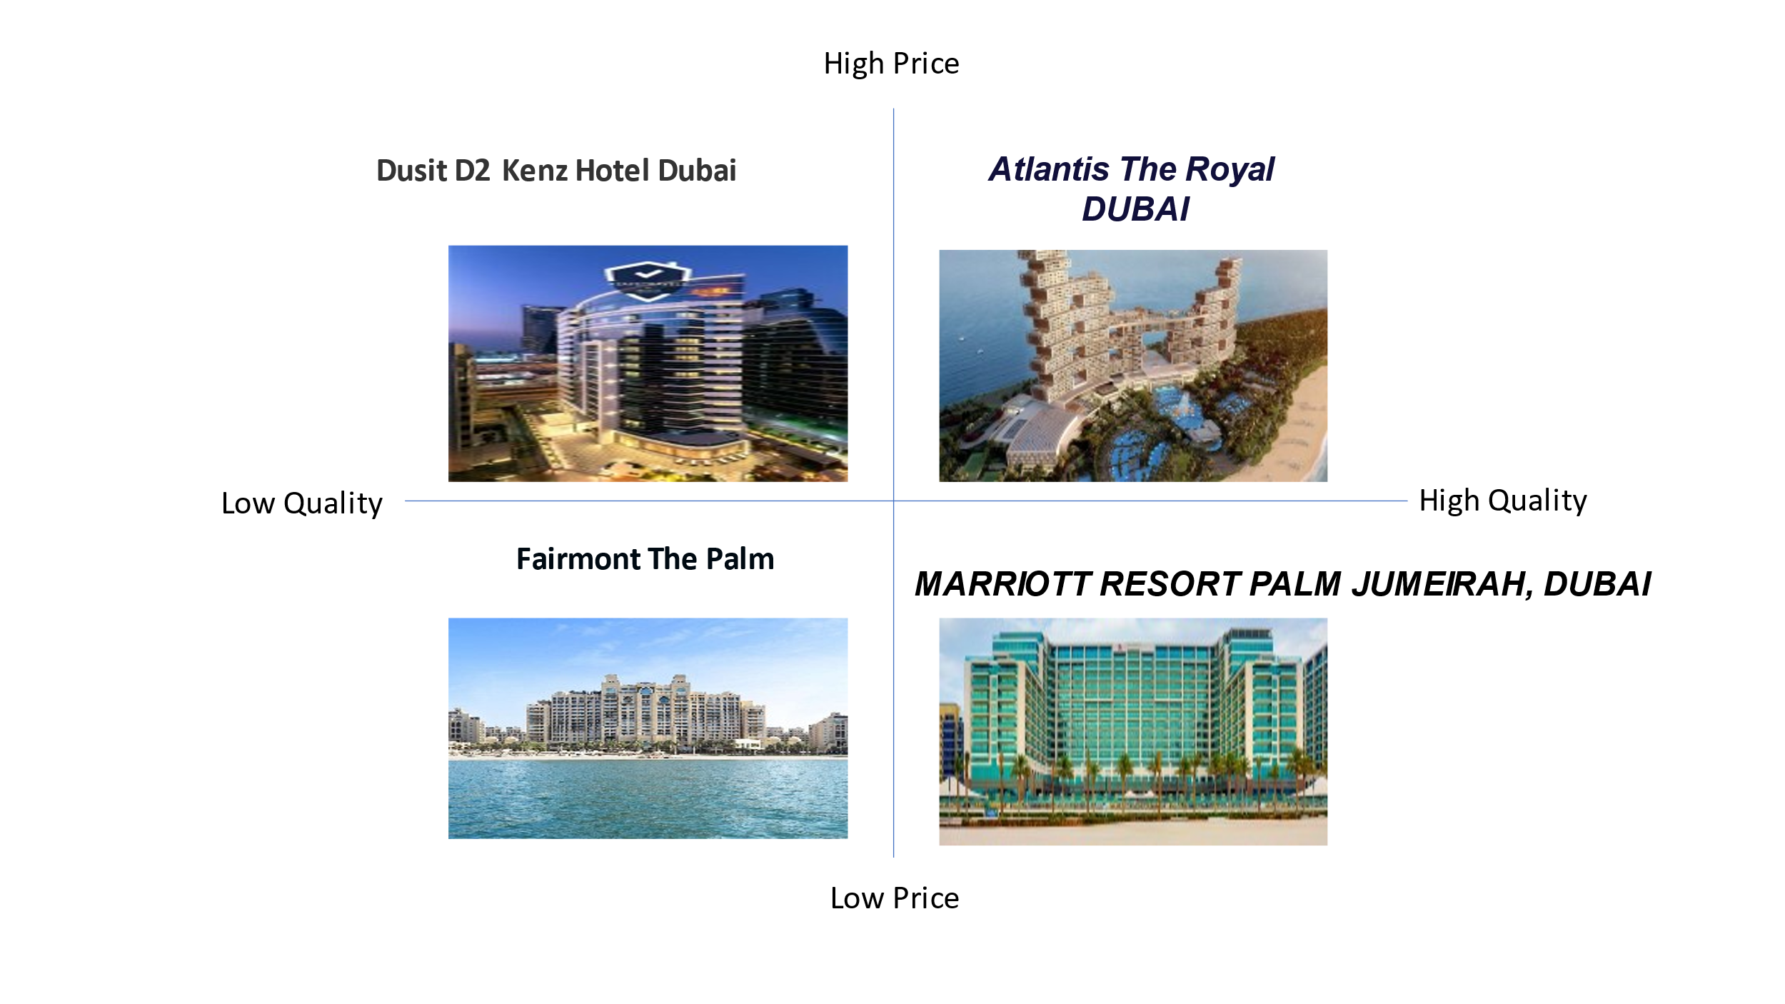
Climate:
PESTLE-
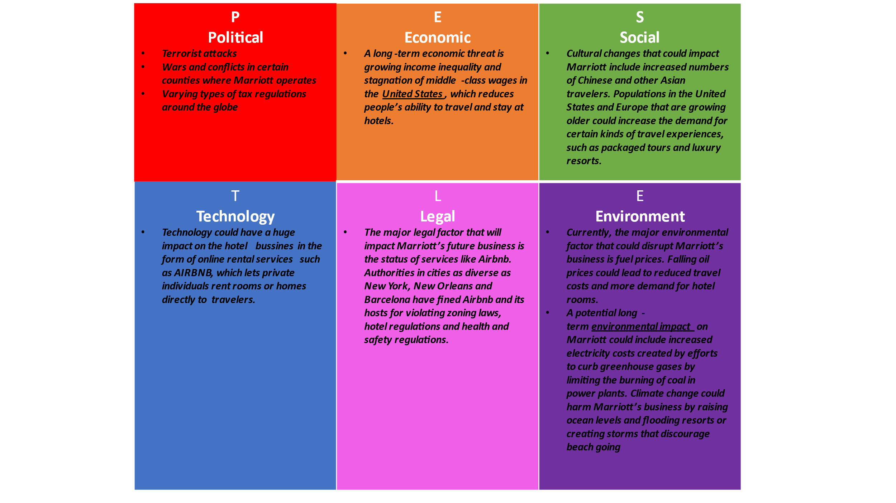

Objectives:
There are three main objectives.
First, to attract a new base of high-value, high-spending guests to the Marriott Resort, with the intention of encouraging this clientele to frequent and eat at the hotel's restaurant at other times as well, and to increase the chances that these guests will become loyal, repeat customers. Second one, to encourage interest from this group of customers in other attractions in Dubai. Third one, to enable a regular event to take place which, by attracting celebrity chefs, will enable monthly publicity and media interest which will raise the profile of the resort in general and lead to an increase in the number of long-term guest visits.

Strategy:
It is well known that differentiation means creating products or services that are both different from those offered by competitors and more attractive to customers than what competitors offer (Porter, 1985). Such a differentiation strategy requires businesses to provide goods or services that are unique in terms of brand image and functionality.
Emirati cuisine offers extensive local and international culinary expertise, combining the art of cooking with the experience of learning from master chefs. Using local raw materials, with the possibility to complete the experience with a fine dining evening and the additional option of accommodation nearby.
Tactics:
Marketing Mix (4P’s)-
Product:
Exclusive culinary instruction by a celebrity chef (e.g. Chef CZN Burak) who has a significant degree of national and international media exposure. Events will follow a pre-established and pre-announced menu, which will include different cooking styles, as well as different national cooking styles, but using high quality locally sourced produce where possible. The chefs may also change from time to time, as will the cooking styles featured. This change in cooking styles offered and celebrity chefs would be designed to encourage people who enjoy the experience to become repeat purchasers of the service.
Place:
The whole process takes place inside the resort, more precisely in the hotel kitchen. The Marriott Resort Palm Jumeirah has a spacious and modern kitchen, which will help makeing the experience as smooth and enjoyable as possible for the learners. The site offers interest and activities that can engage customers, both before and after the dining experience or, for those who choose the accommodation option the following day.
Promotion:
Promotion will be achieved through a variety of means. There will be links on the resort's official website directing people to a site created specifically for this experience. This website will contain information about the experience, have a calendar of events, chefs and cooking styles throughout the year, and allow for online reservations. It will highlight the special nature of the experience and its exclusivity. For those who wish, a telephone booking system will be available. Leaflets and fliers. A Twitter feed will be created as well as a Facebook page. Selected Newspapers will be approached, which have high earning readerships (for example GULF NEWS, KHALEEJ TIMES, The National, Al Bayan, Emirates 24/7 etc.) and advertising will be discussed.
Price:
Price will initially be set at around £200-£250 per person, with an additional supplement if the customer wishes to attend the post-training feast, and further supplements when the customer wishes to invite a further guest to the dining event. Alcohol consumed at the dining event will be charged separately in addition. Guests opting for the option to stay overnight at the hotel will be charged for this, with a reduced rate offered if the hotel booking is made at the same time as the dining experience booking. The overall cost will be significant, but it will be targeted to that section of the population able to afford it.
Action:
The action will take place through the use of the loyalty program and online advertising. Using, FaceBook, Twitter, Instagram, flyers and leaflets the cost will be twice as low as TV, radio or billboard ads.Offers will also be sent to customers by e-mail. However, this means no need to hire new staff and much lower costs. With the lower costs used for advertising, the profit will be much higher.

Control:
Control activities could be used to monitor marketing and financial performance such as quality, customer service satisfaction, return on investment and return on sales. During implementation, monthly sales and costs will be measured and reported to assess marketing performance. Return on investment and return on sales will be reported quarterly. Similarly, the customer satisfaction survey could be conducted quarterly via a questionnaire. Through these measures and monitoring activities, Emirati cuisine can ensure the quality of its services and timely implementation.
Conclusion:
In summary, the Emirati cuisine experience would directly contribute to raising awareness and visitation of a high value segment of the population/foreigners and it’s aim is to encourage this group to purchase the other services available at Marriott Resort Palm Jumeirah. This long-term investment, will pay for itself by establishing sustainable growth and a unique image to keep customers in Marriott Resort Palm Jumeirah.

Reference List:
Image + Location for Marriott Resort Palm Jumeirah-
https://www.marriott.com/en-us/hotels/dxbpj-marriott-resort-palm-jumeirah-dubai/overview/ Accessed 03/12/2022 12:40
Price and transport methods-
https://www.bayut.com/mybayut/guide-public-transport-palm-jumeirah/
Accessed 03/12/2022 13:39
Activities for Jumeirah beach-
https://www.loveholidays.com/sem/jumeirah-beach.html?WT.mc_id=pgo-60522755274-kwd-26085899027&ch=des&gclid=CjwKCAiAhKycBhAQEiwAgf19eh-FZyfqosXq5od-NvvxCSNBLP0BQ3jk1OnLQKtyNuKDNxaeDPCfPxoCJ0QQAvD_BwE Accessed 03/12/2022 14:02
SWOT Marriott-
https://www.trade.gov/country-commercial-guides/united-arab-emirates-market-challenges Accessed 03/12/2022 14:10
https://pestleanalysis.com/marriott-swot-analysis/ Accessed 03/12/2022 14:09
https://www.marketingtutor.net/swot-analysis-of-marriott/ Accessed 03/12/2022 14:11
Disposable income-Dubai-
https://www.khaleejtimes.com/article/dubai-among-worlds-top-cities-for-high-salary-disposable-income Accessed 03/12/2022 14:52
Image of Atlantis The Royal-
https://www.elegantresorts.co.uk/luxury-properties/dubai/atlantis-the-royal
Accessed 03/12/2022 15:33
(Booking)Image of Dusit D2 Kenz Hotel-
https://www.booking.com/hotel/ae/dusit-d2-kenz-dubai.en-gb.html?aid=303948&label=dubai%2Fpalmjumeirah-3HZo23FRMbk_KzfAjOkzNAS553165422612%3Apl%3Ata%3Ap195%3Ap2%3Aac%3Aap%3Aneg%3Afi%3Atikwd-37263509927%3Alp1006959%3Ali%3Adec%3Adm%3Appccp%3DUmFuZG9tSVYkc2RlIyh9Yf5EcukO1MOGLSSAuId8ToA&sid=656d450195fb036f2df19085b08c98c1&all_sr_blocks=188900003_120612625_0_42_0&checkin=2023-01-08&checkout=2023-01-15&dest_id=-782831&dest_type=city&dist=0&group_adults=2&group_children=0&hapos=2&highlighted_blocks=188900003_120612625_0_42_0&hpos=2&matching_block_id=188900003_120612625_0_42_0&no_rooms=1&req_adults=2&req_children=0&room1=A%2CA&sb_price_type=total&sr_order=popularity&sr_pri_blocks=188900003_120612625_0_42_0__291919&srepoch=1670262865&srpvid=89577de8056c024a&type=total&ucfs=1&activeTab=main Accessed 05/12/2022 17:56
(Tripadvisor)Image of Fairmont The Palm-
https://www.tripadvisor.co.uk/Hotel_Review-g295424-d3704416-Reviews-Fairmont_The_Palm-Dubai_Emirate_of_Dubai.html Accessed 05/12/2022 17:59
PESTLE Marriott-
https://pestleanalysis.com/pestle-analysis-of-marriott/#Economic_Factors_That_Could_Hurt_Marriotts_Business Accessed 05/12/2022 18:26
https://www.coursehero.com/file/14101658/PESTLE-Marriott/ Accessed 05/12/2022 18:30
Newspapers in the United Arab Emirates-
https://www.4imn.com/ae/ Accessed 0/5/12/2022 21:16
Marriott Resort facilities-
https://www.zawya.com/en/press-release/companies-news/marriott-resort-palm-jumeirah-poised-for-its-highly-anticipated-debut-jij3f7aw Accessed 05/12/2022 19:02
https://www.anantara.com/en/palm-dubai/kids-and-teens Accessed 05/12/2022 19:08
Sustainbility-
https://www.anantara.com/en/palm-dubai/sustainability/?category=recycling-and-waste-reduction Accessed 05/12/2022 19:17
Porter, M. E. (1985). Competitive advantage: creating and sustaining superior performance. Nova.

Appendices:

Resort:
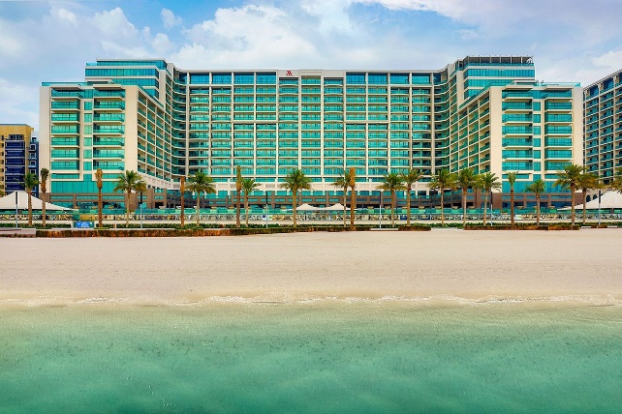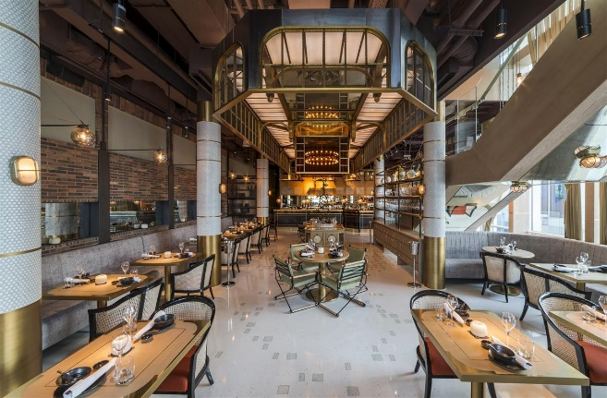
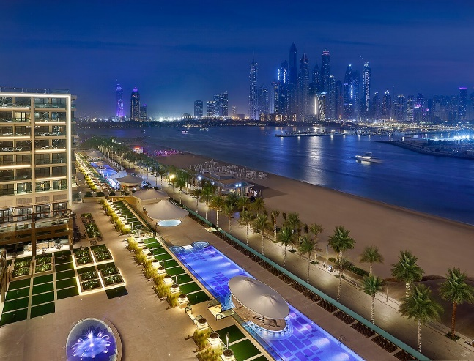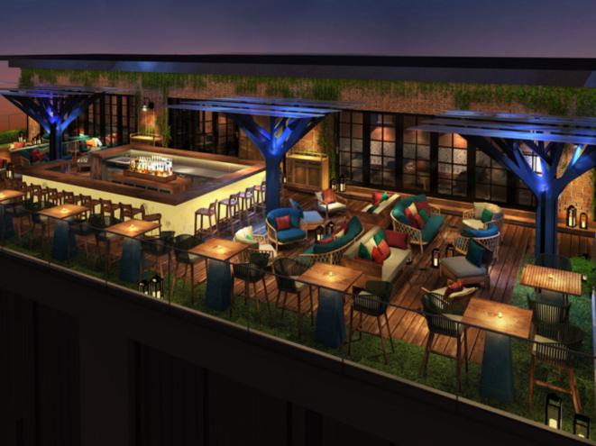

Chef, CZN Burak:
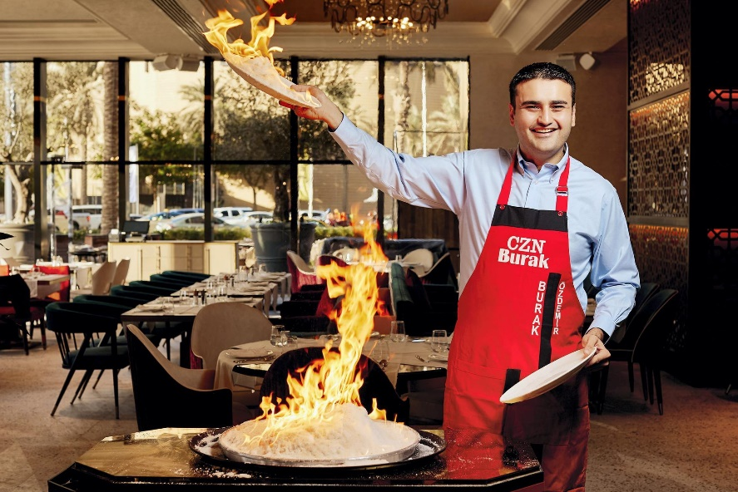

PowerPoint Presentation:


