

BMSW4010Learning in the Digital Era
Employability Skills

Name:md cherag ali
ID: 1813646

Contents
Contribution to Overall Module Assessment (%): 1
Task 1 4
Task 2 5
Academic writing 5
Importance of academic writing 5
Task 3 7
Critical Analysis 7
Knowledge of Critical Analysis 7
Task 4 9
Reference 13

Task 1
Since a report is an official document, you must use a proper tone and style while writing it. Third-person language is required throughout the report. First- and second-person pronouns, as well as phrases like "you" and "yours," are off-limits (Schneider, Lichtenberger, Mather, and Kaufman, 2018). The report should not be prepared from the author's personal perspective but rather from an unbiased, objective one.
The structure of a report is given below:
Title Page: Title pages contain crucial details like the report's title, authors' names and numbers, the report's host and publishing organization, and the publication date.
Executive Summary: Present a high-level summary of the problem(s) or issue(s) you were tasked with resolving. It should also touch on the major conclusion(s) reached.
Contents Page: A List of Sections and Subsections, Each Linking to Its Own Page, Is Provided Here.
Terms of Reference: Who requested the report, Date of request, Reason for Report, Report Author, Synopsis of the Issues, Submission Date
Findings:This is the meat of the report, so it should give a thorough and specific description of the current state of affairs, sectioned off into its own subsections. Evidence in the form of citations, paraphrases, or direct quotes from scholarly books, articles, and websites is required. The use of only online resources as your sources is strictly forbidden.
Conclusion:The last section might be presented as its own paragraph(s) or organize your work into distinct parts, such as "Analysis of the Researcher's Skill Set" and "Developing Needs" that you can then compare to the requirements of potential employers. No other part of the report should be used to support the conclusion; it must be based only on the data presented in the results section.
List of References:Undergraduates should cite any outside information used, such as passages from textbooks and scholarly journals, Name of Author(s)
Author(s), Title of Work, Textbook/Journal Edition, Page(s), Websites: URL and date of visit.

Task 2

Academic writing
Academic writing, also known as scholarly writing, consists of nonfiction works created for schoolwork. This can include anything from reports on empirical fieldwork or research in facilities for the natural sciences or the social sciences to monographs in which academics analeys culture, propose new theories, and develop interpretations based on archival materials. A formal prose register, frequent reference to previous academic work, and the employment of generally steady rhetorical gestures to establish the scope of the project, locate it in the relevant research, and develop a new contribution are common to academic writing across genres and modes of publishing.

Importance of academic writing
Producing, codifying, transferring, assessing, revising, teaching, and acquiring knowledge and ideology in academic fields are all possible via academic writing. Mastering how to write in an academic style is crucial to academic success and is an integral part of learning any discipline.
It might be challenging for students who struggle with academic writing for graduate students to convey what they have learned or comprehended while studying complicated subjects. Essays provide students an opportunity to demonstrate their understanding of the material and their command of appropriate language and presentational conventions, both of which are essential when writing for an intended readership.
The differences between academic writing and other, less stringent forms of writing lie in the emphasis placed on style and method. It explores the potential of form and style as vehicles for communicating meaning. University level writing is far more manageable if a student is familiar with the required format and structure of academic essays prior to entering college. Some lecturers have a preference for certain styles or formatting norms, which means that students need to take note of these details and work within them to craft a paper that will wow their professor (Graham, and Ashworth, 2017). If a student is having trouble with method, they may always seek for assistance with academic writing for graduate students.
Students are discouraged from writing papers that just provide one side of a controversial issue. In order to succeed academically, students need to be able to look at all ideas and research through a new lens, which is what academic papers provide for them. The onus is on students to evaluate ideas from a variety of angles and provide claims that demonstrate their comprehension. Learning this at a young age is beneficial. Being able to step back and assess a situation objectively is a valuable skill that will serve them well in many situations.
Research abilities are honed via the practise of academic writing for graduate students. When it comes to scholarly papers, research goes beyond a simple Google search. Doing thorough research, collecting relevant data, and processing all that information might take a considerable amount of time. It's an exciting adventure since you'll learn new things that are directly applicable to your field of study. This helps you think more critically and formulate more well-rounded judgments. Writing an academic paper requires research abilities, which are valuable to both students and professionals.

Task 3

Critical Analysis
A critical thinker weighs all of the information at their disposal before reaching a conclusion. The topic is complex, and other definitions exist, but they all have in common an emphasis on thinking things through carefully, using healthy scepticism, and approaching evidence with an open mind. Self-disciplined, self-reflective, and self-correcting are all hallmarks of the critical thinker (Kamler, 2011). It demands agreement with exacting criteria of quality and deliberative mastery of their application. It requires the ability to communicate clearly and solve problems, as well as the willingness to push above one's natural egocentrism and sociocentrism.

Knowledge of Critical Analysis
Critical thinking skills are vital in higher education because they enable you to examine the facts, ideas, and assertions presented in your chosen profession. By using critical thinking, you may get a more nuanced understanding of the material at hand. Reflection, discussion, and the honing of ideas keep academic fields vibrant (Tallent, 2019). As a result, critical examination is essential to the maintenance and development of any area of study. A writer might discover new vistas of inquiry when they set out to compose an essay with the goal of doing critical analysis. In order to establish a well-founded opinion or assessment, the writer requires access to extensive data on a wide range of relevant themes and subtopics. Although it broadens the scope of study, critical analysis simplifies and organise the process.

To illustrate, consider a task that requires an analysis of the impact of the Bretton Woods institutions on the international economic system as it exists now. The learner might investigate not only the institutional efforts and acts but also the ideological perspectives on their job. The learner would have a deeper comprehension of the material and be better equipped to make an informed judgement on the success or failure of these organisation in promoting global development and alleviating poverty (Joyce, 2018). A critical study of the assigned subject is a terrific addition to any essay, even if it is not specifically requested. This shows how effectively the learner has grasped the material. As a result, they may sometimes bring in or allude to material from across multiple disciplines that is relevant to the present issue without having to go into great detail about it.

Knowing the history of a society is helpful when writing on its current socioeconomic problems, for instance, even if that history is not fully retold in the essay. The benefits of critical analysis extend beyond the academic enhancement it may provide. Personal development and intellectual expansion are additional benefits for the learner. Students are able to see the relevance of their studies to their own lives and to develop a deeper understanding of the (sometimes abstract) topics and things they are studying. The learner is then better able to participate in the community's conversation.

Example: massive demonstrations against US government participation in the Vietnam War began on college campuses after critical study of the war's effect on the Vietnamese populace and the American tax-payer. The abstract intellectual premise on which the war was begun and justified was contrasted with the very real, tangible effect it had on individuals.

Task 4


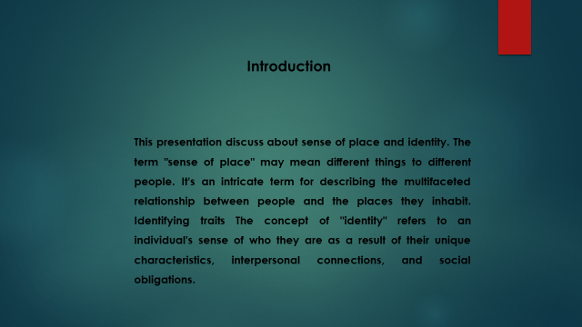
This presentation discusses about a sense of place and identity. The term "sense of place" may mean different things to different people. It's an intricate term for describing the multifaceted relationship between people and the places they inhabit. Identifying traits The concept of "identity" refers to an individual's sense of who they are as a result of their unique characteristics, interpersonal connections, and social obligations.
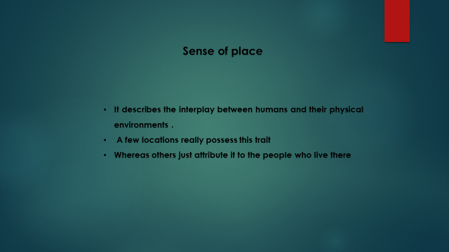The concept of having a "sense of place" may be understood in a few different ways. It is a difficult notion that attempts to define the interaction that takes place on several levels between people and the physical settings in which they live. Some places simply credit this quality to the people who live there, while others believe that the site itself is responsible, either because of the perceptions they've made about the place itself or because of the people who reside there. It is a phrase that is often used to refer to the characteristics of a place that enable the people who live there feel more connected to the area and more at ease there. Others, such as the geographer Yi-Fu Tuan, have expressed less "positive" sensations, including fear, for a particular region. Some students and instructors take part in "place-based education" (Torgovnick, 2019) in order to improve their "sense(s) of place" and to exploit various aspects of location as educational tools. The fields of urban and rural studies, respectively, centre on the importance of place-making and maintaining a community's connection to the land that they were born and raised on.

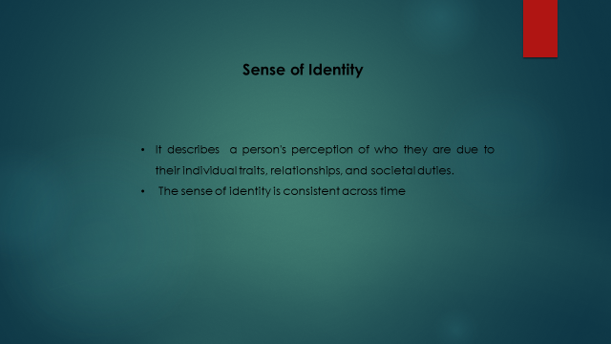An individual's idea of who they are as a result of their particular characteristics, connections, and social responsibilities is what constitutes identity in its most comprehensive sense. Additionally, a person's sense of identity remains the same throughout time, despite the fact that the individual's external circumstances may alter. The people who take care of a kid have the most influence on their growth and development, and it is at this period that they plant the seeds of their identity. People start to question their identities and where they fit in the world as they mature from childhood into adulthood. This is a natural part of the human experience. The search for one's own identity compels adolescents to experiment with a wide range of personalities and activities (Jackson, 2014. ). Even while people are continuously reevaluating who they are and how they should live their lives, the reality is that they don't end up significantly changing who they are throughout the course of their lifetime. Because of this, Erik Erikson, a well-known psychologist, is of the opinion that it is vitally important for young people to go through a period of profound identity formation while they are still in their teenage years. This allows them to have a clear understanding of who they are and what they want out of life at that point in their lives.
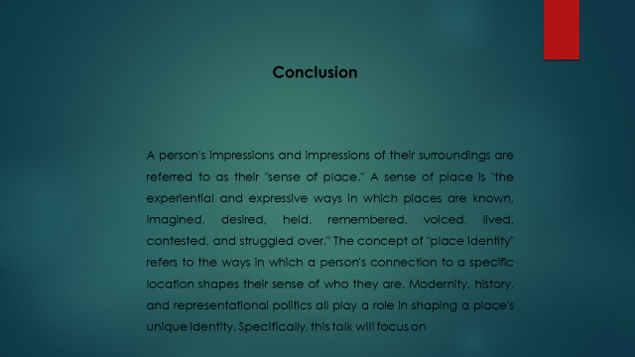A person's impressions and impressions of their surroundings are referred to as their "sense of place." A sense of place is "the experiential and expressive ways in which places are known, imagined, desired, held, remembered, voiced, lived, contested, and struggled over." The concept of "place identity" refers to the ways in which a person's connection to a specific location shapes their sense of who they are. Modernity, history, and representational politics all play a role in shaping a place's unique identity. Specifically, this talk will focus on


Video Link:
https://uowtsd-my.sharepoint.com/:v:/g/personal/1813646_student_uwtsd_ac_uk/EV4ts3ObMKpFvur4rlt-RB8Bs4yoR1h0U_04mK-kBOn6Qg

Reference

Schneider, W.J., Lichtenberger, E.O., Mather, N. and Kaufman, N.L., (2018). Essentials of assessment report writing. John Wiley & Sons.
Tallent, N., (2019). Psychological report writing. Prentice-Hall, Inc.
Kamler, B., (2011). Relocating the personal: A critical writing pedagogy. SUNY Press.
Joyce, J., (2018). Critical writings. Courier Dover Publications.
Torgovnick, M., (2019). Experimental critical writing. Profession, pp.25-27.
Graham, B. and Ashworth, G.J., (2017). Senses of place: Senses of time. Routledge.
Jackson, J.B., (2014). A sense of place, a sense of time. Yale University Press.

