Qualification: CIPD Diploma in Applied Human Resources

Module Name: Understanding Resourcing and Talent Planning

Word Count: – 3298 words

Student Name: Nicola Westcott
Student Number: 1909408
CIPD Membership Number: 55478551

By signing below, I confirm that the work/evidence presented is my own, unaided work. I understand the regulations pertaining to candidate malpractice and the action that may be taken as a result.

Signed: N Westcott
Date: 18/04/2021

- An employee is emigrating and asks you if the labour market trends of their destination country are the same as in the UK. Describe the key contemporary trends in both the UK labour market and in the labour market of any other country (of your choice).
A labour market is a market of potential employees this is people who are willing/able to work for the organisation and what they are looking for in return (Wilkinson and Taylor, 2016). A tight labour market means more jobs available than jobseekers, whereas a loose labour market is vice-versa. Trends in labour market vary in different regions, industries, countries due to several factors and would need to be taken into consideration when emigrating.
- Economic conditions
Current UK economic inactivity rate was estimated at 21.0% (ONS, 2021) and 27.1% in USA (FRED, Economic Research, 2021).
- Levels of unemployment
According to (ONS, 2021) UK employment rate is 75%, seen an increase in women and those aged 50-64 in labour market due to changes to the State Pension Age. Biggest decrease in employment rate for those aged 16-24 mainly due to the covid-19 pandemic.

Unemployment rate at 5.1% although it had been falling for the last few years. 601,000 vacancies from Dec 20 to Feb 21.

8.71 million economically inactive

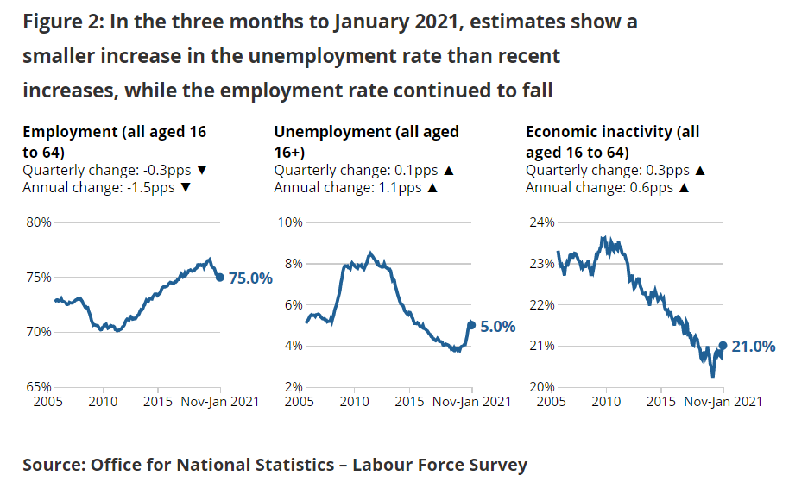

The USA does tend to have a lower employment rate was 67.9% although the long-term unemployment rate is lower (OECD, 2021).
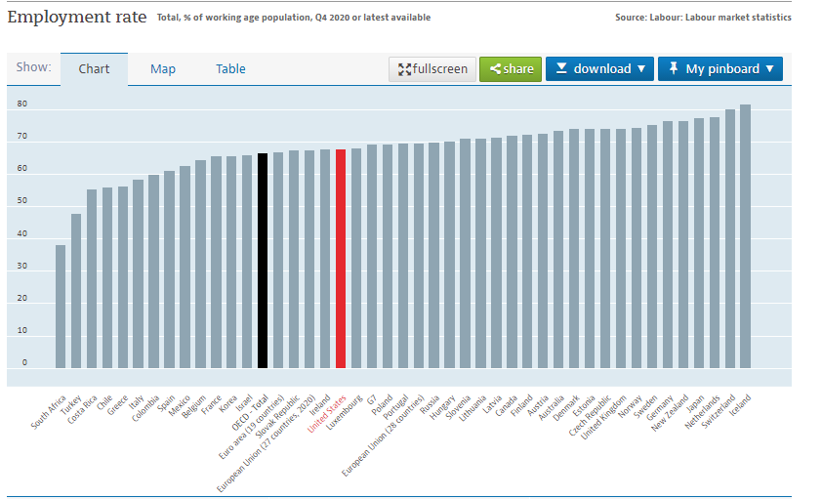
Source: OECD, 2021
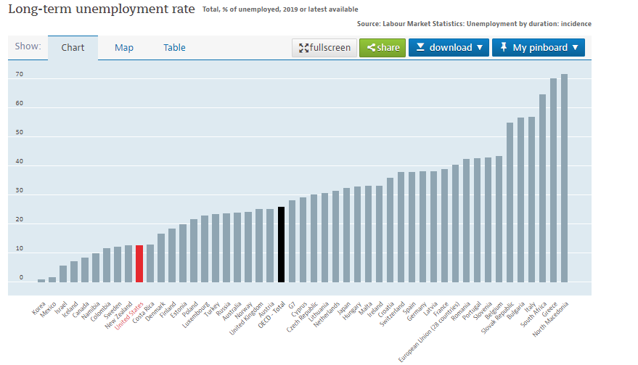
Source: OECD, 2021

- Wage rates and inequalities
Wages are higher in the USA, but other factors such as the availability of the NHS in the UK, compared to paying for healthcare in the USA need to be considered. The ONS (2021) have estimated the net impact of recent job losses will increase average pay by approximately 1.6% suggesting an underlying wage growth of around 3% for total pay and around 2.5% for regular pay. Income inequality is slightly higher in the USA at 0.39% 0.37% in UK (OECD, 2021).
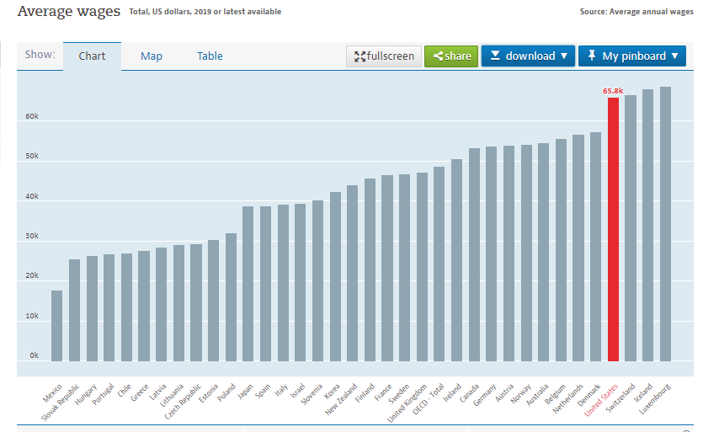
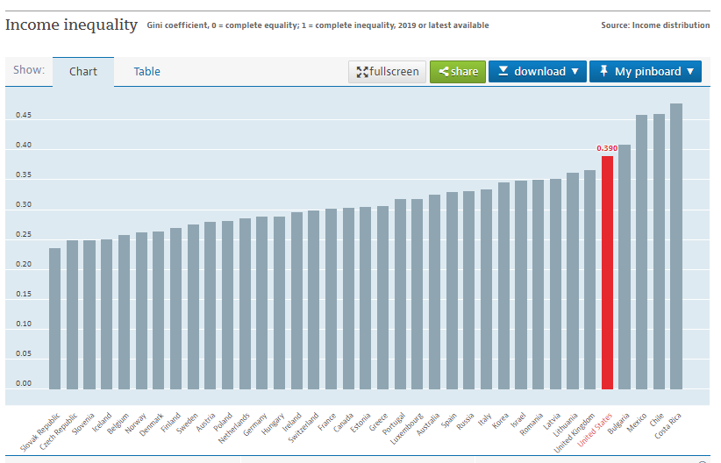
Source: OECD, 2021
- Public/private sector differences
According to CIPD (2021a) survey shows an increase in intentions to recruit, in Healthcare, Public Administration and Defence and ICT, though due to the pandemic many are on hold. Self-employment is approx. 15% in UK compared to 6% in USA.

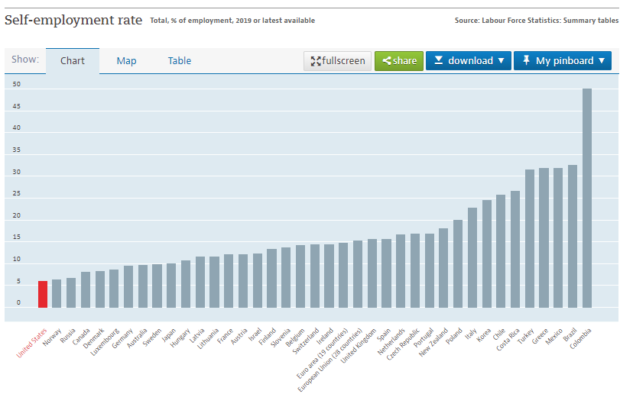
Source: OECD, 2021

- Working arrangements
Up to January 2021, total actual weekly hours worked in the UK saw an increase of 8.0 million, or 0.8%, to 968.0 million hours (ONS, 2021). Average actual weekly hours worked saw an increase of 0.4 hours on the quarter to 29.9 hours. The USA does on average have higher working hours then the UK (OECD, 2021).

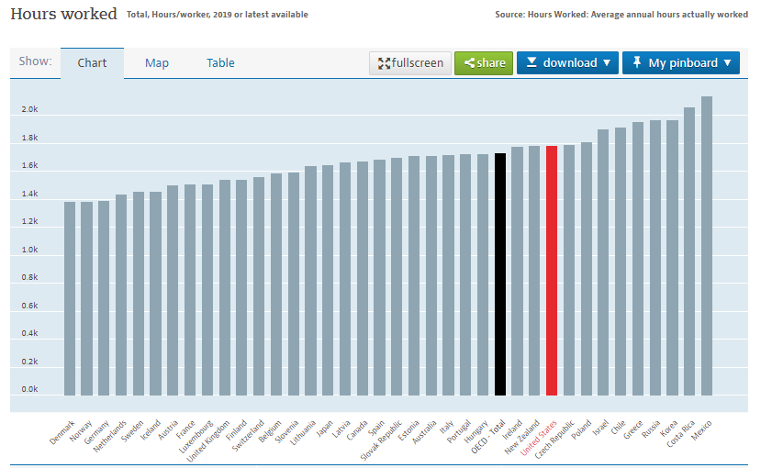
Source: OECD, 2021
Natural disasters such as pandemic have had devastating effect on the labour market around the world. Other factor such as Brexit also need to be considered in the UK labour market but comparing the graphs above will assist in decision making when emigrating
- A new HR assistant asks you to explain the following aspects of workforce planning:
- key principles of workforce planning
- tools used in workforce planning
- how to develop a basic people plan, including succession planning.
1.2 Describe the principles of effective workforce planning and tools used to carry it out.
Workforce planning is essential to ensure an organisation has ‘the right people, with the right skills, in the right place at the right time’ (Wilkinson and Taylor, 2016).

Consisting of four stages:

- Forecasting demand for skills in the future – look at what is the organisation plans, structure/technology/skills will be in the future.
- Forecast supply of skills - considering current workforce/resources, skills and how many employees are likely to remain, consider age of workforce.
- Identify any gaps between demand and supply through a skills audit – this determines the mismatch between the roles/skills of the future to the roles/skills of the present. A competency framework should be established for common roles, each current employee skills are assessed, and results summarised to identify the current available skills and the skill base required for the future.
- Addressing the gaps – consider how to best use existing resources through moving, knowledge-sharing, training, coaching and mentoring, retention of valued employees or the removal of those that skills/aspirations do not match requirements. Then consider external sources by looking at the labour market, recruitment, collaborations between organisations or consider outsourcing certain activities.

‘Workforce planning is about generating information, analysing it to inform future demand for people/skills, and translating this into a set of actions to develop and build on the existing workforce to meet that demand’ (CIPD, 2020i).

Various tools assist with identifying/addressing the gap in skills and demand:
- Analysis of workforce – data on demographics, the ageing workforce trend has been developing for 30 years. ‘The proportion of over-50s in the workforce increased from 21% to 32% between 1992 and 2019’ (Megatrends, 2019).
- Trends and patterns – use past data to predict future trends. Evaluate the if there are consistent reasons for employees leaving, are there peaks in demand, are there trends in longer serving employees
- Talent profiles – assess and detail the skills/capabilities of current workforce through a skills audit. Identify any development needs required to fill future roles, this aids potential redeployment/training.
- Scenario planning – this is recommended in times of uncertainty by organisations such as the CIPD. The Covid-19 pandemic created an urgency in workforce planning in organisations of all sizes to understand how to best support the business/workforce (CIPD, 2020i).

Stages of workforce planning:
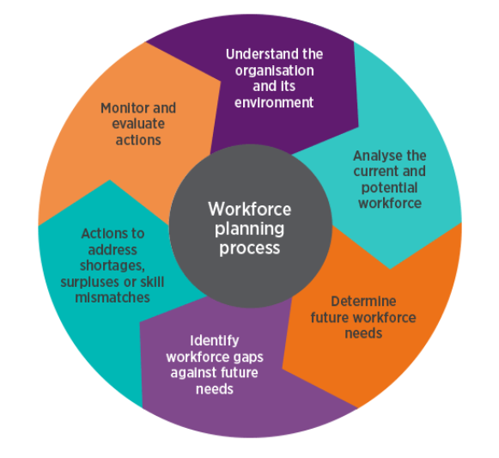
Source: CIPD, 2020i
Failing to plan can damage an organisation and lead to loss of income, disruption to customers, as well as damage to reputation and brand. This was seen when Ryanair failed to plan for its pilots’ holidays, meaning there wasn’t enough to fly the planes, leading to thousands of passengers being forced to change their plans and many pilots jumped ship to other airlines. ‘This PR disaster also led to £320m being wiped off Ryanair’s stock market value after it emerged the company had known about its staffing issues months before it cancelled the flights’ (People Management, 2017).
1.3 Explain how to develop basic people plans and succession plans.
‘Succession planning focuses on identifying and growing talent to fill leadership and business-critical positions in the future’ (CIPD, 2020h) and can be defined as ‘a group of activities aiming to ensure that at any time an organisation has sufficient numbers of people with the ability, knowledge, personal attributes and experience necessary to step in to roles when they become vacant’ (Wilkinson and Taylor, 2016).
Succession planning originally covered the most senior roles targeteing a few individuals in order to ensure a smooth transition of duties, however this now tends to cover the whole workforce in order to have a pool of talent from which to choose once the vacancy is available (Taylor, 2019). This ensures new ideas/approaches are brought forward and prevents senior managers becoming clones of predecessors. Due to recruitment freezes and skill shortages there has been an increased focus on this with many organisations upskilling existing employees through development programmes and professional qualifications. This also reduces the cost of utilising the external labour market.
Approaches to succession planning (Taylor, 2019):

Successors can be identified through a variety of means such as appraisal meetings, conversations which identify wants and aspirations, which can then be used as a basis for development. On the job training, coaching/mentoring work shadowing etc can then be rolled out to equipping them with the skills required to step into the senior roles when they become available (Wilkinson and Taylor, 2016). Lateral moves/project work expose employees to different business areas, this not only equips them with the skills required but also satisfying the employees need for change and variety, by broadening their experiences whilst remaining in the same organisation.
During talent planning activities organisations must ensure that all employees have fair access to the available opportunities. This can be ensured by (Wilkinson and Taylor, 2016):

Measures should be put on place to monitor and evaluate the return on investment, ensuring that organisations understand their existing talent profile and their future requirements (CIPD, 2020f).

- Your Director asks for your thoughts on how the organisation can attract the talented people it requires and ensure that these people stay with the organisation. Explain different approaches an organisation can take to both attracting and retaining talent, and the strengths and weaknesses of each approach.
2.1 Assess the strengths and weaknesses of different approaches to attracting talent to the organisation.
Successful resource strategies should be based on attracting and retaining the right people as well as ensuring the company is different from its competitors (Wilkinson and Taylor, 2016).
Labour market analysis of competitors should be undertaken. Consider what the competitor organisations offer as employment packages and then tailor your organisation to be different to make it stand out from the crowd. Competition for talent can be fierce, particularly when there are skill shortages. Knowing competitors’ strengths and weaknesses can ensure the organisation stays a step ahead.

How an organisation positions itself in the labour market is an individual choice but is noted that there are common approaches. The Higgs model (2004) differentiates on two factors:
- Reward – money that an employer will be able to offer to employees
- Culture – how employees are treated/respected

Organisations tend to fall into one of the following categories:

All organisations have an employer brand, it's the way organisations ‘differentiate themselves in the labour market, enabling them to recruit, retain and engage the right people’ and ‘helps businesses compete for the best talent and establish credibility’ (CIPD, 2020c).

The CIPD (2020c) defines it as ‘a set of attributes and qualities, often intangible, that makes an organisation distinctive, promises a particular kind of employment experience, and appeals to those people who will thrive and perform best in its culture’

The employer’s brand should be aligned to organisational values, strategy and policies and having a strong brand will help to attract and retain talent. Organisations should ensure that the message convened is consistent with the reality of working in the organisation, or otherwise it could risk damaging the brand and reputation. Successful use of this brand can attract the best and most qualified candidates, retain talent, positions can be filled rapidly thus contributing to organisational objectives (SHRM, 2009).

Once key concepts are established that differentiate them from competitors, slogans/statements should be developed to communicate the messages to employees/potential employees. These should be repeated/displayed at every opportunity over a prolonged period for an organisation to gain a positive position in the labour market, which can then lead to being an employer of choice.

Admiral is considered to be an employer of choice with a strong employer brand and slogans ‘People who like what they do, do it better’, catchy recruitment videos (You Tube, 2021), links to the 4 pillars of communication, equality, reward and recognition and fun has paid off and they were voted number 1 in the Sunday Times Best Big Company to work for in 2019 and number 3 in 2020 (Admiral, 2021).

Even being an employer of choice still means that organisations must still invest in branding and recruitment messages especially in tight labour markets, as all leading organisations have the potential to match the employee value propositions (EVP) by offering similar deals.

2.2 Assess the strengths and weaknesses of different approaches to retaining talent.
Organisations use various strategies to attract employees (Taylor, 2019):

The increased use of social media sites (Glassdoor/LinkedIn), where employees can leave feedback, share experiences on employer’s inefficiency can mean employers can be exposed for having a say do attitude which can damage a company’s brand. Facebook/online forums comments about employers can also negatively impact an employer’s brand (CIPD, 2020e). Employers can learn from past efforts and modify recruitment strategies to suit (SHRM, 2009).

As well as attracting the right people it is vital that to ensuring ‘the right people don’t leave the company and leave vacancies that need filling’ (Wilkinson and Taylor, 2016). Two approaches taken look at trends within/outside the organisation.

There is always a certain amount of turnover, called ‘functional turnover’ this is not bad, as it removes poor performers/saves wages, allows others to progress and introduces new blood Wilkinson and Taylor, 2016). However, dysfunctional turnover leads to a negative effect on the organisation, in terms of costs in replacing employees loss of skills and knowledge, impact on morale of remaining employees through the loss of colleagues and increased workloads (direct and indirect costs) (CIPD, 2020b).

Many organisations do not benchmark this turnover cost as it is seen as too complex to calculate, however by measuring/understanding this dysfunctional turnover/associated costs can assist organisations understand the extent of the problem, and use this to make a strong business case and gain commitment from senior managers for the introduction of proposed retention strategies (Wilkinson and Taylor, 2016).

Qualitative data could be gathered through tools such as exit interviews to identify the reasons for leaving and employee satisfaction surveys, which help gather opinions from across the workforce. Other methods could be a survey for ex-employees or surveys of long serving staff to identify reasons for staying (Wilkinson and Taylor, 2016).

Once the level/cost of turnover is ascertained then retention strategies can be developed to align with other HR strategies as well as organisational strategies, and gain management support. These initiatives must be communicated throughout the organisation.

Organisational approaches to retaining talent depends on the organisation’s strategy, positioning/brand. Retention strategy effectiveness depends on the reasons for turnover in an organisation, so it is important to understand what the reasons are before introducing initiatives.

The following are known to have a positive impact on improving retention:
- Recruit the right people – people who wants to work for the organisation
- Pay and benefits – reasonable rate of pay, other benefits such as salary sacrifice schemes can be attractive (Thomas and Hatcher, 2018)
- Selection – ensure prospective employees are provided with a realistic job preview at the recruitment stage
- Career development and progression - provide opportunities for employees to develop skills throughout their career
- Consult employees, ‘employee voice’– giving employees an opportunity to be heard, though surveys/conversations/grievance systems
- Flexibility – try to accommodate individual preferences on working hours/times. Current circumstances due to coronavirus has provided ‘organisations with an opportunity to review their approach to flexible working as well as learn from employee experiences of recent months’ (CIPD, 2020a).
- Employee well-being – ensure managers are supported to help their teams thrive and manage issues such as workplace stress/presenteeism (CIPD, 2020d).
- Treat people fairly – many employees resign due to a perception of unfair treatment linked with the Psychological contract which refers to implicit commitments ‘the perception of two parties and their mutual obligations to each other’ (CIPD, 2021b).
- Recognise and reward innovative/excellent work - promote this to external bodies/general public (Thomas and Hatcher, 2018).
- Ensure multi-dimensional support from strategic partners (Four S model) (HR Magazine, 2019).
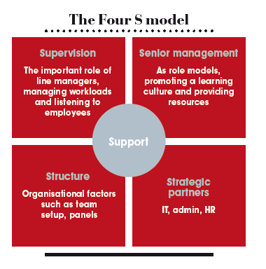
Source: HR Magazine (2019)
There isn’t a one size fits all response to retention and organisations need to consider a mix of strategies as well as building organisational resilience. By using people analytics, having a change ready culture, understanding the changing demographics of the workforce as millennials now entering have different expectations will assist organisations manage turnover to be an acceptable level (Thomas and Hatcher, 2018).
- In preparation for input at a managers meeting*, summarise the following: key aspects of good practice in relation to developing job descriptions, person specifications and competency frameworks different methods of recruitment and selection, and the strengths and weaknesses of each good practice in relation to dismissal, redundancy and retirement.
3.1 Explain key aspects of good practice in relation to the development of job descriptions, person specifications and competency frameworks.
Recruitment is required either when a new job is created or when an existing employee leaves the organisation. When need arises it is good practice to gather information as to what skills and experiences are required for the role (Wilkinson and Taylor, 2016).

This job analysis is the collecting of information from a range of sources about the role, duties and responsibilities, skills, expectations, tools, interactions, and environment will and how these fits in organisational structure (CIPD, 2020e).

From the job analysis data, a job and person specification can be drawn up along with competency analysis and frameworks, which helps with the recruitment and selection process and reduces any potential judgement of the process. This approach is referred to as the traditional approach model (Taylor, 2019).

Job descriptions focuses on the role and summarise the key duties/tasks that is involved in a role as well as who the role is responsible for and who the role reports to, areas of responsibility (CIPD, 2020e). Job descriptions tend to follow a standard format:

Person specifications focus on the attributes a person should have that are required to undertake the role, listed as either essential or desirable and should avoid any bias wording (CIPD, 2020e).

The job/person specification are used by employers as a tool when compiling job advertisements and used by recruitment agencies/perspective applicants to assess if they have the criteria required for the role to ensure the best fit possible of the candidate to the role.

Competency analysis and framework is an alternative approach to job analysis but is regularly being used more alongside them. It is the analysis of people and their attributes and can be used to profile key characteristics/competencies and is used during the recruitment process. It can be used to link the value of the organisation therefore making it generic to the organisation. Competencies defined by Boyzatis (1982, p21) as ‘an underlying characteristic of a person which results in effective and superior performance in a job’.

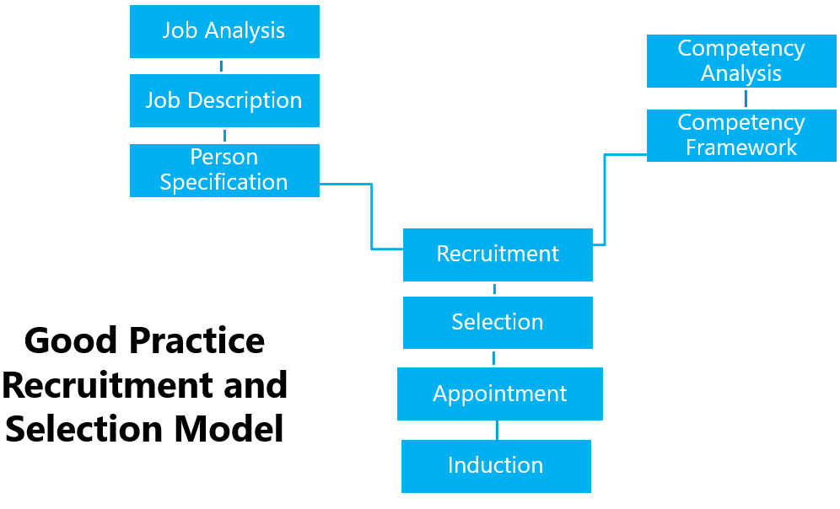
Source (Taylor, 2019)

3.2 Evaluate different methods of recruitment and selection.
‘Good recruitment is vital for every organisation – finding the right people at the right time’ ‘and has an impact on the long-term success of the business’ (CIPD, 2020e).
Identifying the appropriate recruitment method will help with this success (Wilkinson and Taylor, 2016):

Each have different associated costs/target audiences, therefore depending on the role will then determine which avenue is chosen. Using a variety of methods can help increase the talent pool (CIPD, 2020e). Technology is assisting the speed/efficiency of the process, but consideration must be given to the loss of personal interaction and the effects this may have.
Labour market trends should also be considered to understand the current conditions in recruitment, especially in the light of Brexit and the impact of employing overseas workers (CIPD, 2021a). The covid-19 pandemic has affected the recruitment process with many organisations putting it on hold and concentrating on retention and training. Many have turned to the increased use of technology in the recruitment process in advertising/interview process (CIPD, 2020e).
Recruitment practices need to be reviewed/updated to ensure diversity and inclusion. Many organisations use a competency framework for the selection process. This tends to focus on the core organisational values and each candidate is assessed against the framework.
The selection of candidates involves two stages (CIPD, 2020g)
- Shortlisting
- Assessment
Both methods must be fair, without discrimination/bias and based on the individual’s ability to undertake the role. Reasonable adjustments must be made for those individuals with a physical disability.
Interviews

Interviews should be structured and include competency-based questions such as to provide examples of how an individual has demonstrated certain competencies or scenario-based questions. Interviews allow an employer to assess a candidate’s ability to perform the role, explain the role/organisation and gives the interviewee a chance to understand the role/responsibilities, ask questions in order to ascertain if they would take the job if offered.
Interviews can be unfairly bias if information is not collected in the same manner, judgements can be unfairly made about individuals based on impressions, candidates stereo-typed, unfair comparisons made, a preference to candidates who are similar to the interviewer or vice versa or dislike taken, therefore by having a structured interview, conducted professionally with pre-set questions can help to avoid this bias as well as helping to maintain the employer’s brand (CIPD, 2020g).
Ability and personality tests

Including IQ, literacy/numeracy, job specific, personality questionnaires. According to the CIPD (2020f) approx. 50% of employers use a form of these to aid selection. The purpose is to identify and remove poor performers and provide additional information to support high performers.

Personality tests identify skills such as diplomacy/communication. There are no incorrect answers, but they assist in determining a candidate’s natural personality.

The tests are generally online and allow employers to assess differences in individuals and are particularly useful when there are many applicants but should be used in isolation.

Organisations must consider if it is appropriate to use the test and if so, advise applicants of the procedure, requirements and duration beforehand. Those administering the test have had appropriate training. Consideration must be to how the results will be analysed, the value and put a process in place for feedback (CIPD, 2020g).
Assessment centres
These include presentations/work samples/group activities/role-playing requiring the applicants to undertake several different tasks. Real-life tasks allow applicants to show their ability often combine behavioural/cognitive and personality assessments. It could include delivering a report/presentation, problem-solving, business simulations activities, time-management (CIPD, 2020g). Assessors should have adequate training order to observe/actively listen. Feedback should be provided. Advantages are that candidates can be rated for undertaken job specific tasks providing a more realistic representation. Disadvantages are it can be costly, time-consuming and is normally only viable of there are many candidate (Wilkinson and Taylor, 2016).
Whichever method/s are used, organisations have a legal requirement to ensure fair access. The Equality Act 2010 states nine protected characteristics that it against the law to discriminate against. Employers should also consider that ‘unlawful discrimination can be direct, indirect or positive’ and careful consideration is required on wording/branding as well as where the advert is placed (Wilkinson and Taylor, 2016 & Daniels, 2019).

3.3 Explain key aspects of good practice in relation to dismissal, redundancy and retirement.
Employee turnover also consists of:
Dismissal

When a contract of employment is ended by the employer (involuntary turnover). Employers must ensure that the dismissal is fair to avoid unfair dismissal claims being brought against them. Valid reasons for dismissal will be due to conduct or capability (Acas, 2021b). Conduct will be either be:
- misconduct – employee breaches their contract in a minor way e.g. being continuously late, misuse of company equipment.
- Gross misconduct – employee breaches contract in a major way e.g. theft, illegal use of drugs
Good practice means employers must ensure they have a fair procedure in place. The ACAS codes of Practice state that fair procedures should include an investigation, reasonable opportunity to improve, provide notice, reasons/evidence, the right to be accompanied, and the right to appeal the decision (ACAS, 2021a).
Redundancy

Occurs when the organisation, employee job role or place of work ceases to exist (ERA, 1996). Good practice would be for the employer to seek alternatives to compulsory redundancies, which would increase morale, organisational brand, and future. ACAS, (2021c) recommends organisations can introduce measures such as:

If all options have been exhausted and redundancy is the only option, good practice for employers if to ensure the correct procedures are followed. This includes communication/transparency throughout the process, consultation, individual or collective if more than 20 employees. The selection process must be fair and reasonable (ACAS, 2020b). Many organisations have had to resort to redundancies recently due to the effects of the coronavirus pandemic and must still ensure they follow best practice.

Retirement

Usually a planned departure when an employee reaches a certain age. However, employment law changes now mean that there isn’t a set age meaning employees can control the age they retire. If organisations are struggling due to economic factors, they may wish to retain the experience/knowledge of an older workforce. If employees are unable to fulfil the job requirements due to age then employers must manage this through capability (Wilkinson and Taylor, 2016).

Good practice by employer should include open communication in relation to employees’ intentions, training should be provided to line managers on these conversations due to the sensitive nature of employees’ feelings around concerns regarding finances, loss of identity, caring for elderly relatives/grandchildren.

Options can then be provided:
- Reduced hours
- Less responsibility
- Phased retirement
- Extended leave
- Consultancy

Employers should also have health and wellbeing schemes available to employees as well as access to lifelong learning, as well as ensuring line managers have appropriate training in retirement discussions, health and well-being schemes. Employers should also hold pre-retirement seminars for employees to access pensions/investments advice.

References

Acas (2021a) Acas Codes of Practice Available at: https://www.acas.org.uk/codes-of-practice (Accessed 15 Apr 2021).
Acas, (2021b) Dismissals Available at: https://www.acas.org.uk/dismissals (Accessed 15 Apr 2021).
Acas (2021c) Manage staff redundancies [Factsheet] Available at: https://www.acas.org.uk/manage-staff-redundancies (Accessed 15 Apr 2021).

Admiral (2021) [website] Available at: https://www.admiraljobs.co.uk/blog/2019-2/admiral-named-uk-s-best-company-to-work-for-2019 (Accessed 04 Apr 2021).

Boyatzis, R., E. (1982) The Competent Manager: A Model for Effective Performance. New York: John Wiley & Sons Inc.

CIPD (2020a) Coronavirus (COVID-19): Flexible working during the pandemic and beyond [Factsheet] 23 Nov 2020. Available at: https://www.cipd.co.uk/knowledge/fundamentals/relations/flexible-working/during-COVID-19-and-beyond (Accessed 04 Apr 2021).
CIPD (2020b) Employee Turnover and Retention [Factsheet] 21 Jul 2020. Available at: https://www.cipd.co.uk/knowledge/strategy/resourcing/turnover-retention-factsheet#gref (Accessed 04 Apr 2021).
CIPD (2020c) Employer Branding [Factsheet] 29 Oct 2020. Available at: https://www.cipd.co.uk/knowledge/fundamentals/people/recruitment/brand-factsheet#gref (Accessed 04 Apr 2021).
CIPD (2020d) Health and Well-Being at Work [Survey] 31 Mar 2020. Available at: https://www.cipd.co.uk/knowledge/culture/well-being/health-well-being-work (Accessed 04 Apr 2021).
CIPD (2020e) Recruitment: an introduction [Factsheet] 27 Oct 2020. Available at: https://www.cipd.co.uk/knowledge/fundamentals/people/recruitment/factsheet (Accessed 11 Apr 2021).
CIPD (2020f) Resourcing and Talent Management Survey (2020). Available at: https://www.cipd.co.uk/Images/resourcing-and-talent-planning-2020_tcm18-85530.pdf (Accessed 04 Apr 2021).
CIPD (2020g) Selection Methods [Factsheet] 26 Oct 2020. Available at: https://www.cipd.co.uk/knowledge/fundamentals/people/recruitment/selection-factsheet (Accessed 11 Apr 2021).
CIPD (2020h) Succession Planning [Factsheet] 23 Nov 2020. Available at: https://www.cipd.co.uk/knowledge/strategy/resourcing/succession-planning-factsheet (Accessed 01 Apr 2021).
CIPD (2020i) Workforce Planning [Factsheet] 23 Nov 2020. Available at: https://www.cipd.co.uk/knowledge/strategy/organisational-development/workforce-planning-factsheet#gref (Accessed 01 Apr 2021).
CIPD (2021a) Labour Market Outlook Survey [Survey] 22 Feb 2021. Available at: https://www.cipd.co.uk/knowledge/work/trends/labour-market-outlook (Accessed 11 Apr 2021).
CIPD (2021b) Psychological Contract [Factsheet] 04 Feb 2021. Available at: https://www.cipd.co.uk/knowledge/fundamentals/relations/employees/psychological-factsheet#gref (Accessed 04 Feb 2021).
Daniels, K. 2019 Introduction to Employment Law: Fundamentals for HR and Business Students 5th ed. London: Kogan Page.

ERA (1996) Employment Rights Act 1996 Available at: http://www.legislation.gov.uk/ukpga/1996/18/section/8 (Accessed 15 Apr 2021).

FRED Economic Research (2021) Available at: https://fred.stlouisfed.org/series/LRIN64TTUSQ156S (Accessed 15 Apr 2021).

Higgs, M. (2004) Future trends in HRM. In Rees, D. and Mcbain, R. (eds) People management: challenges and opportunities. Basingstoke: Palgrove Macmillan.
HR Magazine (2019) Retaining talent with leadership that cares [Article] 26 Feb 2019. Available at: https://www.hrmagazine.co.uk/content/features/retaining-talent-with-leadership-that-cares (Accessed 05 Apr 2021).
Megatrends (2019) Ageing gracefully: the opportunities of an older workforce. Available at: https://www.cipd.co.uk/knowledge/work/trends/megatrends/ageing-gracefully-workforce#gref (Accessed 10 Apr 2021).
OECD (2021) United States. Available at: https://data.oecd.org/united-states.htm#profile-jobs (Accessed 05 Apr 2021).
ONS (2021) Labour Market Overview March 2021. Available at: https://www.ons.gov.uk/employmentandlabourmarket/peopleinwork/employmentandemployeetypes/bulletins/uklabourmarket/march2021 (Accessed 31 Mar 2021).
People Management (2017) How to solve workforce planning – before you become the next Ryanair [Article] 23 Oct 2017.
SHRM (2009). Recruiting and attracting Talent. Available at: https://www.shrm.org/hr-today/trends-and-forecasting/special-reports-and-expert-views/Documents/Recruiting-Attracting-Talent.pdf (Accessed 15 Apr 2021).
Taylor, S. (2019) Resourcing and Talent Management. 7th ed. London: Chartered Institute of Personnel and Development.
Thomas. J. and Hatcher, C. (2018) The Key to Retaining Talent. Roffey Park Institute: Horsham.
Wilkinson, K. and Taylor, S. (2016) ‘Resourcing and Talent Planning’, in Taylor, S. and Woodhams, C. (ed) Human Resource Management: People and Organisations. 2nd ed. London: Chartered Institute of Personnel and Development.

You Tube (2021) Admiral Campaign. Available at: https://www.youtube.com/watch?v=8VxA8H8_NLE (Accessed 04 Apr 2021).

