BMSW4004

Problem Solving and Decision Making

Arnas Kazlauskas (1920008)
Lecturer’s Name (Yajesh Kumar)

Introduction
Business organizations in today’s world are conducting several different types of activities to survive this era of extreme completion and continuously increasing rivalry among business organizations amid the global business sector (Adair, 2009). Several different problems and challenges are commonly experienced by business organizations in different industries and sectors. Problem solving and decision making has become one of the most important aspects for the managements and owners of small, medium, and large business organizations all over the world. This report will discuss about different aspects, concepts and strategies of problem solving and decision making in the context of a famous and renowned fashion retail business named Burberry which is conducting their business operations with a long history of successful businesses in the UK and all around the world.

Introduction of the organization or workplace situation (Burberry)
The business organization which is selected for this report is Burberry which is a very popular and famous fashion retail business based in the UK and with operational activities in several different countries all around the globe. The company was founded back in the year 1856 by Thomas Burberry and is successfully operating with high level of popularity among the customers and an upscale brand image within the fashion industry. Currently, the business organization has more than 400 outlets all around the world with the support of more than 9500 employees working in different departments and managerial levels within the organization. However, the business organization is facing problems to maintain effective communication within the workplace since last couple of years which is resulting into confusion and disputes within the organization and thus, the overall performance and efficiency level of the business is affected in an adverse way.

Identification of Complex Problem/s in Burberry
Several different problems and complexities are existing within the business organization Burberry regarding effective communication within the workplace among the employees and between the management and the workforce as well (Dwyer, 2013). One of the major problem is the disagreement between the organizational strategy and communication activities. The strategies and plans developed and imposed by the management is often not in harmony with the actual communication related activities and initiatives practiced within the organization. Burberry also has a noteworthy lacking in the aspect of communication with leadership. The leaders within the business organization are not being able to support, motivate, guide and influence the employees up to the level of expectation as a result of low level of effectiveness in their communication activities as well as approaches. There are not a very friendly and understanding relationship between the management, leaders and the employees which is having a direct negative impact on the performances of the employees, the satisfaction level of the employees and eventually the overall organizational performances of the business. Last but not the least, the lack of digital technologies and their successful implementation within the overall operational process within the organization is decreasing the communication related effectiveness and creating miscommunications among the employees as well.

Application of recognized Problem-solving tools and techniques to solve the problems of Burberry.
Some widely used and highly effective problem-solving tools are used by business organizations all over the world to find out effective solutions to different problems which these businesses are experiencing (Bovée and Thill, 2016). The SWOT analysis, PESTEL analysis, brainstorming and Porter’s 5 forces analysis of Burberry and its communication effectiveness problem will be discussed in this part of the report.

SWOT analysis
The SWOT analysis considers the internal strengths and weaknesses along with the opportunities and threats existing in the external environment of a business organization. The strength of Burberry regarding effective communication is the availability of resources to invest in improving the communication activities and tools. The weakness is the lack of awareness and sincerity among the management to increase the effectiveness level of communication within the organization. The opportunities are the high availability and emergence of effective digital technologies to support communication within workplaces at very low costs due to continuous advancements in the technological sector. Lastly, the threats may include the failure in effective communication due to inefficiency of digital services providers and pressure from outside of the organization that may create disputes.
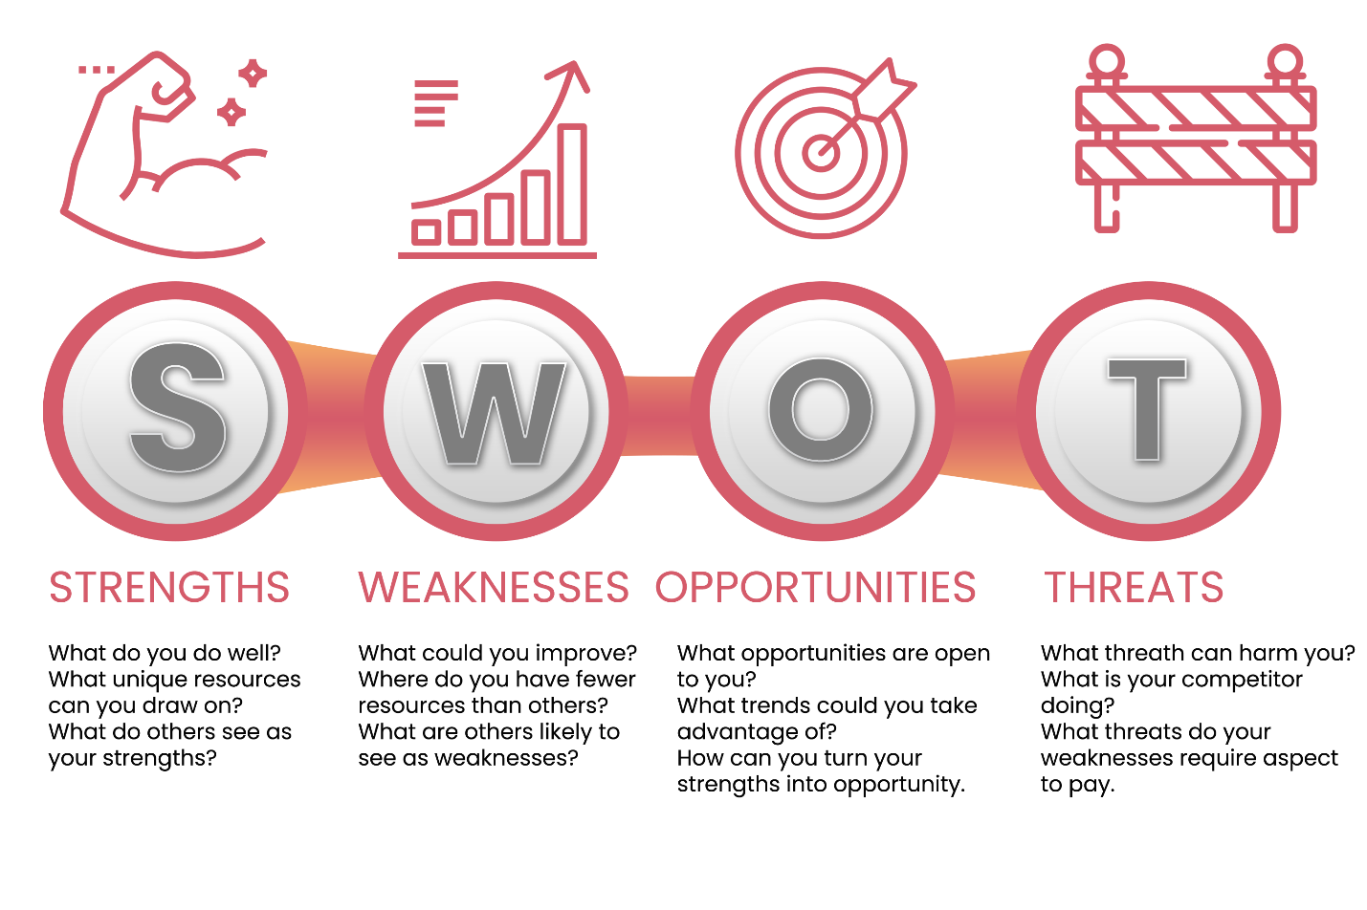
Source: (Knobler et al., 2006)

PESTLE analysis
PESTEL analysis discusses about the political, economic, environmental, technological, environmental and legal aspects of a business organization and all of these are external environmental factors. The political aspects of Burberry may include the rules and regulations developed and imposed by the government about maintaining communication and the ways of communication within workplaces. The economic factors are the efficiency and ability of the customers to spend on luxury fashion items. The social factors represent the trends among customers and the social values associated with communicating with others within the workplaces. The technological factors refers to the increasing level of digital technologies and advancements in the communication sector which is making it very cost effective for business organizations such as Burberry. Environmental factors may include the ecofriendly initiatives taken by the business organization and how they present it to the customers to earn improved brand image and popularity. Lastly, the legal factors may include complying with the rules and laws about the secrecy and maintaining privacy of the personal and sensitive information of employees and the communication which occur among employees and within the workplace on a regular basis.
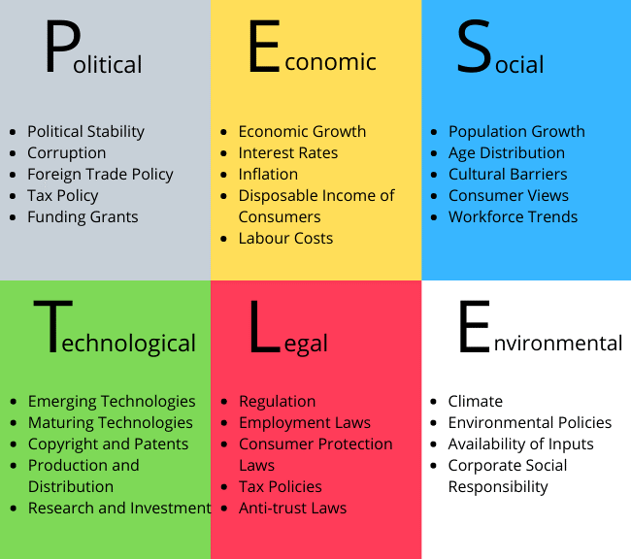
Source: (Watkins and Leigh, 2010)

Brainstorming
Brainstorming is one of the most effective ways and tools for problem solving (Arnold and Underman, 2011). In order to come up with effective solutions regarding the lack of effective communication within business organization Burberry, it is important for the management to arrange group discussions and meetings so that brainstorming sessions can be conducted where both the management and the workforce will get the opportunity to share their opinions to find out the reasons of lack of effectiveness in communication within the workplace. Along with this, employees and management can share their innovative ideas on how to increase the effectiveness of communication within the workplaces.

Porter’s five forces
The concept of Porter’s 5 forces model is focused on the overall competitive environment and level of a business organization. The threat of new market players in the case of burberry is quite low because it takes a high amount of initial investment to establish a luxury fashion retail business. The threat of substitute products is moderate due to the presence of several other renowned luxury fashion brands in the global market and each of them with interesting and attractive products to attract the customers and increase market share. The power of customers are moderate as they have other options of luxury fashion items. The power of suppliers over the management of burberry is also moderate as burberry has the financial ability to buy in bulk and there are several different suppliers interested to work with burberry. The level of industry rivalry is very high due to increasing competition and the efforts of other luxury retail businesses to increase the market share.
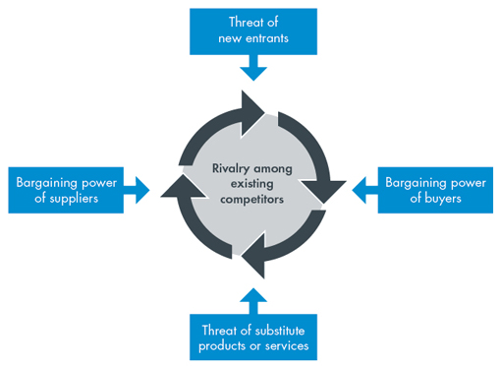
Source: (McCrie, 2016)

Solutions to the complex Problems
Several different opportunities, strategies and initiatives are available for business organizations such as Burberry in order to solve the problems and issues regarding effective communication. The most important among these is the thorough assessment of the current strategic initiatives to improve communication within the workplace to find out the weaknesses and the roots of these problems so that these issues can be addressed (Boggs, 2011). Optimizing the meeting strategy is another very important solution to increase the success level and positive impact of communication between the management and the employees of the organization. In addition to that, the management of Burberry must arrange and conduct meetings with the employees in order to develop and build positive relationship and understanding with the workforce and to increase the efficiency of the overall organizational performance. A very effective and important strategy is to involve the employees in the strategic decision making and communication strategies activities so that the employees feel important and get motivated to invest their highest level of efficiency and skills for improving the communication effectiveness.

Alternate Solution Generations
Introducing the available as well as cost effective means of digital technologies within business organizations in order to improve the level of effectiveness of the communication process is very important for Burberry. It is a very effective and successful as well as widely used solutions to increase effectiveness in communication within workplaces. Maintaining the transparency of information within the business organization is also very important and a smart solution to the problem of lack of effectiveness within organizations (Ivey and Bradford, 2003). This strategy not only helps the employees to feel important and empowered within the organization, but also develop a strong sense of responsibility among the employees to maintain regular and effective communication with others inside the organization and work as a part of the team and the whole organization towards better level of personal as well as organizational performance and success.

Evaluation of best alternatives
The effectiveness of the solutions proposed in the previous sections of the report will be evaluated in this part. Assessing the current communication strategies helps to identify the actual problems which are hampering the effectiveness of the communication process. Optimizing the meeting strategies and arranging regular meetings helps in the development of internal relationship and understanding between the management and workforce and among the employees themselves (Levett-Jones and Barraclough, 2014). Involving team members in strategic decision-making process can be effective to come up with innovative, creative, and cost-effective ideas to improve the organizational communication process. The implementation of digital technologies helps to improve communication level in a cost-effective way and saves both time and resources required for communication. Sharing important information with the employees helps to build the trust and the credibility among the employees which has a positive impact on the communication process.

Implementation
The implementation of the strategies related to improving the level of effective communication within workplaces is very important for accomplishing the desired success. First, the management of Burberry must need to identify the underlying problems which are affecting the effectiveness of the communication activities within the organization. After the successful identification of the problems, the management need to develop effective and smart as well as innovative strategies to solve these problems (Lieu, Sadler and Fullerton, 2007). Required resources and other important things should be arranged in a timely manner and allocated to the respective departments and employees who are involved in the implementation processes of the strategies. Last but not the least, the strategies which are highly innovative, creative, and cost effective and expected to bring enormous success for the organization burberry should be selected only to be implemented in order to avoid the loss of the valuable time, energy and resources of the business organization.

Monitoring and Control
One of the most significant aspects of assuring the desired success from the implementation of any strategy’s initiatives within business organizations such as Burberry is the strict, regular, and successful monitoring and controlling of the activities related to the implementation of the strategies. Not only the utilization of the resources, but also the dedication and effort level of the employees, the timeliness of the task’s completion and time management within the teams are very important to accomplish success for business organizations (Gibson, 2010).

Communicate to the stakeholders
It is very important to communicate intensely and regularly with the stakeholders involved in the communication activities and processes. The owners, shareholders, employees, the digital technology services providers and other stakeholders need to know the strategic initiatives about the communication improvement.

Recommendations
Based on the information and discussions presented in the report, some recommendations are presented below to help Burberry to improve the effectiveness of communication within workplace.
- Promptness in problem solving
- Strong approaches in strategic decision making
- Encouraging participation of employees in strategic decision making
- Increasing productivity of the management
- Maintain consistency in the communication activities
- Responding more efficiently to the stakeholders of the business

Conclusion
It is the responsibility of the managements of business organizations to assure effective communication within the business organizations. Effective and appropriate strategies should be developed for assuring effective communication within workplaces.

References
Adair J. 2009. Effective communication. Pan Books: London.
Arnold EUnderman K. 2011. The Nurse-Client Relationship. Interpersonal Relationships: Professional Communication Skills for Nurses : 83-102.
Boggs K. 2011. Bridges and Barriers in the Therapeutic Relationship. Interpersonal Relationships : 103-117.
Bovée CThill J. 2016. Business communication essentials, 7th ed. Pearson: 48.
Dwyer J. 2013. Communication for Business and the Professions: Strategies and Skills, 5th ed. Pearson Australia: Frenchs Forest, N.S.W.
Gibson B. 2010. The complete guide to understanding and using NLP. Atlantic Pub.: Ocala, Fla.
Ivey ABradford M. 2003. Encouraging, Paraphrasing and Summarizing: The Skills of Active Listening. Intentional interviewing and counselling : 124-147.
Knobler S, Burroughs T, Mahmoud ALemon S. 2006. Ensuring an infectious disease workforce, 1st ed. National Academies Press: Washington, DC: 79.
Levett-Jones TBarraclough B. 2014. Why do Patients Complain about How Health Professionals Communicate?. Critical Conversations for Patient Safety : 26-36.
Lieu C, Sadler GFullerton J. 2007. Communication Strategies For Nurses Interacting with Deaf Patients, 4th ed.: 239-245.
Watkins RLeigh D. 2010. Handbook of improving performance in the workplace, 1st ed. Jossey-Bass: San Francisco, Calif.: 117.

