iStudent number: 1907725
BA Course: Fine Art

Task 1 - Julia Lockheart-Manifesto Writing: “What do I believe in?”

8 statements

- Art is not perfect, it should make the audience feel.

- People should be more considerate of their actions, what people are doing right affects everything.

- Without the Disability Discrimination Act 1995 and the Equality Act 2010. Disabled or Deaf students would not be excluded from here in University undergraduate education courses. doing BA degrees.

- British Sign language and other nationality’s signed languages will always have a place in this world.

- Speaking and writing is just one way of expressing emotion or creating a narrative.

- Art isn’t always about what you can understand from a simple form. It can be a black line and mean so much to someone.

- Once a person changes their ways it can influence other people to do the same.

- Communication and Language deprivation can happen with Deaf people because access to their own language is denied in institutions.

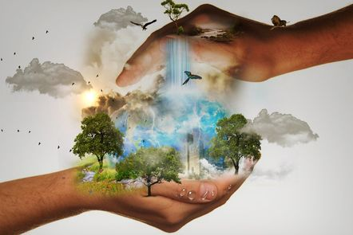

7. Once a person changes their ways it can influence other people to do the same

Human activity is causing irreparable harm to the life on this world and many current life forms will be extinct by the end of this century. At this moment, we may be causing the Sixth Mass Extinction in Earth’s history. We are in a situation where there are bush fires, sea levels rising, desertification, water shortages, crop failures and extreme weather. “We are in a planetary emergency.” (Hansen 2020 https://rebellion.earth/the-truth/the-emergency/). Everyone has a responsibility to help protect the environment. This collective responsibility could really change the world by reversing the damaging effects of global warming.

Although it's difficult to change lifestyles because people are so busy but everyone knows that it will affect the whole world. In truth, the planet will be uninhabitable by 2050, just 30 years away. This is frightening and overwhelming but if I personally can make big changes in my life then I feel everyone can, although, I do feel like a hypocrite as I continue with bad habits. However, I am motivated to make big changes this year which I hope to continue and support others that wish to change, to do the same. “It’s a very human response to follow the crowd, and that can have a positive consequences if the crowd is shifting towards sustainable behaviours. When a crowd becomes a movement, governments have to start listening too.” (Wynes 2019 p.6)

Many people are sharing posts of the Australian bushfires on social media but possibly unaware that such dangerous weather situations can happen everywhere, ultimately affecting the whole population. I desire to influence people to become proactive, change their lifestyles and make positive change this Earth.

Collective action can go beyond your own emissions and spur change in friends, family, neighbours and society.

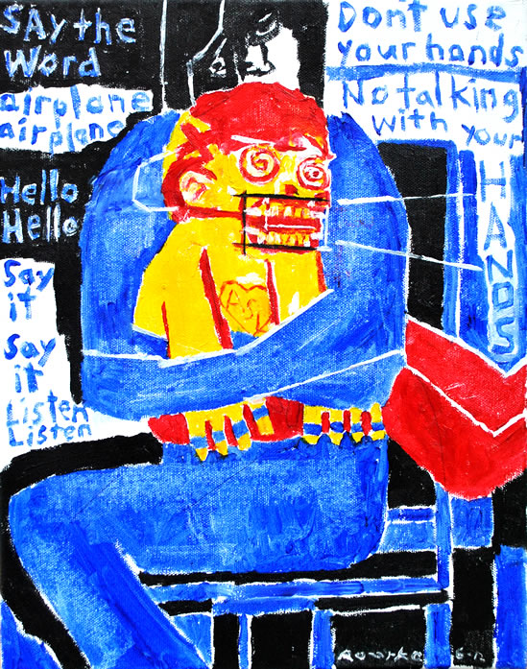

8. Communication and Language deprivation can happen with Deaf people because access to their own language is denied in institutions.
https://www.nancyrourke.com/languagedeprivation.htm
Nancy Rourke
This is a picture of Nancy Rourke’s painting “Language Deprivation”. She is an internationally-known Deaf artist and ARTivist. Her painting is about a deaf child who been brainwashed in mainstream oral school. You can see that the deaf child has his mouth braces locked, keeping his mouth open and his hands are tied up to stop him from signing in his first language. This painting is about language deprivation and building awareness for Deaf people and their limitation in mainstream school. “Language development can be particularly impacted by social factors, as seen in the developmental choices made for deaf children which can create language deprivation” (Hall et al, 2017).

Speaking and listening limits the child's language development. I believe is their right to allow to have their natural language right from the start.
This has to stop, as there’s so much research and it shows clearly that a Deaf child need to develop their first language to able to thrive in education and in general really.

Task 2 - Jon Pugh-Reflective Writing: Do you know what you think?

I’m showing a picture of my recent personal project “The struggles of a Deaf person”. This surprised me when I first started doing the project because I always avoided talking or expressing about my Deafness in art projects. I didn’t want my Deafness to define me as a person. I didn’t like writing down about my worries, my rants and other issues when it comes about being Deaf.
This project took me out of my comfort zone, as these frustrations and feelings are things that I have longed to express.
Attending a specialist deaf school made my secondary education easier for me as I had trained teachers of the deaf and the other students were all like me, I never had to worry about accessibility or inclusion. The transition from Deaf school to hearing world has been a complete shock, and I find that I have lost my identity, I do not know where I belong. Even with interpreters, I am the odd one out, I rely on a third party to convey my thoughts or to translate effectively to me what my lecturers and peers are saying.

Until I started my first term in Uni this year, I really felt the odd one out.
Few people told me to express how I felt/ still feeling in my course as it’s an important time of my life and it might be valued for other deaf people too.

When I first started the personal rant book about access. I felt like I was being so rude talking about other people and they are not providing me the right things to support me through this.

For example, few months ago I was in lesson with no BSL interpreter with me. I wanted to leave the classroom as there was no point of me being there not knowing what been said. Then I decided instead of leaving the classroom, I stayed and got my project book out. I started to try listen hard through my hearing aid and lip reading too. I wrote down what I thought my teacher said for the last half hour without looking the book. When I looked down, there was so many words missing so I put dots….. blah blah…. Blah blah….

I felt a lot better afterwards

I am aware it didn’t improve the situation as I need the support but it was nice for me to actually express what is happening to me for once.

It’s not just about booking interpreters to help me to understand what’s happening. It’s the language too. “The support for deaf students is provided based on their sensory impairment, rather than cultural and linguistic difference.”

Task 3 - Ryan Moule-Observational Writing: Identify an image and write a semiotic analysis

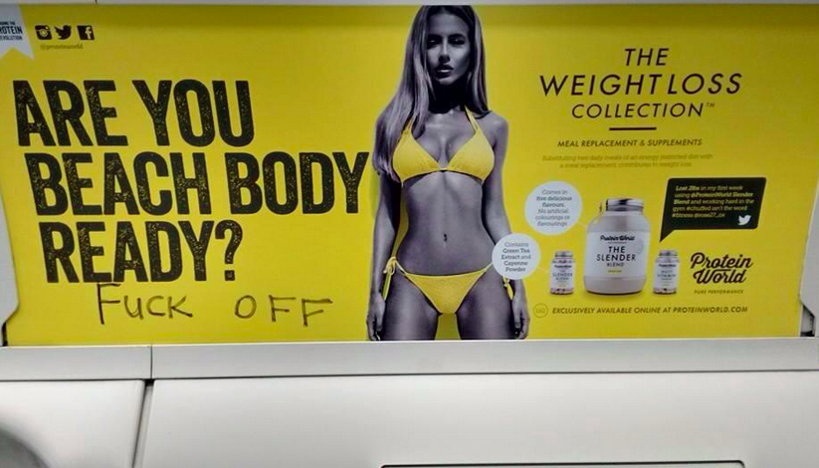

The photograph, to me, represents false advertising for women weight loss and put a great pressure on their body image and their insecurities. It’s also an insult to the feminist term as they used a woman body that are almost impossible to achieve and put quote like “Are you beach body ready?” it’s almost like a psychological blackmail to make women feel that they have to conform and look like the image shown. This was made by Protein World, their influences are to make profit out of woman’s insecurities and their anxieties. It’s not appropriate in modern times as we live in a world of equality and feminism; where is the image of a man? A group of feminists started to complain about the false advertising. The Advertising Standards Authority is launching launch an investigation into the advert campaign after it received 270 complaints, mostly arguing the advert is irresponsible and promotes an "unhealthy" body image. (https://www.buzzfeed.com/rossalynwarren/women-are-improving-this-beach-body-advert-with-their-own-bo)

References
Wyatte C. Hall, Leonard L. Levin, and Melissa L. Anderson
Language Deprivation Syndrome: A Possible Neurodevelopmental Disorder with Sociocultural Origins 2017
(Hansen 2020 https://rebellion.earth/the-truth/the-emergency/).
(Wynes 2019 p.6)
https://www.buzzfeed.com/rossalynwarren/women-are-improving-this-beach-body-advert-with-their-own-bo

