DIGITAL SKILLS AND RESEARCH METHODS
Stefan Daniel Necsutu 2011892
Lecturer Afzal Munna

Executive Summary
This paper has discussed the key impacts of online learning tools such as VLEs on the learning experiences of students. The pandemic has disrupted the learning experiences for students this study has found that online study platform improves experiential learning experiences by great amounts. This paper illustrates several outcome-based strategies, including providing an in-depth knowledge regarding the ways online learning can change students’ motivation to greater extent. The study also provides set of recommendations which can be effective for developing an effective VLE Moodle for the University students including improving the overall performance of the Moodle platform for students
Table of Contents
Chapter 1: 3
Research Title: 3
Research Aim: 3
Research Objectives 3
Research Limitations: 3
Chapter 2: Literature Review 3
Critical analysis of the Impact of VLE on the learning experiences of students 3
The ways online learning has changed the student motivation including better learning experience needs 4
Outcome-based strategies for supporting students’ skill development through online platforms 4
Theoretical framework 4
Chapter 3: Research Methodology 5
Researcher Onion 5
Research Process: 5
Research Philosophy: 5
Research Methodology 5
Data Collection 6
Sampling techniques: 6
Chapter 4: Data Collection and analysis 6
Primary data collection and analysis: 6
Secondary data collection and analysis: 9
Chapter 5: Conclusion and Recommendation 10
Recommendations: 10
Conclusions: 11
References 12
Appendices: 14
Appendix 1: Survey Questionnaire 14
Appendix 2: research onion 17
Appendix 3: Types of research process 18

Chapter 1:

Research Title:
Impacts of VLE (Virtual Learning Environment) on students’ learning experience at the University of Wales Trinity Saint David London Campus.

Research Aim:
Aim of this study is to identify and assess present online learning experiences of University students of the University of Wales Trinity Saint David London Campus.

Research Objectives
- To define critical areas of improvement associated with the virtual learning environment of the University students.
- To assess how the online learning environment has changed student motivation and needs for better learning experiences.
- To recommend prospective outcome-based strategies to support students’ skill development by the provision of experiential learning on online platforms.

Research Limitations:
The study has utilised an online survey method for collecting primary research data from students of the University of Wales Trinity Saint David London Campus. Thereby, the limitations due to its selection of students have limited to only one university. This has limited the scope for reviewing students' experiences from multiple universities from other regions and countries to overcome research bias.

Chapter 2: Literature Review

Critical analysis of the Impact of VLE on the learning experiences of students
Virtual learning experience or VLE has created a deep impact on the learning experience of students (Nguyen et al. 2017). It has been found that it creates a positive impact on the upper-grade elementary students. For instance, using a software collaboration tool, students, as well as teachers, are not only able to communicate with each other. Consequently, the analytical skills including the level of understanding are also enhanced to a greater extent. Using VLE, the performance of the students on several standardised tests in reading, language as well as vocabulary including the self-reflection skills is also enhanced to a greater extent.
It is evident that VLE has also maximised the independent thinking capabilities including encouraging progressive thoughts in students. Conversely, Memon et al. (2020) highlighted that students in VLE or a particular online learning environment basically lack the benefits as well as the opportunity to structure dialogues. It also created a lack of sense of community created in a traditional as well as the on-site classroom environment. Therefore, VLE has created both positive impacts on the student’s performance including creating some adverse impacts too.

The ways online learning has changed the student motivation including better learning experience needs
E-learning or online learning has gained popularity for delivering education as well as training in an appropriate way. Aliyyah et al. (2020) stated that both conveniences as well as flexibility associated with virtual or online learning has mainly a paramount influence on students' motivation for e-learning. Accordingly, since, online learning provides students with the freedom to work at their own pace, thereby, both participations, as well as perseverance, are maximised to a greater extent. Since having control over the timing of learning including pace, online learning has changed the student motivation completely. Accordingly, the computer-mediated learning settings also help to accomplish the learning experience needs of the majority of the students through a different type of interaction

Outcome-based strategies for supporting students’ skill development through online platforms
Implementing a set of strategies such as creating a team of competent as well as skilled teachers, embracing effective technology for maintaining uninterrupted communication is necessary to support students' skill development through online platforms. Creating a flexible teaching plan including empowering courses with several videos, in turn, can help to fulfil student' skill development requirements (Nguyen et al. 2017).

Theoretical framework
Cognitive learning theory
Cognitive theory is considered to be one of the most effective theory learning, which in turn depicts the ways human beings process information while they are associated with any kind of learning (Ghazi et al. 2018). Along with this, the theory also depicts several internal as well as external factors that help to influence a person’s learning. Applying the cognitive learning strategies, negative impacts associated with VLE can be mitigated. Consequently, students’ skill development needs can be fulfilled through an online platform by mitigating the impact of external as well as internal factors on a person’s learning and mental processes.

Chapter 3: Research Methodology

Researcher Onion
As per the Saunders et al. (2007) model of research onion, as cited by Estacio and Raga (2017), this depicts different stages of the research process and facilitates a structured and logical methodology for research. Accordingly, Al-Azawei and Al-Masoudy (2020) noted different research elements. This includes its contribution to the research has resulted in finalising the research outcomes. This study also followed a structured methodology and methods for the research that has been discussed in the below sections.
[Refer to appendix]

Research Process:
The process that has been followed for this study involved the primary search for relevant information related to online learning experiences under the influences of the online learning platforms. Thereafter, the selection of appropriate methodology and data collection has been followed for this study (Alegre et al. 2020). Data analysis and interpretation of data collected for the conclusion and recommendation for online learning experiences.
[Refer to appendix]

Research Philosophy:
This research aimed to assess the experiences of students and intends to describe the behaviour of students concerning their new learning experiences. Furthermore, this study has been selected to study based on factual understanding followed by direct observation from the area study. Thereby, as commented by Alegre et al. (2020), this study has followed Positivism philosophy of research. The researcher has utilised the underpinning potential of the positivist views. It enabled to understand critical changes and improvements associated with the interest of study.

Research Methodology
This research has followed a quantitative and qualitative research methodology to maintain its relevance with positivism research philosophy. Citing Tuyet et al. (2020), quantitative research methodology entails the quantitative study of the research problem where numerical terms have focused and prioritised for understanding impacts of VLEs. By contrast, Qualitative study has enabled us to interpret key behavioural changes of students in online platforms amid the pandemic situation. Hence, as commented by Alegre et al. (2020), this has allowed maintaining the relevancy of research in parallel to the aim of this study.

Data Collection
Primary data was collected using the online survey method where the survey questionnaire was delivered to the University students utilising email along with the consent form for adhering to ethical guidelines (Waheed et al. 2020). Besides, the Likert scale questions have been used for collecting data from students. For this purpose, the researcher complied with the Data Protection Act 2018 of the UK (Gov.uk, 2018).
For secondary research, 3 published articles on the impact of online learning platforms on student learning experiences have been selected from Google Scholar for the thematic study of secondary data.

Sampling techniques:
Random probability sampling allowed the unbiased study of data collected from respondents in primary research. Primary data from the University 71 student were collected randomly whereas non-probability sampling has been utilised for secondary data and thematic analysis.
For this purpose, 3 themes have been selected for the study of secondary data.

Chapter 4: Data Collection and analysis

Primary data collection and analysis:

Out of 71 participants, 70 students have responded to the questions. Question 1 has investigated the facts on the key improvements associated with the online learning experiences of University students. Majority of students represents 70% of the total population and represents that online learning has improved the overall understanding of the subjects. According to Waheed et al. (2020), experiential learning such as experience-based in e-learning platform has incorporated a better understanding of key subject areas. However, the difficulties associated with the acceptance of new learning platforms have also been a matter of concern. This can be evidenced from 34% of denial to the fact. Thereby, an online learning platform yet to be improvised especially for overcoming barriers associated with the digital platform. Yunus et al. (2020) mentioned three critical barriers responsible for food technological adaptation and acceptance is social, cultural and economic. Therefore, these factors have influenced 34% of students at the University in their undergraduate and postgraduate studies.

Additionally, going beyond the traditional face-to-face or direct interaction-based teaching, this has been proven for its efficiency concerning communication and mitigation communication barrier-related issues within the organisation (Yunus et al. 2020). Considering the points mentioned by Waheed et al. (2020), 52% of the student population has agreed to the fact that the confusion developed due to the communication gap has been reduced in the online platform. In reference to the psychological concerns of students, confusion has directly depended upon the communication barriers. Therefore, the internet has reduced the barriers of communication and enhanced accessibility has supported its ability for students at the University. Flexibility related issues were depicted by 34% of disagreed students. This further assures that online platform yet to be acknowledged as the promised medium of study for many due to the presence of multiple barriers.

Question 3 further collected evidence concerning communication, flexibility and key deliverables in the study to convey a message from the educators to learners. Respondents have demonstrated that 60% of students have agreed to the fact. According to Alegre et al. (2020), concrete experiences, reflective observation, conceptualisation and active experimentation are essential criteria for experiential learning Thereupon, in reference to the study, reduced communication barriers between learners and educators have been identified in the university present learning patterns. However, 23% of disagreed students have depicted that communication yet to be developed in the VLE Moodle platform.

Question 4 has depicted that strong favour towards the online learning platform where 70% of students have rated with high scores. According to Alegre et al. (2020), this depicts changes in students' behaviour that are associated with online-based learning platforms including assessment processes. Therefore, as per the comments of Barari et al. (2020), abstract conceptualisation has been delivered with the VLE Moodle platform to university students.

Lastly, question five has depicted that 47% of students have found it as a more viable source than conventional methods of study in a pandemic situation. By contrast, 33% of the student population disagrees that concrete experiences gathered in the online medium are not sufficient for matching their needs due to the academic gaps developed in the pandemic situation.

Secondary data collection and analysis:
Theme 1: Experiential learning in online platforms has improved the critical thinking and problem-solving skills of students.
As commented by Estacio and Raga (2017), the VLE Moodle has positive impacts on students that enabled them in iterative learning irrespective of the time, place and other barriers. Therefore, this method of teaching has sufficient amounts of potential to help students with abstract conceptualization and active experimentation. However, concrete experience is completely based on the practical implementation of previous learnings. Therefore, the study of Al-Azawei and Al-Masoudy (2020), stated that reflective observation active experimentation is sufficient for developing insight into key problem-solving techniques. According to Tuyet et al. (2020), organise learning experiences promote critical thinking by offering online activities such as assessments tasks. This provides challenges to learners under activities such as observation, analysis, reflection, interpretation and many more.
Theme 2: Virtual Learning environment has supported overcoming academic crises for university students amid pandemic situations and restoring the skill gaps for students.
From the above discussions, the World Economic Forum report has depicted that Covid-19 has developed academic crises around the world due to the discontinuation of schools and academic institutions as well (Weforum.org, 2020). Amid this situation, virtual learning has reduced the distance between learners and their courses. Therefore, in the supporting views of Waheed et al. (2020), online learning has supported the retention of information due to remote teaching and e-learning flexibility as well.
Theme 3: Changes in student roles and readiness in virtual learning environments has been observed in past months.
This online or VLE Moodle allowed shared learning using social learning and also allowed experiential learning such as gamification, and this helps to improve knowledge supported by experience (Yunus et al.2020). This has improved the performance of students by reducing cost and delay in the study process and procedures.

Chapter 5: Conclusion and Recommendation

Recommendations:
Recommendation 1: A structured VLE Moodle course can be effective for developing skills and knowledge with sufficient place for experimentation of knowledge and key learnings (Yunus et al. 2020).
Recommendation 2: Small computer System Interface (SCSI) can be effective for developing an effective VLE Moodle for the University students and can improve the overall performance of the Moodle platform for students (Waheed et al. 2020).

Conclusions:
This study has emphasised on the key impacts of the VLEs on students’ experiences has major positive impacts and improved their learning experiences by the provision of experiential learning. Better communication with professors and flexibility in the learning environment has improved the overall performance of students. Accordingly, the online platform has enhanced the transparency in knowledge transfer and improved the communication between two parties such as students and learners.
This qualitative study has deeply investigated the facts concerning students’ behaviour. Present trends have depicted that students are greatly influenced by the online learning model due to multiple benefits. Furthermore, this will be an effective solution for future educational crises as well where the needs of students can be anticipated under the online VLE Moodle.

References
Al-Azawei, A. and Al-Masoudy, M., (2020). Predicting Learners' Performance in Virtual Learning Environment (VLE) based on Demographic, Behavioral and Engagement Antecedents. International Journal of Emerging Technologies in Learning (iJET), 15(9), pp.60-75.
Alegre, F., Moliner, L., Maroto, A. and Lorenzo-Valentin, G., (2020). Academic Achievement and Peer Tutoring in Mathematics: A Comparison Between Primary and Secondary Education. SAGE Open, 10(2), p.2158244020929295.
Aliyyah, R.R., Rachmadtullah, R., Samsudin, A., Syaodih, E., Nurtanto, M. and Tambunan, A.R.S., (2020). The Perceptions of Primary School Teachers of Online Learning during the COVID-19 Pandemic Period: A Case Study in Indonesia. Journal of Ethnic and Cultural Studies, 7(2), pp.90-109.
Barari, N., RezaeiZadeh, M., Khorasani, A. and Alami, F., (2020). Designing and validating educational standards for E-teaching in virtual learning environments (VLEs), based on revised Bloom’s taxonomy. Interactive Learning Environments, pp.1-13.
Estacio, R.R. and Raga Jr, R.C., (2017). Analyzing students online learning behaviour in blended courses using Moodle. Asian Association of Open Universities Journal.
Ghazi, C., Nyland, J., Whaley, R., Rogers, T., Wera, J. and Henzman, C., (2018). Social cognitive or learning theory use to improve self-efficacy in musculoskeletal rehabilitation: A systematic review and meta-analysis. Physiotherapy theory and practice, 34(7), pp.495-504.
Gov.uk, (2018). The Data Protection Act 2018 Available at:https://www.gov.uk/data-protection#:~:text=The%20Data%20Protection%20Act%202018%20is%20the%20UK's%20implementation%20of,used%20fairly%2C%20lawfully%20and%20transparently [Accessed on: 29.12.2020]
Memon, M.M., Hashmani, M.A., Jameel, S.M., Junejo, S. and Raza, K., (2020). Analysis of Student Procrastinatory Behavior in Virtual Learning Environments Using Machine Learning. Journal of Hunan University Natural Sciences, 47(10).
Nguyen, Q., Rienties, B. and Toetenel, L., (2017, March). Unravelling the dynamics of instructional practice: A longitudinal study on learning design and VLE activities. In Proceedings of the seventh International learning Analytics & knowledge conference (pp. 168-177).
Tuyet, N.T., Long, N.T. and Van Hanh, N., (2020). The effect of positive learning culture in students’ blended learning process. Journal of e-Learning and Knowledge Society, 16(3), pp.68-75.
Waheed, H., Hassan, S.U., Aljohani, N.R., Hardman, J., Alelyani, S. and Nawaz, R., (2020). Predicting academic performance of students from VLE big data using deep learning models. Computers in Human Behavior, 104, p.106189.
Weforum.org, (2020). The COVID-19 pandemic has changed education forever. This is how Available at:https://www.weforum.org/agenda/2020/04/coronavirus-education-global-covid19-online-digital-learning/ [Accesesd on: 31.12.2020]
Yunus, M.M., Yaacob, N. and Suliman, A., (2020). The Use of Electronic Frog VLE in Assisting Reading Comprehension Activities. Universal Journal of Educational Research, 8(3), pp.879-887.

Appendices:

Appendix 1: Survey Questionnaire
Participants: 71
Total Respondents: 70
Question 1:  Do you agree, online learning platforms such as VLE Moodle have improved your understanding in your key study areas? | Responses:
Strongly agree | 12
Agree | 30
Neutral | 15
Disagree | 3
Strongly Disagree | 10

Question 2:  How far do you agree that online VLE provisioned better clarity for subjects and online video tools reduced confusion concerning key learning concepts? | Responses:
Strongly agree | 20
Agree | 16
Neutral | 10
Disagree | 24
Strongly Disagree

Question 3:  Do you agree online interactions with professors and access to study materials has a positive influence on communication that improves the understanding of concepts? | Responses:
Strongly agree | 32
Agree | 10
Neutral | 12
Disagree | 16
Strongly Disagree | 0

Question 4:  On a scale of 1(minimum) to 5 (maximum), how do you want to rate present online study experiences concerning its mobility and flexibility? | Responses:
1
2
3 | 26
4 | 27
5 | 17

Question 5:  Do you agree, online learning platforms such as VLE Moodle have sufficient quality to improve your knowledge attributes and enhance your interactive learning experiences? | Responses:
Strongly agree | 10
Agree | 25
Neutral | 15
Disagree | 25
Strongly Disagree | 5

Appendix 2: research onion

(Source: https://www.researchgate.net/figure/Research-Onion-Source-Saunders-et-al-2009_fig7_324171957)

Appendix 3: Types of research process
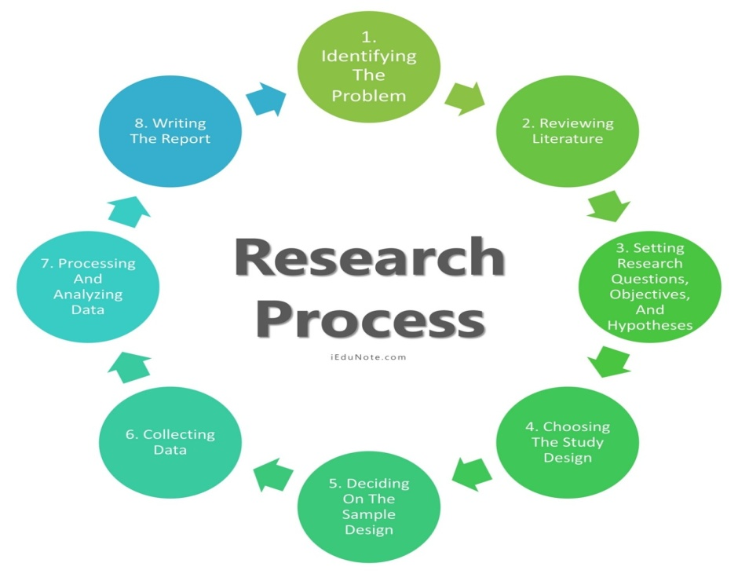

(Source: https://guides.monmouth.edu/research)

