River Ilston Field Guide
Monday 6th November, 2023

Site Description
The study catchment (the Ilston basin, Gower) drains a total area of 30 km² and is underlain by rocks of the Avonian series comprising the south crop of the South Wales coalfield: Millstone Grit, Namurian Shales, Coal Measures and Carboniferous Limestone. The Ilston is a gravel-bed river (Lawler, 1986). The Ilston becomes Pennard Pill at the confluence of the Ilston and the tributary running past the Gower Heritage Center. It then makes its way to Three Cliffs Bay where it meets the sea. The red walking route in Figure 1 highlights an accessible route to access the river channel.
Please be respectful of local wildlife and other trail users. Cows will likely be grazing around Pennard Pill. Please give them some distance. Local conditions are currently fairly saturated, so please be careful on paths, river banks and in the channel.
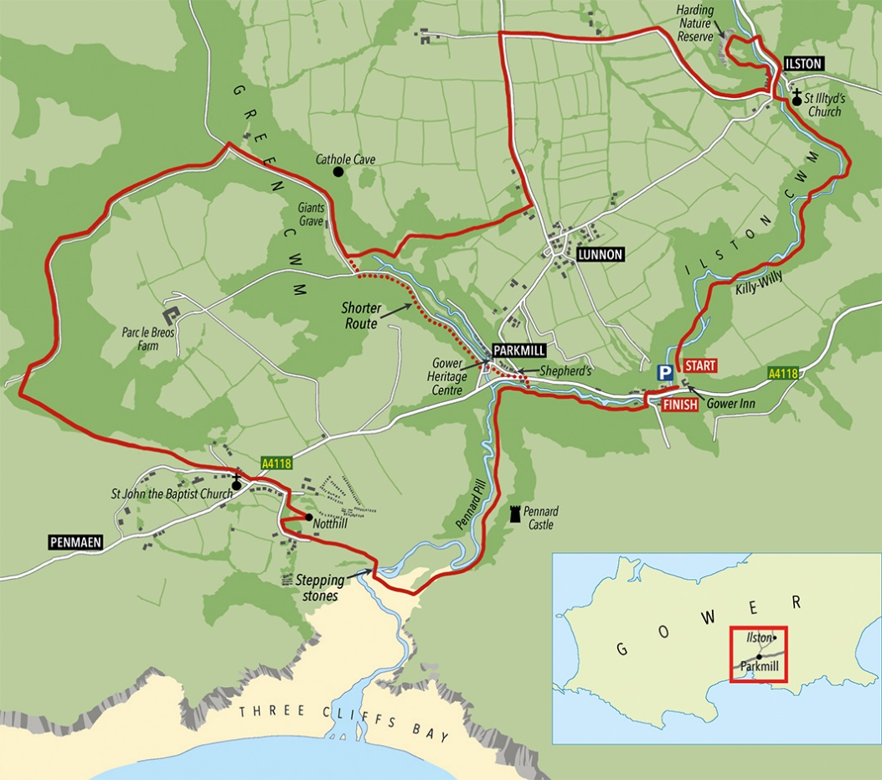
Downstream
Upstream access
Figure 1. Map of Field Area. Modified from: Ilston Cwm circular walk - The Bay Magazine Swansea (theswanseabay.co.uk).

Gower Heritage Centre and significance to study
Gower Heritage Centre (Figure 2) has a working 12th century water mill. A Corn Mill was established on this site sometime during the 12th century, as part of the estate belonging to the powerful Le Breos family, who were granted sovereignty of Gower by King John in 1203. The first written references to the Mill appear in government records from about 1300 onwards (Gower Heritage Website, 2023). The mill pond that drives this wheel is fed by a little brook (see pic) which rises in Parc-le-Breos wood, hald a mile up the valley and has never been known to run dry (Herald of Wales, 1931).

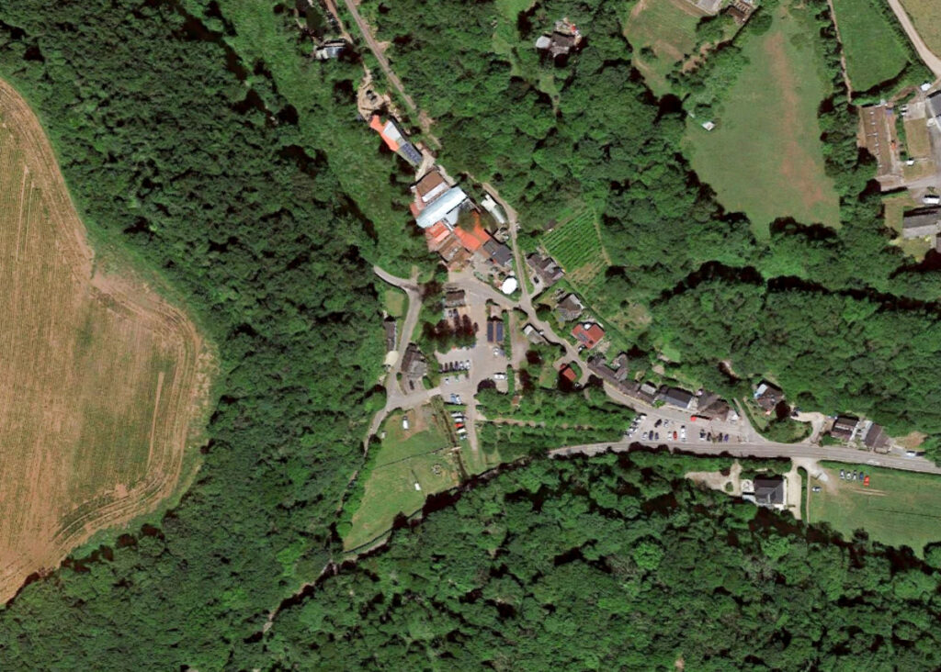
Toilet Block
Toilet (in shop)
River Access (and trail)
Parking
Figure 2. Aerial View of the Gower Heritage Centre showing access route to the river.

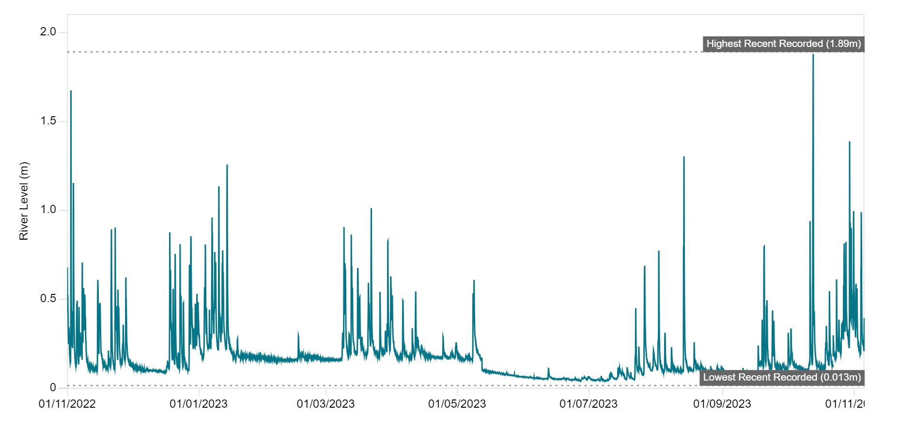
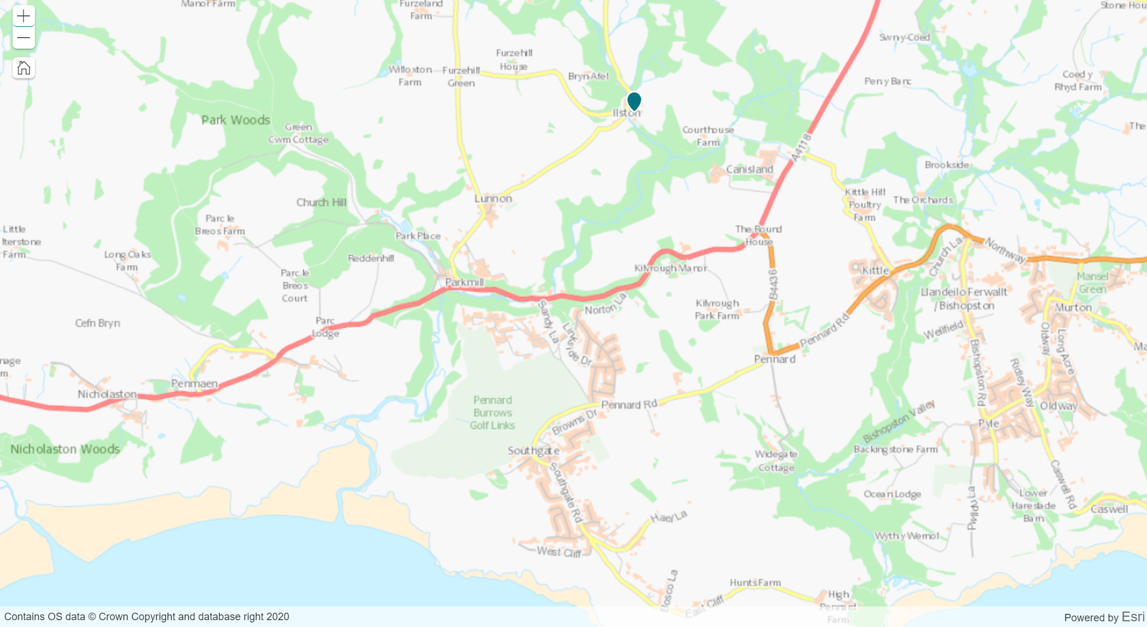
Figure 3. River Stage Data at Ilston from 11/22-11/23. Source: Pennard Pill at Ilston - River levels, rainfall and sea data (naturalresources.wales) and River levels, rainfall and sea data (naturalresources.wales).

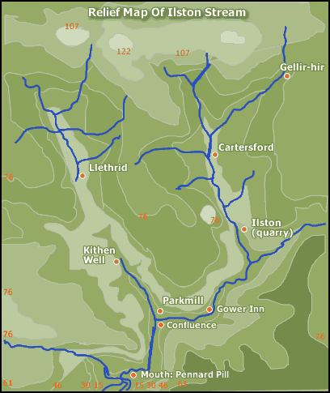
Figure 4. Relief Map of River Ilston and Pennard Pill. Source: Ilston Stream (digitaldesk.org).

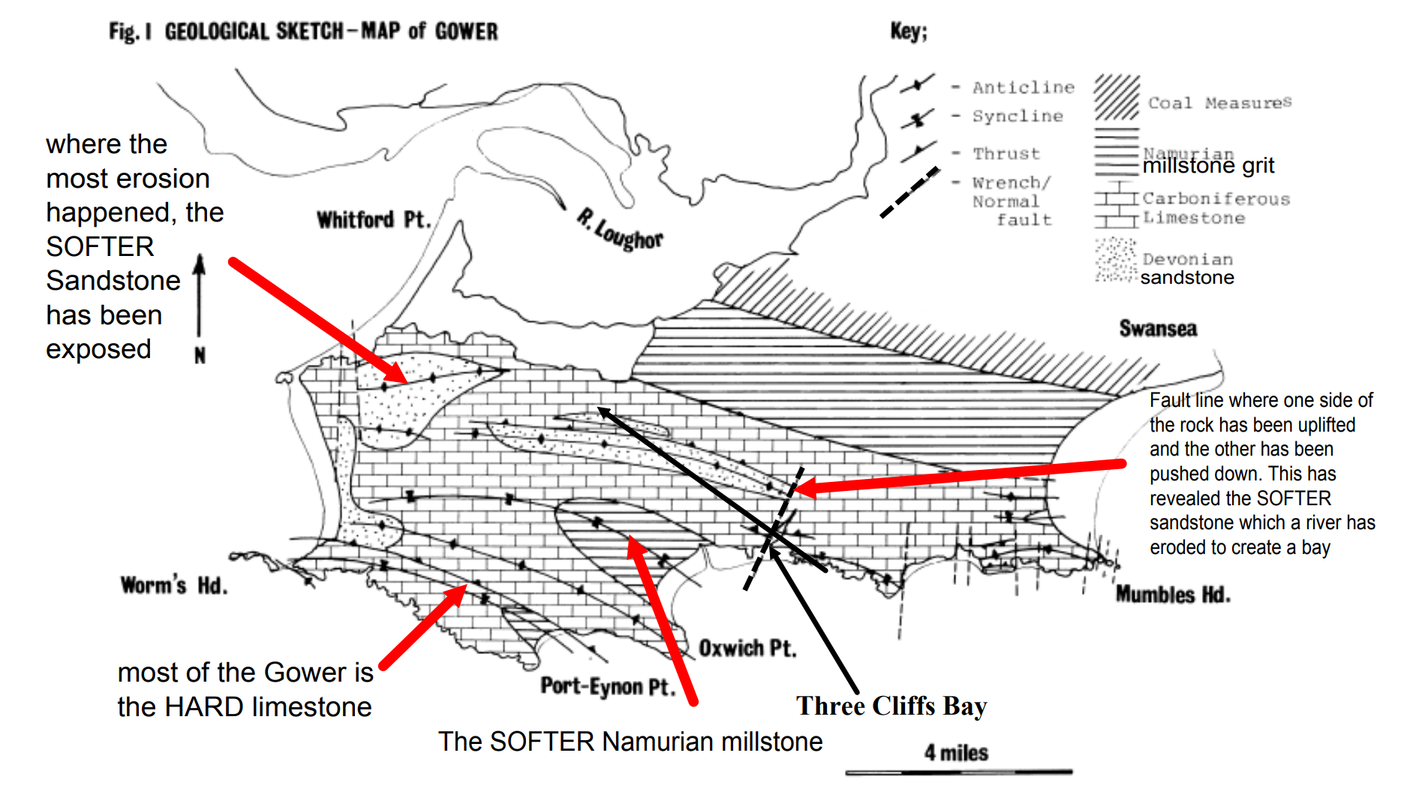
Figure 5. Gower Geological Sketch. Source: Untitled (weebly.com).
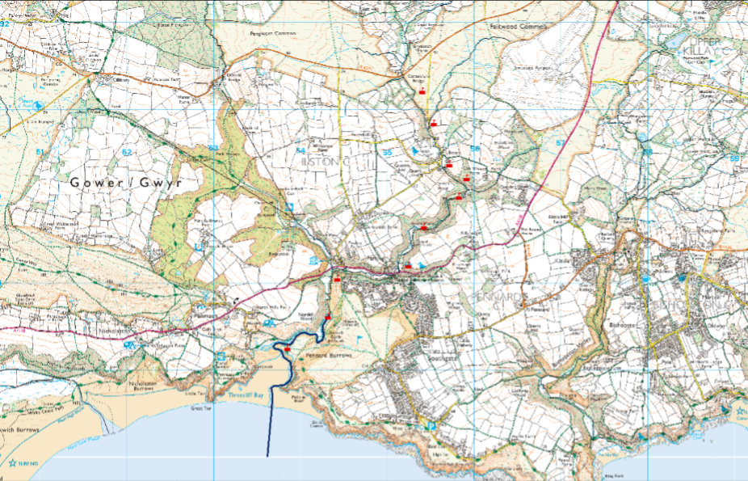
Figure 6. Cross sections taken in previous discharge measurement trips.

References
Herald of Wales (1931). Where the Mills of Man Grind Slow. Saturday 28th November. Source: rsz_last_of_the_gower_mills-1.jpg (2356×1347) (gowerheritagecentre.co.uk).

