ASSESSMENT 1: INDIVIDUAL BLOG
MARKETING FUNDAMENTALS
ANALYSIS AND EVALUATION

Table of Contents
Introduction 3
STP determination 3
7Ps of marketing 6
Conclusion 9
References 10

Introduction
Marketing segmentation and marketing mix are both crucial tools for businesses in today's market. Marketing segmentation involves distributing a market into smaller groups of customers who have similar characteristics or demands. By doing this, businesses can develop targeted marketing campaigns which are customized to the specific preferences and needs of each group (Huang and Rust, 2021). This helps to improve the effectiveness of marketing efforts by ensuring that the right message is reaching the right people at the right time. The marketing mix, on the other hand, refers to the set of tactics and strategies that businesses use to promote their products or services. The four to seven elements of the marketing mix can be found, by carefully balancing these elements, businesses can create a marketing strategy that is designed to meet the needs of their target market. Here, in this study, marketing segmentation as well as marketing mix of the company Tesco is discussed.

STP determination
As a UK-based multinational general merchandise and grocery retailer, Tesco, as with any business, the company uses segmentation, targeting, and positioning (STP) strategies to create marketing campaigns that resonate with its target customers. Here, in this section a comprehensive analysis of Tesco's STP strategies is provided below:
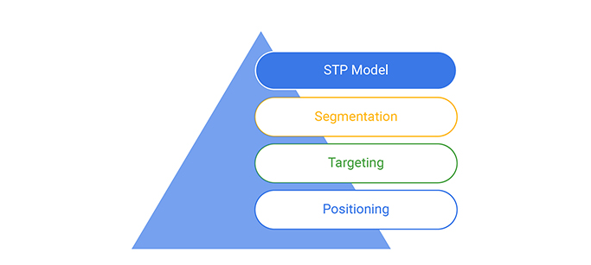
Figure 1: Marketing Segmentation-STP model
(Source: Huang and Rust, 2021)
Segmentation:
Tesco uses various segmentation strategies to divide the market into smaller groups of customers with similar characteristics and needs. Some of the main segmentation strategies used by Tesco include:
- Demographic Segmentation: Tesco segments its market on the basis of demographic factors such as gender, age, family size and income. One example of that is the company's Clubcard program, it offers different benefits and discounts to customers based on their age, income level, and other demographic factors (Tescoplc.com, 2023).
- Geographic Segmentation: Tesco segments its market based on geographic factors such as location, climate, and cultural differences. For example, the company offers different products and promotions in its stores located in urban areas compared to those in rural areas (Tescoplc.com, 2023).
- Psychographic Segmentation: Tesco segments its market on the basis of psychographic factors such as values, lifestyle, and personality. For example, the company offers a range of healthy and organic products to appeal to customers who value healthy living.
- Behavioral Segmentation: Tesco segments its market based on behavioral factors such as purchasing behavior, brand loyalty, and benefits sought (Vidjaya, 2017). For example, the company offers discounts and promotions to customers who frequently shop at its stores to encourage repeat purchases.
Targeting:
After segmenting its market, Tesco uses targeting strategies to focus its marketing efforts on the most attractive customer segments. Tesco's targeting strategies include:
- Undifferentiated Targeting: Tesco targets the mass market by offering a wide range of products and services that appeal to customers across various segments.
- Differentiated Targeting: Tesco targets multiple segments with different marketing campaigns and product offerings. For example, the company offers a range of products and services tailored to different age groups and income levels. Regarding that one of the main is providing products with competitive cost, which not only enabled the company a better differentiable portfolio image of convenience, along with that it also enabled the company to broaden their customer base at the same time (Huang and Rust, 2021).
- Concentrated Targeting: Tesco targets a specific segment with a highly focused marketing campaign. For example, the company targets students with discounts and promotions during the back-to-school season (Tescoplc.com, 2023).
Positioning:
Tesco uses various positioning strategies to differentiate its products and services from those of its competitors. Tesco's positioning strategies include:
- Value Positioning: Tesco positions itself as a value-oriented retailer that offers high-quality products at affordable prices (Varadarajan, 2017). This is reflected in the company's "Everyday Value" line of products, which are designed to be affordable for customers on a budget.
- Convenience Positioning: Tesco positions itself as a convenient retailer that offers a wide range of services and products in one location. This is reflected in the company's "One-Stop Shop" slogan, which emphasizes its ability to meet all of a customer's shopping needs in one place (Tescoplc.com, 2023).
- Quality Positioning: Tesco positions itself as a retailer that offers high-quality products and services. This is reflected in the company's partnerships with well-known brands and its focus on offering fresh, high-quality produce.
- Innovation Positioning: Tesco positions itself as an innovative retailer that is constantly introducing new services and sproducts to meet the changing needs of its customers. For example, the company has invested heavily in online shopping and home delivery services to cater to customers who prefer to shop from home. In that aspect, it also needs to be suggested that online shopping and presence on online media enable the company in connecting with their stakeholders in amore collective manner, because of the double way communication option availability in these platforms (Huang and Rust, 2021). Along with that, as the company is able to meet their clients and customers it helped them in gaining better understanding about the market’s demands and needs which also helped them in making relevant changes in their products and operations which helped them in gaining better competitive advantages in the market.

7Ps of marketing
Here in this section of the study a comprehensive analysis of Tesco's 7Ps marketing strategy is provided below:
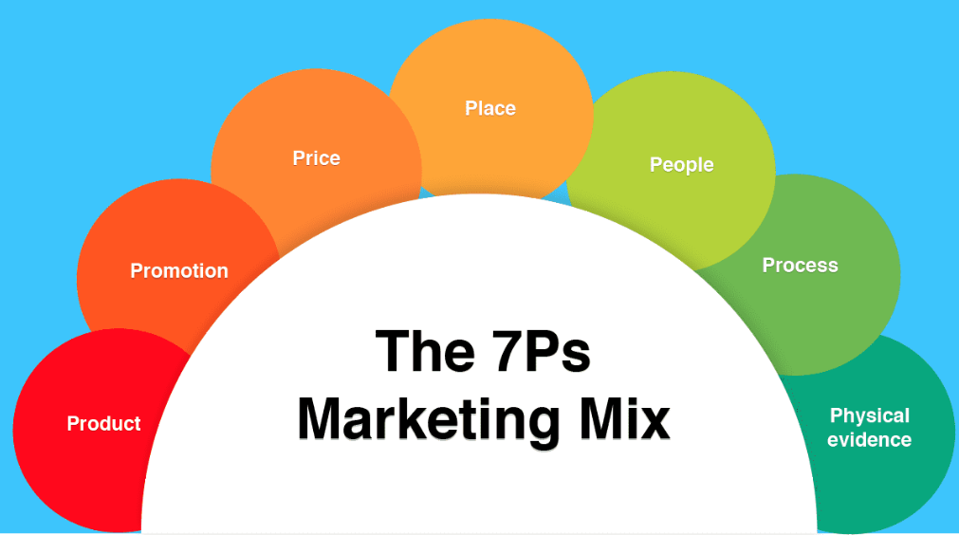
Figure 2: The 7Ps Marketing Mix
(Source: Kaushik, 2018)
Product:
Tesco's product strategy is centered on offering a wide range of services and products that cater to the demands of its consumers. The company offers a variety of products and services across various categories, including groceries and foods, clothing, home goods, electronics, and financial services. Tesco's product strategy is based on the principle of customer-centricity, which means that the company focuses on understanding its customers' demands and preferences and tailoring its products and services accordingly (Tescoplc.com, 2023).
An example of Tesco's product strategy is its range of own-brand products. Tesco offers a range of own-brand products, including Tesco Value, Tesco Finest, and Tesco Organic. These products are designed to cater to customers with different needs and preferences. For example, Tesco Value products are designed to be affordable for customers on a budget, while Tesco Finest products are designed to appeal to customers who value high-quality, premium products (Mbaskool.com, 2023). Along with that Tesco Organic as the name suggests the company ensured products for the customers who are health conscious as well as environmental conscious at the same time, and popularity of these products also increasing in an exceptional manner due to the reason awareness about green environment, increasing pollution and better health is increasing significantly among the people and society.
Price:
Tesco's pricing strategy is based on offering competitive prices that are affordable for its customers. The company uses a variety of pricing strategies, including value-based pricing and promotional pricing, to attract customers and increase sales. Tesco's pricing strategy is designed to create value for its customers while also generating profits for the company. In this aspect, due to the competitive pricing strategy of the company it is able to gain cost leadership in the market, which enables the company a better competitive advantage in the market (Kaushik, 2018).
An example of Tesco's pricing strategy is its Clubcard program. The Clubcard program offers customers discounts and rewards based on their shopping habits (Mbaskool.com, 2023). This allows Tesco to offer personalized discounts to customers while also incentivizing them to shop more frequently at Tesco stores.
Place:
Tesco's place strategy is centered on making its products and services easily accessible to its customers. The company operates over 6,800 stores across 12 countries, making it one of the largest retailers in the world. Tesco's place strategy is designed to create a convenient shopping experience for its customers, no matter where they are located (Tescoplc.com, 2023).
An example of Tesco's place strategy is its online shopping and home delivery services. Tesco offers a range of online shopping and home delivery services, including Tesco Direct and Tesco Groceries (Tescoplc.com, 2023). These services allow customers to shop for Tesco products from the comfort of their own homes and have them delivered directly to their doorstep.
Promotion:
Tesco's promotion strategy is centered on creating awareness and interest in its products and services. The company uses a variety of promotional tactics, including advertising, sales promotions, and public relations, to reach its target customers and increase sales (Jain and Jain, 2022). Along with that, online marketing in various social media such as Twitter, Facebook, Youtube and others also helped the company in gaining a better market share development process. The organization also uses various influencers for promoting their products in online channels, which helps them not only connect with the customers but also make a better understanding of the customers’ demands as influencers presence in online media or in general online markets assure a two way communication process.
An example of Tesco's promotion strategy is its "Food Love Stories" campaign (Tescoplc.com, 2023). The campaign features a series of videos that showcase the stories behind Tesco's food products. The campaign is designed to create an emotional connection with customers and increase brand loyalty.
People:
Tesco's people strategy is centered on providing excellent customer service and creating a positive shopping experience for its customers (Altay et al. 2022). The company invests heavily in training and development programs for its employees to ensure that they have the skills and knowledge needed to provide exceptional customer service.
An example of Tesco's people strategy is its "Tesco Academy" program. The program provides training and development opportunities for Tesco employees at all levels of the organization (Tescoplc.com, 2023). The program is designed to improve employee skills and knowledge, which in turn improves the customer experience.
Process:
Tesco's process strategy is centered on providing a seamless and efficient shopping experience for its customers. The company invests heavily in technology and logistics to ensure that its products and services are delivered to customers quickly and efficiently.
An example of Tesco's process strategy is its "Scan-and-Shop" service. This service allows customers to scan and bag their items as they shop, which saves time and reduces wait times at checkout (Tescoplc.com, 2023). Customers can pay for their items using a self-checkout machine, which further streamlines the checkout process. This process strategy not only improves the customer experience but also reduces operating costs for Tesco by reducing the need for checkout staff.
Physical evidence:
Tesco's physical evidence strategy is centered on creating a pleasant and inviting shopping environment for its customers (Hasan and Islam, 2020). The company invests heavily in store design, layout, and signage to create a visually appealing shopping experience for customers.
An example of Tesco's physical evidence strategy is its "Food Love Stories" in-store displays. These displays showcase Tesco's food products in a visually appealing way, using high-quality imagery and creative layouts (Tescoplc.com, 2023). This creates an immersive shopping experience for customers and helps to reinforce Tesco's brand identity as a provider of high-quality, affordable food products.

Conclusion
From the above discussion it is clear that STP strategies and 7Ps of marketing for a company like Tesco provides a clear understanding about the target marketing process as well as marketing strategy of the company. In that aspect, it can be found that affordable pricing and value for product is one of the main mottos of the company to be differentiable in the market, the strategy helped the company significantly as it ensured them as one of the main cost leaders of the market. Moreover, the company's focus on personalized discounts, online shopping, and home delivery services, along with its investment in employee training and development, technology, and store design, has helped to create a positive brand image and improve customer loyalty.

References
Altay, B.C., Okumuş, A. and Adıgüzel Mercangöz, B., 2022. An intelligent approach for analyzing the impacts of the COVID-19 pandemic on marketing mix elements (7Ps) of the on-demand grocery delivery service. Complex & Intelligent Systems, 8(1), pp.129-140.
Hasan, M.M. and Islam, M.F., 2020. The Effect of Marketing Mix (7Ps’) on Tourists’ Satisfaction: A Study on Cumilla. The Cost and Management, 48(2), pp.30-40.
Huang, M.H. and Rust, R.T., 2021. A strategic framework for artificial intelligence in marketing. Journal of the Academy of Marketing Science, 49, pp.30-50.
Jain, R. and Jain, S., 2022. Analyzing and Exploring the Effectiveness of Each Element of 7Ps of Marketing Mix. International Journal of All Research Education and Scientific Methods, 10(1), pp.243-251.
Kaushik, A., 2018. 7P's of marketing mix in MOOCs environment. International Journal of Information Dissemination and Technology, 8(2), pp.57-61.
Mbaskool.com (2023), Tesco Marketing Strategy & Marketing Mix (4Ps), Accessed from: https://www.mbaskool.com/marketing-mix/services/16731-tesco.html, Accessed on: 2ns April, 2023
Tescoplc.com (2023), TescoPLC - About us Accessed from:https://www.tescoplc.com/, Accessed on: 2ns April, 2023
Varadarajan, R., 2017. Innovating for sustainability: a framework for sustainable innovations and a model of sustainable innovations orientation. Journal of the Academy of Marketing Science, 45, pp.14-36.
Widjaya, P.G., 2017. Analisis Segmenting, Targeting, Positioning dan Marketing Mix pada PT. Murni Jaya. Agora, 5(1).

