
Module Name: Academic Skills in the Digital Era
Module Code: BMSW4013
Assessment 1:
Student Name: Zander Hiller
Student Number: 2528768
Lecturer: Chris Wilkin
Deadline: 27/02/26

Wordcount: 1730
AI Acknowledgement

I acknowledge the use of [Research Assistant] (librarysearch.uwtsd.ac.uk/discovery/researchAssistant?vid=44WHELF_UWTSD:44WHELF_UWTSD_VU1 - on 10.02.2025 - 20.02.2025 to support research.

I confirm that I have not presented any AI-generated text as my own work. I confirm that I have retained copies of drafts, notes, and resources used before and after the use of AI tool

Contents
Component 1 – Development of Academic Skills (500 words) 3
Component 2 – Application of Academic Skills (1,000 words) 6
Component 3 – Academic Poster 9

Component 1
Evaluating Academic Sources Using the CRAAP Test (427 - words)
Source 1
Author(s) and year: Jared Keengwe, February 2023
Where you found the source (e.g. library database): IGI Global

Using the CRAAP Test, briefly evaluate:
- Currency: The book was published in 2023, so the ideas and examples are very up to date. This matters because digital practices and globalisation change quickly, and newer sources reflect current trends.
- Relevance: The content fits well with topics such as digital learning, innovation, and global changes in higher education. It is useful for students, educators, and anyone studying how technology shapes teaching and learning.
- Authority: The content fits well with topics such as digital learning, innovation, and global changes in higher education. It is useful for students, educators, and anyone studying how technology shapes teaching and learning.
- Accuracy: The book is research based and published by an academic press. It uses evidence, references, and established theories, which suggests the information is reliable and trustworthy.
- Purpose: The purpose is to inform and educate readers about new digital practices
and global trends. It is not written to sell a product or push a biased viewpoint.

Full reference (Harvard style): Keengwe, J., 2023. Innovative Digital Practices and Globalization in Higher Education.

Source 2
Author(s) and year: Ordóñez de Pablos, P., Lytras, M.D. and Zhang, X., 2020. IT and the Development of Digital Skills and Competences in Education
Where you found the source (e.g. library database,): IGI Global

Using the CRAAP Test, briefly evaluate:
- Currency: Published in 2020, the book is fairly recent. It discusses digital skills and education, which change quickly, but the content is still modern enough to be useful.
- Relevance: The book is directly relevant to topics such as digital skills, technology in education, and how learners and teachers adapt to digital environments. It fits well with studies on digital competence and educational development.
- Authority: The authors: Ordóñez de Pablos, Lytras, and Zhang are established academics with strong backgrounds in information systems, digital learning, and knowledge management. Their expertise gives the book strong credibility.
- Accuracy: The text is research based and published by a recognised academic publisher. It uses evidence, case studies, and scholarly references, which supports the reliability and accuracy of the information.
- Purpose: The purpose is to inform and educate readers about how digital skills are developed in education. It aims to share research and best practice rather than persuade or promote a commercial viewpoint.

Full reference (Harvard style): Ordóñez de Pablos, P., Lytras, M.D. and Zhang, X., 2020. IT and the Development of Digital Skills and Competences in Education

Synthesis of Academic Sources (194 words)
Both sources examine how education is changing because technology now plays a major role in teaching and learning. Ordonez de Pablos, Lytras and Zhang (2020) explain how students can be supported to build the skills they need to use technology confidently in their studies. They highlight the importance of giving learners clear guidance and regular opportunities to develop these skills. Keengwe (2023) discusses similar ideas but focuses more on how technology is reshaping higher education on a wider scale, including global influences and new way of teaching.
The two sources agree that the technology is now essential in education and that students must be supported to use it effectively. However, they differ in their main focus. Ordonez de Pablos et all. (2020) look closely at how students learn and strengthen their technology related skills, while Keengwe (2023) looks at broader changes affecting universities and teaching methods. Together, they complement each other by linking what students need to learn with the wider changes happening across the education sector.
Using both sources gives a clearer understanding of technology enhanced learning by showing how individual skills development and wider institutional change work together to support effective education.

Identifying a Key Challenge and Opportunity (107 words)
A key challenge for students in the Digital era is learning how to use technology effectively for their studies. Ordones de Pablos, Lytras and Zhang (2020) explain that students often need structured support and guidance to build the skills required to work confidently with technology. Without this support many learners struggle to keep up with the demands of modern education.
A key opportunity is that technology can open acces to new ways of learning. Keengwe (2023) shows thar Digital tools and global developments allow students to learn in more flexible and engaging ways. This gives learners more chances to develop their knowledge and participate in higher education.

Academic Planning for Component 2 (85 Words)
The challenges section will be prioritised first as it introduces the main problem students face when using technology in higher education. After this, the opportunities section and the strategies section will be developed. Key academic skills that will be streinhgtened include critical reading, identifying reliable sources and organising ideas clearly. The report will follow a clear structure as introduction, a section on challenges, a section on opportunities, three strategies for student success, and a conclusion that summarises the main points and answers the overall questions.

Timeline
Task | Date/ Deadline
Finish research | 20.02.2026
Draft first section | 24.02.2026
Complete first draft | 24.02.2026
Final editing | 25.02.2026

Reference List – Component 1
(Harvard style, alphabetical order. Only sources used in Component 1.)
Keengwe, J., 2023. Innovative Digital Practices and Globalization in Higher Education.
Ordóñez de Pablos, P., Lytras, M.D. and Zhang, X., 2020. IT and the Development of Digital Skills and Competences in Education.

Component 2 – Application of Academic Skills

(916 - Word Report)
(Personal experiences must NOT be included in this component)
Technology now plays a major role in higher education, with universities using online tools for teaching, communication, and accesing learning materials. As Digital learning becomes more common, it is important to understand the challengies and opportunities this creates for students. Research shows that technology can support learning, but students may struggle if they do not have the skills needed to use it effectively. (Ordóñez de Pablos et al., 2020; Keengwe, 2023). At the same time Digital learning can offer new ways to study and access information. Understanding these issues is important because they directly affect students, academic progress and their ability to engage with their students.
This report will discusses key challenges students face in the Digital era, followed by opportunities created by technology. It will then present three strategies students can use to succeed. The report ends with summary of the maim points.
One major challenge for students is learning how to use technology effectively for academic work. Ordonez de Pablos, Lytras and Zhang (2020) explain that many students need clear support to learn how to use online tools for reading, researching and completing assigments. Without this support students may feel unsure about how to study online, which can affect their confidence and academic performance. This challenge links to academic skills taught in class such as reading, note taking and evaluating information, because these skills now often use online tools.
Another challenge is adapting to rapid changes in technology. Keengwe (2023) notes that higher education regulary introduces new systems and platforms. Students who are not familiar with these changes may find it difficult to stay organised or access important materials. Vachkova et al. (2022) add that teachers also face pressure to update their Digital skills, which means students may experience inconsistency in how technology is used across courses. This can affect key academic skills such as time management and independent study.
These challenges shows that students need strong academic and digital skills to succeed and that universities must provide clear guidance to help them adapt.
Both challenges and opportunities have been discussed in lectures and are supported by McPherson (2018), who explains that note-taking helps students make information meaningful. If used well, note-taking can help students manage their working memory and rely less on technology. However, it also creates a challenge that if information is not noted clearly, it becomes harder for students to remember and use the learning later.
Technology also creates important opportunities for students. One of the opportunity is easier access to learning materials. Keengwe (2023) explains can now access lectures, readings, and resources from anywhere, giving them more flexibility in how they study. This supports academic skills such as independent learning, because students can review materials at their own pace.
Another opportunity is improved access to information for research. Ordonez de Pablos et all. (2020) show that technology gives students access to a wide range of online sources. This can help them build stronger arguments and improve their academic writing. Vachkova et al. (2022) also highlight that teachers are increasingly using digital tools to create more engaging learning experiences, which can help students understand complex ideas more easily. However, these opportunities are only effective if students know how to chose reliable informations and use digital tools properly.

Overall technology can support learning, but students must understand how to use it well. When used effectively, digital tools can help students become more confident, organised and independent learners.
Students can use several strategies to succeed in digital era. These strategies can help them build important academic skills and manage challenges.
Learning how to evaluate online information develops critical reading skills. Ordonez de Pablos et al.(2020) explain that students need support to chose trustworthy sources. By learning how to check if information is realible, students can avoid weak sources and produce stronger academic work. This strategy addresses the challenge of dealing with large mounts of online information and supports the opportunity to use online research tools effectively.
Using digital tools to stay organised develops planning and time management skills. Keengwe (2023) notes that technology can support flexible learning, but students must stay organised to benefit from it. Using calendars, reminders and online planners can help students manage deadlines and keep track of tasks. This strategy helps students adapt to new system and supports the opportunity to study more flexibly.
Practicing using essential online tools develops independent learning skills. Vachkova et al. (2022) highlight that both teachers and students need ongoing practice to use technology confidently. By practicing with online platforms, library and databases, and learning systems, students can build confidence and reduce stress. These strategy addresses the challenge of limited digital skills and supports the opportunity to access a wider range of learning materials.
Together this strategies help students adapt to digital learning and strengthen the academic skills needed for sources. Digital learning is now a key part of higher education, bringing both challenges and opportunities. Research shows that students may struggle with using technology effectively and keeping up with the new system (Ordonez de Pablos et al. 2020: Keengwe, 2023). At the same time technology offers benefits such as flexible access to materials, improved research options and more engaging teaching methods (Vachkova et al., 2022).
The three strategies discusses evaluating information, staying organised and practicing essential tools helps students respond to these challenges and make the most of the opportunities available. Overall students can succeed in the digital era by developing strong academic skills and using technology in a confident and purposeful way.

Reference List – Component 2
(Harvard style, alphabetical order. Only sources used in Component 2.)
Keengwe, J., 2023. Innovative Digital Practices and Globalization in Higher Education.
Ordóñez de Pablos, P., Lytras, M.D. and Zhang, X., 2020. IT and the Development of Digital Skills and Competences in Education.
Vachkova, S.N., Petryaeva, E.Y., Tsyrenova, M.G., Shukshina, L.V., Krasheninnikova, N.A. and Leontev, M.G., 2022. Competitive Higher Education Teacher for the Digital World. Contemporary Educational Technology, 14(4), p.ep391

Component 3 – Academic Poster
Copy and paste your academic poster below.

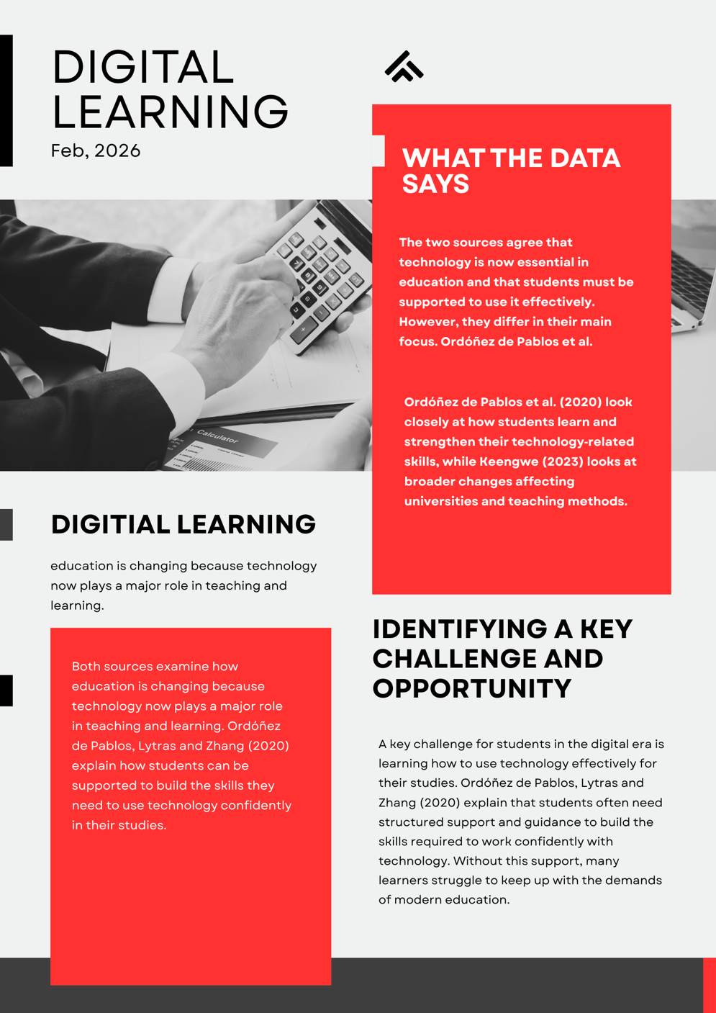

Reference List Component 3 (Only sources cited on the poster.)
Keengwe, J., 2023. Innovative Digital Practices and Globalization in Higher Education.
Ordóñez de Pablos, P., Lytras, M.D. and Zhang, X., 2020. IT and the Development of Digital Skills and Competences in Education.

