Writing Module: Effective Team working & communication
Student name: Aneliya Georgieva
Student ID: 2125657
Module Code: BMSW4002
Assignment Title: Task 1 Report on Effective Teamworking for business success
Lecturer name: Hafiz Rahmani

Executive summary
A case from Amazon, where the manager Tom has trouble forming his team as uses the wrong communication channel. This leads to the creation of many conflicts between the team members, as well as poor attachment, which in turn turns out to be a severe obstacle and threatens the project with failure from the very beginning.
It is considered what defines the team and its characteristics, the main team problems, and how to develop an effective team. Tuckman's model of team development, Belbin's team roles, and Coyle's culture code are considered methods for improving teamwork. The advantages and disadvantages of partnership are discussed, as well as why teamwork is so important.

Table of content
1.Introduction…………………………………………………………………4
1.1. Definition of team and teamwork…………………………………5
2.Models of teamwork……………………………………………………….7
3.Role for creating effective teams………………………………………...9
4.Impact of effective teamwork on team success……………………….11
4.1. Advantages of having an effective teamwork………………….11
4.2. Barriers to teamwork in the case study……………………...…12
5.Conclusion/Recommendation…………………………………………..14
6.Reference List…………………………………………………………….15

1.Introduction
In this report, based on the problems that the Amazon team faces, such as poor communication, interpersonal conflicts, and lack of shared commitment, we discuss the ways how the team leader Tom could find the correct strategy and build his team for the project.
The stages of Tuckman's team development model (Forming - Storming - Norming - Performing – Adjourning) and Belbin's team roles (Action- Oriented Roles, People-Oriented Roles, and Thought-Oriented Roles), are considered as methods that could benefit to create an effective and efficient team. Moreover, we focus on Coyle's Culture code as a method to build a cohesive and motivated team.
In addition, we advise Tom on how to develop a successful team, which team roles could be used, what are the benefits of teamworking, and what could be the barriers to team collaboration.

Definition of team and teamwork.
Team building is essential for each business or organization to be successful and prosperous. “A team is a number of individuals working as one to achieve a particular goal to which they are mutually committed”. (Morgan, 2017, p.204) Each team is a group but not each group can be called a team. Teams are formed intentionally, with strictly created interdependencies and clearly defined team member roles.

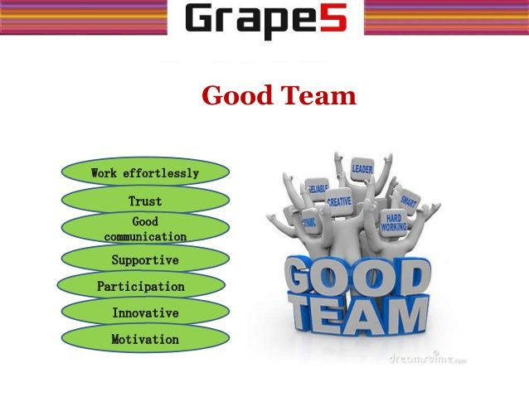
(Source: Grape 5, https://pin.it/3916mar)

The foundation of teamwork is a collective mission, also other important factors such as determining how decisions will be made, using team-based reward systems, and focusing the team on established aims. Keeping the team membership solid helps the participants to learn to work together and on their optimal level, and in this way, everyone feels their own contribution to the common goal is done.
It is equally important for team members to coordinate their efforts and to be updated about each person's progress through clear and appropriate feedback. Arrahtu (2018) points out, effective teams must maintain open communication channels and the communication must be honest and free flowing among all members. Communicating freely allows teams to support and assist one another in times of need. Another vital factor in each effective team is creating a learning environment because in that way the team members could learn from success, but especially from mistakes.
Teamwork is the ability of the participants in a certain team to collaborate together to achieve a certain common goal and it is critical to each organization or business's success. Open communication and commitment among members through strictly defined roles contribute the effective teamwork. On the other hand, poor leadership, "process losses" and interpersonal conflict as well could complicate the cooperation between the team members. (Figure 1)

Figure 1. Characteristics of an effective team
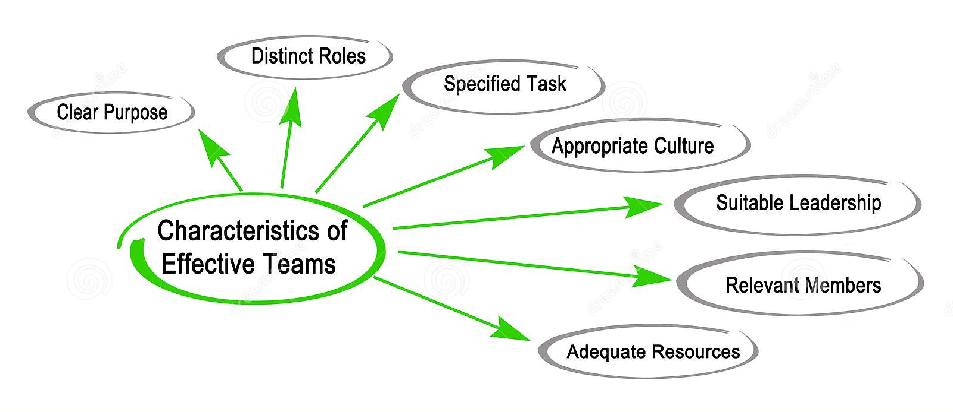
(Sourse: https://www.dreamstime.com/characteristics-effective-teams-image130565787)

2.Models of team development
“The core theme in group development is that groups as a whole change systematically over time” (Arrow et al., 2004). Two of the more popular methods are Tuckman’s development model (1965) and Whellon's model of team development (2005). They overlap to some extent because include team developing stages and describe the relationships among team members, but according to Whellon’s model, the groups achieve maturity in the process of working together.

Figure 2. Tuckman’s model of team development (1965) 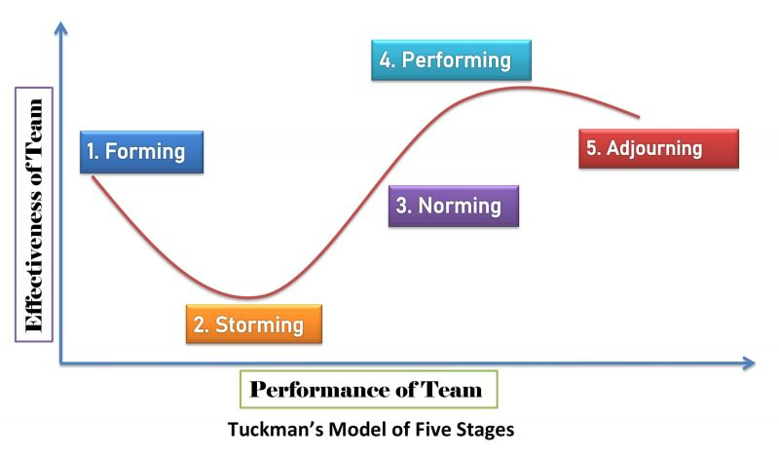
(Source: https://newsmoor.com/tuckmans-model-five-stages-of-group-and-team- development-theory/)

Tuckman's model might suit best on Amazon case study because according to the model the team is each group come through changes until it becomes an effective and cohesive team. The model includes five stages, from the group beginning until it be transformed in the effectively working team: Forming - Storming - Norming - Performing – Adjourning (Figure 2). Using the model stages, Tom can come up to effective strategy to form his team for the project.
Forming stage: formation of the team structure begins; exist primary tension between members. The leader (Tom Jackson) should determine team purpose, ensure a supportive environment, where each of the members could express themselves and encourage building confidence between them.
Storming stage: Disagreements, interpersonal conflicts, and power struggles, it becomes difficult for members to respect established boundaries. To come through this stage, Tom Jackson should clearly define roles and responsibilities in the team, direct his efforts to create a team culture and trust, and continually work on better collaboration.
Norming stage: the team works together, exchanges ideas, and progresses in its work. “There is less conflict happening in this stage and more mind streamlining of thoughts and ideas. That’s where cohesion and harmony prevails” (Jones, 2019, p.4). The team is cohesive and members show a bigger commitment than in the previous stages (Mihaela and Spenser) to the team's aims.
Performing stage: where the effective team should be; team performs to its full potential; the team is mature, functional, and work motivated; team effectiveness is enhanced by a team commitment. A leader should encourage clear communication and build a structure that boosts productivity.
Adjourning stage: The team has achieved the set task and everyone is satisfied with the result. Here the role of the leader is to evaluate everyone's contribution and reward the team.

3.Role for creating an effective team
Team composition is very important for any successful team because when it is well-selected, it will achieve its goals. To achieve maximum efficiency, the size and diversity of the group must be tailored to the team task.
We focus on Belbin’s 9 team roles, where he determines a team role as "a tendency to behave, contribute and interrelate with others in a particular way" (Belbin, 2010). (Figure 3)
Figure 3. Bulbin’s team roles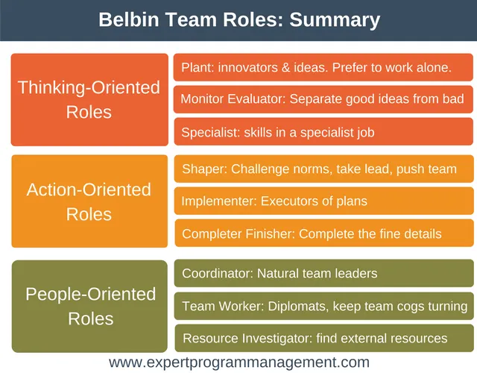
(Source: https://expertprogrammanagement.com/2017/06/belbin-team-roles/)

In his theory, Belbin divides roles into three main groups, as the first one is Action-oriented roles, where are included: shaper – implementer - completer(finisher). The shaper (role Tom should be) is the task leader, dynamic, thrives on pressure person, who set the objectives
and transforms ideas into decisions and action; the implementer is an organizer, who changes the decisions into tasks and knows how to do these tasks, conservative and inflexible person (as some members in Tom’s team); and the completer controls that everything is executed correctly and within the established deadlines.
People-oriented roles are the next group and include coordinator - team worker - resource investigator and this category suits Amazon’s case best. The coordinator will define the roles, considering people's strengths and that will decline disagreements between members. It seems too many people play the same role in Tom's team, and this causes interpersonal conflicts because of the competition between them. The team worker- a diplomatic and perceptive, internal communicator, will support the team and ensures that the team works together in cohesion, which boosts the team's commitment to the task (Mihaela and Spenser). Additionally, the resource investigator- a sociable and enthusiastic person, who looking for new ideas and opportunities, will monitors for innovative ideas seeing often rise during conflicts in the team.
In the third group are the Thinking- oriented roles: plant - monitor valuator - specialist. The plant is a creative, free-thinking person, who is able to solve difficult problems in an innovative way; the monitor-valuator is a critic, an analyst who can unerringly judge which idea is good and which is bad, knows what and where is the problem; the specialist is an expert, highly professional person, who often is not a team member and provide specific skills or knowledge.
In addition to his theory, Belbin (1993) states that for a team to be effective and successful it should include all nine diverse roles (without duplicating), and only then it could be called a ‘balanced team’. Therefore, when selecting a team or requiring new staff, management must be aware of which roles are necessary at the moment.

4. Impact of effective teamwork on team success
“Successful teams produce desired outcomes” (Lacerenza et all, 2018, p.517). Teamwork is critical for the success of each organization. Modern companies have deep knowledge of teamworking, and all is about collaboration
4.1. Advantages of teamwork (Figure 4)
• Increase productivity - “With the help of teamwork you complete the work on time and produce high-quality output product” (Amin. B, 2011). When work is distributed, it reduces the workload of team members and thus the team works at maximum efficiency.
• Provides support network - all team members support each other, and everyone can contribute by knowledge, skills, or experience, which leads to considerably more effective results.
• Encourages innovation - the age and cultural diversity, and variety of perspectives in the team lead to new creative and considerably more effective problem solutions. According to Fay (2014), “teamwork changes the affective experiences, cognitions, and attitudes of individuals, which in turn enhance their creativity and their ability to solve problems creatively” (Fay, D. et all, 2014)
• Improve motivation - the shared workload, cooperation, and sense of belonging in the team leads to an increase in motivation. Team members “have a sense of ownership of the organization's mission and vision and integrate personal ambition with organizational ambitions”. (Suyono and Mudjanarko, 2017, p.30)
Figure 4. Advantages of teamwork
Encourage innovation
Provide support network
Improve motivation
Increase productivity
Advantages of teamwork
4.2. Barriers to teamwork in the case study (Figure 5)

Based on the Amazon case study, we could define a few problems in the Tom Jacksons’ team:
• Lack of commitment – team members do not have a sense of belonging to the organization and are not emotionally connected and enthusiastic and this endangers the work of the team. “It is not uncommon for a majority of the work to be done by only a few members’’ (Griffin & Dunham, 2014, p.5), which demotivates those who work and leads to conflicts between members.
• Poor communication – “Team members can emerge from the same meeting with completely different perspectives of what was said or what was or was not accomplished” (Griffin & Dunham, 2014, p.5). Differences in perspectives lead to conflicts and a tense working environment, where it is difficult to achieve high motivation and efficiency.
• Poorly constituted team - it leads to conflicts, and lack of engagement and motivation among the team members, which could decline productivity. A properly formed team has clearly defined roles, rules, and responsibilities, which in turn helps to avoid interpersonal conflicts in the group (as everyone is aware of what they should do and what is expected of them).
• Interpersonal conflicts – According to Rocha & Correa (2020), interpersonal conflict “can be defined as a dynamic process that arises among individuals who experience negative emotional reactions to perceived disagreement”. This leads to a lack of collaboration in the team and decreases team effectiveness and efficiency.
Interpersonal conflicts are one of the common problems in a team creating and even "communication problems easily give way to the interpersonal conflict"(Griffith, BA, & Dunham, 2014, p.5). They could be avoided by clearly defined job roles, improving communication skills in the team, and also by "culture code" (Coyle, 2018), providing a safe and constructive working environment. Coyle defines three skills of leaders, which could contribute to successful and effective teamworking:

- Build safety, through “communicating one’s listening, overcommunicating gratitude, and ensuring everyone has a voice’ (Aradillas, 2020, p.68).
- Share vulnerability - leaders should not be afraid to show vulnerability because according to Coyle “it exemplifies people’s need for each other” (Coyle, 2018) and also, leaders must demonstrate trust in the team by allowing them to make informed decisions.
- Establish purpose- “Coyle states that a leader has the responsibility of making sure his or her priorities are ranked” (Aradillas, 2020, p.69). The leader must name his priorities and ensure that the members of the group consider the priority as such because in this way the group feels connected to the task.

Figure 5. Barriers to teamwork
Lack of commitment

Poor communication
Barriers to teamwork
Interpersonal conflicts
Poorly constituted team
5. Conclusion / Recommendation
Teamwork is critical for each organization or company because it leads to better outcomes, encourages innovation, and improves motivation in the team. In building teamwork, we face barriers such as poor communication, lack of shared commitment, and interpersonal conflict, which are characterized by each group before it becomes a team. Teamwork could be enhanced through a well-structured team, clearly defined team roles and responsibilities, and a good working culture. Tuckman's stages of team development (Forming - Storming - Norming - Performing – Adjourning), Belbin's Team Roles (People - Oriented, Action - Oriented and Thinking - Oriented), and Coyle's Culture code could contribute to creating an effective and balanced team.
Reference list:
Amin, B. and No, R., (2011). Importance of teamwork in business. Mohammad Ali Jinnah University.
Aradillas, L. A. (2020). The Culture Code: The Secrets of Highly Successful Groups (Book Review). Georgia Journal of College Student Affairs, 36(1), pp.68-70. Available at: https://doi.org/10.20429/gcpa.2020.360106( Accessed:12 October 2022)
Aranzabal, E. Epelde, M. Artetxe (2022) “Team formation on the basis of Belbin’s roles to enhance students’ performance in project-based learning”. Education for Chemical Engineers, 38, pp.22-37. Available at: https://doi.org/10.1016/j.ece.2021.09.001. (Accessed: 8 October 2022)
ARRAHTU, A.M., (2018). “TITLE PAGE THE ROLE OF TEAMWORK ON EMPLOYEES AND ORGANIZATIONAL PRODUCTIVITY CASE OF SOME SELECTED FINANCIAL INSTITUTIONS IN BONABERI, CECAW IN PARTICULAR”. (Doctoral dissertation, University of Bamenda)
Arrow, H., Poole, M.S., Henry, K.B., Wheelan, S. and Moreland, R., (2004).” Time, change, and development: The temporal perspective on groups”. Small group research, 35(1), pp.73-105. Available at: https://journals.sagepub.com/doi/pdf/10.1177/1046496403259757?casa_token=cZZo0C5SVjAAAAAA:BT1Tl2oc6dd3c9E-F4akeLQ3g6jOax6U4Dg43EWip49OxVYm9u5Te8Jnwbiyj6vQ-QD9fwZoeZKTUw. (Accessed: 4 Octomber2022)
Fay, D., Shipton, H., West, M.A. and Patterson, M., (2015). Teamwork and organizational innovation: The moderating role of the HRM context. Creativity and Innovation Management, 24(2), pp.261-277.
Grape 5, https://pin.it/3916mar (Figure 1)
Griffith, BA, & Dunham, (2014). ‘Working in Teams: Moving from High Potential to High Performance ‘, London: SAGE Publications
Jones, D., 2019. The Tuckman’s Model Implementation, Effect, and Analysis & the New Development of Jones LSI Model on a Small Group. Journal of Management, 6(4).
Lacerenza, C.N., Marlow, S.L., Tannenbaum, S.I. and Salas, E., 2018. Team development interventions: Evidence-based approaches for improving teamwork. American psychologist, 73(4), p.517.
Morgan, P. (2017). ‘The Business Student’s Guide to Study and Employability’. London: Sage Publications Ltd.
Rocha, P.M.B. and Correa, H., (2020). Addressing interpersonal conflict among healthcare workers during the coronavirus pandemic. Brazilian Journal of Psychiatry, 42, pp.572-573.
Saniya Munvar, (2019) Available at: https://medium.com/@saniyamunwar/team-work-and-communication-skills-1d13805668d2( Figure 1)
Senaratne, S. and Gunawardane, S., (2015). Application of team role theory to construction design teams. Architectural Engineering and Design Management, 11(1), pp.1-20. Available at: https://doi.org/10.1080/17452007.2013.802980 (Accessed: 8 October 2022)
Suyono, J. and Mudjanarko, S., (2017). Motivation engineering to employee by employees Abraham Maslow theory. Journal of Education, Teaching and Learning, 2(1), pp.27-33.

