HUMAN CAPITAL MANAGEMENT

Assessment component 1: Individual report – HR strategy

Student Name: Anjaliben Harishbhai Chavda
Student number: 2532966
Professor: Anuapam Mazmundar

Table of Contents
Part 1: Building a Culture of Innovation & Future Work Practices 3
1. Introduction 3
2. The current practices in culture and work among the tech companies 3
3. Recommend cultural and structural initiatives that embed innovation 5
3.1 Intrapreneurship 5
3.2 Innovation sprints and sandboxes 6
3.3 Networked cross-functional squads 7
4. Proposing a Future of Work model (hybrid/remote) that supports collaboration and creativity 8
4.1 Task-based allocation 8
4.2 Protecting wellbeing and focus 8
4.3 Hub-and-spoke organisational design 9
4.4 Communication rituals 9
5. Motivation and performance: Applying the AMO framework 9
5.1 Ability: Agentic AI upskilling 9
5.2 Motivation: Autonomy and radical candor 10
5.3 Opportunity: The job characteristics model 10
6. Conclusion 10
Part 2: Reflection 11
1. Personal learning journey (The Gibbs reflective cycle) 11
1.1 Description 11
1.2 Feelings 11
1.3 Evaluation 12
1.4 Analysis 12
1.5 Conclusion 13
1.6 Action plan 13
2. Strategic relevance in the age of AI 13
2.1 AI as a the high-volume lever 13
2.2 The human-in-the-loop 14
Reference list 15
Part 1 15
Part 2 18

Part 1: Building a Culture of Innovation & Future Work Practices

Introduction
Aether Innovations is a fast-growing tech company that employs 300. Currently the organisation is struggling with high staff turnover, flat growth as well as decreasing consumer satisfaction level. According to Wujarso and Dameria (2023), human capital is a key resource for attaining competitive advantage. The failure of Aether Innovation indicates a systemic disconnection between its people practices and the ‘human value proposition’ that is required in the current age of AI. As Poynton et al. (2026), sates that competitive advantage is now primarily less driven by ‘technology differentiation’ and more by cultivating the ‘human edge’ as AI is replicable but people are not. To recover from these challenges, the firm must align innovation as an embedded behaviour.

The current practices in culture and work among the tech companies
In the current (2026) tech landscape, ‘agility’ has evolved from a software methodology into a core cultural requirement. Leading tech companies have abandoned the industrial-era taylorist pursuit of rigid efficiency in favour of high-trust, decentralised environments for attaining growth and agility. Tech firms in current market are aligning agile teams, flatter structures, and cultures that fosters experimentation (Class material: Nature and Future of work). For instance, ‘Project Aristotle’ by Google identifies psychological safety as the single most critical predictor of team success (Google, 2026). Google has been able to increase its employee number in the UK from 3,658 in 2018 to 7,442 in 2023 (Statista, 2025).
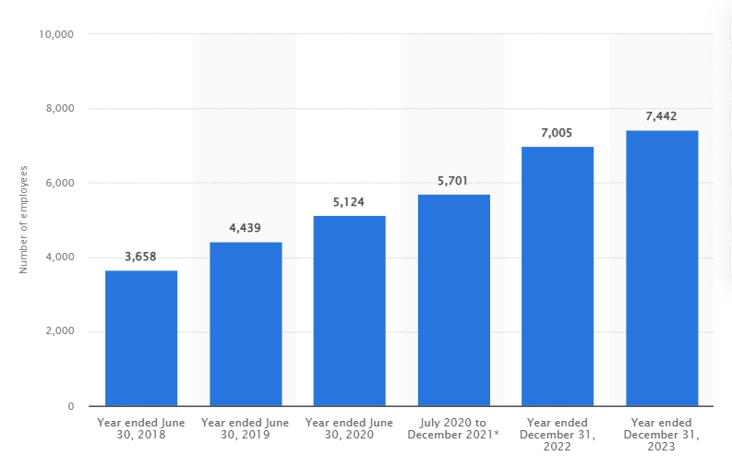
Figure 1: Number of employees at Google UK
(Source: Statista, 2025)
The current practices of the tech companies also reflect a move toward networked and flat structures. As Wen et al. (2025, p.3), states that “organizations often prefer a flat structure”, as it fosters smooth flow of information. It is noted that this model fosters a more innovation and collaborative work environment. Flat structure enables improve communication, faster decision-making, greater innovation, improved communication, and enhanced employee engagement (Mitov, 2024; BBC, 2026). Top-tier companies are utilising cross-functional ‘product squads’ that utilises engineering, design, and data roles. This assists in reducing the ‘wasted time’ (as per Taylor’s scientific management) by minimising hand-offs and communication bottlenecks. According to Zucker (2025), ‘stagility’ (provides workers with psychological stability while maintaining organisational agility), is now the dominant strategy for retention in a volatile marketplace.
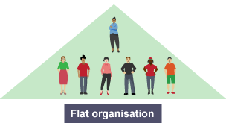
Figure 2: Flat organisational structure
(Source: BBC, 2026)
The current tech sector have shifted toward ‘radical condor’ models, where rapid, honest feedback loops replace the slow, annual performance review (Class material: Nature and Future of work). This supported by DevOps as well as agile practices. These factors prioritises continuous deployment and iterative improvement. However, a significant 2026 trend is the rising challenge of ‘digital friction’. It is noted that about 51% of total work hours of employees (white collar and IT decision makers) are lost on tedious and low-value tasks (Talk Research, 2025). To combat this challenge, leading companies are utilising Agentic AI tin order to automate administrative ‘drudgery’ (Thia, 2025). This is allowing humans to focus on deep-focus innovation. Hence, the flat growth of Aether Innovation that it is lagging in this evolution. Aether Innovation is likely burdening its 300 staff with manual procedure that competitors have already automated. This factor is resulting driving employee turnover as talent seeks more meaningful, ‘AI-augmented’ roles elsewhere.

Recommend cultural and structural initiatives that embed innovation
In order to assist Aether Innovation toward a future of ‘exploration’, the company must become an ambidextrous organisation (Reitano, 2024). This requires a structural ability to maintain ‘exploitation’ (an efficiency in current operations) while aggressively pursuing ‘exploration’ (innovation).

Intrapreneurship
Aether Innovation can adopt an intrapreneurship program. This can assist the company in allowing ‘core’ staff to dedicate about 20% of their capacity to experimental projects. For instance, Google’s ‘Innovation Time off’ (20% time) encouraged engineers to spend 20% of their paid time on passion projects (Addanki, 2024). This initiative resulted in the development of products such as Google News, Google Cardboard, and Gmail. Gmail has about 26% of all email opens, indicating its massive user base and strong presence as it has 1.8 billion active users in 2025 (Lee, 2025). This can allow employees to utilise resources of the company to develop new prototypes. This counters ‘flat-growth’ challenge directly by creating a steady pipeline of internal startups. Successful intrapreneurship requires a high failure tolerance. Aether Innovation must align ‘blame-free-post-mortems’, where project failures are treated as valuable data points rather than performance deficits (Patel, 2025).
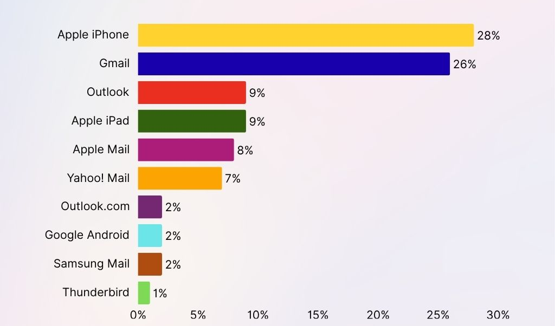
Figure 3: Most popular email clients in the world
(Source: Lee, 2025)

Innovation sprints and sandboxes
The implementation of quarterly innovation sprints can also pose as an effective strategy for Aether Innovation. The company can introduce intensive, 3 day ‘hackathons’ where cross-functional teams solve specific customer pain points (Koycheva and VandenBroek, 2024). Creating ‘cultural sandboxes’ can assist Aether Innovation in facilitating the strategy without disrupting daily operations. Cultural sandboxes are mainly isolated environments where teams can experiment with radical new workflows or digital tools before a wider rollout. For instance, Salesforce utilises sandbox method for secure testing (Lane, 2024). This assists teams to conduct in-depth evaluations and collaborate in an effective manner. These factors has assisted Salesforce in developing innovations such as Einstein (2016) and Agentforce (2024) (Chalamasandra, 2025).
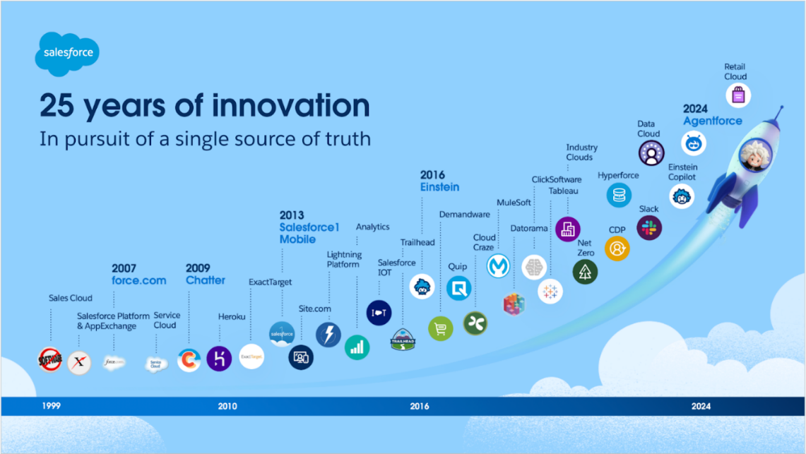
Figure 4: Innovations of Salesforce
(Source: Chalamasandra, 2025)

Networked cross-functional squads
The existing departmental silos in Aether Innovation must be replaced with ‘networked structures’. The company can aim at creating a ‘customer-centric squad or team’ that can focus on R&D, sales as well as customer success leads. Providing end-to-end ownership of a customer segment, to these teams can assist Aether Innovation in ensuring that those building the product are directly exposed to the ‘falling consumer satisfaction’ feedback. As mentioned by Roze (2024), customer-centric strategy is effective in understanding the wants, needs, and preferences of consumers resulting in hyper-tailored solutions, cultivating loyalty, and enhancing customer satisfaction level. On the other hand, Conway (2023), states that interaction with consumers assist workers in understanding customers and identify issues, as every employee has an impact on customer experience. For instance, Apple regularly gathered customer feedback and makes iterative improvements in its products (Renascence, 2024). The company focuses on addressing the real needs and pain points of customers resulting in improved user loyalty and satisfaction as well as maintaining over 90% customer retention (Lee, 2025).
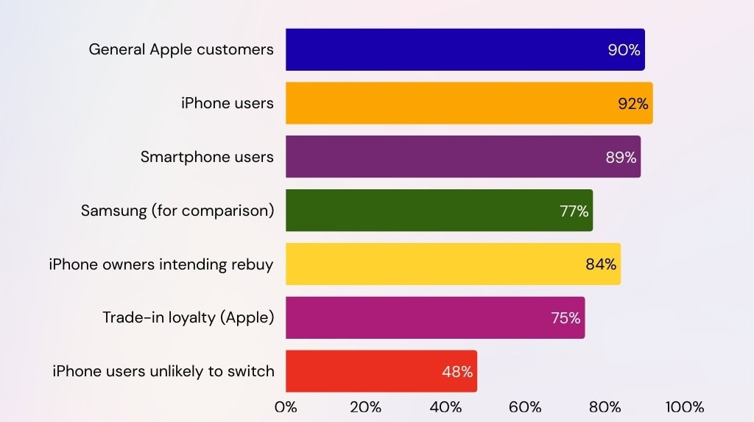
Figure 5: Customer retention rate of Apple
(Source: Lee, 2025)

Proposing a Future of Work model (hybrid/remote) that supports collaboration and creativity
Increasing turnover of Aether Innovation signifies that the current work-life integration is failing. As MWAKIBETE (2023), states that issue regarding work-life balance can influence attrition and turnover. About 60% of IT professionals stated that lack of work-life balance is a key reason for leaving their current job (Vagale, 2024). Hence, the introduction of a ‘3-2-intentional’ model in Aether Innovation can assist in aligning the gold standard ‘international hybrid design’. The ‘3-2-intentional’ model will strategically match task types to the most effective work environment.

Task-based allocation
- 3 days remote (deep focus): This can consists of ‘deep work’ such as coding and analysis. Remote work is effective in minimising digital exhaustion and office-based interruptions. As remote workers save about 62 hours per year by reducing the downtime that occurs after interruptions as they spend 60% of week on ‘focus time’ in comparison to 50% for in-office teams (Crist, 2024).
- 2-days office (collaboration hub): This can consists of high-touch- activities such as co-creation, innovation sprints, and mentoring.

Protecting wellbeing and focus
The company can also focus on implementing ‘meeting-free focus time’ as well as ‘right to disconnect’ policies. About 49.2% of professionals do not understand their company’s plan for hybrid work, indicating lack of effective communication (Tsipursky, 2023). Adoption of asynchronous communication as the default is effective in hybrid model (Buła, Thompson, and Żak, 2024). On the other hand, reserving synchronous meetings for creative strategy can be beneficial for Aether Innovation. For instance, Doist developed ‘Twist’ to make asynchronous communication its default, and this has assisted in improving employee productivity level (Purbasari, 2021).

4.3 Hub-and-spoke organisational design
This model utilises a central hub for cultural immersion while supporting home spokes with ergonomic stipends (Anjnaet al., 2025).This structure is effective in boosting efficiency, reducing costs as well as improving scalability by centralising core functions.

4.4 Communication rituals
Aether Innovation can prevent proximity bias by ensuring that all meeting are remote-first (Runyon, 2022). This can assist in ensuring factors such as information symmetry and equitable participation. Ensuring performance reviews are outcome-based can also assist in overcoming this issue.

Motivation and performance: Applying the AMO framework
Aether Innovation can ensure that the strategies drives performance through the application of the AMO framework. As per this framework, performance is a function of ability, motivation as well as opportunity (Mangal and Dhamija, 2023).
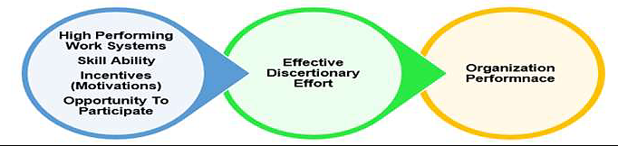
Figure 6: AMO framework concept
(Source: Mangal and Dhamija, 2023)

Ability: Agentic AI upskilling
Increasing ability can assist Aether Innovation in addressing the issue of flat growth. Providing training regarding collaboration with Agentic AI can enhancing worker’s capacity for high-value knowledge (Patel, 2025). This is effective in moving the workforce from repetitive data entry to data-driven strategy.

5.2 Motivation: Autonomy and radical candor
Hygiene factors (Herzberg’s two-factor theory) such as pay are insufficient for current talent (Lui, 2022). Motivation is driven by autonomy (hybrid model) and recognition (radical candor). High-trust environment with decentralised decision-making assist in fostering a genuine innovation mind-set (Almazrouei, 2026).

5.3 Opportunity: The job characteristics model
Introduction of new structural initiatives can assist Aether Innovation in providing opportunity to employees to perform. The application of the job characteristics model can maximise;
- Skill variety: through cross-function teams
- Task identity: through end-to-end ownership
- Task significance: connecting work directly to consumer outcomes
This structure can increase work meaningfulness and reduce turnover in Aether Innovation, while creative output breaks the cycle of flat growth.

Conclusion
The application of the selected strategies and structures can assist Aether Innovation in aligning work practices with strategic goals and attaining competitive advantage in the current marketplace. Dismantling taylorist bureaucracy and adoption of ambidextrous, networked structure can assist the company in providing opportunity to workers for its 300 workers to excel. The introduction of 3-2 intentional model and AMO-based AI upskilling is effective in ensuring that motivation and performance are structurally aligned. These methods can make Aether Innovation into a high-trust, agile leader where workers engagement and customer satisfaction are high.

Part 2: Reflection

Personal learning journey (The Gibbs reflective cycle)
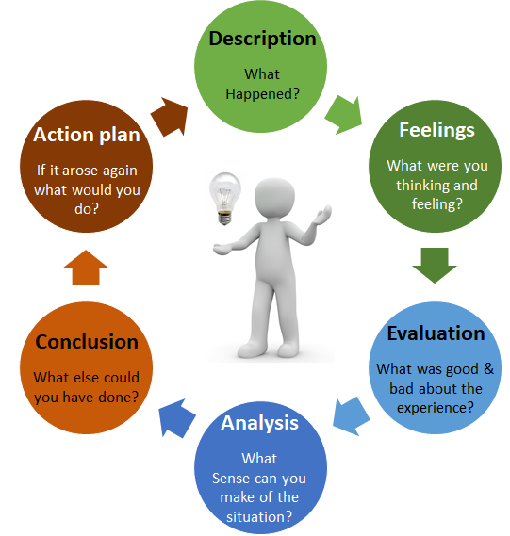
Figure 7: Gibb’s reflective cycle
(Source: Dutta, He, and Tsang, 2023)

1.1 Description
This module has assisted me in enhancing my understanding regarding HCM (Human capital management), and the way it plays a critical role in organisational success. Throughout the sessions, I moved from analysing classical management theories such as Taylor’s scientific management and Weber’s bureaucracy, to exploring contemporary frameworks such as Mintzberg’s adhocracy and the ‘squads and tribes’ model of Spotify. The key factor that my reflection focuses on is the Aether Innovation’s case study that was presented an issue of 15% turnover and flat growth. I applied the AMO framework as well as the 3:2 hybrid work model to this case study. This allowed me to bridge the gap between theoretical constructs and practical HR interventions.

Feelings
In the beginning, I felt overwhelmed due to the tension between ‘hard HRM’ and ‘soft HRM’ (Collings, Wood, and Caligiuri, 2014). As result-driven professional, I was naturally inclined towards Taylorist efficiency, yet the analysis of the declining satisfaction level of consumers made me feel a sense of dissonance. I noted that efficiency without engagement results to stagnation. However, discovering the concept of psychological safety through the module provide me with a significant emotional shift. This assisted me in moving my mind-set of controlling labour to enabling talent. This shift also assisted me in identifying and developing more sustainable and humane way to drive performance in current tech landscape.

Evaluation
The evaluation of the personal journey indicates a successful synthesis of ‘stagility’. The usage of the job characteristics model to diagnose the issue of turnover in Aether Innovations posed as a positive outcome (Judge, Klinger, and Li, 2023). I realised that the lack of task significance as well as autonomy was the key driver of talent flight in the case. However, a challenging aspect was reconciling the requirement for ‘deep work’ with ‘collaborative co-creation’. At first, I use to think of hybrid model as a mere ‘perk’. Later, after appropriate amount of research and analysis, I realised that it is a strategic design requirement for retention. This module assisted me in evaluating that ‘wasted time’ is often the result of poor organisational design rather than poor employee effort.

Analysis
As per my analysis, the module focuses on the seismic shift of the nature of work. The shift from a ‘desk farm’ mentality to a ‘collaboration hub’ showcases a move away from the obsession of Industrial era with physical presence. The AMO framework has assisted me in realising that the 300 employees of Aether Innovations likely had the ability, but lack of appropriate command and control culture denied them the opportunity to perform.
I noted that innovation is impossible without fail-fast framework where post-mortems are blame-free. Innovation thrives not only on the ability to fail but on the capability to learn rapidly from failures through a structured and psychologically safe environment (Farkas, 2025; Heinrich, 2025). This analysis played a key role in reshaping my view regarding leadership. I now see that the role of a leader is to create cultural sandboxes for experimentations. i also noted that development of human capital analytics skills is crucial to measure engagement and safety in real-time. Moving beyond annual surveys to continuous, AI-augmented feedback loops.

Conclusion
As per my experience and journey, I have concluded that a growth mind-set is not just an individual trait but it is organisational output of good structural design. I now understand that talent management is the proactive forecasting of skills rather than reactive hiring.

Action plan
Specific | Measurable | Actionable | Relevant | Time-bound
Lack of technical skills in using AI tools for talent forecasting and succession planning | Producing a report that identifies the top 3 critical skill shortage for 2027. | Input workforce data into an AI tools for generating a skills heat map. | This can assist me in improving my future ability to align AI usage with my work and improve workflow. | 4 months
A personal reliance on rigid hierarchy and taylorists structures during high-pressure tasks | Tracking reduction in time spent on administrative drag or unnecessary check-ins. | Mapping the new workflow utilising a digital tool such as Miro. |  | 6 months
Table 1: SMART objectives
(Source: Self-created)

Strategic relevance in the age of AI
As it is noted that Agentic AI is increasingly automating routine knowledge work. Staying relevant requires a shift toward human-centric strategy.

2.1 AI as a the high-volume lever
I am planning on aligning AI as a drudgery distiller in order to improve my strategic ability. As per Crist (2024), AI can perform over half of HR assistant tasks by 2032, as HR assistance could see 55% of their tasks getting automated or assisted by generative AI. The usage of AI can be effective in areas such as;
- Automating the synthesis of engagement surveys to recognise early flight risks.
- Generating data-driven skills map in order to assist in succession planning.
- Streamlining compliance monitoring, freeing my time for deep focus tasks such as cultural architecture.

The human-in-the-loop
AI can also stimulate empathy, ethics, or contextual judgement. It is noted that social influence and emotional intelligence are the most resilient skills for the next decade (World Economic Forum, 2025). I will focus on remaining indispensable by acting as the ethical anchor in AI-driven environments. AI can predict which employee can quit. On the other hand, only a human can conduct a stay interview with the empathy that is required to fix a broken psychological contract. Mastering stagility through the usage of stagility of data and myself for the agility of human connection, I can ensure that my role is augmented, not replaced. My value lies in my ability to interpret AI data through a human lens, ensuring that Aether Innovations remains a high-performance ecosystem where people, not just machines thrive.

Reference list

Part 1
Addanki, S. (2024). Dynamics of Corporate Entrepreneurship in Technology Companies: A Study of Strategic Practices and Governing Frameworks Shaping Entrepreneurial Ecosystems.
Almazrouei, S. (2026). Enhancing innovation: the moderating role of hierarchy of authority between organizational leaders and organizational innovation. IIMBG Journal of Sustainable Business and Innovation, pp.1-16.
Anjna, M.R., Garg, C.N., Jithesh, C.V. and Kaur, S.L.C.H. (2025). Hub and Spoke Model in Health Care–A Descriptive Study to Determine the Operating Cost for Running a Hospital in India. Journal of Marine Medical Society¦ Volume, 27(3), p.363.
BBC (2026). Structures. [Online]. Available at: https://www.bbc.co.uk/bitesize/guides/z48y92p/revision/1 [Accessed on: 06 March 2026]
Buła, P., Thompson, A. and Żak, A.A. (2024). Nurturing teamwork and team dynamics in a hybrid work model. Central European Management Journal, 32(3), pp.475-489.
Chalamasandra, K. (2025). Debunking Myths: Salesforce Einstein and Agentforce. [Online]. Available at: https://www.salesforce.com/blog/debunking-myths-salesforce-einstein-and-agentforce/ [Accessed on: 06 March 2026]
Collings, D., Wood, G. and Caligiuri, P.M. eds. (2014). The Routledge companion to international human resource management. Routledge.
Conway, S. (2023). Strategies for Creating a Customer-Centric Company Culture. [Online]. Available at: https://content-convergehub.medium.com/strategies-for-creating-a-customer-centric-company-culture-f37f839eec99 [Accessed on: 06 March 2026]
Crist, C. (2024). With fewer interruptions, remote workers engage in deeper work, research indicates. [Online]. Available at: https://www.hrdive.com/news/remote-workers-engage-in-deeper-work-more-productive/705303/ [Accessed on: 06 March 2026]
Google (2026). Understand team effectiveness. [Online]. Available at: https://rework.withgoogle.com/intl/en/guides/understanding-team-effectiveness [Accessed on: 06 March 2026]
Koycheva, L. and VandenBroek, A. (2024). Sandbox innovation: Potentials and impacts. Practicing Anthropology, 46(1), pp.36-45.
Lane, A. (2024). Move Fast, But Don’t Break Things — Innovating Securely with Sandboxes. [Online]. Available at: https://www.salesforce.com/blog/secure-test [Accessed on: 06 March 2026]
Lee, R.A. (2025). Apple Customer Loyalty Statistics 2026: Why Users Stick Around. [Online]. Available at: https://sqmagazine.co.uk/apple-customer-loyalty-statistics/ [Accessed on: 06 March 2026]
Lee, R.A. (2025). Gmail Statistics 2026: User Growth, Market Share & Emerging Trends. [Online]. Available at: https://sqmagazine.co.uk/gmail-statistics/ [Accessed on: 06 March 2026]
Lui, J. (2022). This is the biggest reason people quit—and it’s 10 times more important than pay. [Online]. Available at: https://www.cnbc.com/2022/01/14/the-biggest-reason-people-quit-is-10-times-more-important-than-pay.html [Accessed on: 06 March 2026]
Mangal, V. and Dhamija, S. (2023). The impact of employee retention strategies on fast-moving consumer goods manufacturers in India: An analysis using AMO model and ANOVA. Journal of Advanced Zoology, 44(3), pp.1241-1250.
Mitov, S. (2024). How Flat Organizational Structure Can Foster Sustainable Company Growth. [Online]. Available at: https://www.forbes.com/councils/forbestechcouncil/2024/10/24/how-flat-organizational-structure-can-foster-sustainable-company-growth/ [Accessed on: 06 March 2026]
MWAKIBETE, R. (2023). Examining The Effectiveness of Retention Strategies in Inhibiting Labour Turnover Rate For Information Technology Professionals In Tanzania.
Patel, P. (2025). Agentic AI for Enhanced Site Reliability Engineering: Augmenting Availability, Reliability, and Performance in Cloud-Native Environments. Reliability, and Performance in Cloud-Native Environments (July 01, 2025).
Poynton, S., Flynn, J., Scoble-Williams, N., Reyes, V., Mallon, D., and Cantrell, S. (2026). 2026 Global Human Capital Trends. [Online]. Available at: https://www.deloitte.com/us/en/insights/topics/talent/human-capital-trends.html [Accessed on: 06 March 2026]
Purbasari, A. (2021). These companies are turning off Slack notifications, and their employees are happier and more productive for it. [Online]. Available at: https://www.businessinsider.com/companies-use-asynchronous-communication-tools-slack-meetings-why-it-works-2021-7 [Accessed on: 06 March 2026]
Reitano, K. (2024). What Is an Ambidextrous Organization?. [Online]. Available at: https://online.hbs.edu/blog/post/ambidextrous-organization [Accessed on: 06 March 2026]
Renascence (2024). How Apple Enhances Customer Experience (CX) Through a Seamless Customer Journey. [Online]. Available at: https://www.renascence.io/journal/how-apple-enhances-customer-experience-cx-through-a-seamless-customer-journey . [Accessed on: 06 March 2026]
Roze, E. (2024). The Customer-Centric Mindset: Benefits & Brand Examples. [Online]. Available at: https://www.icagile.com/resources/the-customer-centric-mindset-benefits-brand-examples#:~:text=First%20Name%20*-,Customer%20Loyalty,contribute%20to%20gaining%20market%20share. [Accessed on: 06 March 2026]
Runyon, N. (2022). How CLOs can mitigate bias as they move to a “remote-first” paradigm. [Online]. Available at: https://www.thomsonreuters.com/en-us/posts/legal/mitigating-bias-remote-first-paradigm/ [Accessed on: 06 March 2026]
Statista (2025). Number of employees at Google UK Limited from 2018 to 2023. [Online]. Available at: https://www.statista.com/statistics/1221823/google-uk-limited-number-of-employees/?srsltid=AfmBOooGMk9cdvgxxkNpXBh3njwBr6-oiEM9tqoty9V3Z-TLoGwtXarx [Accessed on: 06 March 2026]
Talk Research (2025). Drowning in busywork? Low-value tasks breaking workers. [Online]. Available at: https://talkerresearch.com/drowning-in-busywork-low-value-tasks-breaking-workers/ [Accessed on: 06 March 2026]
Thia, B.S. (2025). From Human Resource to Strategic Resources: How Agentic AI Will Redefine Talent, Data, and the Digital Workforce. [Online]. Available at: https://medium.com/@boonsing/from-human-resource-to-strategic-resources-how-agentic-ai-will-redefine-talent-data-and-the-e6d19943f354 [Accessed on: 06 March 2026]
Tsipursky, G. (2023). New Study Shows Shocking Lack Of Hybrid Work Guidelines. [Online]. Available at:https://www.forbes.com/sites/glebtsipursky/2023/02/17/new-study-shows-shocking-lack-of-hybrid-work-guidelines/ [Accessed on: 06 March 2026]
Vagale, S. (2024). The Impact of Work-Life Balance on IT Talent Attraction. [Online]. Available at: https://www.multirecruit.com/blogs/the-impact-of-work-life-balance-on-it-talent-attraction/#:~:text=The%20IT%20industry%20is%20notorious,who%20prioritize%20their%20well%2Dbeing. [Accessed on: 06 March 2026]
Wen, T., Chen, Y.W., Syed, T.A. and Ghataoura, D. (2025). Examining communication network behaviors, structure and dynamics in an organizational hierarchy: A social network analysis approach. Information Processing & Management, 62(1), p.103927.
Wujarso, R. and Dameria, R. (2023). Human capital management as a resource in achieving competitive advantage. Asadel Publisher.
Zucker, J. (2025). 2025 Deloitte Human Capital Trends: Insights from the Workday Perspective. [Online]. Available at: https://www.deloitte.com/global/en/alliances/workday/perspectives/deloitte-human-capital-trends.html [Accessed on: 06 March 2026]

Part 2
Crist, C. (2024). AI could perform more than half of HR assistant tasks by 2032, report says. [Online]. Available at: https://www.hrdive.com/news/HR-automation/716468/ [Accessed on: 06 March 2026]
Dutta, S., He, M. and Tsang, D.C. (2023). Reflection and peer assessment to promote self-directed learning in higher education. Journal of Educational Research and Reviews, 11(3), pp.35-46.
Farkas, Z. (2025). The Dangerous Myth of Failing Fast: What Smart Leaders Actually Do. [Online]. Available at: https://medium.com/wisestart-blog/the-dangerous-myth-of-failing-fast-what-smart-leaders-actually-do-a6ff8e07a978 [Accessed on: 06 March 2026]
Heinrich, A. (2025). Failing Fast: Why It's Essential for Entrepreneurs. [Online]. Available at: https://online.hbs.edu/blog/post/fail-fast [Accessed on: 06 March 2026]
Judge, T.A., Klinger, R. and Li, M. (2023). Promote job satisfaction through mental challenge. Principles of Organizational Behavior: The Handbook of Evidence‐Based Management 3rd Edition, pp.161-178.
World Economic Forum (2025). The Future of Jobs Report 2025. [Online]. Available at: https://www.weforum.org/publications/the-future-of-jobs-report-2025/in-full/?gad_source=1&gad_campaignid=22228224717&gbraid=0AAAAAoVy5F4pInfnIOi1TGkRBH6srMiuG&gclid=CjwKCAiAtq_NBhA_EiwA78nNWNYRlF6Y6L6_KuoryPBTEyVcCSQPM57G1MDNjddZoRnS8JiZemsdVhoCQHEQAvD_BwE [Accessed on: 06 March 2026]

