

Module Name: Well-being, care and healthy living
Module Code: (ECEY5009/C)
Student ID: 2403964
Module Leader Paul Darby

Health, Well-being and Lifestyles


Attachment Theory
Attachment theory focuses on the need to have secure bonds between caregivers and children. The secure attachments ensure emotional health, resilience, and social competence because they offer the children a steady platform upon which they can explore their surrounding. Children whose care is responsive, and constant are prone to feeling safe and have better self-esteem, emotional control and trust in interpersonal interactions. These early relationships assist the child to learn how to cope during stress, process feelings properly and develop trusting relationships with others, which affect their well- being and health in adulthood. Conversely, insecure attachment can cause emotional problems and behavioural problems, which influence both health and well-being in adulthood. The children who are subjected to inconsistent, neglecting or unpredictable care giving might develop anxiety, low self esteem or failure to build relationships in later years. The development of brain appears to be affected by the earlier experiences of attachment, indicating the long- lasting effect of early relationships. One of the functions that early years practitioners have is facilitating a secure attachment through warm and responsive care and developing a relationship of trust with children and families (National Society for the Prevention of Cruelty to Children, 2021).







Interconnection Between Health, Well-being and Lifestyles
Lifestyles, health and well-being are closely intertwined with each other. Physical health directly depends on the lifestyle behaviors that are directly related to the mental and emotional health.
Indicatively, regular physical exercise helps to ensure good cardiovascular health, helps to maintain good weight and boosts mood and self-esteem. On the same note, a healthy diet also facilitates physical and brain development, which in turn has a positive influence on concentration, emotion regulation and learning. Sleeping is also important in facilitating the immune system, emotional stability and cognition among the children.
Lifestyle disorders are harmful to health and well being. Poor nutrition, lack of exercise and sleep problems may lead to physical sickness, tiredness as well as emotional troubles. In the long term, these can promote the development of mental health issues including anxiety and depression, especially when the poor habits turn out to be chronic. This connectedness underscores the need to use a holistic approach when working with children and families and to make sure that the needs of all three are met simultaneously; that is, physically, emotionally,
and socially (World Health Organization, 2019).
Key Concepts
Health
Health is a multidimensional and complex concept. According to the definition of the World Health Organization (WHO, 2025), the term health is defined as total physical, mental and social well-being not just the lack of disease or illness. This definition focuses on the fact that a good health is not only a healthy functioning of the body, but also emotional stability, the positive state of mind, and the possibility to be a part of society. Physical health can be defined as the proper operation of the body and systems, nutrition, exercise, sleep and the lack of a disease. Mental health is the regulation of emotions, coping ability, resilience and stress management ability whereas social health can be concerned with interpersonal relationships, communication and belonging.
Health is a phenomenon that is affected by various factors that are commonly referred to as the social determinants of health. These are income, education, housing, employment, access to healthcare and environmental conditions. Children who have lived in poverty or unstable environments have a higher chance of having worse health outcomes such as chronic illness and developmental delays. Hence, health can be considered an individual and social mandate.
Introduction
Health, well-being and lifestyle concepts are three phenomena that are interdependent and play a major role in human development during the life course. The contemporary society is increasingly troubled by the implications of personal choices, social environments and wider structural circumstances on the physical, emotional, social and mental health status.
Research has always found out that health cannot be felt as the lack of sickness but as an overall well being that is ascertained by lifestyle practices, relations, learning, money and service accessibility. This poster explains and outlines the key principles of well-being and lifestyles and especially in the early-childhood case. It explains the connection between these notions and the reason why practice in early years is a very important element in the development of positive outcomes among children, families and communities (Schramme, 2023).



Lifestyles
Lifestyle refers to patterns of behaviour, habits and choices that are adopted by individuals or families in their daily lives. These are diet, physical activity, sleep rituals, screen use, substance use and social interactions. Lifestyles are influenced by more than personal choice and include cultural norms, socioeconomic status, education and access to resources, which means that not all families have access to the opportunity to adopt healthy behaviors. Environmental factors, including housing, neighborhood safety and access to recreational spaces, also play a role in determining lifestyle choices. Healthy lifestyles are linked to greater physical health, mental health and a lower risk of suffering from chronic illness. For children, lifestyle habits developed in the early years tends to persist into adulthood, which makes the difference between the early intervention and later on. Regular physical activity, balanced nutrition, adequate sleep and positive routines promote healthy growth, brain development and emotional regulation. In comparison, poor lifestyle choices such as poor diet, sedentary behavior and erratic routine can contribute to obesity, anxiety and poor academic achievement as well as low self esteem. Parents and caregivers play a significant role in shaping children's lifestyles. Their attitudes, behaviors and routines have strong influence on children's habits and understanding of health. Early years settings also contribute through promoting healthy eating, physical activity and emotional well-being through structured routines, play-based learning and supportive environments that promote positive lifelong behaviors (Brivio et al., 2023).


Well-being
Well-being is the way individuals feel about and make judgements of their lives. It is a broad concept which has emotional, psychological and social dimensions. Emotional well-being is related to happiness, life satisfaction and positive emotions, psychological well-being is related to personal growth, autonomy, purpose and self-acceptance. Social well-being is about relationships, social inclusion and belonging in a community and feeling valued.
Two approaches to well-being which are commonly discussed are hedonic well-being and eudaimonic well-being. Hedonic well-being concerns the concepts of pleasure, happiness and the avoidance of pain, whereas eudaimonic well-being puts a greater emphasis on meaning, personal development and the achievement of one's potential. In terms of childhood, both perspectives are important, especially in childhood, where positive experiences, emotional security and opportunity for learning contribute to well-being over the long term. In early childhood, well being is strongly associated with secure attachments, consistent care and responsive relationships. Children who feel safe, supported and valued are more likely to develop confidence, resilience and positive self-esteem. On the other hand, chronic stress, neglect or instability can have a negative impact on the regulation of emotions and mental health (Ryff, 1989).



Theoretical Perspectives
Maslow's Hierarchy of Needs Maslow's hierarchy of needs is a good way to think about health and well-being. According to this theory, individuals must first have their basic physiological needs met i.e. food, water and shelter before they can be able to focus on higher level needs, such as belonging, self esteem and self-actualisation. In early childhood, fulfillment of the basic needs is imperative for healthy development. Children who face hunger, neglect or insecurity may find it very difficult to engage in learning or form positive relationships.



Role of Government and Policy
Government policies have a major influence on health and well-being outcomes. Public health initiatives to promote better nutrition, physical activity and to reduce inequalities are important in supporting families. Access to healthcare, early years services and community resources help to promote positive lifestyles and reduce health disparities. Targeted programmes such as free school meals, health visitor services and immunisation campaigns are especially effective in supporting the vulnerable children and families, ensuring that they are identified at an early stage in terms of health and development needs.
Investment in early childhood education and care is especially critical, given that this is critical for both children's development and family wellbeing. High-quality early years provision supports cognitive, social and emotional development as well as offering opportunities for parents to access employment or training opportunities. Policies that tackle poverty, housing and work also contribute to better health outcomes, showing the importance of taking a whole-of-society approach. By addressing the broader social determinants of health, governments can work to minimize inequalities in the long term, improve life chances and promote sustainable well-being across communities (The Patients Association, 2024).
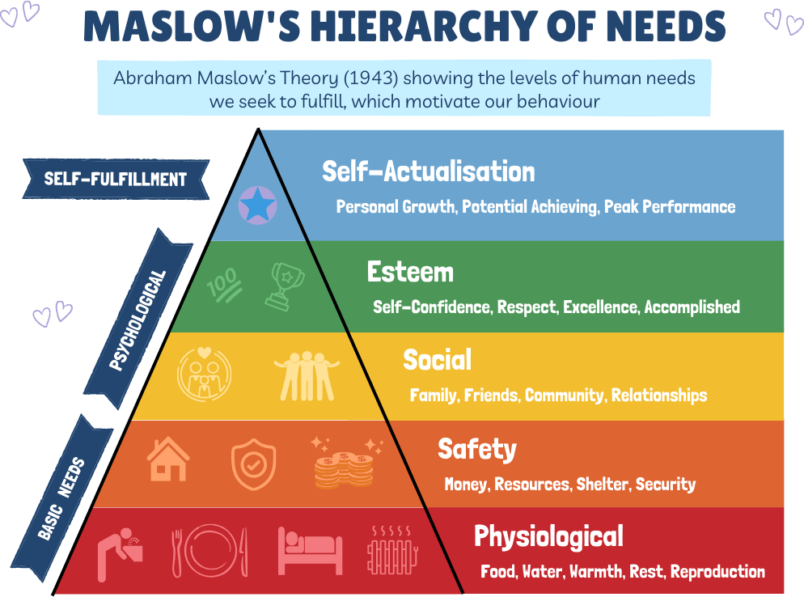



Conclusion
Health, well-being and lifestyles are interdependent concepts which play a major role in the process of human development, especially during the early childhood period. Health is more than physical functioning, it also involves mental and social dimensions, where well-being refers to emotional, psychological and social experiences that influence the way people think about and interact with the world around them. Lifestyles, influenced by individual choices and broader social, cultural and economic influences are important contributors to health and well-being outcomes over the life course.
This poster addresses the importance of taking a holistic approach which recognizes the interrelated nature of these concepts. Children's development is influenced not only by biological factors but also by their relationships, environments and experiences in life. Early years practice underpinned by theory, informed by policy and working collaboratively with families plays a key role in promoting positive outcomes for children. Practitioners are in a unique position to support healthy routines, emotional security and inclusive environments that foster resilience and confidence.
By focusing on health, well-being and healthy lifestyles from an early age, society can help individuals to reach their full potential and prevent inequalities in the long term. Early intervention and effective policy implementation and partnership working help to address disadvantage before it is embedded. Investing in early childhood health and well-being is not only good for children and their families, it is also good for building healthier, more resilient communities and better outcomes across generations.
Furthermore, supporting health, well-being and positive lifestyles in early childhood are key to lifelong learning, social inclusion and economic participation. A preventative approach means fewer pressure on health and social care services in the future, with the positive long term value to individuals, families and society as a whole, and sustainable and equal outcomes across diverse communities, and across the generations to come.
Impact on Early Childhood Development
Early childhood is a critical period for the establishment of foundations for health, well-being and lifestyle habits. During this stage rapid physical, cognitive and emotional development takes place. Positive experiences in the early years can have lifelong benefits and adverse experiences may have long-term consequences.
Healthy lifestyles at an early age help with physical development, brain development and emotional regulation. Opportunities for play, physical activity and social interaction, promote motor skills, communication and confidence. Emotional well-being is developed through nurturing relationships, predictable routines and supportive environments. Children's mental health also gets affected by their early experiences. Exposure to chronic stress, family conflict or poverty can affect emotional development negatively and be risk factors for mental health issues later in life. Therefore, early intervention and support are key in the reduction of inequalities and ensuring positive outcomes (Lafave et al., 2024).
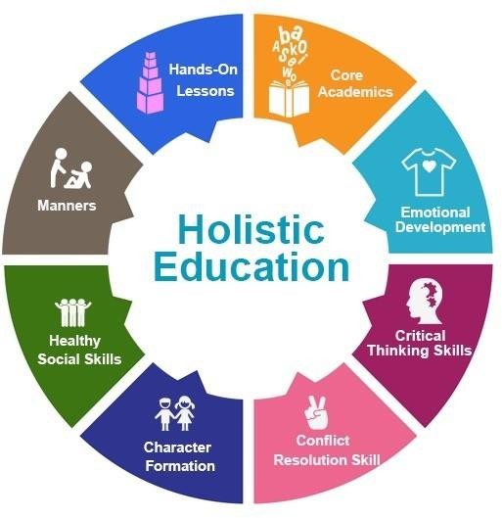



` Holistic Development of a Child (Hussain, 2023)
Application to Early Years Practice
Early years practitioners play an important role in promoting health, well-being and healthy lifestyles. Through the creation of safe, inclusive and nurturing environments, practitioners are able to foster children's holistic development. This involves offering balanced meals and snacks, encouraging physical activity, supporting emotional expression and encouraging positive relationships. Practitioners also model healthy behaviors and help children to develop healthy attitudes to food, movement and emotional regulation from an early age.
Practitioners are also responsible for practicing in partnership with parents and caregivers. Sharing of information, providing guidance and signposting of support services can help families to maintain a healthier lifestyle and establish consistency between home and early years settings. Policies and frameworks such as Early Years Foundation Stage (EYFS) emphasize the importance of safeguarding, well-being and promoting healthy development. Observation and assessment enable practitioners to identify the children who may need further support. Early intervention can treat developmental delays, emotional problems or health issues before they turn into issues. Inclusive practice is the idea that all children regardless of their background, culture and abilities have equal opportunity to thrive and reach their full potential (Department For Education, 2023).


References
- Brivio, F., Viganò, A., Paterna, A., Palena, N. and Greco, A. (2023). Narrative Review and Analysis of the Use of ‘Lifestyle’ in Health Psychology. International Journal of Environmental Research and Public Health, [online] 20(5), p.4427. doi:https://doi.org/10.3390/ijerph20054427.
- Brodie, K. (2024). Maslow’s Hierarchy of Needs. [online] Early Years TV. Available at: https://www.earlyyears.tv/maslows-hierarchy-of-needs/.
- Centers for Disease Control and Prevention (2024). Social Determinants of Health. [online] Public Health Professionals Gateway. Available at: https://www.cdc.gov/public-health-gateway/php/about/social-determinants-of-health.html.
- Department For Education (2023). Help for Early Years Providers : Early Years Practitioner Wellbeing Support. [online] help-for-early-years-providers.education.gov.uk. Available at: https://help-for-early-years-providers.education.gov.uk/support-for-practitioners/early- years-practitioner-wellbeing-support.
- Hussain, W. (2023). As humans, we are complex beings with various physical, emotional, social, and intellectual dimensions. Therefore, it is essential to approach the education of a child in a holistic way, encompassing all aspects of their development. [online] Linkedin.com. Available at: https://www.linkedin.com/pulse/holistic-development-child-wajahat-hussain.
- Lafave, L.M.Z., Hayek, J., Webster, A.D. and McConnell, C. (2024). Creating healthy eating and active environments in early learning settings: protocol of the CHEERS eHealth intervention study. Frontiers in Nutrition, 11. doi:https://doi.org/10.3389/fnut.2024.1337873.
- National Society for the Prevention of Cruelty to Children (2021). Attachment and child development. [online] NSPCC Learning. Available at: https://learning.nspcc.org.uk/child-health-development/attachment-early-years.
- Ryff, C. (1989). Happiness is everything, or is it? Explorations on the meaning of psychological well-being. [online] psycnet.apa.org. Available at: https://psycnet.apa.org/record/1990-12288-001.
- Schramme, T. (2023). Health as Complete Well-Being: the WHO Definition and beyond. Public Health Ethics, [online] 16(3), pp.210–218. doi:https://doi.org/10.1093/phe/phad017.
- The Patients Association. (2024). Health must be at the heart of all government policies. [online] Available at: https://www.patients-association.org.uk/blog/health-at-the-heart-of-government.
- World Health Organization (2019). Guidelines on physical activity, sedentary behaviour and sleep for children under 5 years of age. [online] www.who.int. Available at: https://www.who.int/publications/i/item/9789241550536.
- World Health Organization (2025). Social Determinants of Health. [online] World Health Organization. Available at: https://www.who.int/health-topics/social-determinants-of-health#tab=tab_1.
Maslow’s Hierarchy of Needs (Brodie, 2024)
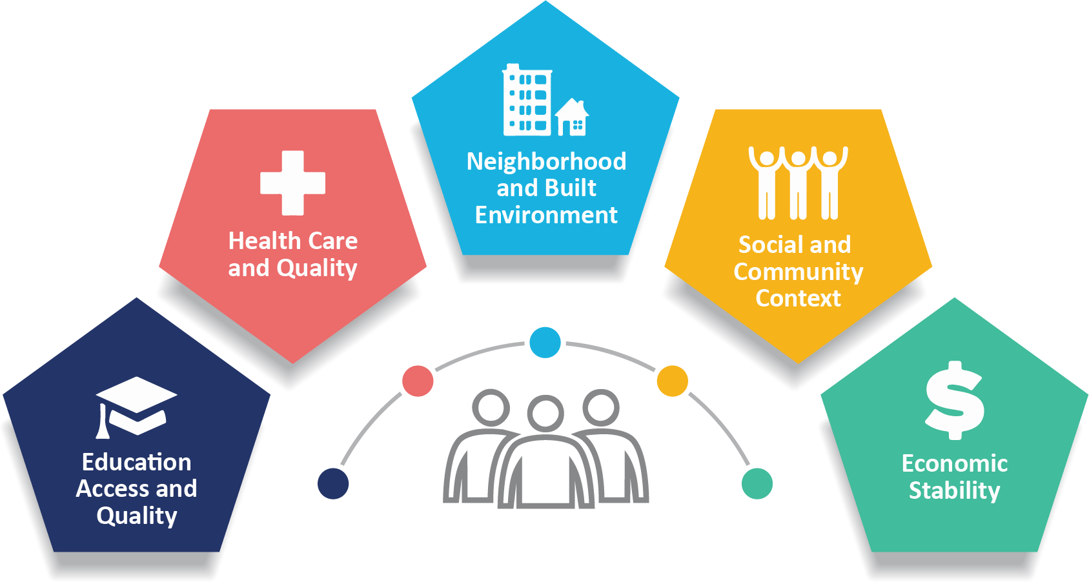
Social Determinants of Health
(Centers for Disease Control and Prevention, 2024)

