The importance of reflective practice as a professional practitioner
What is reflection and reflective practice?
Reflection and reflective practice are key values of professionals and play a key role in early years practitioners (Brock, 2015). As Schon (1983) highlights that a professional practitioner will need to allow themselves to experience a surprised situation in which they are uncertain on. Schön (1983) suggests that as a professional practitioner you will need to be able to reflect on the situation that has happened and find a new understanding and change the situation. Reflective practice is about how you work as an individual and as a team, this will help to improve your practice and help to improve the outcomes you provide for the children and families in your care (Lyndon and Trodd, 2016). There are two types of reflective practice according to Schön (1976) Reflection in action and reflection on action, reflection in action refers to reflecting when doing something for example thinking on your feet and acting straight away. Whereas reflection on action is reflecting after you have done something and thinking what you could have done differently in the situation (Brock, 2015).
How can reflective practice support you developing as a professional.
As an early year’s professional practitioner, reflecting and reflective practice is a vital part of the job. This helps practitioners to develop their understanding of their own practice and to enable them to develop the necessary skills to achieve their best development and learning outcomes for them and the children (birth to five matters, no date). According to Brock (2015) practitioners who apply reflective practice in their setting will be more aware and in control of situations around them. Reflection must be used daily to better practitioners practice and teaching skills (Brock, 2015). Reflective practice is required to be meaningful for a professional practitioner it would need to be related to their work with children within the early years (Brock, 2015). Paige-Smith and Croft (2011) believe that early year’s practitioners may even change their practice by focusing more on the children’s perspectives and how different children learn about the world around them, by doing this practitioners can then focus on the children’s interests and plan different activities which can help and support the children’s individual needs (Paige-Smith and Croft, 2011). Johns and Burnie (2014) identifies that practitioners who carry out reflection will pay more attention to their own self within practice. Practitioners will be more aware of their thinking and their response to certain situations. Furthermore, Johns and Burnie (2014) highlight that reflection will become a natural quality within a practitioner’s everyday practice and therefore be beneficial to providing the upmost in their profession.

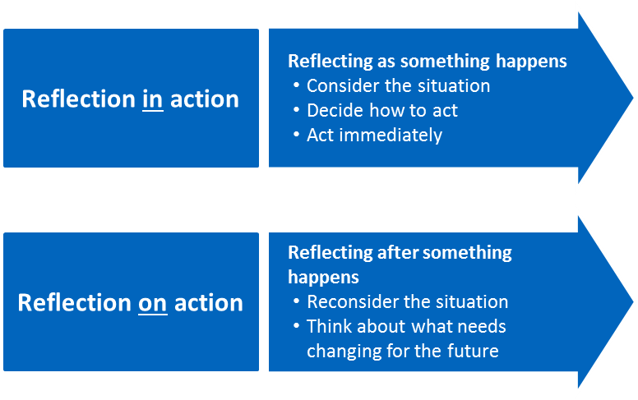

(Cambridge Assessment,2023)

How reflective practice can improve quality in the early years setting.
Tarrant (2017) states that as well as practitioners carrying out self-reflection it is also beneficial to carry out reflection within as part of a team in the setting. By doing these practitioners are able to help and support each other through the reflection process, this will help to create a safe and professional working environment for reflection to take place. Tarrant (2017) also highlights that by being able to carry out reflection with work colleagues that you trust will add a new depth to your professional and personal reflection that you are carrying out. Within a setting it is also possible for another professional practitioner to observe an activity that one is carrying out with children for you to then be able to reflect on the information they have found together to develop your professional practice. Within professional practice it is key to develop good relationships with both children and their families. Being able to speak to and involve parents or guardians about their child’s development or behaviours within the setting is crucial to your role. Through good communication one would be able to involve parents in reflective processes in relation to their child. Parents would be able to reflect on situations at home and therefore the findings may be helpful when put together with findings within the setting to work together to create a plan that could best support the child and aid their development (Paige-Smith and Craft 2011). Hallet (2013) believes that by reflecting with other colleagues, parents, and children we are able to include the ability to problem solve and find solutions, reason, give constructive feedback and also receive feedback from others in order for us to then think in a reflective way and improve our provision and practice.

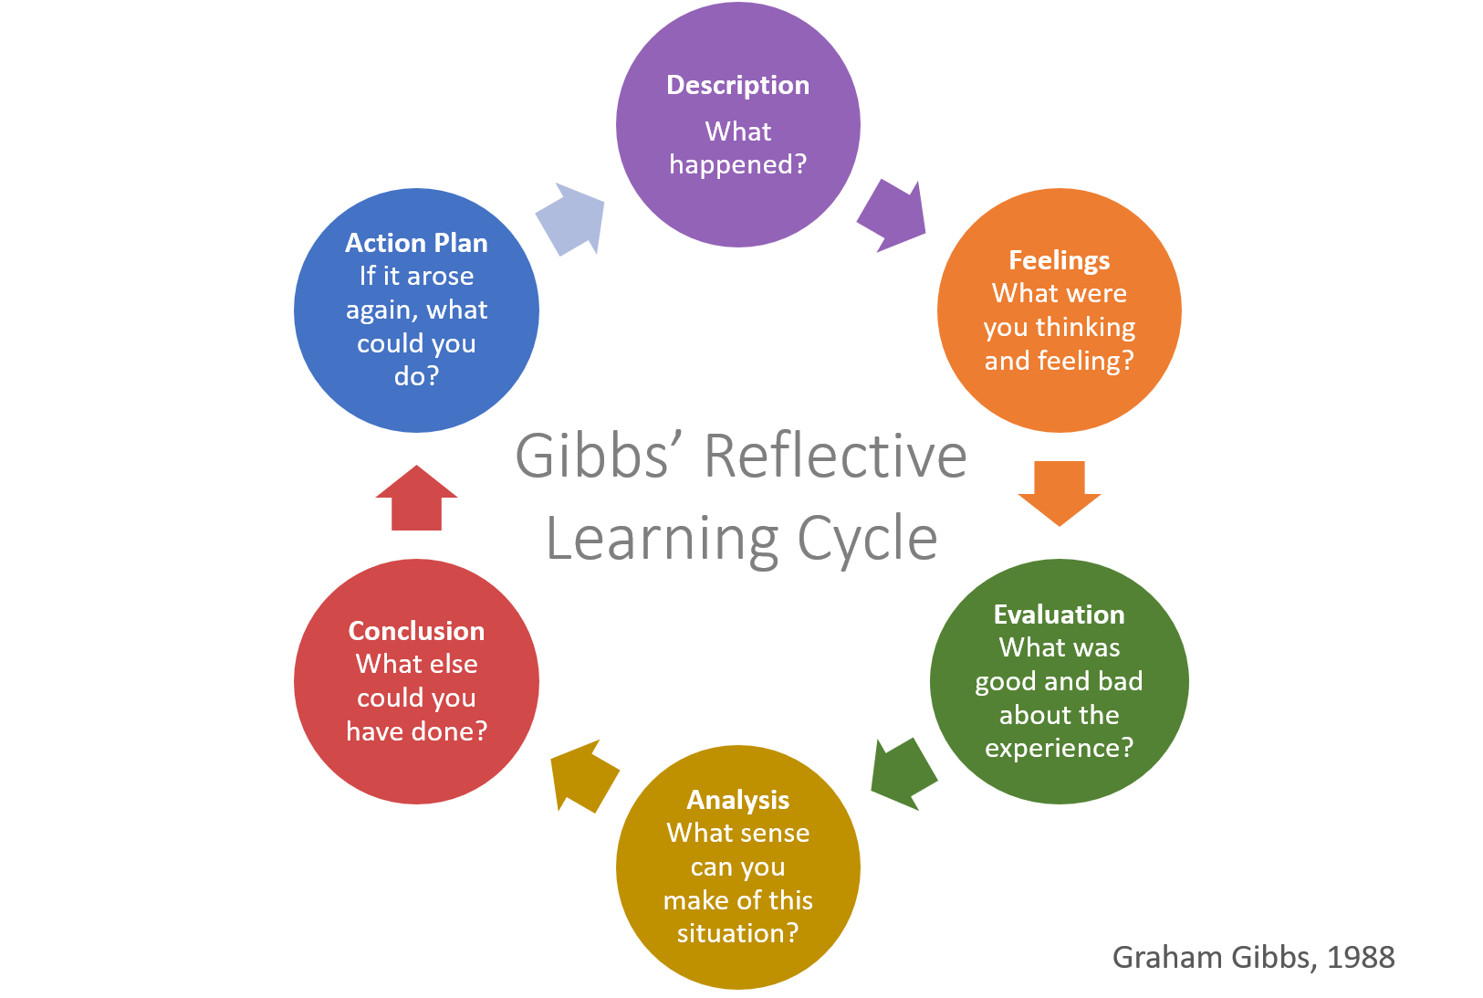
Models and theories of reflection
According to Brock (2015) when it comes to models of reflection there are many different ones that can support you in your reflective practice. Although the models are different, they can support you in the same ways as they all have similar stages some more than others (Brock, 2015). University of Cumbria (2020) highlight that Gibbs’ (1988) reflective cycle is the most used in early years settings as the cycle has more in-depth stages. Gibbs' (1988) Reflective Cycle was developed by Graham Gibbs in 1988 to give structure to learning from experiences. This cycle offers a framework for examining experiences, and given its cyclic nature offers itself particularly well to repeated experiences, allowing you to learn and plan from things that either went well or didn’t go well. It covers 6 stages including the description on what happened how the people involved were feeling at the time, it then gives an evaluation and analysis and to finish off it suggests a conclusion and action plan to use in the future. One of the crucial points about Gibbs is the acknowledgement of the importance of Feelings in reflection (university of Cumbria, 2020). By reflecting on these in depth as a professional practitioner you would be able to critically evaluate exactly what was being reflected on in order to learn and plan from the outcomes (university of Edinburgh, 2023).

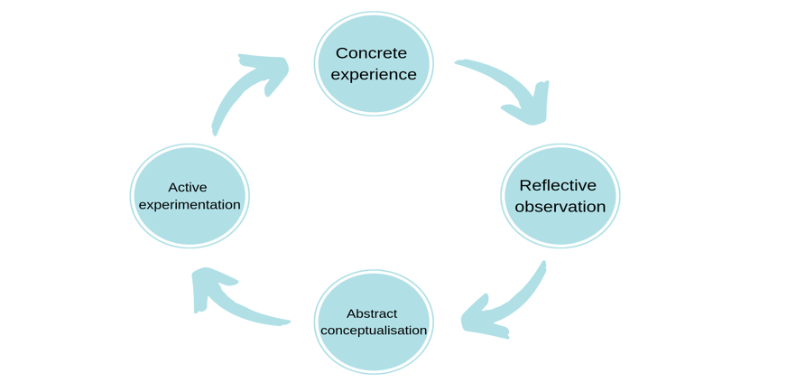
(Gibbs reflective cycle, 1988)
Another reflective model practitioners can use is Kolb’s Experiential cycle. Kolb’s (1984) cycle is a smaller reflective cycle made up of four stages, these are concrete experience, reflective observation, abstract conceptualise and active experimentation. University of Cambridge (no date) highlight how Kolb’s model argues that you must start with an experience whether this is a repeat of something that has happened before or something completely new to us. The next stage involves practitioners to reflect on the situation by taking notes about anything that is unusual or practitioners have not seen before, after that practitioners will then develop new ideas as a result from what information they have found. The final stage is then used for practitioners to apply their new ideas into the different situations. By practitioners following the stages it then demonstrates that practitioners have learnt from their experiences and reflections (university of Cambridge, no date).

(Kolb’s experiential learning cycle, 1984)
According to University of Cambridge, (2023) there are both pros and cons when it comes to using these reflective models, some of these include offering practitioners who may be new to using reflective practice a format to follow, as these models have a starting point on where you can develop what has happened in the situation by following the stages one step at a time. Although these models of reflection can be very useful to practitioners there are also some cons to using them as the university of Cambridge imply that all steps must be followed in a certain way, whereas in everyday practice you may not always start at the beginning and models may not be applied in every situation a practitioner may come across, as reflective practice is a continuous process and practitioners may wish to continue from where they previously carried out an observation (university of Cambridge, 2023)

Finally, to conclude it is highly recommended by following one of the above methods practitioners would be able to start using reflection in practice. Reflection is a key skill for all practitioners who work within the childcare settings. Practitioners who use reflection in their setting will ensure that all children will receive the upmost care and learning provided to them. Practitioners can also use reflection in the setting to see how different children are developing and if they need any more support in certain areas of their developmental needs. Reflection is also of a way of identifying children’s likes and dislikes in order to aid future planning where the individual child’s interests will be taken into consideration.

