Amjad Hussain 1715254
BMSW 5104
Project planning and management in the workplace
Lecturer Paul Ranson

Page of content
Cover page page 1
Page of contents page 2
Introduction page 3
The organization page 3
Risks associated with the project page 3
Project management tools and techniques page 4
Project plans page 5
Ppersonal reflection page 5
Reference list page 6
Appendix page 7

Introduction
This report is being developed for Vinters antique shop it will describe the Vinters organization the report is being developed to Provide a critical assessment of the risks associated with the project. The report will Describe the project management tools and techniques being used in the Vinters case study. The report will Indicate how the project plans will be communicated to the stakeholders. The last section will be Providing a personal reflection of my ability of managing the project with future recommendation and self-development plan to improve own performance.
This report will critically assess the usefulness of project management tools and techniques for managing a project within an organization. Project management tools can be useful to keep on the right track for finishing a project and it will give the manager less options in getting strayed of the project goals and outcomes.
The organization
This report is being developed for Vinters it is an antique shop aiming to relocate to bigger premises to cope with online demand in sale due to covid-19 lock down restrictions Vinters antiques is wanting to concentrate more on online retail sales and shipping and marketing the products online.
The tools for project management will necessitate what is needed and what is most important and what can be not useful but can be time consuming and going over the overall budget for the project cost issues can arise.
Due to increased online sales the Vintners antiques company have outlined that they must follow the trend of increased online sales to cope with the demand the business will have to move to a bigger premise and concentrate more on online sales and outline safe delivery options. The organization has been well established located in Shirley and moving the Sparkhill to bigger premises that will be structured to accommodate the business moving to online sales.
Risks associated with the project
Risks associated with the project are moving delicate old antiques and which will need a lot of packing and insurance to cover any accidents and damages the move will involve a lot of planning to do it right. However, what happens when you must move furniture that is a little different. When you must deal with having to pack and move antique furniture. Well, things get orders of scope more complicated because suddenly you must be a lot more careful. However, scratch on a living room sofa is one thing, but a scratch on an antique is a serious value loss. To make sure you can deal with this task, we made this quick guide on how to relocate antique furniture. or going over time and spending more money than anticipated for the project completion going off the plan and not setting to the plan and the project will be only half completed.
However according to (Langley,2020) Whether it be fine art, a collection of porcelain dolls, or a piece of large antique furniture, antiques by their very definition are old, usually fragile, or delicate, are of a good quality, are of high monetary, and usually, high sentimental value.

According to (Kumar 2005)” complex challenges confronted by today's project managers is cost controlling and project schedule overruns a well-organized project “A failing project can necessitate in wasting time and the project getting not completed.
Project management tools and techniques
Trello noticeboard is a project management tool which can help to work out what is a must have and what can be a like to have and what can be discarded Vinters antiques can prioritize the tasks that are most important to them by using user stories for example a user story can be the delivery driver would like to lift heavy delicate items of furniture safely out of the van, the delivery driver is asking for by using Trello it is a web-based list making application originally created by Fog Creek Software in 2011. Trello helps teams work more collaboratively and get more done. Trello’s boards, lists, and cards enable teams to organize and prioritize projects in notice boards to outline must haves. To identify what they need the most and getting rid of nice to have to shorten the tasks they must do. Trello helps to work as a team more collaboratively and get more done resourcefully.
The Gantt charts will help your project at the management stage in creating your project schedule. It can outline certain elements that can be used to estimate the total number of days and how much it would cost. The project planning stage can be called the project schedule.
Gantt charts are incredibly useful in project management because they allow you to track the status of project tasks that have been completed so the next stage can follow. It can help to keep track of deadlines and days worked. Using Gantt chart template can save you time by organizing your project plan and using it at the planning stage.
According to (Niak2019) Agile is a project management philosophy for collaborative working which can consist certain values and principles that can be used in employment or in any area. It is was adopted by the software development community a long time ago and now several methodologies based on agile principles have become established as a method. These agile based software development methodologies have developed as an integral part of the software engineering and software development curricula for many computing degrees courses”. Trello which is a free project management and collaborative working tool but particularly designed to use anywhere. However, its functionality and features can be transformed to make it a basic tool for teaching and learning purposes. This paper presents a systematic development and application of Trello-based agile free to use method not just for teaching and learning purposes but for real project development. It is employed in the delivery of the software engineering module in BSc courses and subsequently,”
However, project management tools can be valuable but can encounter certain problems considering COVID-19 lock down restriction.

Project plans
The project plan is to plan the project in stages the most important stage is to complete the planning and stick to the plan to this project on time and not to go over the project budget and the stay on the right track and not get stayed of the project plan.
According to (chapman)All aspects of it have been tested and developed in the context of successful practice (and difficulties associated with achieving success). The process of synthesis has provided several new insights. These include: a more detailed phase structure based on objectives, tasks, and deliverables; a more formal process of defining the project to be assessed; treating the risk management process as a project in its own right; and treating the resolution of ownership-contractual issues as a project. Often with projects we can find people spend a lot of time building a plan and then simply ignoring it when it comes to the action.
This means a regular review of the work in progress with daily conducting a standup meeting and having clear understanding on how we are working to the plan.
As a project manager will be the person in charge of the project the manager will monitor its progress and make sure it stays on track. If changes need to be made there needs to be a process by which we can inform everyone on the team to minimize disruption. The manager will conduct a daily standup meeting to check and keep up to date with the progress and problems that can arise with the project plan. For example, by means of estimating techniques estimating can be very difficult but can be critical in the success of completing a project on time working out the average cost of certain stages to complete the project for instance the first stage would be to outline the cost of the structure of the building than the next stage could be the interior design and then the cost of the packing and moving the antiques.
Personal reflection
I have learnt that the planning stage is the first and most important stage of a project to succeed and to get completed on time. The Gantt charts will help your project at the management stage in creating your project schedule. It can outline certain elements that can be used to estimate the total number of days and how much it would cost. The project planning stage can be called the project schedule.
We learnt that it can be done with a few different systems in class we learnt about user stories they can be useful techniques to communicate with stakeholders they can outline what is a must have a want to have a nice to have using user stories it will be easier to see the must haves rather than nice to haves. The user stories can be done with different online tools. We discovered that it can be accomplished with project management tools to get the project finished on time. working out the average cost of certain stages to complete the project for instance can be known as overall estimate it can be a better planning process than an expert estimate.

References
Chapman, C., 1997. Project risk analysis and management—PRAM the generic process. International Journal of Project Management, 15(5), pp.273-281.
Heagney, J., 2016. Fundamentals of project management. Amacom.
https://www.removalreviews.co.uk/move/how-to-move-antiques-and-collectibles/(acessed21/11/2020)
Kumar, P.P., 2005. Effective use of Gantt chart for managing large scale projects. Cost engineering, 47(7), p.1
Lewis, J.P., 1995. Project planning, scheduling, and control: A hands-on guide to bringing projects in on time and on budget. Irwin.4.
Naik, N., Jenkins, P. and Newell, D., 2019, July. Learning Agile Scrum Methodology Using the Groupware Tool Trello $$^{\textregistered} $$ Through Collaborative Working. In Conference on Complex, Intelligent, and Software Intensive Systems (pp. 343-355). Springer, Cham.
Roberts, P., 2013. Guide to Project Management: Getting it right and achieving lasting benefit. John Wiley & Sons.
Sarangee, K.R., Schmidt, J.B. and Calantone, R.J., 2019. Anticipated regret and escalation of commitment to failing, new product development projects in business markets. Industrial Marketing Management, 76, pp.157-168.
Weeth, A., Prigge, J.K. and Homburg, C., 2020. The Role of Departmental Thought Worlds in Shaping Escalation of Commitment in New Product Development Projects. Journal of Product Innovation Management, 37(1), pp.48-73.

Appendix
Gant chart
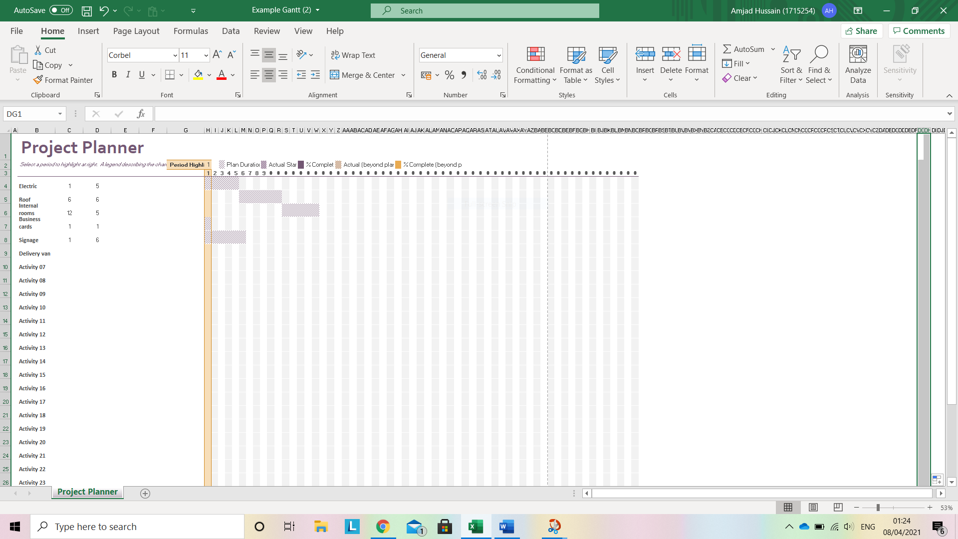
Trello board


