Derek Hughes
1702910
MA Contemporary Dialogues (Part-Time)
Coexistent Perspectives (ADAA7000)
Lecturer – Rob Jones
Space and Place
4000 Word Essay
Word Count - 4155

Table of Contents
- Introduction
- Chiaroscuro: History, Theory, and Meaning
- Early Work: Light and Hope
- Later Work: Shadow and Grief
- The Role of Space and Place
- Online Digital Images
- Understanding Emotion in Images
- Summary of Images
- Conclusion
- Bibliography

How does the use of chiaroscuro in the work by Eugene Smith, from his early and later work, convey emotional responses in relation to the place and space that they are viewed?

Introduction

“Everything looks worse in black and white,”
Paul Simon sings in his song Kodachrome (1973), invoking a preference for colour that seems at odds with the starkness of black and white imagery that dominated much of the 20th century. Yet beneath this lyrical nostalgia lies a deeper message: between clarity and ambiguity, and representation and reality. Black and white photography, especially when chiaroscuro is used to show the interplay of light and shadow, has the power to communicate emotions, tonal complexity, and psychological intensity.
The use of light and shadow, what we call chiaroscuro, has been around since the Renaissance, but W. Eugene Smith gave it a renewed purpose in his photography. For him, it wasn’t just about making things look dramatic, it was about creating emotions. In both his early and later work, the contrast between dark and light helped tell stories full of feeling, tension, and meaning. But how we react to these photos also depends on where we see them, whether that’s in Life magazine, an art gallery, sat at home or even looking online. This essay looks at how Smith used chiaroscuro and his style changed over time, and where we experience his work matters as it can actually affect our emotions and response.
In Smith’s photography, chiaroscuro isn’t just about how things look, it’s a way of showing emotion, this is why his work is so powerful. It helps us connect memories along with pain, space, and place. I will start by looking at his early work, which sometimes used harsh contrasts, and suggests that the real strength of chiaroscuro is in showing light and dark together, creating tension rather than getting rid of it.
Photography has always been important for telling stories, but this became even more powerful with the photo essay. Before that, magazine editors usually had full control and chose how the images were arranged to fit their own version of a story. Life magazine was different from most magazines from that time because it gave more pages and space to the images, sometimes ten or more pages. But it was Eugene Smith who really changed things. He pushed back against editors, as he wanted to have more control again over the order of his pictures and what they meant.
Smith joined Life magazine in 1938, but by 1942 he was already fed up with how the editors controlled the story. He got the chance to do things his own way when he became a war photographer during WWII. He wanted to show the real side of war, the human side. “I wanted to take pictures that made people say, ‘This is what war is,’” he said later. “War is horrible. But things like racism, poverty, and hate, they’re just as bad in everyday life, and harder to spot.” (Hughes, 1989)
My essay will focus on the following images:
Early Work:
- Fig. 1. The Walk to Paradise Garden (1946)
- Fig. 2. Country Doctor series (Dr Ceriani in hallway, 1948)
Later Work:
- Fig. 3. Minamata series (Tomoko Uemura in Her Bath, 1972)
- Fig. 4. Minamata Series (Child crying out after a seizure, 1972)

Chiaroscuro: History, Theory, and Meaning
The word "chiaroscuro" comes from the Italian for “light and dark”. At first, it was used in paintings, centuries ago. Artists like Caravaggio and Rembrandt used strong contrasts between light and shadow to add depth and emotion to their scenes. Light often revealed the truth, character and drama. Darkness wasn’t empty, it had meaning, it showed fear, or mystery.
When photography came along, chiaroscuro naturally carried over, especially in black and white images. For some photographers, it wasn’t just about how things looked, it was about how things felt. Light and shadow became tools to express emotion, to guide the viewer’s eye, and nudge a person towards what they might be feeling, without using any words (Berger, 1972).
In this essay, chiaroscuro isn’t just a style. It’s a feeling. Some may call it a “structure of feeling”, something hard to explain, but that comes from emotion, history, and culture (Williams, 1977). A narrow beam of light in a dark room could suggest hope or loneliness. A shadow on someone’s face could make them seem thoughtful, concerned, or strong.
Photographers like Eugene Smith used light and dark not just for effect, but to make us feel something. Sadness, fear, warmth, empathy, chiaroscuro can show it all. It also leaves each of us to respond in our own way. Roland Barthes called this the punctum, the part of a photo that hits you personally, even if you’re not sure why (Barthes, 1981).
So, chiaroscuro is about more than what we see. It’s about what we feel. Smith’s use of this technique changes and develops as time goes on, beginning with gentle, human images, and later becoming darker, heavier, and more powerful.

Early Work: Light and Hope

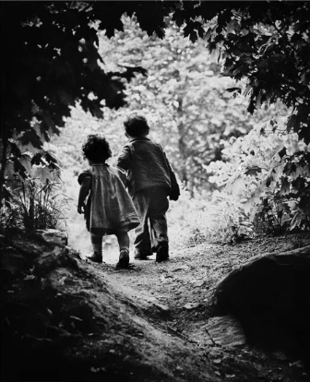
Eugene Smith’s early photos show how light, and shadow can carry real feeling, gentle warmth, quiet emotion, and a sense of depth. One of his most famous images, The Walk to Paradise Garden (1946), shows his two children walking hand in hand toward a bright patch of light at the edge of a forest. The light draws them forward, like it’s leading them to somewhere safer or better. Taken not long after World War II, the photo came to mean more than just a family moment, it became a symbol of healing, innocence, and hope for the future.

Fig.1
The use of chiaroscuro in this photo is gentle but very powerful. The children’s bodies are surrounded by a dark vignette of branches and undergrowth. It creates a feeling of depth and mystery, but also tenderness. The darkness doesn’t feel threatening, it just makes the light more meaningful by emphasising it. The emotional response here is shaped by the balance between these two tones. We’re shown a personal moment, but we also feel something universal, the longing to move toward hope and light after difficult times.
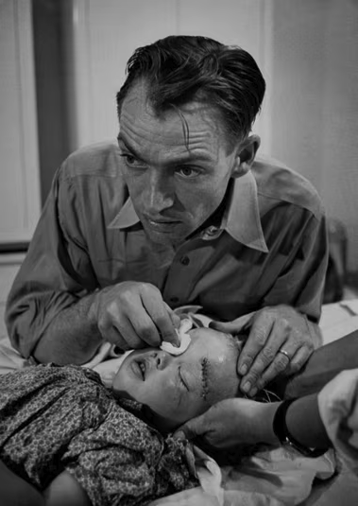
One of the most striking images from Smith’s Country Doctor series, shows Dr. Ceriani tending to a very young girl named Lee Marie Wheatly, who had been kicked in the head by a horse. The doctor’s face is tense and focused as he carefully works on the child's injuries. The girl lies still, with a deep cut still visible on her forehead. The photo doesn’t shout, but it does hit hard. It captures that exact moment where care and working pressure meet, where he is doing everything he can, in a small village, with limited tools, and yet shows total focus. You can almost feel the tension in his face, the tragic situation.

Fig.2
In this moment, chiaroscuro does something powerful but by being subtle. Smith doesn’t explain how the doctor feels, he doesn’t have to. The soft shadows around his face, the close framing, that says it all. It’s a photo that asks you to stop, and sit with what it really means to be alive yet worn out. As Roland Barthes might say, it carries a punctum, a detail that pierces the viewer and stays with them (Barthes, 1981).
Most of these early photos were published in the American Life magazine, often as part of longer photo essays and yet he continued to struggle for what he believed was a moral response to human suffering (Willumson, 1992). Where people viewed them really mattered to him as a result of this. He was fully aware that these other factors came into play when it came to getting the viewers empathy. Readers came across these images at home, having breakfast, in a dentist’s or doctor’s waiting room, and that everyday setting shaped how the photos were seen. They felt personal, but also something special and shared. Smith was one of the first to fight for control over how his stories were laid out. He didn’t just care about what he photographed, he cared about how it was arranged on the page, how the story unfolded, it really did make a difference.

Together, these early images show how Smith used chiaroscuro to get at something real. The light and dark weren’t just for effect, they were a way of telling a true story, emotionally and morally, they helped him show what it is to be human.

Later Work: Shadow and Grief
In Smith’s later work, chiaroscuro takes on a deeper and more intense role. It’s no longer just about soft contrasts or quiet emotion, it becomes something deeper, more ‘in your face’. You can see this clearly in his Minamata series, especially in the heartbreaking photo Tomoko Uemura in Her Bath (1972). It shows a mother cradling her severely disabled daughter in a small bath in Japan. The girl’s body has been twisted by mercury poisoning caused by industrial pollution. It’s a very intimate image, full of care, but it’s also quite political. It shines a light on suffering, injustice, and the human cost of corporate greed.
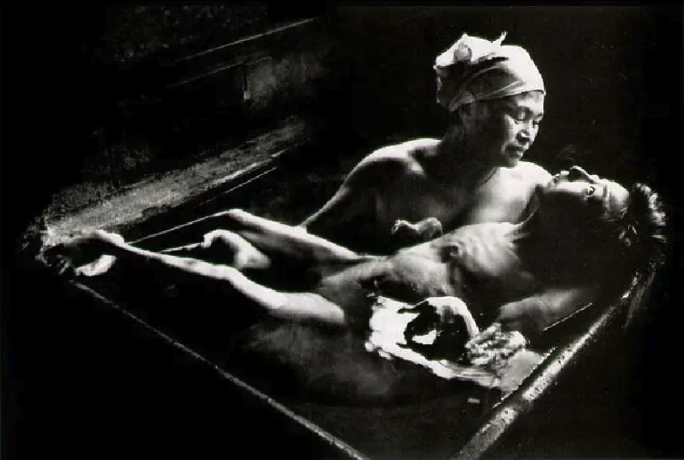
Fig.3
The lighting in this photo is unmistakably chiaroscuro. The figures are lit from above and to the side, casting soft shadows across their bodies and faces, while the background fades into deep, almost complete darkness. This isolation intensifies the emotional focus. There’s nothing to distract from the quiet suffering of the mother and child. The light here doesn’t comfort, it exposes the reality in front of him. It forces the viewer to look directly at the human cost of industrial harm.
Unlike in his earlier work, where chiaroscuro suggested quiet emotions like hope or tiredness, here the contrast feels starker, almost spiritual. The image has often been compared to those religious paintings of Mary holding the body of Christ, called a Pietà. Smith uses chiaroscuro not just to show pain, but to add extra context. It turns something deeply personal into something political, and something political into something painfully human.
Other photographs from the Minamata series also use chiaroscuro to confront the viewer. Street scenes, hospital visits, funerals, they’re all lit in a way that draws attention to human faces, gestures, grief. They aren’t just dramatic, they’re asking us to witness, to feel accountable, to think about it deeply. The dark isn’t just atmosphere, it represents what’s being hidden: corporate denial, systemic failure, environmental collapse.
It’s worth thinking about how people saw these later images. Unlike his earlier work for Life magazine, the Minamata series was shown in galleries and also published as a photo book. That change in setting makes a difference. Seeing a large print of Tomoko in Her Bath on a gallery wall, in silence, hits differently than seeing it on a page in a magazine. The gallery becomes almost like a chapel, a quiet space where the image demands your attention. The shadows don’t just shape what you see, they shape how you feel it in your body, in the room, by yourself.
Smith’s use of chiaroscuro in Minamata shows how his work matured, not just in style, but in purpose. In the early years, light and shadow helped him tell quiet, personal stories. But here, they become something more: tools of protest, empathy, and truth. The darkness doesn’t just set the mood, it carries meaning and substance. And the way these images are lit, framed, and displayed changes how we feel and encounter them. They ask that we dig deep and search for meaning.
As Susan Sontag writes, some photographs “haunt” us more than others, not just because of their content, but because of the way they’re composed and the space we see them in (Sontag, 2003). Smith certainly understood that. He used chiaroscuro to draw us in, to hit us emotionally, and to make sure we didn’t forget what we’d seen.
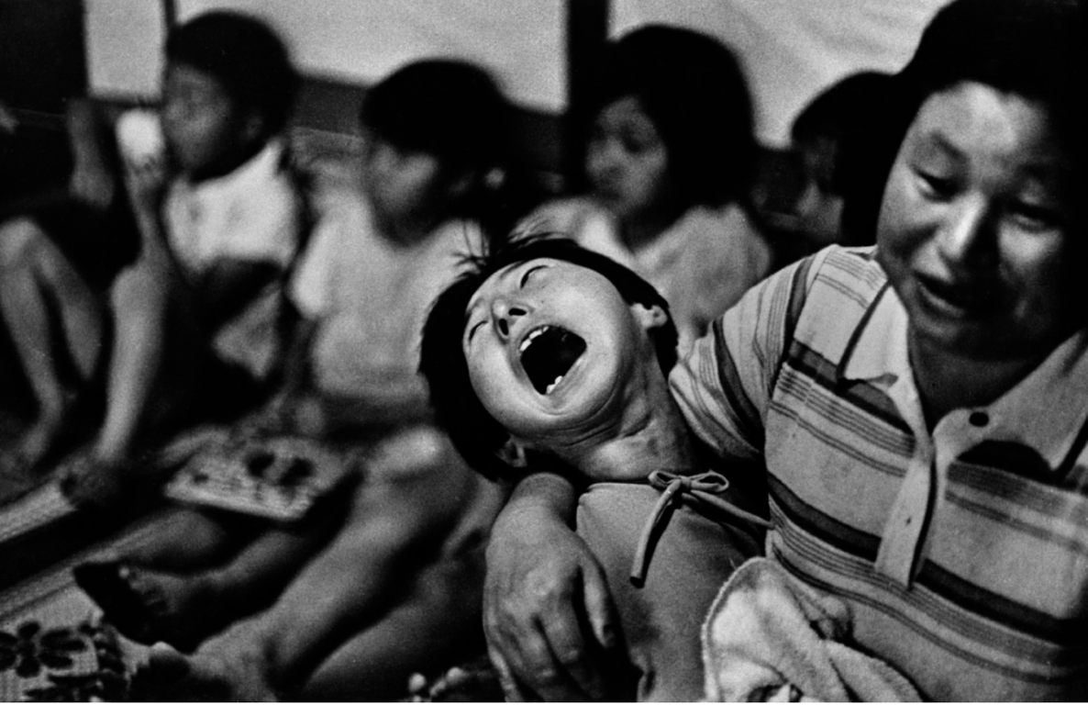
Another deeply affecting image from the Minamata series shows a child in the grip of a seizure and overwhelming pain. Their head is thrown back, mouth wide open, body stiff and full of tension. It’s the kind of moment that most people would look away from, but Smith doesn’t. And he doesn’t let us either. Someone, probably the child’s parent, holds them close, one arm wrapped around them to offer some comfort, yet not able to hide how physically and emotionally exhausted they are.

Fig.4
In the background, other children sit on the floor, out of focus, some blurred into shadow. Their stillness makes the child’s suffering feel even louder as they don’t appear surprised by the outburst. The light is quite soft, maybe from a window or doorway, but it’s enough to carve out the child’s face and the strain in the parent’s eyes. The chiaroscuro here isn’t stylised or dramatic, it comes naturally from the room itself. The shadows fall where the pain is, it isn’t a performance or act.
This photo doesn’t just show illness. It shows what it means to live with it, to witness it, to love someone through it. And that’s what makes it political too, because it demands that we pay attention. It doesn’t ask for pity, it asks for justice.
Even though the child in the photo is clearly in pain, there’s a stillness to the image that really stays with you. It’s not loud or dramatic, it just quietly shows what it’s like to live through this kind of suffering. The soft light and heavy shadows give the moment space to speak. Nothing feels staged, it doesn’t need to be manipulated. This image doesn’t just show illness, it shows what it’s like to sit with it, to care through it, day in and day out.

The Role of Space and Place
The emotional power in Eugene Smith’s photos doesn’t just come from what’s in the frame, it also depends on where and how we’re seeing it. A photo hits differently in a gallery than it does in a magazine or online. That really matters with chiaroscuro, because how we see light and shadow changes with the space we’re in, how big the print is, how the room’s lit or how large it is, even how fast we move past it.
Take The Walk to Paradise Garden, for example. It first appeared in Life magazine, something loads of people flicked through at home or in waiting rooms. Readers didn’t sit with it for very long. It was surrounded by advertss, writing, and other stories. But even then, the photo stood out. The strong contrast of light and dark made it more than just a nice picture, it carried emotion. It cut through the noise of the magazine and stopped people in their tracks.
But this kind of setting also made the photos feel personal. You saw them in your own space, whilst getting on with your life. The Country Doctor series had that kind of intimacy too, moments of care and fatigue made visible in black and white. Readers didn’t just look at them; they related to them. The viewing space made those emotions feel closer, more familiar.
Later, when Smith exhibited work like the Minamata series in galleries or photo books, everything changed. A dark gallery with spotlights and silence makes chiaroscuro hit differently. Tomoko in Her Bath, for example, takes on an almost untouchable quality when it’s viewed as a large print on a quiet gallery wall. The space naturally slows you down. It gives you time to stare and feel, without distraction. That deep black background pulls you in, while the soft light on the mother and child creates a feeling of stillness and grief.
Roland Barthes talked about the idea of the punctum, the detail in a photo that “pierces” you emotionally (Barthes, 1981). But the punctum can change depending on how and where you’re viewing the image. What hits you while looking through a magazine might be different from what moves you in a gallery or online. The space adds context, and sometimes, that context becomes part of the meaning.

Online Digital Images
These days, a lot of Smith’s most powerful images are seen online, often cropped, resized, and on mobile phone screens. That doesn’t mean they stop working completely, but it does change something. You start to wonder: does the emotional magic of chiaroscuro still come through when a photo’s been shrunk down to phone size? Does it need the silence of a gallery, or the feel of a printed page, to really hit you?
Smith seemed to get this. He fought hard to control how his images were shown, the layout, the order, the space around them. He knew that meaning isn’t just in the picture itself, it’s in ‘how’ we see it. Chiaroscuro doesn’t just live inside the photo, it’s in the liminal space between the photo and the person looking at it. That space, what we bring to it, where we are, how we feel, really matters just as much.

Understanding Emotion in Images
Both Roland Barthes and Susan Sontag have shaped how we think about photography’s emotional effect. Barthes’s idea of the punctum, that unexplained detail in an image that “pierces” the viewer, aligns with Smith’s use of chiaroscuro. The shadowed face of Dr. Ceriani or the barely lit hand of Tomoko’s mother might not seem significant in themselves, but they carry emotional weight.
Sontag, on the other hand, warns us not to confuse emotional reaction with moral understanding. In Regarding the Pain of Others (2003), she argues that images of suffering can provoke empathy, but they don’t always lead to any action. This is where Smith is different. His careful use of chiaroscuro doesn’t just provoke feeling, it invites reflection. He slows us down, forces us to think about it.
In many ways, Smith’s work sits between Barthes and Sontag: it uses chiaroscuro to create a punctum, but it also asks us to reflect on what we see. His photographs are not only aesthetically moving, they are thought provoking too.
Raymond Williams talks about something called a “structure of feeling”, the kind of mood or emotional atmosphere people live through, even if they don’t talk about it (Williams, 1977). You can really see that in Smith’s work, especially in Minamata. His use of shadows and low light doesn’t just set a mood, it holds something deeper. The dark hospital rooms, quiet homes, and near-black backgrounds carry the weight of grief, silence, and things left unsaid, I really feels like the aftermath of carnage, emotional and political.
In that way, chiaroscuro becomes more than just a style, it becomes a way of showing things that aren't always easy to say. The darkness isn’t just there for effect. It holds the stuff that’s been ignored, pain and neglect. The shadows are allowed to do all the talking. Williams believed that culture isn’t just made of words and ideas, but of feelings, and how those feelings show up in everyday life, and Smith captures that feeling through light and dark.
Again, Roland Barthes often writes about the punctum, a detail in a photo that sticks with you and hits something personal (Barthes, 1981). In Smith’s images, that might be the tilt of someone’s head, a hand, or the way a face is half-lit. But what’s interesting is that these details are often surrounded by shadow. The light doesn’t scream “look here”, it makes you search for what really matters. That searching becomes part of the emotional impact.
Susan Sontag warned that too many images of pain can wear people down, make them stop feeling (Sontag, 2003). But she also said some photos fight that effect, especially the ones that slow us down, Smith’s work does that. The dark tones and quiet settings don’t allow for quick reactions, as they make you stop and always think hard.
That’s the power of Smith’s use of chiaroscuro. It’s not just about what you see. It’s about what you feel, and how long you’re willing to sit with it.

Summary of Images
Fig. 1. The Walk to Paradise Garden (1946)
This is probably Smith’s most hopeful photograph. It shows his two young children walking hand-in-hand toward the light at the edge of a dark forest path. The use of light and shadow here is gentle but very powerful. The forest around them is dark, but not scary, it certainly looks like a space they’re moving out of. Because we see them from behind, it feels less like a family photo and more like something shared, a symbol of hope, of moving forward after difficult times. It’s not just about light and dark, it’s about leaving something behind and heading toward something better, having trust in the unknown. Seen in Life magazine, the photo became more than just personal, it became something people could see themselves in.

Fig. 2. Dr. Ceriani with Lee Marie Wheatley (1948)
The use of chiaroscuro in this image is subtle but effective. The light falls mostly on Dr. Ceriani’s face and hands, the parts doing the work, while the rest of the room stays in soft shadow. There’s no drama in the lighting, but it still draws your eye to the right place. It creates a quiet intensity, framing the doctor not just as a medical figure, but as a symbol of responsibility and care. The shadows aren’t overwhelming, they just remind you that he’s working in isolation, under pressure, and that the job he’s doing is as emotionally difficult as it is physical.
Fig. 3. Tomoko Uemura in Her Bath (1972)
A mother cradles her daughter in a bath, the child’s body twisted from mercury poisoning. Unlike the quiet hope of earlier works, this image’s chiaroscuro is brutal and honest. The background is pure shadow, it removes context, placing the figures as the centre of attention. The soft light outlines their bodies, sculpting emotion from skin and stillness. In this image, chiaroscuro doesn’t just create beauty, it creates unbearable truth., it demands the observer to show empathy.
Fig. 4. Child crying out during a seizure (1972)
This photo shows a child in the middle of what looks like a seizure, their mouth is wide open in a cry, their body twisted, and their head thrown back. The parent holding them is trying to comfort them, but there’s little they can do. You can see the sadness and helplessness on their face. Behind them, other children sit quietly, blurred into the background, which somehow makes the scene feel even more isolating. The light is soft, but the emotion is sharp. The shadows fall gently across the scene, helping to focus the eye without feeling staged. There’s no performance here, it’s just real, raw suffering. Smith’s use of chiaroscuro gives the moment space and seriousness.

Conclusion
Eugene Smith’s use of light and shadow changed over time, just like the stories he was telling. In his early work, like The Walk to Paradise Garden or the Country Doctor series, the contrast between dark and light added warmth and emotion. These photos felt personal, something everyday readers could connect with while looking through Life magazine.
But in his later work the chiaroscuro feels heavier. It doesn’t just show, it confronts. The light becomes more serious. The shadows carry a lot more weight. These pictures aren’t just about people anymore, they’re about injustice and loss.
And it’s not just the way that he lit the photos. Where people saw them mattered too. In a magazine, his photo’s feels like part of a story. On a gallery wall, it can stop you and force you to look. Even online, squeezed onto mobile phone screens, Smith’s work still manages to cut through, but it certainly hits differently.
In the end, Smith didn’t use chiaroscuro to make his photos look good. He used it to make us feel something. His pictures remind us that photography isn’t just about what’s in the frame, it’s also about the space around it, and the people looking at it. Light and shadow, in Smith’s hands, became more than just style, they became a way of caring, telling the truth, and holding on to what reallymatters.
If light shows, and darkness hides, then chiaroscuro reminds us that the truth often lives somewhere in between, in the liminal space. Smith understood this and his photos, whether of a child walking into sunlight, a doctor slumped in shadow, or a mother holding her child in pain, they all sit in that space between hope and grief. They ask us to stop, to look properly, and to stay with the feeling. In a world full of fast images and quicker reactions, Smith’s work slows us down, and that’s exactly what makes it matter.

Bibliography
Books
Barthes, R. (1981) Camera Lucida: Reflections on Photography. New York: Hill and Wang.
Berger, J. (1972) Ways of Seeing. London: Penguin Books.
Berger, J. & Mohr, J. (1982) Another Way of Telling. New York: Vintage International.
Hughes, J. (1989) W.Eugene Smith - The Life and Work of an American Photographer. New York: McGraw-Hill Publishing Company
Maddow, B. (1985) Let Truth Be the Prejudice: W. Eugene Smith, His Life and Photographs. New York: Aperture.
Simon, P. (1973) Kodachrome. [song] On: There Goes Rhymin’ Simon. Columbia Records.
Sontag, S. (2003) Regarding the Pain of Others. London: Penguin.
Williams, R. (1977) Marxism and Literature. Oxford: Oxford University Press.
Whelan, R. (1984) W. Eugene Smith: Let Truth Be the Prejudice. New York: Aperture
Willumson, G. (1992) W. Eugene Smith and the Photographic Essay. Cambridge, Cambridge University Press.

Images
Fig. 1. The Walk to Paradise Garden (W. Eugene Smith, 1946).
Available at https://www.time.com/37534/into-the-light-w-eugene-smiths-walk-to-paradise-garden/

Fig. 2. Dr Ceriani in hallway, Country Doctor (W. Eugene Smith, 1948).
Available at https://www.life.com/history/w-eugene-smiths-landmark-photo-essay-country-doctor/

Fig. 3. Tomoku Uemura in her bath (W. Eugene Smith, 1972).
Available at https://www.icp.org/browse/archive/objects/tomoko-uemura-in-her-bath-minamata-japan

Fig. 4. Child crying out during a seizure (W. Eugene Smith, 1972).
Available at https://www.magnumphotos.com/arts-culture/w-eugene-smith-aileen-minamata-japan/

Television
Berger, J. (1972) Ways of Seeing. London: BBC.

