

Student name: Adriana Rodrigues Bissoli
Student ID: 2337158
Module name: Principles of Health and Social Care Practice.
Component: 2 Written Assignment Essy Social Model of disability.
Module code: BMHP5016
Lecturer name: Dr Itse Olaoye
Date: 12th December 2025.

Table of Contents
Introduction 3
The Social Model of Disability. 3
The Development of the Social Model of Disability, Its Critiques, and Responses. 4
Application of the Social Model of Disability in Health and Social Care Policy and Practice, and Associated Challenges. 6
Recommendations for Health and Social Care Policy and Practice Based on the Social Model of Disability. 8
1. Develop Inclusive and Accessible Environments. 8
2. Implement Person-Centred Care Practices. 8
3. Promote Disability Awareness and Training. 9
4. Integrate Assistive Technologies and Support Services. 9
5. Strengthen Policy, Advocacy, and Rights-Based Frameworks. 9
6. Implement Continuous Evaluation and Improvement. 9
Conclusion 10
References 11

Introduction

The Social Model of Disability.

The Social Model of Disability views disability not because of an individual’s impairment but because of social, structural and attitudinal barriers that limit full participation in everyday life. Instead of focusing on what a person cannot do, this model highlights how inaccessible environments, negative assumptions and discriminatory systems create exclusion (Lawson and Beckett, 2020). It challenges society to adapt by improving accessibility, promoting equal opportunities and encouraging inclusive attitudes. This model is important because it shifts responsibility from the individual to the wider community, influencing how health and social care professionals design and deliver support. By recognising the role of society in disabling people, organisations can develop fairer policies, remove obstacles and enhance independence and wellbeing (gill, 2025). Overall, the Social Model encourages a more just, empowering and person-centred approach to disability.

The Development of the Social Model of Disability, Its Critiques, and Responses.

The Social Model of Disability is a foundational framework in understanding disability, emphasising that barriers in society, rather than individual impairments, are the primary contributors to exclusion. Originating from the activism of disabled people in the late 20th century, it was developed as a critique of the Medical Model, which positions disability as a personal deficiency requiring treatment or correction. The Social Model reframes disability as a social issue, focusing on environmental, structural, and attitudinal obstacles that prevent full participation in society. Over the years, this concept has been refined to address contemporary challenges in education, health, and social care, offering a more inclusive lens through which policy and practice can be shaped (Athanasios Koutsoklenis and Adam, 2024).

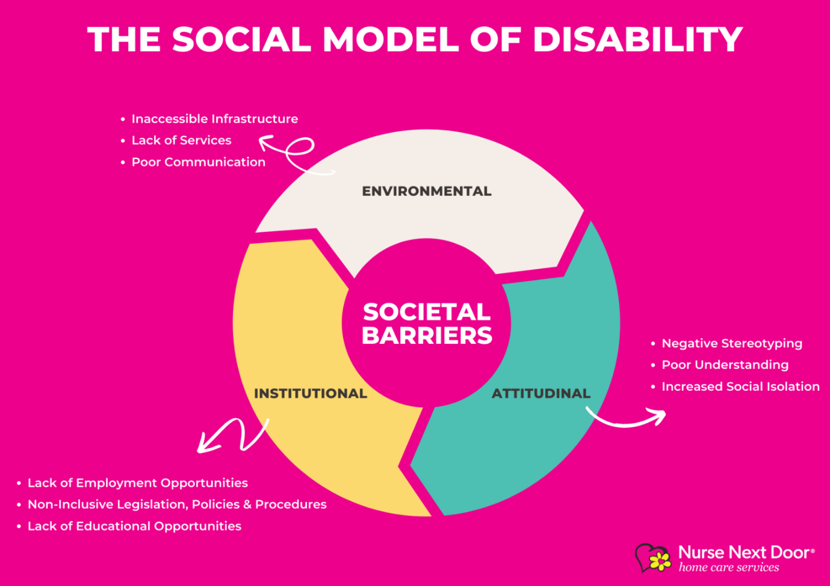
(Bing, 2025)
Since 2020, the Social Model has evolved to incorporate modern societal barriers. Digital exclusion, economic marginalisation, and limited representation of disabled individuals in leadership positions are increasingly recognised as factors that contribute to disabling experiences. Scholars have also emphasised the importance of intersectionality, acknowledging that disability intersects with gender, ethnicity, socioeconomic status, and other identity markers, which can compound disadvantage. These developments demonstrate the model’s adaptability and relevance to contemporary society, highlighting its capacity to address complex and layered forms of exclusion (GOV.UK, n.d.).

Despite its strengths, the Social Model has faced critiques, a notable criticism is that it overly separates impairment from disability, sometimes minimising the lived experiences of pain, fatigue, or cognitive limitations, which can significantly affect daily life. Critics argue that focusing solely on societal barriers risks underestimating the personal and medical dimensions of disability. Furthermore, the model has been criticised for historically prioritising the experiences of people with physical impairments, potentially overlooking the barriers faced by those with learning disabilities, mental health conditions, or neurodiverse profiles. This limitation suggests that, in its traditional form, the model may not fully capture the diverse experiences of all disabled people (Rik van Berkel and Breit, 2024).
Additional critiques focus on the model’s application in practical settings such as healthcare. While it effectively frames disability as a social issue, some scholars suggest it may underplay the importance of medical interventions or symptom management, which remain vital for wellbeing. Moreover, the model’s political roots and theoretical nature may make it challenging for practitioners to translate directly into day-to-day care, where individual impairment-related needs must be addressed alongside social barriers (Karimian, Petelos and Evers, 2022).

Responses to these critiques emphasise the model’s inherent flexibility and its ongoing relevance. Advocates stress that the Social Model does not deny impairment, rather, it seeks to locate the source of disadvantage in societal structures rather than in individuals. Contemporary interpretations increasingly integrate elements from the biopsychosocial model, allowing practitioners to address both impairment-related challenges and social barriers simultaneously. This integrated approach ensures that the Social Model retains theoretical rigor while remaining practically useful in healthcare, education, and social policy (Tsatsou, 2020).

Moreover, the model’s adaptability has allowed it to expand into areas such as digital accessibility, economic inclusion, and cultural representation, demonstrating its continued evolution. Its influence on legislation, inclusive education, and person-centred social care underscores its capacity to empower disabled people and challenge systemic inequalities. By framing disability as a societal responsibility rather than an individual deficit, the Social Model continues to inform policy, promote equality, and shape cultural attitudes toward disability. In the Social Model of Disability has developed into a flexible, influential framework that highlights societal responsibility in creating inclusive environments. Although critiques have highlighted potential limitations in scope and applicability, responses and adaptations have strengthened the model, ensuring its ongoing relevance in contemporary health, social care, and policy contexts (Holler and Ohayon, 2022).

Application of the Social Model of Disability in Health and Social Care Policy and Practice, and Associated Challenges.

The Social Model of Disability has played a significant role in shaping contemporary health and social care policy and practice by promoting the idea that disability is created by societal barriers rather than individual impairments. This perspective has influenced policymakers and practitioners to focus on removing structural and environmental obstacles, improving accessibility, and promoting equality and independence for disabled individuals. In health and social care, the Social Model has encouraged services to be more person-centred, ensuring that care is designed around individual needs and preferences rather than a one-size fits all medical approach. By prioritising social inclusion and participation, the model has informed legislation, service design, and professional practice standards (Wong et al., 2022).

In policy, the Social Model has guided the development of inclusive strategies such as the Equality Act 2010 in the UK, which requires organisations to eliminate discrimination and provide reasonable adjustments for disabled people. Health and social care policies increasingly emphasise accessibility, user involvement, and empowerment, reflecting the model’s principles. In practice, care providers are encouraged to adapt environments, improve communication, and involve service users in decision making processes, fostering independence and dignity. For example, social care frameworks often integrate person-centred planning, co-production, and advocacy services to ensure disabled individuals have a voice in their care (Health, 2024).

The model has also influenced community-based health initiatives and integrated care approaches. By recognising that societal barriers such as inaccessible transportation, inadequate housing, and cultural attitudes can limit health outcomes, services have aimed to create supportive environments that enable participation. Rehabilitation and therapy programmes increasingly focus on removing environmental barriers, supporting social engagement, and enhancing quality of life rather than solely addressing medical conditions. This has contributed to a broader understanding of health as encompassing social, psychological, and environmental well-being, aligning with the biopsychosocial approach (GOV.UK, 2021).

Despite these advances, the application of the Social Model in health and social care has faced several challenges. One issue is that the model’s emphasis on societal responsibility can sometimes overshadow the medical and clinical needs of individuals. Health practitioners must still address impairments, symptoms, and medical interventions, and an overreliance on the Social Model may risk underestimating these essential aspects of care. For example, someone with chronic illness may require medical treatment alongside social support, and services that focus predominantly on environmental adjustments may fail to meet clinical needs (Thorneycroft, 2024).

Another challenge is the uneven implementation of policies informed by the Social Model. While legislative frameworks exist, organisational cultures, resource limitations, and workforce training gaps can restrict the model’s practical impact. Health and social care professionals may struggle to balance policy ideals with day-to-day operational realities, leading to inconsistencies in access, quality of care, and user involvement. Additionally, the model has been critiqued for historically focusing on physical disabilities, which can result in the underrepresentation of individuals with learning disabilities, mental health conditions, or neurodiverse profiles in service planning and delivery. Furthermore, systemic barriers such as inadequate funding, societal attitudes, and digital exclusion continue to challenge full implementation. Although the Social Model provides a framework for inclusive practice, translating theoretical principles into sustainable action often requires coordinated effort across sectors, long-term investment, and cultural change within organisations (Cowie et al., 2020).
The Social Model of Disability has profoundly influenced health and social care policy and practice by emphasising societal responsibility, accessibility, and person-centred approaches. While its application has improved service design, user empowerment, and inclusion, challenges remain in integrating clinical needs, ensuring equitable implementation, and addressing diverse experiences of disability. A balanced, flexible approach that combines social and medical considerations is essential to fully realise the model’s potential in improving health and social care outcomes (SCOPE, 2024).

Recommendations for Health and Social Care Policy and Practice Based on the Social Model of Disability.

The Social Model of Disability emphasises that disability arises not solely from an individual’s impairment, but from societal, environmental, and attitudinal barriers. Applying this framework within health and social care policy and practice requires deliberate strategies to remove obstacles, promote equality, and ensure that disabled individuals can participate fully in society. Based on contemporary research and practice, several recommendations can guide policy makers and practitioners in embedding the social model effectively (Bailie et al., 2023).

1. Develop Inclusive and Accessible Environments.
Health and social care services must prioritise accessibility in both physical and digital spaces. Policies should require organisations to implement ramps, lifts, accessible signage, communication aids, and adaptive equipment in healthcare settings, workplaces, and public facilities. Digital inclusion, such as providing screen-reader compatible websites, subtitles, and simplified interfaces, should also be mandated to ensure equitable access. By reducing environmental barriers, these measures align with the social model and foster independence and participation for disabled individuals (England, 2025).

2. Implement Person-Centred Care Practices.
Practitioners should adopt person-centred approaches, tailoring care plans to the unique needs, goals, and preferences of everyone. This includes assessing environmental and social barriers, such as transport limitations or communication challenges, and co-designing solutions with service users. Embedding person-centred care ensures that interventions empower individuals while addressing systemic obstacles, which enhances both engagement and outcomes (Dong et al., 2024).

3. Promote Disability Awareness and Training.
Staff education is critical for fostering a culture that respects diversity and challenges negative attitudes. Policies should require ongoing training in the social model of disability, inclusive communication, and anti-discrimination practices. This equips health and social care professionals to recognise unconscious bias, engage effectively with disabled service users, and implement accessible practices consistently (Derbyshire et al., 2023).

4. Integrate Assistive Technologies and Support Services.
Health and social care providers should ensure access to assistive technologies, such as mobility aids, adaptive software, and communication devices, as part of care provision. Support services, including personal assistance and inclusive education programs, should be embedded within policy frameworks to facilitate participation in employment, education, and social activities. This ensures that both environmental and social barriers are addressed systematically (Bonanno et al., 2025).

5. Strengthen Policy, Advocacy, and Rights-Based Frameworks.
Policy makers should embed the principles of the social model into legislation, commissioning guidance, and organisational strategies. This includes enforcing standards of accessibility, monitoring compliance, and involving disabled people in decision-making processes. Advocacy initiatives should empower service users to challenge discriminatory practices, ensuring that policies are implemented in a way that promotes equity, autonomy, and human rights (Dorien Claessen et al., 2023).

6. Implement Continuous Evaluation and Improvement.
Policies and practices should include mechanisms for monitoring, feedback, and iterative improvement. This can include audits, service user feedback, and outcome measurement to identify persistent barriers and evaluate the effectiveness of inclusive strategies. Continuous evaluation ensures that social model principles are not just theoretical but embedded in practical, day-to-day care delivery. The Social Model of Disability provides a strong theoretical foundation for health and social care policy and practice. Recommendations include adopting person-centred approaches, addressing environmental barriers, investing in workforce training, integrating care, promoting advocacy, and monitoring effectiveness. By implementing these strategies, health and social care services can move towards inclusive, equitable, and empowering systems that align with the principles of the Social Model (Bowen et al., 2020).

Conclusion

This conclusion in Social Model of Disability is a framework that shifts the focus from individual impairments to societal barriers that restrict participation and inclusion. It argues that disability is not caused by a person’s condition, but by the physical, cultural, and organisational obstacles that limit opportunities. Central to the model is the idea that society has a responsibility to remove these barriers, ensuring equality, accessibility, and autonomy for disabled people. It has influenced legislation, policy, and professional practice by emphasising person-centred approaches, reasonable adjustments, and inclusive environments. The model also highlights the importance of empowerment, participation, and advocacy, enabling disabled individuals to shape services and assert their rights. While primarily social in focus, it complements healthcare by promoting holistic approaches that address both societal and individual needs, fostering greater dignity, independence, and engagement.

References

Lawson, A. and Beckett, A.E. (2020). The social and human rights models of disability: Towards a complementarity thesis. The International Journal of Human Rights, [online] 25(2), pp.348–379. doi:https://doi.org/10.1080/13642987.2020.1783533.
gill, marie (2025). Shakespeare: The Social Model of Disability - An In-Depth Analysis. [online] Studocu. Available at: https://www.studocu.com/en-ca/document/university-of-ottawa/experience-of-illness-impairment-and-disability/shakespeare-the-social-model-of-disability-an-in-depth-analysis/136424920 [Accessed 8 Dec. 2025].
Rik van Berkel and Breit, E. (2024). Organizational Practices for the Inclusion of People with Disabilities. A Scoping Review. Journal of Occupational Rehabilitation. doi:https://doi.org/10.1007/s10926-024-10228-5.
‌Bing. (2025). Social Model of Disability Definition - Bing. [online] Available at: https://www.bing.com/images/search?q=Social+Model+of+Disability+Definition&mmreqh=TJfefjFeKfSPtZ7j5924%2b48pi0sV%2f2IHF08xU8P7ats%3d&FORM=IDINTS [Accessed 9 Dec. 2025].
‌Athanasios Koutsoklenis and Adam, S. (2024). The Social Model of Disability. pp.1–6. doi:https://doi.org/10.1007/978-3-031-40858-8_294-1.
Tsatsou, P. (2020). Is Digital Inclusion Fighting Disability stigma? Opportunities, barriers, and Recommendations. Disability & Society, 36(5), pp.1–27. doi:https://doi.org/10.1080/09687599.2020.1749563.
Thorneycroft, R. (2024). Screwing the Social Model of Disability. Scandinavian journal of disability research, [online] 26(1), pp.286–299. doi:https://doi.org/10.16993/sjdr.1130.
Wong, J., Pedersen, J., Tennety, N., DuBois, L., Chiu, R., Shah, D., Malecki, G., Wafford, Q.E. and Heinemann, A.W. (2022). Service-Delivery Competencies in Home and Community-Based Services Needed to Achieve Person-Centered Planning and Practices: A Systematic Review. Journal of Applied Gerontology, 42(3), pp.493–504. doi:https://doi.org/10.1177/07334648221139476.
GOV.UK (2021). National Disability Strategy, Part 1: practical steps now to improve disabled people’s everyday lives. [online] GOV.UK. Available at: https://www.gov.uk/government/publications/national-disability-strategy/part-1-practical-steps-now-to-improve-disabled-peoples-everyday-lives.
Bailie, J., Fortune, N., Plunkett, K., Gordon, J. and Llewellyn, G. (2023). A call to action for more disability-inclusive health policy and systems research. BMJ Global Health, 8(3), p.e011561. doi:https://doi.org/10.1136/bmjgh-2022-011561.
England, N. (2025). NHS England» Accessible Information Standard – implementation guidance. [online] England.nhs.uk. Available at: https://www.england.nhs.uk/long-read/accessible-information-standard-implementation-guidance/?utm_source [Accessed 9 Dec. 2025].
Dong, M.Y., Meredith, L., Forrester-Jones, R., Kothari, A., Ryan, D., Ryan, B.L., Mathews, M. and Sibbald, S.L. (2024). Individualized participatory care planning for individuals with intellectual and developmental disabilities: a qualitative descriptive study. BMC Health Services Research, 24(1). doi:https://doi.org/10.1186/s12913-024-12009-5.
Derbyshire, D.W., Spencer, A.E., Grosskopf, B. and Blackmore, T. (2023). The importance of disability representation to address implicit bias in the workplace. Frontiers in Rehabilitation Sciences, [online] 4. doi:https://doi.org/10.3389/fresc.2023.1048432.

Bonanno, M., Saracino, B., Ciancarelli, I., Panza, G., Manuli, A., Morone, G. and Calabrò, R.S. (2025). Assistive Technologies for Individuals with a Disability from a Neurological Condition: A Narrative Review on the Multimodal Integration. Healthcare, [online] 13(13), pp.1580–1580. doi:https://doi.org/10.3390/healthcare13131580.
Ferri, D. (2024). Advancing an Embodied Understanding of Accessibility for Persons with Disabilities. Journal of Human Rights Practice. doi:https://doi.org/10.1093/human/huae049.
Dorien Claessen, Majda Lamkaddem, Oomen, B. and Quirine Eijkman (2023). Bringing Human Rights Home: Access to Justice and the Role of Local Actors Implementing the United Nations Convention on the Rights of Persons with Disabilities. Journal of Human Rights Practice. doi:https://doi.org/10.1093/jhuman/huad053.
Whelan, L., McLean, S., Edwards, A., Huglin, J. and Farlie, M.K. (2024). The evaluation of health, disability and aged care-sector engagement with resources designed to support optimisation of the allied health assistant workforce: a qualitative study. BMC Health Services Research, 24(1). doi:https://doi.org/10.1186/s12913-024-11253-z.
Whelan L, McLean S, Edwards A, Huglin J, Farlie MK. The evaluation of health, disability and aged care-sector engagement with resources designed to support optimisation of the allied health assistant workforce: a qualitative study. BMC Health Serv Res. 2024 Jul 26;24(1):848. doi: 10.1186/s12913-024-11253-z. PMID: 39060917; PMCID: PMC11282609.
Bowen, C.N., Havercamp, S.M., Karpiak Bowen, S. and Nye, G. (2020). A call to action: Preparing a disability-competent health care workforce. Disability and Health Journal, 13(4), p.100941. doi:https://doi.org/10.1016/j.dhjo.2020.100941.
‌ Holler, R. and Ohayon, Y. (2022). Understanding Disability Policy Development: Integrating Social Policy Research with the Disability Studies Perspective. Social Policy and Society, pp.1–16. doi:https://doi.org/10.1017/s1474746422000367.
Karimian, G., Petelos, E. and Evers, S.M.A.A. (2022). The ethical issues of the application of artificial intelligence in healthcare: a systematic scoping review. AI and Ethics, [online] 2(1). Available at: https://link.springer.com/article/10.1007/s43681-021-00131-7.
‌ Cowie, J., Nicoll, A., Dimova, E.D., Campbell, P. and Duncan, E.A. (2020). The barriers and facilitators influencing the sustainability of hospital-based interventions: A systematic review. BMC Health Services Research, 20(1). doi:https://doi.org/10.1186/s12913-020-05434-9.
SCOPE (2024). Social Model of Disability | Disability Charity Scope UK. [online] Scope. Available at: https://www.scope.org.uk/social-model-of-disability.
GOV.UK. (n.d.). Equality in 2022: how DHSC met the public sector equality duty. [online] Available at: https://www.gov.uk/government/publications/dhsc-equality-information-2022/equality-in-2022-how-dhsc-met-the-public-sector-equality-duty.
‌

‌

‌

‌

‌

‌

‌

‌

‌

‌

‌

‌

‌
‌
‌

‌

‌

