

Module Title: Building your Personal Brand
Module Code: BMHP5015
Student Name: Bianca Muntean
Student ID: 2323244

Task 1 - Personal Brand
Introduction
Personal branding conveys my professional capabilities, career aspirations, and values. Therefore, employability is based on illustrating competence rather than image building (Bolton-King, 2022).
Current Personal Brand and Development
As a result of my experience as a heat bander, a packing operative, and a babysitter, my teamwork skills, time management skills, sense of responsibility, and adaptability have been enhanced. These skills help me become dependable in different working environments. Therefore, I have come to realise that having practical experience alone is not enough to show that I am ready for supervisory roles. I should, therefore, work on improving my leadership, communication, and technical abilities to enhance my professional credibility.
According to Szántó (2026), it is significant to focus on personal brand equity in terms of success at work. However, it cannot be a substitute for the set of skills, work experience and performance expected by the employer. To build a better brand, I plan to update my CV with relevant accomplishments, ask for constructive feedback from my supervisors, and go through the training, which will cover my skill weaknesses. Moreover, I will try to establish professional relationships and prove my leadership. The process of my performance evaluation will be based on completed training, achieved results and feedback, not self-evaluation only.
Conclusion
My long-term objective is to move towards taking up a supervisory position. By using a real presentation of myself with demonstrable performance and continual learning, I can be able to establish an authentic personal brand that encourages sustainable career ambition and employability.
Task 2 - Network Map and Rationale
2.1 Network Map
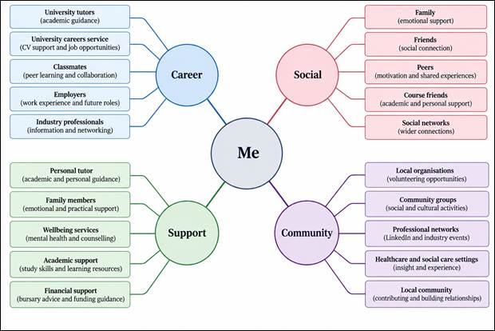
Figure: Personal Network Map
Source: (Self-created)
2.2 Supporting Rationale
I regard myself as having a hybrid network since mine includes both tight-knit interpersonal networks and educational networks alongside professional networks. The family and friends provide social capital by way of bonding since there is trust, support and encouragement. Nonetheless, dependence on familiar people would limit access to career-related opportunities and information.
The area in which I am weakest is bridging social capital, as I lack good connections outside of my immediate group of people. Studies on 18 graduates have shown that volunteering, professional networking, and work-integrated learning can be used to create career connections (English et al., 2021). As such, I will attend career-relevant events, connect with professionals and seek relevant experience through LinkedIn. In addition to this, my linking social capital also requires development. I should proactively develop relationships with individuals who can offer institutional guidance, involving tutors, career advisors and employers.
Research conducted on 7,036 European firms has shown that there was more satisfaction with graduate employability among employers as their collaborations with universities increased (Arranz et al., 2022). Regardless of this, networking may not ensure employment and thus, experience, recruitment conditions and skills are also important. Besides this, I will reinforce bonding through supportive relationships, linking through institutional guidance and communicating through professional engagement. Such actions must diversify my potential network instead of simply elevating its size.

Task 3- Blog
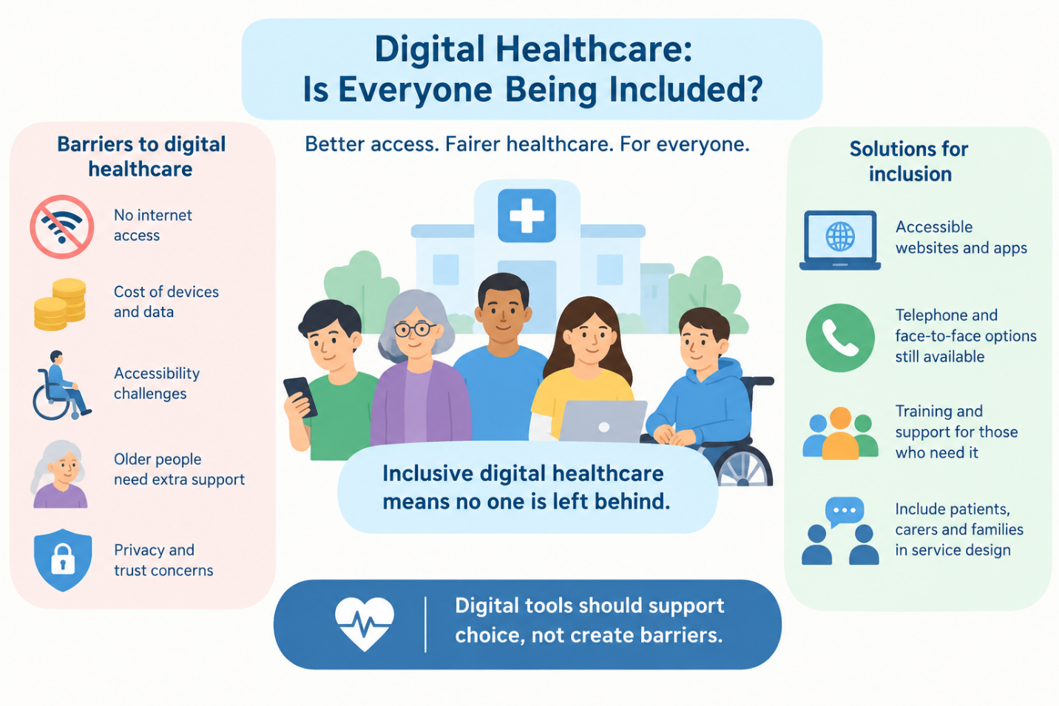
Figure: Blog
(Source: Self-Created)
Digital Healthcare: Is Everyone Being Included?
Target audience: Patients, families and carers in the UK.
1. Introduction
Consider a situation where someone needs to make a GP appointment and finds themselves unable to do the task as they have no internet access or digital literacy skills. Digital healthcare delivers several conveniences, yet can everyone be able to take advantage? Digital inclusion is essential as the NHS progresses with digital solutions to ensure that access to healthcare is determined by medical needs instead of technology.
2. Main Body
Online appointments, health applications, and online prescriptions can increase convenience, prevent unnecessary trips, and allow people to manage their health. However, these advantages are not equally available. People from poor backgrounds may lack funds to purchase devices and pay for internet data, whereas some disabled people find websites difficult to navigate. Old people may need extra assistance, while not all old people have poor digital skills. NHS England (2023) highlights the importance of addressing inequality in both the workforce and services and thus emphasises the significance of inclusive approaches in healthcare. The issue of digital exclusion should not be considered a personal problem. Inaccessible technology, lack of support, and the assumption that everybody has equal skills to use online services can make inequalities
Although a digital-first approach can make the process of managing people's health more efficient, focusing on cost saving rather than allowing people to choose whether to use these services is likely to result in discrimination against those vulnerable groups of service users. Moreover, online services bring up the issue of privacy and trust in sharing one's health data online. The NHS must provide accessible websites and guidance and training for people who require it (NHS, 2024). Telephone and face-to-face consultations need to remain an option where appropriate. Including people and their carers in the design process of services can enable the identification of barriers that professionals cannot see for themselves. The success of any digital healthcare service should be gauged by the uptake and the accessibility of different services (NHS England, 2026).
3. Conclusion
Digital technology has the potential to transform the healthcare system only if inclusion becomes a priority rather than an afterthought. Patients, their families, carers, and healthcare professionals need to campaign for services that integrate digital technologies along with alternatives. Everyone must have access to health care, regardless of whether it is through online or offline channels.

Task 4- NHS Equality, Diversity and Inclusion Quiz
1. What is the primary goal of the NHS Equality, Diversity, and Inclusion Improvement Plan?
To reduce discrimination in the workplace, reinforce belonging and enhance staff experience across the NHS workforce (Scheuer et al., 2025).
2. How does the NHS EDI Improvement Plan propose to tackle the gender pay gap?
Analyse salaries according to gender and ethnicity, put in place improvement programmes, and support flexible work. The report identified a gender pay gap of 47% for NHS staff not on the Agenda for Change scheme (GOV.UK, 2025).
3. What is meant by the term ‘intersectionality’ as used in the NHS EDI Improvement Plan?
It demonstrates how overlapping characteristics may establish diversified experiences of discrimination, necessitating responses beyond the categories of single identity.
4. Why is it important for the NHS to create a psychologically safe work environment?
It is essential that staff members are made to feel respected and are not afraid to speak up. It upholds safer patient care and efficient teamwork.
5. How does the NHS EDI Improvement Plan suggest improving the experience of internationally recruited staff?
Providing comprehensive induction, clear guidance regarding employment, equal opportunities for career development and pastoral support.
6. What role does leadership play in advancing EDI objectives according to the NHS Improvement Plan?
Leaders should set tangible EDI goals and be accountable for their achievements. Otherwise, without measurements, commitments might just remain symbolic instead of producing change.
7. Identify one way the NHS EDI Improvement Plan aims to reduce health inequalities within the workforce.
Reduce harassment and bullying through targeted actions that is informed by the evidence of workforce.
8. Why does the NHS EDI Improvement Plan emphasise the importance of collecting and analysing data on protected characteristics?
Evaluate safeguarded characteristic data to assess disparities, target interventions and monitor progress despite assuming equal experiences (NHS England, 2023).
9. Explain how flexible working policies can contribute to equality and inclusion in the NHS workforce.
Accessible policies for flexible working may enhance career access and work-life balance, specifically or staff with responsibilities of care.
10. What is one strategy mentioned in the NHS EDI Improvement Plan to combat bullying and harassment in the workplace?
Develop reduction targets, monitor workforce data and strengthen prevention, reporting and support for impacted staff.
Task 5- A Letter to Yourself
Dear Younger Me,
I know there were instances when things made you feel overwhelmed, such as the pressures of study, future concerns and your personal obligations. You never accepted being tired, worried and emotionally exhausted. Hence, reflecting back on those behaviours, I realised that denying my feelings did not make me more resilient rather prevented me from knowing my requirements. During my learning about emotional intelligence, I have understood the significance of recognising, understanding and controlling my emotions. Early development of self-awareness could help in prior identification of inner stresses that impacted personal abilities and self-confidence. Additionally, I should have been able to regulate my emotions through constructive reactions towards the challenges to save myself from being frustrated or afraid. In fact, emotional intelligence is realising inner feelings and meeting their needs constructively instead of hiding them.
Consequently, I have discovered that resilience refers to adapting to challenges instead of ignoring them. Though previously I considered my failures as the limitations of my capabilities, later, I have realised that failures provide another chance to grow and develop further. Resilience could have helped in staying balanced, asking for help and continuing to strive for success despite the imperfections. Gradually, I would like to remind you that asking for help is not a sign of weakness. Open communication with the right people, following healthy habits and dividing big problems into smaller ones could have prevented you from harming your well-being. In addition, I advise you to appreciate every little victory instead of comparing yourself with other people. Looking ahead, I am going to take care of my emotional health, use my challenges to get knowledge and be ready to deal with uncertainties confidently. Although I cannot undo anything that has already happened, I can transform my experience into increased self-awareness and resilience.
With understanding and hope,
Your older self

Task 6- GANTT Chart
Employment Goal: To secure an entry-level position in Health and Social Care by September 2027, I must develop the requisite skills and experience that will facilitate my transition into a higher-level role in care work.
1. Task Planning Table
Task | Start Date | End Date | Duration | Dependencies
Complete Level 5 Coursework | January 2027 | March 2027 | 3 months | None
Attend Relevant Workshops | January 2027 | June 2027 | 6 months | None
Complete Level 6 Coursework | April 2027 | June 2027 | 3 months | Successful completion of Level 5
Gain Relevant Work Experience | March 2027 | July 2027 | 5 months | Arrange a suitable placement or experience opportunity
Develop Professional CV and Cover Letter | July 2027 | July 2027 | 1 month | Identify relevant skills and experience
Apply for Jobs | August 2027 | September 2027 | 2 months | CV and cover letter completed
Prepare for Interviews | August 2027 | September 2027 | 2 months | Job applications submitted
Secure and Start Role | September 2027 | September 2027 | Target milestone | Successful recruitment and required employment checks

2. Visual Gantt Chart
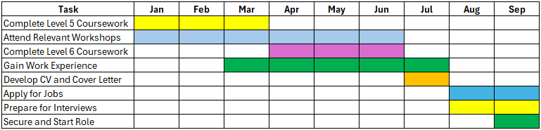
Figure: Gantt Chart
(Source: Self-created)
3. Key Milestones and Dependencies
March 2027: Complete Level 5 coursework.
June 2027: Complete Level 6 coursework.
July 2027: Complete relevant work experience and finalise the CV.
August 2027: Begin job applications and interview preparation.
September 2027: Target date to secure and start employment.
Task 7- Making Changes- Report
1. Introduction
As a care home manager, I would introduce a system of digital care planning in order to make communication, documentation and client-focused care more efficient. Although digitising the system has many benefits, success in implementation requires training for the staff, involvement of the residents and implementation of safety measures (Cresswell et al., 2024).
2. Planning the Change
To implement the innovative change, Lewin’s Change Theory, developed by Kurt Lewin, will be used, which involves three stages: unfreezing, changing, and refreezing (Burnes, 2020). I would begin by demonstrating how digital records can help minimise errors of documentation as well as enhance the accessibility of renewed needs of care of residents. I would involve all stakeholders, including care workers, residents, and IT specialists. In the process of implementation, a group of a small number of people would carry out a pilot project where they would be trained in and faced obstacles during using the system.
3. Skills Required
Effective communication would allow for the explanation of the changes and the possibility to answer concerns. Leadership would communicate the main responsibilities in the situation, while digital literacy would ensure the proper function of the system. Time management would allow for carrying out training according to plan.
4. Barriers and Solutions
Staff resistance: Employees might worry about their use of technology and workload increases. I would include them in discussions about solutions and how they work in practice.
Limited resources: Purchasing equipment, software and providing training might be expensive. I would make a budget, choose what is critical to purchase and implement things step by step.
Technical difficulties: System failures might prevent access to information. Therefore, I would provide technical support, create the data backup plan and downtimes.
Confidentiality risks: Digital data might be unsafe. Different levels of access to information, training people and checking data regularly would be used to comply with the UK GDPR and Data Protection Act 2018 (Phillips, 2021).
5. Conclusion
Digital care planning could allow for better sharing of information and improvement of the quality of care. However, technology cannot solve problems alone. People’s participation, sufficient resources and constant monitoring are required to make change efficient.
Reference List
Arranz, N., Arroyabe, M.F., Sena, V., Arranz, C.F. and Fernandez de Arroyabe, J.C., (2022). University-enterprise cooperation for the employability of higher education graduates: a social capital approach. Studies in Higher Education, 47(5), pp.990-999.
Bolton-King, R.S., (2022). Student mentoring to enhance graduates’ employability potential. Science & Justice, 62(6), pp.785-794.
Burnes, B., (2020). The origins of Lewin’s three-step model of change. The Journal of Applied Behavioral Science, 56(1), pp.32-59.
Cresswell, K., Anderson, S., Elizondo, A.M. and Williams, R., (2024). Opportunities and challenges of promoting integrated care through digitalisation–learning lessons from large-scale national programmes in England. Health Policy and Technology, 13(2), p.100838.
English, P., de Villiers Scheepers, M.J., Fleischman, D., Burgess, J. and Crimmins, G., (2021). Developing professional networks: the missing link to graduate employability. Education+ Training, 63(4), pp.647-661.
GOV.UK, (2025). 2025 gender pay gap report. [Online] Available at: https://www.gov.uk/government/publications/dhsc-gender-pay-gap-report-and-data-2025/2025-gender-pay-gap-report [Accessed 22 10 2026].
NHS England, (2023). NHS equality, diversity and inclusion (EDI) improvement plan. [Online] Available at: https://www.england.nhs.uk/publication/nhs-edi-improvement-plan/ [Accessed 23 10 2026].
NHS England, (2026). Digital Services for Integrated Care. [Online] Available at: https://digital.nhs.uk/services/digital-services-for-integrated-care [Accessed 21 10 2026].
NHS, (2024). What all NHS services need to do about accessibility. [Online] Available at: https://service-manual.nhs.uk/accessibility/what-all-nhs-services-need-to-do [Accessed 22 10 2026].
Phillips, B., (2021). UK further education sector journey to compliance with the general data protection regulation and the data protection act 2018. Computer Law & Security Review, 42, p.105586.
Scheuer, C.L., Loughlin, C., Prowse, D., McNally, C., Arnold, K.A. and Chalise, S., (2025). Diversity-specific empowering leadership: an alternative approach to reducing sex-based bias and enabling inclusivity. Journal of Business Ethics, 201(1), pp.111-144.
Szántó, P., (2026). Understanding and Quantifying Personal Branding (Doctoral dissertation, bgte).

