UNIVERSITY OF WALES TRINITY SAINT DAVID
LONDON CAMPUS
Assignment 2
Learning in the Digital Era
Video Link https://youtu.be/KeehpnbDrk4

Module Name: Learning in the Digital Era
Module Code: ACCA 4025

Student Name: Mohamed Ibrahim Mohamed Abdul Karem
Student ID:2510896
Group:2
Lecturer’s Name: Koushik Modak

Table of Contents
Introduction 2
Main Body 2
Conclusion 9
References 9

Introduction
A general introduction for this word document (Briefly in a few sentences explain what this report is going to be about)

Main Body
Write one/two sentences.
Video Link:
Slide 1 COVER PAGE
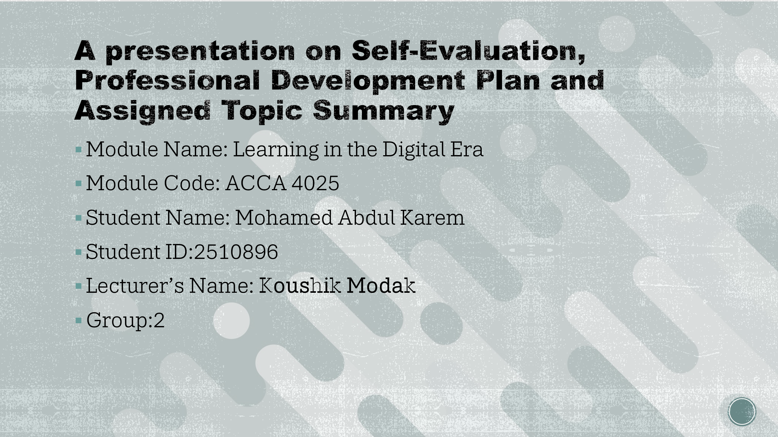

Slide 2 CONTENTS

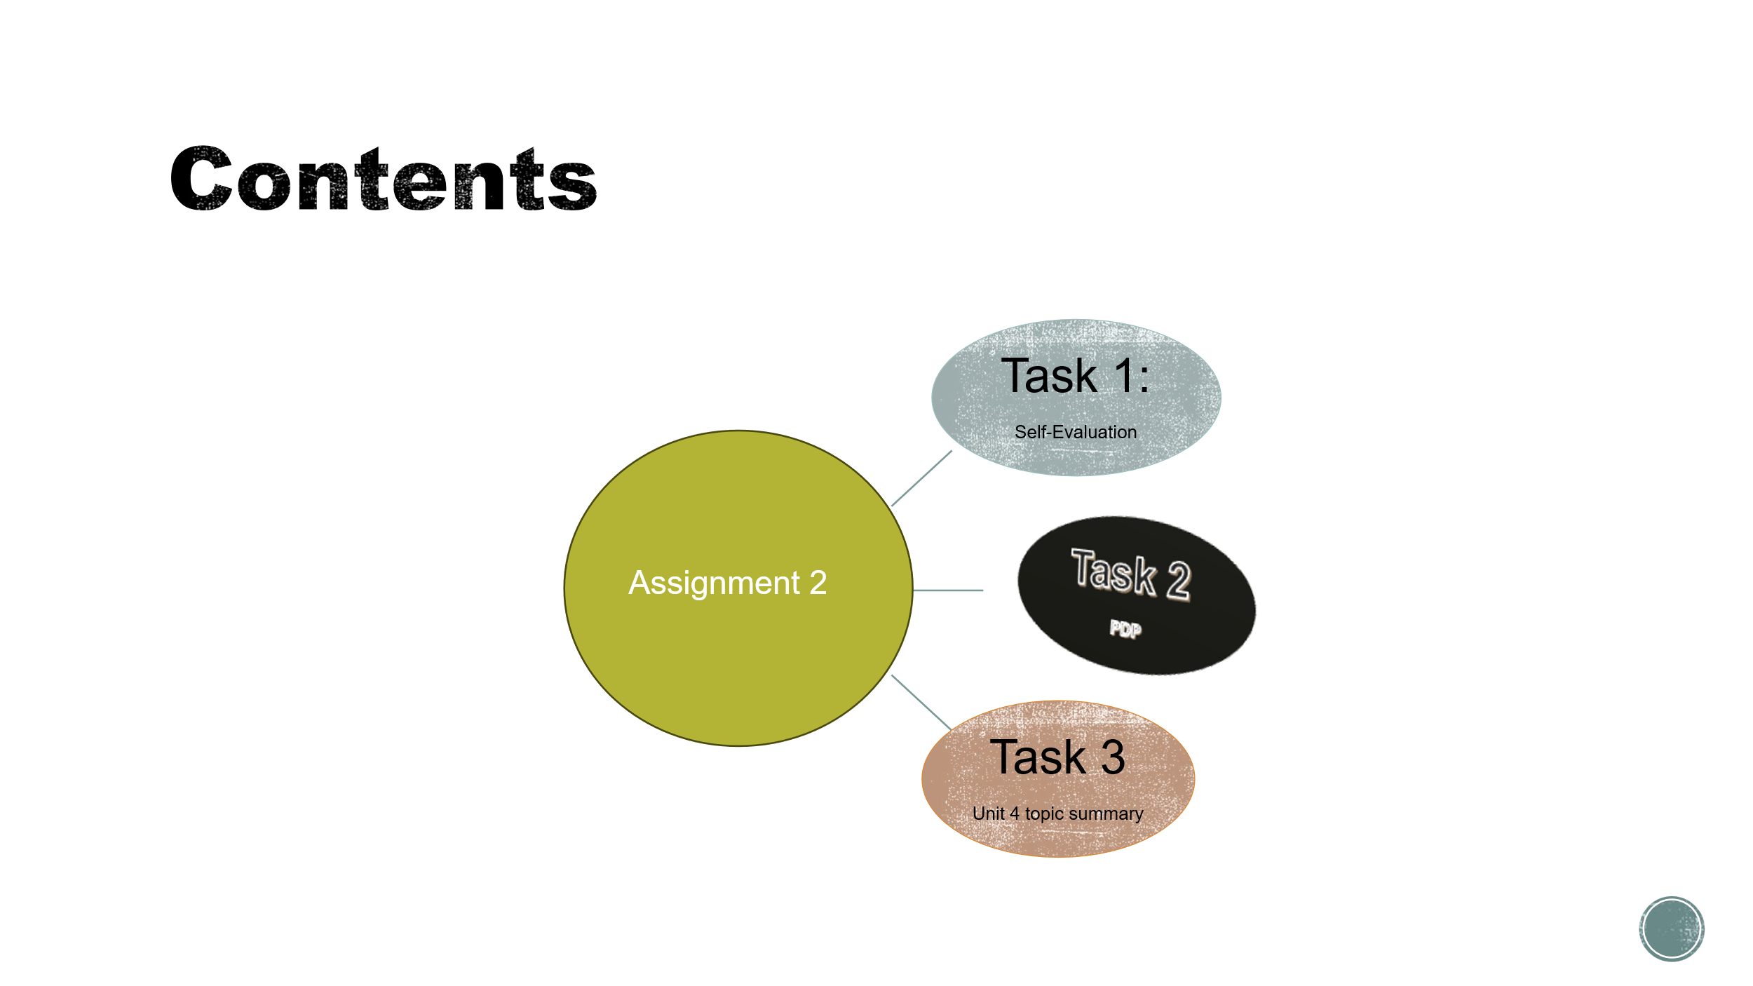

Slide 3 INTRODUCTION
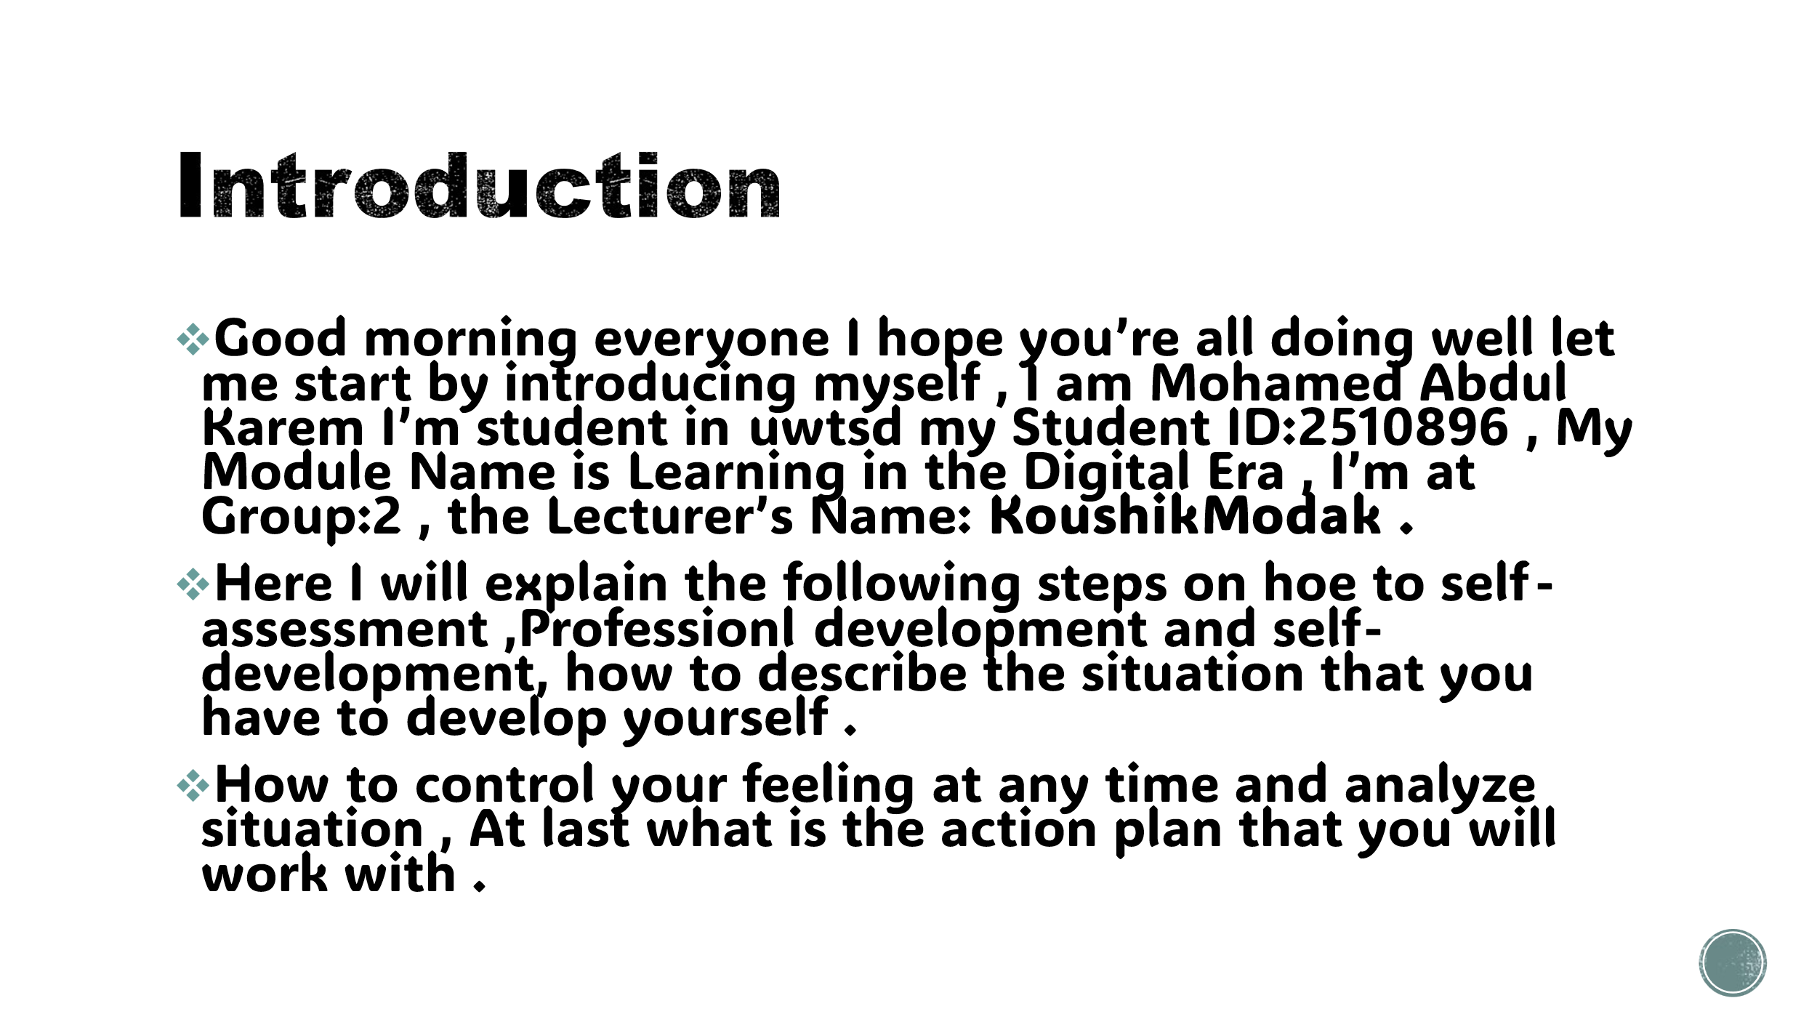

Slide 4 MAIN BODY
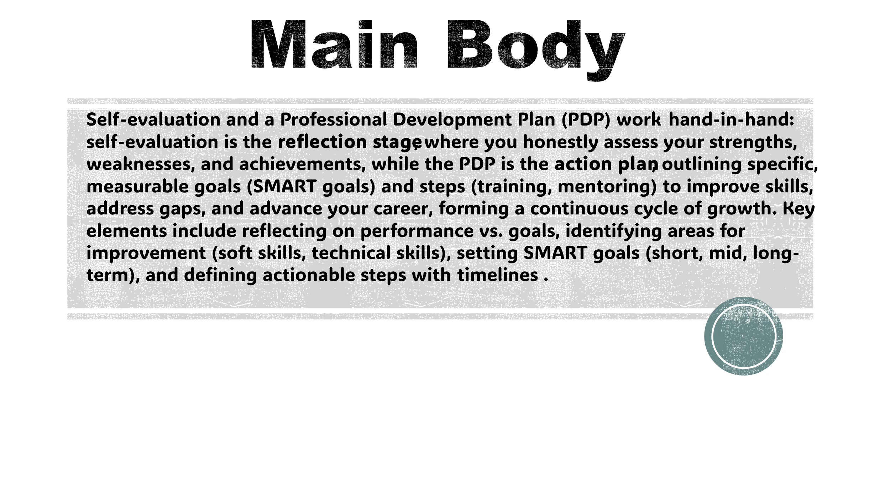
- A presentation on Self-Evaluation, Professional Development here I explain how I can develop myself through education and self-development , Reflective Model for six steps Description , Feelings , Evaluation , Analysis , Conclusion , Action plan .

Slide 5 GIBB’s REFLECTIVE MODEL
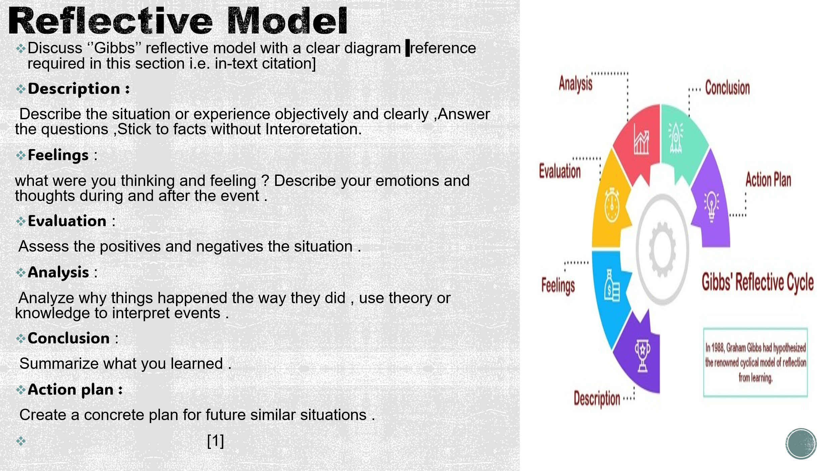
Brief explanation: This diagram explains all the steps that must be taken for self-development and professional development for a person who wants to develop himself .

Slide 6 TASK 1: SELF EVALUATION
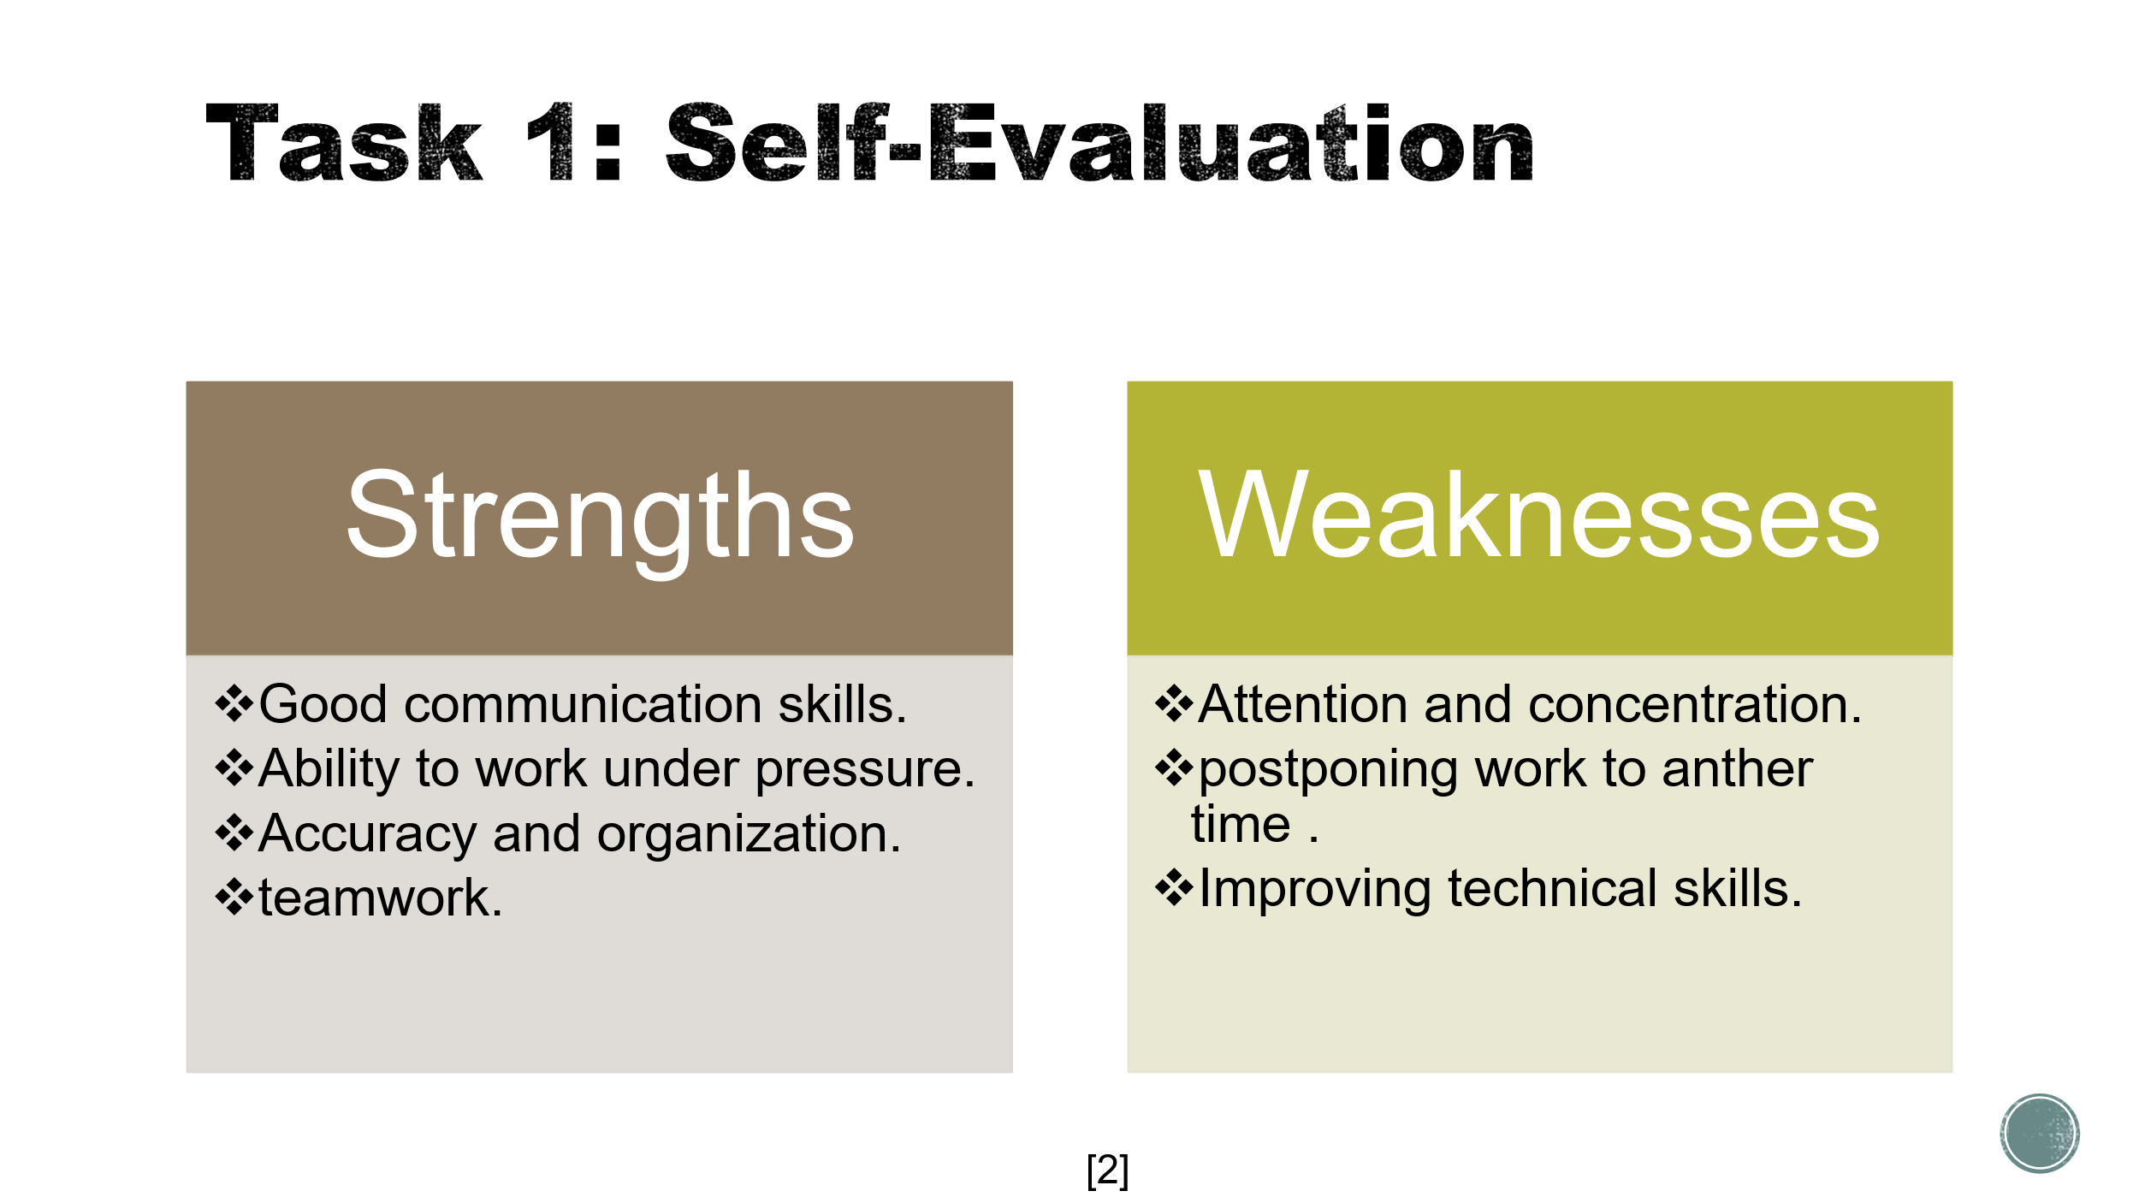
Brief explanation: This table shows the comparisons between weaknesses and strengths I want to make it clear that a person should focus on weaknesses in to improve .
Slide 7 TRAITS GAINED FROM THE SELF EVALUATION
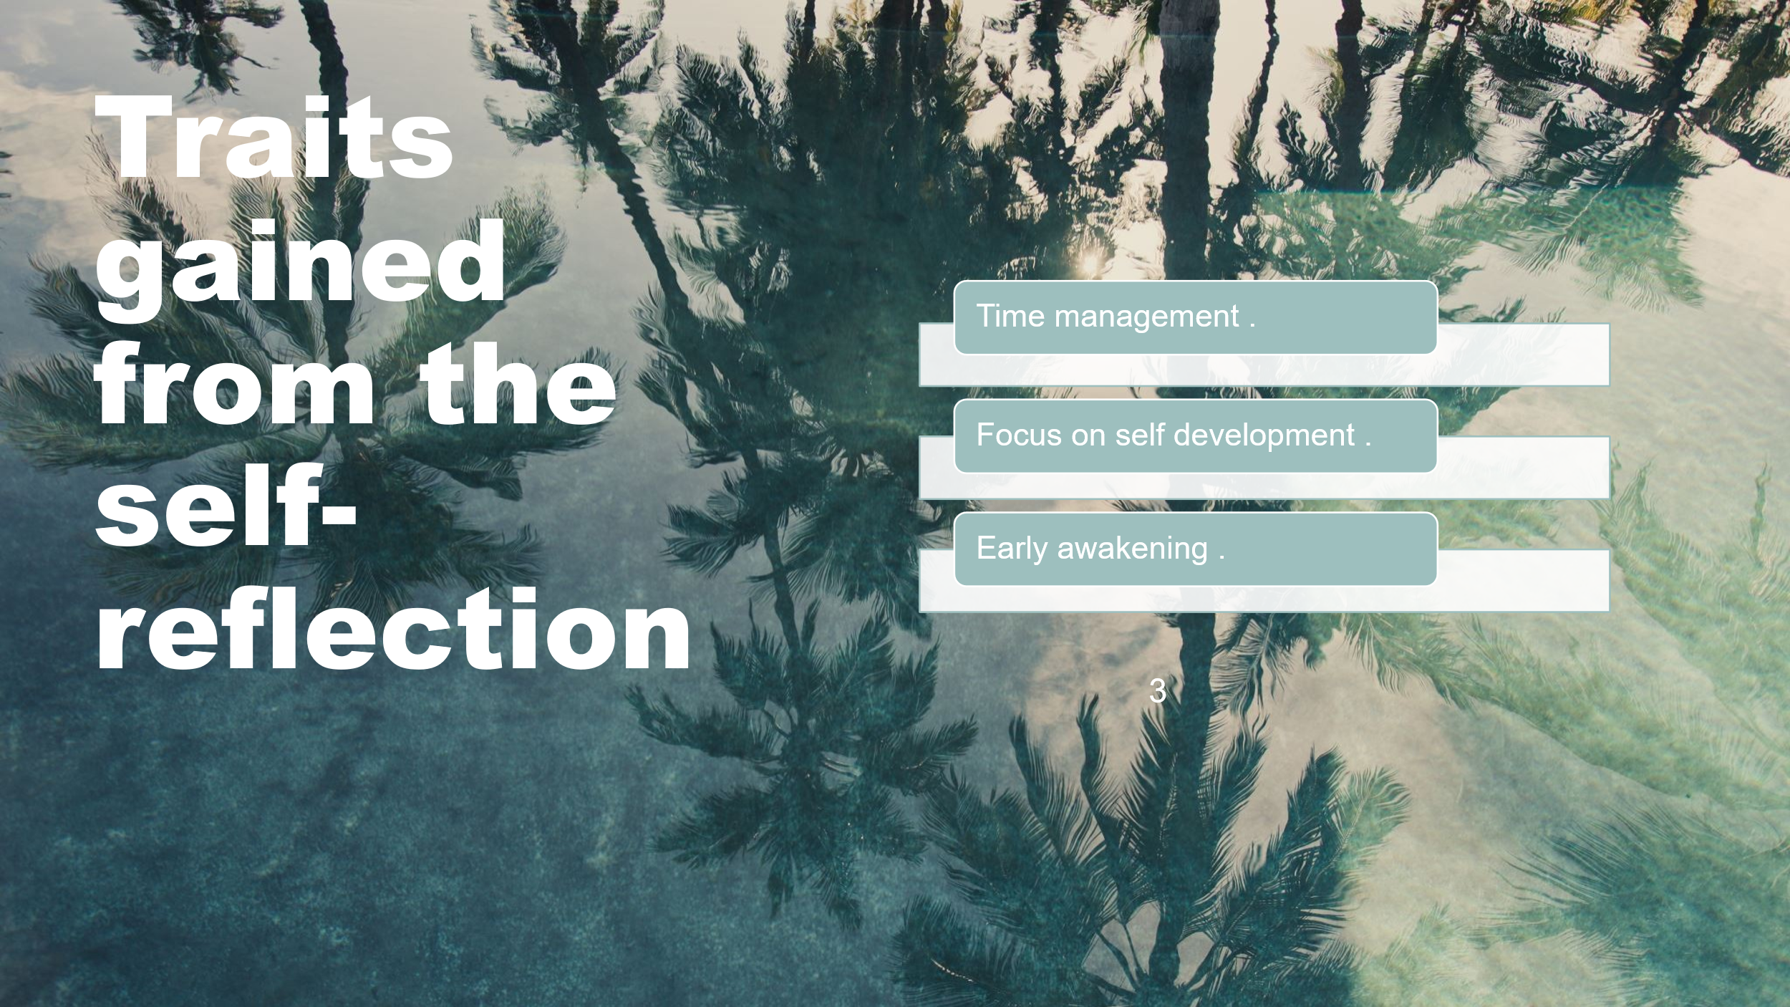
Brief explanation: The best qualities to acquire in professional life are the most important thing is time management

Slide 8 PROFESSIONAL DEVELOPMENT PLAN
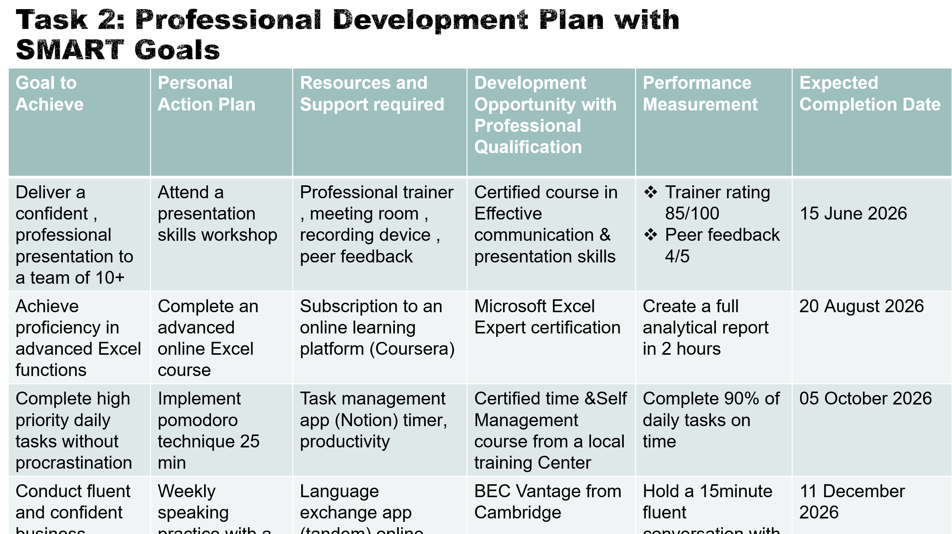
Brief explanation:
These are the goals I have set in the coming to do in my order to develop myself with this plan I will develop myself for the better with this plan .

Slide 9 UNIT 4 TOPIC SUMMARY
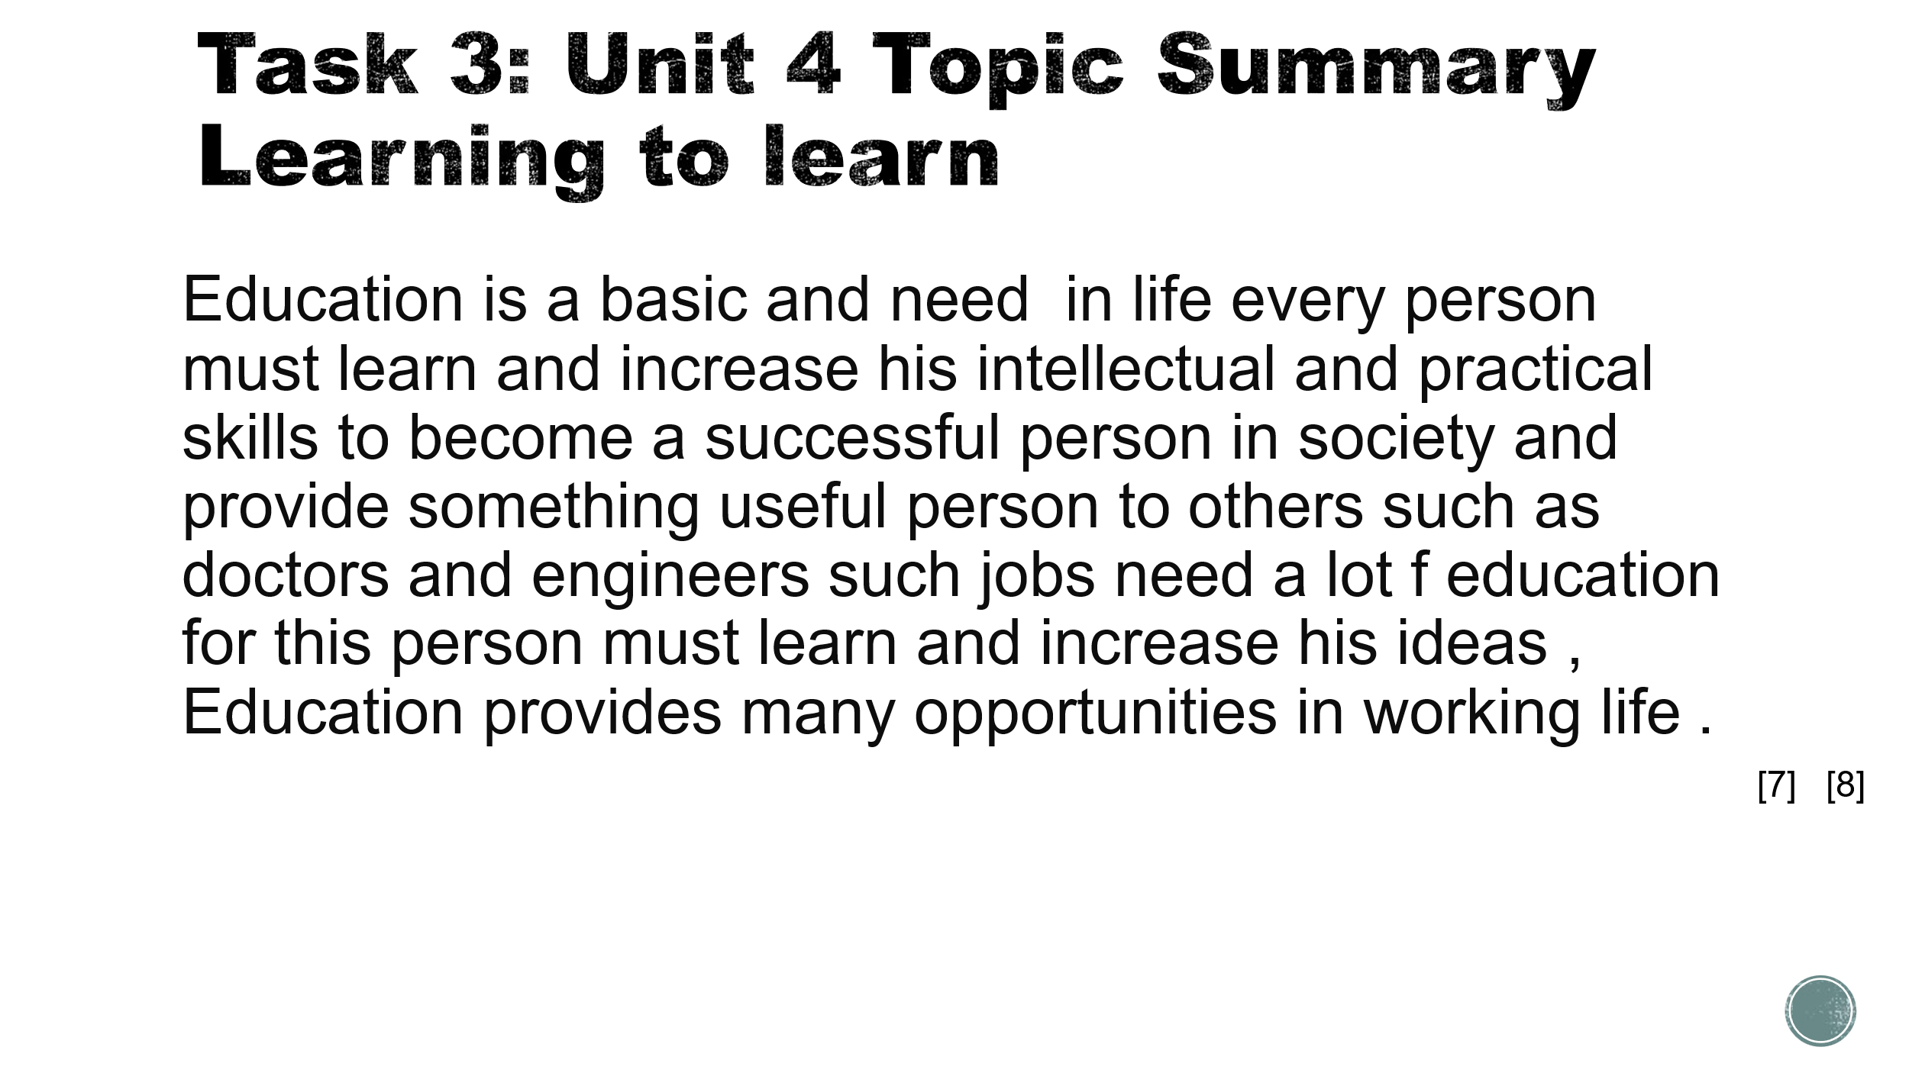
Brief explanation:
Education is one of the best successful ways that guarantees a successful future in all fields of work around the world and facilitates self-development .

Slide 10 CONCLUSION

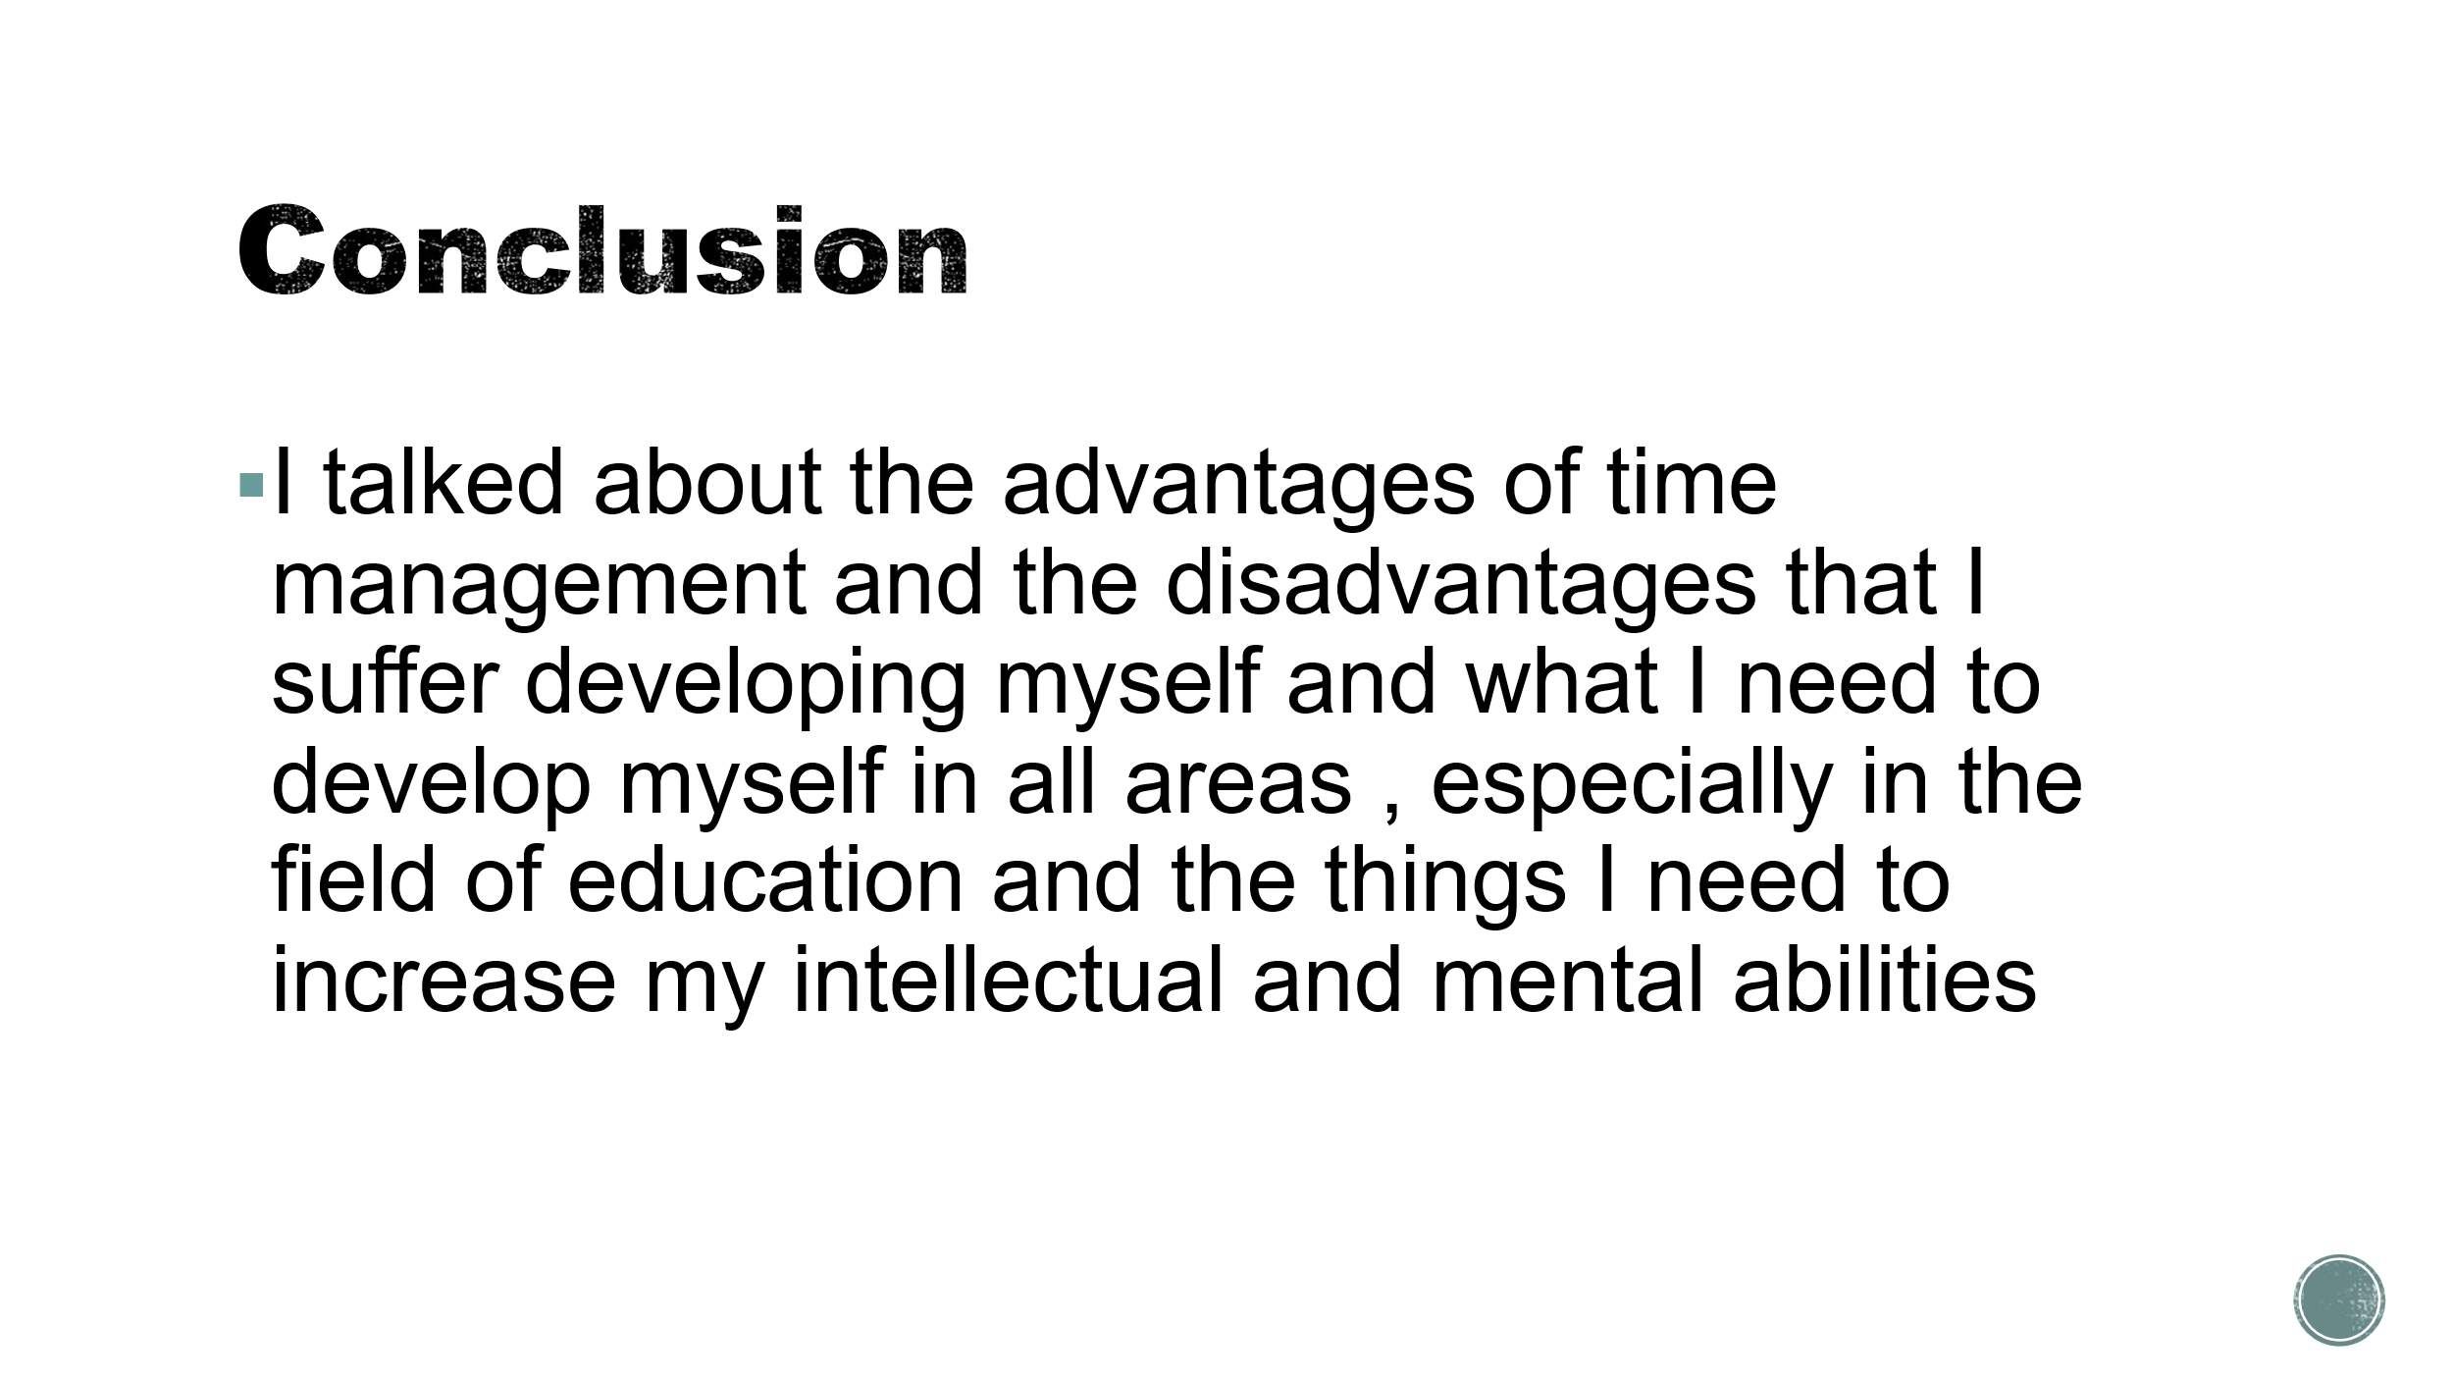

Slide 11
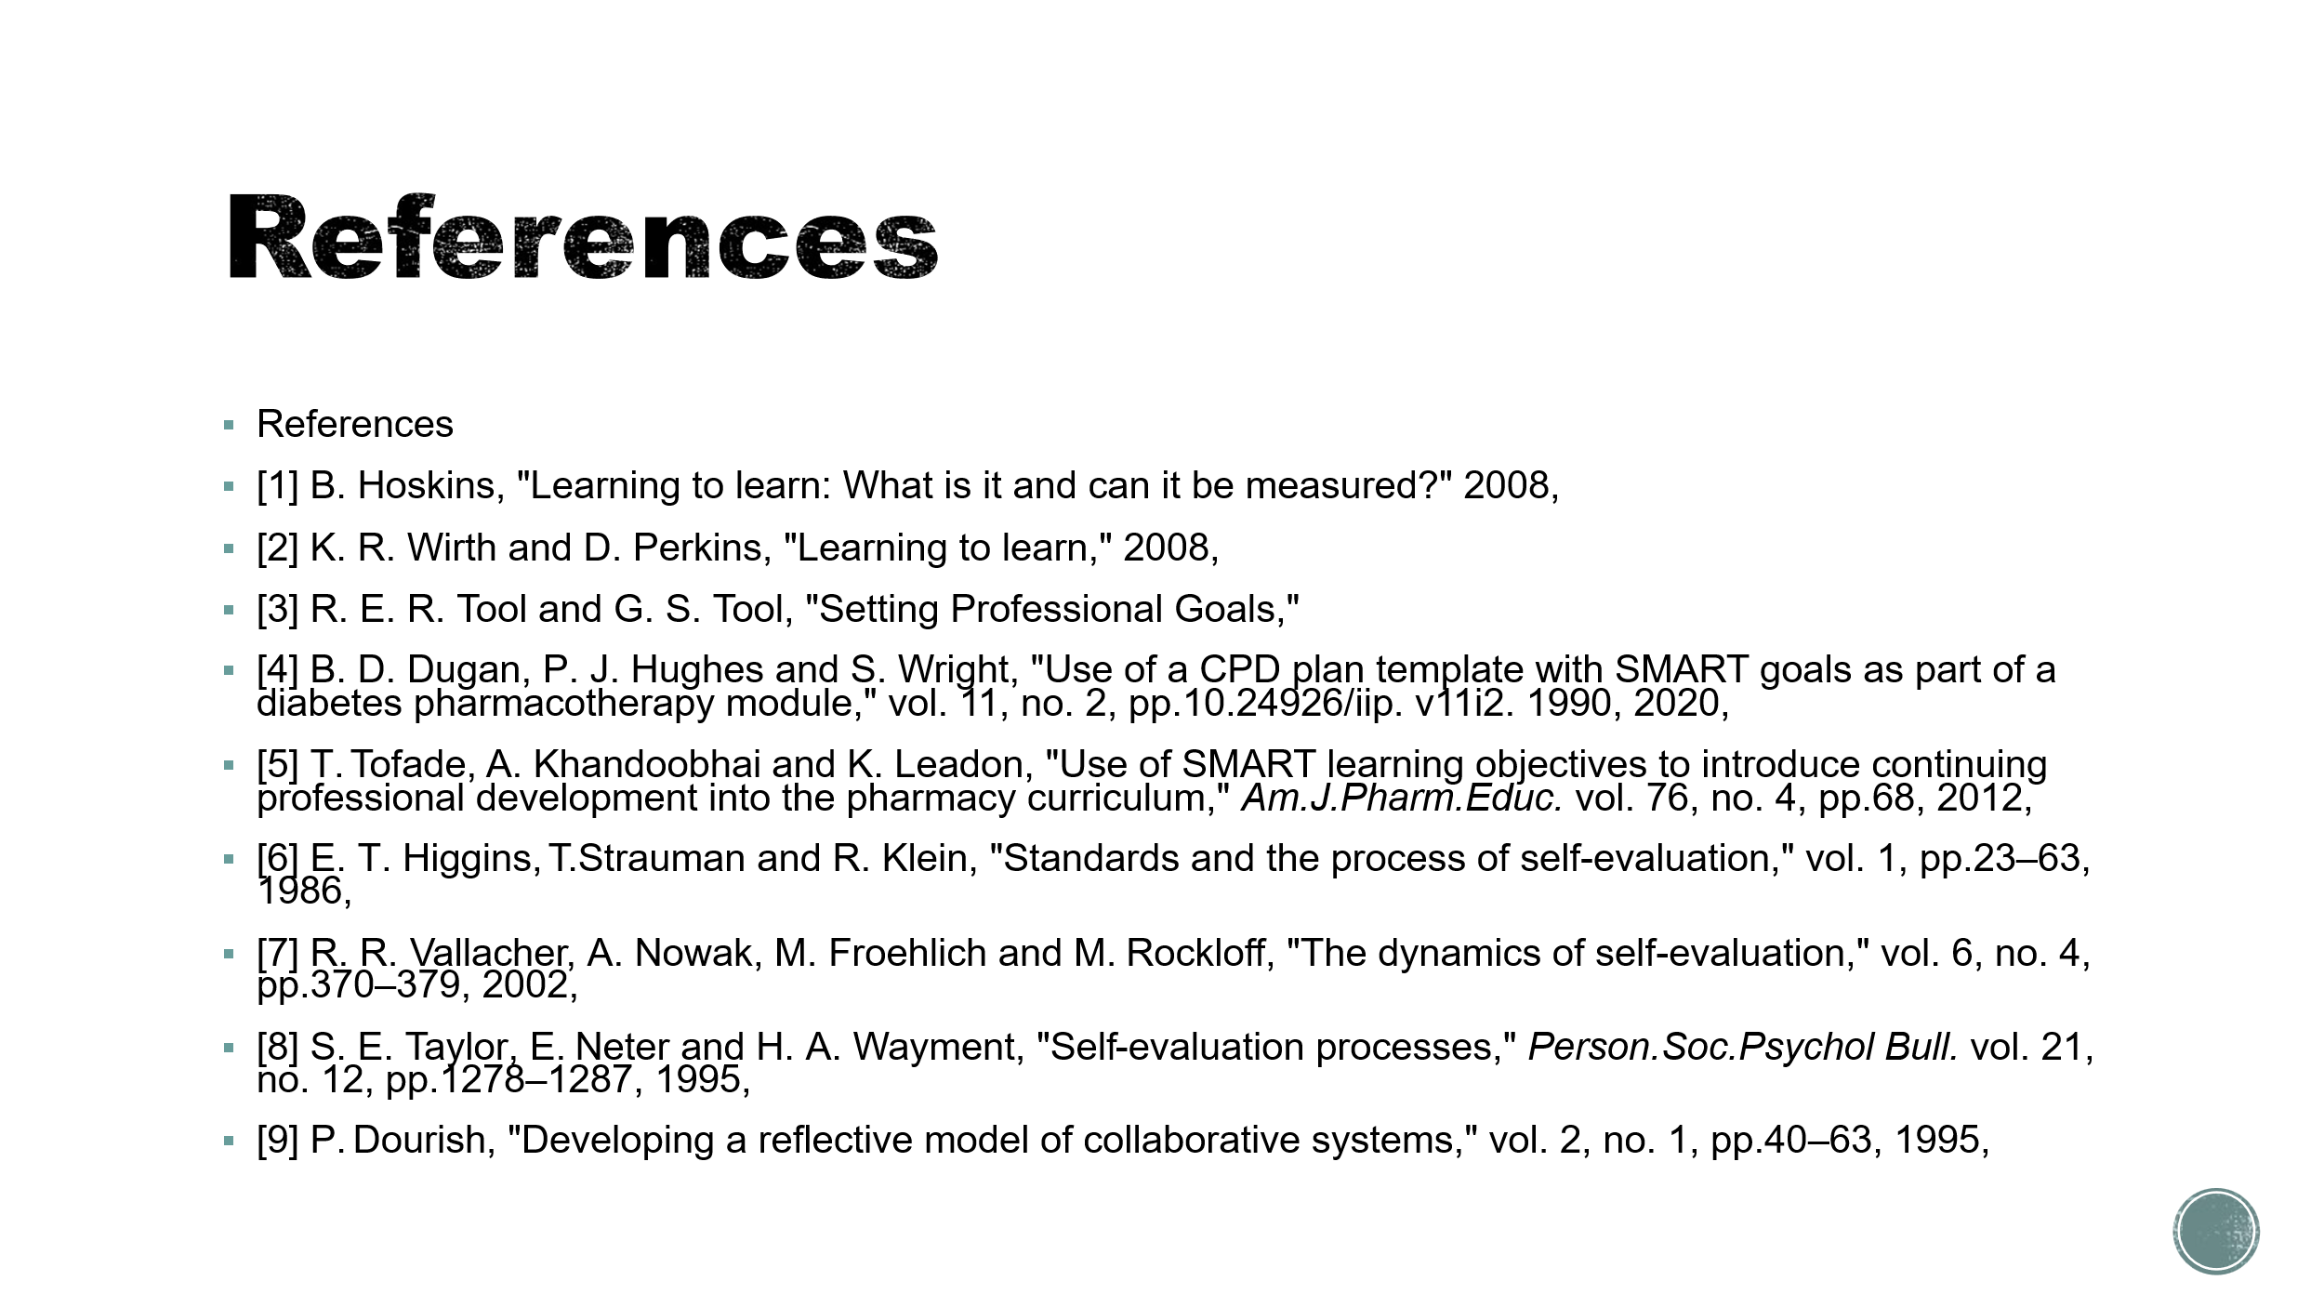

References
References
[1] B. Hoskins, "Learning to learn: What is it and can it be measured?" 2008,
[2] K. R. Wirth and D. Perkins, "Learning to learn," 2008,
[3] R. E. R. Tool and G. S. Tool, "Setting Professional Goals,"
[4] B. D. Dugan, P. J. Hughes and S. Wright, "Use of a CPD plan template with SMART goals as part of a diabetes pharmacotherapy module," vol. 11, no. 2, pp.10.24926/iip. v11i2. 1990, 2020,
[5] T. Tofade, A. Khandoobhai and K. Leadon, "Use of SMART learning objectives to introduce continuing professional development into the pharmacy curriculum," Am.J.Pharm.Educ. vol. 76, no. 4, pp.68, 2012,
[6] E. T. Higgins, T. Strauman and R. Klein, "Standards and the process of self-evaluation," vol. 1, pp.23–63, 1986,
[7] R. R. Vallacher, A. Nowak, M. Froehlich and M. Rockloff, "The dynamics of self-evaluation," vol. 6, no. 4, pp.370–379, 2002,
[8] S. E. Taylor, E. Neter and H. A. Wayment, "Self-evaluation processes," Person.Soc.Psychol Bull. vol. 21, no. 12, pp.1278–1287, 1995,
[9] P. Dourish, "Developing a reflective model of collaborative systems," vol. 2, no. 1, pp.40–63, 1995,

