05/12/2025
Michael Kofi Awua Asiedu (2411698)
Lecturer name: Sadeque Imam Shaikh
BSc Applied Computing
Network Operating System and Services
Research, build, and deploy a Virtualised Enterprise network


Table of Contents
Contents
Table of Contents 1
Introduction 2
Task 1 2
Hypervisor Research 2
Research on IP Addressing 2
Understanding Internet Data Routing and IP Addressing 2
Research on Routing 3
Research on Network Services 4
Task 2 5
2.1 Choosing Hypervisor 5
Justification for Choosing Oracle VirtualBox 5
2.2 Download and Setup 7
2.2.1 7
2.2.2 9
Configuring IP Addressing 12
2.3.1 12
2.4 Testing and Troubleshooting 13
2.4.1 Performing Connectivity Tests 14
Task 3 15
3.1.1 15
3.1.2 16
Conclusion 16
Reference 16

Introduction

Task 1

Hypervisor Research
A hypervisor is a software layer that enables server virtualization. Type 1 (Bare-Metal) hypervisors, such as VMware ESXi and Microsoft Hyper-V, are installed directly on physical hardware, offering direct access to CPU, memory, and storage. While this architecture is often praised for enterprise workloads, it comes with complexity, licensing costs, and hardware dependencies that can limit flexibility[1].
In contrast, Type 2 (Hosted) hypervisors, like VirtualBox, run as applications on a host operating system. Although they introduce some performance overhead compared to bare-metal solutions, VirtualBox excels in accessibility, ease of use, and versatility. It is particularly well-suited for environments where testing, development, and cross-platform compatibility are priorities. Its open-source nature and broad support for Windows, Linux, and macOS make it an adaptable choice for both personal and professional use.
For a production topology hosting Windows Server 2022 and a Debian Server, VirtualBox offers a compelling solution. Its hosted architecture simplifies deployment, reduces administrative overhead, and provides a user-friendly interface for managing multiple VMs. VirtualBox’s snapshot and cloning features make it easy to experiment with configurations, roll back changes, and maintain resilience in dynamic environments like the SWANSEA.ACCA domain.
This preference is strongly justified for SWANSEA.ACCA. VirtualBox provides the flexibility to run mixed-OS environments seamlessly, supporting both Windows and Debian clients without vendor lock-in. Its advanced networking options allow modelling of complex topologies, while its resource management features ensure efficient use of available hardware. By prioritizing VirtualBox, the domain gains a secure, scalable, and cost-effective virtualization platform that balances performance with accessibility—ideal for organizations seeking agility without sacrificing capability

Research on IP Addressing

Understanding Internet Data Routing and IP Addressing
How Data Travels Across the Internet
Internet communication depends on the transfer of information in small units called packets. Each packet carries a source and destination IP address, acting as unique identifiers. These addresses allow routers to guide packets across interconnected networks toward their intended destination. Without IP addressing, reliable and accurate routing would not be possible[2].
Essential Network Devices and Their Roles
• Switches: Within a Local Area Network (LAN), switches use MAC addresses to forward data between devices on the same segment. This ensures rapid and efficient communication inside a confined network.
• Routers: Functioning as gateways between networks, routers rely on IP addresses to determine optimal paths for data transfer, enabling seamless global connectivity.
The Progression of IP Addressing
• IPv4: The most widely adopted addressing system, IPv4 uses a 32-bit format (e.g., 192.168.1.1). Because of its limited address space, subnetting (e.g., 192.168.1.0/24) was introduced to divide networks into smaller segments, improving traffic management, security, and address efficiency.
• IPv6: Designed to overcome IPv4’s limitations, IPv6 employs a 128-bit format (e.g., 2001:db8::1). It provides a vast pool of addresses, supports automatic configuration, and enables more structured and efficient routing.
IP addressing forms the backbone of internet communication. Switches manage local traffic, while routers connect networks worldwide. Although IPv4 remains dominant, the transition to IPv6 is vital for the internet’s continued expansion, offering greater scalability, enhanced security, and improved performance[3].

Research on Routing

Routing Protocols: Purpose and Operation
Routing protocols enable routers to discover and maintain network paths dynamically, ensuring efficient and reliable data delivery. Their primary function is to adapt to network changes by exchanging information about reachable networks and calculating optimal routes using metrics such as hop count, bandwidth, or delay.
Static routing requires administrators to manually configure fixed paths (e.g., ip route 10.0.0.0 255.255.255.0 192.168.1.1). It is straightforward, secure, and resource-efficient but lacks flexibility, making it best suited for small, stable environments.
Dynamic routing leverages protocols like OSPF or BGP to automate path discovery and updates. Routers share topology details, enabling scalability and automatic failover. However, this approach introduces additional complexity and administrative overhead[4].

Recommended Routing for the SWANSEA.ACCA Topology
In the SWANSEA.ACCA domain, which includes a Debian DHCP Relay and a Windows Server, static routing is the most appropriate solution.
The topology is centralized and predictable: client subnets forward DHCP requests through the Debian server to the Windows Server hosting core services such as Active Directory and DHCP. This traffic pattern is fixed, eliminating the need for dynamic adaptability.
Static routing delivers clear advantages in this setup:
- Security: Prevents risks associated with routing protocol attacks or unintended route propagation.
- Simplicity & Reliability: Ensures stable, predictable paths without the overhead of protocol convergence.
- Performance: Provides direct, low-latency routes for critical services like DHCP and domain authentication.
In this controlled environment, static routing offers the precision, security, and stability required, making it the optimal choice for the SWANSEA.ACCA topology.

Research on Network Services
Summary of Core Network Services
VPN (Virtual Private Network)
A VPN establishes a secure, encrypted tunnel across public networks, allowing remote extension of private networks.
- Key Features: Confidentiality through encryption (IPsec, SSL/TLS) and strong user authentication.
- Best Practice: Enforce multi-factor authentication (MFA) and adopt modern, robust protocols such as IKEv2/IPsec or WireGuard[5].
DHCP (Dynamic Host Configuration Protocol)
DHCP automates the allocation of IP addresses, subnet masks, gateways, and DNS servers to clients, eliminating manual configuration and reducing errors.
- Key Features: Simplifies network management and prevents IP conflicts.
- Best Practice: Configure DHCP reservations for critical servers and enable DHCP snooping on switches to block rogue DHCP servers[6].
Active Directory Domain Services (AD DS)
AD DS provides centralized management of users, devices, and resources within a Microsoft domain environment.
- Key Features: Centralized security enforcement, single sign-on (SSO), and hierarchical organization via Organizational Units (OUs).
- Best Practice: Apply the principle of least privilege, conduct regular audits to remove stale accounts, and deploy multiple Domain Controllers for redundancy and resilience[7].
Certificate Authority (CA)
A CA is a trusted entity that issues and manages digital certificates, ensuring secure identity verification and encrypted communication.
- Key Features: Validates identities of users, services, and websites, enabling secure transactions.
- Best Practice: Protect the root CA by keeping it offline, delegate issuance to subordinate CAs, and enforce strict certificate lifecycle management policies[8].

Task 2

2.1 Choosing Hypervisor

Justification for Choosing Oracle VirtualBox
Key Benefits of Using VirtualBox in Networking Coursework
- Advanced and Realistic Networking Functions
VirtualBox supports multiple networking modes (NAT, Bridged, Host-Only, Internal) that accurately replicate the behaviour of physical switches, routers, and isolated networks. This allows students to model complex packet flows, design multi-segment LANs, and recreate real-world topologies essential for modern networking studies.
- Scalability Without Licensing Costs
Unlike lightweight virtualization tools, VirtualBox can efficiently run numerous virtual machines with precise control over CPU, memory, and storage resources. This enables the deployment of full-scale environments-DNS, DHCP, web servers, firewalls, and routers-across multiple subnets, all without the financial overhead of VMware ESXi or Hyper-V.
- Comprehensive IPv4 and IPv6 Support
With native dual-stack networking, VirtualBox provides practical experience in both IPv4 and IPv6. Students can experiment with subnetting, SLAAC, DHCPv6, transition techniques, and inter-protocol routing, ensuring readiness for current and next generation addressing systems.
- Cross-Platform, Free, and Community-Supported
As an open-source solution available on Windows, Linux, and macOS, VirtualBox avoids vendor lock-in and platform restrictions. Its widespread adoption in education ensures abundant tutorials, lab manuals, and community forums, making troubleshooting and independent learning more accessible[9].
VirtualBox delivers enterprise-level networking capabilities, full IPv4/IPv6 support, and scalability-all at zero cost. Its accessibility and strong community backing make it the most practical and effective platform for hands-on networking coursework.

2.2 Download and Setup

2.2.1
Below show several screenshots of the creation of a virtual machine for Windows and Linux.
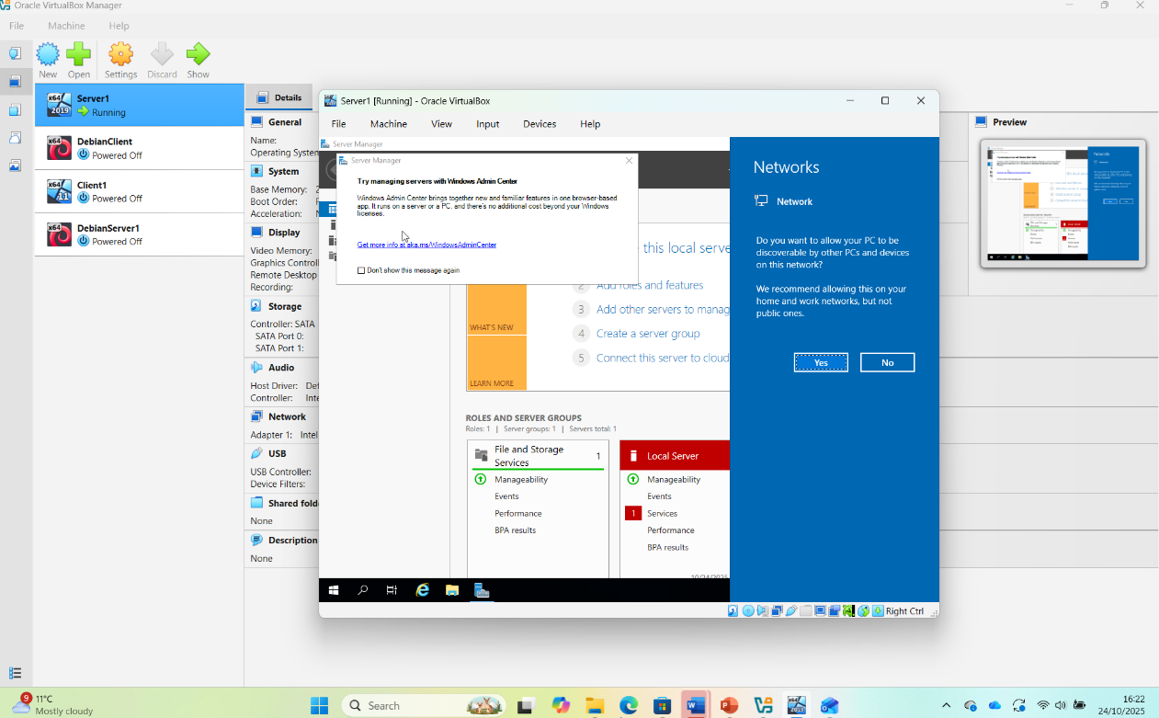

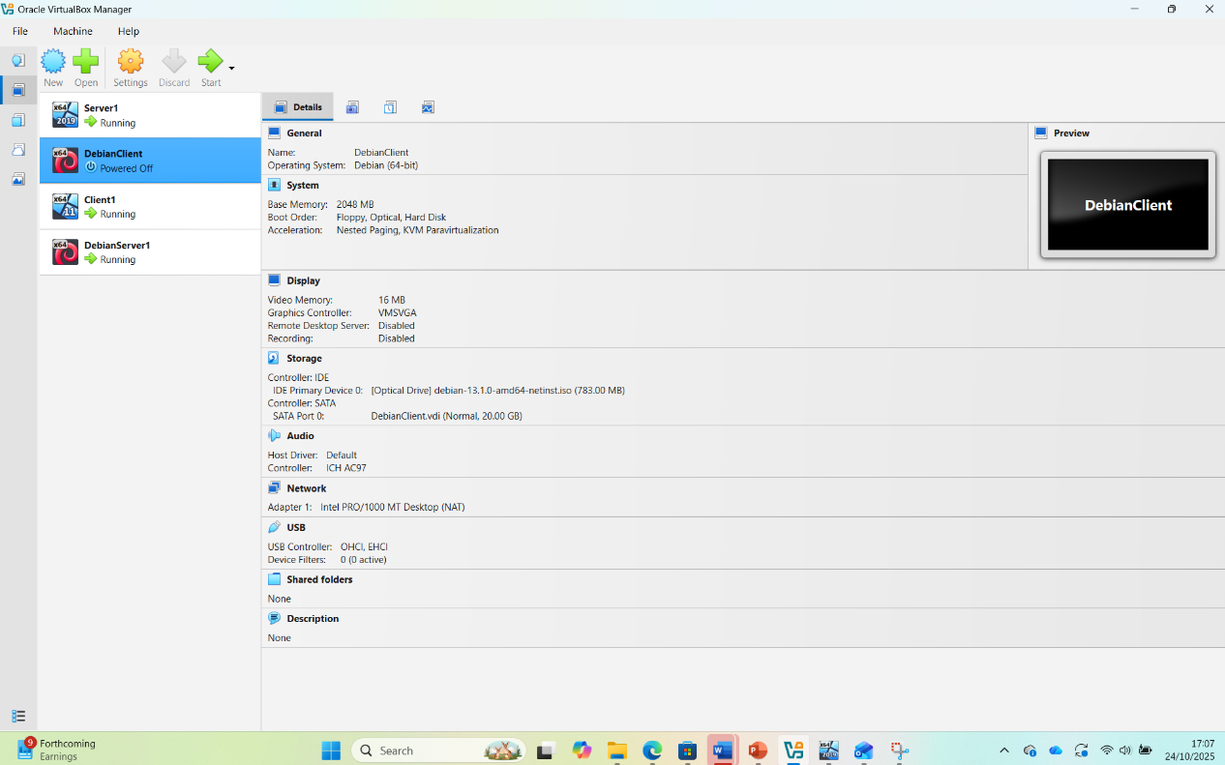
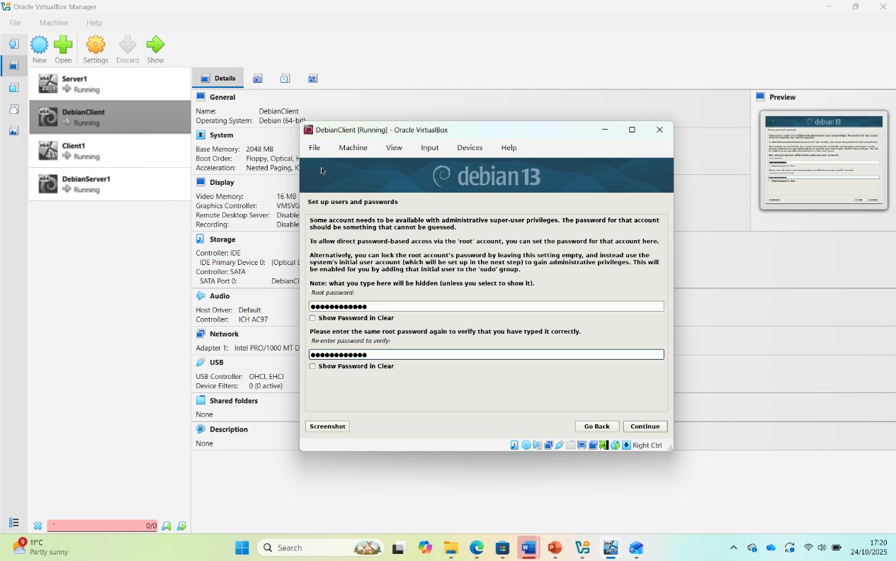
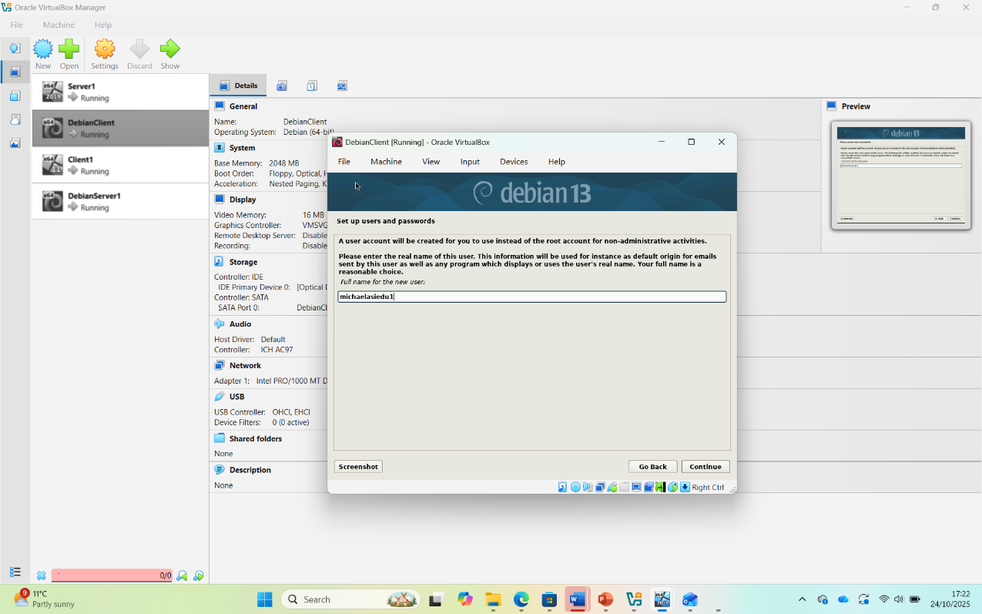

2.2.2
Creation of network with NAT for windows server and client server
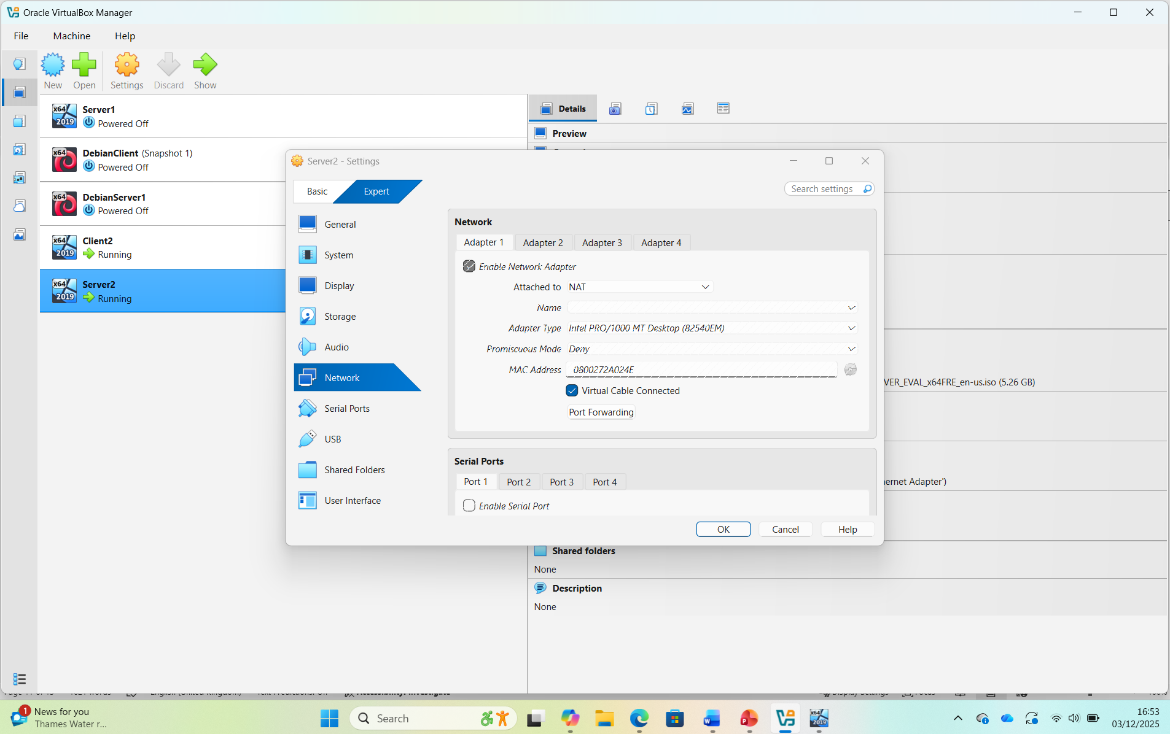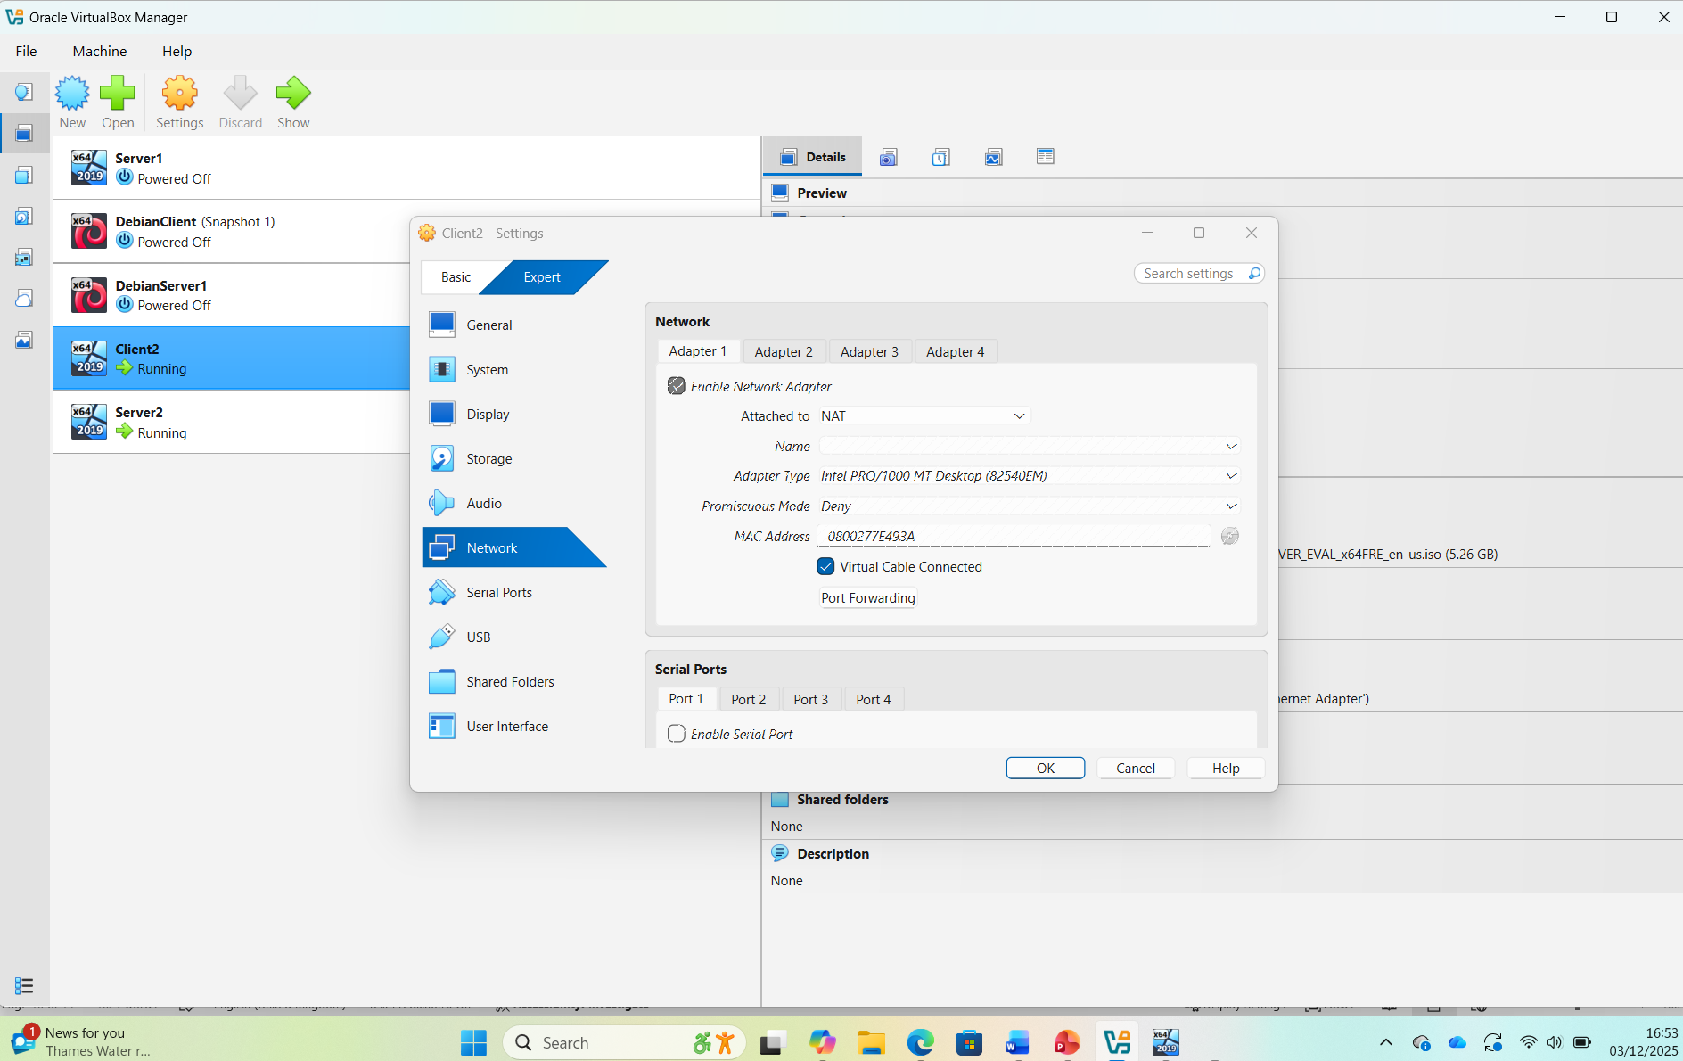
Creation of Network with NAT for Linux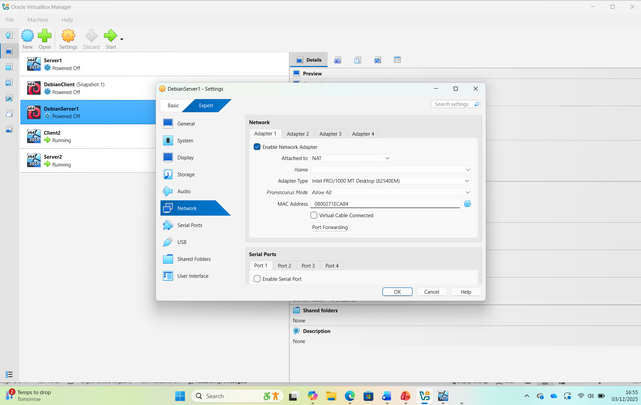 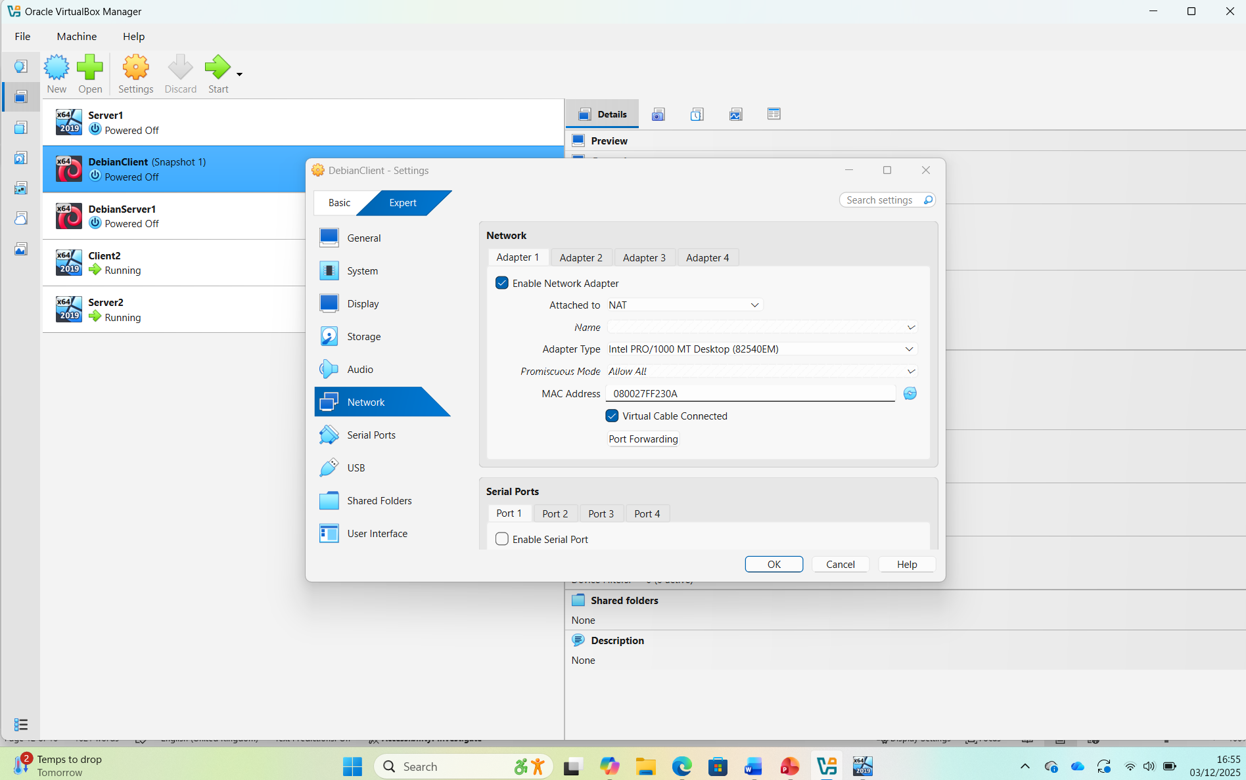

IP address setup for windows server and client server
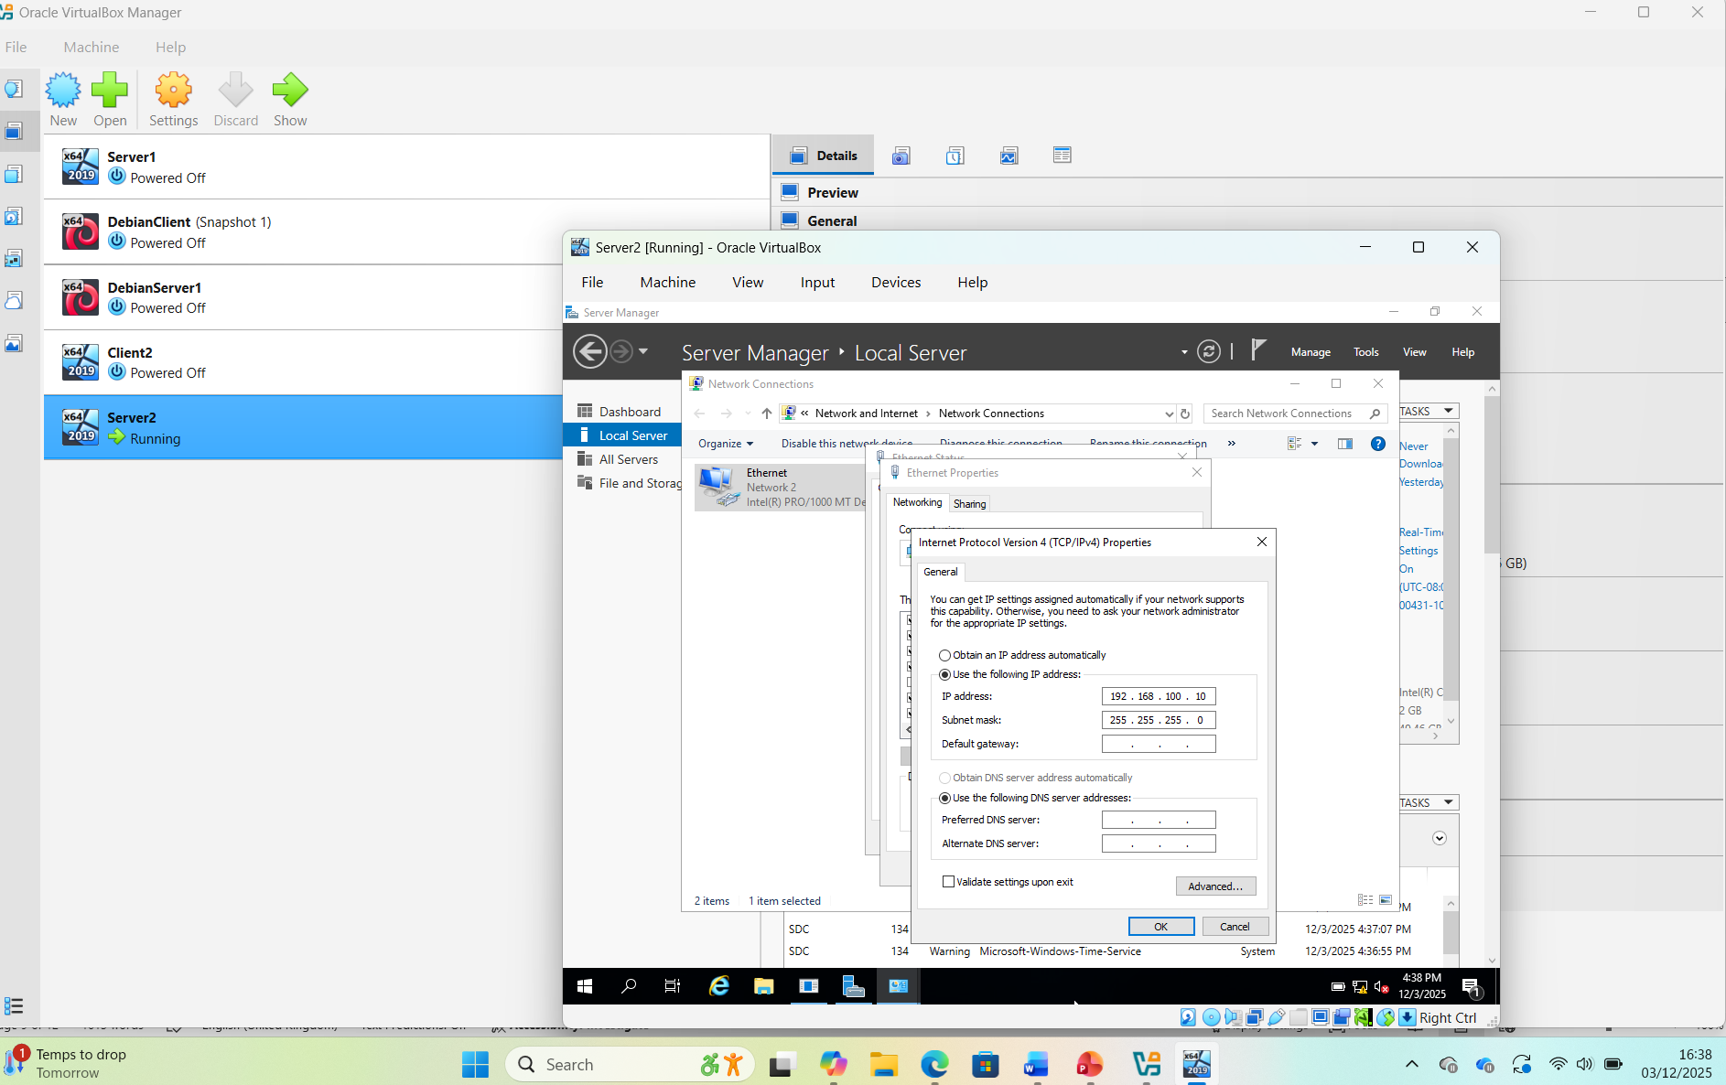 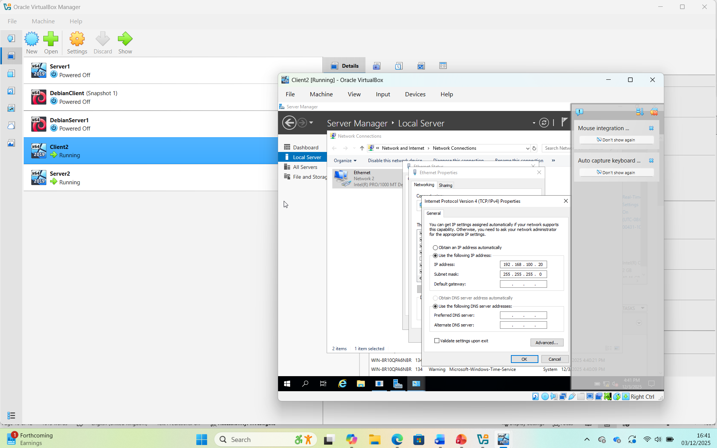#

Configuring IP Addressing

2.3.1
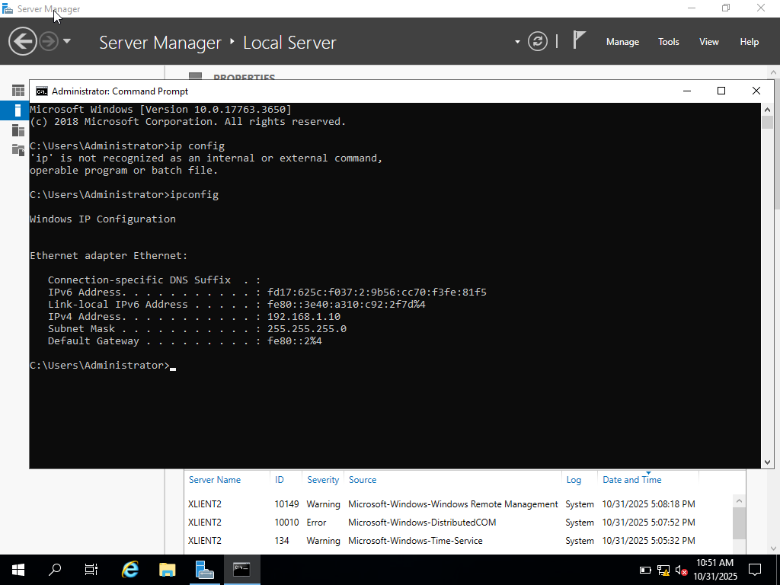
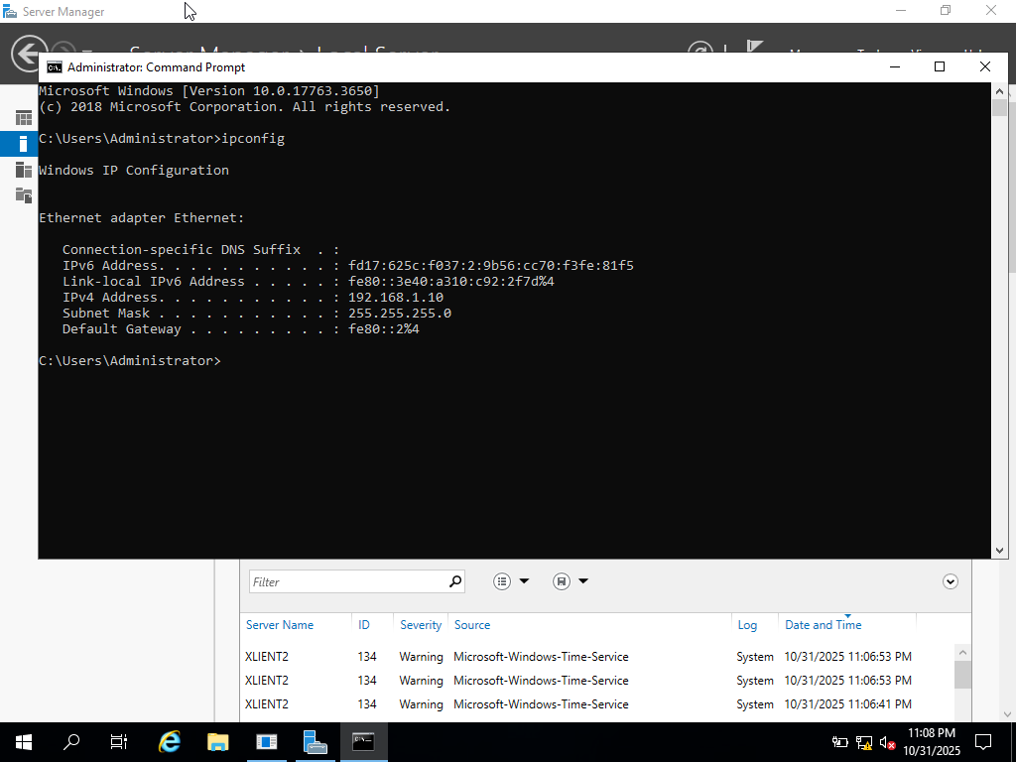

2.4 Testing and Troubleshooting
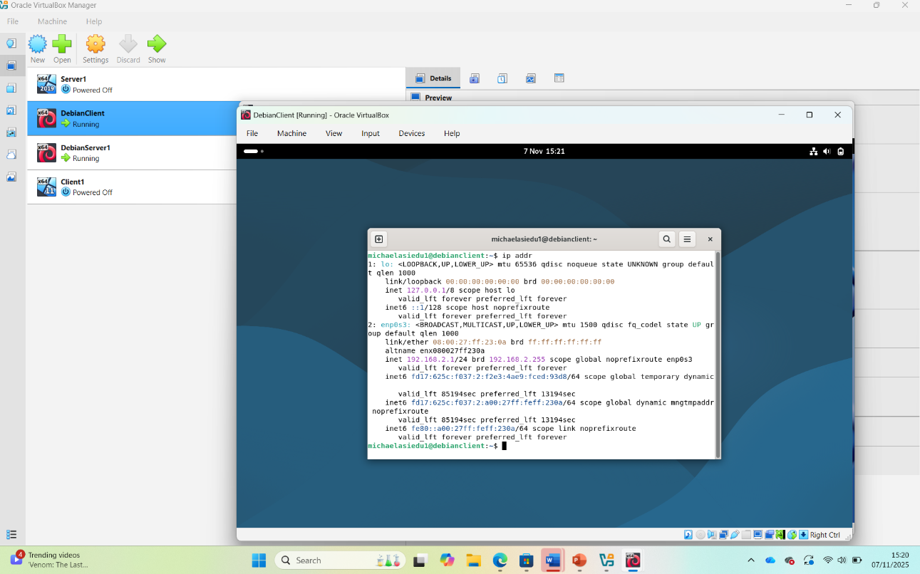
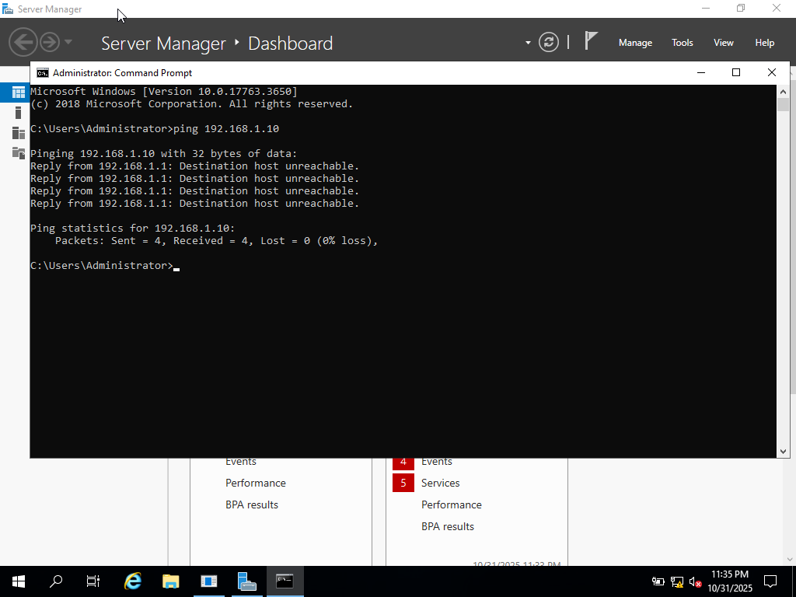

2.4.1 Performing Connectivity Tests
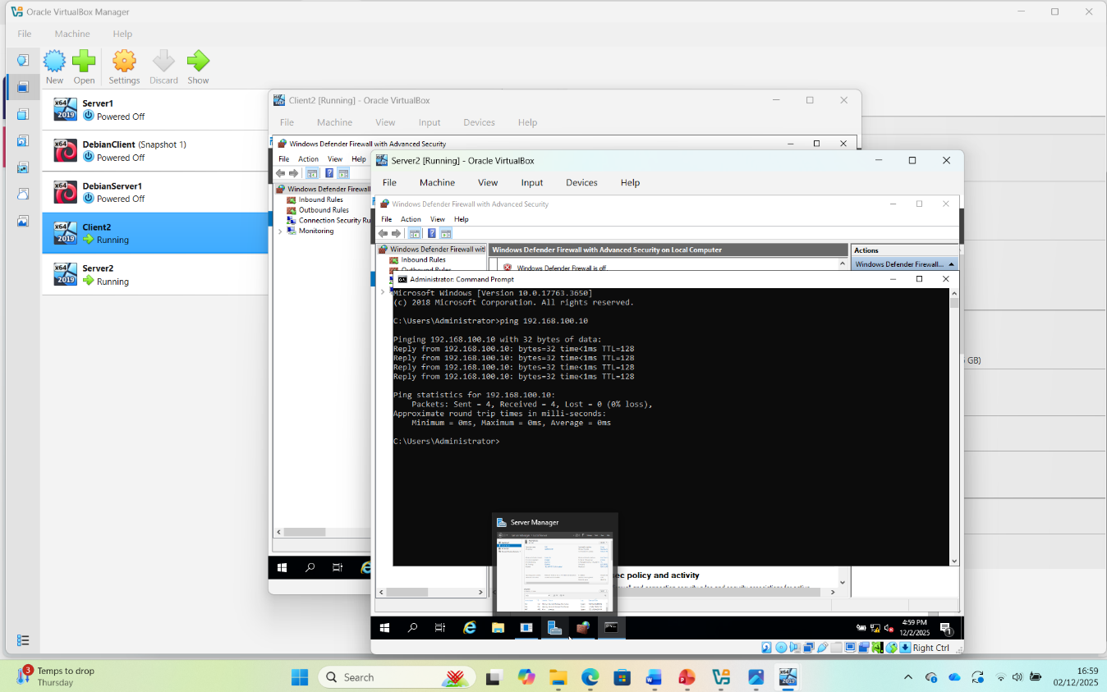
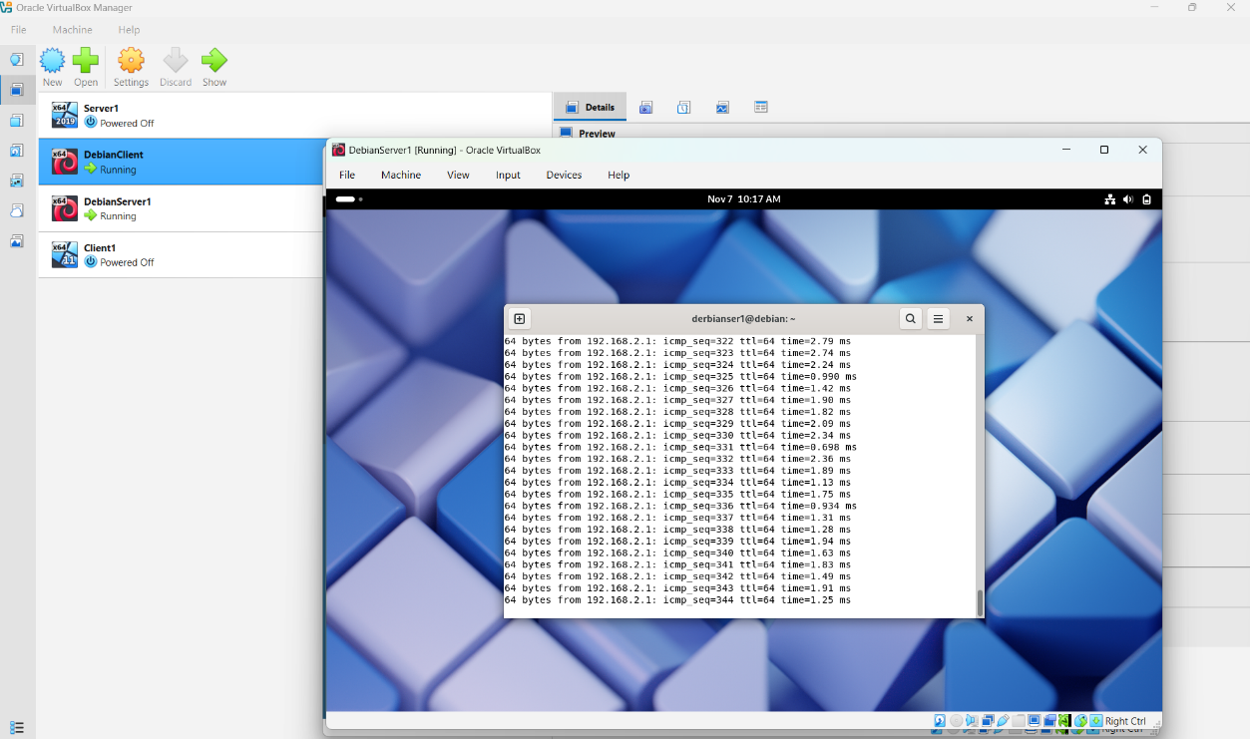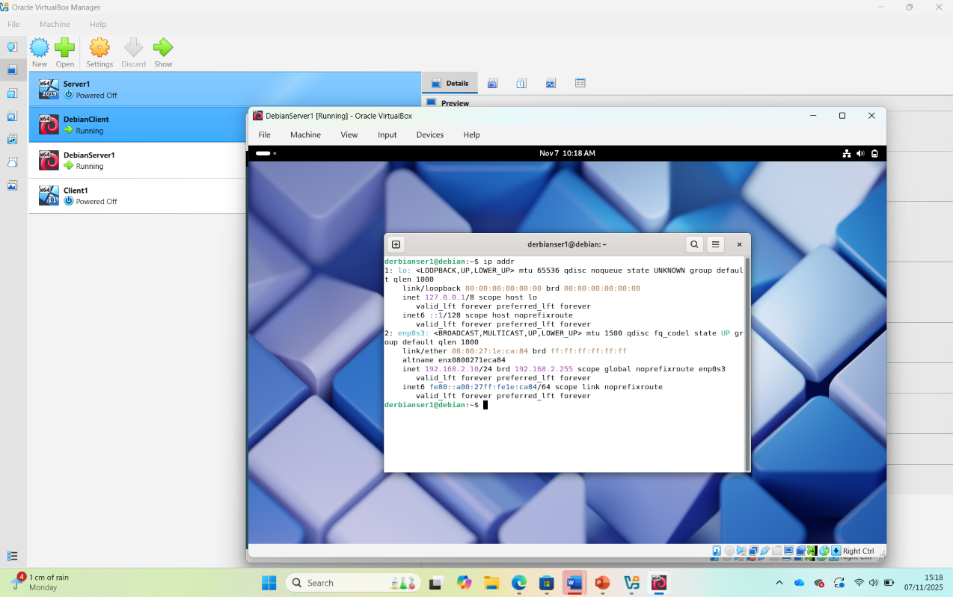

Task 3

3.1.1

In Task 2 of my networking coursework, I designed and implemented a segmented virtual network using Oracle VirtualBox to simulate a multi‑service enterprise environment. The topology consisted of four virtual machines: a Debian DNS/DHCP server, a Debian client, a Windows 11 server, and a Windows 11 client. Subnets were isolated through VirtualBox’s Internal Networking feature and connected to a NAT adapter for external access, which also supported initial testing.
Deployment presented challenges, including a misconfigured DHCP scope that caused IP conflicts between the DNS and web servers. This was diagnosed using the command -*and VirtualBox logs, then resolved by adjusting the DHCP range and renewing client leases. Additional issues arose with firewall and routing rules, where HTTP traffic was blocked due to an incorrect NAT configuration. Correcting port forwarding and enabling IPv6 forwarding restored connectivity.
Testing with ping confirmed inter‑subnet routing and service availability. The four‑hour process strengthened my skills in service configuration, troubleshooting, and hybrid routing, aligning with module outcomes on scalable, secure network design.

3.1.2

Conclusion
This task transformed theoretical networking knowledge into practical skill. Configuring a segmented LAN with DNS and DHCP demonstrated how concepts such as subnetting, routing, and protocol stacks function in real environments. VirtualBox provided a safe, cost‑effective platform for experimentation and rapid iteration. Challenges including IP conflicts and firewall misconfigurations demanded systematic diagnosis with logs and command‑line tools, sharpening troubleshooting skills and reinforcing the importance of thorough pre‑deployment checks. The exercise also emphasized network security, showing how misconfigured rules can disrupt traffic. Successfully deploying an IPv4 network was rewarding and underscored the growing importance of IPv6 proficiency

Reference

References
[1] A. Desai, R. Oza, P. Sharma and B. Patel, "Hypervisor: A survey on concepts and taxonomy," vol. 2, no. 3, pp.222–225, 2013,
[2] T. Dreibholz and S. Mazumdar,2022 18th International Conference on Network and Service Management (CNSM), pp. 359–363 doi:10.23919/CNSM55787.2022.9965091.
[3] M. E. Dooley and T. Rooney,IP address management, Hoboken, New Jersey: Wiley, 2021. doi: 10.1002/9781119692263
[4] T. M. Behera, U. C. Samal and S. K. Mohapatra, "Routing protocols," in Computational Intelligence in Sensor Networks, Springer, 2018, pp. 79–99.
[5] R. S. Ravindran, Changcheng Huang and K. Thulasiraman,IEEE International Conference on Communications, 2005. ICC 2005. 2005, pp. 105–109 Vol. 1 doi:10.1109/ICC.2005.1494329.
[6] A. K. Rajput, R. Tewani and A. Dubey,2016 3rd International Conference on Computing for Sustainable Global Development (INDIACom), pp. 634–637
[7] D. Francis, Mastering Active Directory: Design, Deploy, and Protect Active Directory Domain Services for Windows Server 2022, Packt Publishing Ltd, 2021.
[8] X. Liang, N. Guo and C. Hong,2022 International Conference on High Performance Big Data and Intelligent Systems (HDIS), pp. 90–94 doi:10.1109/HDIS56859.2022.9991690.
[9] P. Dash, Getting started with oracle vm virtualbox, Packt Publishing Birmingham, UK, 2013.

