Evaluate the reasons for and against the return of the death penalty.

Student ID: 1900576
Tasnim Kadir
University of Wales Trinity Saint David

Contents
Executive summary 3
Introduction 4
Main body 5
References 10

Executive summary

In this report, I chose to explore the question title ‘evaluate the reasons for and against the return of the death penalty’. I have looked at three areas, for and against of the death penalty, the government and what the situation is currently with this subject matter. I focused on these areas specifically as I wanted to have a wide range of opinions and information to look at when making my conclusion. For the first part of my project I aimed to explore the for and against for bringing back the death penalty. My second aim was to assess what actions the government have put in place and what’s their opinions are on this matter. For my final aim I investigated what the current situation is.

Introduction

For this assignment, I will be looking into the complicated discussion on whether the death penalty should be reinstated or not. As well as the pros and cons of the death sentence from the members of the British public. I will be looking and comparing the different views people have on if the death penalty needs to be brought back and if it shouldn’t then the reasons why it wouldn’t work today. In Great Britain, the death penalty was first used as early as the 17th century, until in 1965 when it was abolished. In Northern Ireland the act was abolished in 1973. The death penalty was brought in by the government as a corporal punishment where a person would be executed by the state for the crimes they have committed. The crimes that are punishable by death are such offences as murder, genocide and war crimes. These crimes are known as capital offences which are very serious offences.

Main body

The death penalty has been a subject matter of debate and discussion for a long time, there are many reasons for and against capital punishment. Capital punishments were common at one time or other in the evolving history of many countries and numerous of them have now abolished the capital punishment from their criminal justice systems. There are 7 forms of capital punishments that are widely known. These are: Death by Hanging, Execution by Firing Squad, Lethal Injection, Gas Chamber Executions, Death by Stoning, Death by Beheading and Electrocution. (Cornell Center on the death penalty worldwide, 2012). Arguments for the reinstation of the death penalty include; that if a person murders another person they have therefore given up their human rights (BBC , 2011) most people believe in this and believe in a life for a life, and that the suspect does not deserve to live after taking another life. “Money is not an inexhaustible commodity and the government should very well better spend the limited resources on the old, the young and the sick” (Capital punishment UK, n.d.) several people believe that the taxpayers money should go to pay for more important issues for example the NHS and not for the imprisonment of murderers, rapists, and paedophiles. Another main argument people have for bringing back the death penalty is by executing criminals, the death penalty eliminates the problem of housing them inside the prison system. Prisons are overcrowded and due to the seriousness of inmates’ sentence, the expenses are a lot to house, feed and isolate these prisoners. If these dangerous criminals were discharged on bail there is always a likelihood they could re-offend, this is abolished with the death penalty. From the graph below, you can see there has been a major increase of the number of prisoners since the millennium. 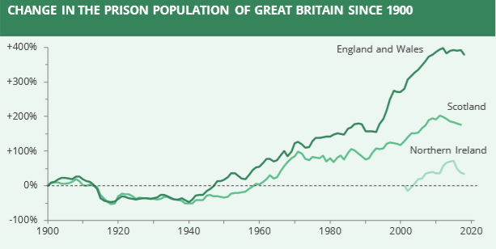
(UK Prison Population Statistics , 2019)
Arguments against the bringing back the capital punishment, include that the death penalty violates human rights, the right to live (BBC , 2011) this argument is supported by a number of people who believe that penalising a person to death and killing them contravenes that right. The most popular reason against the death penalty is that innocent citizens will get executed because of mistakes and errors, for example from the case of Donald Marshall Jr, he was falsely sentenced of murder and he was put in prison for more than a decade for a crime he didn’t do (Crime Museum, 2017). Occasionally people turn out to be not guilty, the death penalty is irreversible as a result re-establishing the death penalty it can cause uprisings if mistakes happen. Another reason is that is the deaths aren’t always quick and painless especially with the lethal injection and electrocution (BBC , 2011).

A member of the Conservative Party, John Hayes, has asked parliament to seriously consider bringing back the death penalty. He believes that there should be punishments given to those who have committed horrendous crimes. The justice minister Edward Argar “opposes the use of the death penalty in all circumstances and has no plans to reintroduce it”. (Tory MP asks government to consider bringing back death penalty, 2018) “The Minister of State for the Home Office, Lord Williams of Mostyn QC, said that ratification made it impossible for Parliament to reintroduce the death penalty” (David Hoffman, 2010) Certain members of the government think that the death penalty would go against all legal matters. Overall, the British government do not want to bring back the death penalty in any form but instead want to encourage other countries to abolish it as well. (Is the UK government's stance on the death penalty shifting?, 2018). As they advocate in human rights especially those in minority groups such as people of colour, religious people and LGBT people. (HRC40: UK Statement on the use of the Death Penalty, 2019). The current situation regarding the death penalty is that there is improvement on abolition over the past 2 decades and the international trend towards abolishing the act is increasing. (HMG Strategy for Abolition of the Death Penalty 2010-2015, 2011) The government’s main aim is for global abolition of the all forms of the death penalty.
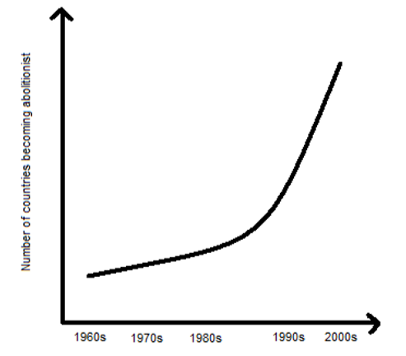
(HMG Strategy for Abolition of the Death Penalty 2010-2015, 2011)

Conclusions

To conclude there are many reasons for and against the death penalty. The main reasonings for the death penalty to be brought back are that people want justice and believe that a life should be exchanged for another. As well that the criminals gave up their human rights long ago. The arguments against the issue are the opposite as people believe it violates human rights and that wrongfully convicted people can end up on death’s row years before they are proven innocent which is a not justice at all.

References
(n.d.).
(2011, September 21). Retrieved from BBC : https://www.bbc.co.uk/newsround/15007511
Capital punishment UK. (n.d.). Retrieved from Capital punishment UK: http://www.capitalpunishmentuk.org/contents.html
Cornell Center on the death penalty worldwide. (2012, june 22). Retrieved from Death penalty worldwide : www.deathpenaltyworldwide.org/methods-of-execution.cfm
Crime Museum. (2017). Retrieved from Crime Museum: https://www.crimemuseum.org/crime-library/famous-prisons-incarceration/donald-marshall-jr/
David Hoffman, J. J. (2010). Human rights in the UK An introduction to the Human Rights Act 1998. In J. J. David Hoffman, Human rights in the UK An introduction to the Human Rights Act 1998 (p. 148). Essex: Pearsons Education limited .
HMG Strategy for Abolition of the Death Penalty 2010-2015. (2011, October). Retrieved from Gov uk: https://assets.publishing.service.gov.uk/government/uploads/system/uploads/attachment_data/file/35448/death-penalty-strategy-oct-11-15.pdf
HRC40: UK Statement on the use of the Death Penalty. (2019, February 26). Retrieved from GOV: https://www.gov.uk/government/news/hrc40-uk-statement-on-the-use-of-the-death-penalty
Is the UK government's stance on the death penalty shifting? (2018, July 23). Retrieved from The Guardian: https://www.theguardian.com/world/2018/jul/23/is-the-uk-governments-stance-on-the-death-penalty-shifting
Tory MP asks government to consider bringing back death penalty. (2018, November 3). Retrieved from The Independent : https://www.independent.co.uk/news/uk/politics/tory-mp-bring-back-death-penalty-john-hayes-lincolnshire-capital-punishment-a8615731.html
UK Prison Population Statistics . (2019, july 23). Retrieved from House of Commons Library : https://researchbriefings.files.parliament.uk/documents/SN04334/SN04334.pdf

