Jack Rout
1802047
Internet Technology and Security
(ACCA4018)
20/12/19

Table of contents
- Title page. Page1
- Introduction. Page 3
- Requirements. Page 3
- Implementation.
  - Screenshots of all pages. Pages 4 and 5
  - Validation of the completed website. Pages 6, 7 and 8
- Evaluation
  - Research. Pages 8, 9, 10 and 11
  - Evaluation of the completed website. Pages 11 and 12
- References. Page 13

Introduction:
The purpose of this report is to introduce the website that has been created, describe the purpose of the website and subject matter, the target audience and the website’s relevance to its audience. There will be screenshots of each page on the website, the website will also be tested both for the HTML file and CSS style sheet for errors and have brief descriptions on how the errors were fixed or if the errors were too difficult to fix. There will also be a section in the report that will have some research on website usability, accessibility and search engine optimisation and what role each of these terms take in web development, then after the research portion provide an evaluation of the completed website following the terms in the research portion.
Requirements:
The website to begin with was originally to be about some interests but then it became more in the aspect of gaining information even if it is irrelevant to the individual using the website, as mentioned the purpose was to be about interests and give information about bands that are opinion rated, show latest albums, merchandise and give tour dates for each of the bands on the website.
Originally the target audience was just for others who enjoy the rock, metal, heavy metal and metalcore genre of music but then the target audience was for everyone or for those who wanted to give the genre a try or find out more about each of the bands present on the website. To anyone who does not like the genre of music on the website most of its information is irrelevant to them but for those who do like the genre this website is more or less relevant to them as either of the bands information on the website could be interesting to them.

Implementation:
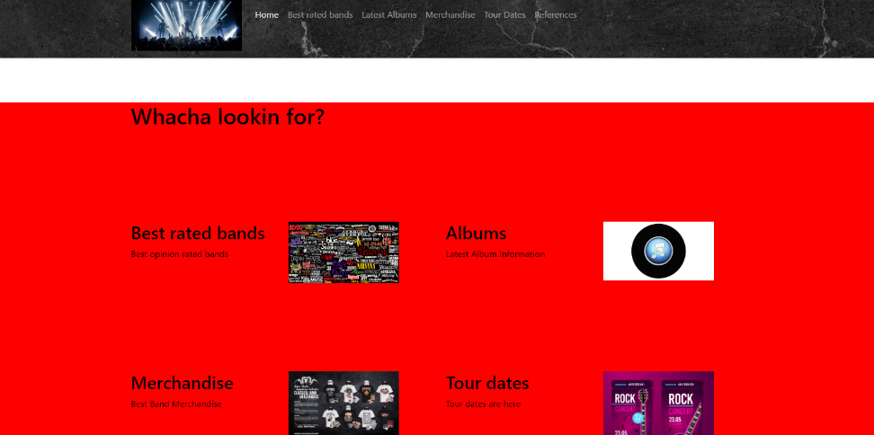
Below are screenshots of all 6 pages on the finished website:

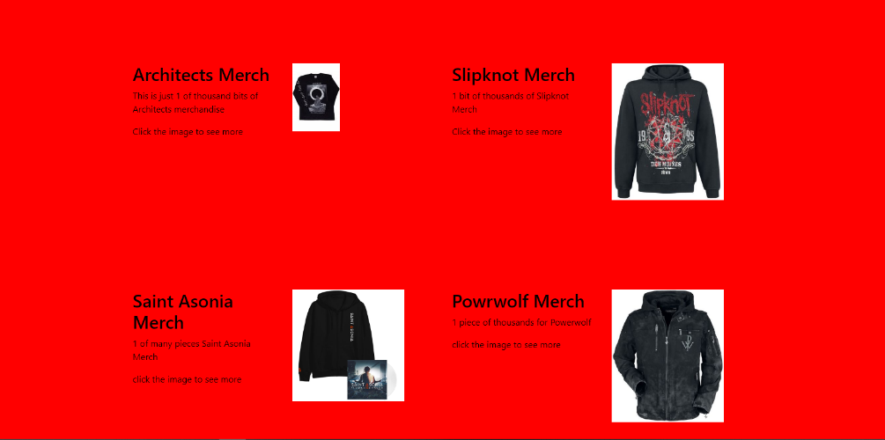
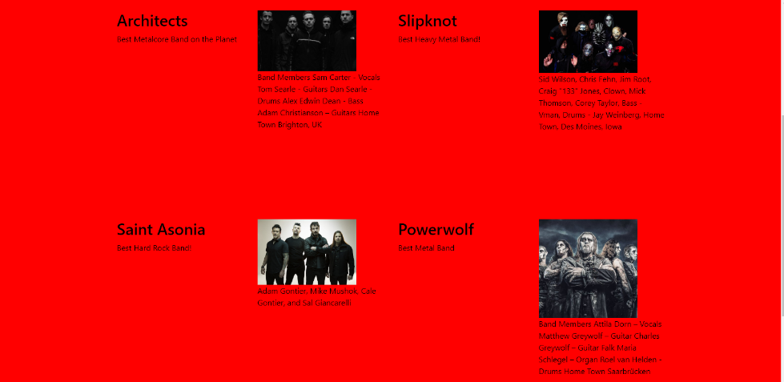

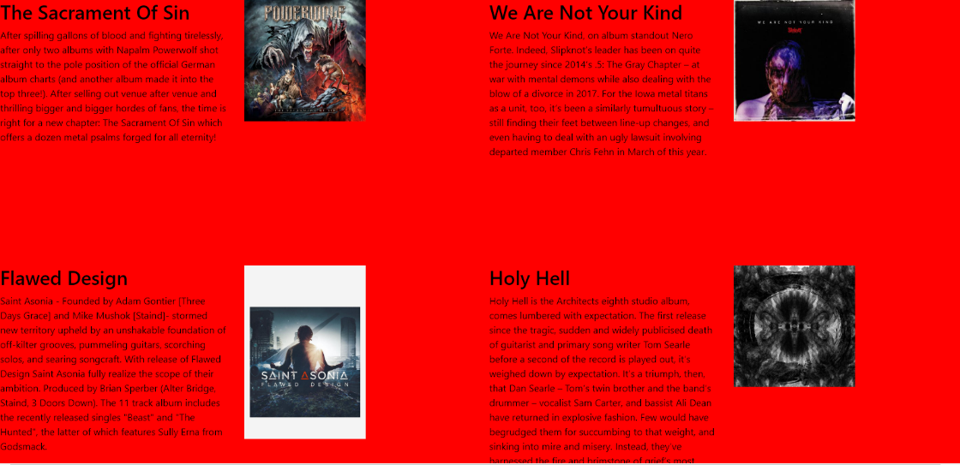

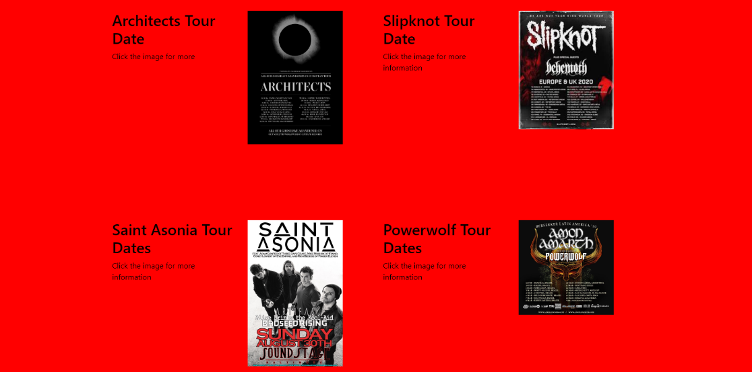
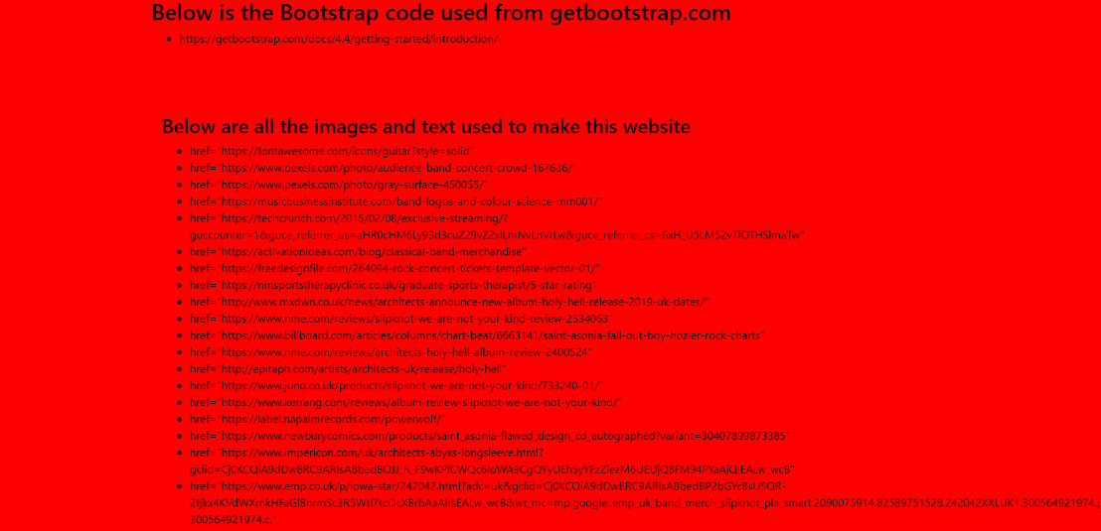

Validation of HTML and CSS files.
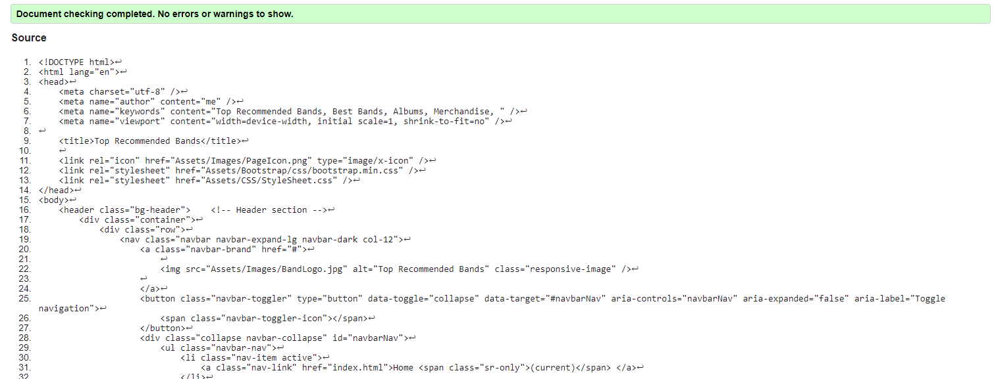
Below are screenshots of the validation of all 6 HTML files for each page of the website and the Stylesheet CSS file.
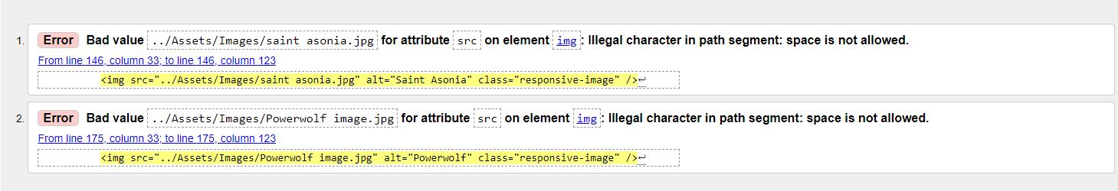

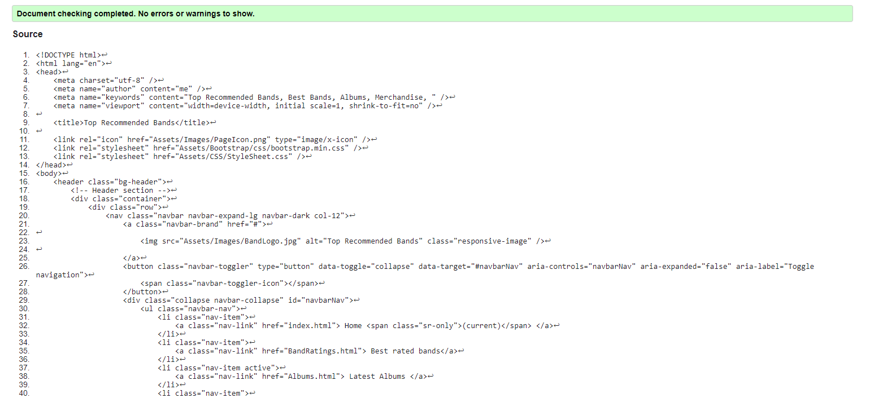

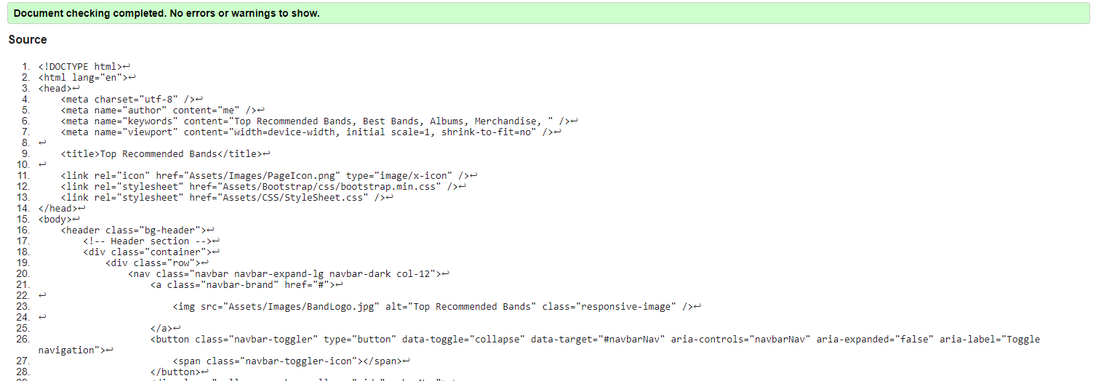

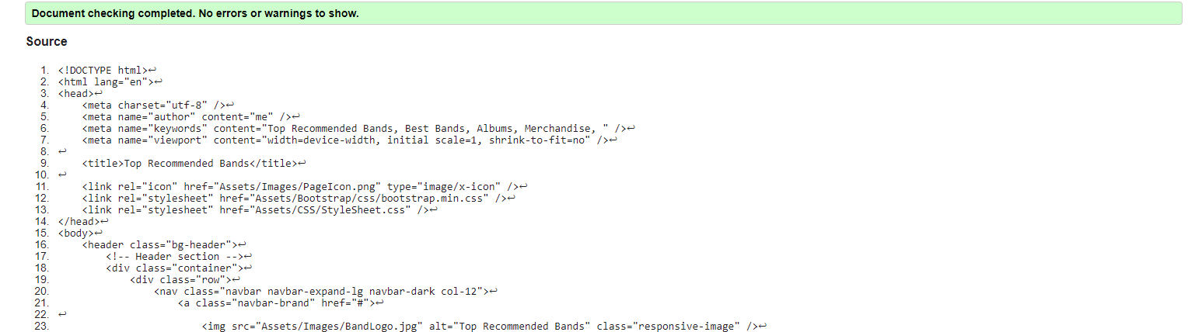
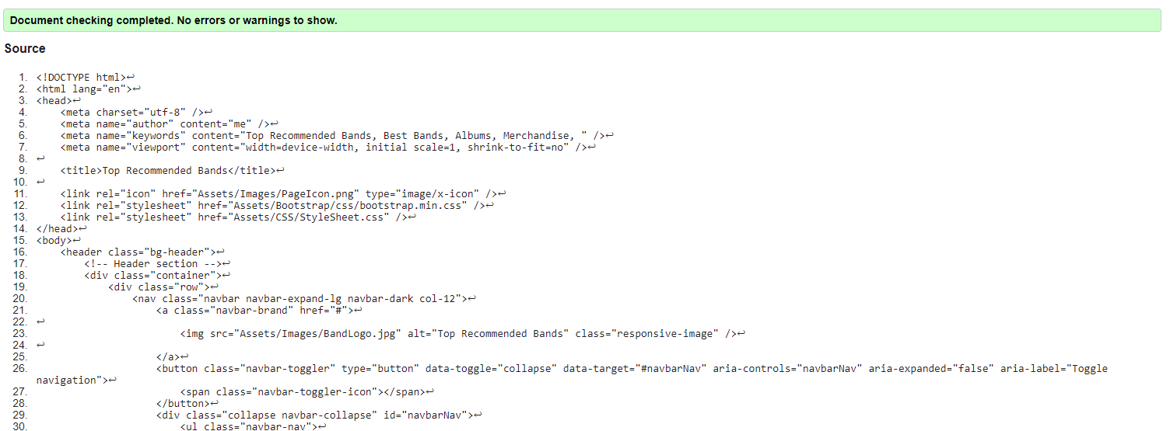

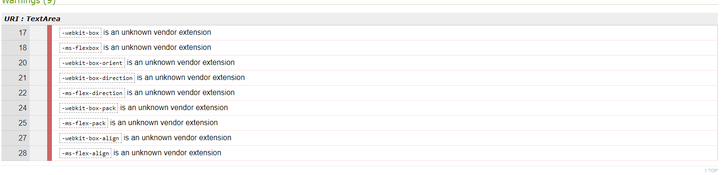

During the tests for Validating the HTML files there were only 2 errors that occurred and to fix the error it was quite simple, the file names for images on that page had spaces in it and the validator picked up on it and showed that it needed to be changed to a file without any spaces in it. After realising that this was done for every page with images the fix was simple and all what was needed to be done was to fix the names of the images to have no spaces in it.
As for the CSS file there were 7 errors that proved to be too difficult to fix, the way to fix it in theory would be to find the missing bits of code that allow it to run on another website but finding that code proved to be too difficult and time consuming.
Evaluations:
Website usability is measured by how well people visit a website, the usability part is important for advertising a website and providing services because “80% of users” are very likely to click off a website that does not have very good services or quality on the website before buying something on the website in question. [1]
Website usability is mostly centred around the user in mind as both design and development of a website will be created around the targeted audience or individual and for a website to be centred around these individuals you need to think about how available the website is to the target audience and how accessible it is to the audience.
For this to happen many things need to happen everything that is added to a website needs to work such as hyperlinks, images, buttons, navigation bar etc. if these don’t work this will more than likely put off the intended audience and push them away making the websites availability almost pointless. The next part accessibility will play to the user in question as not everyone accessing a website may be able to perceive and navigate a website as well as others which is where accessibility to people with disabilities may come in or people trying to access the website using other devices such as phones and laptops as a website will need to be able to be responsive in that regard. [2] [3]

A website needs to be clear to everyone that is using it also, by saying this a website needs to have simplicity on it so that way everyone using it can grasp its concept and not having it being overcomplicated and not so satisfying to use, you will also have to take into account similarities to other websites as there is nothing wrong with having a layout of a website that’s similar to another, the problem of that arises when it is an exact copy and paste of another website or when it has copy righted images.
It is also good to have some sort of help when it comes to navigating a website so having a form of helping hand for the users that are struggling is something to consider since not everything will be as simple or easy to find when accessing a new website. It is also good to have some kind of feedback as part of the website so that way there can be users giving constructive criticism about the website and what can be done to make the website better not just for their sake but for everyone if there are multiple individuals making the same comments.
Another and final thing that make a website clear to everyone is to have good structure that has everything that users are looking for on the website such as hyperlinks to different parts of the website that seem relevant to the user trying access bits of information.
As mentioned a website needs to have simplicity what ties in with the user in questions ability to learn how to use the site they are trying to access, so or a user to be able to learn how to use the site they will also need some help which is where its good to have a comments part of a website so that way the users that have experience using the site can help others navigate or find things faster and have some sort of system in place that warns users that there are going to be new changes so that way there will not be any dissatisfaction when it comes to being warned about changes.
Another feature than needs to happen is making sure that there are other sources to back up the information that you are trying to get across to other people since the internet is filled with lies and deceit so it is a good thing to make sure that you have verified sources to back up whenever information that you are trying to get across to the intended audience.

There is also the issue of websites information being relevant to its intended audience since information out there that may seem relevant and interesting to one person, it maybe be irrelevant and uninteresting to another, so when making or searching for websites make sure that the information being added or found is relevant to its intended audience. [2]
Website Accessibility
Website accessibility was briefly mentioned in a previous paragraphs but there are online guidelines such as WCAG which is a guideline that provides guidelines for websites made have to be made for everyone not just the intended audience and for those people that suffer with disabilities and accessible with all devices and not just for devices that the website was created on. There are 4 main principles that must be obeyed when creating a website and those 4 principles and the first principle is perceivable information, which means that all and any information found on a website must be able to be interpreted by anyone using the website in any form even if it is interpreted incorrectly. The next principle is that all interfaces on a website must be working and operational so that when a user tries to interface with the website it works in every aspect such as hyperlinks, searching for information etc. The next principle is having information on a website that is understandable and the interfaces/operations on the website must be understandable to anyone using the website. The last principle is that a created website must be robust to ever changing technology and must be able to run on every platform possible for now and the future. [4] [5] [6]
Search Engine Optimisation (SEO)
Search Engine Optimisation (SEO) is important for websites as there are businesses and companies that create their websites and then pay to have their websites advertised on the first page of search results of the related topic that a user searched for which will bring that website up as an advert on the first page to try and prompt the user to check the website out, whereas SEO is more for small websites that don’t have any payment schemes on them to be also on the first page instead of these larger companies just being able to pay their way to the front page, this is important because a lot of good information on the internet could be buried under pages and pages if companies got their way since not everyone who uses the internet is trying to buy something and just searching for general information. [7] [8]
SEO works in many ways and it works by examining the quality of websites and its does this by first checking websites for links to multiple other websites because most websites will not usually have a link to another website and SEO sees this as a bad quality website if there are not links to other websites, if there are links to other websites on a website then this is seen as good quality because google or any other type of search engine will see this is a “vote of quality”.
Then after SEO has examined websites for links it will then examine the content on website and then look for keywords that the user is trying to search for and choose websites that have the most relevant information through the keywords that the user has typed into the search browser.
As mentioned in the last paragraph SEO searches websites by keywords for relevant information, well SEO also searches the HTML code that makes up a website for keywords also to make searching for relevant that much more consistent for the user trying to search for the keywords entered into the search engine that they are using. [7]
When looking at the finished website it is relatively simple in design which is good for users who want to have an easy experience when using the website and it has multiple hyperlinks to different websites that can be easily accessed by clicking images and has text next to it that tells the user to click the image for more information. The website’s links in the header are fully functioning and users can simple click them to get around the website easily, the over all look of the website being basic and all it could have been better but there was not much thought or effort put into making it, the overall content is fairly informative but there could have been more information in some pages but there are good images on each page and the overall layout is pretty much the same on each page. If there was anything to be done differently and improve the website it would have been to spend more time building the website and do research on how to make things better for the font and the overall background of the text.

As for Search Engine Optimisation the only 2 things that can be listed for techniques used in the websites development and that is the links that are linked to other web pages for information and for references. The other is that there is a fair amount of information in some of the pages that SEO can detect if it were ever to find the finished website.
After using a contrast checker to check the images for accessibility every image was passed for their sizes, colours and contrast of each image. Then moved on to checking the font colour and background colour to check if they were incompatible with each other and both the black text on a red background passed with the juicy studio checker.
Then moved onto using chrome extensions aXe pointed out issues with the contrast that violates the perceiving principle of WCAG 2.1 as some of the text can barely be seen. When using the Tota11y extension in chrome it found errors in the code that showed that a “parent node” was undefined in the code and was pretty much doing nothing. When using the WAVE chrome extension there was no errors in the code or on the website but there were a few contrast errors on each page making it difficult to find some of the text on the website.

References

[1] | C. Doyle, "A Dictionary of Marketing," in A Dictionary of Marketing, 3rd ed., Oxford University Press, 2011, pp. 93-94.
[2] | "5 Key Principles Of Good Website Usability," 10 July 2019. [Online]. Available: https://www.crazyegg.com/blog/principles-website-usability/. [Accessed 16 December 2019].
[3] | B. Witten, "What Is Website Usability Why Is It Important," USF Health, 13 March 2018. [Online]. Available: https://health.usf.edu/is/blog/2018/03/13/what-is-website-usability--why-is-it-important. [Accessed 16 December 2019].
[4] | "Are you reaching as wide an audience as possible?," [Online]. Available: https://diginclusion.com/?imt=1&gclid=EAIaIQobChMI99rLovvz5gIVjbHtCh19kAnpEAAYASAAEgLA_vD_BwE&utm_campaign=Search&utm_source=Adrac&utm_medium=PPC&utm_content=&utm_term=%2Baccessibility+%2Bwebsite. [Accessed 17 December 2019].
[5] | [Online]. Available: https://go.monsido.com/accessibility-2020?utm_medium=ppc&utm_source=adwords&utm_campaign=UK-IR+Accessibility&utm_term=wcag%202.1&hsa_acc=5682086402&hsa_ver=3&hsa_mt=p&hsa_src=g&hsa_kw=wcag%202.1&hsa_net=adwords&hsa_ad=397866171970&hsa_cam=1683551189&hsa_t. [Accessed 17 December 2019].
[6] | A. G. W. Group, "Understanding WCAG 2.1".
[7] | "Search Engine Optimization," [Online]. Available: https://www.optimizely.com/uk/optimization-glossary/search-engine-optimization/. [Accessed 18 December 2019].
[8] | C. Doyle, "A Dictionary of Marketing," in A Dictionary of Marketing , 3rd ed., Oxford University Press, 2011, pp. 84-94.

marking criteria and Student FEEDBACK

This section details the extent to which the assessment criteria are demonstrated by you, which in turn determines your mark. The marks available for each category of skill are shown. Lecturers will use the space provided to comment on the achievement of the task(s), including those areas in which you have performed well and areas that would benefit from development/improvement.

Common Assessment Criteria Applied (Assignment 1) | Marks available | Marks  awarded
1. Engagement with Literature Skills

Provides a good discussion of the concepts but the supporting related research is missing. There is also room for improvement in making your discussion and explanations more coherent. (Grade mark: 56.00%) | 25 | 14
2. Knowledge and Understanding Skills

Demonstrates a good understanding of the standards used to design and implement a website. As mentioned below, I would have liked to see some more variation of the class tutorial exercise and use of more concepts to further demonstrate your understanding and skills. A good evaluation of the website based on the specified criteria has been provided. (Grade mark: 62.50%) | 20 | 12.5
3. Cognitive and Intellectual Skills

4. Practical Application Skills

A satisfactory attempt featuring a simple website with some well-thought-out content. Pay attention to your colour combinations. Ensure that there is enough contrast between text and background colours and some colour combinations do not work well together. The contrast of the main navigation and footer content is too low and one can barely see the menu links against the background, and yes, I know you have used the Bootstrap template, but you can use CSS to override the styles. Using a red background for a large area, the entire page in your website, is something that should be avoided. If you want to use red for the entire background, then use a different shade of red and not bright red. The combination of red and black is also a colour combination that should be avoided as these are two overpowering colours and generally cause eye strain for users. See more: https://bit.ly/304yHcA. Some other things to note: some of your image links were broken, consider opening links to external websites in a new tab, and make the logo a link to the home page as users expect this behaviour. Also, note the difference between margin and padding. Margin does not take on the background colour of the element, while padding does. The white space before the header and footer section was due to using margin instead of padding. Generally, I would have liked to see some more variation of the content and concepts used. (Grade mark: 48.00%) | 50 | 24
5. Transferable Skills for Life and Professional Practice

The report is of a good standard. Generally, aim to improve your writing style. See your report for suggested improvements. (Grade mark: 50.00%) | 5 | 2.5

Assignment Mark (Assessment marks are subject to ratification at the Exam Board. These comments and marks are to give feedback on module work and are for guidance only until they are confirmed. ) | Late Submission Penalties (tick if appropriate) |  | 53%
 | Up to 1 week late (40% Max) |  | 53%
 | Over 1 week late (0%) |  | 53%

