Flow Chart In-Class Exercises
The following empty flowchart gives the steps to be followed while seeking admission to a university. The phrases to be filled in the boxes are also given. Complete the flowchart by filling in the number of the corresponding phrase, inside each box. For example: the number corresponding to the first box in the flowchart is 7.

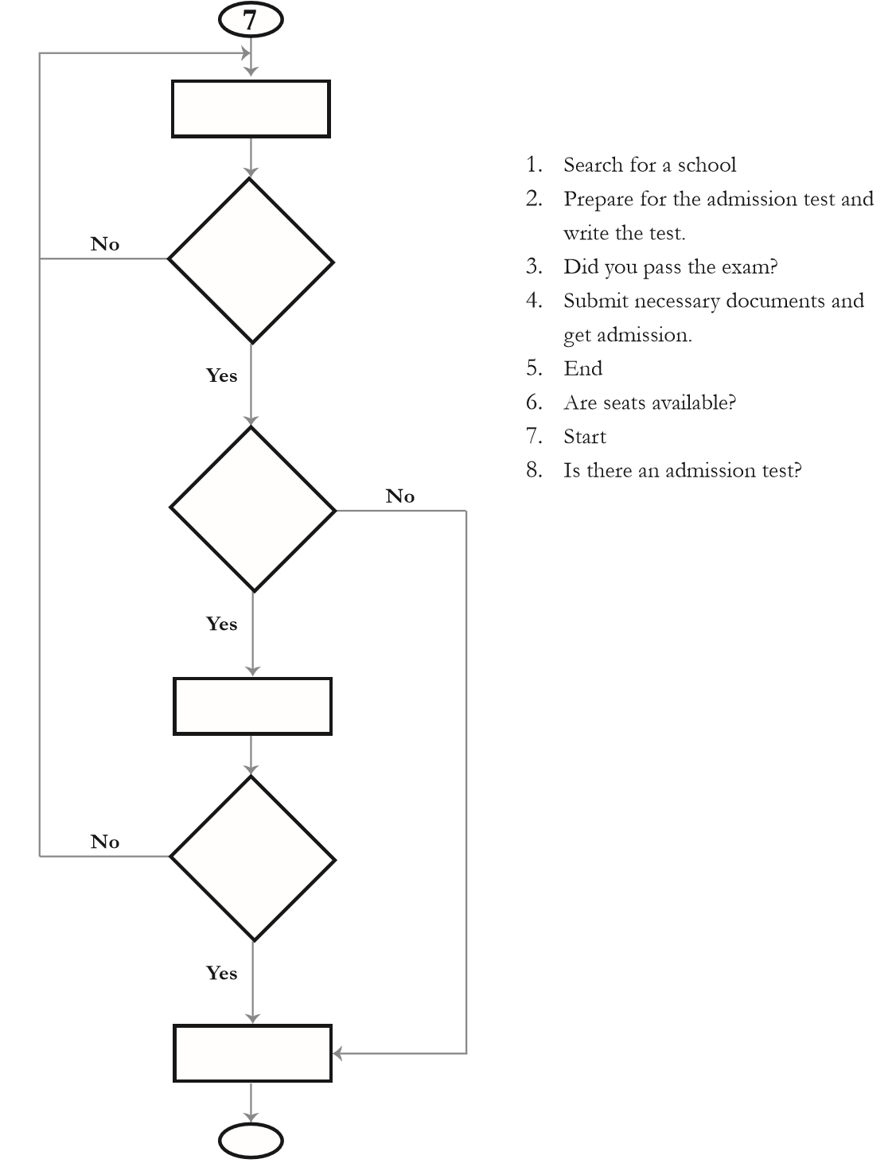

Snakes & Ladders Board Game
Develop a flow chart for the activity flow in snakes and ladders.

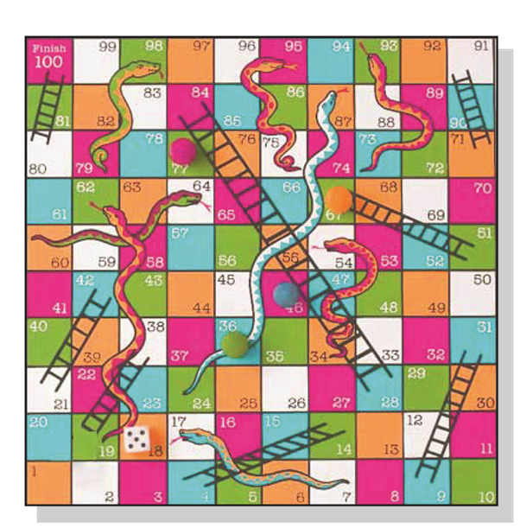
End
Start

