

Student Name: Hetvi Rajendrasinh Sangdot
Student ID Number: 2526007
Programme: Msc Public Health And Social Care In Practice
Module: Pulation Health And Digital Health Promotion
Module Code: LCHS7009

Table of Contents

Blog 1: Breaking the Cycle of Period Pain: How Mobile Health Apps Are Transforming Dysmenorrhoea Management Among Young Women in the Uk 2
1.1. The Public Health Problem 3
1.2. The Digital Technology: Clue App 4
1.3. Advantages of Clue for Dysmenorrhoea Management 5
1.4. Disadvantages and Shortfalls of Clue 5
1.5. Addressing the Shortfalls 6
Blog 2: CycleWell : A Designed Digital Technology for Dysmenorrhoea Self-Management 7
2.1. The Public Health Proble 7
2.2. The Designed Technology: CycleWell 8
2.3. Use in Health Promotion 8
2.4. advantages and Shortfalls of CycleWell 8
2.5. Disadvantages and Shortfalls of CycleWell 9
2.6. Addressing the Shortfalls: 9
1.6. Reference bolg 1: 10
2.7. References — Blog 2 12

Blog 1: Breaking the Cycle of Period Pain: How Mobile Health Apps Are Transforming Dysmenorrhoea Management Among Young Women in the Uk

The Public Health Problem

Dysmenorrhoea painful menstruation is prevalent yet chronically under-managed in the UK (MacGregor et al., 2023). Prevalence ranges from 45% to 97% in community studies, peaking at 67-90% in women aged 17-24, yet fewer than 37% seek formal medical help due to normalisation of menstrual pain. (MacGregor et al., 2023). The burden extends beyond the individual: pain contributes to school absenteeism and an estimated 8.9 days of annual workplace productivity loss (Karout et al., 2021). Unmanaged adolescent dysmenorrhoea also predicts adult chronic pain, making early intervention a public health priority (The Lancet Child & Adolescent Health, 2025; Serya et al., 2025).
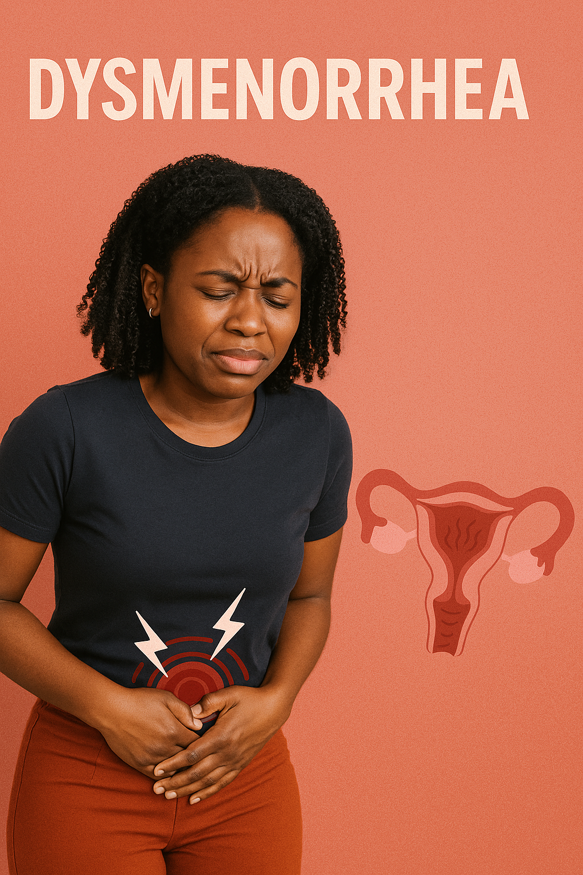
(Velvet Health, 2025)
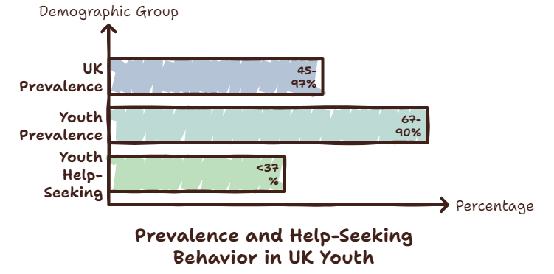

Graph: 1 prevalence of demographic group

The Digital Technology: Clue App

Clue is a free, science-based menstrual tracking app developed with academic researchers and clinicians. Users log pain, medication, mood, sleep, and activity, generating personalised insights. With over 11 million monthly users across 190 countries, it is among the most widely used menstrual health platforms globally (Clue, 2024). Its data informs academic partnerships, including with the University of Exeter, aimed at closing the research gap in female reproductive health (Frontiers in Computer Science, 2023). Clue helps users recognise abnormal pain patterns that may indicate endometriosis, supporting earlier help-seeking (Armour et al., 2024; University of Exeter, 2023).

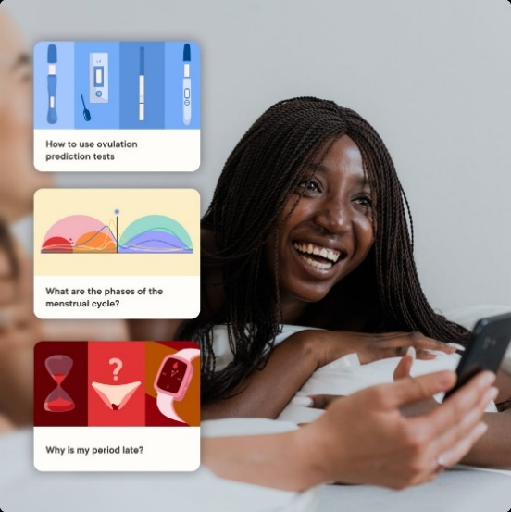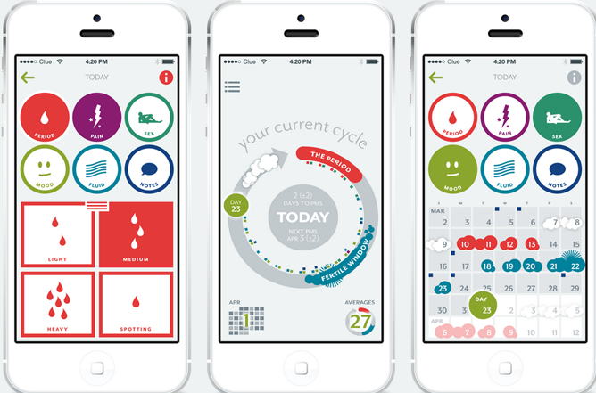(Clue;2026)

Advantages of Clue for Dysmenorrhoea Management

- Free and accessible without clinical appointments (BMC Women's Health, 2023)
- Evidence-based, scientifically reliable content (BMC Women's Health, 2023)
- Real-time tracking reduces recall bias (BMC Women's Health, 2023)
- Improves self-management of pain (Seo and Seo, 2025)
- Promotes menstrual health literacy (Seo and Seo, 2025)
- Encourages earlier healthcare-seeking (BMC Women's Health, 2023)

Disadvantages and Shortfalls of Clue

- Data privacy concerns over third-party sharing (Frontiers in Computer Science, 2023)
- Persistent user trust issues (Oxford Open Digital Health, 2025)
- Digital exclusion from limited literacy or access (MacGregor et al., 2023)
- Risk of widening health inequalities (MacGregor et al., 2023)
- Algorithm inaccuracies for irregular cycles (Seo and Seo, 2025)
- Limited long-term evidence (Seo and Seo, 2025)
- Cannot diagnose conditions such as endometriosis or PCOS (Seo and Seo, 2025)

Addressing the Shortfalls

Public health bodies have been urged to develop NHS-funded period-tracking apps under UK GDPR and NHS data governance frameworks, removing commercial data-sharing incentives (The Guardian, 2025). Digital exclusion could be mitigated by embedding app based tools within NHS school health and sexual health services alongside offline equivalents (Armour et al., 2024). Larger, longitudinal RCTs are needed to provide robust evidence of long-term clinical effectiveness (Seo and Seo, 2025).

Blog 2: CycleWell : A Designed Digital Technology for Dysmenorrhoea Self-Management

2.1. The Public Health Proble

Dysmenorrhoea affects 67-90% of UK women aged 17-24, yet fewer than 37% seek medical advice due to normalisation of pain and low health literacy (MacGregor et al., 2023; Matheson and Durand, 2024). Unmanaged adolescent dysmenorrhoea predicts adult chronic pain, and existing apps lack structured behaviour-change support and NHS data governance creating a clear gap for a purpose-built intervention (The Lancet, 2025; Seo and Seo, 2025).
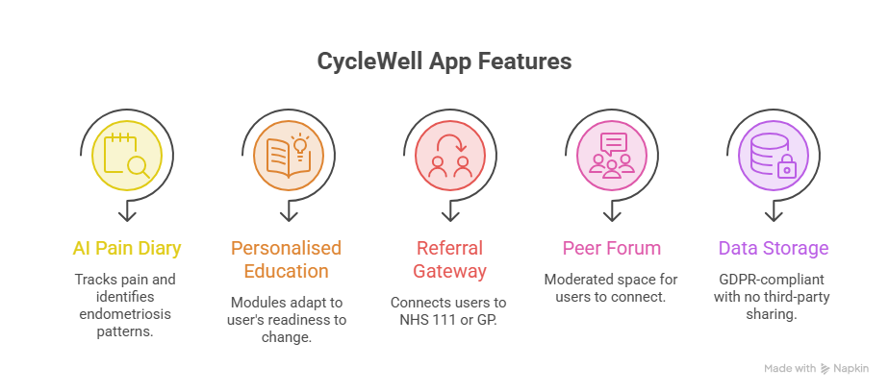
(Self-generate)

2.2. The Designed Technology: CycleWell

CycleWell is a proposed free NHS-endorsed app (iOS/Android) for women aged 16-30, designed to build users' knowledge, confidence, and motivation to manage menstrual pain effectively. Features include an AI pain diary flagging endometriosis-consistent patterns, personalised education modules matched to each user's readiness to change, an NHS 111/GP referral gateway, a moderated peer forum, and GDPR-compliant data storage with zero third-party sharing (Oxford Open Digital Health, 2025).

2.3. Use in Health Promotion

CycleWell builds users' knowledge and skills through pain-management education, creates opportunity to act via the NHS gateway and peer forum, and strengthens motivation through personalised dashboards and progress feedback. An onboarding questionnaire identifies each user's current attitude towards their pain from dismissing it as normal to actively managing it and delivers tailored content accordingly, an approach shown to outperform generic health information delivery (Nigg et al., 2024).

2.4. advantages and Shortfalls of CycleWell

- Combines personalised behaviour-change support with a direct NHS referral pathway, unlike existing commercial apps
- AI pain-pattern flagging could reduce the UK's 6-8year average endometriosis diagnostic delay (MacGregor et al., 2023)
- Tailored, stage-matched content improves user engagement compared to generic health information (Nigg et al., 2024)
- NHS-grade data governance removes commercial data-sharing risk (Oxford Open Digital Health, 2025)

2.5. Disadvantages and Shortfalls of CycleWell
- Substantial development and ongoing maintenance costs (Armour et al., 2024).
- Risk of digital exclusion for women without smartphones or reliable internet access.
- High attrition rates are a common limitation of mHealth tools over time (Seo and Seo, 2025).
- Limited long-term, large-scale evidence of real-world effectiveness.

2.6. Addressing the Shortfalls:
A printed NHS companion guide distributed via GP surgeries and schools would mitigate digital exclusion (Armour et al., 2024). Reward-based features could sustain engagement, funded through NHS England's Digital Health Strategy (Nigg et al., 2024; NHS England, 2023). Adequately powered RCTs across diverse populations are essential before national roll-out (Seo and Seo, 2025).

Reference bolg 1:
- Armour, M., Dahlen, H.G. and Smith, C.A. (2024) What is known about adolescent dysmenorrhoea in (and for) community health settings? Frontiers in Reproductive Health, 6, p.1394978. Available at: https://doi.org/10.3389/frph.2024.1394978
- BMC Women's Health (2023) More than blood: app-tracking reveals variability in heavy menstrual bleeding construct. BMC Women's Health, 23, p.170. Available at: https://doi.org/10.1186/s12905-023-02312-4
- Burnett, M. and Lemyre, M. (2017) No. 345 Primary Dysmenorrhea Consensus Guideline. Journal of Obstetrics and Gynaecology Canada, 39(7), pp.585–595. Available at: https://doi.org/10.1016/j.jogc.2016.12.023
- Clue (2024) How tracking your period advances women's health. Available at: https://helloclue.com/articles/about-clue/scientific-research-at-clue
- Frontiers in Computer Science (2023) Reimagining the cycle: interaction in self-tracking period apps and menstrual empowerment. Frontiers in Computer Science, 5, p.1166210. Available at: https://doi.org/10.3389/fcomp.2023.1166210
- Karout, S. et al. (2021) Prevalence, risk factors, and management practices of primary dysmenorrhea among young females. BMC Women's Health, 21(1), p.392. Available at: https://doi.org/10.1186/s12905-021-01532-w
- MacGregor, B., Allaire, C., Bedaiwy, M.A., Yong, P.J. and Bougie, O. (2023) Disease burden of dysmenorrhea: impact on life course potential. International Journal of Women's Health, 15, pp.499–509. Available at: https://doi.org/10.2147/IJWH.S380006
- Ofcom (2024) Online Nation Report 2024. London: Ofcom. Available at: https://www.ofcom.org.uk
- Oxford Open Digital Health (2025) Flowing data: women's views on privacy and data security when using menstrual cycle tracking apps. Oxford Open Digital Health. Available at: https://doi.org/10.1093/oodh/oqaf011
- Schoep, M.E., Adang, E.M.M., Maas, J.W.M., De Bie, B., Aarts, J.W.M. and Nieboer, T.E. (2019) Productivity loss due to menstruation-related symptoms: a nationwide cross-sectional survey among 32,748 women. BMJ Open, 9(6), e026186. Available at: https://doi.org/10.1136/bmjopen-2018-026186
- Seo, M.S. and Seo, B.N. (2025) Effectiveness of digital healthcare in managing menstrual symptoms: a systematic review. Women's Health Nursing, 31. Available at: https://doi.org/10.4069/whn.2025.05.22
- Serya, H. et al. (2025) Dysmenorrhea among working women and its effect on their work productivity and activity impairment. Journal of the Egyptian Public Health Association, 100(1). Available at: https://jepha.springeropen.com
- The Guardian (2025) Public health bodies urged to launch period tracking apps to protect data. The Guardian, 11 June. Available at: https://www.theguardian.com/society/2025/jun/11
- The Lancet Child & Adolescent Health (2025) Longitudinal association between dysmenorrhoea in adolescence and chronic pain in adulthood. The Lancet Child & Adolescent Health. Available at: https://doi.org/10.1016/S2352-4642(25)00213-5
- University of Exeter (2023) Global researchers team with menstrual health app Clue. Available at: https://news.exeter.ac.uk
- Women and Equalities Committee (2024) Menstrual Health: Government Response and Evidence Review. London: UK Parliament. Available at: https://committees.parliament.uk

2.7. References — Blog 2
- Deci, E.L. and Ryan, R.M. (2000) The "what" and "why" of goal pursuits: human needs and the self-determination of behaviour. Psychological Inquiry, 11(4), pp.227–268.
- Karout, S. et al. (2021) Prevalence, risk factors, and management practices of primary dysmenorrhea among young females. BMC Women's Health, 21(1), p.392. Available at: https://doi.org/10.1186/s12905-021-01532-w
- MacGregor, B., Allaire, C., Bedaiwy, M.A., Yong, P.J. and Bougie, O. (2023) Disease burden of dysmenorrhea: impact on life course potential. International Journal of Women's Health, 15, pp.499–509. Available at: https://doi.org/10.2147/IJWH.S380006
- Matheson, S.C. and Durand, H. (2024) Help-seeking behaviour in dysmenorrhoea. Women's Health, 20, p.17455057241273588. Available at: https://doi.org/10.1177/17455057241273588
- Michie, S., van Stralen, M.M. and West, R. (2011) The behaviour change wheel: a new method for characterising and designing behaviour change interventions. Implementation Science, 6, p.42. Available at: https://doi.org/10.1186/1748-5908-6-42
- NHS England (2023) NHS digital health strategy 2023–2028. London: NHS England.
- Nigg, C.R., Lisha, N. and Jordan, P.J. (2024) Applications of behavioral change theories and models in health promotion interventions. Behavioral Sciences, 15(5), p.580. Available at: https://doi.org/10.3390/bs15050580
- Oxford Open Digital Health (2025) Flowing data: women's views on privacy and data security when using menstrual cycle tracking apps. Oxford Open Digital Health. Available at: https://doi.org/10.1093/oodh/oqaf011
- Prochaska, J.O. and DiClemente, C.C. (1983) Stages and processes of self-change of smoking: toward an integrative model of change. Journal of Consulting and Clinical Psychology, 51(3), pp.390–395. Available at: https://doi.org/10.1037/0022-006X.51.3.390
- Seo, M.S. and Seo, B.N. (2025) Effectiveness of digital healthcare in managing menstrual symptoms: a systematic review. Women's Health Nursing, 31. Available at: https://doi.org/10.4069/whn.2025.05.22
- The Lancet Child & Adolescent Health (2025) Longitudinal association between dysmenorrhoea in adolescence and chronic pain in adulthood. The Lancet Child & Adolescent Health. Available at: https://doi.org/10.1016/S2352-4642(25)00213-5

