

MODULE NAME: Marketing Fundamentals LCBB4004
TITLE: Assessment 1 Marketing Fundamentals Analysis and Evaluation

Lecturer: Olusoyi Ashaye
Module Leader`s Name: Hossein Shokri
Student Name: Pavel Bodushki
Student Number: 2023711
Submission date: 8.9.2021
Name of University: University of Wales Trinity Saint David
Module Code: LCBB4004
Word Count: 2,068

Table of Contents
Introduction 3
Role and stages of marketing 3
Marketing mix 7
Product 7
Price 8
Place 8
Promotion 10
Conclusion 10
References 11

Introduction
By definition, marketing is a comprehensive activity which combines numerous processes in fields, such as communication, delivering and exchanging of offerings (AMA, 2021). Thus, marketing aims at benefiting different stakeholder groups, including consumers, business partners and community members (AMA, 2021).
The current report is interested in exploring the role and stages of the marketing process. For this purpose, relevant theoretical considerations are critically discussed together with actual evidence from the chosen organisation – Tesco. Moreover, the report focuses on understanding the role of marketing mix as a whole. The choice of Tesco is not accidental, as it is the largest retailer in the UK with market share of approximately 27% (Statista, 2021). With more than 4,600 stores and revenue exceeding $64 billion, Tesco is a representative example about the entire retail sector and a relevant case in analysing the role and application of marketing (Blazquez, 2021; Reuters, 2021).

Role and stages of marketing
The role of marketing is extensive, especially in the context of rapid external changes and uncertainty. Hence, business organisations apply a range of marketing techniques in order to better analyse the existing context and consumer preferences, as well as deliver relevant products and services which maximise performance in the marketplace (Kotler and Keller, 2012). In this light, marketing appears to be of significant importance in a wide range of performance domains; hence, marketing effectiveness could be considered as a main factor for successful management of business organisations.
In order to be effective, organisations have to comply with several key stages of the marketing process, as visualised by Weller (2017) below. Given the fact that marketing is a process of several consecutive stages, it is important for companies to be consistent and address the stages accordingly. The five distinctive stages include 1) mission; 2) situational analysis; 3) marketing strategy; 4) marketing mix and 5) implementation and control (Weller, 2017). These stages are discussed with relevant examples from Tesco.
Figure 1 – Overview of marketing process
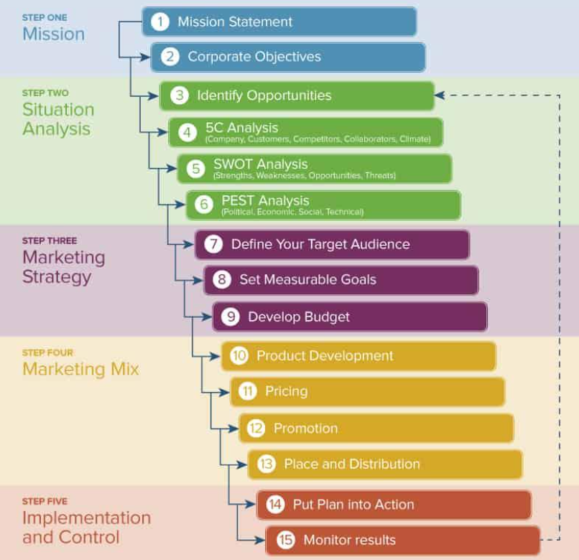
Source: Weller (2017)
To begin with, mission statement and corporate objectives play a significant role in determining the purpose of an organisation (Weller, 2017). Moreover, these two pillars set relevant directions which guide the remaining stages of the marketing process hereafter, as evidenced by the chart. Tesco’s mission statement is to be customers’ most preferred choice by delivering value and product quality in the right way (Tesco, 2021). This also requires continuous improvements in the process of customer service – an ambitious goal motivating changes in the marketing process and mix (Tesco, 2021).
The second stage of the model requires a thorough understanding of the existing context. Different strategic tools are applicable at this stage. The PEST analysis aims at understanding the relevant political, economic, social and technological trends which shape the industry and the overall external environment (Johnson et al., 2017). Thus, Tesco has a more objective view regarding the existing opportunities and threats which in turn influence the strategic development process at the company (Johnson et al., 2017). In addition, the SWOT framework is also considered as relevant, as it focused not only on the external opportunities and threats, but also on the internal strengths and weaknesses for Tesco (Worthington and Britton, 2006). In this way, the SWOT model combines key internal insights, as well as the information from the external environment which is typically derived by the PEST model (Johnson et al., 2017). The SWOT of Tesco is summarised below in order to demonstrate the potential of the tool to review relevant contextual information with potential impact on strategy development and marketing processes.
Table 1 – SWOT of Tesco
Internal | Strengths  - Market leadership position (Statista, 2021).  - Extensive distribution network of stores across the UK (Blazquez, 2021).  - Recogniseable brand  - Ability to serve various customer segments due to the large market share of 27% (Statista, 2021). | Weaknesses  - Inventory management issues – paying fines for displaying old products (Sudhakaran, 2020).  - Changes in leadership which cause uncertain about future development (Sudhakaran, 2020).  - Product shortages amid the pandemic panic buying (Sudhakaran, 2020).
External | Opportunities  - Strong economic recovery after the pandemic which fosters consumer demand (Harari, 2021).  - Demographic growth as a driver for higher demand in the future (Focus Economics, 2020).  - Online technologies supporting sales channels and promotion (ONS, 2021). | Threats  - Continuous pandemic uncertainty.  - Increased competition in the retail sector limiting profit margins (Statista, 2021).  - Changing customer preferences requiring constant adaptation by Tesco.  - Changes in the regulatory and legal frameworks requiring costly adaptation.
The third stage – marketing strategy – is of significant importance in the process of marketing. Here, business organisations should determine its positioning, customer segments and positioning (Kotler and Armstrong, 2013). In general, the segmentation process aims at dividing the entire market into smaller and homogenous groups of customers with common characteristics (Kotler and Armstrong, 2013). Typically, segmentation process is conducted on the basis of four distinct segmentation criteria – demographic, behavioural, geographic and psychographic (Kotler and Armstrong, 2013).
Figure 2 – Main segmentation criteria
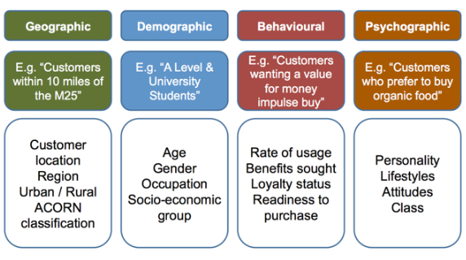
Source: Savage (2019)
Once the broad market is segmented, it is important for companies, including Tesco, to target the most attractive segments with the highest potential for profitability and development of customer loyalty (Kotler and Armstrong, 2013). The case of Tesco is specific, as the retailer targets the entire market, rather than specific segments. This is supported by the fact that the retailer has unprecedented market share of 27% (Statista, 2021). This key statistical finding suggests that Tesco targets numerous segments across the entire market. Considering this, Tesco’s positioning as a market leader justifies a broader market approach across different customer segments.
It is also important to note that the marketing strategy usually determines key goals and resources to be applied after the completion of the segmentation and targeting process. This is important, as the strategy requires resources and effective goals in order to be successful (Kotler and Armstrong, 2013).
The fourth stage of the marketing process refers to marketing mix. This is often known as the 4Ps – product, price, place and promotion – while service sector companies also employee three more elements, including process, physical evidence and people (Kotler and Armstrong, 2013). The role of the marketing mix is decisive, as it determines the positioning of a company in the marketplace (Kotler and Armstrong, 2013). In addition, appropriate changes in the marketing mix may also determine the actual performance and prospects for profit maximisation; hence, marketing mix elements have a special place in the marketing process (Kotler and Keller, 2012). Considering the role of marketing mix, the next section of the report explores its role and application in the case of Tesco in more details.
Last, but not the least, the marketing process has to apply effective instruments for monitoring and control (Weller, 2017). This ensures that the plan is implemented accordingly and it is possible to motivate changes depending on the relevant internal and external circumstances.

Marketing mix
Given the importance of the marketing mix as a positioning and demand maximisation tool, it is analysed in more details as a part of the analysis hereafter.

Product
Product is not only the first element of the marketing mix, but also tends to influence the other components (Kotler and Armstrong, 2013). Depending on the industry under consideration, the offered products or services may significantly vary. Products have tangible characteristics and they are offered in the marketplace with the purpose of addressing consumer demand (Kotler and Armstrong, 2013). Depending on the generic strategy of a company, products may largely vary in terms of quality and diversity. For example, differentiated companies tend to offer diverse, innovative and high-quality products, whereas cost leadership organisations deliver more basic products due to the focus on low price (Porter, 1985).
Tesco is a well-differentiated company with an extensive product range. As a market leader, Tesco offers products and services, which meet diverse needs of customers in different segments, and contribute to the leading industry position in terms of market share (Reuters, 2021; Statista, 2021). Thus, the company sustains its market position by constant product adjustment and a wide variety of product options to choose from; thereby, meeting customer demand.

Price
Price is a very important element from the marketing mix, as it determines the affordability of the offered products (Kotler and Armstrong, 2013). Pricing strategy may depend on a variety of factors, such as the uniqueness of the offered products, price elasticity of product categories, production costs, purchasing power of consumers, existing competition determining general supply, choice of generic strategy, etc. (Porter, 1985; Kotler and Armstrong, 2013). Eventually, business organisations determine market prices when taking into consideration the above-mentioned factors. The purpose of pricing strategies is to maximise the profitability in most instances (Kotler and Armstrong, 2013). In other circumstances, companies may temporary alter prices with the idea of achieving tactical goals, such as higher market share or elimination of unnecessary inventory. Considering all, pricing decisions are complex and may be largely determined by internal and external factors (Kotler and Armstrong, 2013).
Tesco follows a differentiation generic strategy – an assumption based on the large market share and product diversity of the company (Statista, 2021). This strategy means that the retailer offers average prices which are higher than the discounters Lidl and Aldi and lower in comparison to the premium retailers, such as Morrisons and Waitrose. Maintaining affordable prices and focusing on product quality and diversity appears to be appropriate strategy for Tesco. Nevertheless, the company has experienced an increasing competitive pressure by discounters Lidl and Aldi, which have managed to gain a significant market share on the expense of Tesco and other established retailers (Statista, 2021). In this light, Tesco may consider price changes in order to cope with the competition and re-position in the marketplace.

Place
The place element of the marketing mix determines the distribution of products and services to potential consumers (Kotler and Armstrong, 2013). Thus, the sales channels are established with the purpose of ensuring fast delivery and effective supply of all products and services depending on changes in consumer demand (Kotler and Armstrong, 2013).
Given its leading market position, Tesco has a very significant distribution network of more than 4,600 physical stores not only in the UK, but also in other countries of operations (Blazquez, 2021). These findings demonstrate the ability of the retailer to establish a dense distribution network at global scale. The recent technological changes, as also discussed in the SWOT analysis, suggest the rapid increase in online-based distribution channels, as a substitute of the traditional brick-and-mortar stores. Thus, the number of physical stores has significantly declined from a peak of 7,000 to just 4,600 and the focus has been shifted to online sales channels (Blazquez, 2021). Official data by the Office for National Statistics (ONS) show that the growth of online-based retailing has been quite considerable in the last decade and especially amid the pandemic and imposed social distancing measures (ONS, 2021).
Figure 3 – Growth of e-commerce as a share of all retail sales in UK (%)
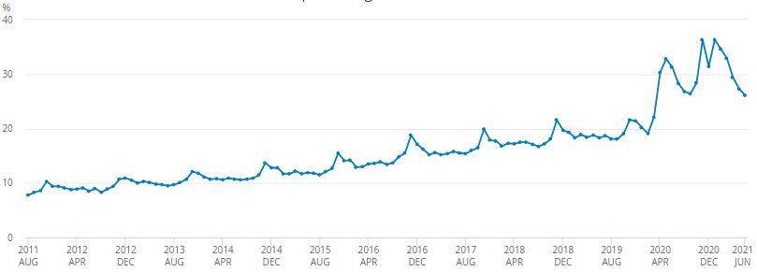
Source: ONS (2021)
Tesco has been quite pro-active and flexible enough to benefit from the changing trends. The company has an effective online sales platform contributing to the significant growth in online sales in 2020. More specifically, Tesco achieved £6.3 billion in online sales or 77% increase in comparison to the previous year (Mari, 2021). This evidence shows the importance of developing online sales channels as an extension of the place element of the marketing mix, so that a higher number of prospect customers.

Promotion
The last element of the marketing mix refers to promotion. It is an important area aiming at delivering informative and persuasive information to customers (Kotler and Armstrong, 2013). In this way, it is possible to position the brand and address the specific preferences of targeted consumer segments. In general, promotion may be based on a variety of activities which comprise the promotional mix – advertising, personal selling, direct marketing, public relations and sales promotion (Todorova, 2015).
Tesco applies a range of promotional methods to stimulate consumer demand and brand awareness. Considering the case of the retail industry, Tesco is the largest spender in the traditional advertising domain with annual expenses of £80.8 million, as reported by Briggs (2020). These activities include TV, radio and printed media advertising (Rahman, 2020). In addition, sales promotion is also evidence in the case of Tesco. These are offers when consumer buy one and get two or more items (Rahman, 2020). Loyalty is also awarded through the ClubCard membership and received price discounts for repetitive purchases (Rahman, 2020). Given the advance in modern technologies, Tesco’s activities on social media have been of growing importance as a part of the promotional process.

Conclusion
In the light of research findings, the evidence reveals the complexity of the marketing process and the requirement to gather extensive information regarding the external environment and consumer groups. Appropriate segmentation and targeting are necessary in order to identify the segments with the highest growth prospects. The role of the marketing mix is essential for positioning of the brand and maximising consumer demand. The evidence from Tesco shows the organisation’s actions in regards to all elements of the marketing mix and the respective changes, so that the marketing mix is better adapted to changing external developments. Tesco’s success in the future largely depends on its ability to change marketing mix elements accordingly.

References
American Marketing Association (AMA) (2021) Definitions of Marketing, [online] Available: https://www.ama.org/the-definition-of-marketing-what-is-marketing/ [Accessed: 15 August 2021]
Blazquez, A. (2019) Tesco's number of stores worldwide from 2008 to 2021, [online] Available: https://www.statista.com/statistics/238667/tesco-plc-number-of-outlets-worldwide/ [Accessed: 14August 2021]
Briggs, F. (2020) Tesco is UK’s biggest traditional advertising spender in grocery retail, [online] Available: https://www.retailtimes.co.uk/tesco-is-uks-biggest-traditional-advertising-spender-in-grocery-retail/ [Accessed: 17 August 2021]
Focus Economics (2020) UK Economic Forecast, [online] Available: https://www.focus-economics.com/countries/united-kingdom [Accessed: 12 August 2021]
Harari, D. (2021) GDP – International Comparisons: Key Economic Indicators, House of Commons, [online] Available: https://commonslibrary.parliament.uk/research-briefings/sn02784/ [Accessed: 17 August 2021]
Johnson, G., Whittington, R., Scholes, K., Angwin, D. and Regner, P. (2017) Exploring Strategy. 11th edition, Pearson
Kotler, P. and Armstrong, G. (2013) Principle of Marketing. 15th edition, Prentice Hall
Kotler, P. and Keller, K. (2012) Marketing Management. 14th edition, Pearson Education
Mari, A. (2021) Tesco reports online sales surge, advances digital platform, [online] Available: https://www.computerweekly.com/news/252499325/Tesco-reports-online-sales-surge-advances-digital-platform [Accessed: 17 August 2021]
Office for National Statistics (ONS) (2021) Internet sales as a percentage of total retail sales (ratio) (%), [online] Available: https://www.ons.gov.uk/businessindustryandtrade/retailindustry/timeseries/j4mc/drsi [Accessed: 15 August 2021]
Porter, M. (1985) The Competitive Advantage: Creating and Sustaining Superior Performance. NY: Free Press
Rahman, M. (2020) Marketing mix of Tesco (7Ps of Tesco), [online] Available: https://howandwhat.net/marketing-mix-tesco-tesco-marketing-mix/ [Accessed: 17 August 2021]
Reuters (2021) Tesco PLC, [online] Available: https://www.reuters.com/companies/TSCO.L [Accessed: 14 August 2021]
Savage, K. (2019) How to Segment Your Customers to Grow Revenue, [online] Available: https://www.getfeedback.com/resources/cx/how-to-segment-your-customers-to-grow-revenue/ [Accessed: 30 August 2021]
Statista (2021) Market share of grocery stores in Great Britain from January 2017 to May 2021, [online] Available: https://www.statista.com/statistics/300656/grocery-market-share-in-great-britain-year-on-year-comparison/ [Accessed: 15 August 2021]
Sudhakaran (2020) Tesco SWOT Analysis 2020: A Detailed Report, [online] Available: https://pestleanalysis.com/tesco-swot-analysis/ [Accessed: 11 August 2021]
Tesco (2021) Core Purpose and Values, [online] Available: https://www.tescoplc.com/about/how-we-do-business/core-purpose-and-values/ [Accessed: 15 August 2021]
Todorova, G. (2015) Marketing Communication Mix, Trakia Journal of Sciences, Vol. 13(1), pp. 368-374.
Weller, J. (2017) The Definitive Guide to Strategic Marketing Planning, [online] Available: https://www.smartsheet.com/strategic-marketing-processes-and-planning [Accessed: 15 August 2021]
Worthington, I. and Britton, C. (2006) The Business Environment. 5th edition, Pearson Education

