Dylan Hocking (2312757)
2312757@student.uwtsd.ac.uk
Practical and Porfessional Development
Changemakers (ACCA5033)

Table of Contents
1. Introduction 2
2. Practical Development 2
2.1. Initial Feedback 2
2.2. Implementation 3
3. Innovation 7
3.1. PEST Analysis 7
4. Project Feedback and Reflection 8
4.1. Practical Feedback 8
4.2. Product Progress Diary 8
4.3. Skills 9
4.4. Positive Social Impact 9
5. Conclusion 9
References 9
Appendix 10
Progress Report Sheets 10
CPD Evidence 12

1. Introduction
The author of this report was task to take the project that they came up with, planned and designed in the first assignment and start creating the implementation of the project. This report includes the initial feedback that they gained on the project. The author also needed to write on how the author would implement and maintain their project in inside of a larger organisation. Then the author has created a Political, Economic, Social and Technological (PEST) analysis with the help of AI and other sources they found. Once they had finished the implementation stage the author ran an evening for Cub Scouts to help them earn their Digital Citizen badge which they allowed the Cubs to user test the project and the author gained some practical feedback they gained this feedback with parental and the child's permission. The author then reflected on how they have managed the project and what they would do differently if they decide to do the project again. They also reflected on the hard and soft skill that they learn or improved upon. Then they need to write about how this project and their new skills has had a positive social impact on society. In the appendix the author has added their weekly progress report sheets and their Continuing Professional Development (CPD) evidence.

2. Practical Development

2.1. Initial Feedback
The author has collected some initial feedback from other Cub Leaders by using a face-to-face method the author asked the question and then wrote down the notes of the answer that the Cub Leader give them. Below is the question the author asked.
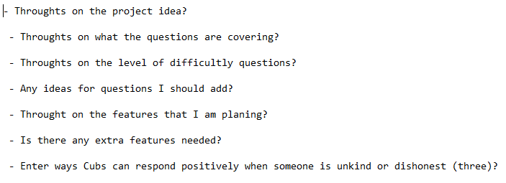The feedback on the quiz questions that the author wrote was mostly about changing the wording of the question to make them more understandably for children, the author has used this feedback to change the wording of the questions. Another question they asked was if they had ideas about any question the author should add, one of the answers to this question was to add a question about how to stay safe online. The other main question that the author asked was about how Cub Scouts could respond correctly to someone online that is being unkind, this question was important because this was one task the Cubs needed to do to earn their Digital Citizen badge. The feedback that the author got was for the Cubs needed to either not respond in the same way as them or not to respond at all.

2.2. Implementation
The author as finish developing their project by using Unity, Visual Studio and C#. They have created a quiz and a password authenticator for Cubs Scout to gain their Digital Citizen badge. First the author created the scene for multiple answer questions below is a screenshot of the design of the scene.
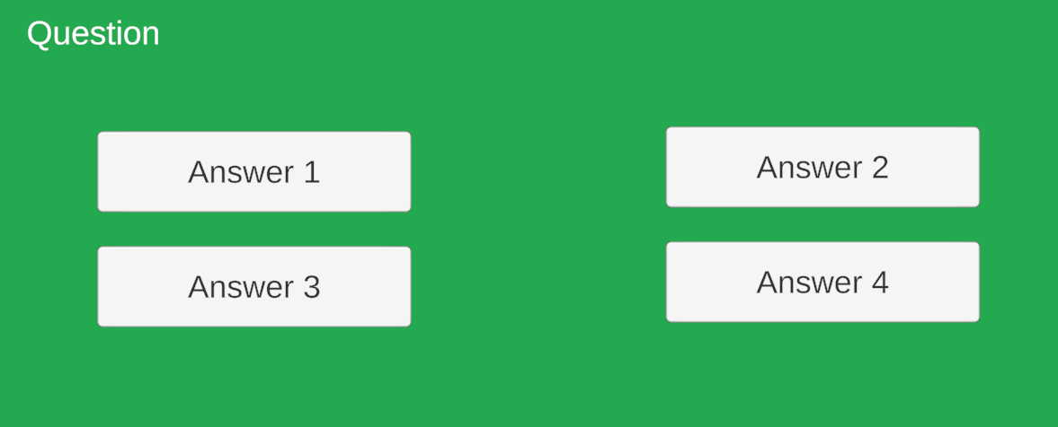
This scene handles three different questions so the scene starts off like above then the text will change depending on what question the user is on. Below is how the questions are being stored in the code.
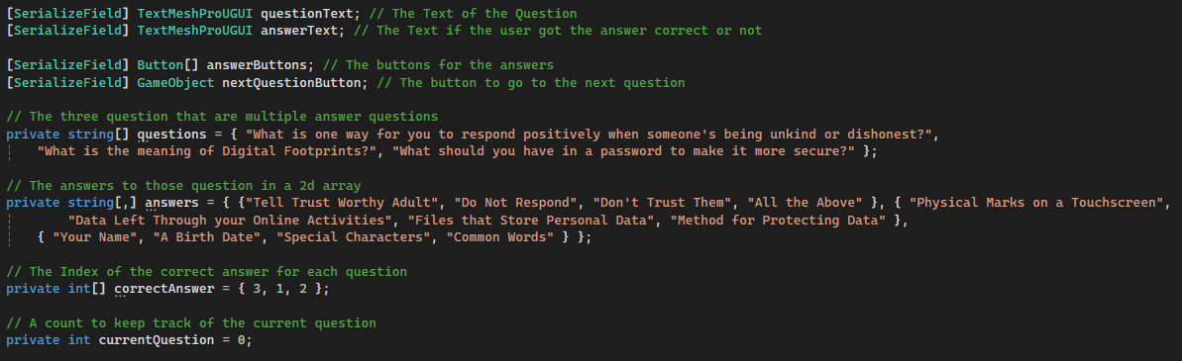
The questions are being stored in an array which will be accessed using the currectQuestion as an index the same with how the answers for each question will be accessed but they are stored in a two-dimensional (2d) array. Below is a screenshot of the main parts of the code. Which two of the methods are called when a button is clecked. The author had some problems with coding how the program would tell which answer button was clicked. As the author does not have much experience with using Unity buttons like this, they did not know that you could add parameters on methods that are called by buttons.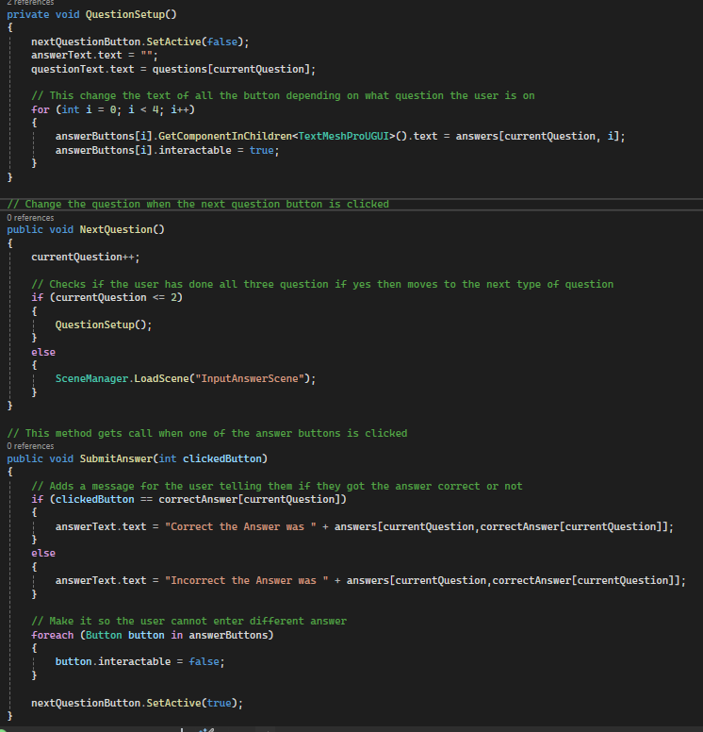
The next type of question the input question was easy to code and the author had no problems. The toggle type question was not too difficult to program as the author as never used Unity toggles before. Below are screenshots of the scene and a part of the code which checks if the user got the correct answer or not.
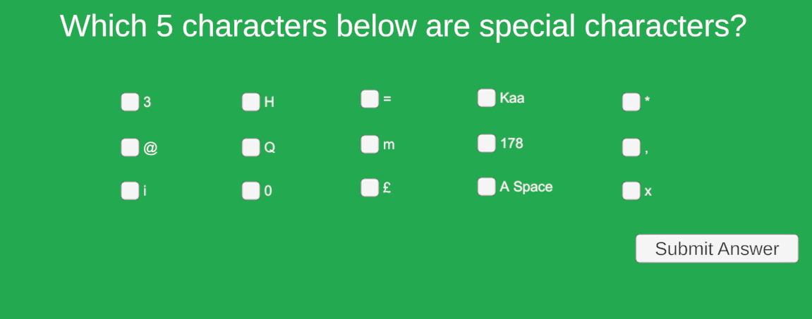
Only the wrong answer toggles had the tag of AnswerToggles and the correct answer toggles were stored inside the specialToggles array.
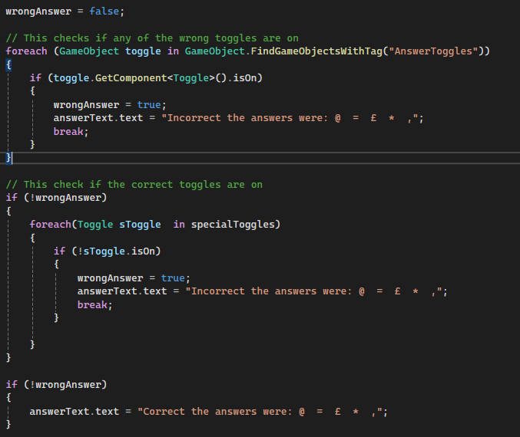
The next scene that the author worked on was the password authenticator scene which the author gained some ideas on how to authenticate a password from a LinkedIn course that they did in the first assignment [1]. Below are the screenshots of the scene and a part of the code that does the authentication of the password.
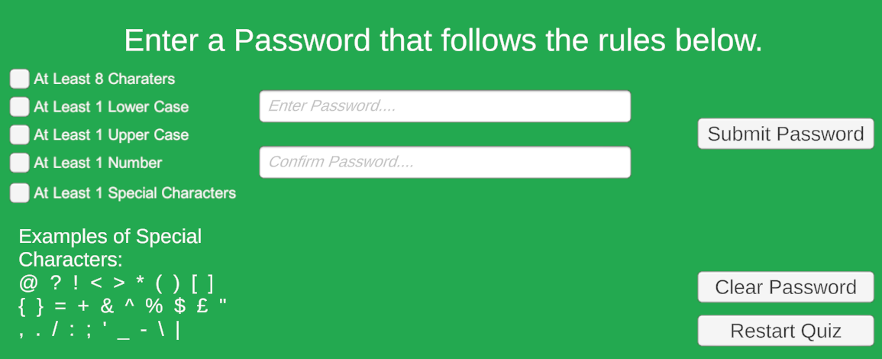
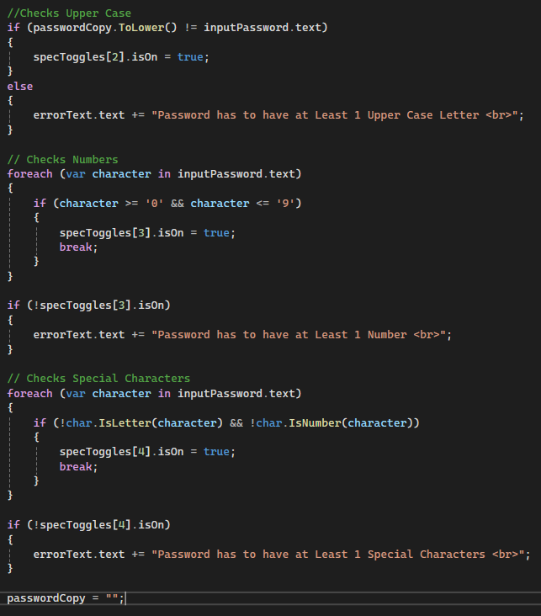
The code to check if the password has at least one lower case letter is the same but the opposite from the code to check if there is at least one upper case letter. To check if there is at least one special character the code checks if the character is not a number and not a letter. The final scene the author created was the start main which was the easiest scene to make can code. The author add the Password Scene button just in case one of the Cubs accidentally restarted the quiz so they did not need to quickly run through the quiz again.
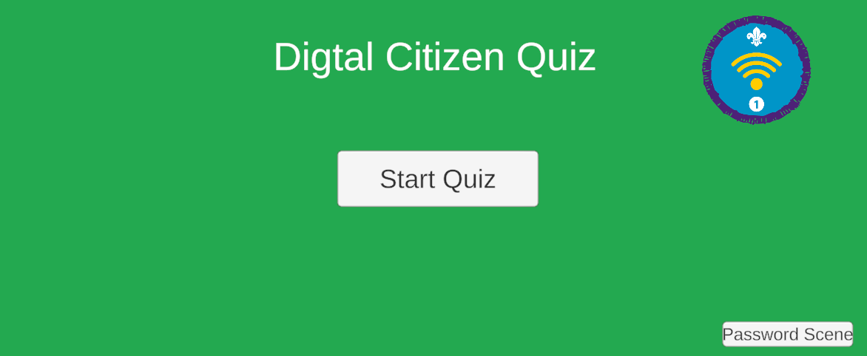

3. Innovation
To develop their project the author used the game engine Unity. The integrated development environment (IDE) the author used was Visual Studio using the language C# they chose to use these as Unity uses this IDE and language, C# is also the language the author is most familiar with. The author has created this project to work on desktop or laptop computer. To version control their game the author will use GitHub. The author would deploy their project on a website. The project will have server-side updates as the project will be on a website and users can have the updated game without client-side updates.

3.1. PEST Analysis
To create a PEST analysis the author has used an AI tool and some additional sources. One political consideration was the data protection laws [2] which the author would needs to keep in mind are only using data were it is necessary and keeping data for no longer than is necessary [3]. Some economic considerations are looking at exchange rates, supply costs, wage rates and tax rates [2][4]. A social factor that should be considered is sustainability which includes the how environmentally is it, the diversity, and the quality of life the project gives [2][5]. Example of technological consideration that needs to be considered is thew emerging technologies [2] which are innovative but requires the need to use in an ethical way [6]. Legal considerations that have been mentioned before like the data protection laws, wage rate and minimum wages and tax rates. Ethical factors that need to be considered is impact on the environment, emerging technologies like AI, misuse of personal data and fake information [2][7].

4. Project Feedback and Reflection

4.1. Practical Feedback
The practical feedback that the author gained from a face-to-face method when they asked questions and wrote the notes of the answers that the Cub Scouts give. Gaining the feedback was very useful and the author will add the suggestions that they give to improve upon the project. Below is the question that the author asked.
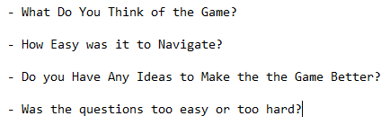
The answers to the first question that the Cubs give were that the game was helpful and a good learning experience. They Also found making the passwords fun to do. All the Cubs said that the game was easy to navigate. The third question there was more suggestions on how to make the game better they wanted more toggle question, they said to add true or false questions as well and some of them want more explanation on the questions and answer. All the Cubs said that they like the difficultly of the questions but said to also add harder questions as a challenge for them, which they give a suggestion on the multiple chose questions to add six answers instead of four.

4.2. Product Progress Diary
The management of the project that the author did in the first assignment was useful for the author to stay on track on what they were doing and what still needed to be done. Which helped the author to complete the project in time for the deadline. The risk analysis that they did was also useful for them to be aware of losing data that was not saved and be aware of age appropriateness. The weekly progress sheets that the author did was helpful to remember what the author did the week before and what they need to do next week. The progress sheets were also useful at making the author concentrated on the tasks that needed to be completed. If the author redid this project again, they would add more question and make the question slightly more challenging for the age group that the project was for. The author would also make the design of the game more interesting with more images.

4.3. Skills
The author while developing their project have improved both their hard and soft skills. While during the project planning stages the author have developed their project management and planning skills, also they have increased their knowledge on tools to help them in this stage like Tom’s Player, Trello and Miro. When the author was implementing the project, they improved on their problem-solving skills and improved on their skills working in Unity and C# by learning new tools in Unity and new Unity specific methods for C#. During the feedback stages the author developed their communication skill while talking to other Cub Leaders to collect initial feedback and Cubs to collect practical feedback. The author also needed to take ethical considerations while collecting practical feedback from the Cubs as they are minors.

4.4. Positive Social Impact
The positive social impact that the author’s project brought was making learning how to be safe online for children more engaging for them. The author’s programming skill that they have improved on will have a positive impact on the author ability to understand programming. The soft skill that the author has improved on like project management, problem-solving and communication skill will allow the author to use these skills in employment.

5. Conclusion
In conclusion the author has gained some initial feedback for their project and then developed their project. While implementing the project they created weekly progress sheets and followed their project plan that they made in the first assignment to keep them on track with the project. The author then mentioned if they created this project while they were in a large organization and created a PEST analysis as well. After finishing their project, the author did some user testing to gain some feedback from users. Then finally they mentioned the improved upon their skill and how the project and their new skill will have a positive social impact.

References
[1] A. Jones. "Java Essential Training: Syntax and Structure, Code Solution: Password validator." Linkedin Learning. Sep 3, 2024. Accessed: Mar 8 2026. [Online]. Available: https://www.linkedin.com/learning/java-essential-training-syntax-and-structure-16025610/code-solution-password-validator?resume=false&u=77966930
[2] ChatGPT. Accessed: May 6 2025. Prompt Used: “a PEST analysis for the large Tech Company of your choice including some legal & ethical considerations.“ . Available: https://chatgpt.com/
[3] "Data protection." GOV.UK. Accessed: May 6 2026. [Online]. Available: https://www.gov.uk/data-protection
[4] "What are economic factors? (Importance and examples)." Accessed: May 6 2026. [Online]. Available: https://uk.indeed.com/career-advice/career-development/what-are-economic-factors
[5] "What is social sustainability?" ADEC ESG. Accessed: May 6 2026. [Online]. Available: https://www.adecesg.com/resources/faq/what-is-social-sustainability/
[6] S. Christakos. "Ethical Considerations in the Adoption of Emerging Technologies." Accessed: May 6 2026. [Online]. Available: https://www.linkedin.com/pulse/ethical-considerations-adoption-emerging-technologies-christakos-z5gmf/
[7] A. Watters. "5 Ethical Issues in Technology to Watch for in 2025." GTIA. Accessed: May 6 2026. [Online]. Available: https://gtia.org/blog/ethical-issues-in-technology
[8] J. Marini. "Learning C#, String operations." Linkedin Learning. Sep 14, 2023. Accessed: Mar 8 2026. [Online]. Available: https://www.linkedin.com/learning/learning-c-sharp-8581491/string-operations?contextUrn=urn%3Ali%3AlearningCollection%3A7434900154144690176&u=77966930

Appendix

Progress Report Sheets

Date: 15/04/2026

Progress:
- Create Start Menu
- Get Assets for Game
- User Testing

Actions:
- Add Features that was in the Feedback of the User Tests

Next review date: Project Finished

Date: 08/04/2026

Progress:
- Start and Finish Programming the Quiz Questions

Actions:
- Create Start Menu
- Get Assets for Game
- User Testing

Next review date: 15/04/2026.

Date: 01/04/2026

Progress:
- Email Survey to other Cub Leaders
- Gained Feedback from Survey
- Finished Programming Authenticator for Password

Actions:
- Start and Finish Programming the Quiz Questions

Next review date: 08/04/2026.

Date: 25/03/2026

Progress:
- Created Survey
- Design the Layout of the Password Authenticator
- Started Programming Authenticator for Password

Actions:
- Email Survey to other Cub Leaders
- Finish Programming Authenticator for Password

Next review date: 01/04/2026.

Date: 18/03/2026

Progress:
- Finished the layout of quiz scene
- Finished the quiz questions

Actions:
- Create Survey
- Design the Layout of the Password Authenticator

Next review date: 25/03/2026.

Date: 11/03/2026

Progress:
- Started creating the design of the quiz scene
- Started creating questions for the quiz

Actions:
- Finish the layout of the quiz scene
- Finish the quiz questions

Next review date: 18/03/2026.

CPD Evidence
The author has completed a chapter of a LinkedIn course that they found in the first assignment about strings [8].


