Introduction to Archaeology (Graveyard Report)
Introduction

The graveyard is not just a place in which people can go to mourn their deceased, but it is a place where the descendants of the dead can go to remember their long-lost past. The graveyard can also be of great historical value to historians, archaeologists and those who study geology and such. There are monuments that stand tall and proud showing off all their great detail and grandeur, and those which lay flat which show a less overpowering form but give a feeling of romanticism. Headstones and surveying them can also be a way of not only giving us some personal and intriguing detail about the person or persons, but some can give the surveyor a glimpse of what kind of life they actually lived even the skills they had when they where alive, the role they played and standing in the community. We all have access to a graveyard somewhere most are a stone throw away, but due to the risk of vandals destroying and defacing these great historical monuments and the notable attribution of rot and natural decay it is paramount that these are recorded before the information has gone completely. “Even though many of the headstones where carved in stone which is a much more durable material that weathers slowly, it does still erode, leaving the information written on the headstone in a poor state. Eventually the writings and decoration will be less informative and unrecognizable but in certain cases gone completely”. Jones (1979)
The unmarked grave
The cemetery at st peters church in Lampeter has over 2500 graves of different character style, size and age. The first grave that was recorded had little in the way of design, a tomb style grave which had plain kerbs around the base which left little to the imagination. Below is a picture of the grave, there is no markings or detail but this could have had writing in the past this is possibly due to erosion.

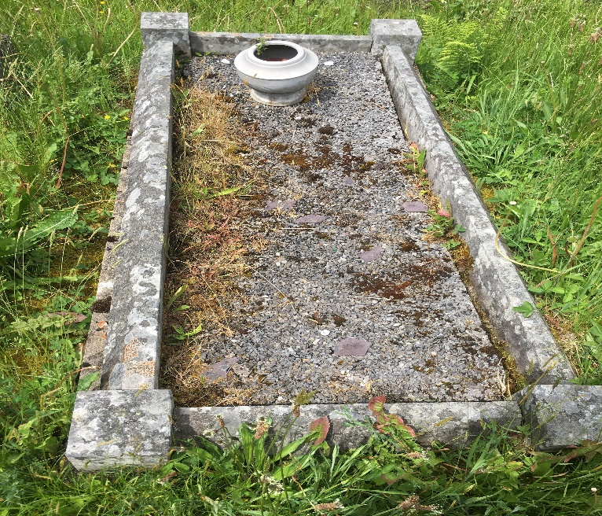
1 Savage (2018)

The monument

By looking at the different styles of graves at the churchyard with a resourceful eye, it is possible to get lots more information than just by reading what is written on the stones. There is a particular one that has an angel holding a passion lily which according to the lectures has a great importance, “it represents Christ, but also lilies can also represent death that’s why these are very popular in the early 19th to 20th century. But these go in and out of fashion and can be seen all around the cemetery there are also certain designs that where in fashion at the time and had a certain meaning but also popular in other periods and had a totally different meaning. For instance, people in the 18th century had a different view and perspective to cherubs in the 20th century, as times change so does the style of writing, and different views on what designs mean” Harold (2000). Below is a picture of an angel holding a passion lily on what seems to be a pedestal style tomb, but with a sculpture overlooking the other graves. Just by looking at the base of the grave you can clearly see that it is overgrown with weeds and it looks like it has not been cared for, for a long period of time. The monument has been moved to the right-hand side of the grave because of possible subsidence the picture shows that if one was to look at the left you can see the ground starting to lower whether this has been going on for a long period of time or has just started is anyone’s guess.

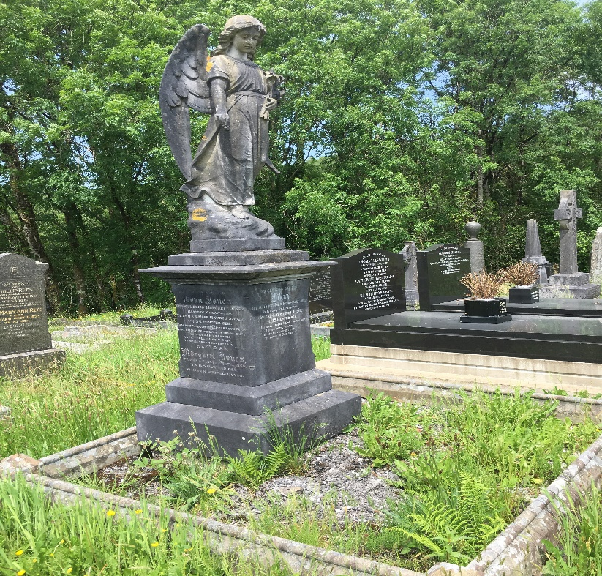
(2) Savage (2018)

The well designed gravestone

Most of the data collected off the gravestones was of people who lived around the early to mid 20th century, the more elaborate ones are made of marble and some others are a more cheaper materia,l and as a large majority of the gravestones are written in welsh it was very hard to make out this information especially due to the erosion on some of them. The one that was interesting is the one in picture 3 which is fully in welsh as a non welsh speaker, translating this was a little difficult, but doing some research it translates to “in memory of, Margeret Cwraig Griffith Jones, who died aged 21 a mother who lies here, to the head of a sweet pepper of faith, and a dungeon where I would like to sit together with the oath of my farthers. Wheather the translation is correct is another matter. But not knowing if welsh was spoken a little bit differently back then does beg the question are all translations of older style welsh totally accurate. But apart from the obvious welsh writing there is some lovely detail work. At first glance it looks like a bunch of flowers and a hand, but sitting there examining the piece you can clearly see a cloud formation at the top of the headstone and a hand protruding downwards from it holding what seem to be a wreath. This could possibly represent the hand of god and the flowers representing life or death.

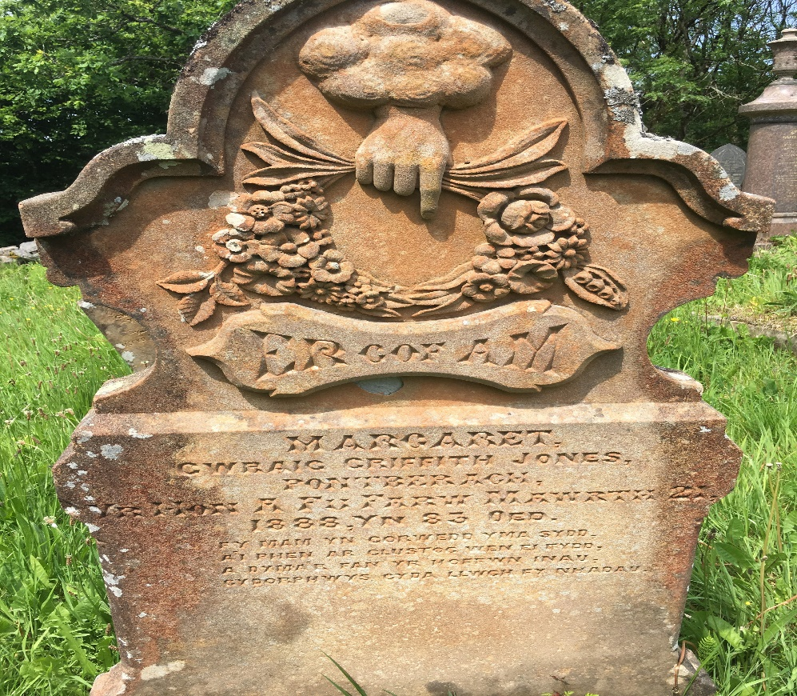

(3) Savage (2018)

As I was walking around the cemetery something caught my eye it was a stone buried beneath the grass. The stone was around a foot wide and roughly two foot long with no distinctive patten or writing of and sort. It was broken into pieces, and was either missing parts of its original design or maybe it had no design to start with but from what was appaernent was the size, it was clearly very small and must have been for a very small child. Without having any information about the child’s grave there was really not a lot to decipher, again weathering of the stone was apparent and definitely some subsidence. As you can see in picture 4 there is really not a lot to go on in regards to information but to those who study graveyards this could definitely be a challenge to find out who this young person was, when they died and what standing their family had a such a small country community.

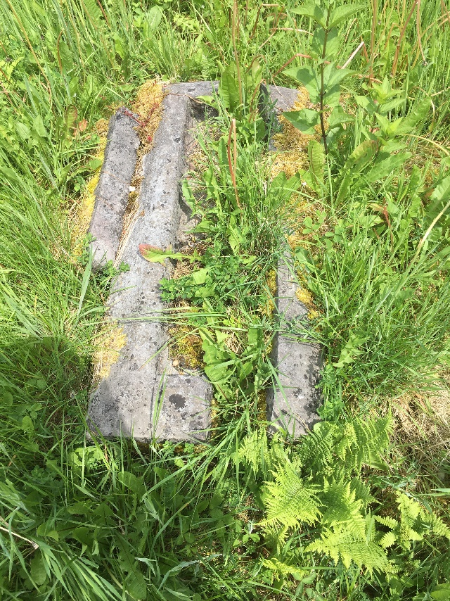
(4) Savage (2018)

The decayed gravestone
Gravestones don’t just whether away, subside into the ground or get buried over,there are a large majority of these graves in and around the country that have clapsed, some might think like myself that these have been intensinally vandalised by children young adults or even adults themselves but this is not always the case. Many gravestones in the country are not always in the greatest of conditions due to age, the material they are made from plays a big factor in the deterionation process, some can last a short period of time and other an extremely long time for example stone is probably the longest lasting as it erodes a lot slower as does marble and others a lot less. This process can break the foundation of a standing piece but it can still stay upright. There are cases every year of small children who visit graveyards with their families or just end up playing in them and unfortunately due to no fault of their own get seriously injured and even killed in a majority of cases due to the headstone being dangerously unsafe.

Over the years the counils around the country have had to mark certain graves with sometimes different coloured tape to not only let the visitors to the cemetery know about these but to also come back at a later date and purposely tip the gravestones onto their side to prevent injury or death. Then the council or contractor involved has to then contact each individual family to ask them if they would be willing to repair or in some cases replace the whole gravestone even though sometimes this could not be financially beneficial to the families they could try for a cheaper alternative this could also possibly be because the gravestone is to big like a monument and or due to its age. The headstone could also just be removed altogether. Below in picture 5 is an example of the fallen headstone wheather this was done intentionally, by an authority or just a natural occurrence its one to think about.

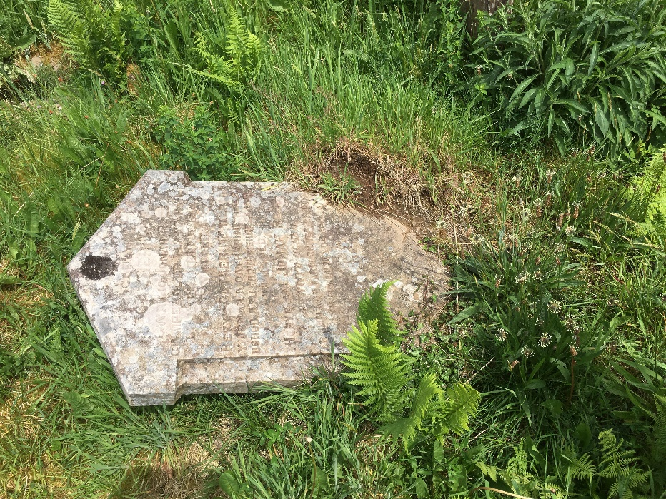
(5) Savage (2018)
The last gravestone in the churchyard that I had encountered was flat, there was now immediate signs of subsidence but it had some age and wethering to it it had kerbs and chains around it and the grave itself has what surveyers would call a “low monument with hipped top” according to Harold (2018) “kerbs can be a monument in their own right but when kurbs form the monument, they are given a code. If the kerb forms an additional element an example of this a headstone or a tomb they should be recorded as such in the next section. However in the late 20th century kerbs comprise the only feature of a monument and deserve to be recorded in this section of the form as a discrete type”. So what this is saying is that even if there is a slight distinction in appearance whether that be a pointed corner or an extra post even additional chains or railings they have to be recorded with these distinctive slight adaptations in mind giving every one its own unique number system. In picture 6 you can see that it has most of the above mentioned.

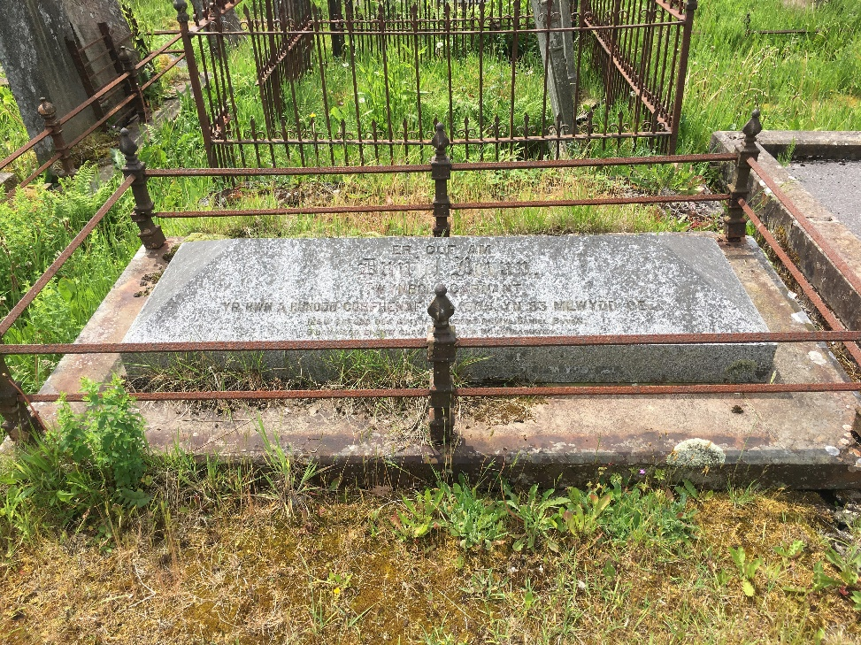

So I am going to conclude with what I have learnt while studying these graves, the first thing is definitely the size of these monuments, they differ from very small to huge in stature and can be an overwhelming site, but not only do these carry with them a great library of information they also give us a look into what the lives of the people might have been like in relation to their uniformity. Also the material, thinking that marble was always one colour, and now realising that this can change with time is an intriguing piece of valuable information. The weathing of stone and tring to disifer the wording was a challenge in its own right. But what I had learnt more trhan anything is time can play a damaging part in the desecration of these valuable monuments and even

Jones, J. (1979) How to Record Graveyards: The Trust for British Archeology: london
Mytum, H. (2000) Recording and Anylising Graveyards: The Council for British Archeology: york

