Research proposal – Salman Rexa - 2004540
Title – The impact of Artificial Intelligence on Accounting Practices
Aim of study
The aim of this dissertation is to analyse and evaluate the impact of how artificial intelligence (AI) has changed the way accountants practice their day-to-day business and the potential future effects and changes it may have on accountants as AI continues to rapidly improve.
To help focus further on my research and to achieve the aim of this dissertation, the research question I will focus my research on is:
- How has the integration of artificial intelligence reshaped traditional accounting practices, and what are the implications?
To fulfil this, by the end of completing the dissertation I will be aiming to have achieved the following objectives:
Research objectives
- Analyse and compare AI impact across various accounting firms.
- Investigate the influence of AI on data-driven decision-making process in accounting.
- Evaluate ethical implications of adopting AI in Accounting.
- Examine Regulatory compliance with AI-enhanced accounting.

Background
Artificial intelligence is advancing at an incredible speed and the usefulness and capabilities of AI will soon have the potential to revolutionise the world as we know it. However, to focus more specifically on the accounting industry, the accountant profession could potentially be at risk with AI technology being able to perform most accounting tasks more efficiently. This concern for the accounting industry has been a hot topic for debate where all accountants whether sole traders or the ‘big four’ are keeping a close eye on AI and getting themselves prepared to adapt to AI. Although ICAEW have found a practical challenge that need to face which includes “conscious adoption of AI capabilities to solve business or accounting problems will often require substantial investment.” (ICAEW, 2023 p.9). This will mean that larger accounting firms such as the ‘big four’ will be more likely to take advantage of the benefits of AI in their accounting practices whereas smaller accounting firms will not have the capital available to invest in the expensive AI technology.
Although the opinions and judgements may vary between the different sectors of the industry as the ‘big four’ agree that “currently, AI technology cannot replace human accountants” (Steinhardt, 2023) Even though they are heavily investing in generative AI, the future for accountants is still unknown depending on how advanced AI can get and what it can be capable of.
Ethical concerns surrounding the use of AI in accounting is something that all accountants need to consider. As Railton emphasises the ethical danger that “besides adding new technological possibilities of its own, it alters the capabilities and potential benefits and risks of a wide range of other technologies.” (Railton, 2020, p.45). Therefore, as AI becomes more advanced it will impact existing technologies accountants use today whether for good or bad.
As AI develops, so does the regulations regarding AI to ensure that it can continue to be utilised appropriately. This is vital for the future as the implementation of AI in accountancy is still in its early stages and will only continue to grow. Government bodies have recognised the significance of AI in accountant practices. The CPA suggests that “the legislation is expected by industry expects to come into force sometime in 2025” (Lajartre, 2023) however some may not be satisfied that this is soon enough as we are already seeing AI being used to perform basic accounting tasks.
As this is a topical issue for accountants to consider right now, and as I am considering a career as an accountant this is a subject that I am interested in researching about to see what accountants should expect in the future and how their practice will change.

Research Methods
For this study, the methodology I intend to use is a research onion.
My research philosophy of choice will be interpretative. I have chosen this philosophy due to the current nature and unfamiliarity surrounding AI which will therefore allow for a more holistic approach to better understand the various effects of AI in accounting for multiple parties.
From the second layer of the research onion, my research approach will be inductive. This approach is chosen as from the research I will be gathering, the data and information found will be used to devise my own theory and judgement on the impact of AI on accounting practices. This is because this concern surrounding AI is recent and only started growing in the past few years.
I will be gathering data and information from a variety of different sources which will include both quantitative and qualitative methods of research. Therefore, a mixed-method approach will be used. This will allow for a more comprehensive and thorough amount of data to be analysed. I will also benefit from the strengths of both quantitative and qualitative methods of research which should also compensate for the limitations of both methods. By qualitative research using case-studies and other document analysis and quantitative research through questionnaire and statistic reports I feel that this will provide better coherent results.
The research strategy I will be using for 3 out of the 4 objectives will be the questionnaire which will be sent to local and emailed to accounting firms’ employers and employees. By having current accountants ranging from sole traders to working for the large accounting firms will allow me to gather primary data to analyse. For the final objective examine regulatory compliance with AI enhanced accounting I will be using a qualitative research method of document analysis through a case study. This will allow me to interpret my findings from this examination of the case study and provide my own judgement and justification.
For the time horizon, due to the time limitations of this study, I will be choosing to use the cross-sectional method. This will allow for a better comparative analysis when looking at the data gathered from the questionnaire aimed at current accountants. This method is also more suitable due to resources however if needed this research can be used in future further analysis if necessary.
Once I have gathered all the necessary data, I will be able to analyse it through the method of content analysis for the qualitative research from a case study. For the questionnaire data, this will be analysed through SPSS for the closed-ended questions and for the few open-ended questions I will use a word cloud to analyse the qualitative data to identify key themes.
Research limitations
There will be a time limitation for this study so therefore a strict plan to manage time spent efficiently to gather research is essential. To achieve and organise my time managing this project I have created a Gantt chart to organise my time appropriately. There may also be a risk that I will not receive enough completed questionnaires back. To minimise this risk, I have started early to send out questionnaire which will give me time later to send more to other if needed.
There is also an ethical risk where data privacy and confidentiality will need to be suitably acquired and stored for this project. This risk will be mitigated through obtaining a formal ethics approval which will clearly communicate this project’s purpose and highlight any potential risk to those participating in this study.
Resources and Planning
The resources that I will require to complete this project include a computer, Microsoft 365 package, IBM SPSS software, and access to online library for journal and other academic sources.
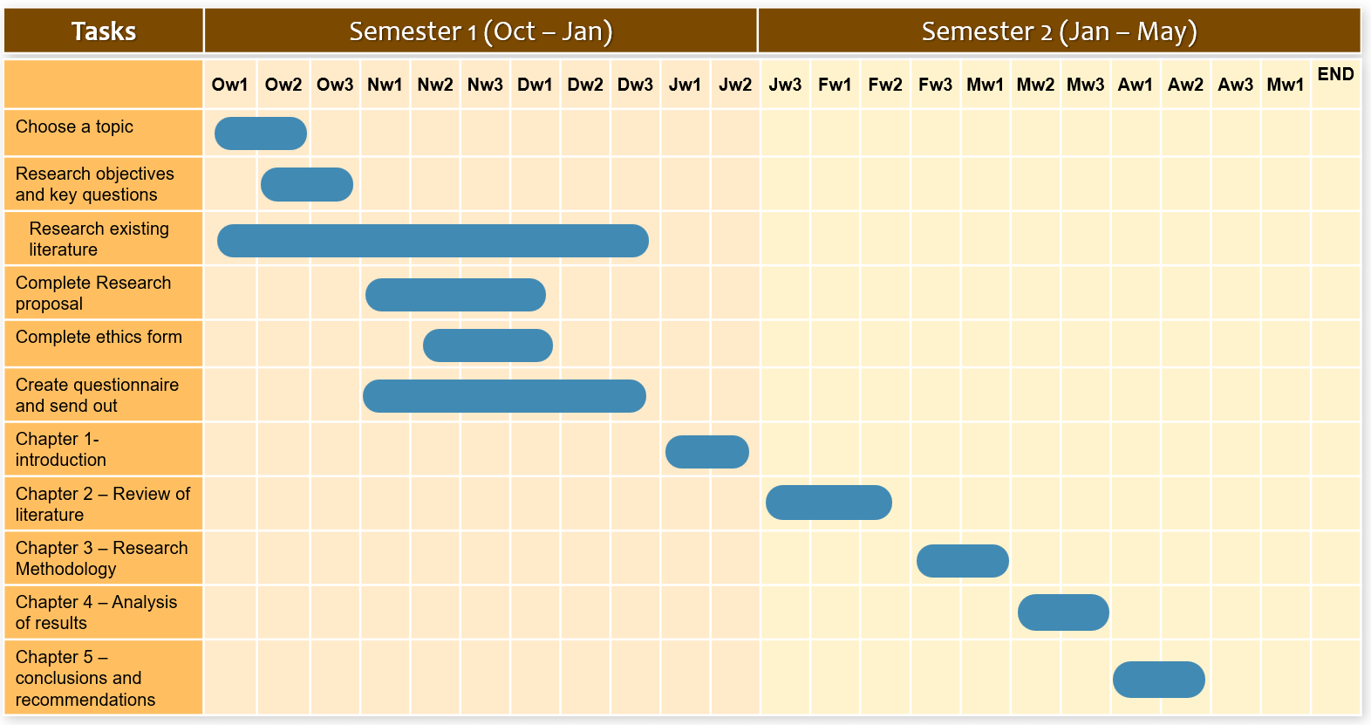
Gannt Chart

This Gantt chart will allow me to clearly see the time I have to complete sections of this project. I have given generous amount of time for each section and so if I have completed a section before the time is up then I can continue to the next section which may leave me even more time at the end to review. I have also left myself an extra week in case things to do not go to plan for extra time if necessary.

References
Steinhardt, SJ (2023) Big four agree: AI will not replace Accountants. NYSSCPA. Available at: Big Four Agree: AI Will Not Replace Accountants (nysscpa.org) (Accessed: 5 November 2023)
Railton, P (2020) Ethical learning, natural and artificial in: Ethics of Artificial intelligence. Oxford University Press. P. 45
Larjartre, M (2023) Is AI moving too fast for regulators to keep up? Chartered Professional Accountants (CPA) Available at: Is AI moving too fast for regulators to keep up? | CPA Canada (Accessed: 5 November 2023)
ICAEW (2023) Artificial intelligence and the future of accountancy. ICAEW’s Tech Faculty. P.9.

