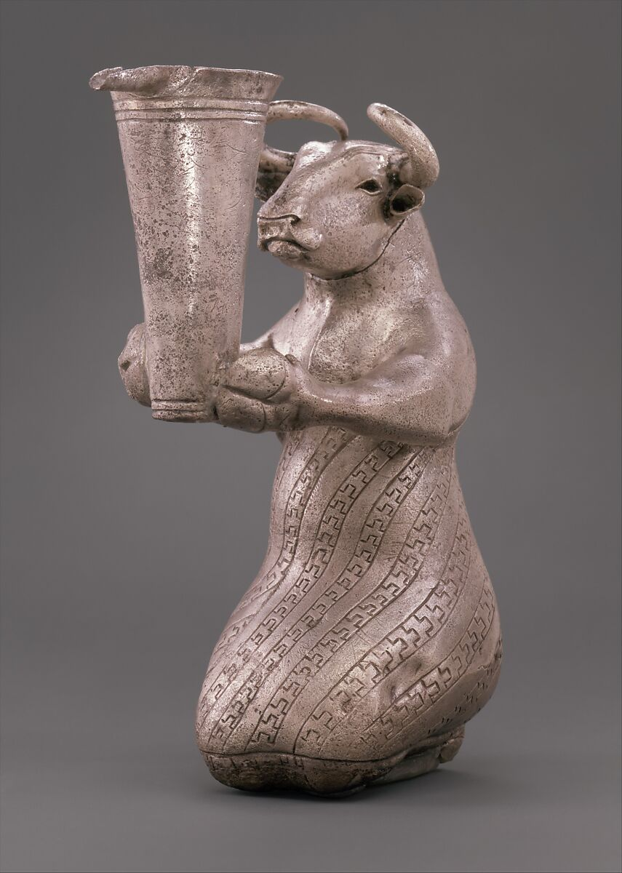
(Fig. 1) (Metropolitan Museum, 1966) - (Purchase, Joseph Pulitzer Bequest) - (Accession No. 66.173) – The Kneeling Bull with Spouted Vessel, displaying its exquisite craftsmanship.

Abstract:
This object analysis will examine the imaginatively named silver ‘Kneeling (anthropomorphic) Bull holding Spouted Vessel’ (Accession No. 66.173), which has been broadly identified as part of the Proto-Elamite culture near Susa in Southwestern Iran. This analysis seeks to provide an academic (re)examination of the Kneeling Bull rooted in new materialities literature. A new materiality perspective was chosen, as it provides a theoretical framework to conceptualise the Bull beyond its obvious physical and metaphysical parameters. Furthermore, an examination of the objects physicality and sensory stimuli will be considered within and outside of the context of political-religious and cultic ideologies involved in its creation in the Southwestern Iranian Bronze age (3100-2700 BCE). Moreover, this object analysis will divulge into an extended (re)negotiation into the functionality and theoretical interpretations to discuss a range of socio-ritualistic, symbolic, cosmological, or spiritual function to such a detailed artefact. The Kneeling Bull represents a unique multifaceted object, capable of extensive sensory communication to the beholder in a number of complex and multi-dimensional forms. However, the Kneeling Bull, is notably unexplored in modern archaeological and theoretical scholarship and represents an expansive canvas for a concoction of contemporary and modern archaeological theory.

Proto-Elamite Culture
The southwestern area of Iran, near Susa is important to briefly contextualize as the Bull figure was removed from its primary deposit without record. The first modern record of purchase was by the Metropolitan Museum of Art in 1966 from Joseph Pulitzer, bequest. The lack of provenance (Hansen, 1970, pp. 5) removes the Bull figure from examination in its original context, and so its material qualities must be foremost in debating its possible ancient applications. However, in the wider cultural context of the ancient far east the hybridized animal forms (Hunt, 2018, pp. 1-2) and a largely undeciphered glyptic script (Alvarez-mon, 2020, pp. 62); Dyson, 1968, pp. 30) bear a strong association yet distinct differences to Southern Mesopotamian and Near eastern cultures (Lamberg-Karlovsky, 1978, pp. 114). The Proto-Elamite period also known as Susa III (3100-2700 BCE) was a distinct cultural collective defined by newly extended interactions between populations of the Iranian lowlands, and the Zargos highlands (Alvarez-Mon, 2020, pp. 60). This formational period, often attributed in part to the halt of the expansion of Uruk (Alvarez-Mon, 2020, pp. 59; Pittman, 2003, pp. 42;), embodied a genesis of cultural identities that must have represented a period socio-economic, political and cosmological renegotiation.
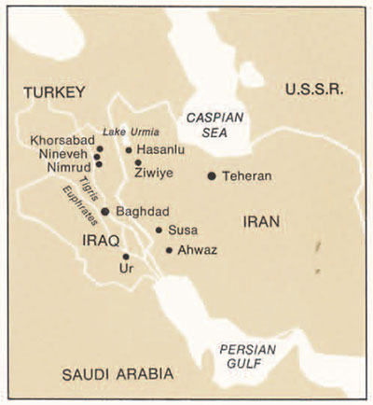
(Fig. 2) - (Dyson, 1968, pp. 21) In the south-western area of Iran within proximity to Susa the Kneeling Bull was said to be discovered.
The problem that frequently appears when comprehending the Proto-Elamite period and culture the sparsity of scholarly discussion, much of which took place in the 1960’s-1980’s (Alden, 1982; Lamberg-Karlovsky, 1978; Dyson, 1968; Hansen, 1970) lacked theoretical expansion that came with later post-processualist academics (Hodder, 1985; Hoskins, 2005; Fahlander & Kjellstrom, 2010) who began to suggest new methods of envisioning objects. Secondly, the Proto-Elamite culture was a formative culture with high levels of cultural homogeneity (Edens, 1992, pp. 129), which often can blur the line between Proto-Elamite or Mesopotamian. However, as the Proto-Elamite culture was the primogenitor to the Elamite Culture (3200- 539 BCE) the level of hybridity present becomes an embedded part of cultural interactions in both the Arabian Gulf and Southern Mesopotamian neighbours (Whitcomb, 1966, pp. 2-3), through trade, political, military, or socio-cultural forces (Edens, 1992, pp. 134;). In this analysis Proto-Elamite culture will be presented as a broad cultural and economic web (Alavarez-Mon, 2020, pp.59), which allows objects like the Bovine Figure provides a more malleable interpretation of the Proto-Elamites.
In examining the bovine figure, Hansen (1970) provides a notably lucid analysis of its physicality and supposed origins of the object. This astute investigation will be considered in this analysis as despite its age it provides an extensive framework for building upon the empirical qualities (Hansen, 1970 pp. 5-7). Scholars such as Pittman (2003, pp. 41-2) provide interesting but brief insights into the figure, as it is relegated to forgotten sidenote. Moorey (1993, pp. 131-2) builds upon Hansen’s earlier observations affirming that an intricate and multi-layered construction process took place. While more modern interpretations of Alvarez-Mon (2020, pp. 64) help solidify the commonplace of animals and animal hybrid symbology amongst the Proto-Elamite culture. The considerable shortage of research into the Bull figure, imbues it a level of esotericism even in modern research, and it is apparent many scholars (Moorey, 1993;) refuse to develop more speculative theories until more is deciphered about the Proto-Elamites. The work of modern archaeological theory and more antiquated empirical studies mesh well to attempt to elevate the bovine vessel beyond unclear socio-political rituals.
Empirical Observations of the Kneeling Bull
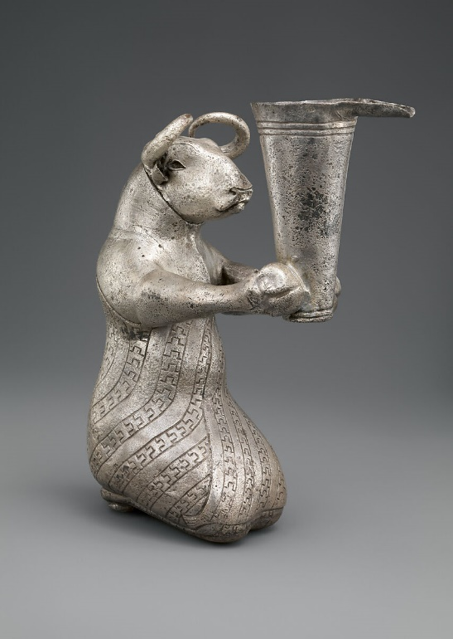
Fig. 3 (Metropolitan Museum, 1966)). A right facing view of the Kneeling Bull.
The dexterous and creative vigour of Proto-Elamite metalworkers is evident at first observations of the Kneeling Bull with Spouted Vessel (Accession Number: 66.173, Metropolitan Museum of Art). The figure is an anthropomorphised kneeling bovine figure holding a spouted vessel. The figures dimensions are listed as 16.3 x 6.3 x 10.8cm (Metropolitan Museum, 1966), making it a small and portable object. Furthermore, the figure is hollow inside and is filled with small pebbles (Pittman, 2003, pp. 43). The hybrid figure-vessel is made of silver, which was is a relative rarity in areas of southern Mesopotamia in the 4th-3rd millennia BCE (Sherratt, 2018, pp. 102), revealing the importance of extended exchange networks in unison with new forms of social display. The creation of the figure involved 15-17 flat pieces of flat silver that were hammered into rounded shapes, scarf joined by overlapping the silver, and then soldered along the legs. Additionally, the figure was worked from the inside by with tool marks in the body and head from hammers and blunt tools, further reinforcing both the technical mastery and the skilful rendering of hybrid-animal body forms (Moorey, 1993 pp. 132).
The figure Is dressed in an alternating stepped pattered robe that covers the legs and stomach portion of the body and stops below the raised arms. All upper edges of the cloth have been finely tooled with parallel lines. The legs, covered by the garment are folded beneath the figure, and receive less emphasis comparatively to the buttocks and knees, to emphasise a full kneeling position. Large horns emerge from the sides of the cranium and encircle around the head like a crowned monarch. The almond-shaped eyes are deeply set into the figure and may have been inlayed with additional material. The ears emerge blow the horns, with openings into the figure, which may have aided with noise reverberation. The depressions on the nostril are clear and deep and joined by a groove across the muzzle, which from a fuller appearance to the lips. The bull head is set into a thick and powerful curved neck, narrowing at the front and broader at the rear. Large shoulders and chest lead into the outstretched hooved arms (forelegs). The foreleg hooves are thin suggesting a simulacrum of human hands, which holds the lower part of the spouted vessel. The rear hooves are moderately flattened, Hansen (1970, pp. 7) suggests their curved tops would never have been able to stand on a hard surface without support. The silver vessel has long spout, with two lines incised at the base and three lines between the rim. When first acquired, the bovine figurine was covered with a layer of corrosive products. Moreover, the corrosion revealed traces of fabric (Hansen, 1970, pp. 6-7), indicating that the figure had been wrapped in cloth. The vessel displays no breakage but appears smoothed and tarnished around the body from usage.
Analysis
Silver was a highly prized material for the construction of precious objects in newly emergent urban centres of Mesopotamia (Sinclair, 2012, pp. 13). The use of silver on the bovine figure reveals the social dispute between copper and silver (Alden, 1982, pp. 622), in which silver began to now reflect an emerging ornament for display and exchange, and helped accumulate social, political, or even economical capital. Moreover, Silver was a rarity amongst the region, and was only obtainable (in quantity) from exchange with peripheral cultures, suggesting a level of exoticism inherent to its material in a Proto-Elamite context (Hansen, 1970, pp. 14). Helm suggests that cultural distance in acquiring silver renders it of the exotic, intangible or esoteric (Helm, 1988, pp. 137-9). Furthermore, the figure even before it is constructed was imbued with something beyond the mundane, and may require elite knowledge both in its craftsmanship and ownership required to ‘unlock’ its power (Broodbank, 2010, pp. 320-2). Silver enacts a unique performance on the senses, in which its reflective surface reacts with light, creating luminosity which in antiquity may be manifestations of the divine or the presence of divinity (Winter, 2002, pp. 7; Sinclair, 2012, pp. 6). These sensorial qualities also ensure the attention of the observer is held, and in socio-ritual contexts may act to enhance socio-cultural performances (Maran & Stockhammer, 2012 pp. 3).
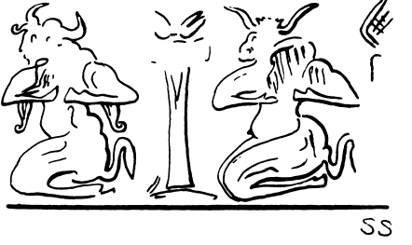
(Fig. 4) – (Hansen, 1970, pp. 13) A Proto-Elamite seal impression, from Susa. Reveals a similar kneeling bull motif to the figurine.
Anthropomorphic figures are deeply imbedded into Proto-Elamite culture (Alden, 1982, pp. 613), and it would be amiss to not discuss cosmological and symbolic communication of a hybrid creature. Malafouris et al, suggests that the human body can be ‘supplemented, expanded and integrated’ with material artefacts (Malafouris et al, 2014, pp. 3). In the case of the bovine figure the hybridity integrates votive messages, to engage with agents (Shriver-Rice, 2009, pp. 1-3) through dedicated gods (Campbell. 2004, pp. 69), magical rituals, or embodied shamanism, the figure encapsulates a mediatory role between humans and the divine (Alvarez-Mon, 2020, pp. 69). Furthermore, it suggests heightened connection into the celestial world of the gods (Hansen, 1970, pp. 12) and may have been necessary in an increasingly structured world of crowded cities, trans-cultural interactions, and socio-economic changes. From this perspective the figure may have helped maintain social cohesion in the formative stages of the Proto-Elamite culture and renegotiate a changing relationship with the natural world, in the throes of advancing Urbanization (Stockhammer, 2012, pp.8). Nadali (2019 pp. 63) suggest encounters between art objects (bull figure) and agents generates a vital moment of symbolic memory, helping to (re)negotiate the past and future (Bailey, 2014, pp. 29). The Kneeling body-schema of an anthropomorphic bull, an animal of power, evokes a sense of furtive submission or worship in the eyes of the godhead or ruler (Grombrich, 1966, pp. 396). In addition, the characterisation of the figure in such a human position, preludes a movement between the worlds; of celestial and mortal, animal and human (McMahon, 2022, pp. 243).
Bull symbolism has deep rooted mythical origins in near eastern culture and has developed to represent symbols of fertility, power, greatness, virility, strength, intimidation as well as decorative function(s) (Hussein, 2020, pp. 746). Moreover, the bull partakes an important cosmological roll, involved in the struggles of life and death, good and evil, and mythological stratification. The bull also bears strong connections to royalty (Noffke, 1966, pp. 14) and authority. This essence of royal authority is further enhanced by the ‘crown of horns’ encircling around the cranium, an animalistically dangerous and regal symbolic formation on the figure. The drinking vessel sits at the end of outstretched hooves, which invites the beholder to both physically imbibe and to symbolically sip on ‘bottled’ divinity, prestige, and power such an object may bestow. The Bull beholds (or judges) those who drink, and it enchants (Gell; 2010) it’s audience through this performance as they must observe the face and bodily proportions to drink from the vessel. The longer length of the spout must be observed as it appears the bull controls the speed of imbibement, if consumed with alcohol it invokes transformative effects (ASC) to provoke emotions, human stimulation, sensory effects that can catalyse social changes (Wang & Liu, 2022, pp. 5). Suggesting the embodied bull, is the one capable of elevating the user to otherworldly realms. The small pebbles inside of the figure may have acted to enhance socio-ritual performances (Fahlander & Kjellstrom 2010, pp. 6) through auditory and tactile stimulation as the pebbles moved, the bull may also function as a symbolic aid and helped enhance socio-memorial function (DeMarrais, 2014, pp. 158). The patterned robe represents another tactile experience, when held the repetitive textures reveal ‘enactive knowledge’ (Tringham, 2010, pp. 188) which becomes an internalized socio-cultural experience amongst those who engaged.
Conclusion:
The imaginative capabilities and technical talent of the Proto-Elamite craftsmen are obvious when analysing the Bull figurine. The use of silver reflects a desired sensorial performance with the audience and user, the distant, esoteric, or even otherworldly. The common place of anthropomorphic figures represents a form of symbolic communication that may amalgamate a notion of active hybridity. This hybridity bridges a movement between nature and the structured world and mortal and divine. The figurine was an object of communal yet social elite use, as group identity would be negotiated via imbibement and sensorial engagement with the figure and vessel. The engagement between the figurine and peripheral agents, must have evoked a plethora of sensory responses, that through repetitive symbology committed itself to a symbolic memory function (Renfrew & Scarre, 1998, pp. 229). The bull is multi-faceted symbol, that commands power and authority, it bears a regal ‘crown of horns’ that reveal a link between symbolically imbibement access to heightened realms of authority and providence. Ultimately, the bull figure still remains mysteriously exquisite multi-faceted object, which could articulate whole books off speculation on its function and material connections. This analysis aimed to provoke a theoretically (re)analysis, in hopes to reveal a more diverse assessment of the figure’s material and sensory qualities.

References:

Alden, J.R. (1982), Trade and Politics in Proto-Elamite Iran [and Comments and Reply], Current Anthropology, Vol. 23, No. 6, pp. 613-640, Published by: University of Chicago Press, Url: https://www-jstor-org.ezproxy.uwtsd.ac.uk/stable/2742643?seq=4, Accessed online: 08/03/23
Alvarez-Mon, J. (2020), The Art of Elam ca. 4200-525 BCE, Chapter 3: The Proto-Elamite Period - Susa and the highlands (ca. 3100–2900 bc), Vol. 1, pp. 59-77, Published by: Routledge Url: https://www.routledgehandbooks.com/doi/10.4324/9781003018254-4, Accessed online: 08/03/23
Bailey, D. (2014),Sculpture and Touch, Chapter: Touch and the cheirotic apprehension of prehistoric figurines, pp. 27-44, Published by: Ashgate Pub Co., Url: https://www.abebooks.co.uk/Sculpture-Touch-Dent-Peter-Editor-Ashgate/13389923006/bd, Accessed online: 19/02/23
Brentjes, B. Tosi, M. (1983), On Proto-Elamite Iran, Current Anthropology, Vol. 24, No. 2, pp. 240-1, Published by: University of Chicago Press, Url: https://www-jstor-org.ezproxy.uwtsd.ac.uk/stable/2742592?searchText=&searchUri=&ab_segments=&searchKey=&refreqid=fastly-default%3A0563a1c103618ecc21c5be5285b33372, Accessed online: 08/03/23
Broodbank, C. (2010), Ulysses without sails: Trade, distance, knowledge and power in the early Cyclades, World Archaeology, Vol. 24, No.3, pp. 315-331, Published by: Taylor & Francis, Url: https://www.tandfonline.com/doi/abs/10.1080/00438243.1993.9980211, Accessed online: 15/02/22
Campbell, L.M. (2005), Anthropomorphic and Zoomorphic Figurines of the Eastern Mediterranean, Iris: the Journal of the Classical Association of Victoria Vol. 18, pp. 65-72, Published by: Academia, Url: https://www.academia.edu/426922/Anthropomorphic_and_Zoomorphic_Figurines_of_the_Eastern_Mediterranean, Accessed online: 09/03/23
DeMarrais, E. (2014), Introduction: The Archaeology of Performance, World Archaeology, Vol. 46, No. 2, pp. 155-163, Published by: Taylor & Francis, url: https://www.tandfonline.com/doi/pdf/10.1080/00438243.2014.899157, Accessed online: 19/12/20
Dyson, R.H. Jr. (1968), Early Work on the Acropolis At Susa, The Beginning of Prehistory in Iraq and Iran, Vol. 10, No. 4, pp. 21-34, Published by: Expedition & Penn Museum, Url: https://www.penn.museum/sites/expedition/early-works-on-the-acropolis-at-susa/, Accessed online: 08/03/23
Edens, C. (1992), Dynamics of Trade in the Ancient Mesopotamian "World System" American Anthropologist,, Vol. 94, No. 1, pp. 118-139, Published by: Wiley, Url: https://www-jstor-org.ezproxy.uwtsd.ac.uk/stable/680040?searchText=&searchUri=&ab_segments=&searchKey=&refreqid=fastly-default%3A0563a1c103618ecc21c5be5285b33372, Accessed online: 08/03/23
Fahlander, F. & Kjellstrom, A. (2010), Making Sense of Things – Archaeologies of Sensory Perception, pp. 1-10, Published by: TMG Sthlm Stockholm, Url: , Accessed Online: 21/10/20
Gell, A. (2010), The Theory of Enchantment and the Enchantment of Theory: The Art of Alfred Gell, No. 2, Vol. 80, pp. 40-63 Published by: Wiley, Url: https://www.jstor.org/stable/25699954, accessed online: 12/02/22
Grombrich, E.H. (1966), Ritualized Gesture and Expression in Art, Philosophical Transactions of the Royal Society of London. Series B, Biological, Vol. 251, No. 772, pp. 393-401, Published by: Royal Society, Url: https://royalsocietypublishing.org/doi/10.1098/rstb.1966.0025, accessed online: 06/02/23
Hansen, D. (1970), A Proto-Elamite Silver Figurine in the Metropolitan Museum of Art, Metropolitan Museum Journal, Vol. 3, pp. 5-26, Published by: Metropolitan Museum Journal,, Url: https://www-jstor-org.ezproxy.uwtsd.ac.uk/stable/1512596?seq=22, Accessed online: 08/03/23
Helms, M.W. (1988), Ulysses' Sail: AN ETHNOGRAPHIC ODYSSEY OF POWER, KNOWLEDGE, AND GEOGRAPHICAL DISTANCE, pp. 1-297, Published by: Princeton University Press, Url: https://booksc.org/book/79838600/a9c3d9, Accessed online: 15/02/22
Hodder, I. (1985), Postprocessual Archaeology, Advances in Archaeological Method and Theory, Vol. 8, pp. 1-26, Published by: Springer, Url: https://www-jstor-org.ezproxy.uwtsd.ac.uk/stable/20170185?seq=6#metadata_info_tab_contents, Accessed online: 07/01/23
Hoskins, J. (2005), Chapter 5: AGENCY, BIOGRAPHY AND OBJECTS, Handbook of Material Culture, pp. 74-84, Published by: ResearchGate, Url: https://www.researchgate.net/publication/288915635_Agency_biography_and_objects, Accessed online: 10/10/22
Hunt, P. (2018), Proto-Elamites: Master Sculptors of Animals in Antiquity, Electrum Magazine: Why the Past Matters, pp. 1-2, Published by: Electrum Magazine, Url: http://www.electrummagazine.com/2018/08/proto-elamites-master-sculptors-of-animals-in-antiquity/, Accessed online: 08/03/23
Hussein, I.L. (2020), Bull Symbolism in Ancient Iraqi Thought, International Journal of Innovation, Creativity and Change, Vol. 11, No.2, pp. 734 – 749, Published by: International Journal of Innovation, Url: https://www.ijicc.net/images/vol11iss2/11243_Hussein_2020_E_R.pdf, Accessed online: 09/03/23
Kiernan, P. (2015), Miniature Objects as representations of Realia, World Archaeology, No. 47, Vol. 1, pp. 45-59, Published by: Routledge, Url: http://www.tandfonline.com/loi/rwar20, Accessed online: 12/02/23
Lamberg-Karlovsky, C.C. (1978), The Proto-Elamites on the Iranian Plateau, Antiquity, Vol. 52, No. 205, pp. 114-120, Published by: Antiquity Publications Ltd, Url: https://www.cambridge.org/core/journals/antiquity/article/abs/protoelamites-on-the-iranian-plateau/EC0A47FF4CDC9E8FE3DD04B975084FDD, Accessed online: 08/03/23
Maran, J. Stockhammer, P.W. (2012), Materiality and Social Practice: Transformative Capacities of Intercultural Encounters, Vol. 1, pp. 224, Published by: Oxbow Books Oxford & Oakville, Url: https://www.jstor.org/stable/j.ctvh1dhvj, Accessed online: 12/02/22
McMahon, A. (2022), COMPOSITE HUMAN-ANIMAL FIGURES IN EARLY URBANNORTHERN MESOPOTAMIA: SHAMANS OR IMAGES OFRESISTANCE?, OXFORD JOURNAL OF ARCHAEOLOGY, Vol. 41, No. 3, pp. 230-51, Published by: Wiley & Sons, Url: https://onlinelibrary.wiley.com/doi/epdf/10.1111/ojoa.12251, Accessed online: 10/03/23
Moorey, P.R.S. (1993), High Relief Decoration on Ancient Iranian Metal Vessels: Development and Influence, New Series, Vol. 7, Iranian Studies in Honor of A.D.H Bivar, pp. 131-139, Url: https://www.jstor.org/stable/24048435, Accessed online: 09/03/23
Nadali, D. (2019), The Power of Narrative Pictures in Ancient Mesopotamia, pp. 63-80, Published by: Heideberg, Url: https://books.ub.uni-heidelberg.de/propylaeum/reader/download/399/399-30-85903-1-10-20190807.pdf, accessed online: 29/01/23
Noffke, G.L. (1966), The Symbol of the Bull as an Art Form, pp. 1-52, Published by: Eastern Illinois University, Url: https://thekeep.eiu.edu/cgi/viewcontent.cgi?article=5219&context=theses#:~:text=for%20many%20centuries.,the%20sun%2C%20god%20of%20thunder, Accessed online: 09/03/23
Pittman, H. (2003), The Proto-Elamite Period: Cities of the South: Art of the Early City-States, Art of the First Cities, The Third Millennium B.C. from the Mediterranean to the Indus, Edited by: Joan Aruz & Ronald Wallenfels, pp. 42-57, Published by: The Metropolitan Museum of Art & Yale university Press, Url: https://www.metmuseum.org/art/metpublications/Art_of_the_First_Cities_The_Third_Millennium_BC_from_the_Mediterranean_to_the_Indus, Accessed online: 08/03/23
Renfrew C. Scarre, C. (1998), Cognition and Material Culture: the Archaeology of Symbolic Storage, Published by: American journal of Archaeology, Vol. 106, No. 2, pp. 1-318, url: https://www.researchgate.net/publication/269423026_Cognition_and_Material_Culture_The_Archaeology_of_Symbolic_Storage, accessed online: 04/05/22
Sackett, J.R. (1997), The Meaning of Style in Archaeology: A General Model, American Antiquity, Vol. 42, No. 3, pp. 369-380, Published by: Cambridge University Press, Url: https://www-jstor-org.ezproxy.uwtsd.ac.uk/stable/279062?seq=1#metadata_info_tab_contents, Accessed online: 12/11/20
Sharp, L.A (2000), THE COMMODIFICATION OF THE BODY AND ITS PARTS, Vol. 29, pp. 287-328, Published by: Annual Reviews, Url: http://lchc.ucsd.edu/cogn_150/Readings/sharp.pdf, Accessed online: 04/05/22
Sherratt, S. (2018), Why was (and is) silver sexy? Silver during the 4th-3rd millennia in the Near East and Mesopotamia. Universities of Leeds, Sheffield and York, pp. 97-106, Published by: White Rose University Consortium, Url: https://eprints.whiterose.ac.uk/138782/1/SS%20Metals%2C%20Minds%20and%20Mobility_Chapter-7.pdf, accessed online: 09/03/23
Shriver-Rice, M. (2009), Materiality, Objects, and Agency: Examples from Archaeology and Anthropology A Brief Overview, No. 1, pp. 1-17, Published by: ResearchGate, Url: https://www.researchgate.net/publication/312376598_Materiality_Objects_and_Agency_Examples_from_Archaeology_and_Anthropology_A_Brief_Overview, accessed online: 04/05/22
Sinclair, A. (2012), Colour Symbolism in Ancient Mesopotamia, pp. 1.-15, Published by: AncientPlanet, Url: https://hcommons.org/deposits/item/hc:24491, accessed online: 29/01/23
Stockhammer, P.W. (2011), Conceptualizing cultural hybridization in archaeology, Transcultural Research – Heidelberg Studies on Asia and Europe in a Global Context, Vol. 1, pp. 43-58, Published by: Springer Berlin & Heidelberg, Url: https://link.springer.com/book/10.1007/978-3-642-21846-0#about, Accessed online: 24/02/22
Tringham, R. (2012), A SENSE OF TOUCH - THE FULL-BODY EXPERIENCE - IN THE PAST AND PRESENT OF ÇATALHÖYÜK, TURKEY, Making Senses of the Past: Toward a Sensory Archaeology, pp. 177-195, Published by: University of California, Url: https://d1wqtxts1xzle7.cloudfront.net/30871844/RET_SIU_senses_071912-libre.pdf?1392206467=&response-content-disposition=inline%3B+filename%3DA_Sense_of_Touch_the_Full_Body_Experienc.pdf&Expires=1678408675&Signature=H59efbuXC~dv6Mcq0rHXBWh19mennjmcfkUlm5Qo85m3slB0GKELzvZVdAUha5aLeqZP65A9tGjHQVDL2Z0qGXDE5SyCy9MesLEwHXAgtNSDOwz3hriFfC1QS4eg3Zn9UXroahZ8NOAItwlnWHGOXrub7VJBzL-zSlaWSRCBpRzBvn7I1-CSx8ErjxR-GMX6A6mi5sA6ERQ5UdFgo8d5Ud1M3A9ZkI0SK~NXCqbNUA467uDVeEzapRxCB5coyVir0p27JOOi-AJ3aO0zH3WARSmg1Dq4rN2pwWChozXe1yp4hWLcfRwfUPyOWDhQw1zgMx2kqb5wfybFi1zD56c2BQ__&Key-Pair-Id=APKAJLOHF5GGSLRBV4ZA, Accessed online: 10/03/23
Wang, J. Liu, L. (2022), Introduction: Alcohol, rituals, and politics in the ancient world, Journal of Anthropological Archaeology, Vol. 65, pp. 1-8, Published by: Elsevier, Url: https://reader.elsevier.com/reader/sd/pii/S0278416522000058?token=2DD8ADFDA72A5F4F10FF0533BDB9828E6F78A625DAB2E98B9092F9B4843A40E8F427D0956D971DC8132D7644E6AA45BD&originRegion=eu-west-1&originCreation=20230309201313, Accessed online: 09/03/23
Whitcomb, D.S. (1966), The Proto-Elamite Period at Tall_I Ghazir, Iran, Emory University, Published by: University of Georgia, pp. 1-106, Url: https://www.academia.edu/393665/The_Proto_Elamite_Period_at_Tall_I_Ghazir_Iran, Accessed online: 09/03/23
Winter, I. (2002), Defining "Aesthetics" for Non-Western Studies: The Case of Ancient Mesopotamia. Art history, Aesthetics, Visual Studies. M. A. Holly and K. Moxey (eds.). Williamstown, Mass, pp. 3-28, Published by: Sterling and Francine Clark Art Institute, Url: https://www.academia.edu/36234144/Winter_I_J_2002_Defining_Aesthetics_for_Non_Western_Studies_The_Case_of_Ancient_Mesopotamia_Art_history_Aesthetics_Visual_Studies_M_A_Holly_and_K_Moxey_eds_Williamstown_Mass_Sterling_and_Francine_Clark_Art_Institute_3_28, Accessed online: 09/03/23
Image References:
Fig 1. – Metropolitan Museum, (1966), Kneeling bull holding a spouted vessel, Proto-Elamite, ca. 3100–2900 BCE, Metropolitan Museum of Art, Purchase, Joseph Pulitzer Bequest, Published by: The Metropolitan Museum of Art, Url: https://www.metmuseum.org/art/collection/search/329074?searchField=All&amp;sortBy=relevance&amp;deptids=3&amp;high=on&amp;ft=*&amp;offset=0&amp;rpp=40&amp;pos=16, Accessed online: 07/03/23
Fig. 2 – Dyson, R.H. Jr. (1968), Early Work on the Acropolis At Susa, The Beginning of Prehistory in Iraq and Iran, Vol. 10, No. 4, pp. 21-34, Published by: Expedition & Penn Museum, Url: https://www.penn.museum/sites/expedition/early-works-on-the-acropolis-at-susa/, Accessed online: 08/03/23
Fig 3. -– Metropolitan Museum, (1966), Kneeling bull holding a spouted vessel, Proto-Elamite, ca. 3100–2900 BCE, Metropolitan Museum of Art, Purchase, Joseph Pulitzer Bequest, Published by: The Metropolitan Museum of Art, Url: https://www.metmuseum.org/art/collection/search/329074?searchField=All&amp;sortBy=relevance&amp;deptids=3&amp;high=on&amp;ft=*&amp;offset=0&amp;rpp=40&amp;pos=16, Accessed online: 07/03/23
Fig 4. - Hansen, D. (1970), A Proto-Elamite Silver Figurine in the Metropolitan Museum of Art, Metropolitan Museum Journal, Vol. 3, pp. 5-26, Published by: Metropolitan Museum Journal,, Url: https://www-jstor-org.ezproxy.uwtsd.ac.uk/stable/1512596?seq=22, Accessed online: 08/03/23

