

Student name: Rahima Sheikh Ibrahim
Student ID:2336641

Module name: Changemakers: Building your Personal Brand for Sustainable
Module code: BMHP5015
Lecturer name: Caroline Salami

Report: Developing Employability for the Role of Healthcare Support Worker (NHS)

Table of Contents
1. Introduction 3
2. Job Description of the Selected Job 3
3. Analyse the Skills Needed for the Job and Assess Your Skills and Experience 4
Self-Assessment of Current Skills and Experience 5
4. Development of Personal Skills and Resources 6
5. Action Plan and Timeline 7
6. Communication of Skills to Potential Employers 9
7. Conclusion 9
References 11

1. Introduction
In this report, the occupational role of the Healthcare Support Worker (HCSW) at University Hospitals Sussex NHS Foundation Trust as published on the NHS Jobs in March 2025 (NHS Jobs, 2025) will be discussed. I have chosen this role because it aligns with my values of compassion, integrity, and service that first led me towards Health and Social Care. The reason I am interested in working in the NHS is its philosophy of providing equal and quality care at no cost that directly relates to my personal beliefs of social justice and human dignity. This job is also another milestone towards my future career as a registered nurse. The structure of this report will be as follows: in the first part I will discuss the skills that the job will need and evaluate my personal skills; the second part will discuss how I will develop my personal skills and resources; the third part will discuss my action plan and timeline; the fourth part will discuss how I will convey my skills to prospective employers; and the last part will be a conclusion.

2. Job Description of the Selected Job

The Healthcare Support Worker (HCSW) at University Hospitals Sussex NHS Foundation Trust is a particular Health and Social Care job that I am interested in doing. The work description involves the job holder helping the patients with personal care (washing, toileting, dressing), monitor and note vital signs (blood pressure, temperature, pulse), aid feeding and movement, and documenting accurately care given to the patients by using electronic records (NHS Jobs, 2025). The person specification demands Level 2 in Literacy and Numeracy and prior experience in care (paid or unpaid) and the capacity to demonstrate behaviours that support the NHS Constitution Values, such as respect, dignity, compassion and collaborating on behalf of patients (Scott and Willison, 2021).
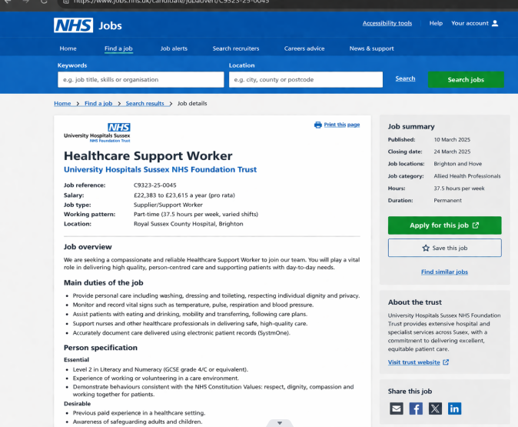

3. Analyse the Skills Needed for the Job and Assess Your Skills and Experience
Skills Required for the Job
According to the job description, there are four main employability skills needed to succeed in this job:
Communication: The HCSW should explain clinical procedures to scared patients using clear words that would be reassuring, and also inform registered nurses about slight changes in the condition of a patient with the use of specific clinical terminology. This two-sided need is an evidence of what theorists refer to as code-switching (Fajaryati et al., 2020).
Resilience: Working in a hospital ward implies a certain level of exposure to suffering and end-of-life situations, challenging family experiences, and even verbal or physical aggression. Burnout and compassion fatigue are critical dangers to patient safety without strong emotional resilience.
Teamwork: The HCSW has to collaborate well with nurses, physicians, physiotherapists, occupational therapists, social workers, and household workers all with varying priorities towards one end goal; patient wellbeing.
Digital Literacy: The majority of NHS trusts currently have electronic patient record systems (such as SystmOne or EMIS). The HCSW should be able to log-in safely, navigate menus, input observations accurately, and mark abnormal results and comply with GDPR data protection (Scott and Willison, 2021).
Applying the Skills for Care Core Skills Framework (Skills for Care, 2022), the competencies that are specific to this role are person-centred care and safeguarding. Using the 6Cs of Nursing (NHS England, 2017) Compassion, Competence, Courage, Communication, Commitment, and Care, a real-life scenario would be when a support worker confronts a dementia patient who is distressed and refuses to be looked after, and turns verbally aggressive instead. With the help of emotional intelligence, the worker discerns non-verbal cues (fist clenching, lack of eye contact) and diverts the patient by providing a cup of tea and a favourite photo. It reduces the use of physical restraint and maintains patient dignity.
Systematic experience is the acquisition of employability skills whose theory is featured in the Learning Cycle (Kolb, 1984). A tangible experience (patient refusal) results in reflective observation (asking why that happened), causing abstract conceptualisation (trust must precede care), and active experimentation (sitting quietly with the patient first). By cycling, a painful experience turns into a professional competence (Tushar and Sooraksa, 2023).

Self-Assessment of Current Skills and Experience
To critically evaluate my profile with the HCSW requirements, I used a SWOT analysis to compare my current profile and requirements.
Strengths: I have finished a Level 2 Certificate in Health and Social Care and this involved basic life support, moving and handling practices, and basics protection. My voluntary placement supervisor gave me positive feedback that I am naturally kind and can easily be cool in stressful situations. I have good written communication.
Weaknesses: I do not have any paid care experience, just volunteering. I am only digitally literate with simple office programs; I have never dealt with an NHS electronic patient record system. I am not fond of emotionally-charged discussions as well.
Opportunities: Future NHS offers free NHS learning in digital skills, and I can volunteer in my local Age UK branch to gain practical experience.
Threats: Intense competition in the job of the NHS support worker (usually there are more than 50 candidates per vacancy) and the fact that my work schedule may be incongruent with part-time education.
To further explain, I applied Gibbs Reflective Cycle (Gibbs, 1988) to something that had happened when I was at a care home as a volunteer. One case of dementia patient, yelling at the table, threw a spoon (Monteiro et al., 2022).
Description: I stood in silence a few seconds till a more senior colleague came in and guided the resident towards a favourite photograph.
Feelings: I was terrified, inadequate and humiliated.
Evaluation: The good thing was that I did not scream back. The downside was I was paralysed and failed to de-escalate using a de-escalation plan.
Analysis: I was not trained in de-escalation and my brain had reverted to freeze response to threat.
Conclusion: I need to be taught the practical, scenario-based methods of dealing with distressed behaviour rather than just theoretical information.
Action Plan: Within eight weeks, complete a free online dementia awareness and de-escalation online course provided by the Alzheimer Society.
This self-evaluation demonstrates my readiness to accommodate weaknesses. With the help of the Hierarchy of Needs based on Maslow (Maslow, 1943), my needs of belonging and esteem are fairly met with academic results and favourable feedback on the placement. My practical competence in the face of pressure, however, is not as high in practical competence in the face of pressure as I need to make myself a better care worker than I am today, which is my need to self-actualise. A valuable result of this assessment is that my voluntary placement helped me gain clarity about my development priorities.

4. Development of Personal Skills and Resources
In order to develop my personal brand, I will concentrate on my values of empathy, accountability, and lifelong learning that directly connect to the values of the NHS Constitution respect, dignity, and compassion (NHS England, 2021). What I call My Unique Selling Point (USP) is the combination of academic rigour (high grades in written work) and the practical hands-on experience in volunteering. There are lots of applicants who possess only theoretical knowledge and do not have practical experience, or who possess practical experience but lack reflective ability - I have both. My two best personality types according to the Theory of Career Choice developed by Holland (Holland, 1997) are Social (enjoys to help, to teach and to serve others) and Realistic (enjoys practical and hands-on work). This is precisely what is needed in the HCSW position.
To build professional contacts, I will become a member of Student Hub of Royal College of Nursing (free, but requires aspiring nursing associates to become a member) and follow NHS Sussex on LinkedIn, posting insightful comments to their posts. I will also visit two NHS virtual careers events this year.
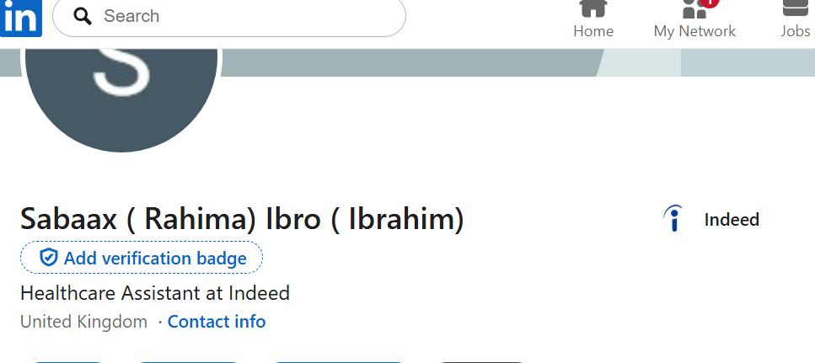

Figure 1: Screen shot of Support Worker Job Description
The materials I will require to achieve the skills I need are:
• Digital skills training: Free Digital Skills for Care course (Skills for Care)
• Dementia awareness and de-escalation training: Free online dementia awareness and de-escalation training (Alzheimer's Society).
• Experience in paid care: Applications to local care homes and NHS bank.
• Interview preparation: Practice interview with my past placement supervisor.
• Internet and laptop to do online schooling and job applications.

5. Action Plan and Timeline
I am looking to achieve a part-time HCSW job by December 2026 and a Nursing Associate apprenticeship by 2028. The following action plan is my SMART-based action plan (Doran, 1981).
Goal (SMART) | Activities | Resources | Deadline
Short-term: Complete Level 3 Diploma in H&SC | Attend classes weekly, complete assignments | College library, tutor support | Aug 2026
Short-term: Gain digital literacy | Complete "Digital Skills for Care" (Skills for Care) | Laptop, internet | May 2026
Medium  Term: obtain paid HCSW role | Apply to NHS bank, attend interview prep session | CV, LinkedIn, interview coaching | Dec2026
Longterm: Secure Nursing Shadow a nurse applies for apprenticeship  Associate position |  | Mentor, NHS career Advisor Sept  2028

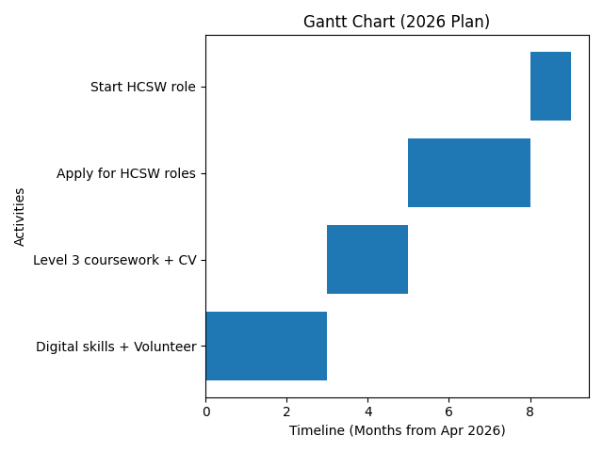
Based on the Self-Efficacy Theory of Bandura (Bandura, 1977), I will cultivate my self-belief in success by role modelling a successful peer (a friend who has been hired by a bank as the HCA) and being supported by a mentor. The previous placement supervisor will also be asked to carry out a mock interview to gain confidence.

6. Communication of Skills to Potential Employers
In order to convey my skills to my future employers, I will employ the following techniques:
CV: I will include in my CV the experience of my voluntary placement and transferable skills, such as active listening, time management, and confidentiality keeping. I will not simply enumerate duties, I will use the STAR method (Situation, Task, Action, Result) to explain particular contributions. As an illustration: "During my voluntary placement in a care home (Situation), I was asked to help a resident with dementia who did not want any personal care (Task). I sat silently with them and showed them a favorite photograph (Action), which led to the resident feeling calmer and accepting support (Result).
LinkedIn Profile: In my LinkedIn profile, I will have a profile photo, a headline of Aspiring Healthcare Support Worker Level 2 H&SC Compassionate and Reliable, and a featured section with my Level 2 certificate and a reflective case study (Monteiro et al., 2022).
Online Portfolio: I will create a simple online portfolio with the help of Google Sites that will include my CV, certificates, a written reflection on a challenging care situation, and a short video on why I am pursuing this career.
Professional Networks: To enhance my professional visibility, I will join Royal College of Nursing student networks and approach NHS Sussex on LinkedIn.

7. Conclusion
Finally, my profile is an excellent beginning to the role of a Healthcare Support Worker, especially when it comes to the alignment of values and the basic care skills. Digital literacy, the paid care experience, and emotional resilience in the face of a difficult situation are the most significant areas that I will gain. These gaps are directly addressed through my action plan through SMART goals, volunteering, and networking. In the process I have learnt that employability is not the perfection that one has at the given point in time, but the honest self-assessment coupled with a planned and inspired action. This has given me more interest to work in the NHS, and I am determined to work with the bank as an HCSW by December 2026.

References
Bandura, A. (1977) ‘Self-efficacy: Toward a unifying theory of behavioral change’, Psychological Review, 84(2), pp. 191–215.
Doran, G.T. (1981) ‘There’s a S.M.A.R.T. way to write management’s goals and objectives’, Management Review, 70(11), pp. 35–36.
Fajaryati, N., Budiyono, Akhyar, M. and Wiranto, 2020. The employability skills needed to face the demands of work in the future: Systematic literature reviews. Open Engineering, 10(1), pp.595-603.
Gibbs, G. (1988) Learning by Doing: A Guide to Teaching and Learning Methods. Oxford: Further Education Unit, Oxford Polytechnic.
Holland, J.L. (1997) Making Vocational Choices: A Theory of Careers. 3rd edn. Englewood Cliffs, NJ: Prentice-Hall.
Kolb, D.A. (1984) Experiential Learning: Experience as the Source of Learning and Development. Englewood Cliffs, NJ: Prentice-Hall.
Maslow, A.H. (1943) ‘A theory of human motivation’, Psychological Review, 50(4), pp. 370–396.
Monteiro, S., Almeida, L., Gomes, C. and Sinval, J., 2022. Employability profiles of higher education graduates: a person-oriented approach. Studies in higher education, 47(3), pp.499-512.
NHS England (2017) The 6Cs of Nursing. Available at: https://www.england.nhs.uk/6cs/ (Accessed: 2 April 2026).
NHS England (2021) NHS Values. Available at: https://www.england.nhs.uk/values/ (Accessed: 2 April 2026).
NHS Jobs (2025) Healthcare Support Worker – University Hospitals Sussex. Available at: https://www.jobs.nhs.uk (Accessed: 1 April 2026).
Scott, F.J. and Willison, D., 2021. Students’ reflections on an employability skills provision. Journal of Further and Higher Education, 45(8), pp.1118-1133.
Skills for Care (2022) Core Skills Framework for Health and Social Care. Leeds: Skills for Care.
Tushar, H. and Sooraksa, N., 2023. Global employability skills in the 21st century workplace: A semi-systematic literature review. Heliyon, 9(11).

