

Module: Community Care and Development
Module code: BMHP6022
Student name /Student number: Shekinah mala Biasala
Assessment Component 2: Written Assignment (Report)
Task: Approaches and Initiatives for Addressing Health and Social Needs of a Community

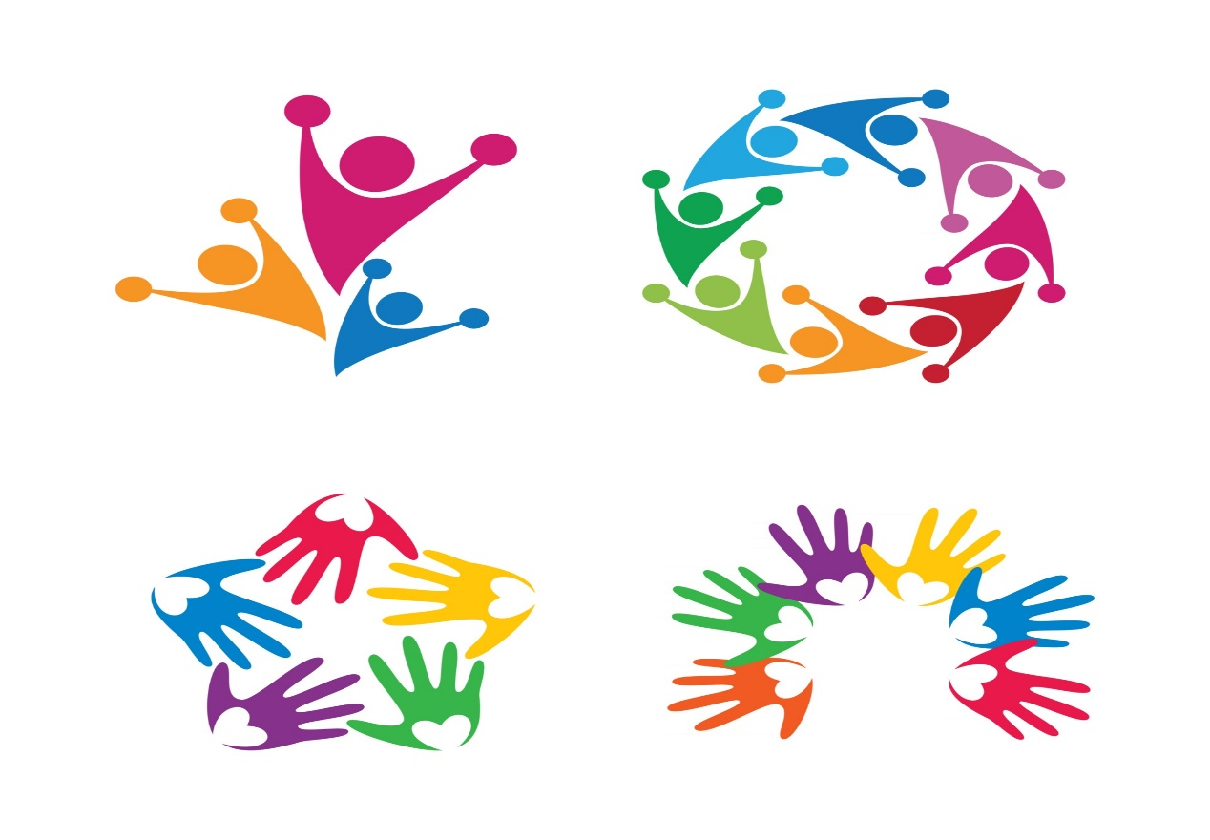

Table of Contents
Introduction 3
Overview of main characteristics and demographics of the community 3
Exploring the health needs and social issues faced within the community 4
Approach and initiative to drive health and social improvements 5
Methods to communicate and raise awareness of the population of focus 6
Recommendations 7
Conclusion 7
References 8




Introduction
Community care and development are potentially intended to help and support people belonging to a particular community to satisfy their health and social needs by addressing the issues that are faced by them. The main aim is to improve the overall health and social aspects for ensuring that the people live with dignity and in an independent manner. This comprises of three main approaches that involves primary care, health promotion and community development (Popple, 2015). It potentially focuses on addressing the social, cultural, economic and other subsequent issues to drive the health and social improvements. The main objective is to work with the community people to make them aware regarding the issues and help them by providing knowledge regarding the approaches and initiatives to make improvements (Bulmer, 2015). This particular report is based on this aspect of community care and development and is particularly focused on the young people of Barking and Dagenham. The main aim of this report is to meet and promote the health and social care within this community by taking proper actions aligning the identified approach and initiative and by communicating the same to the population of focus. The main focus is to address the identified health and social needs that exist in the community to drive their health and social improvements.

Overview of main characteristics and demographics of the community
The community of focus is Barking and Dagenham, which is the London Borough situated in East London. The population of focus is the young people of this particular borough. The borough consists of a total population of more than 218 thousand as of 2021, which has increased by 17.7% since 2011. The children between the age group of 0 to 15 years accounts to 26% of this population. 65% of this population consists of the young people and the adults falling in the age group of 16 to 64 years and the rest 9% is the older people who belong to the age group of 65 years and more. The total population of this age group has decreased by 1.7% while the people in the age group of 15 to 64 years have significantly increased in numbers and this resulted in the increase in their population by 20.8% (London Borough of Barking and Dagenham, 2023). The community consists of different ethnicities such as Asian, White, Mixed and Black (ONS, 2022). Majority of the population. 76% uses English as their main language and 45% follows Christianity. 45% of the population are predominantly from white ethnicities while 55% of the population are from the non-white ethnicities. The Asian people are the largest minority group consisting of 25.9% and this is followed by the Black ethnicities that consists of 21% of the population. The sex ratio is 94.9 males as compared to 100 females. The age statistics denote that 75.5% of the population belongs to the age group of 18 and more. The working population constitutes of 66,8% and the people under the age of 16 represents 24.5% of the total population. The community consists of people from different religions which includes Buddhist (0.4%), Hindu (3%), Jewish (0.1%), Muslim (24.4%), Sikhs (2%) and others (24.7%) along with Christianity as majority (Varbes, 2023).

Exploring the health needs and social issues faced within the community
The health needs associated with the young people of Barking and Dagenham potentially align to the issues that exist in the societies. The crime rate in the community is high, 93 crimes for every 1000 people and this makes it one of the most dangerous boroughs in London (CrimeRate, 2023). Knife Crime is one of the most prevalent crimes associated with the young people of Barking and Dagenham. This is thereby one of the major issues associated with the health needs of these young people. There are numerous cases of stabbing, threatening and being armed with knives that have been reported and for which young people are remanded in the borough (Williams et al., 2021). This forced the council to take decisions like punishing shops who sell knives to kids and young people to address this issue. These crimes have been majorly done on the young people by the ones belonging to their age group and this thereby have resulted in emergence of health needs and social issues associated with it (Barking and Dagenham, 2023a). The pandemic situation made teenagers and young people more vulnerable owing to the associated economic and other issues that further led to the disproportionate increase in the killings of young people because of knife crime. According to the ONS report, the total number of knife crimes had been the highest as per the records in 2021 and 2022 since the last 76 years. There had been an 18% rise in the number of male victims in the last 12 months till March of 2022. There is a largest increase in volume for the young boys of 16 and 17 years who had been involved in homicides using knives. There has been an increase in knife crime cases on the BAME young males have been disproportionately affected. Almost half of these crimes are done on the young people belonging to black ethnicity which demonstrates the cultural issues associated with it (Brenner, 2022). The pandemic restrictions have been viewed as the major reason for this sudden increase that further enhances the vulnerabilities of young people after the lifting of the restrictions. The ONS report stated that sharp objects or knives have been used in 75% of the teenage murder cases. It is noticed that there has been a notable difference in the interactions between young people in the post pandemic environment. This has potentially resulted in the emergence of a range of drivers of knife crime that have engraved deep into the community. The community thereby has to deal with one more health and social issue along with drugs, mental health and school exclusion that is knife crime. This has been underestimated for too long but now it is extremely important to formulate a robust public health response to eradicate this social issue driven health need in the community (Barking and Dagenham, 2023b).

Approach and initiative to drive health and social improvements
In order to reduce knife crime, an Act has been introduced, Knife Crime Prevention Orders (KCPOs) that is the new type of order which focuses on diverting people away from getting involved in knife crime. These orders can be used by the police officials to work with the community people over 12 years who might be carrying knives or might be at a risk of knife based serious violence (Norton, 2021). This is the part of the Serious Violence Strategy that focused on preventing and responding to the knife crimes and involved the recruitment of 20,000 new police officials along with the increase in stop and search aspects (Parliament UK, 2021). In order to further mitigate this issue and address the health needs associated with it, the multi-agency partnership approach needs to be implemented. The approach focuses on offering support to the young people who have been the victims of the crime and also to enhance the confidence and trust of the young people of this community over the agencies. This facilitation of the multi-agency approach would involve sharing information and planning actions to protect the young people who are at risk of harm and for supporting them who are the victims of the same (London.GOV.UK, 2017).
The strategy involves the collaboration of police service, social care agencies, neighbourhood and the community. This approach involves a range of services such as targeting lawbreakers, offering ways out of crime, keeping deadly weapons off the streets, protecting and educating young people through implementing educational programmes, standing with the communities and families against crime and supporting victims of knife crime (London.GOV.UK, 2017). This will involve effective policing to tackle the crime and ensure safety at streets by providing robust scrutiny. This will also involve partnerships to support the police to ensure proper safety. The operational activities will involve using a wide range of resources to target the priorities such as sweeping of weapons, targeted stops, searching of the profiling knife carriers, test purchases and plain cloth policing. This will involve working with agencies to target activities across the non-licensed venues that are the hotspots of knife crime in the borough. Neighbourhood policing will be done to deal with the crimes in the local manner. Training should be provided to young people to facilitate good practice, and this involves arranging events such as sports, football and so on (Williams and Squires, 2021). Stop and Searches need to be increased as informed by the opinion of young people in an effort to maintain a balance between the trust and confidence of the communities and keep the young people safe. All these would thereby potentially play a vital role in encouraging the community people to come forward and report the crimes (Skarlatidou et al., 2022). In addition to this, the approach would also involve school workshops to prevent knife crime that would focus on dispelling myths about the knife carrying and crimes as well as teach the young people regarding the choices and consequences as well as educate them to stay away from youth violence (The Ben Kinsella Trust, 2023).

Methods to communicate and raise awareness of the population of focus
To promote the multi-agency partnership approach to raise awareness regarding it, social media campaigns need to be arranged. The campaign provides a two-way communication, that is, it would share information such details regarding the actions, policing, stop and searches and events to enhance the awareness of the young people and also would obtain feedback, alerts and information regarding crimes and all other reports related to knife crime from the audiences (Schneider, 2016). The recent efforts of using the social media campaigns shows that it has helped in keeping the young people engaged to design contents related to the criminal activities and to spreading it through the social media platforms such as Facebook and Instagram. It has also provided the opportunity to the victims to share their stories and experiences associated with the crime. These campaigns have thereby been acting as a major diversion as it not only helps in increasing awareness but also helps in improving employment related to acquiring skills and experiences in digital marketing, public speaking, project management and filmography while making the digital contents (YMCA, 2019). Digital and traditional advertisements regarding the programmes and events associated with this strategy can also be used to reach out to the young people. The digital contents that are shared between peers also plays a vital role in enhancing awareness and fighting against crime (PR Week Global, 2023).

Recommendations
The recommendations are developed based on the examination of the communication techniques to adapt them more to the digital world and these are as follows:
- The young generation is hugely invested in social media and thus using the social media platforms to disseminate information related to the campaigns and the policing strategies would help in increasing their awareness
- Digital advertisements need to attract the attention of the youth and to make them aware regarding the consequences and the programmes and events.
- Digital content needs to be made by involving young people as this will help in keeping them engaged and in gaining more information regarding the strategy while creating the same.

Conclusion
Thus, it can be concluded from the report that the young people of Barking and Dagenham are vulnerable to Knife Crime which further leads to the emergence of their health needs associated with the social issue. This crime is highly prevalent and thereby has been negatively affecting the health and social aspects within this community. Thus, to further drive health and social improvements, a multi-agency partnership approach needs to be formulated and implemented. Social media platforms, digital advertisements and digital contents need to be used to communicate this information to young people to promote the approach.

References
Astrup, J., (2019). KNIFE CRIME: WHERE'S THE PUBLIC HEALTH APPROACH? Community Practitioner, 92(6), pp.14-17.
Barking and Dagenham (2023a) Knife crime, Barking and Dagenham. Available at: https://www.barkinganddagenhampost.co.uk/topics/knife-crime/ (Accessed: April 12, 2023).
Barking and Dagenham (2023b) Knife crime on rise due to 'teenagers made vulnerable by pandemic', Barking and Dagenham. Barking and Dagenham. Available at: https://www.barkinganddagenhampost.co.uk/news/national/23311677.knife-crime-rise-due-teenagers-made-vulnerable-pandemic/ (Accessed: April 12, 2023).
Brenner, E., (2022). Youth Knife Crime in London and Croydon. Contemporary Challenges: The Global Crime, Justice and Security Journal, 3, pp.118-136.
Bulmer, M., (2015). The social basis of community care (routledge revivals). Routledge.
Crime Rate (2023) Barking and Dagenham crime and safety statistics, Crime Rate. Available at: https://crimerate.co.uk/london/barking-and-dagenham (Accessed: April 12, 2023).
London Borough of Barking and Dagenham (2023) Population and demographics, London Borough of Barking and Dagenham. Available at: https://www.lbbd.gov.uk/council-and-democracy/statistics-and-data/population-and-demographics (Accessed: April 12, 2023).
London.GOV.UK (2017) Knife crime strategy, London.GOV.UK. Available at: https://www.london.gov.uk/sites/default/files/mopac_knife_crime_strategy_june_2017.pdf (Accessed: April 12, 2023).
Norton, J. (2021) How the courts help tackle knife crime, GOV.UK. Available at: https://insidehmcts.blog.gov.uk/2021/09/06/how-the-courts-help-tackle-knife-crime/ (Accessed: April 12, 2023).
ONS (2022) Census maps - census 2021 Data Interactive, Office for National Statistics. Available at: https://www.ons.gov.uk/census/maps/choropleth/identity?lad=E09000002 (Accessed: April 12, 2023).
Parliament UK (2021) Tackling Knife Crime, Parliament UK. Available at: https://researchbriefings.files.parliament.uk/documents/CDP-2021-0129/CDP-2021-0129.pdf (Accessed: April 12, 2023).
Popple, K., (2015). EBOOK: Analysing community work: Theory and practice. McGraw-Hill Education (UK).
PR Week Global (2023) From our readers, PR Week Global. Available at: https://www.prweek.com/article/834205/readers---digital-content-key-fighting-knife-crime (Accessed: April 12, 2023).
Schneider, C.J., (2016). Policing and social media: Social control in an era of new media. Lexington Books.
Skarlatidou, A., Ludwig, L., Solymosi, R. and Bradford, B., (2022). Understanding knife crime and trust in Police with young people in East London. Crime & Delinquency, p.00111287211029873.
The Ben Kinsella Trust (2023) Knife crime workshops in barking and Dagenham, Essex, The Ben Kinsella Trust. Available at: https://benkinsella.org.uk/barking-essex-knife-crime-workshops/ (Accessed: April 12, 2023).
Varbes (2023) Barking and dagenham demographics: Age, ethnicity, religion, wellbeing, Varbes. Available at: https://www.varbes.com/demographics/barking-and-dagenham-demographics (Accessed: April 12, 2023).
Williams, E. and Squires, P., (2021). Rethinking Knife Crime: Policing, Violence and Moral Panic?. Springer Nature.
Williams, E., Squires, P., Williams, E. and Squires, P., (2021). There Is no Home Office Definition of Knife Crime. Rethinking Knife Crime: Policing, Violence and Moral Panic?, pp.1-60.
YMCA (2019) Young People Launch Social Media Campaign to tackle Knife Crime, YMCA Newcastle. Available at: https://ymcanewcastle.com/young-people-launch-social-media-campaign-to-tackle-knife-crime/ (Accessed: April 12, 2023).

