Easy J1917001
Alexander George-Ufot

Introduction
EasyJet plc, commonly referred to as easyJet, is a dynamic British multinational low-cost airline group with its headquarters situated at London Luton Airport. Since its inception in 1995, easyJet has grown to become a prominent player in the aviation industry, operating both domestic and international scheduled services. The airline serves a vast network of 927 routes across more than 34 countries through its affiliate carriers, including EasyJet UK, EasyJet Switzerland, and EasyJet Europe (What we do – easyjet plc, 2023). Listed on the London Stock Exchange and part of the FTSE 250 Index, easyJet boasts a solid financial footing.
Founder Stelios Haji-Ioannou's vision of affordable air travel for all underpins easyJet's ethos (Guardian News and Media, 2012). The company prioritizes customer-centric services and accessibility. The airline is renowned for its cutting-edge pricing strategy, which enables a wide spectrum of passengers to travel by air without having to sacrifice quality. EasyJet has made strategic advancements through acquisitions and base openings, aligning with the growing demand for budget-friendly air travel. Over the years, the airline has established a network of 29 bases across Europe, with Gatwick as its largest hub (The impact of low cost carriers in Europe 2023). By 2014, easyJet was recognized as the second-largest budget airline in Europe in terms of passenger numbers, a testament to its successful growth strategy and commitment to delivering value to its passengers.
The following sections of this report will delve deeper into the organizational culture, structure, environmental analysis, ethical practices, and recommendations for enhancing performance within the context of easyJet plc. EasyJet, a prominent low-cost budget airline in Europe, was established by Cypriot businessman Stelios Haji-Ioannou in 1995 (What we do – easyjet plc, 2023). Initially operating flights between London Luton and Scotland, it expanded its routes to include overseas destinations like Amsterdam. Acquiring competitor Go and embracing online bookings fueled further growth. With a fleet of over 128 aircraft, it operates across 28 countries on 500 routes. Stelios, through his company easyGroup IP, owns about 26% of easyJet shares, while his family holds over 10% (The impact of low cost carriers in Europe 2023). Tensions between Stelios and the board led to a settlement in 2010, limiting his influence and securing his earnings share.
b) Critically assess the relationship of organisational culture and structure of Easy jet and explain how these impact on achieving financial and non-financial performance.

EasyJet Plc's organizational culture can be dissected using Edgar Schein's cultural model, consisting of three layers: artefacts, values, and assumptions. The visible aspects, or artefacts, encompass tangible elements such as their open-door policy, office arrangement, and dress code. While externally observable, these elements may carry deeper meanings that are not immediately apparent (Coghlan, 2020). Beneath the surface, the core values of EasyJet play a pivotal role. These include accountability, diversity, quality, collaboration, passion, integrity, and leadership, guiding employees' conduct and choices. Effective communication of these values is integral to aligning behavior with the organization's objectives. At the foundation of the culture lie assumptions – deeply entrenched ideologies and beliefs that may remain unrecognized by employees. Nevertheless, these assumptions significantly influence the development of core values and the visible behaviors exhibited within the company. In essence, comprehending EasyJet's organizational culture requires delving beyond the superficial artefacts, recognizing the core values that guide actions, and appreciating the underlying assumptions that shape the entire cultural framework.

Organizational Culture and Structure: Impact on Performance
The relationship between organizational culture and structure plays a pivotal role in influencing the financial and non-financial performance of a company like EasyJet Plc. EasyJet's unique organizational culture and structure are tightly intertwined, contributing to its success in the competitive airline industry.
Organizational Culture: Innovation and Agility
The organisational culture of EasyJet is distinguished by innovation, agility, and a decentralised strategy. The organisation promotes a culture of continuous improvement while placing a high priority on passenger safety and operational excellence. The airline is able to react quickly to shifting market dynamics and customer preferences thanks to its culture, which encourages creativity, adaptability, and employee empowerment. Stelios Haji-Ioannou, who founded the business and sought to lower the cost of air travel for a bigger audience, is in tune with the innovation-oriented culture. This creative effort goes beyond pricing and includes advancements in technology, operational efficiency, and customer service.
Decentralisation and organisational structure flexibility
The organisational design of EasyJet reflects its innovative and flexible culture. The company's decentralised structure gives employees the freedom to make decisions at different levels, which encourages a sense of accountability and ownership. Rapid decision-making is made possible by this framework, which is essential in the constantly evolving aviation industry. The airline's organisational design supports its mission to provide affordable air travel. EasyJet is better able to react to market demands by reducing bureaucracy and empowering teams to make choices at the local level (Group report - learnenglish - british council 2020).
The airline's structure supports its goal of offering inexpensive air travel. By cutting red tape and allowing teams to make localised decisions, EasyJet can quickly respond to market demands. Routes, costs, and services can all be altered as needed. The company can quickly cut risks and seize new opportunities because to its agility.
Effect of Financial Performance
The harmony of EasyJet's organisational structure and culture has a significant effect on that company's financial performance.

1. Operational Efficiency: A decentralised structure and an operational efficiency culture reduce costs. EasyJet can quickly adjust routes and schedules in response to market changes by making quick judgements, which helps to minimise revenue losses.
2. Innovation: A culture that is innovative promotes continuous improvement, which leads to the development of novel solutions that boost customer satisfaction while cutting expenses. For instance, the company's emphasis on digital technology streamlines processes and reduces operating expenses (EasyJet plc - Digital Transformation Strategies 2023).
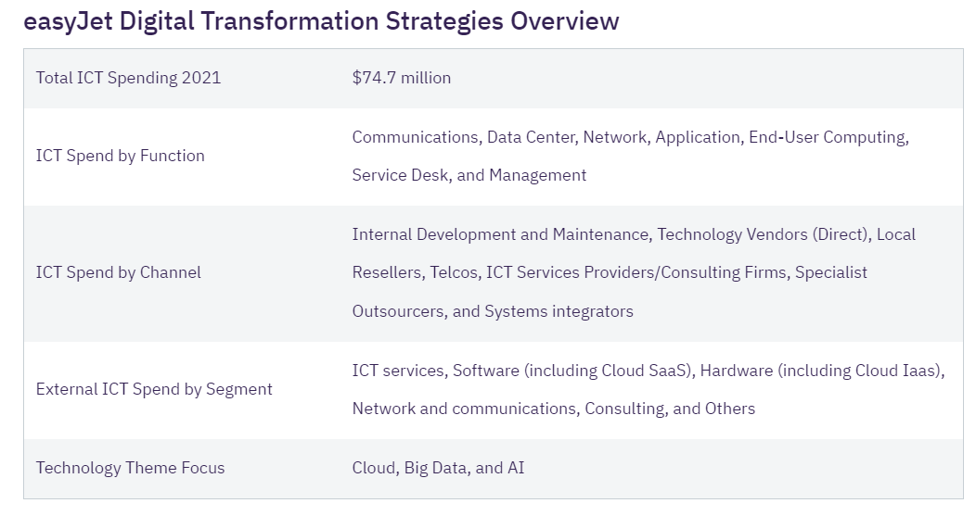
Figure 1 EasyJet Digital Transformation Strategies Overview (EasyJet plc - Digital Transformation Strategies 2023)
EasyJet's digital transformation strategy is underpinned by a $74.7 million ICT spend in 2021. The focus lies on Cloud, Big Data, and AI technologies. The airline allocates its ICT budget across various functions and channels, including communications, data center, and network. Their initiatives encompass partnerships, investments, and acquisitions, aiming to enhance efficiency and customer experience.
3. An edge over rivals EasyJet's adaptable organisational structure and culture allow it to maintain its competitiveness in the low-cost airline industry. By streamlining operations and offering affordable rates, the company attracts more clients and grows its revenue.

Effect on Performance Other Than Financial
According to EasyJet's H1 2023 financial results, revenue increased to GBP 2.69 billion from GBP 1.5 billion YoY, although net loss decreased to GBP 307 million from GBP 431 million the year before (Lon:EZJ financials: Easyjet plc 2023).
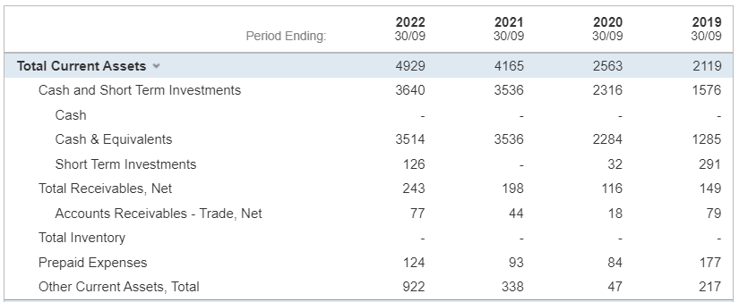
Figure 2 Total current asset (Lon: EZJ financials: EasyJet plc 2023).
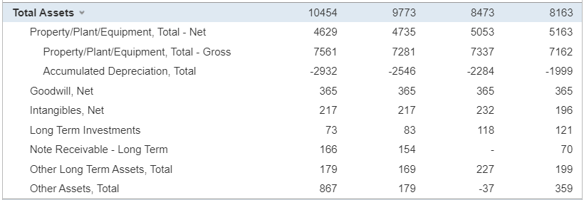
Figure 3 Total asset (Lon: EZJ financials: EasyJet plc 2023).
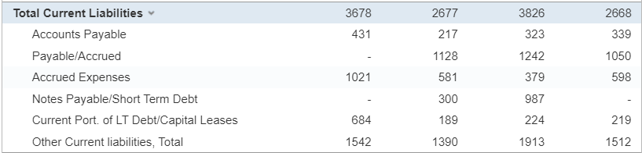
Figure 4 Total Current liability (Lon: EZJ financials: EasyJet plc 2023).
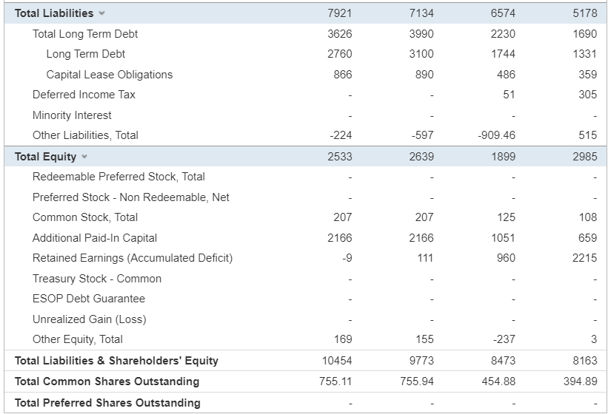
Figure 5 balance sheet of Easyjet (Lon:EZJ financials: Easyjet plc 2023).
The aforementioned numbers show an easyJet financial overview for several time periods in 2022 and 2023. It lists important details such current assets, liabilities, equity, and the number of existing shares. Revenue, net loss, cash, short-term investments, accounts receivable, and property/assets are noteworthy numbers. Information on the company's financial position and health is provided by the data. Data provides information about easyJet's financial situation and developments over time. It displays changes in revenue, net loss, the breakdown of assets (including cash, investments, and real estate), the structure of liabilities, the distribution of equity, and the number of outstanding shares. Assessing the company's financial performance, liquidity, and general health is made easier with the use of this information (Lon: EZJ financials: EasyJet plc 2023).
The interaction between culture and structure has a significant impact on non-financial performance:
1. Customer Experience: EasyJet's decentralised organisational structure and customer-centric culture offer personalised services. Employees are given the authority to respond quickly to customer demands, increasing passenger happiness and loyalty.
2. Employee Engagement: A sense of belonging and purpose is fostered by the culture of innovation and empowerment. A more engaged workforce and improved service quality are the results of this involvement.
3. Operational Excellence: EasyJet excels in operational performance thanks to the synchronisation of culture and structure. Rapid decision-making and flexibility improve on-time performance, minimising hiccups and lowering customer despair.
In summary, EasyJet's innovative culture and decentralized structure create a virtuous cycle where agility, innovation, and responsiveness to customer need lead to improved financial and non-financial performance. This holistic approach positions EasyJet as a market leader, driving its success in the competitive airline industry.
c) Evaluate the broader environment of EasyJet Plc by using appropriate environmental and organisational analytical techniques/tools (PESTEL and Porter’s Five Forces Model & others). You must identify the key drivers for the change in working practices/ approaches at EasyJet Plc.

Evaluation of the Broader Environment of EasyJet Plc using PESTEL and Porter's Five Forces Model
PESTEL Analysis:
Political:
• Regulatory Changes: Political decisions, such as changes in aviation regulations, can impact operations and costs.
• Brexit: The UK's exit from the EU affects cross-border operations and regulations.

Economic:
• Economic Cycles: Economic downturns can lead to reduced travel demand, impacting revenue.
• Fuel Prices: Fluctuations in fuel costs influence operational expenses.

Sociocultural:
• Consumer Preferences: Changes in travel preferences due to societal factors impact route planning and services.
• Health and Safety: Post-pandemic concerns affect passenger willingness to travel and influence safety measures.

Technological:
• Digital Transformation: Technological advancements shape online booking systems, customer engagement, and operational efficiency (Heiets et al., 2022).
• Data Security: Ensuring cybersecurity and data protection is crucial in the digital age.

Legal:
• Air Travel Regulations: Compliance with regulations such as safety standards and operational guidelines is essential.
• Competition Laws: Ensuring fair competition and preventing anti-competitive practices is crucial.

Environmental:
• Sustainability: Increasing focus on environmental impact drives the need for fuel-efficient aircraft and eco-friendly practices.
• Emissions Regulations: Stringent regulations require airlines to reduce their carbon footprint (Olk, 2020).

Porter's Five Forces Analysis:
Threat of New Entrants:
• Barriers to Entry: Capital requirements, regulatory hurdles, and established competition limit new entrants.

Bargaining Power of Suppliers:
• Aircraft Manufacturers: Limited suppliers may hold leverage over pricing and delivery schedules (Waramontri, 2021).
• Fuel Suppliers: Fluctuations in fuel prices can impact costs and profitability (Waramontri, 2021).

Bargaining Power of Buyers:
• Price Sensitivity: Passengers often prioritize affordability, giving them some bargaining power.

Threat of Substitutes:
• Alternative Transportation: Trains, buses, and car rentals serve as substitutes for short-haul flights (Waramontri, 2021).
Competitive Rivalry:
• Industry Competition: Competing with other budget airlines for market share intensifies rivalry.

Key Drivers for Change in Working Practices at EasyJet Plc:

1. Technological Advancements: Rapid digital transformation necessitates changes in working practices to adapt to evolving customer preferences and expectations. Online booking systems, contactless services, and digital marketing strategies become crucial.
2. Sustainability Initiatives: The growing emphasis on environmental sustainability drives the need for innovative approaches. EasyJet must adopt working practices that align with emission reduction goals, such as investing in fuel-efficient aircraft and operational practices.
3. Regulatory Compliance: Evolving air travel regulations and post-Brexit implications require changes in working practices to ensure legal compliance and seamless cross-border operations.
4. Health and Safety: The COVID-19 pandemic has necessitated the adoption of new health and safety protocols. Flexible working practices, remote communication, and heightened hygiene standards are essential to ensure passenger confidence.
5. Customer-Centric Approach: As consumer preferences shift, working practices should focus on enhancing the customer experience. From personalized services to efficient issue resolution, a customer-centric approach drives differentiation.
6. Adapting to Economic Fluctuations: Changes in economic cycles influence travel demand. EasyJet must employ agile working practices to adjust routes, capacity, and pricing to align with varying economic conditions.
7. Competition and Innovation: To maintain a competitive edge, EasyJet must continuously innovate its working practices. Agile decision-making, streamlined operations, and responsive customer service contribute to competitive advantage.
In conclusion, the PESTEL and Porter's Five Forces analyses highlight the numerous variables influencing the operating environment for EasyJet. These evaluations identify significant factors, such as technology development, sustainability initiatives, regulatory compliance, health and safety considerations, customer-centricity, economic fluctuations, and the need for innovation, that are driving changes in working practises. EasyJet must make these adjustments in order to stay successful and competitive.
Using the SWOT Analysis and McKinsey 7S Framework, evaluate EasyJet Plc's external environment.
The SWOT analysis
Strengths:
• Recognisable Brand: Due to EasyJet's well-known brand and reputation, customers are more devoted to the airline.
• Low-Cost Model: The airline has a competitive advantage in the market for low-cost airlines thanks to its efficient operations.
• Wide Route Network: EasyJet's vast network increases accessibility and consumer alternatives.
Weaknesses:
• Dependency on Europe: The airline's focus on European routes makes it vulnerable to regional economic fluctuations and regulatory changes.
• Vulnerability to External Factors: Events like geopolitical tensions and natural disasters can disrupt operations and revenue.
Opportunities:
• Sustainable Travel Trend: Growing demand for eco-friendly travel presents opportunities for EasyJet to enhance its sustainability initiatives.
• Digital Innovation: Utilizing technology for personalized services, online booking, and customer engagement can boost efficiency and customer satisfaction.
Threats:
• Competitive Rivalry: Intense competition from other low-cost airlines poses a threat to market share and profitability.
• External Disruptions: Unexpected events like pandemics and geopolitical tensions can severely impact air travel demand and operations.

McKinsey 7S Framework:

1. Strategy: • Adaptive Business Model: EasyJet should continuously adjust its strategy to adapt to changing market dynamics and customer preferences (Rotondo et al., 2019).
2. Structure: • Decentralized Operations: EasyJet's decentralized approach empowers local teams for efficient decision-making and responsiveness.
3. Systems: • Digital Integration: Implementing advanced digital systems for booking, customer service, and data analytics enhances operational efficiency.
4. Shared Values: • Customer Focus: EasyJet's commitment to providing affordable travel solutions aligns with its core value of customer-centricity.
5. Skills: • Operational Efficiency: Developing and nurturing skills related to cost-effective operations, safety, and customer service is paramount (Rotondo et al., 2019).
6. Staff: • Diverse Workforce: Encouraging a diverse workforce enhances creativity, adaptability, and cultural understanding.
7. Style: • Agile Leadership: EasyJet's leadership style should prioritize adaptability and quick decision-making to navigate industry challenges.

Key Drivers for Change in Working Practices at EasyJet Plc (McKinsey 7S Framework):

1. Digital Transformation: The emphasis on digital integration calls for changes in working practices to ensure seamless technology adoption and customer interaction.
2. Customer-Centricity: Aligning with shared values, working practices should emphasize personalized services, efficient issue resolution, and passenger satisfaction.
3. Operational Excellence: The skills aspect demands a focus on continuous improvement, safety protocols, and efficient operational practices.
4. Agile Leadership: To effectively respond to changing external factors, EasyJet's leadership style must prioritize flexibility, quick decision-making, and adaptability.
5. Diversity and Inclusion: Encouraging a diverse staff contributes to a dynamic work environment, fostering innovation and cultural sensitivity.
In conclusion, the SWOT Analysis and McKinsey 7S Framework shed light on EasyJet Plc's internal strengths and weaknesses, external opportunities and threats, and key elements influencing its operations. The analysis highlights the need for changes in working practices to harness opportunities, mitigate threats, and align with the organization's values and strategies.

d) Explains how Easy Jet Plc has been practising some Ethical approaches as a part of its organisational culture and benefits thereof.
Ethical Approaches in EasyJet Plc's Organizational Culture and Their Benefits
EasyJet Plc has demonstrated a commitment to ethical approaches as an integral part of its organizational culture. These ethical practices extend across various aspects of the company's operations and contribute to both its reputation and overall success.

1. Environmental Responsibility: EasyJet has shown dedication to minimizing its environmental impact through various initiatives, including investing in more fuel-efficient aircraft, adopting sustainable operational practices, and reducing carbon emissions. These efforts align with growing societal concerns about climate change and the environment. By prioritizing environmental responsibility, EasyJet not only fulfills its ethical duty but also appeals to eco-conscious customers. The benefits include enhanced brand reputation, attracting environmentally aware passengers, and aligning with changing industry regulations focused on sustainability (Kassem et al., 2022).
2. Passenger Safety and Service Quality: Ethical practices in passenger safety are paramount in the aviation industry. EasyJet's adherence to rigorous safety standards and continuous improvement of safety protocols not only safeguards passengers' well-being but also builds trust and confidence among travelers. Ethical practices in service quality, such as clear communication, fair treatment, and reliable services, contribute to customer loyalty and positive word-of-mouth, further enhancing the airline's reputation (El Haddad, 2019).
3. Employee Welfare and Diversity: EasyJet places emphasis on fair treatment of its employees, valuing diversity and promoting inclusivity. By fostering a positive work environment, the company boosts employee morale and engagement. Ethical practices such as providing equal opportunities and embracing diversity enhance employee satisfaction, which translates into improved customer service and overall operational efficiency. A diverse workforce also enhances the company's ability to cater to a global customer base effectively.
4. Transparency and Accountability: Ethical practices in transparency, accountability, and governance contribute to a culture of trust within the organization and among stakeholders. EasyJet's commitment to ethical business conduct ensures that stakeholders are kept informed about company operations, financial performance, and strategic decisions. This transparency builds investor confidence, enhances relationships with regulatory bodies, and minimizes reputational risks associated with unethical behavior.
5. Social Responsibility: EasyJet's engagement in community outreach programs and philanthropic initiatives demonstrates its commitment to social responsibility. By giving back to communities, supporting charitable causes, and contributing to social development, the company builds a positive image as a socially conscious corporate entity. These efforts resonate with customers, investors, and the wider society, fostering goodwill and enhancing the company's reputation.

Benefits of Ethical Approaches:

1. Enhanced Reputation: Ethical practices enhance EasyJet's reputation as a responsible corporate citizen, attracting customers who value ethical behavior and sustainability.
2. Customer Trust and Loyalty: Ethical practices build trust among customers, leading to increased loyalty and repeat business.
3. Employee Morale and Productivity: Ethical treatment of employees boosts morale, leading to higher productivity, lower turnover rates, and a positive work culture.
4. Stakeholder Confidence: Ethical conduct reassures investors, regulators, and partners, promoting confidence in the company's operations and financial stability.
5. Mitigation of Risks: Ethical approaches minimize legal and reputational risks associated with unethical behavior, safeguarding the company's long-term prospects.
6. Competitive Differentiation: Ethical practices set EasyJet apart in a competitive market, attracting customers and partners aligned with the company's values.
In conclusion, EasyJet Plc's ethical approaches encompass environmental responsibility, passenger safety, employee welfare, transparency, and social responsibility. These practices not only align with societal expectations but also bring substantial benefits, contributing to the airline's reputation, customer loyalty, employee satisfaction, and overall business success.
e) Based on the environmental and ethical challenges, provide recommendations to Easy Jet Plc to improve its performances and justify suggested actions.
Recommendations to Improve Performance: Addressing Environmental and Ethical Challenges
1. Sustainable Fleet Renewal: Recommendation: Invest in the procurement of modern, fuel-efficient aircraft to replace older, less eco-friendly models. Justification: Upgrading the fleet reduces emissions, enhances fuel efficiency, and aligns with environmental sustainability goals. This investment not only reduces the company's carbon footprint but also lowers operational costs over the long term.
2. Carbon Offsetting Programs: Recommendation: Collaborate with reputable carbon offsetting organizations to implement programs that allow passengers to voluntarily offset their carbon emissions. Justification: Offering carbon offset options demonstrates the airline's commitment to environmental responsibility. It empowers passengers to take an active role in reducing their environmental impact and supports projects that contribute to carbon neutrality.
3. Employee Training on Ethical Practices: Recommendation: Provide regular training to employees on ethical behavior, diversity and inclusion, and customer-centric service. Justification: Educating employees about ethical practices fosters a culture of accountability and respect. This, in turn, translates into enhanced customer experiences, better teamwork, and improved customer satisfaction.
4. Collaboration with Sustainable Suppliers: Recommendation: Collaborate with suppliers who share similar sustainability goals, promoting ethical and eco-friendly business practices throughout the supply chain. Justification: Partnering with like-minded suppliers strengthens the commitment to sustainability, ensuring that the entire value chain adheres to ethical and environmentally responsible practices (Duong & Chong, 2020).
5. Transparent Communication: Recommendation: Enhance communication channels to keep stakeholders informed about the company's sustainability efforts and progress. Justification: Transparent communication builds trust among investors, customers, and regulators. Sharing progress and challenges demonstrates a genuine commitment to ethical and sustainable practices.
6. Innovation in Customer Experience: Recommendation: Utilize technology to enhance the passenger experience, making it more efficient, personalized, and environmentally friendly. Justification: Leveraging technology for online check-in, digital boarding passes, and personalized travel recommendations not only improves customer satisfaction but also reduces paper waste and contributes to a greener travel experience.
7. Continuous Monitoring and Reporting: Recommendation: Establish a dedicated team for monitoring and reporting environmental and ethical performance metrics. Justification: Regular monitoring ensures that sustainability and ethical goals are met. Transparent reporting showcases the company's progress, increasing credibility and demonstrating commitment to stakeholders.
8. Partnerships for Community Impact: Recommendation: Collaborate with local communities on social impact projects, supporting education, health, and environmental initiatives. Justification: Engaging with communities generates positive social impact, strengthens the brand's reputation, and fosters goodwill among customers and stakeholders.
9. Recognition and Rewards for Ethical Contributions: Recommendation: Introduce recognition and reward programs for employees who actively contribute to ethical and sustainable practices. Justification: Recognizing and rewarding ethical behavior motivates employees, fostering a sense of pride and dedication to the company's values.
By implementing these recommendations, EasyJet Plc can further solidify its commitment to ethical practices and environmental sustainability. These actions not only address challenges but also position the airline as a responsible leader in the industry, attracting environmentally conscious customers, engaged employees, and supportive stakeholders. This strategic alignment of values and actions contributes to the company's long-term success and positive impact on the environment and society.

References
Coghlan, D. (2020). Edgar Schein on change: Insights into the creation of a model. The Journal of Applied Behavioral Science, 57(1), 11–19. https://doi.org/10.1177/0021886320924029
Duong, L. N., & Chong, J. (2020). Supply Chain collaboration in the presence of disruptions: A literature review. International Journal of Production Research, 58(11), 3488–3507. https://doi.org/10.1080/00207543.2020.1712491
EasyJet plc - Digital Transformation Strategies. Market Research Reports & Consulting | GlobalData UK Ltd. (2023, April 14). https://www.globaldata.com/store/report/easyjet-plc-enterprise-tech-analysis/
El Haddad, R. (2019). Exploring service quality of Low Cost Airlines. Services Marketing Quarterly, 40(4), 301–315. https://doi.org/10.1080/15332969.2019.1665901
Group report - learnenglish - british council. (n.d.-a). https://learnenglish.britishcouncil.org/sites/podcasts/files/Writing_for_a_Purpose-Case_Study-Structure-Case-Study1_0.pdf
Guardian News and Media. (2012, June 13). EasyJet founder sir Stelios moves closer to low-cost African airline. The Guardian. https://www.theguardian.com/business/2012/jun/13/sir-stelios-low-cost-african-airline-fastjet
Heiets, I., La, J., Zhou, W., Xu, S., Wang, X., & Xu, Y. (2022). Digital transformation of airline industry. Research in Transportation Economics, 92, 101186. https://doi.org/10.1016/j.retrec.2022.101186
The impact of low cost carriers in Europe. (n.d.-b). https://www.icao.int/sustainability/casestudies/statesreplies/europe_lowcost_en.pdf
Kassem, R., Salama, A., & Ganepola, C. N. (2022). CSR, credibility, employees’ rights and legitimacy during a crisis: A critical analysis of british airways, WizAir and easyjet cases. Employee Relations: The International Journal, 45(1), 1–20. https://doi.org/10.1108/er-11-2021-0517
Lon:EZJ financials: Easyjet plc. Investing.com. (n.d.). https://www.investing.com/equities/easyjet-financial-summary
Olk, S. (2020). The effect of self-congruence on perceived green claims’ authenticity and perceived greenwashing: The case of easyjet’s co2 promise. Journal of Nonprofit &amp; Public Sector Marketing, 33(2), 114–131. https://doi.org/10.1080/10495142.2020.1798859
Rotondo, F., Corsi, K., & Giovanelli, L. (2019). The social side of sustainable business models: An explorative analysis of the low-cost airline industry. Journal of Cleaner Production, 225, 806–819. https://doi.org/10.1016/j.jclepro.2019.03.345
Waramontri, R. (2021). Service quality in tourism management: comparison between traditional and low-cost airlines. The EUrASEANs: Journal on Global Socio-Economic Dynamics, (1(26)), 43–51. https://doi.org/10.35678/2539-5645.1(26).2021.43-51
What we do – easyjet plc. (n.d.-c). https://corporate.easyjet.com/about/what-we-do

