

Matthew Morgan – 200587
International Travel Operations (BMTP5017)
Jacqui Jones

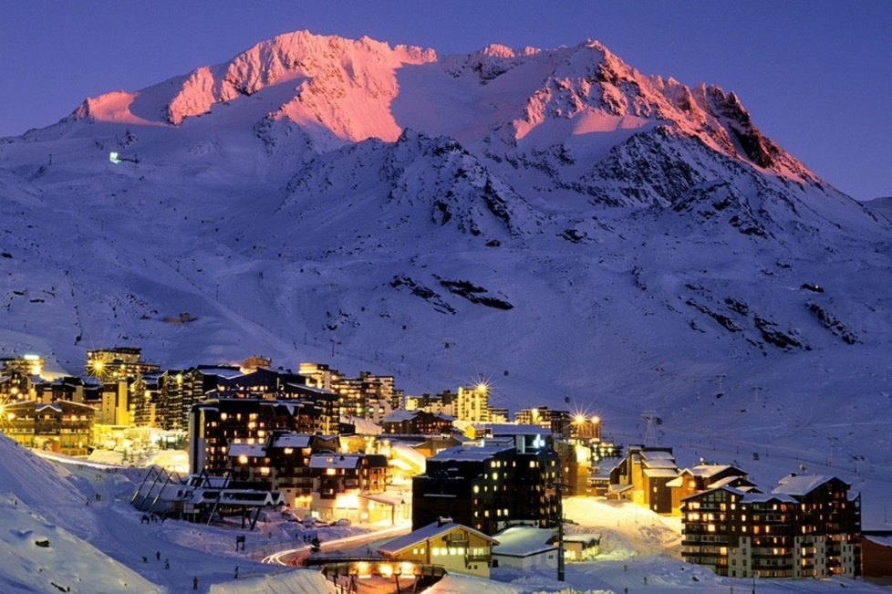

Introduction
An outbound business to consumer University of Wales Trinity Saint David educational university trip of 6 students and 2 lecturers departing from the United Kingdom and heading to Val Thorens in France on a one-week educational skiing trip. The dates for this trip will be from January 7th until January 14th, 2023. They will be travelling by air from London Gatwick airport. I have chosen January as it is the best month to ski and it’s also in the middle of winter and would be quieter due to the Christmas holidays ending. Also, it will be much cheaper than travelling before Christmas so will help to keep the costs down. The university students are aged between 18-21 and will be 4 male and 2 female students, with two female lecturers present as well.
Val Thorens is a big ski resort located in the Tarentaise Valley, Savoie in the French Alps. It is the highest ski resort in Europe which has 83 trails and 68 runs, and is at an altitude of approximately 2300 metres, so therefore it offers spectacular views from the top which can be absolutely breath-taking. Most of the slopes at Val Thorens aren’t too difficult to master with a lot of green and blue level slopes, however if you want a challenge then there are eight black slopes available, which are the hardest and the steepest, but if you feel brave enough that you can do it then why not give them a go? Val Thorens is open from the winter season on November 19th all the way up until May 8th every single year. Since Val Thorens is situated at such a high altitude, snow is guaranteed every year so you will not be left disappointed and can have a magnificent holiday on the slopes.
The 3 Valleys would be at a higher cost than Val Thorens, but it is definitely worth the extra money. The 3 Valleys has 600km of runs instead of Val Thorens only having 150km, and there are 55 runs on the green slopes and 140 runs on the blue slopes, making it a lot better and easier for beginners and intermediates and for those who aren’t too comfortable on steep slopes. If you are experienced with skiing though there are 107 red runs and 35 black runs, making there be lots of challenges to face if it is wanted. There are also 163 lifts in The 3 Valleys.
LINK TO BROCHURE - https://issuu.com/mountains2022/docs/ito_brochure_-_val_thorens.pptx
Things to pack/bring for the skiing trip to Val Thorens
Ski jacket
Salopettes
Snow boots and other appropriate shoes for the day and night when you are not skiing
Snow goggles
Thermals/thermal fleece
Bobble hat
Ski mask
Ski socks
Sunglasses for the winter sun
Clothes for the evening (e.g., jeans, hoodie, t shirts)
Toiletries e.g. (toothbrush, hair products)
Gloves
Segmentation
The target market for this university educational trip would be students and lecturers. The targeted group is from a tourism course. Because of this there wouldn’t be any problems if the students wanted to drink or party in the evenings since they would be of a legal age. This also means that there aren’t any restrictions on activities. Because the target market is an even split of men and women, the marketing has to be either of a neutral colour or one associated with skiing. Because of this the decision was made to stick with blue and while as it applied to the slopes.
This target group is also great as the students are seen as mature enough to be trusted on the slopes and can easily call for help if something did happen to a student or the general public that is having a good time on the slopes too. The number of students was also selected so as to allow more activities and a longer stay to take place. The less students mean a week is more possible for all the attendees.
Impacts and Issues
The Coronavirus pandemic has quite clearly affected most or maybe even all businesses, people, families and transportation. Since COVID-19 hit the UK and most of the world back in March 2020, things haven’t been the same since. With multiple lockdowns globally and not being able to go outside to see friends and family members, or even to travel, we have finally come out of the worst of it and can live our normal lives again after the longest two or so years of our lives.
If this was a year ago, the covid restrictions would have been completely different. However, since August 2022 France requires absolutely nothing to enter the country. Not even proof of a covid vaccination is required and non-vaccinated travellers are very welcome into the country. Forms do not have to get filled out prior to arrival and departure and you are also no longer required to show proof of a negative COVID-19 PCR or antigen test.
To enter France and be eligible to travel, passports must be issued less than 10 years before the date you enter the country and must be valid for at least 3 months after the day that you plan to leave.
A visa is not required, and you can travel to countries in the Schengen area, which France is part of, for up to 90 days in any 180-day period without a visa. This applies if you travel as a tourist, to visit family or friends, to attend business meetings, cultural or sports events, or for short-term studies or training. Entry requirements - France travel advice - GOV.UK (www.gov.uk)

Insurance
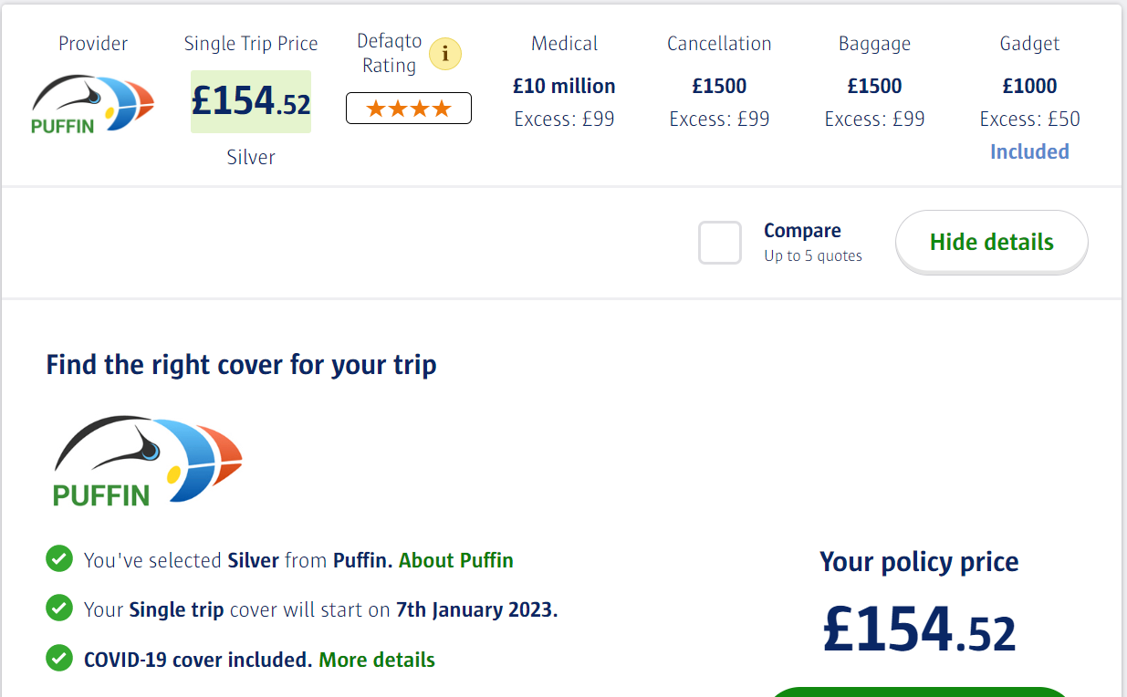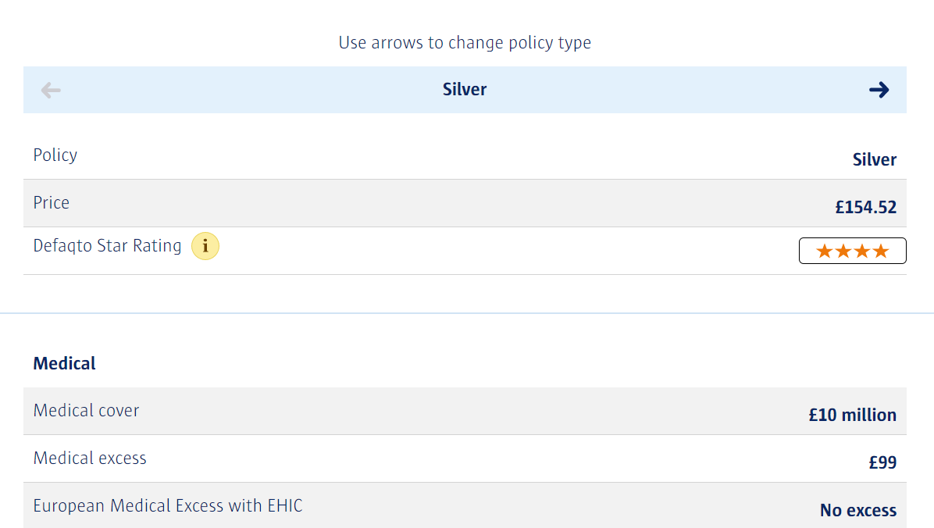
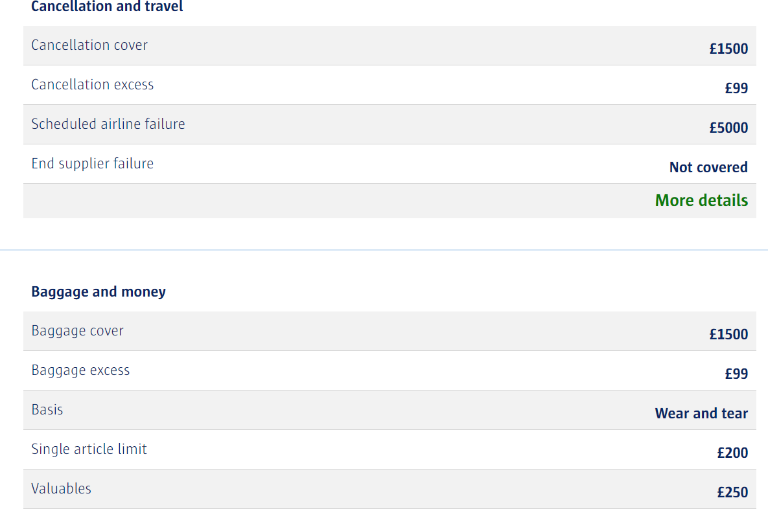
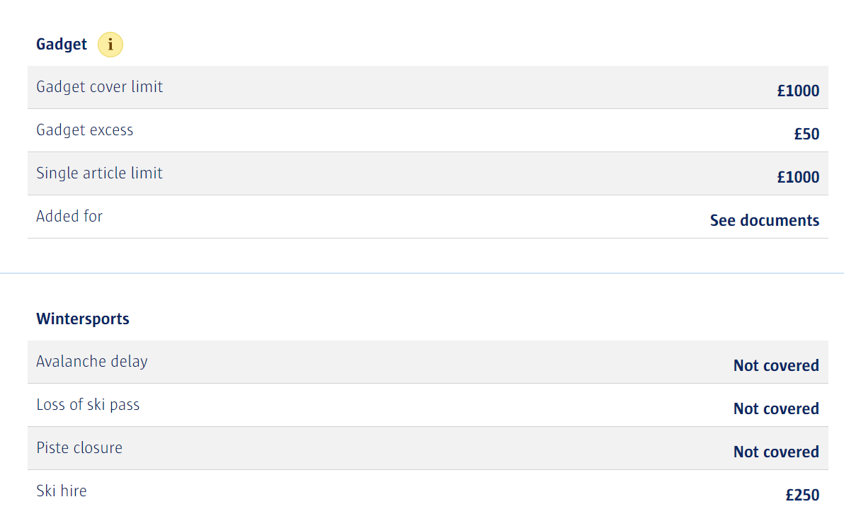
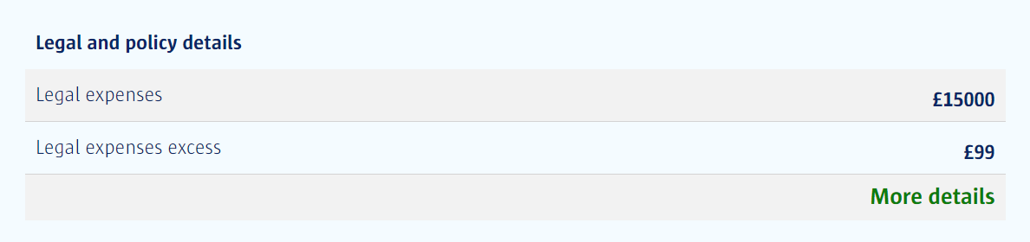
Information about ski school, travel and accommodation (8 people, 6 students and 2 lecturers)
Flights
Departing London Gatwick at 15:45pm GMT on Saturday January 7, arriving at Lyon Saint-Exupery at 18:20pm CET. Be at the airport two hours before departure at 13:45pm GMT.
Departing Lyon Saint-Exupery airport at 12:05pm CET and arriving at London Gatwick at 12:35pm GMT.
Outbound flight – EZY8419 (easyJet, 1h 35m)
Inbound flight – W95768 (Wizz air, 1h 30m)

Accommodation
Residence Les Hauts De La Vanoise – Val Thorens
Breakfast is included
4 rooms – 2 guests per room
(Students can choose who will be in each room when they arrive at the hotel and have checked in)
Address – Grande Rue, 73440, Val Thorens, Les Belleville
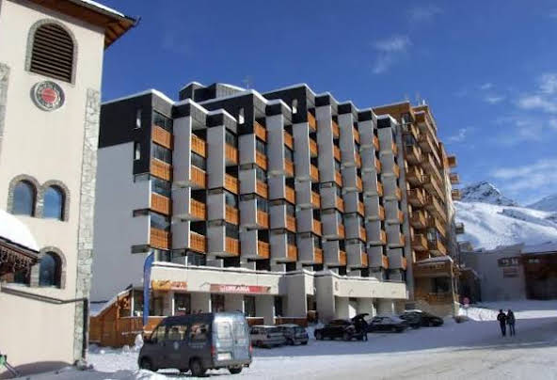

WeSki | Ski Holidays | Skiing & Snowboarding Trips
Résidence Les Hauts De La Vanoise - Val Thorens – Google hotels

Ski lessons
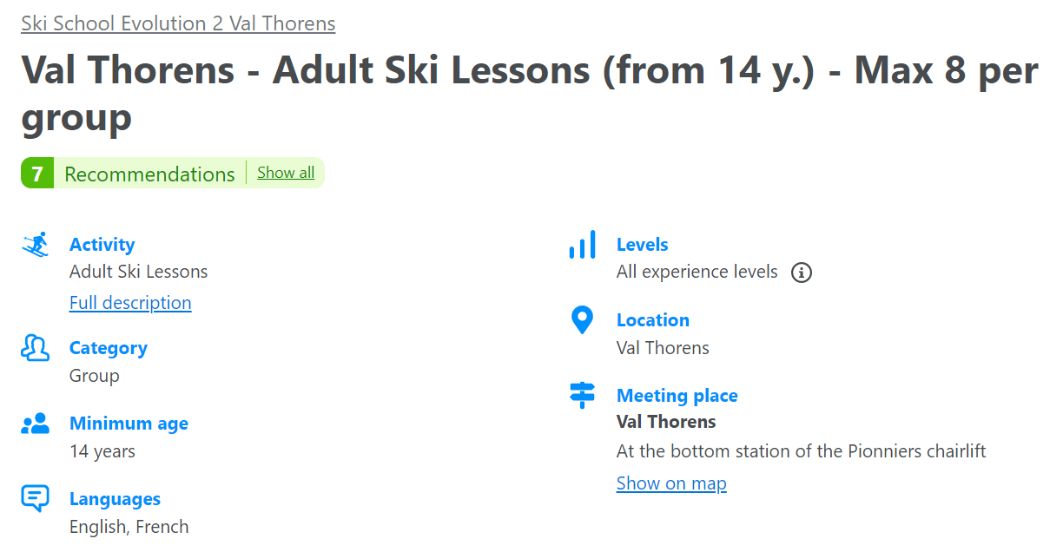
Ski lessons is highly recommended for those who are beginners and for those who want their techniques to improve. The location to meet at is at Val Thorens and the meeting place is at the bottom station of the Pionniers chairlift. The ski lessons are every day and last for two and a half hours.
▷ Val Thorens: Adult Ski Lessons (from 14 y.) - Max 8 per group ❄️ from 40 € - CheckYeti

Travel Itinerary
Day 0 (January 7th, 2023) – Arrive at London Gatwick airport (LGW) at approximately 13:45pm on January 7th and check-in and go through security ready to board your flight that leaves at 15:45pm GMT. Grab any necessities that you need for the flight after you have gone through security and board the plane when it is time to when it comes up on the board.
The airline operating the flight to France and back to the United Kingdom will be easyJet and Wizzair. You will depart from London Gatwick at 15:45pm and will arrive at Lyon Saint-Exupery airport (LYS) at 18:20pm CET.
The returning flight from Lyon back to London Gatwick will depart on January 14th at 12:05pm CET and will arrive safely back to the UK at 12:35pm GMT. The flight times will take 1 hour and 35 minutes from LGW to LYS and back from LYS to LGW it will take five minutes quicker making the flight time 1 hour and 30 minutes.
After arriving at Lyon collect your bags when they all come and make your way to the transfers where a private transfer vehicle will be waiting for you to take you to Val Thorens to start your holiday. There is no waiting time and is door to door service. The travel duration from Lyon airport to Val Thorens will take approximately 2 hours and 17 minutes. Arrive at the hotel at 21:30pm after you have collected your baggage and been on the transfer from the airport to the resort.
Upon arrival and once you have settled into your rooms, take the time to explore the area and find somewhere to eat but remember to wear appropriately clothing even though you will not be skiing on the first night as it will still be very cold outside.
Day 1 (January 8th, 2023) – Wake up bright and early and start your morning off with some breakfast downstairs at the hotel. Once breakfast has been eaten, grab your ski equipment to put on and dress in the right gear and head out to the slopes. As this will be your first day of skiing there are ski lessons that you can attend to improve your technique and make yourself more comfortable to be on the slopes by yourself. If you do not want ski lessons, then carry on your day with skiing and make your way off the slopes and back to the hotel to change at 4pm when it closes for the day as it will be getting dark quickly. Ski lessons happen daily for two and a half hours every morning if it is necessary. After you get back, have a shower and change back into your usual clothes and have some time to chill at the hotel for a few hours before getting ready to go out to a restaurant for a meal at 19:00 and then you will call it a night when you are all finished and ready to leave.

Day 2 (January 9th, 2023) – Wake up at 08:00am and if its wanted then you can get some breakfast again and get set up for another busy day of skiing. Leave the ski room at 09:15am and have fun until the slope closes again at 16:00pm. The green and blue slopes for beginner and intermediate are highly recommended as it is still only the second day of skiing and if needed you can attend another day of skiing lessons at the same place where the meeting point was on day two. After a long day of skiing go back to the hotel for a while and go out and explore the town and find the nearby stores to buy your own food to eat back at the hotel. After that, there is the opportunity to go for a night out at a bar or nightclub and then get back safely to your room to get another well-deserved rest.

Day 3 (January 10th, 2023) – Wake up at a later time at 09:00am to give you time from the previous night and get some breakfast. After breakfast, have a few hours to chill and go to the store to eat lunch then get ready for a different day and go on an excursion. Today’s excursion will be a private snowshoe hike in Courcheval and will last for a few hours. There will be a transfer from your hotel at 11:00am and the journey takes approximately two and a half hours so you will arrive at around 13:30pm ready for the hike to start at 14:00pm. Snowshoes and sticks are available to give you some support whilst walking through the fresh snow. Here is an overview from the website: Snowshoeing allows you to discover the mountain from another angle, more natural and more authentic, allows you to enjoy an outdoor activity, healthy, ecological and beneficial. Snowshoeing does not require great technique and is accessible to everybody. Private Snowshoe Hike in Courchevel (expedia.co.uk)
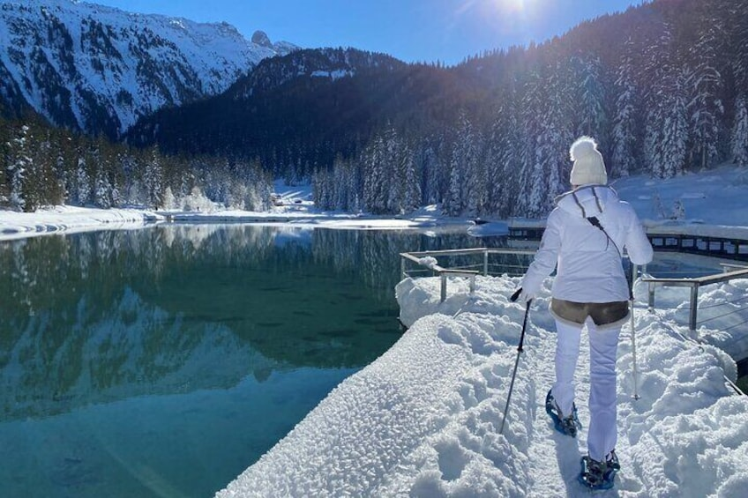
This hike will give you a wonderful opportunity to see nature and wildlife that you may have never seen before. It will also provide you with spectacular views of the area and will be even more pretty with it covered in snow. It is a once in a lifetime hike and will definitely be worth the time. Just dress up in appropriate clothing so you are warm, and you will be just fine. (Résidence Les Hauts De La Vanoise - Val Thorens – Google hotels)

After the hike finishes the transfer back to the hotel leaves at 16:30pm and you will get back at approximately 19:00pm. Once you are back, find an option for food and then wind down for the night and go to sleep.

Day 4 and 5 (January 11th and January 12th, 2023) – Continuing waking up early at 09:00am and having breakfast then heading back out to the slopes. Returning back to the hotel at 16:15pm for dinner where you can have a choice of either going out or going to the supermarket to buy your own food and snacks to eat back at the hotel.

Day 6 (January 13th, 2023) – Wake up call at 08:00am and after breakfast make your way back to the slopes for the final time of the holiday. After a few hours of skiing and enjoying the views for the last time, head back at 14:00pm and change into more casual clothes. You will then have some time to explore the town again, grab some lunch and find gift shops if it is necessary to bring back gifts from Val Thorens for family or friends. In the evening, all find a nice restaurant to have one more meal out together before going back to the hotel and packing your things to depart the following morning.

Day 7 (January 14th, 2023) – Departure Day. Wake up at 06:00am and have breakfast at the hotel for the last time and enjoy the overlooking views of the snowy mountains of Val Thorens before it is time to go home. The transfer departs the resort at 07:30am and will take about two hours again to get back to Lyon airport. (See hotel desk for transfer pick up place) Arrive at the airport at 10:00am and check in ready for your flight to depart at 12:05pm back to London Gatwick airport.

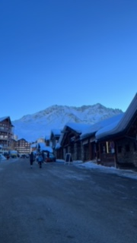
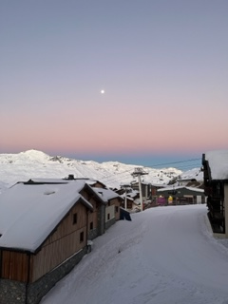

(Photos taken of Val Thorens by me on December 19th and December 21st, 2021)

Costings
Flight London Gatwick- Lyon, France =£44.63 per person
Residence lagrange vacances les hauts de la vanoise = £122.50 per person
Peugeot traveller rental- £46.27 per person
Trip (including flights hotel, transfer) = £213.40 per person
Ski passes: Val Thorens = £247, The 3 Valleys = £293 (£46 difference)
Ski rental:
Evolution pack (beginners) = £85
Sensation pack (intermediate) = £100
Excellence pack (advanced) = £115
Ski lessons: £34.51 per day
Hike excursion: £249.64

Package 1
A
Total costs: Trip + ski pass (Val Thorens) + evolution pack + hike excursion = £795.04
If ski lessons are required for one day = £829.55
B
Total costs: Trip + ski pass (3 valleys) + evolution pack + hike excursion = £841.04
If ski lessons are required for one day = £875.55

Package 2
A
Total costs: Trip + ski pass (Val Thorens) + sensation pack + hike excursion = £810.04
If ski lessons are required for one day = £844.55
B
Total costs: Trip + ski pass (3 valleys) + sensation pack + hike excursion = £856.04
If ski lessons are required for one day = £890.55

Package 3
A
Total costs: Trip + ski pass (Val Thorens) + excellence pack + hike excursion = £825.04
If ski lessons are required for one day = £859.55
B
Total costs: Trip + ski pass (3 valleys) + excellence pack + hike excursion = £871.04
If ski lessons are required for one day = £905.55

Terms & conditions
Many of the flights and flight-inclusive holidays on this website are financially protected by the ATOL scheme. But ATOL protection does not apply to all holiday and travel services listed on this website. Please ask us to confirm what protection may apply to your booking. If you do not receive an ATOL Certificate, then the booking will not be ATOL protected. If you do receive an ATOL Certificate but all the parts of your trip are not listed on it, those parts will not be ATOL protected. Please see our booking conditions for information or for more information about financial protection and the ATOL Certificate go to: www.atol.org.uk/ATOLcertificate
Depending on which combination of products you choose to book, your terms and conditions will vary.
The following details the different types of products available and the applicable terms and conditions:
This product offers you combinations of the hotel des 3 Vallees and easyJet airways flights at an inclusive price. This product enjoys the protection of the Package Travel, Package Travel and Linked Arrangements Regulations 2018, as well as other benefits, such as handpicked accommodation, local assistance, etc.
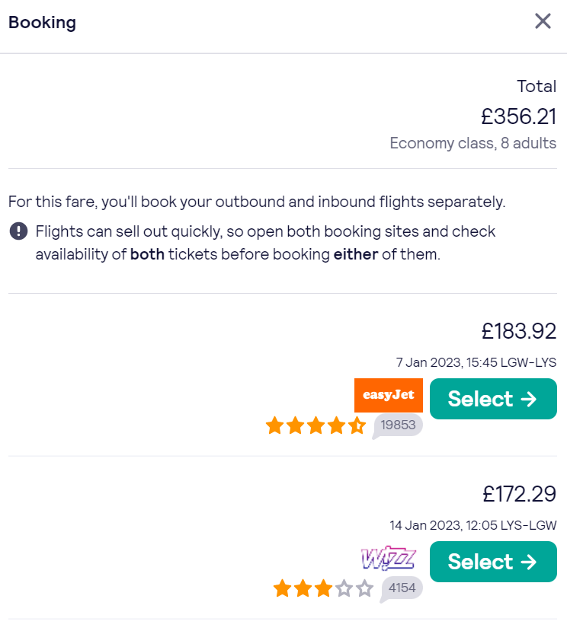

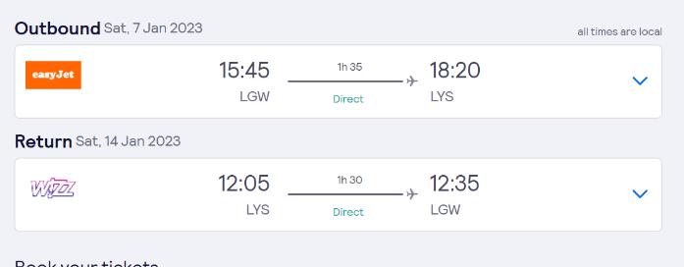

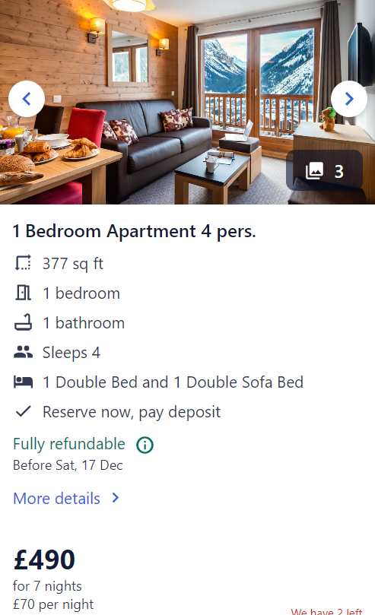

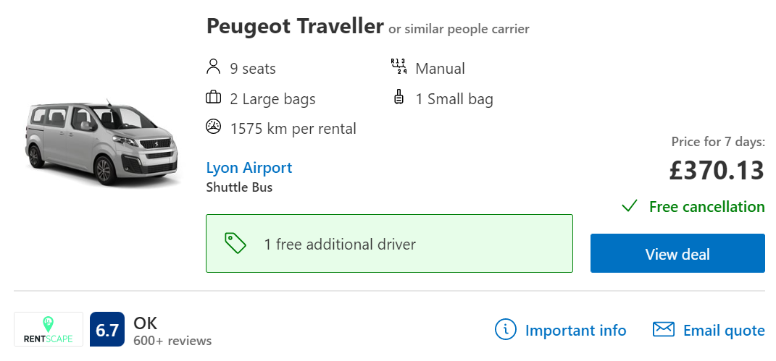

Bibliography
Pinterest. 2022. Pin by Andie on My Pictures | Ski pictures, Skiing, Ski trip. [ONLINE] Available at: https://www.pinterest.co.uk/pin/817825613562072620/. [Accessed 07 December 2022].
Vecteezy. 2022. Abstract Mountain Shape Logo with modern letter M vector line art style. 7932757 Vector Art at Vecteezy. [ONLINE] Available at: https://www.vecteezy.com/vector-art/7932757-abstract-mountain-shape-logo-with-modern-letter-m-vector-line-art-style. [Accessed 07 December 2022].
Pinterest. 2022. Mountains Print - Mountain Forest Photo - Mountain Photography - Nature Photography - Vertical - Mou | Forest photos, Mountain photography, Nature photography. [ONLINE] Available at: https://www.pinterest.co.uk/pin/780107966699287977/. [Accessed 07 December 2022].
Snowplaza.co.uk. 2022. Val Thorens ski | ski holidays in France. [ONLINE] Available at: https://www.snowplaza.co.uk/france/les-trois-vallees/val-thorens/. [Accessed 07 December 2022].

4 star Hotel Val Thorens - Hotel Les 3 Vallees Val Thorens. 2022. 4 star Hotel Val Thorens - Hotel Les 3 Vallees Val Thorens. [ONLINE] Available at: https://www.hotel3vallees.com/en/. [Accessed 07 December 2022].
EXECUTIVE FLYERS. 2022. Can Planes Fly in the Snow? (And What Happens If They Can’t) | EXECUTIVE FLYERS. [ONLINE] Available at: https://executiveflyers.com/can-planes-fly-in-the-snow/. [Accessed 07 December 2022].
To the Mountains and Back. 2022. 26 Essential Winter Van Life Tips - To the Mountains and Back. [ONLINE] Available at: https://www.tothemountainsandback.com/winter-van-life/. [Accessed 07 December 2022].
AirlinesMap. 2022. Leon Airport. [ONLINE] Available at: https://www.airlinesmap.com/leon-airport. [Accessed 07 December 2022].
Fall-Line Skiing. 2022. The Pros' Favourite Ski Lines | Fall Line Skiing. [ONLINE] Available at: https://www.fall-line.co.uk/the-pros-favourite-ski-lines/. [Accessed 07 December 2022].
Condé Nast. 2022. University ski trips: Durham ski trip | Tatler. [ONLINE] Available at: https://www.tatler.com/article/university-ski-trips-report-durham. [Accessed 07 December 2022].

