

HTML & CSS WEB DEVELOPMENT

ACCA4023


MARCH 5, 2026
THAZEB KHAN LECTURER NAME: Dr Sadhana
Contents
Introduction 2
Requirements 2
Purpose 2
Subject Matter 3
Intended Audience 3
Implementation 4
Screenshots of the Webpages 4
Validation 5
HTML Validation 5
CSS Validation 6
Evaluation 7
Part A 7
Website Usability 7
Website Accessibility 7
Search Engine Optimisation 8
Part B 8
Usefulness (Usability and Utility) 8
Search Engine Optimisation (SEO) 8
Accessibility 9
Part C 9
References 10

Introduction

The World Wide Web is a major aspect of the new communication, information exchange and business processes. Websites enable organisations and individuals to provide information, furnish services and also communicate with the users worldwide. With the current development of the internet, web developers need to make sure that websites are made usable, accessible, and search engine optimised.

This report outlines the procedure of designing and developing a responsive website which has been designed using HTML5 and CSS3. The project objective was to come up with a multi-page site that conforms to web standards and illustrates key web development concepts, without the use of automated development aids. The site contains a number of related pages which contain the information about the site and enable the users to move easily across the sections.

The process of development has included the planning of the structure of the site, designing a consistent layout, and implementation of the site using hand-coded HTML and CSS. It was created as a responsive site in order to qualify effectively across the various devices, including, desktops, tablets and smartphones.

This report describes the specifications of the site, the process of implementation of the site and the verification of the HTML and CSS code. The report will also give an assessment of the site in regard to the principles of usability, accessibility and search engine optimisation. Lastly, the report will contain comparisons of two popular live websites to illustrate some real-life uses of these principles of web development.

Requirements

Purpose

The idea behind the site is to create informative and interesting content that addresses a particular issue and at the same time illustrate how the web development technologies can be used like HTML and CSS. The site was developed as a project in a course work in web development which sought to build a practical level of knowledge in web design and coding responsive websites.

The website is meant to deliver information in a simple and orderly way, and to make sure that the users can easily navigate through the information. The project also proves that it is essential to adhere to web standards, use responsive design, and make it accessible to the maximum number of users.

Subject Matter

The site is dedicated to the delivery of information associated with a selected subject matter. The site has a number of pages that include a home page, information or attractions page, and a contact page. Every page serves the general purpose of the site with its useful information and functionality.

The main page gives an overview of the site and lays emphasis on the important information. The information page is highly detailed in the content in relation to the topic, providing descriptions and pictures. The contact page also enables the users to respond to the site by giving feedback or sending their enquiries in a simple form.

The site has navigation menus, pictures, headings and organized information to enhance legibility and usability.

Intended Audience

The target audience of the site comprises people, who are interested in knowing more about the subject of the site. This can be in the form of students, tourists, researchers, or any general internet users who want information.

The design of the website was designed to suit an extremely diverse user group of people by making sure that the layout is understandable, the navigation is uncomplicated, and the information is not hard to grasp. The responsive design will assure users that they can view the site through different devices such as mobile phones, tablets and desktop computers.

The site is designed to ensure that every user enjoys their experience with the site although they may have differing technical strengths and despite the device they may be using, as it is easy to use and navigate.

Implementation

The implementation was done in HTML5 to organize the site and CSS3 to design the layout and visual aids. The webpages’ structure consisting of headings, paragraphs, images and navigation menus were made using HTML. CSS was applied in defining the visual appearance of the site such as colours, fonts, spacing, and layout.

Responsive design method was applied through CSS media queries to make sure that the site varies with various screen sizes. This will enable the site to be usable as well as being attractive on the bigger desktop as well as the small mobile devices.

The navigation menu is found on every page of the site so as to give it uniform navigation. This will enable the users to navigate through pages with ease. The web design was made minimal and clean to make the site easier to read and increase the user experience.

Website structure will consist of the following pages:

- Home Page (index.html)
- Information/Attractions Page
- Contact Page

Relative hyperlinks have been used to connect each page in such a way that the site could be run offline in any computer without the need to have a development environment.

Screenshots of the Webpages

Home Page
Attractions / Information Page.
Contact Page
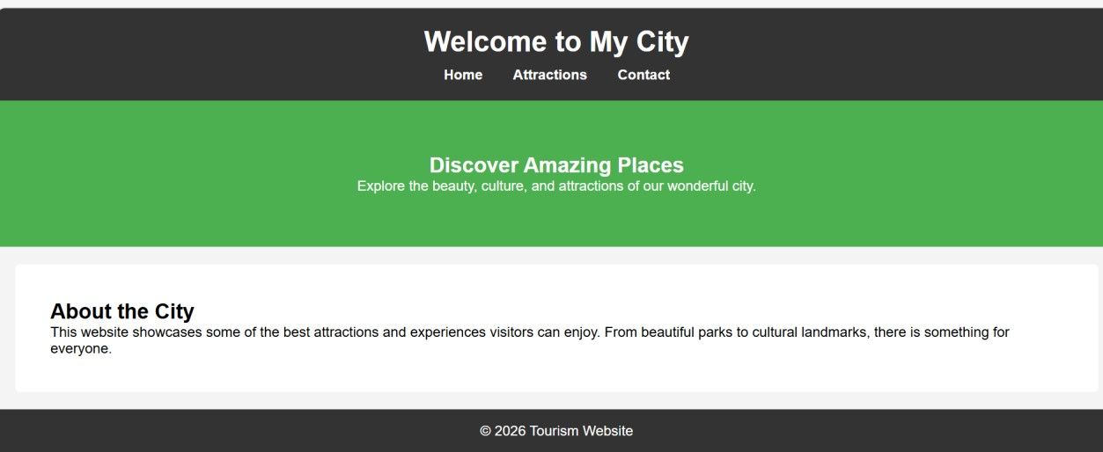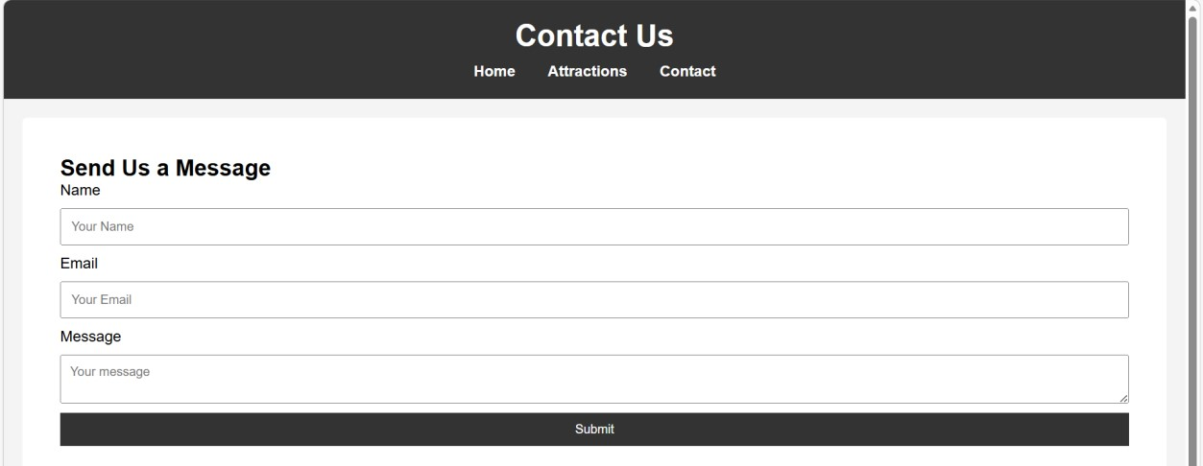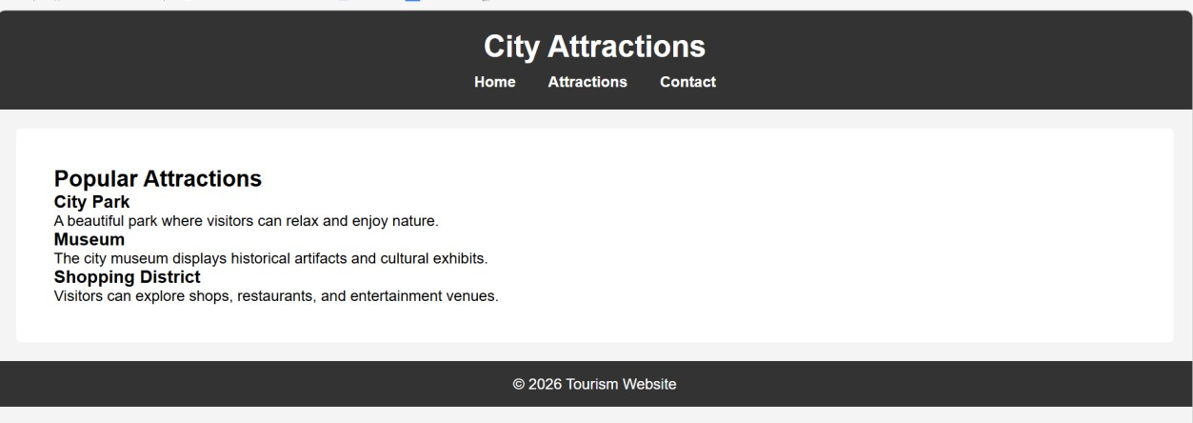
The screenshots illustrate the structure, design, and functionality of this site.

Validation

HTML Validation

The HTML of the home page was checked with the help of World Wide Web Consortium (W3C) HTML Validator which is located at:

https://validator.w3.org

The validation tool will verify the correctness of syntax of the HTML code and that the code adheres to web standards. In the first validation process, some minor errors, including the lack of alternative text attributes of the images and minor structural problems, were observed.

These mistakes have been rectified with relevant alt attributes added to images and also by making sure that all the HTM tags were properly arranged. The HTML code was validated successfully and without error after making the necessary corrections.

The outcome of the HTML validation, as shown in the screenshot provided, is acceptable.
The obtained results of the HTML validation, the screenshot of which is shown, are satisfactory.

CSS Validation

The CSS stylesheet that was applied to the website was checked through W3C CSS Validator that can be found at:

https://jigsaw.w3.org/css-validator

CSS validator identifies syntax mistakes in the stylesheet and verifies that the stylesheet adheres to CSS. Some minor warnings were noted during the validation process of browser compatibility.

The warnings were dealt with by going through the CSS properties applied in the stylesheet and making sure that they were rightly applied. The CSS code was successfully validated after checking a stylesheet and rectifying any mistakes therein.

Evaluation

Part A

Website Usability

Website usability can be termed as the comfort with which users can navigate a site and work with it effectively and efficiently. A well usable website enables users to locate the information they require very easily and browse the site without any complications.

Nielsen (2012) notes that usability is an important consideration when it comes to determining the success of a site. Websites that have a well-defined navigation system, clearly arranged content and readable text are very helpful in user satisfaction and interaction.

One of the research studies conducted by Palmer (2002) examined the connection between usability and satisfaction of websites. Their research concluded that properly designed sites that have a good navigation system enhance the user experience and have a higher chance to increase the time the user spends in the site.

Website Accessibility

Website accessibility is the development of websites that can be accessed by individuals with different disabilities such as visual, hearing, motor, or cognitive impairments. Accessibility guarantees that online information and services can be accessed equally by all the users.

Guidelines such as Web Content Accessibility Guidelines (WCAG 2.1) offer guidelines that assist web developers in coming up with accessible websites. The guidelines are anchored on four major principles:

- Perceivable
- Operable
- Understandable
- Robust

Lazar et al. (2017) emphasizes the fact that the availability of websites can be of benefit not only to people with disabilities but also to everyone users of websites as they become simpler to navigate and comprehend.

Search Engine Optimisation

Search engine optimisation (SEO). can be defined as the act of ensuring that a site enhances the ranking within the search engine. The increased position of the search engines provides more visibility to the site and brings more visitors.

The common techniques in SEO are the descriptive page titles, meta description, heading tags, and alternative text of images. These methods aid the search engines in knowing the contents of a web.

Enge, Spencer, and Stricchiola (2015) say that effective SEO strategies are important in enhancing the traffic of websites and online exposure.

Part B

Usefulness (Usability and Utility)

This project has created a website that has a simple and structured design that enhances usability. The navigation menu enables its users to navigate easily between the various pages of the site. The design is transparent and simple to comprehend hence it becomes easier to find information.

The content was arranged with images and headings to increase readability. The site is also a source of information that is useful concerning the topic chosen.

It may be possible to add some more features in the future like search, embedded maps or galleries to further improve the user experience.

Search Engine Optimisation (SEO)

The website had several on-page SEO strategies when developing the site. These include:

- Descriptive page titles are used.
- Use of meta description tags
- Heading structures (H1, H2, H3) have been used.
- Image alternative text (alt attributes) is used.

These methods are used to enable the search engines to know how the site is organized and what is included in the site to enhance the chances of the site being ranked in search engines.

Accessibility

The design of the web site also included accessibility factors such as readable text, easy navigation and description of alternative text on images.

There was also the consideration of colour contrast between the text and the background in order to make the text readable by the users with visual impairment. The site design adheres to the WCAG 2.1 standard to make it user-friendly to as many users as possible.

Part C
Area Website 1 Website 2
Weblink of the
https://www.bbc.co.uk https:/gov.uk
Website
Usability | GOV.UK offers a  BBC offers a contemporary layout, which straightforward layout, which is contains multimedia material highly organized.
Accessibility | BBC contains accessibility but has GOV.UK is designed complex layouts accessibly in particular.
SEO | Strong metadata, headings, and structured Structured headings and strong content are used also metadata used.
Mobile  Friendliness | Fully mobile-friendly and maximised to Highly mobile and mobilesupport mobile devices friendly.
Conclusion | BBC provides more media content  GOV.UK is more accessible  Logically BBC is more enriched with and usable. media content

On the whole, the GOV.UK exhibits much better accessibility and usability as it has a straightforward design and a clear structure of the layout.

References
567
Enge, E., Spencer, S., and Stricchiola, J. (2015). The Art of SEO. O'Reilly Media.

Lazar, J., Goldstein, D., & Taylor, A. (2017). The Policy and Process of Digital Accessibility. Morgan Kaufmann.

Nielsen, J. (2012). Usability 101: Usability Introduction. Nielsen Norman Group.

Palmer, J. (2002). Web site response, design and usability. Information systems research.

APPENDIX home page
about
contact.

