Academic and Employability Skills
TASK 2
Student Name: Ivan Amaral
Student ID: 1921582

Table of Contents
Introduction 3
Learning: Employability prospects 4
Different depths of reflections 5
Conclusion 10
References 11

Introduction
Employability is the most necessary subject matter for all generation's perspectives who are currently serving in a different area and as well as the segments of young people who are eagerly waiting to develop their new career in various employing prospects. Assessment 1, have already discussed what are the main characteristics are and insides of employability skills and prospects. These prospects have to be developed in the ways of practical knowledge as well as their capacity building procedure for these assessments. From a very personal point of view, the criteria have been affecting greatly in terms of efficiency making and developing me as a proper employee in the working sector. Also, several terms are not widely admired but very efficient enough to make and create sustainable developments in terms of capacity building and improving the performances. These criteria will be fulfilling if the proper process and procedure can be developed for these development processes. The GIBBS reflective cycle will be discussed as per the employability developments with the proper descriptions with the feelings, evaluations with the proper eliminative plans. The exact situation with proper experienced detailed analysis will be analysed from descriptive to action plan for understanding the employability prospects.

Learning: Employability prospects
As a newbie in terms of employment prospects of the global prospects, employability is the most comprehensive term for me as well as the newly recruited people. The employability prospects that we already learned from the various strategies are also adapted in my criteria of learning (Bennett, 2020). In terms of the Gibbs model, we can have the most understandings regarding the learning we got from the employability and the criteria regarding the analysis. The Gibbs reflective cycle is the most prominent option to understand the learning criteria for employability learnings by the 6 steps regarding that (Bennett et al., 2020).

Image 1: Gibbs reflective Cycle (Researchgate.edu, 2020)

Different depths of reflections
Depending on the employability contexts, the analysis showing that the employers from prospects and current job holders must develop and keep themselves up to date because of the ever-evolving criteria of the world's changing prospects. Also, the levels of employment abilities have different aspects of my working experiences in the job fields (Bennett et al., 2020).
As I am trying to work in the structured learning procedure in terms of various aspects of economics and the financial prospects, so the reflective cycle of employability prospects should be set on a prospects and framework where the real-life experiences will be discussed based on the learnings and planning for doing the learning applications on the most applicable way (Sambell et al., 2020).
This model will reflect each stage with full descriptions regarding the examples and the guiding questions basements. Also, the different depth regarding the employability skills on global and domestic's ideas will be developed (Muñoz and González, 2020).
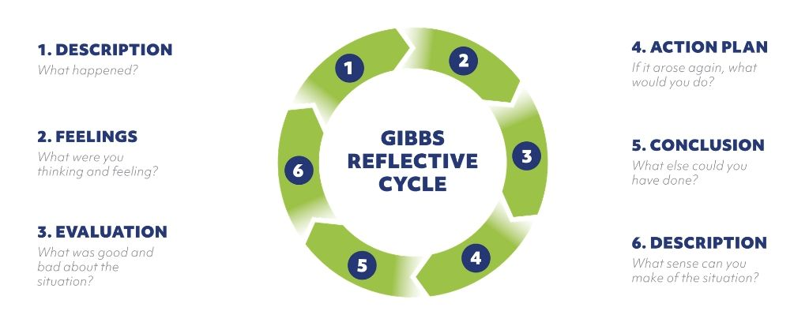
Image 1: My learning criteria and knowledge developments (Self-designed)
Descriptions
The descriptions that I have from the module is that employability is not only a term to derive the employ skills and responsibilities rather considering personal developments and up-gradation for any kinds of unexpected events and I have to be prepared for the moment to recover and to rebuild the normal system (Reedy et al., 2020). Things that are most useful from this part is to understand the in-depth descriptions. The skim through knowledge can be harmful to me for prospects to develop myself in different employability criteria. So from the in-depth descriptive criteria about the employ abilities culture has made me more confident enough from the institutional needs and prospects to develop (Salerni, 2020).

Feelings about the learning's regarding employability's
The first feeling that I got from the employability discussion is that whenever I am trying to enter the market there should be in-depth knowledge of prospective departmental knowledge to develop the skill that already not on my list (Sambell et al., 2020). For me, this is a feeling of employability that is a long-life career choice which is not the only option for me. I should take care of the variety of employing activities in terms of flexible working life (Skene et al., 2020). My education and related experiences can able to drive me towards eligibility for any kind of career option where being successful is the most comprehensive role in most cases (Sambell et al., 2020). And for being most successful those are widely admired and required the specifications regarding the employments sector and employability skills must need which related to soft skills (Sambell et al., 2020). Another internal feeling that from an employer perspective I am getting that job-specific skills are much-needed requirements just as the operating capabilities of the software and computer packages (Skene et al., 2020). In terms of general feelings about the job-specific employabilities and the teaching requirements. In terms of making the soft skills developments making the building block for the career prospects is frequently run stories for me and as well as the applicant's choices (Sambell et al., 2020).

Evaluations regarding employability and my learning's
The most important evaluation skills in terms of my prospects are to make communicative skills developments and getting along with the working capabilities because without the communicative skills the hard and soft skills won't be developed enough in terms of initial days of passings. Another evaluation from my perspective is that reliability and dependability regarding the deadlines of workings criteria. And these skills are very much turning up criteria and that is meant to be for any new recruiter (Sarkar et al., 2020). And willingness is there is a must contest here in terms of developing the job-specific criteria because of the other people working capabilities (Sambell et al., 2020). Also, the interpersonal requirement must be there in terms of effective makings of the communication and building the rapport building activities with emotional intelligence. And also the attitude that is developing the criteria's are and that's the most developments criteria with reliability and dependability on the effective organisation makings consciousness (Skene et al., 2020).

Action plan
Action planning is the procedural activities where the main focus is the generation of ideas and taking the steps in terms of achieving the prospective goals and objectives that I might have needed for developments. Making and creating an action plan is the best way to reaching the objectives in life and organisational prospects (Wang, 2020). The action plan is the procedure regarding my identifications regarding my objectives in near future to understand and achieve the sustainability and flexibility for the prospects of job developments (Skene et al., 2020). But the objectives criteria should not be in places that are not achievable for me and immeasurable (Weaver, 2020). Also making the priorities over various options regarding the skills and knowledge developments must be concise with the employability task and efficiency making criteria. Also, I should make the possible best outcomes regarding the steps I need to achieve the progress and also the identification regarding those is the most valuable activities in terms of goals gain procedure. There should be procedures of listings for the objectives (Weaver, 2020). And I should be able to work under the pressure of working experiences where the needs have to be marked and sustained over the period. The most impressive action plans to achieve the employability context is to creating the deadlines over the working activities that will help me to achieve the deadlines and necessary outcomes can be easily achievable within time (Watson and Barton, 2020). The most necessary action plan for me regarding that is to make a contingency planning that will consist of various emergency response materials and suggestions and also that will help me to create a competitive field to make development prospects for my flexibility and sustainability. Always writing down the goals will make me ambitious enough to create the plan more realistic rather than considering it as a dream. Any planning that will be favourable for me should be more involved in the improving cause and effects criteria (Watson and Barton, 2020).

Conclusive remarks about employability
So, after all these aspects of analysis regarding the employability in terms of my own experiences and learning's from the analysis has to be in sense of prospects. Society is developing in a great sense and the competitions between the company and the society are also increasing. For that reason, human resources are ready to deploy in many cases with different angles and deployments for organisations and employability is very tough nowadays (Watson and Barton, 2020). So, it is not a good choice for the employees or future job holders to understand sonly into the degree of graduations rather they should consider more on the employability skills and that is also applicable for me to develop. To win the most vital competition in terms of deploying the job activities, I should create the most diversified skill about more communicative ways like languages, electronic medium, or by human resource's re-deployments. These multi-skills can able to make me more fundamental about the working environments and more skilled into create the workforces better around me (Watson and Barton, 2020).

So, these are the Gibbs reflective models of analysis that applies to my prospects of understanding employability and my learning from that. Various scholars published their journals around the globe and they said various valuable things about the various prospects of employability and its requirements (Watson and Barton, 2020).
Salerni (2020) states that the outcome of what the employability skills are required by businesses are almost the same across a broad range of literature analysis, which can be divided approximately into the following criteria (Watson and Barton, 2020). Companies today pay more attention to the employability skills of graduates, given the degree, but there is no consistent standard of employability skills. Graduates should have employability skills based on the current working conditions of the organisation and different organisations have different criteria (Watson and Barton, 2020).
Watson and Barton (2020) depicted in their report that every worker need to develop their skills and from their report, I learned that There is no question that workers with a good degree will obtain an outstanding starting point, as a good degree allows employees open the door to find a job, but a degree alone is not enough, employers want even more from their graduate employees, they want employees to bring benefits to the business and during the fierce competition let the company in an invincible place. Through comprehensive analysis, I have outlined eight kinds of employability skills that businesses need the most. After the research study, I did a personal SWOT review focused on internet employability skills and self-assessment assessments and real knowledge that made me more conscious of myself. I then made an action plan for myself after that. I will stick to the plan and hope it will help me develop my employability skills after I complete it and after graduation, I will get a good job in the competitive job market.

Conclusion
So, these brief understandings are the criteria of preliminary developments for me as I am one of the most newbies in terms of employee selection criteria. So for the prospects developments programme must go under the analysis on a general basis. Worldwide consistent scenario analysis and observations regarding these will help me to improve lots of cases in soft and hard skills making criteria fulfillment.

References
Bennett, D., (2020). 'Fostering equitable access to employability development through an institution-wide, in-curricular strategy'. Student retention and success in higher education. London: Palgrave Macmillan.
Bennett, D., Knight, E., and Bell, K., (2020). 'Graduate employability and the career thinking of university STEMM students'. Teaching in Higher Education, 25(6), pp.750-765.
Bennett, D., Knight, E., Dockery, A.M., and Bawa, S., (2020). 'Pedagogies for employability: understanding the needs of STEM students through a new approach to employability development'. Higher Education Pedagogies, 5(1), pp.340-359.
Muñoz García, I.M., and González Monteagudo, J., (2020). 'Perspectives of Non-Traditional University Graduates on Internships: Skills, Employability, and Transition to the Labour Market in Spain'.
Reedy, A.K., Farías, M.L.G., Reyes, L.H., and Pradilla, D., (2020). 'Improving employability skills through non-placement work-integrated learning in chemical and food engineering: A case study'. Education for Chemical Engineers, 33, pp.91-101.
Salerni, A., (2020). 9. 'Learning to learn from experience. Traineeship as a training model to enhance learning'. Psycho-pedagogical research in a Double-degree programme, 53.
Sambell, R., Devine, A., Lo, J. and Lawlis, T., (2020). 'Work-Integrated Learning Builds Student Identification of Employability Skills: Utilizing a Food Literacy Education Strategy'. International Journal of Work-Integrated Learning, 21(1), pp.63-87.
Sarkar, M., Overton, T., Thompson, C.D., and Rayner, G., (2020). 'Academics' perspectives on the teaching and development of generic employability skills in science curricula'. Higher Education Research & Development, 39(2), pp.346-361.
Skene, A., Raffoul, J., and Chittle, L., (2020). 'Higher Education Under Surveillance'. Collected Essays on Learning and Teaching, 13, pp.160-165.
Wang, P., (2020). 'A REFLECTIVE LEARNING APPROACH TO TEACHING COMPUTER AND INFORMATION TECHNOLOGY COURSES'. Issues in Information Systems, 21(2).
Watson, M., and Barton, G., (2020). 'Using Arts-Based Methods and Reflection to Support Postgraduate International Students' Wellbeing and Employability through Challenging Times'. Journal of International Students, 10(S2), pp.101-118.
Weaver, J., (2020). Individual perspectives on how employability can be influenced by study abroad experience as an undergraduate student at Pennsylvania State University.

