Application Development

Student Name: Daniel Davies
Student Number: 1701603
Lecturer: Kemi Ademoye
Date: 02/05/2019
Contents
Introduction 3
Application Development Concepts 4
Introduction 4
Development Concepts 4
Conclusion 5
Requirements 6
Introduction 6
Web Application 6
Requirements 6
Conclusion 6
Design 7
Introduction 7
Design Principles 7
Application Design 7
Conclusion 7
Implementation 9
Introduction 9
Software Application 9
Evaluation 11
Introduction 12
Testing 12
Application Software 14
Future Improvements 14
Conclusion 14
References 15

Introduction
Application development is “the process of creating a computer program or a set of programs to perform the different tasks that a business requires” [1]. However it doesn’t just have to be for a business, anyone is able to make a computer program with the requirements set by themselves. Every application has seven steps for a development lifecycle (SDLC) according to Dave Swersky these include:
- Planning [2]
- Requirements [2]
- Design and Prototyping [2]
- Software Development [2]
- Testing [2]
- Deployment [2]
- Operations and Maintenance [2]
Within the first section of the report, application development concepts will be looked at. This will be done in order to help develop an application, this will be done using the most of the steps development lifecycle. These include:
- Planning
- Requirements
- Design
- Software Development
- Testing
After the software has been created an evaluation of the finished software will be undertaken. This will be done to point out everything which was done well and everything which might not have gone very well. Lastly, any future improvements which could be made to make the application better.

Application Development Concepts

Introduction
Within this section of the report application development concepts will be looked at. This will be done to help with the development of the software. Any key development concepts found will be added in through the development stage of the application.

Development Concepts
The first development concept is going to be “do not implement a feature unless it is required” [3]. What is meant by this is that many times a new feature is implemented in advance it is not really required. This can waste a large amount of time and may even throw creators off focusing on what the application needs in the present and not in the future. This is also very important when starting a new application as if every feature which is going to be in the application in release and all features which are going to be required in the future then it could end up being an unnecessarily complicated piece of software, which could be difficult to develop.
The next development concept which is going to be looked at is the minimum viable product (MVP). This refers to “a new product or website is developed with sufficient features to satisfy early adopters” [4]. What is meant by this is getting less features completed to a high standard rather than getting many features done at a lower standard. This is done as it “makes it easier to demonstrate the utility to a user or customer” [3].
The next development concept which is going to be looked at is the “Don’t repeat yourself” concept. What this concept involves is that it “states that duplication in logic should be eliminated via abstraction” [5]. What is meant by this that any duplication of both features and code is unnecessary, this is because it both wastes time and also makes maintain the application in the future tougher.
The next development concept which is going to be looked at is the fail fast principle. This concept refer to the process in “stopping the current operation as soon as any unexpected error occurs” [6]. What is meant by this it is encourages any errors to occur early in the development stage. This is because it is easier to fix errors earlier on in the development stage rather than error occur just as the software is about to finish, as this would take a lot of time to fix. According to Dat Hoang these are some of the reasons why fail fast is a good development concept:
- Bugs are earlier to detect, easier to reproduce and faster to fix. [7]
- It’s faster to stabilize software’s. [7]
- Fewer bugs and defects will go into production, thus leading to higher-quality and more production-ready software. [7]
- The cost of failures and bugs are reduced. [7]
The next development concept which is going to be looked at is “the simplest option is usually the best” [8]. What is meant by this is that is when any programming is taken place then the simplest option should be taken. This is because it is less likely to break as the code is going to be easier to code and read. With it also being less complex it also makes it faster to create the software. See how it stats “usually” in the concept, sometimes simplicity is not always the best choice. According to Perezpriego some of these cases include:
- Adaptability [8]
- Scalability [8]
- Security [8]

Conclusion
To conclude many different development concepts have been looked, these include:
- Only implement a feature when it is required
- Minimum viable product concept
- “Don’t repeat yourself” concept
- Fail Fast concept
- Simple option is usually the best concept
Some of these concepts are going to be used to help develop the application

Requirements

Introduction
Within this section of the report a brief introduction on the web application, describing its purpose and subject matter, the target audience and its relevance. Furthermore, the requirements for the new system will be created, these requirements will need to be achieved throughout the design and implementation stages.

Web Application
The web application is going programmed in ASP .NET and is going to allow users to view and hire cars, users will be able to see all cars which are available for hiring. Furthermore, users will be able to find out details about the car which they intend to hire.
The target audience is going to be any person looking to hire a car, or anyone trying to look for more details about cars. The audience can be any age (17+ if the user is hiring a car), gender, nationality and religion. This website is going to be relevant as people will be able to both hire cars and find details about cars all in one location.

Requirements
The requirements for the system include:
- Allow users to hire cars
- Allow users to browse through the different cars available
- Allow users to get information about different cars
- Allow users to create accounts
- The application must have a “sort” functionality, for example search for all Ford cars
- The application must be easy to use no matter the user’s computer knowledge
- The application must look professional

Conclusion
To conclude within this section of the report a brief introduction on the web application, describing its purpose and subject matter, the target audience and its relevance. Furthermore, the requirements for the new system has been looked at, these requirements are going to need to be achieved throughout the design and implementation stages.

Design

Introduction
Within this section of the report the design of the application is going to be looked at, this will include the outlined design principles which are going to be used for the application software. As well, as design ideas for the application itself.

Design Principles
Within the first section of the report design principles were looked at, the principles which are going to be used are now going to be decided on. The first being “Simple option is usually the best concept”, this principle has been chosen because there is not a lot of time to complete the application meaning that the application will not be created to have any complicated features.
This will then lead into the next principle which is going to be followed, this principle is “Minimum viable product concept”. Again as there is not a lot of time to complete the application this means that only the features which have been set in the requirements will be attempted to follow.

Application Design
Within this section design ideas for the final application will be looked at, these designs will be followed in order to develop the application.
Main Page
The following image is going to be the main page for the application, it will allow the user to filter the different cars whilst allowing the user to see all the cars within a grid format.
Navigation Bar

Conclusion
Filter Options
Car Pictures
Car Pictures
Car Pictures
Car Pictures

Car Pictures
Car Pictures
Car Pictures
Car Pictures

Car Info Page
The following image is going to be the car info page for the application, it will allow the user to find more information about the car, and it will also allow the user to hire the car.
Navigation Bar

Car Details
Car Pictures

Back
Hire Car

Conclusion
To conclude within this section of the report all design principles which are going to be used in the application have been looked at. Furthermore, the design of the application has been decided on and will be followed as close as possible.

Implementation

Introduction
Within this section of the report the implementation stage of the application will be looked at, this will include screenshots of the final application

Software Application
Home Page
This is going to be the home page for the application, this will be the first page that the users see. It has a very simple design with a link heading to the main page where the cars can be found along with register and login options on the top right.
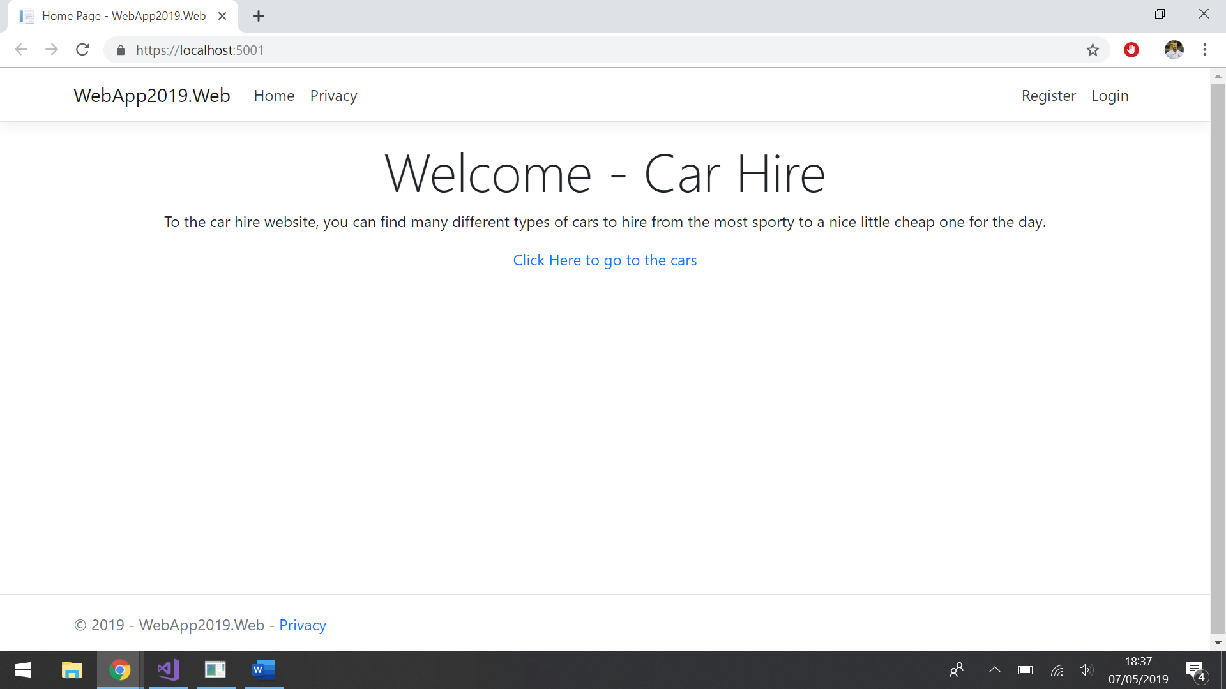

Car Page
This is going to be the main page which the user is going to be using, it allows the user to browse through the different cars which are available to hire. The user is also able to create a new car to the list. This will be adjusted in a future build where only the admin have access to this. It also has the option to register and login options on the top right. In future build there will be options to filter the cars so that the user is able to find what car they would like easier.
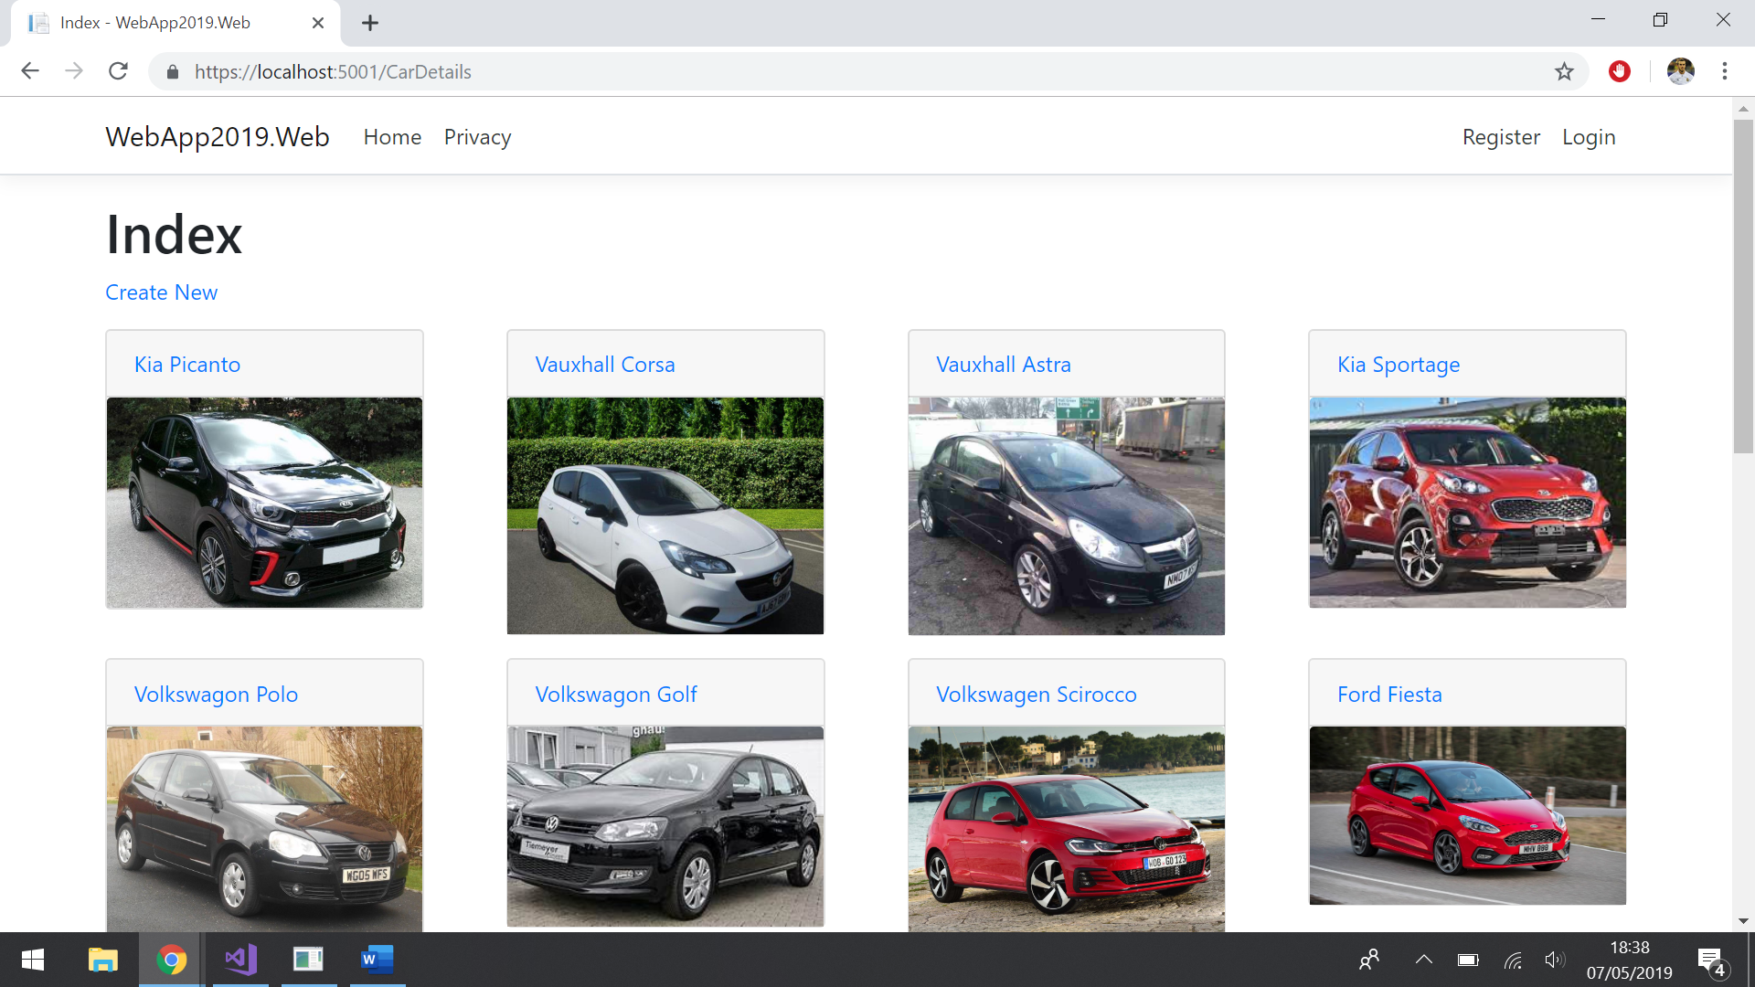

Car Information Page
This is the car information page, it is a location where users can find out all the information about the cars. The user can simply click on one of the cars to get to this page. There is an option to head back to the car page and there is an option to edit the car. This will be adjusted in a future build where only the admin have access to this.

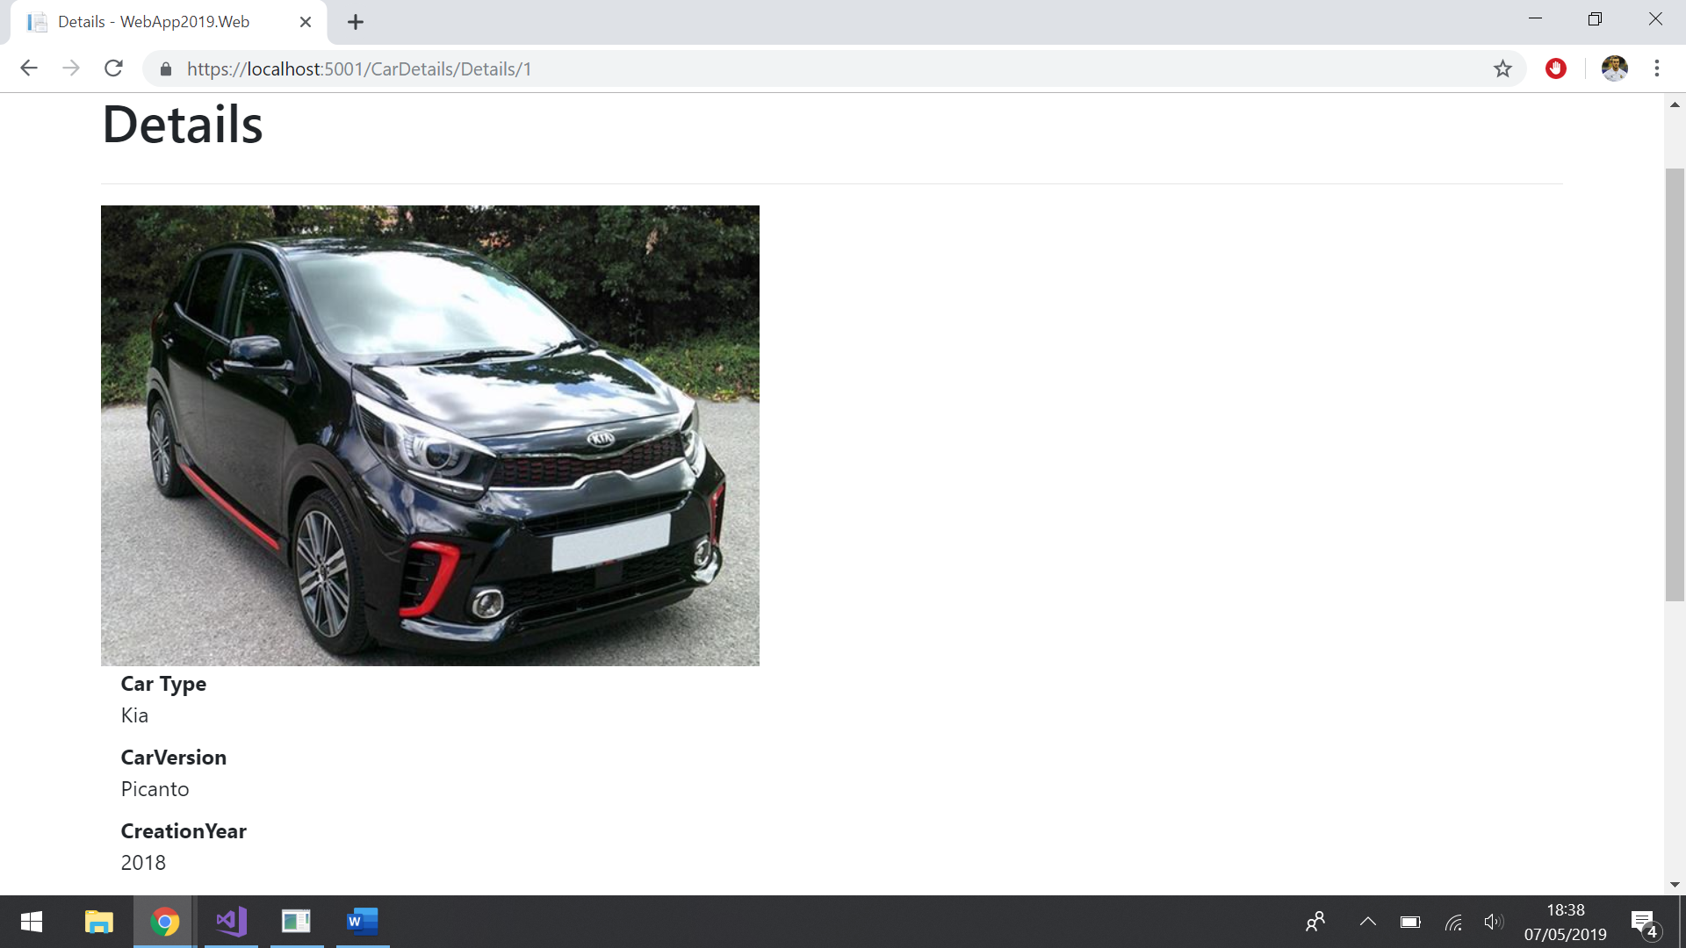
Register Page
This is the register page and is where the user registers an account, they simply enter their details in and click register to create an account.
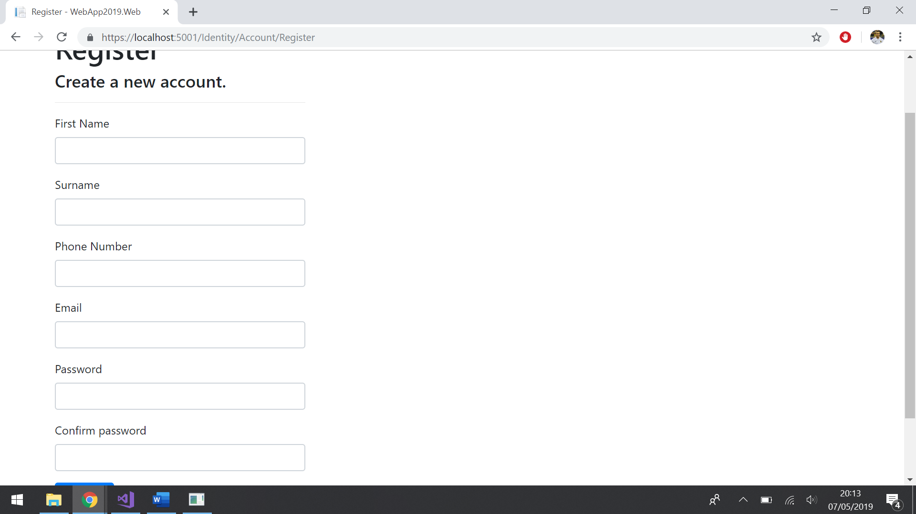

Log In Page
This is the log in page and is where the user logs into their accounts, they simply enter their details in and click log in to log into their account.
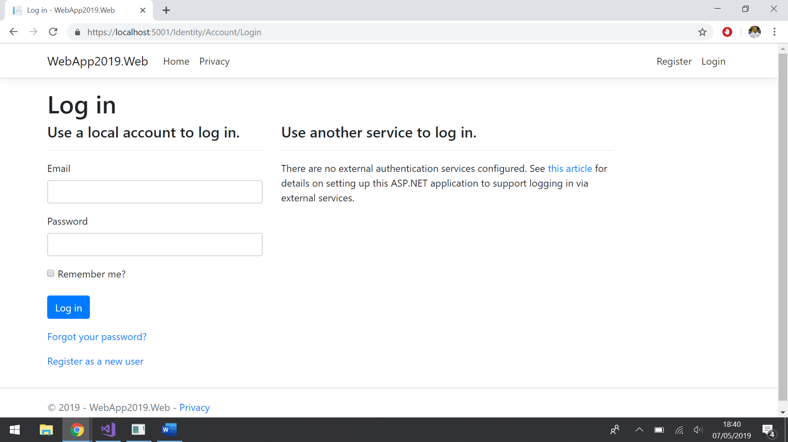

Conclusion
To conclude the final application has been looked at through screenshots, with an explanation of what each page is for

Evaluation

Introduction
Within this section of the report the evaluation of the final application is going to be taken, this will include testing the application for software verification and validation. Also an evaluation of the application to take note of it’s:
- Design
- Usability
- Content
Lastly any future improvements will be identified and discussed.

Testing
There are going to be three tests to test for verification and validation these tests are going to test the following requirements:
- Allow users to browse through the different cars available
- Allow users to get information about different cars
- Allow users to create accounts

Name of Test | Test Details | Result
Allow users to browse through the different cars available | To test this the main page will be examined to see if the user can browse through the various cars. | Firstly the register form was filled out with valid information the register button was then pressed.  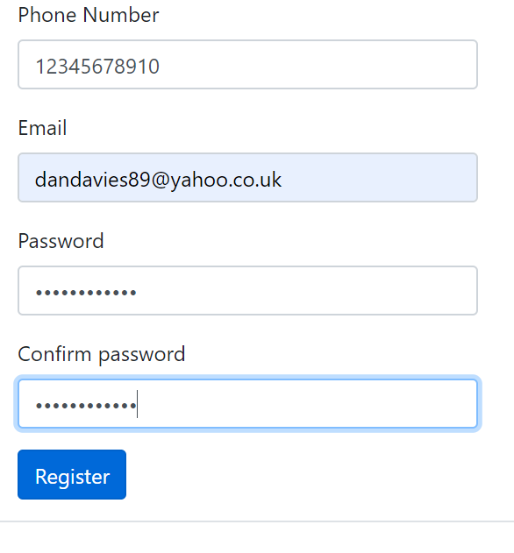  The application then redirected the user back to the main page with the user log in and with their account created.  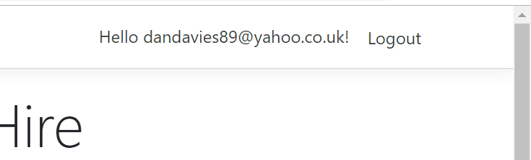
Allow users to get information about different cars | To test this various cars will be clicked on to see if more information comes up about the car | The next test the user went to the main page and click on a variety of different car (Wolkswagon Golf in the example below)  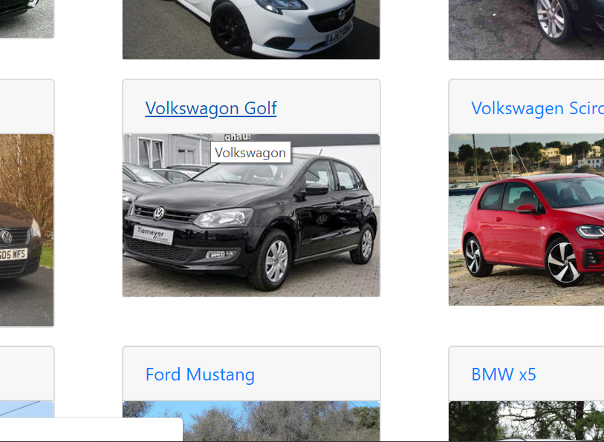  Every time the user click on one of the cars it opened up the secondary page and allowed the user to get more details about the car.  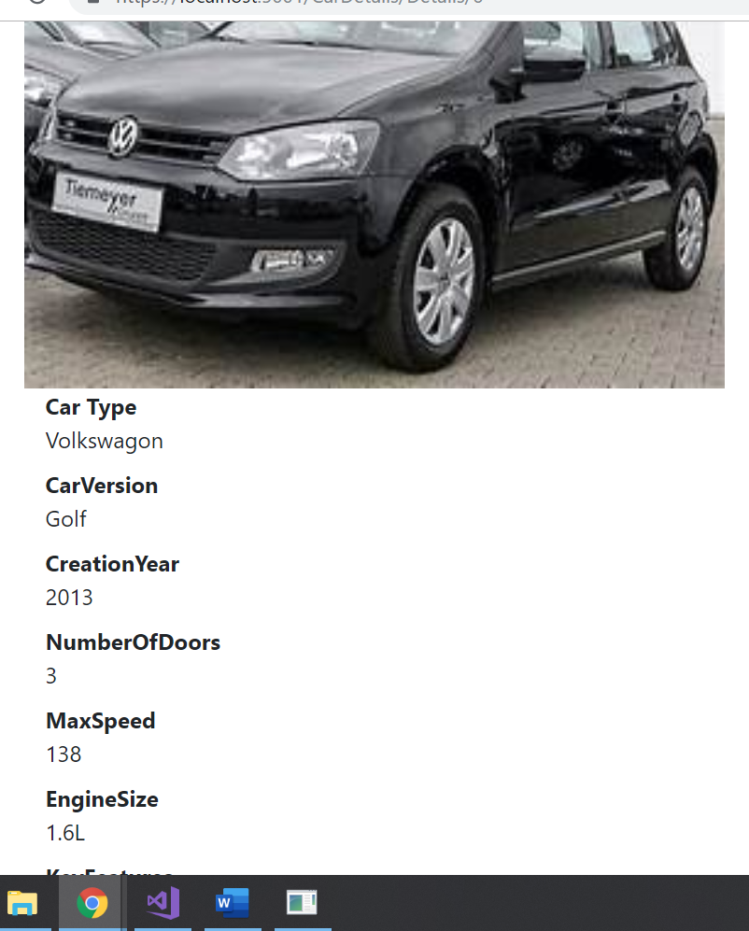
Allow users to create accounts | To test this various accounts will go through the creation stage to see if the account creation is working | This test is simple the user was asked to go onto the main car page and check if they could browse through the various cars which they could.  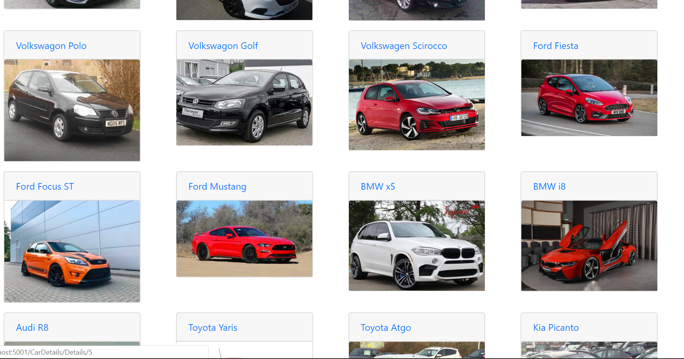

Application Software
Design
As for the design of the application it has a very simple design with no complicated layouts used. The grid for the cars is very professional looking, however the application can look a bit bland and could possibly do with some colour or art to make it look a bit more professional. Overall through it is a nice little plain design which does still look professional.
Usability
As for the usability it is very easy to use, this is because there are not many functions for it to be difficult. What is meant by this is that users are able to scroll through the different cars and click on one to find out more information about it. The functionality of the website is not very good as a lot of the key features are not currently working such as the filters and the hire section. However, the user experience is very good as it is easy to use and navigate through.
Content
As for content it doesn’t have an over the top amount, I the application just states the main facts about the cars with some information about the specifics of the car. This however was intentional as the aim of the application wasn’t to give lots of information but to give information which is short sweet and easy to read, this has been achieved and is good.

Future Improvements
As some of the requirements were not meet due to time management then there is lots of room for future improvements. Some of these improvements include:
- Allow the user to filter the cars so that the user is able to find what car they would like easier.
- Change admin and member rights so the members are not able to add and edit the cars.
- Add an actual hire section so that users are able to place orders for the cars they would like.
- Improve the look of the website to make it look more professional.

Conclusion
To conclude some testing has taken to place so that the software can be verification and validation. Also an evaluation of the application has been done with any future improvements have been identified.

References

[1] | “What is application development?,” [Online]. Available: https://www.zoho.com/creator/application-development/. [Accessed 03 05 2019].
[2] | D. Swersky, “The SDLC: 7 phases, popular models, benefits & more [2019],” 31 05 2018. [Online]. Available: https://raygun.com/blog/software-development-life-cycle/. [Accessed 03 05 2019].
[3] | A. C. Oliver, “12 essential software development principles and concepts,” 19 09 2017. [Online]. Available: https://www.infoworld.com/article/3233866/12-essential-software-development-principles-and-concepts.html. [Accessed 03 05 2019].
[4] | “Minimum Viable Product (MVP),” [Online]. Available: https://www.techopedia.com/definition/27809/minimum-viable-product-mvp. [Accessed 03 05 2019].
[5] | “The Don’t Repeat Yourself (DRY),” [Online]. Available: https://deviq.com/don-t-repeat-yourself/. [Accessed 03 05 2019].
[6] | “The fail fast principle,” [Online]. Available: https://enterprisecraftsmanship.com/2015/09/15/fail-fast-principle/. [Accessed 03 05 2019].
[7] | D. Hoang, “The Fail-Fast Principle in Software Development,” 05 01 2018. [Online]. Available: https://dzone.com/articles/fail-fast-principle-in-software-development. [Accessed 03 05 2019].
[8] | Perezpriego, “10 Principles for Effective Software Development,” 21 03 2016. [Online]. Available: https://m.alphasights.com/10-principles-for-effective-software-development-aa5df91d0f00. [Accessed 2019 05 04].

