
Skills for the Workplace
Module Assignment Submission
Student Name: | NASIMA BEGUM
Student Number: | 1917852
Module No: | BMSK4002
Module Title: | Effective Team Working and Communication  Part 2

Statement of Confirmation of Authenticity
By the act of making this submission, the student declares that this is the work of the student named above. The work has not, in whole or in part, been knowingly presented elsewhere for assessment, or where assessment has been built on a previous assessment, this has been identified. Where materials have been used from other sources it has been properly acknowledged. If this statement is untrue, the student acknowledges that an assessment offence has been committed.
Attention is drawn to the plagiarism and unfair practice policies of both the University and of ILM.

Table of Contents
Part 2 Communication 3
1.0 3
Communication Cycle 3
2.0 5
Assessing Own Communication Skills 5
Gap Analysis 6
PDP 6
References 7
Appendix A 7
Skills You Need Communication Quiz 7
Mind Tools Communication Quiz 9

Part 2 Communication

Introduction

The focus of this assignment is communication cycle. The types of communication there is and the challenge we face when one communicates. Communication is plainly the act of human’s process of transferring information to one person to place or person. Communication may sound simple because it can be transmitted in several ways today, we have a lot of ways to communicate like face to face, text message, video call, social media they all are unique in their own way. There are several ways one cans communicate, verbal, no verbal, oral, visual, formal, written. How workplace communication deals with complex problems
Communication is related to every human sending and receiving like words in a text message verbal, non-verbal, visual, active listening, assertiveness.

1.0

Communication Cycle

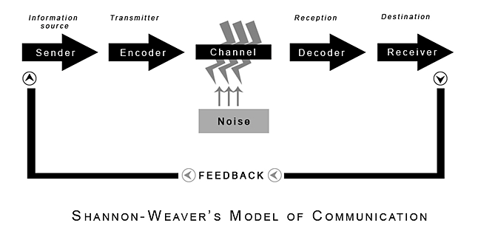
(Shannon and Weaver, 1949)
The Shannon weaver model of communication is a mathematical theory of communication it is made of 6 main points that are a (sender) (Encoder) (Channel) (Noise) (Decoder) (Receiver) it is a linear model. It is said to be the mother of all communication. Chris Drew PhD (2020)
(Sender) The Sender who makes the message and finds a channel to communicate e.g. mobile phone, voice message, Text message.
(The encoder) The encoder is the telephone network company. Who encodes the message?
(The channel) The channel is the machine (signal) could be a phone, message, or text where the message is sent through to the receiver.
(Noise) Is a disturbance or distractions that can interrupt the phone line or message.
(Decoder) The decoder is the phone company who decodes the message
(Destination) The receiver is where the message reaches its end.
This model was made to formulate the effectiveness of communication between sender and the receiver and what is the Noise that interrupts the message. Noise can be a lot of things it can be internal noise is where the sender makes a mistake writing a message or when the phone line cuts off due to noise in the line when noise is present the feedback is important in Shannon weaver model the feedback was not proposed it was later added. This model being a liner model which means the message is only one-sided. (Chris Drew,phD)

Communication in the workplace

Good communication in Workplace is essential for any company. it improves productive and ability to run smoothly for the organization and their workers. Active listening is important in the workplace it is when one is truly listening to what is being said to them instead of what it means. (Elle Kaplan 2018)
For example, when a manager(sender) in a toy store leave a message to his assistant to #arrange a staff meeting regarding a complaint from a client. He calls and says there has been a compliant regarding a how a toy that has not been properly assembled and who is liable for it (goes missing due to noise of builder working outside the office. The assistant (feedback) replies by I can’t hear you sir? What complaint? (open.
(Sender) is the manager who sends the message
(Encoder) is the telephone network who encodes the message.
(Channel) is the telephone wires or Wi-Fi
(Noise) is the builders working close by who interrupt the message with their machines
(Decoder) is the mobile phone who decodes it
(Receiver) is the assistant who the message is for.
(Feedback is when the assistant responds with a what complaint? Due to the noise the assistant did not understand the voice note which result in the feedback. Feedback is needed to restart the process of the message. (Mary Clare Novak April 2019)
The Shannon weaver model is a starting point in communication theory it is a simplest theory to apply when in a complex matter. (Mary Clare Novak April 2019)

Berlo’s model of communication

In 1960 David Berlo developed a communication prosses model after Shannon weaver’s model of communication (1949). It was made of four compartments a Sender-message-channel-Receiver (SMCR). Its key points describe the elements affecting the communication prosses to make it more efficient. Berlo’s model of communication concentrates on encoding and decoding. (businesstopa.net2018) The sender is individual who starts the communication prosses by sending the message to the receiver by writing or speaking Channel is the electrical machine in which the message sent e.g. telephone, or it can be any five human sense, hearing listening, smelling, and the receiver is recipient who decodes the message through reading the message or listening.

BERLO’S MODEL OF COMMUNICATION

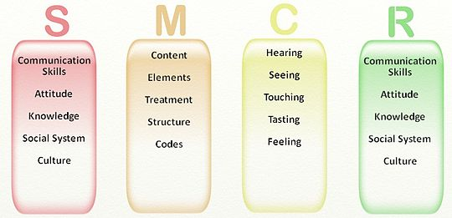
This Photo by Unknown Author is licensed under CC BY-SA
The SMCR model of communication Advantage’s is that it looks at different aspect of the message. Communication only happen when both the sender and receiver have the same ability and that the meaning is not always in the message. It must have communication skills SMCR. Drawback of Berol’s model is that it leaves no room for feedback. If there is no feedback, then the message can be interpreted differently. (Andris Peterson and Ilkhom Khalimzoda 2016:426)

2.0

Assessing Own Communication Skills

To be a in communication I first need to look at how my interpersonal skill and to act well with others I need to improve my reading and writing skills After taking the online assessments my score was 61% on the interpersonal skill -assessment I got 41% on verbal communication which is the below average mark. In order to communicate well verbally I need to understand the message first to understand it and then give feedback with oral communication. After taking the mind tool how good is your communication skill assessment I scored total of 43% which is an average score need to work on my communication skills e.g. verbal communication and an active listener. I must learn to more assertive. I must ask more question when I don’t understand something first time round.

Gap Analysis

Objective | Current Position | Deficiency | Action
What do I want to do? | What can I already do? | What am I lacking? | How do I fix this?
I must be more affective on given time with my assignments. | I understand the task given to me. | I am lacking not asking questions when needed. | I will ask more questions when I don’t understand something in the assignments.
I must take my time management into account keeping on top of my assignments. | I can take notes throughout lessons. | I am lacking not reviewing the class materials. | I will review class resource when starting my assignments.
I must do my research beforehand and use the smart objective and applying it to my assignments. | I now understand the important of smart objective. | I am skill lacking the citing in my assignments. | I will cite my research on my assignments.

PDP

Objectives | Tasks | Success Criteria | Time Frame | Resources
List your Goals | What do you need to do to achieve these goals? | How will you identify your success? | When do they need to be done by? | Who or what do you need to help you?
My goal is to use Harvard referencing appropriately | By using Harvard referencing on my assignment | When I start to cite my work correctly | As soon as possible | Ask my lecturer or read on it
My goal is to be a good verbal communicator | I must understand the message first to improve the feed back | It will be a success if given a task I take the time to understand it then give feedback | As soon as I can | By asking when I don’t understand something on the assignment
My goal is to complete level 4 and go on to level 5 | To complete this level 4 | It will be a success for me if I can complete this level 4 and go to the next level 5 | End of November | By asking for help when needed and using all information given on moodle and on teams.

Reference

petersons, A. and Khalimzoda, I., 2016. Researchgate | Find And Share Research. [online] ResearchGate. Available at: <https://www.researchgate.net/> [Accessed 16 July 2020].
novak, m., 2019. Learning Hub | G2. [online] Learn.g2.com. Available at: <https://learn.g2.com/> [Accessed 23 August 2020].
Mindtools.com. 2020. How Good Are Your Communication Skills?: – Speaking, Listening, Writing, And Reading Effectively. [online] Available at: <https://www.mindtools.com/pages/article/newCS_99.htm> [Accessed 30 August 2020].
Communication Theory. 2020. Communication Theory. [online] Available at: <https://www.communicationtheory.org/> [Accessed 14 August 2020].
Drew ph.D, C., 2020. [online] Available at: <https://hepfulprofessor.com> [Accessed 11 July 2020].
Businesstopia. 2018. Businesstopia - Economics, Management And Communication Site. [online] Available at: <https://www.businesstopia.net/> [Accessed 26 July 2020].
2011-2020, (., 2020. Interpersonal Skills Self-Assessment. [online] Skillsyouneed.com. Available at: <https://www.skillsyouneed.com/quiz/343479/_> [Accessed 24 August 2020].
Kaplan, E., 2018. Active Listening. [online] Available at: <https://medium.com/@ellekaplan/active-listening> [Accessed 7 August 2020].

Appendix A

Skills You Need Communication Quiz

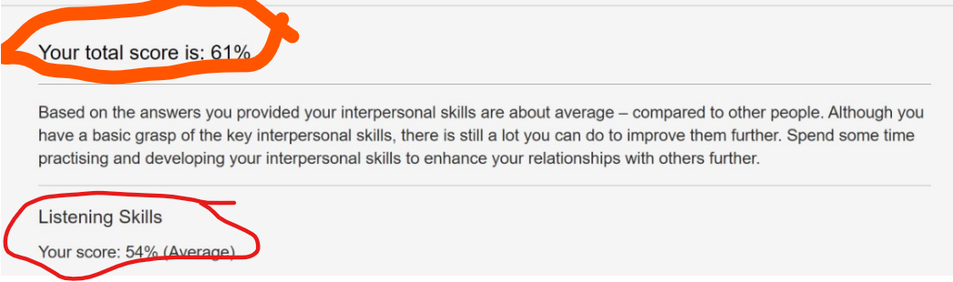

Mind Tools Communication Quiz



