

Assessment 1 – Reading Task Template
Upload your photo of your A3 in-class notes here:
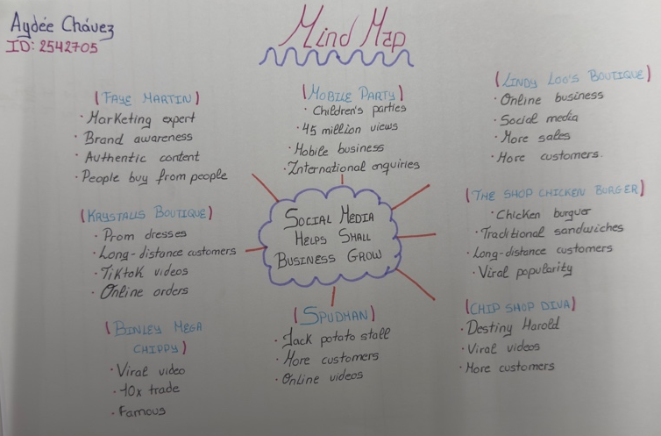

1. Answer these questions using the sentence starters below
a. What is the main idea of the text?
The text mainly explains how social media can make small businesses better known and attract more customers.

b. What are two key points?
One important point is that posting videos on plataforms such as TikTok and Instagram can help businesses get more visitors and increase sales.

Another important point is that people trust businesses more when they see genuine and honest content online.

c. What part of the text did you find most important? Why?
I found the examples of business owners most important because they showed how social media helped them grow their businesses in a short time.

d. Was anything unclear or difficult to understand?
No, I didn’t find anything difficult because the text explained the ideas clearly.
e. How did your group help you understand the text better?
Talking with my colleagues helped me understand the text better because we compared our ideas and discussed the main points.
2. One sentence reflection
Question: What did you find challenging about this task?
I found it difficult to decide which ideas were the most important because the article was extensive and included many different examples.

