The number of Lichen species
is a good indicator of air quality – the fewer the number of species the poorer the air quality.
In the zonal system as illustrated below zone 1 has 0-2 species (very poor) and zone 6 has 9-10 species (very good air quality) and the map shows where these are found

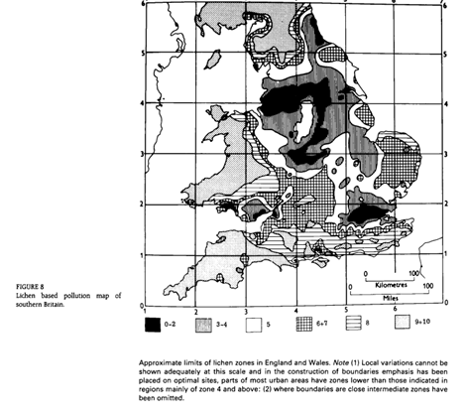

Forestry Commission Handbook 4 Lichens in Southern Woodlands Broad 1989

