
Construction and Analysation of A Smart Car Park Environment
[Company name] | [Company address]
REsearch proposal
Andom Alemayo (P151438)
2019

Table of Contents
<…>

Table of Figures
<…>

Table of Tables
<…>

Introduction
<A broad description of the project in 1-2 paragraphs>

Industrial Context
<If needed. Who is your industrial partner? What is the industrial sector involved and why is the problem you are studying important.>

Background
In this day and age, due to the large volume of vehicles in outdoor environment’s, road traffic become increased at a higher ratio and due to the lack of parking space many drivers are forced to waste valuable time, for fuel and energy in search of locating a parking space[1]. Hence, the construction of a smart car park that has the capability of informing the users whether there is a free space or not with the aid IoT (Internet of Things) technology, and can factor alternative benefits such as lighting, understanding of timing (duration of remaining time), and other factors can also indicate a user of potential free parking space and minimising irrelevant timing in locating a suitable structure for parking. Moreover, to reduce the occurrence of any possible incident in a carpark, the drivers/user should be informed upon illegal or dangerous parking position.
The construction of smart and automated car park is heavily relay on the Internet of Things (IoT) technology. But what is IoT? and how it came to existence?
The concepts of the Internet of Things (IoT) was primarily introduced by Kevin Ashton back in 1999. Back then, the IoT concept was defined as an object which is distinctively recognizable interoperable objects that are linked with each other and with the Radio-Frequency Identification (RFID) technology[2] [3].
Nevertheless, through time this concept has evolved to include the Internet systems, actual sensors, electronic devices and the interconnection which exits between them, the environment and the human being [4][3].The IoT can be also defined as the internetwork of tangible objects which are comprises of embedded technology to interconnect, sense and interact with each other and or the external world[5][6]. The emergence of this technology has totally shifted direction of the traditional technological development approach where, technological development was heavily relayed on the object-oriented approach or machine to machine technology. And more emphasis was placed on developing and creating a new type of machineries to boost the standard of life and productivity[7][8].
One of the most distinguishable characteristics of IoT technology is that, the presence of the global system of Internet Protocol (IP) linked computing networks, sensors, devices and machine in which the physical object is able to connect to the internet[9]. The new version of IP address (IPV6) has a huge number of IP address. And this allows as many electronic devices to be able to connect to each other either locally or globally[10].using the IoT technology it possible to construct a smart home, smart health care, smart phones, smart city, smart wearables, and so on[11].

Literature review
According to Abhirup Khanna and Rishi Anand [12] ,the issue of car parking and traffic management was addressed by constructing a smart car park and utilizing integrating the IoT and Cloud technologies. And in doing so, two types of sensors the Ultrasonic sensors and Passive Infrared sensors were used to check the availability of the empty car park slot. The Ultrasonic sensors are connected with raspberry pi wirelessly using the ESPE8266 Wi-Fi chip which contains autonomous SOS with the TCP/IP protocol[13]. Any data gathered from the sensors will be transferred to the raspberry pi where, the raspberry pi transfers the data to the IBM Message Queue Telemetry Transport (MQTT) server using the MQTT protocol. Then the IBM MQTT server is accommodated on the cloud service, which serves as database to reserve the all the data regarding the smart car parking system. Using Apache Cordova and Angular JS frame work, a mobile is created to allow the users get an information regarding the smart car park [12]. However,[14] discovered that these this approach to words solving the parking space problem is ineffective mainly because of the high cost involved due to extra sensors. In addition, [15]there will a delay of data transmission, as a considerable amount of time is required to send the data from the sensors to the cloud server and back again.
Jana et al. [16][17], presented a model of an intelligent car parking management system using the wireless sensor networks. The smart car parking is expected to show graphically the actual time information in regard to the space availability in the parking slot so that the drivers know if there is a free space and if there is, enable them to book a parking lot. Furthermore, the system allows the users to park their vehicle quickly and safely by guiding them through the empty space in the park. And to construct the smart car park, Wireless Sensors Network(WSN), Sink Automated Guidance, entrance display and user reserve system are utilised. The WSN system encompasses the sensing, distribution, routing and display statues [17]. The Sink system is used to gather information from the WSN and transmits them to the parking system management. The Sink also serves as gateway to connect the outside world with the WSN. But [18] concluded that a mote sensors are capable of covering a large area and they also provide more significant information regarding the actual scene as compared to the visual once and those monitored by the radar system if the various mode of operations assessed carefully.

Wael et al.[19]and Burak [20] proposed an innovative model to save expense, time and energy consumption that can occur place due to the delay in the transfer of data. The information collected from the sensors are immediately transmitted to parking area through the cloud technology and then the information is processed and send back again. The study has also extended its scope to seek solution about the information of the nearest cark park and traffic congestion on the road. In this research the structure of the smart park is classified into three section. The first section contains sensor nodes, Microcontrollers and smart parking services. The second section includes the cloud technology which serves as mediator between the mobile application users and the parking area. The last part will deal with user use of the android application so the user can get information about the nearest cark park from any location. To minimise the possible high costs, the system facilitates the communication between the sensors and the microcontroller through Bluetooth wireless technology. Similarly, communication between the users and the cloud technology is conducted through the web protocol know as Hyper Text Transport Protocol (HTTP) protocol.
Dae-hyun et al.[21] Presented a mini-parking platform, which encompasses the short parking route guidance using the Beacon and the NFC Reader, collision prevention guidance and display for the parking information as well as reserved parking slot. For the sake of practical application Beacon and RFID were used. The vehicle was also assumed as a smart phone in the modulation. In this paper the Mobius IoT was used as a platform and using the Raspberry Pi allows interconnection between the Mobius and the other electronic devices. And MQTT protocol also used to communicate the Raspberry Pi and the Mobius server. In order to navigate the shortest parking lot distance, an Android application is used to collect information from the Mobius server about the free parking space[22].Unless a good security measure is taken, all these bunch of technology can easily be exposed to theft or damage because untheorized person can access the system and use them to do harm or steal, the identity, the properties of the users and even attack the system[23].

Aims & objectives

Aim
- The main aim of this research is to develop a smart car park, which can be used in closing in an enclosed parking system.

Objectives
- To develop a smart car park which is capable of sensing the availability of the free parking and inform the drivers.
- To analyse the efficiency of the network connectivity and the real time response of the sensors.
- To design a smart car park using a wireless technology Wi-Fi and Bluetooth to minimise cost of implementation and utilisation of the technology.
- To develop a safe smart car park which is able to inform the drivers about the possible collision occurrence or illegal parking.
- To design a smart car park with the aid of IoT devices such as Sensors, Arduino microcontroller, Light Emitting Diode (LED), CCTV (Closed-Circuit Television) and other IoT devices.
- The to develop a user friendly application and server application using the C programming language.
- To design a security system which minimises the risk of any possible hack.
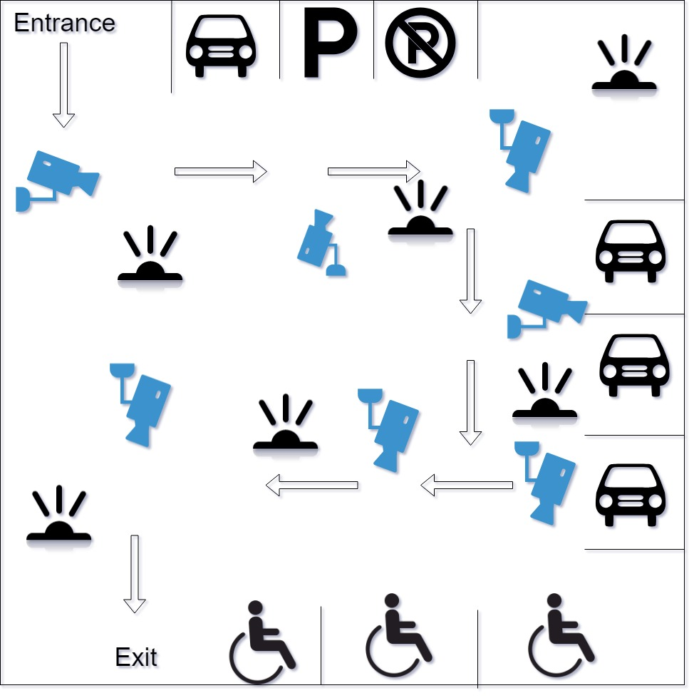Figure 1 – Blue Print Draft

Research Methodology
The author of this paper preferred to conduct a research on the implementation of IoT devices on the car park environment. And as it is in this research, first a smart car park using a car park using an IoT devices and wireless technology will be constructed and then the performance of the system will be analysed.
The researcher has also discovered that in many attempt of building a smart car park using an IoT devices, most the researchers emphasise on the utilisation of extra sensors and designing a wireless connection to set the communication within the system as well as the outside world. Issues like safety, efficiency, cost of the technology, strength of the connectivity, delay, redundancy and above all security have gained less attention by most of the researchers. Moreover, the contribution and importance of the IoT devices in improving the standard of the human beings has drawn the attention of the researcher. Hence, the author decided to use the IoT technology and implement it on a car parking environment mainly because nowadays, large number of vehicles in cities and towns in outdoor environment causes traffic jam in roads almost daily, and most of this road traffic is caused by drivers who are wondering to find a parking space[1].
Constructing a smart car park environment that fulfils the above objectives has a many benefits, some these are; the road traffic can be reduced to some extent, the time and energy of the drivers will be saved, safety on the car parking environment will be maintained, the system will also maintain the security to words possible cyber-attack and above all the system will be affordable and cheap to maintain.
In process of conducting this project in order to minimise and find solution to the possible or unexpected obstacles the experiment will be conducted on a class room situation first. Also test results will be compared with previous researches or experiment. For the above head problems experts and instructors will be consulted.
The project is expected to be valid and reliable mainly because a detailed research has been done by the researcher in regard of the subject, the interest and dedication of the author, the existing know how about the wireless technology, IoT devices and the security system.
In conducting this research, a positivist philosophy is used. Positivist philosophy is a philosophical system which is based on mathematics and science. The core concept of this philosophy is that everything exit can be proven via observation, experiments, tests, logical proof and other scientific methods[24]. And anything fails to prove its existence through these method is considered as not exist. The theoretical and cultural biases or believes usually lack recognition in this philosophical system as the more emphasis is on the objective truth. Moreover, statements in positivism are classified as false, true and neither false nor true(meaningless) [24][25]. As the research project is going deal about a better construction of a smart car park which involves aspects like testing and evaluating the network of wireless connections and IoT devices. Hence, the positivism philosophy is found to be more useful to proof and deal with the realistic study.
This research will try to answer the question which states as, it is not possible to construct a smart car park which is less expensive, secure, scalable and usually accessible using the wireless technology and the IoT devices. A deductive approach has been selected to conducted this researcher. Mainly because the it allows the researcher to use scientific principles and shift from theoretical approach to more quantitative data which can used for evaluation purposes. Deductive approach is an approach that deals with creating a scientific hypothesis on the bases of the original theory and proposing a research plan to in order to check the hypothesis. This approach is helpful in clarifying the occasional that can exist between variable as well as concepts. Additionally, it is also permits the researcher to drawn an overview about the research findings[26][27].
In order get a better outcome and analyse the effectiveness of the design and its implementation, three strategies will be used in this project. First, to be able to compare the result of the research with previous research presented in the literature review an experimental research strategy will be adopted where the previous research work will be left intact and any possible adjustments will be done to this project to measure and analyse the outcome. Additionally, the research will also determine the presence any relationship and its effect on the results. Finally, document review will be done. In the document review, factors that the project in both negative and positive ways will be recognised. Therefore, a quantity and experiment research study will be selected for this research. Manly because the research will depend on the result of quantitative data. And observation strategy will as be used in this research.

Development Methodology
<What methodology have you chosen, why is it the right choice, what advantages does it give, how will you get around any problems it brings? Consider Feature-Driven Development as your development methodology.>
The following methodologies will have followed in implementing the research.
- Identifying the research topic
- Gathering and analysing the requirements
- Designing
- Implementation
- Testing
- Maintenance
- Documentation of the all the necessary steps of the project
The waterfall diagram below shows all the necessary methodologies which will took part in this research paper.

Risks
<What risks apply to the project? Timing? Lack of access to resources? Etc. Are there any ethical issues to be considered?>

Analysis and Deliverables
<What data will you collect? How will you analyse it? What are the final deliverables for the project? What are the minimum success criteria for the project?>

Physical Resources
<What physical resources will you need? Hardware? Software? Access to journals?>

Human Resources
<What human resources will you need? People to take a survey? Test subjects to try out your software?>
Timeline
<Gantt chart – if you are using a timeboxed methodology then remember to show the timeboxes on your Gantt chart.>

References
<List of references cited in numerical (IEEE) order>

Bibliography
<List of sources read but not cited in alphabetical order>

Appendix I
<If needed. Start each new appendix on a new page.>

